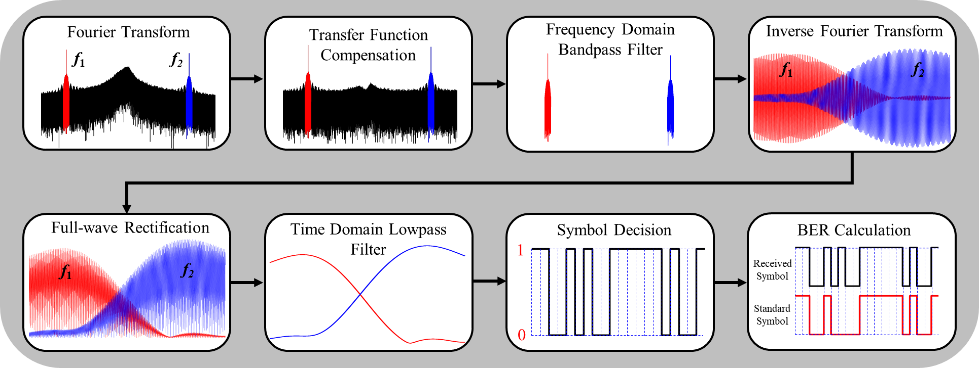
Fig. S1. The complete processes of the LF demodulation.

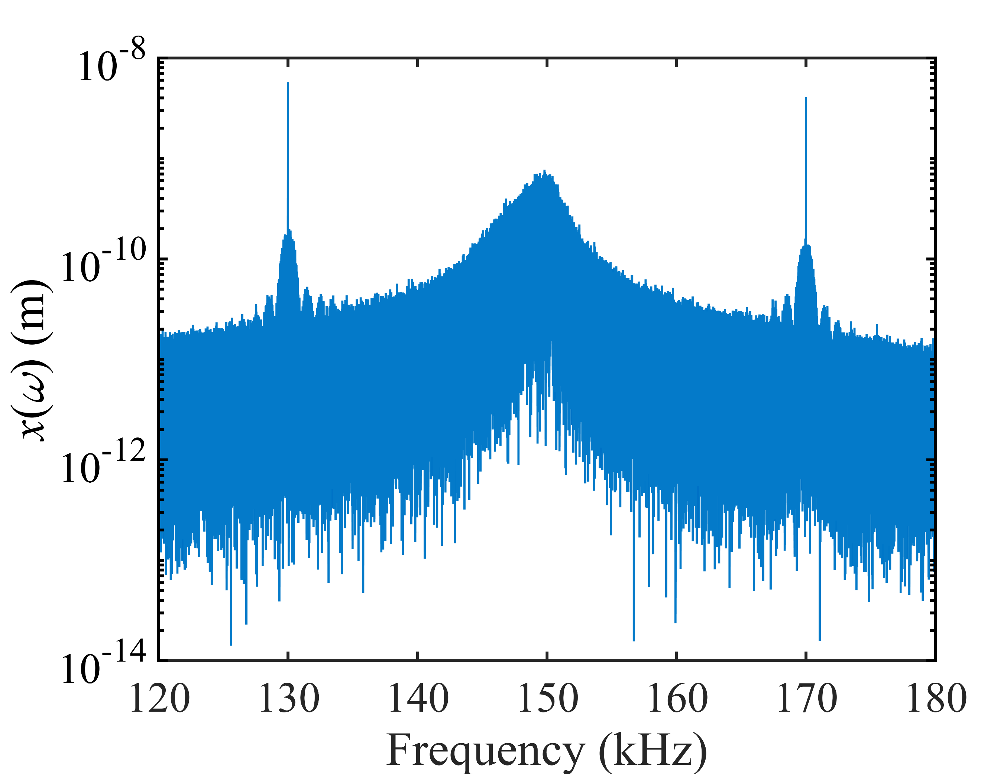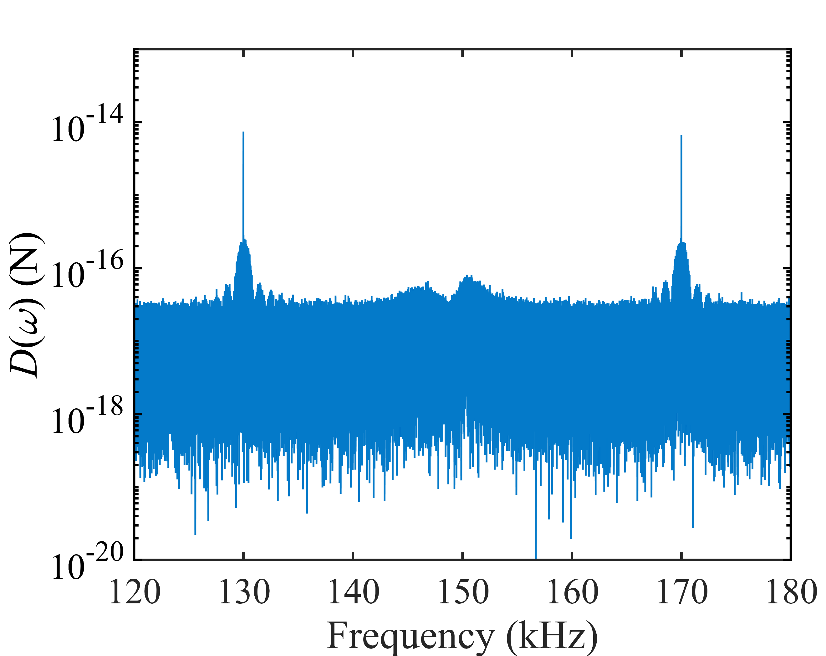
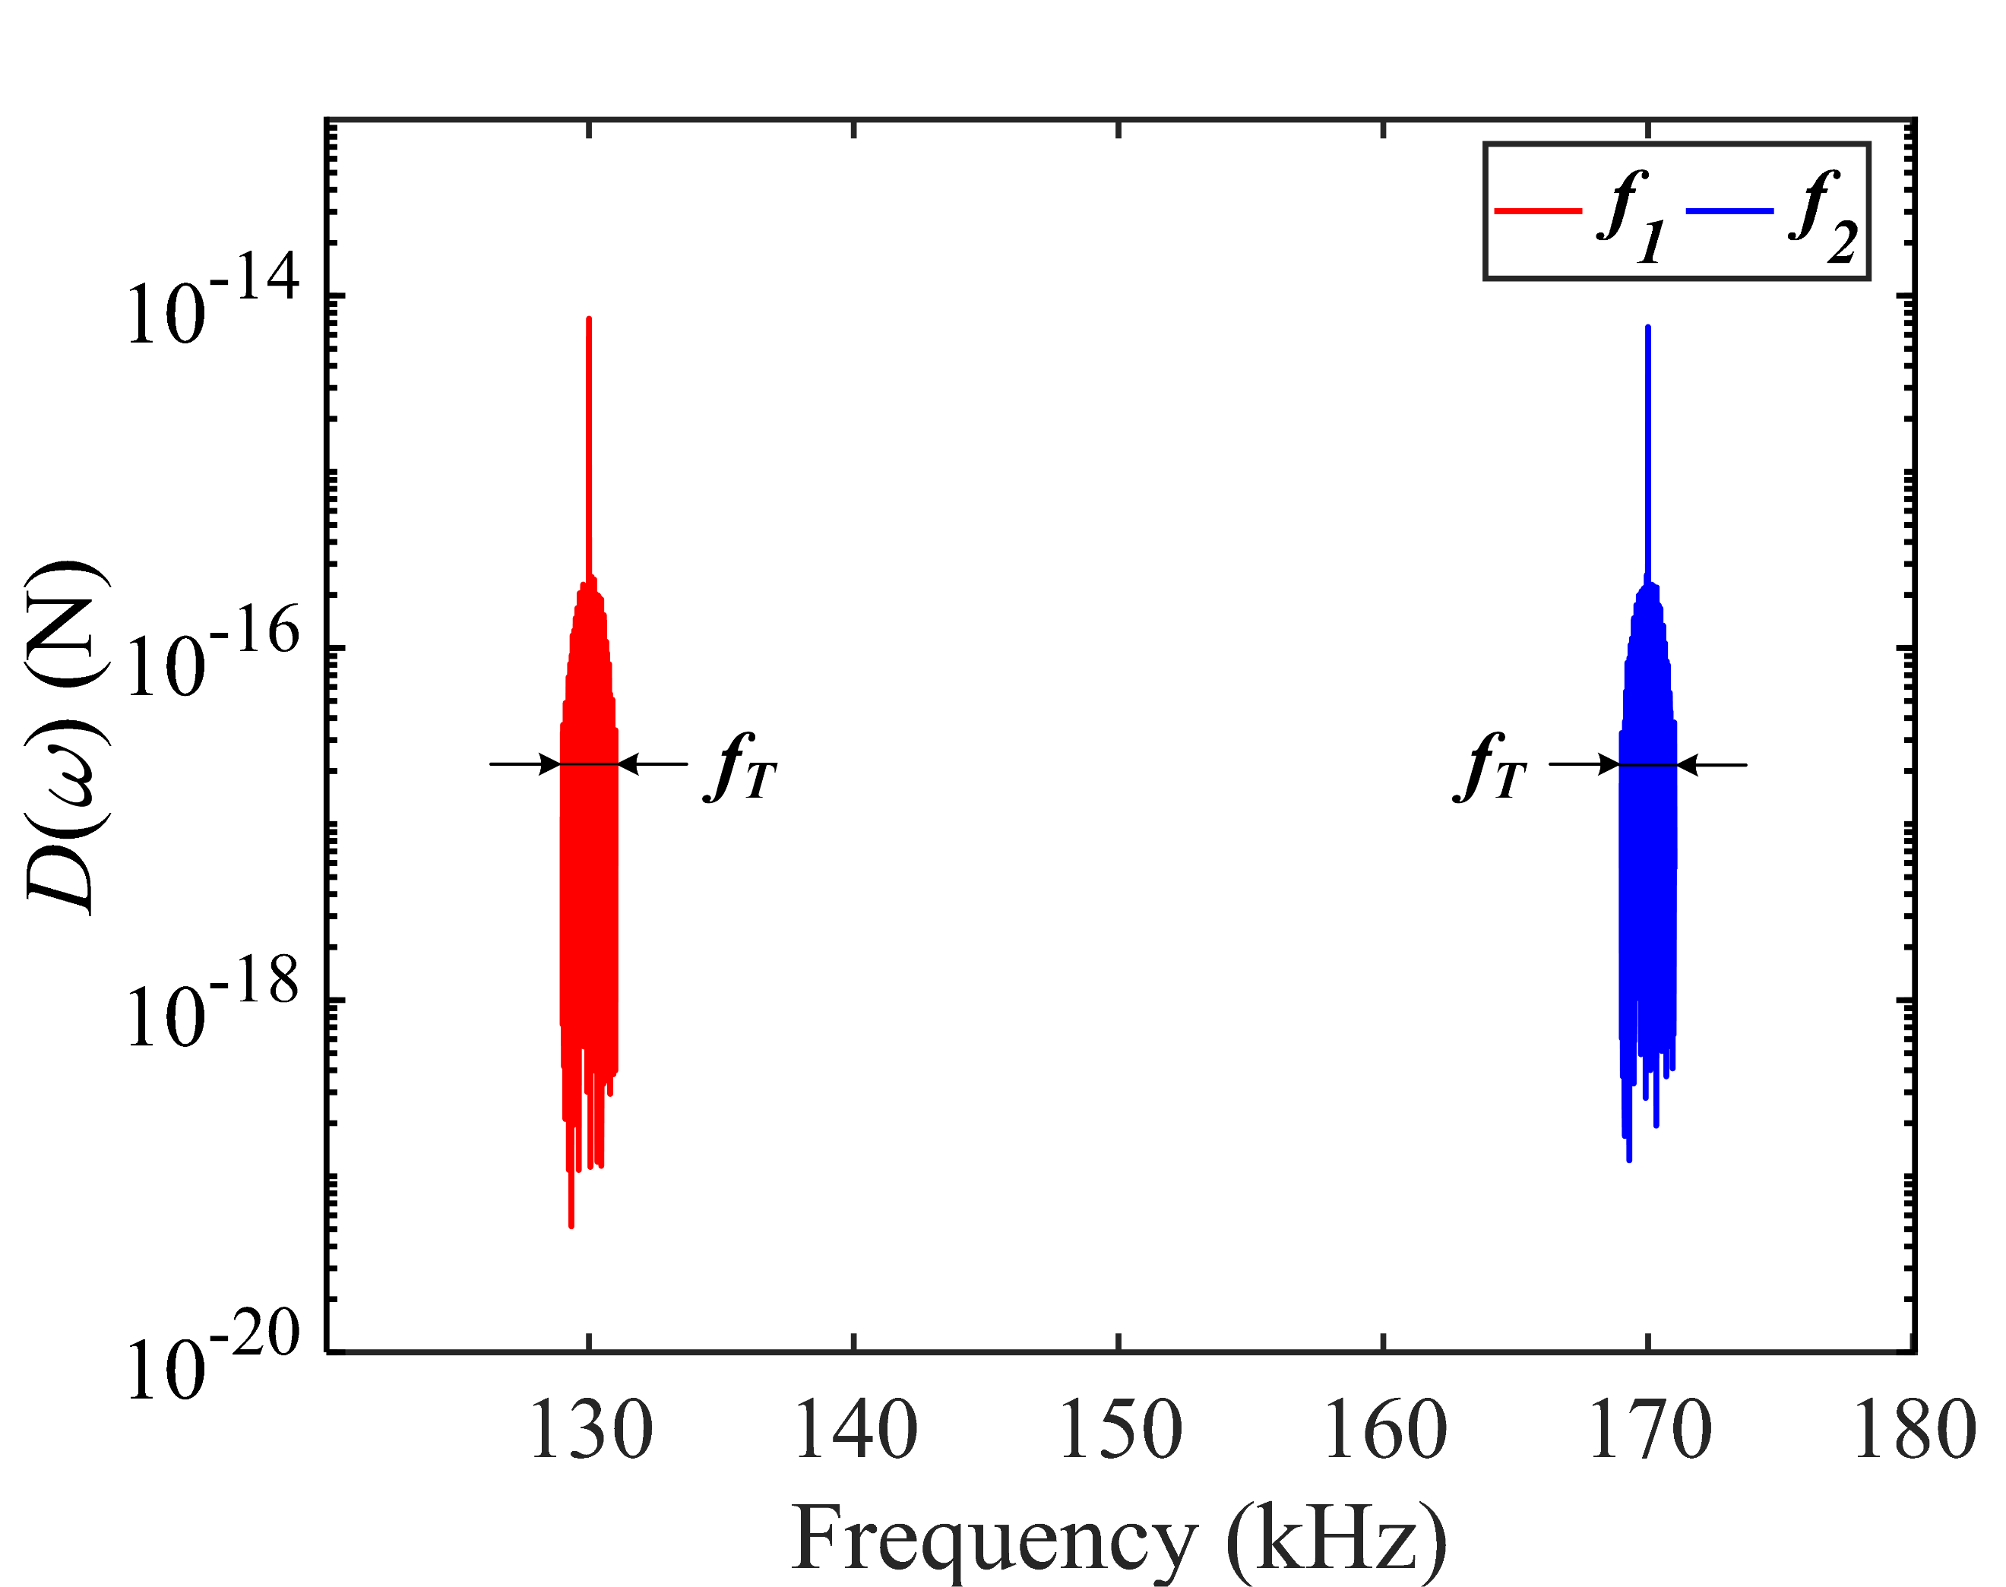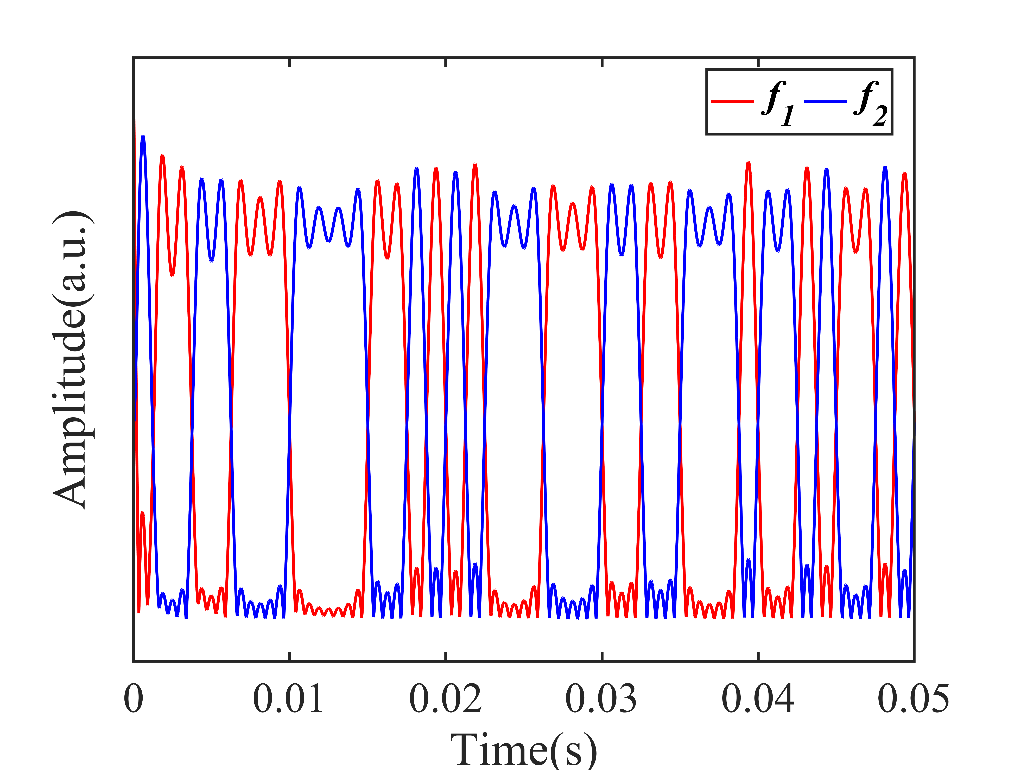
Fig. S2. Demodulation of the transmitted signal. a. Frequency spectrum of the detected motional signals. b. The compensated frequency spectrum. c. The band pass filtered frequency spectrum. d. The time-domain signals obtained by envelope detection, and the recovered symbol sequence can be derived by sampling and evaluation of these signals.

