Supplementary Information for
Self-supervised denoising of dynamic fluorescence images via temporal gradient-empowered deep learning

Woojin Lee¹, Minseok A. Jang¹, Hyeong Soo Nam¹, Jeonggeun Song¹, Jieun Choi^{2,3}, Joon Woo Song⁴, Jae Yeon Seok⁵, Pilhan Kim^{2,3}, Jin Won Kim⁴, and Hongki Yoo^{1, *}

¹Department of Mechanical Engineering, KAIST, 291 Daehak-ro, Yuseong-gu, Daejeon 34141, Republic of Korea
²Graduate School of Medical Science and Engineering, KAIST, Daejeon, Republic of Korea
³KAIST Institute for Health Science and Technology, Daejeon, Republic of Korea
⁴Multimodal Imaging and Theranostic Lab., Cardiovascular Center, Korea University Guro Hospital, 148 Gurodong-ro, Guro-gu, Seoul 08308, Republic of Korea
⁵Department of Pathology, Yongin Severance Hospital, Yonsei University College of Medicine, 363 Dongbaekjukjeon-daero, Giheung-gu, Yongin-si, Gyeonggi-do 16995, Republic of Korea

*h.yoo@kaist.ac.kr

Supplementary Figures and Tables
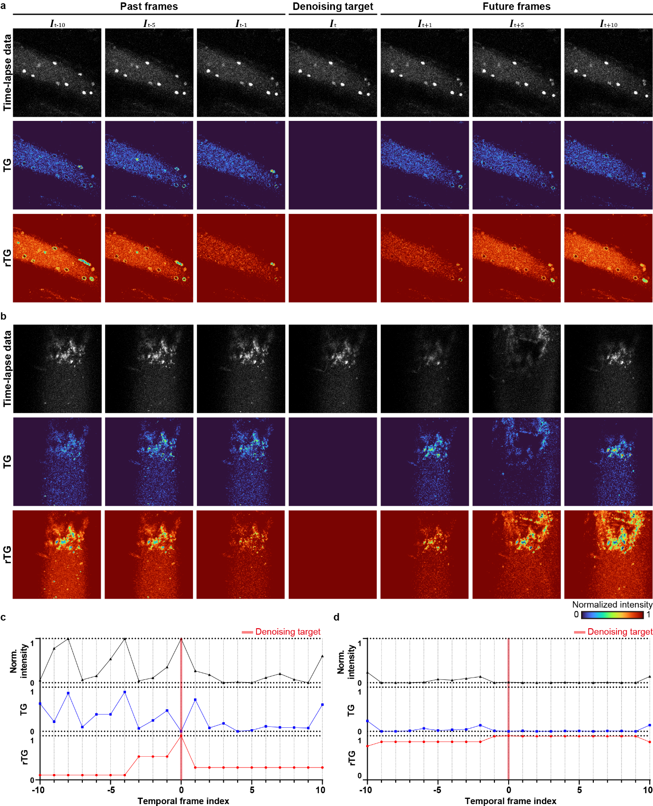
Figure S1: Temporal gradients arising from intrinsic sample dynamics.
a-b, Redundant temporal gradient (rTG) results for samples with a microscopic and b macroscopic dynamics. Both a and b describe the procedure of establishing rTG using past and future frames, with the central frame serving as the denoising target. The noisy image, the TG, and the final rTG are presented from top to bottom. In a, which depicts microscopic dynamics, cell flows are evident, with lower rTGs values along the corresponding pathways. Similarly, in b, perturbation to the vessel wall due to pulsation results in lower overall rTG values regions with bulk motion. c-d, Normalized intensity, TG, and rTG profiles at a specific spatial pixel point with (c) and without dynamics (d). In c, where the pixel value fluctuates significantly due to dynamic changes, the TG is prominent. As a result, rTG maintains lower values at certain temporal points in the past and future frames, guiding TeD to place less emphasis on that temporal information. In contrast, at a static location in d, there is no significant variation in the TG and rTG values, allowing TeD to effectively utilize available temporal information.
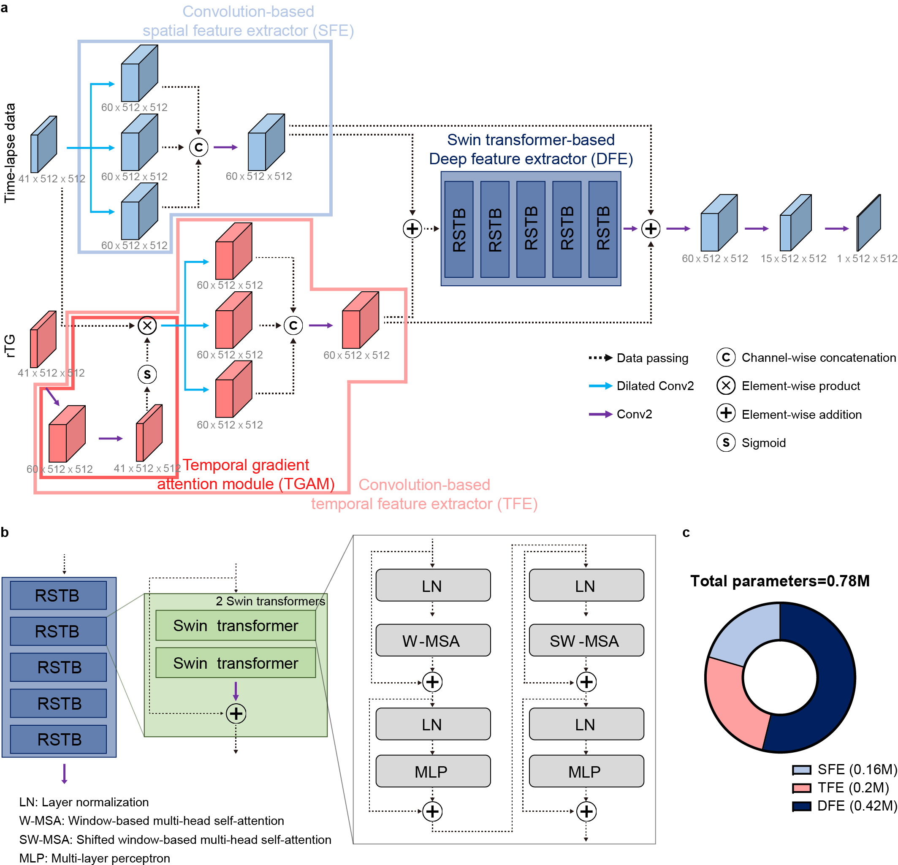
Figure S2: Network architecture of TeD.
a, Overall architecture of TeD. TeD consists of three extractors: the spatial feature extractor (SFE), the temporal feature extractor (TFE), and the deep feature extractor (DFE). The SFE and TFE are primarily built using convolutional layers, while the DFE is constructed based on a Swin transformer (ST). In the SFE, dilated convolutions with kernel sizes of 1, 2, and 3 are employed to capture locality features within various receptive fields. The outputs from these dilated convolutions are then concatenated along the channel dimension and are subsequently passed through an additional convolutional layer to produce the final SFE output. The TFE shares the same overall structure as the SFE, but incorporates an additional TG attention module (TGAM). The TGAM applies rTG-based attention to the time-lapse data by processing rTG through two convolutional layers followed by a sigmoid activation function. This attention mechanism performs an element-wise product with the raw time-lapse data to weight meaningful temporal redundancy. The resulting output then follows the same processing steps as in the SFE. The outputs from the SFE and TFE are combined through elementwise addition and subsequently passed through the DFE. The processed data in the DFE undergoes three additional convolutions, with skip connections incorporated for residual transfer, finally producing the denoised output. b, Detailed structure of the DFE, consisting of ST modules. The DFE contains five sequential Residual ST blocks (RSTBs), each processing data through two ST modules followed by a final convolutional layer. Each ST module is built upon a multi-head self-attention module that operates with both regular (W-MSA) and shifted window (SW-MSA) configurations [1] to learn fine-grained spatial features via a hierarchical structure. To further enhance the ability to capture local features, we introduced a final convolutional layer at the end of each RSTB, complementing the ST’s performance [2]. c, Parameter numbers of TeD and each extractor. TeD has 0.78 million (M) parameters in total, with 0.16 M, 0.2 M, and 0.42 M parameters in the SFE, TFE, and DFE, respectively. The ST-based DFE is the most parameter-intensive part, accounting for about 52% of the total parameters, while TFE has 0.04 M more parameters than SFE due to the inclusion of TGAM.
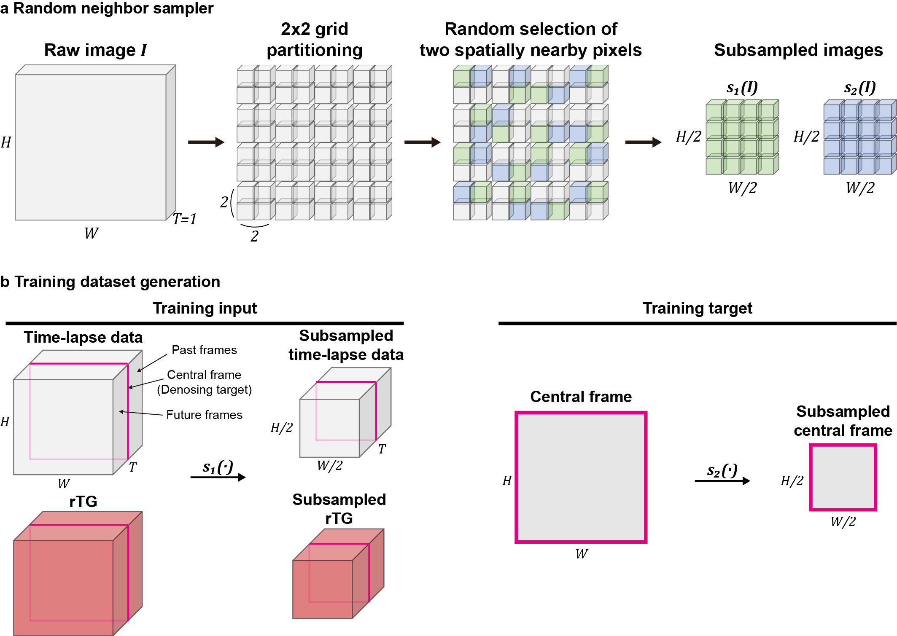
Figure S3: Subsampling strategy for training dataset generation.
a, Schematic of neighboring subsamplers employed to generate training data pairs. Each two-dimensional spatial domain image with a size of $H$ and $W$ was initially partitioned into 2$×$2 grids. Subsequently, two pixels were randomly selected from each 2$×$2 grid that were spatially adjacent, designating one as $s_{1}(∙)$ and the other as $s_{2}(∙)$. The data corresponding to $s_{1}(∙)$ and $s_{2}(∙)$ were used as input and target for training, respectively. This subsampling strategy ensures that the noise characteristics are conditionally independent while preserving the homogeneity of overall morphology in the original signal [3-6]. b, Training dataset generation. Since TeD is designed to denoise the central frame by utilizing past and future frames, there is a mismatch in the temporal dimension size between the input and the target. Therefore, $s_{1}(∙)$ was applied to every temporal channel in both the noisy image and the rTG, while $s_{2}(∙)$ was solely applied to the central frame of the noisy image.
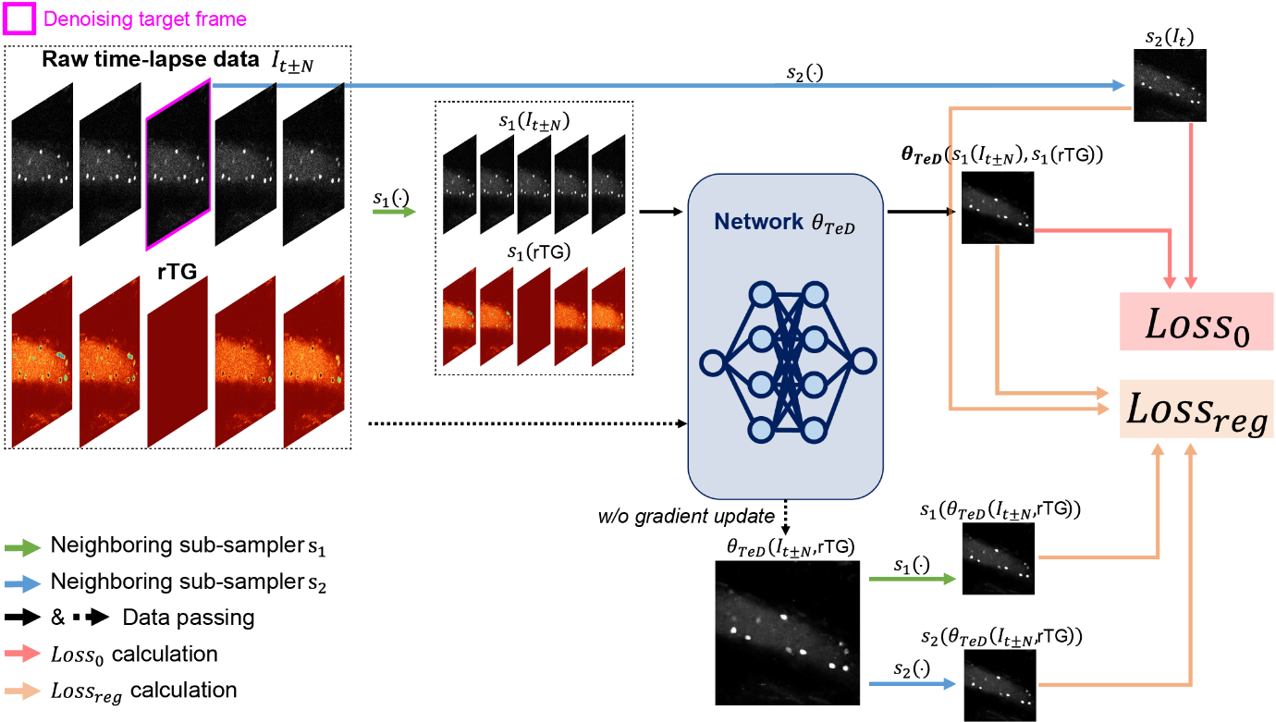
Figure S4: Training overview.
Self-supervised training strategy to optimize TeD. For training, we configured the input and target datasets using the subsampler, as described in Supplementary Fig.3, and calculated the loss by comparing TeD's output from the input with the corresponding target (${Loss}_{0}$). To further improve TeD's ability to learn the denoising mapping from noisy pairs more efficiently, we introduced a regularization loss term (${Loss}_{reg}$). The original, unsubsampled data was fed into TeD to estimate ${Loss}_{reg}$. Here, ${Loss}_{reg}$ was calculated with gradient computation interrupted during training process, allowing it to serve as a compensating factor for discrepancies that can arise due to variations in signal homogeneity in self-supervised denoising [3]. To finally obtain ${Loss}_{reg}$, the output of TeD from the original data was subsequently divided using the same subsampler employed in calculating ${Loss}_{0}$. The numerical definitions of each loss term are provided in the "Methods" section of the main manuscript.

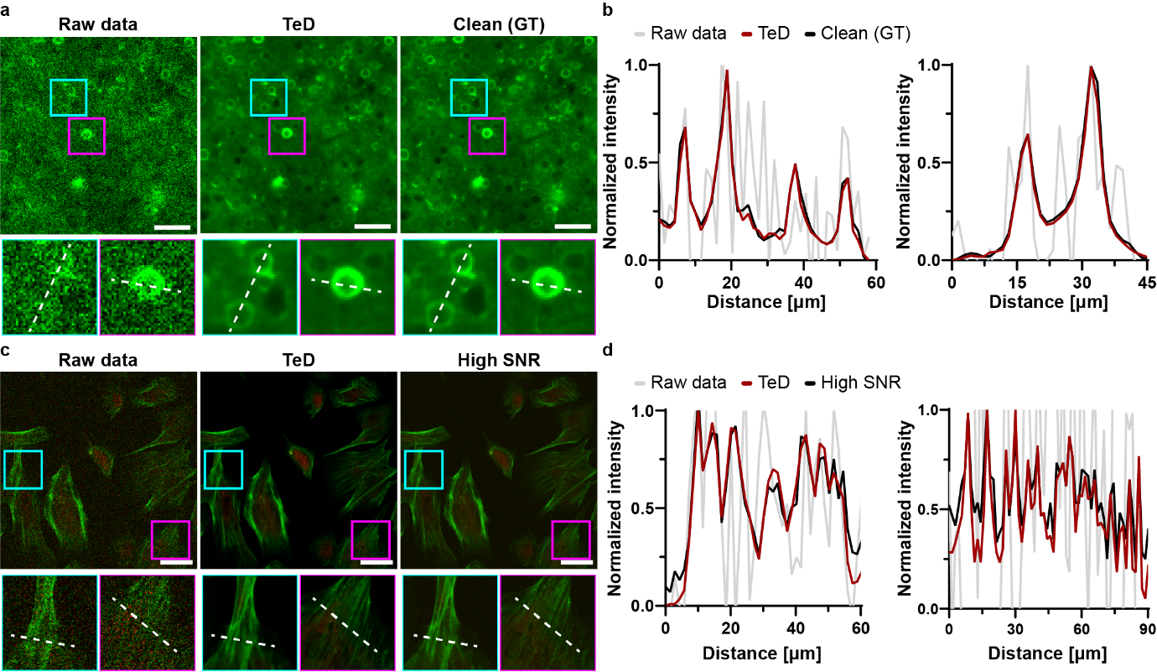
Figure S5: Intensity profile comparison for a spatially static sample.
a, TeD-denoised population calcium imaging data. From left to right: noisy raw data, TeD-denoised result, and ground truth (GT; clean image). ROIs selected from the same location are shown as magnified views (2.7$×$) below each corresponding image. Scale bars, 50 µm. b, Intensity profiles extracted along the dotted line in a. From left to right, the plots show profiles extracted from the cyan box and magenta box, respectively. c, Denoising results for a spatially stationary bovine pulmonary artery endothelial cell. From left to right: noisy raw data, TeD-denoised result, and high SNR images. ROIs selected from the same location are shown as magnified views (2.5$×$) below each corresponding image. Scale bars, 100 µm. d, Intensity profiles extracted along the dotted line in c. From left to right, the plots show profiles extracted from the cyan box and magenta box, respectively.

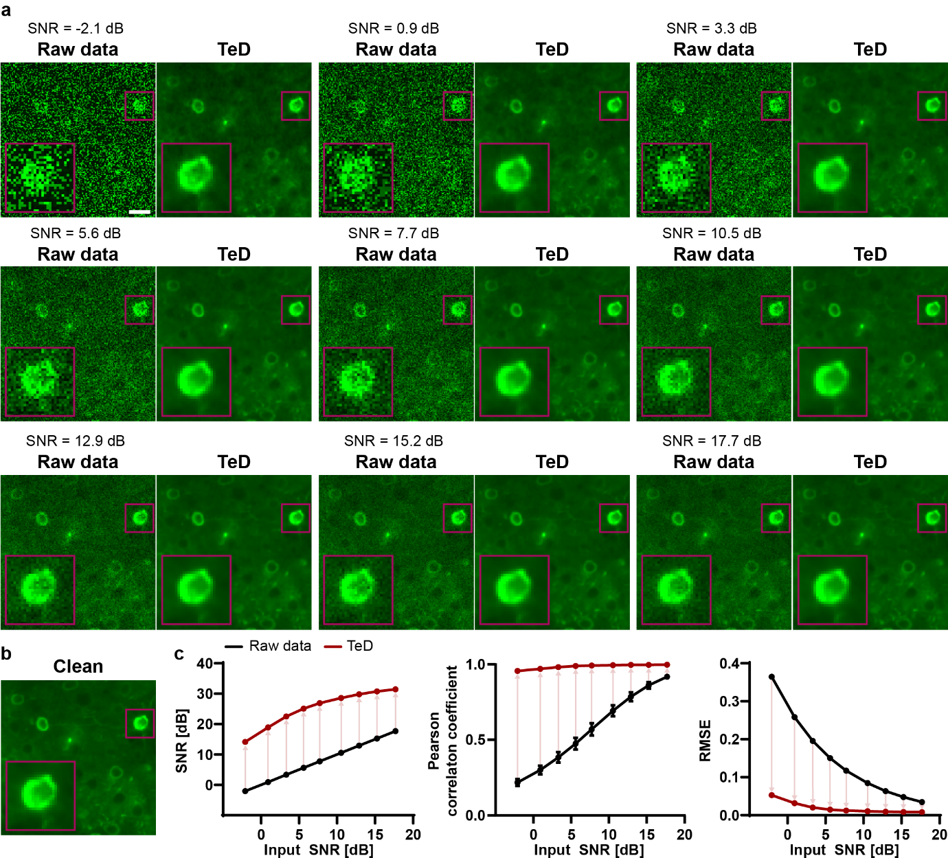
Figure S6: Performance of TeD at different input SNRs.
a, Evaluation of TeD’s denoising performance across varying input SNR scenarios ranging from -2.1 dB to 17.7 dB. The performance of TeD was assessed employing synthetic neuronal imaging data, with a sampling rate of 30 Hz assumed for all data. TeD’s functionality was examined after being trained on a dataset of 684 time-lapse data (each with dimensions of 250 ($T$)$×$300 ($H$)$×$300 ($W$)) with an equal distribution of different SNR levels. The denoised results of TeD (right) corresponding to the raw data (left) are arranged in ascending order of input SNR. Note that all results correspond to the same spatiotemporal location. The magnified view (2.5$×$) of the identical region is provided in the inset at the bottom of each image. Scale bars, 20 µm. b, Clean (ground truth) image corresponding to the same spatiotemporal location. c, Quantitative evaluation results using the clean image as a reference (from left; SNR, Pearson correlation coefficient (R), RMSE). The black line indicates the raw data, while the red line indicates TeD-denoised results. The quantitative analysis reveals that TeD’s outstanding denoising performance is maintained across a wide range of SNR levels. On average, SNR improved by 17.4 dB, R by 0.41, and RMSE decreased by 0.13.
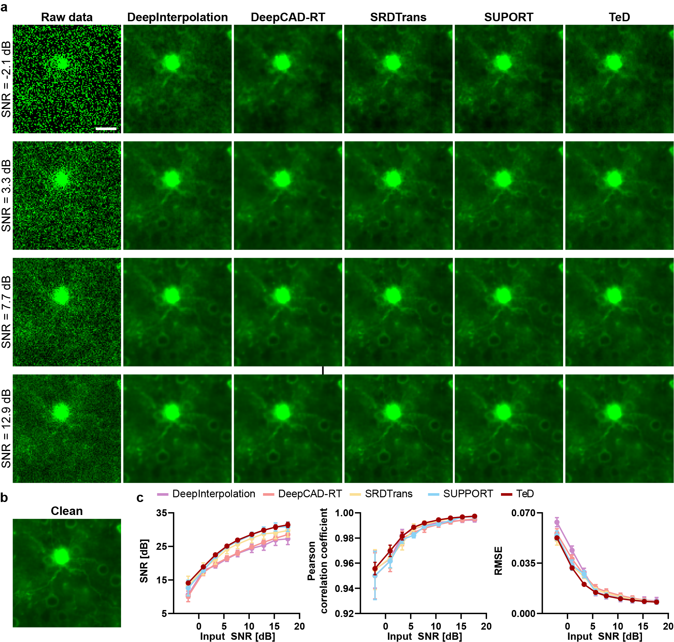
Figure S7: Comparison of TeD’s denoising performance with previous approaches across different input SNR levels.
a, Comparison of denoising performance on inputs with varying noise levels of -2.1 dB, 3.3 dB, 7.7 dB, and 12.9 dB. From left to right: raw data, DeepInterpolation, DeepCAD-RT, SRDTrans, SUPPORT, and TeD. The performance was assessed employing synthetic neuronal imaging data, with a sampling rate of 30 Hz assumed for all data. Each model was trained on the same datasets as in Figure S5. All results correspond to the same spatiotemporal location. Scale bars, 20 μm. b, Clean (ground truth) image corresponding to the same spatiotemporal location. c, Quantitative performance evaluation of each model across different SNR levels. From left to right: SNR, Pearson correlation coefficient, and RMSE. TeD demonstrated robust denoising performance across a wide range of input SNR levels, yielding results comparable to or marginally surpassing those of established methods known for their reliability in similar scenarios.
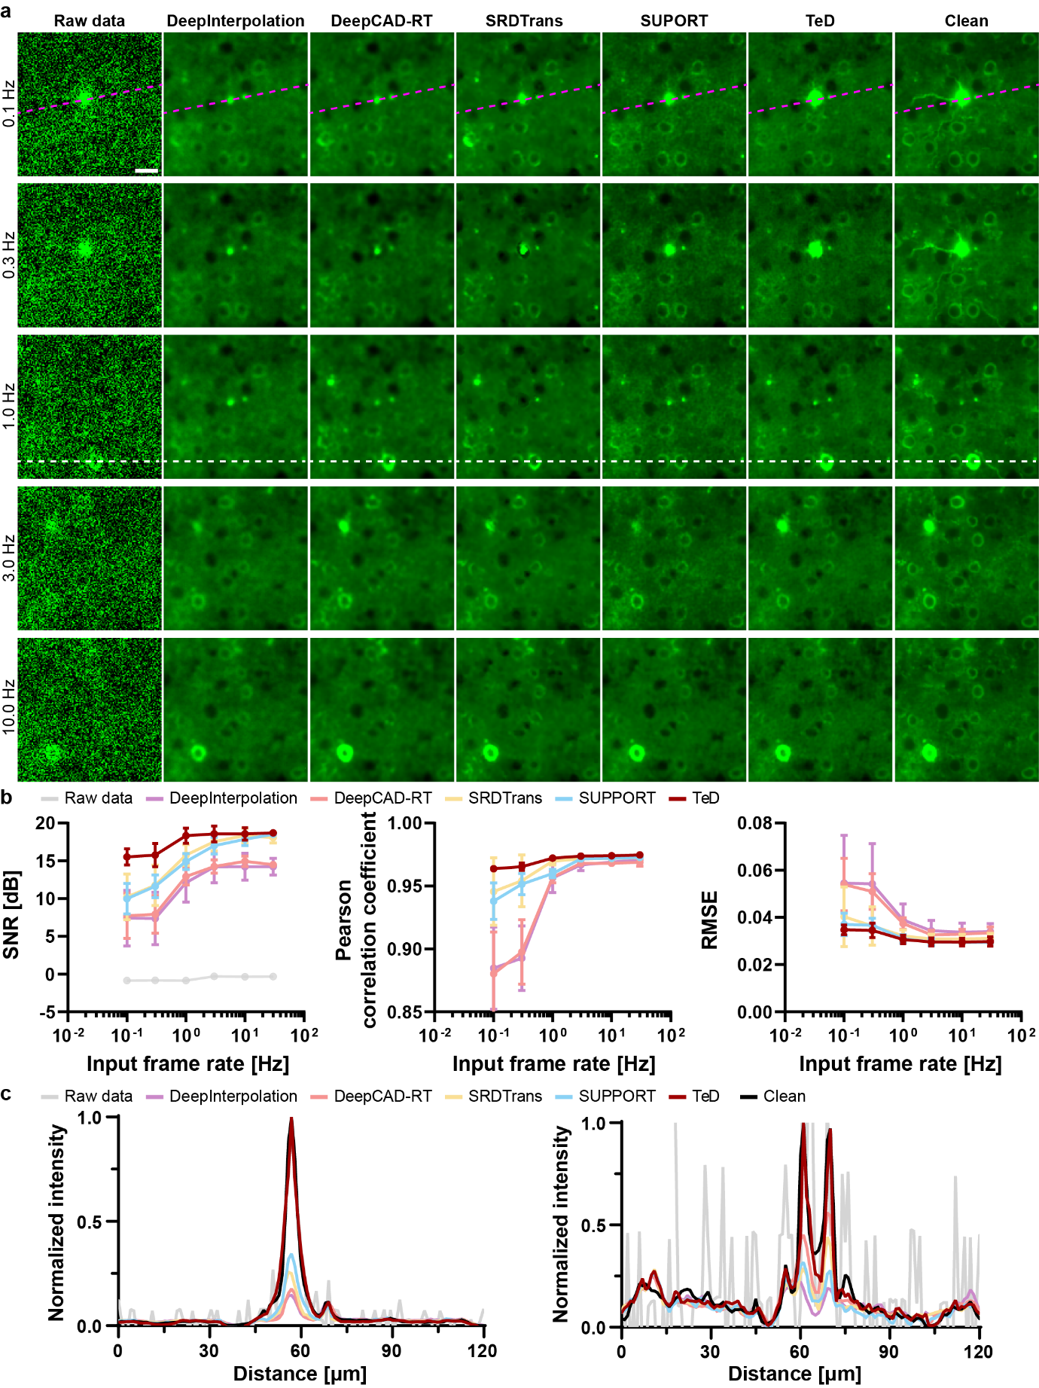
Figure S8: Performance of TeD and previous approaches at different sampling rates.
a, Comparison of denoising performance between TeD and previous approaches at different sampling rates. Results are shown for data sampled at 0.1 Hz, 0.3 Hz, 1.0 Hz, 3.0 Hz, and 10.0 Hz. From left to right: raw data, DeepInterpolation, DeepCAD-RT, SRDTrans, SUPPORT, TeD, and clean (ground truth). Each model was trained using synthetic neuronal data. The training dataset was constructed to ensure an equal distribution of data across all frame rates, consisting of a total of 144 data, each with a size of 250 ($T$)$×$300 ($H$)$×$300 ($W$). Scale bars, 20 μm. b, Quantitative performance evaluation of each model across different sampling rates. From left to right: SNR, Pearson correlation coefficient, and RMSE. Since spiking events exhibit rapid temporal changes, lower frame rates result in degraded similarity between consecutive frames. TeD, which is robust to rapid spatiotemporal dynamics, achieved comparable performance to previous methods at higher sampling rates while delivering superior and more consistent results at lower sampling rates. c, Intensity profile comparisons. Left: profile along the magenta dotted line from the 0.1 Hz result in a. Right: profile along the white dotted line from the 1.0 Hz result in a. Under low sampling conditions, TeD preserve features more closely resembling the clean signal compared to other methods.

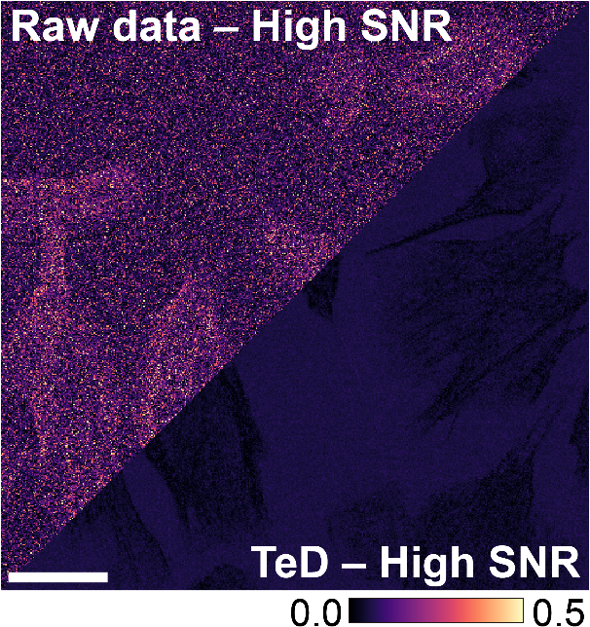
Figure S9: Pixel-wise differences compared to high SNR references.
Visualization of pixel-wise differences relative to high SNR references for the BPAE cell results presented in the main Fig. 3e. The Left shows raw data minus high SNR, while the right shows TeD denoised minus high SNR. Absolute values of the differences are visualized to emphasize pixel-level discrepancies. Scale bars, 100 µm.
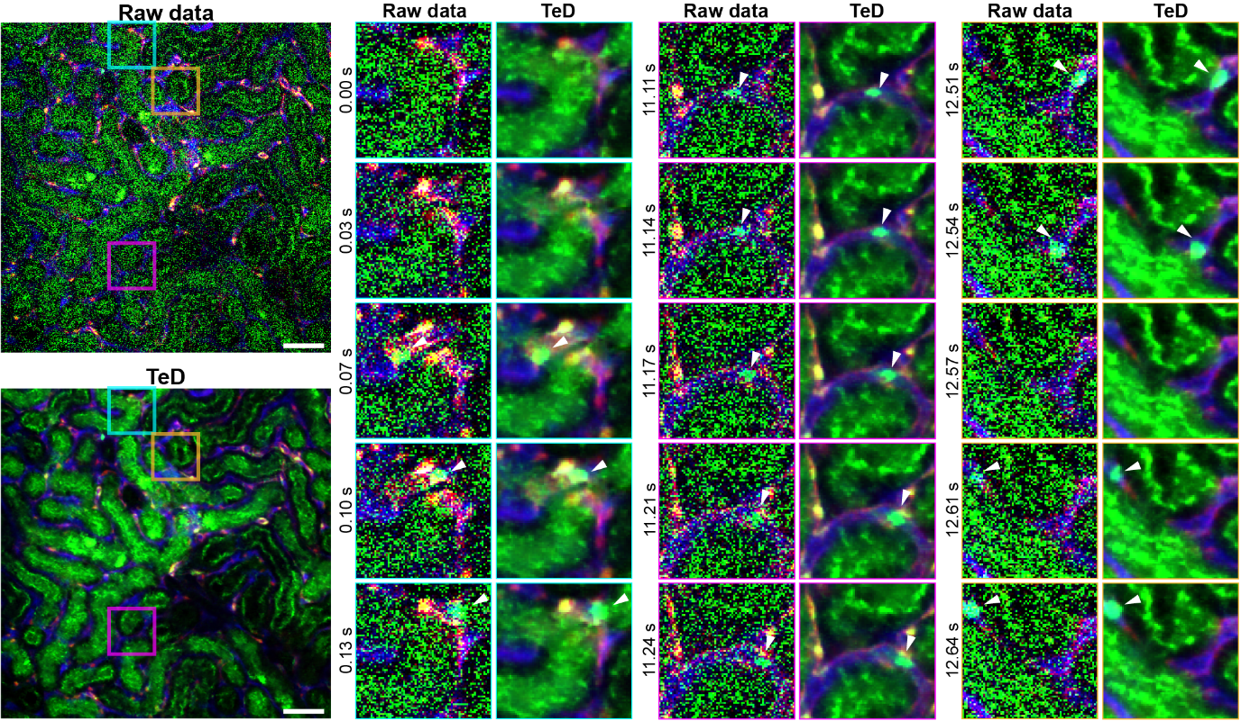
Figure S10: Performance evaluation on intravital fluorescence imaging data exhibiting complex motion patterns.
TeD-denoised intravital imaging data of mouse kidney vasculature (red: CDH5-tdTomato, green: DiO and autofluorescence, blue: Evans blue). Magnified views (3$×$) sequentially show the time-lapse images within the boxed regions in cyan, magenta, and yellow, from left to right. The magnified views of the original image correspond to the frame at 0.00 s. The first magnified view of each colored box starts at a different time point. Each magnified view highlights the complex dynamics of red blood cells. Scale bar, 50 µm.

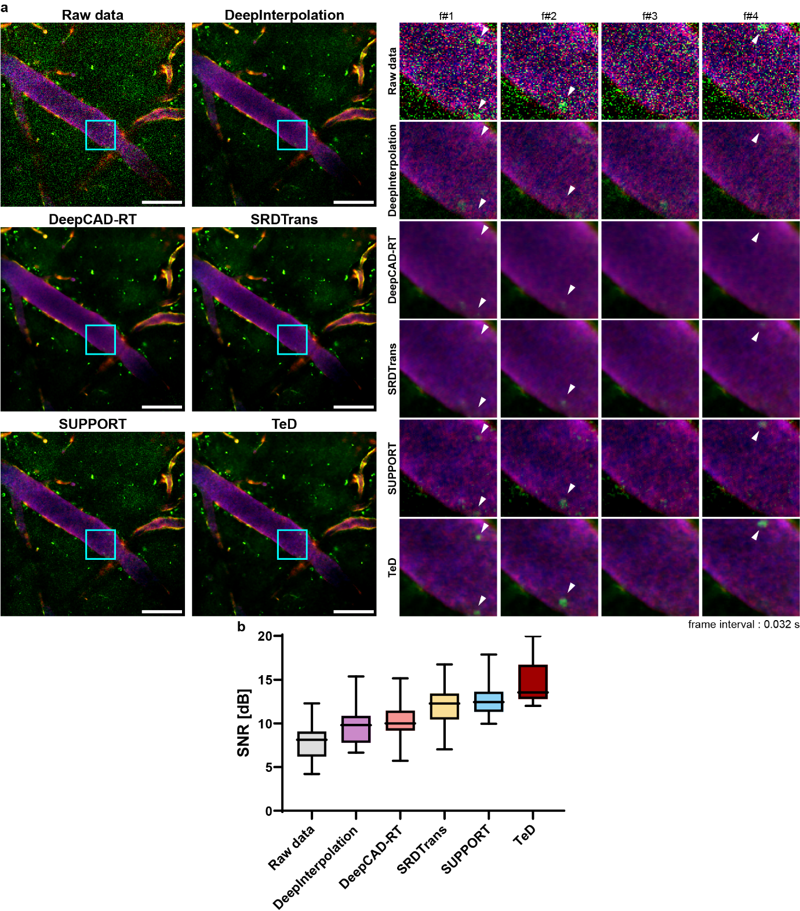
Figure S11: Comparison of denoising performance between previous approaches and TeD in dynamic intravital 2P fluorescence imaging.
a, Comparison of denoising performance of TeD and previous methods on intravital images of the cerebral vasculature in mice (red: CDH5-tdTomato, green: DiO and second harmonic generation, blue: Evans blue). From top left to right: noisy raw data, denoised result by DeepInterpolation, DeepCAD-RT, SRDTrans, SUPPORT, and TeD. The magnified views (3$×$) of the same region in each image display the temporal dynamics of red blood cells (RBCs) in the enclosed area, indicated by cyan box (frame interval, 0.034 seconds). The frame number above each magnified view indicates the relative frame index. The magnified view of the original image corresponds to frame #1. Scale bars, 100 µm. While all approaches achieved desirable results in comparatively static regions, such as the vascular outer wall, TeD demonstrated superior performance in suppressing noise and preserving spatial content in dynamic scenarios, particularly in flowing RBCs (white arrows in magnified views). In contrast to earlier approaches, which produced overly smoothed outcomes due to inadequate temporal redundancy caused by the rapid flow of RBCs, TeD achieved remarkable noise reduction while notably preserving spatial features. b, SNR evaluation for dynamic intravital 2P fluorescence images. SNR was assessed without clean data (see “Methods” section of the main manuscript). The multiple comparison results yielded statistically significant differences in all cases (P<0.0001), except where indicated as non-significant (P>0.9999, denoted by ns), as determined by Dunn’s post hoc tests following a Kruskal-Wallis test (n = 1000 independent frames). Importantly, TeD and other previous methods showed statistically significant differences (P<0.0001).
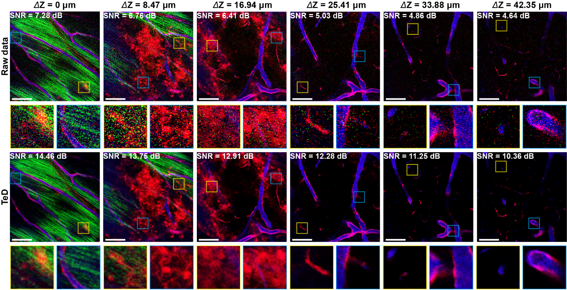
Figure S12: Analysis of TeD’s depth-dependent performance in intravital volumetric imaging of mouse cerebral vasculature.
We analyzed the depth-dependent SNR improvement achieved by TeD in 2P volumetric imaging data. The data were acquired through depth scanning of mouse cerebral vasculature, with the Z-axis regarded as the temporal axis when processed by TeD (red: CDH5-tdTomato, green: DiO and second harmonic generation, blue: Evans blue). Starting from the surface where the brain dura appears, the results show imaging planes at depth intervals of approximately 8 µm. From left to right, the depth-dependent images are arranged with raw data in the top row and TeD-denoised results in the bottom row. The magnified views (4$×$) in each image offer detailed visualization of the regions enclosed by the yellow and cyan boxes for each result. The SNR, evaluated without clean data, is denoted in each image’s upper left corner. To prevent biased SNR evaluation, ROIs containing signals were manually selected for calculation (see “Methods” section of the main manuscript). On average, TeD improved the SNR by 6.67 dB. Scale bars, 100 µm.

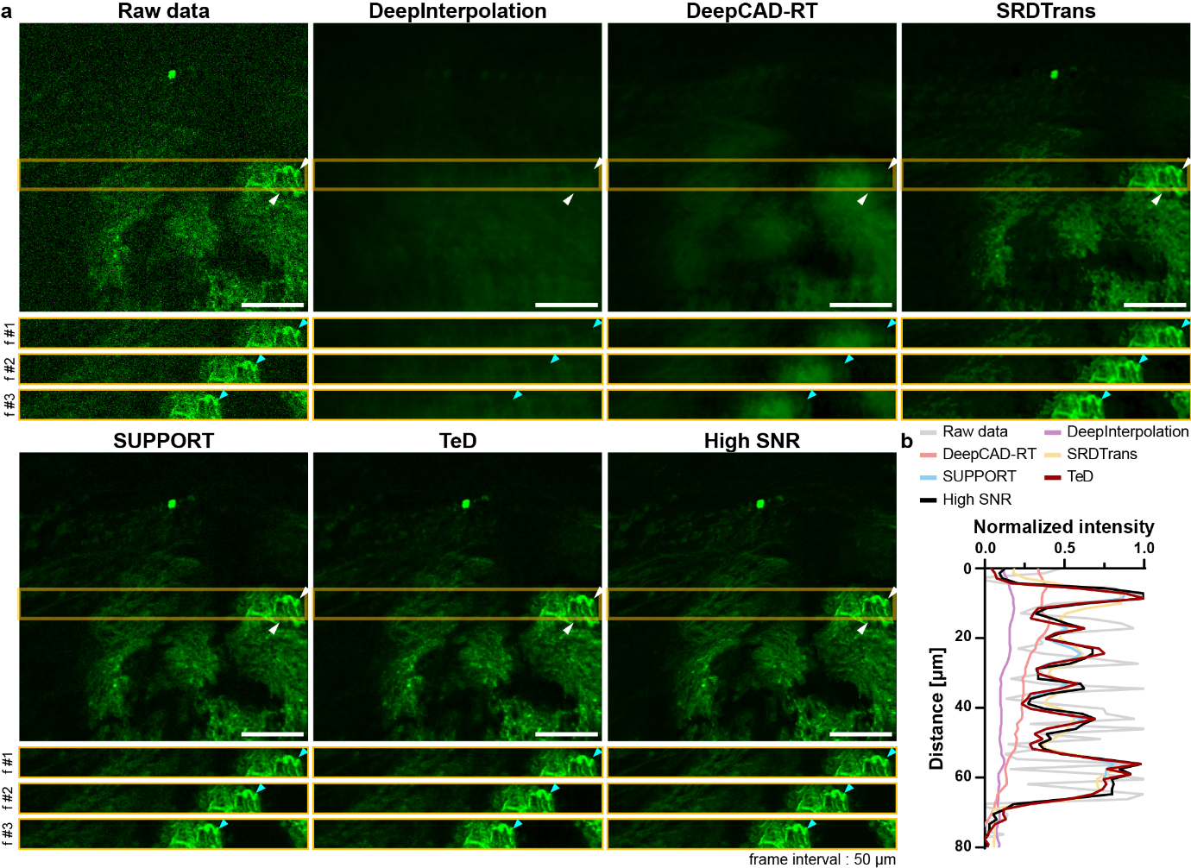
Figure S13: Comparison of the denoising capabilities of TeD and previous methods in 2P fluorescence microscopy images of human thyroid sections.
a, Comparison of denoising performance of TeD and previous approaches on human thyroid section image. We compared the denoising performance of TeD and previous methods on human thyroid section imaging with synthetic dynamics introduced via a linearized motorized stage (35 steps, 50 µm translation per step). From top left to right: raw data, DeepInterpolation, DeepCAD-RT, SRDTrans, SUPPORT, TeD, and High SNR. 15 successive frames were obtained at the same location to provide the time-lapse data, and the movement of the sample was simulated employing a linear motorized stage. The raw data consisted of one frame, while the high SNR reference was calculated as the average of all the 15 frames. In this setup, the macroscopic spatial dynamics of the sample were simulated across the entire imaging region. The ROIs of the boxed area below each image highlight the temporal variation at the corresponding regions. Scale bars, 100 µm. Methods relying on omitted frame prediction, such as DeepInterpolation and DeepCAD-RT, performed inadequately on this dataset, where substantial spatial translations disrupted temporal redundancy. On the other hand, fine structures obscured in the raw data of a single frame were restored to a level comparable to the high-SNR references after TeD-based denoising. Notably, despite the macroscopic spatial displacement of the sample, spatial features were preserved without distortion, as indicated by the cyan arrowheads in the ROIs. b, Intensity profiles between the white arrows in a. TeD successfully preserved macroscopic spatial features with greater sharpness than other methods, achieving a quality comparable to the high SNR reference.

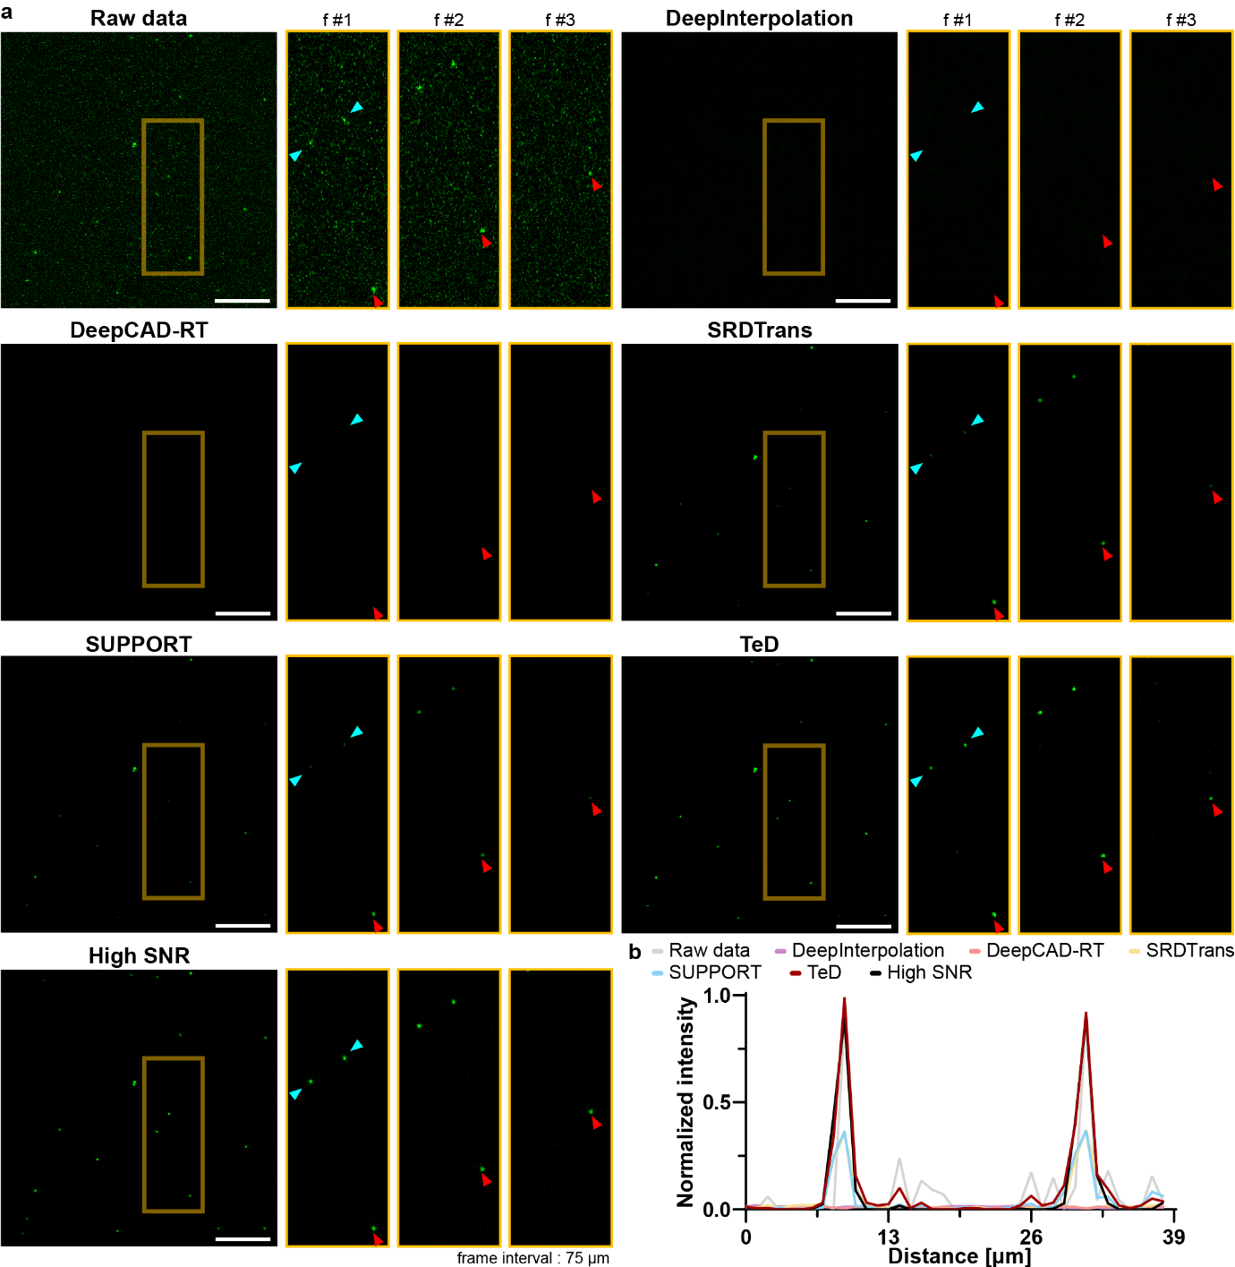
Figure S14: Comparison of the denoising capabilities of TeD and previous methods in 2P fluorescence microscopy images of microspheres.
a, Comparison of denoising performance of TeD and previous approaches on 4 µm-sized microsphere sample. We compared the denoising performance of TeD and previous methods on 4 µm-sized microsphere samples with synthetic dynamics introduced via a linearized motorized stage (100 steps, 50 µm translation per step). From top left to right: raw data, DeepInterpolation, DeepCAD-RT, SRDTrans, SUPPORT, TeD, and high SNR. The image acquisition conditions were identical to those described in Figure S13. The simulated dynamics of this sample introduced microscopic spatial dynamics into the time-lapse data. The magnified ROIs (2$×$) of the boxed areas on the right of each image highlight the temporal variation at the corresponding regions. Scale bars, 100 µm. Previous methods produced excessively smoothed outcomes in the microsphere data, where attainable spatiotemporal redundancy was hindered by microscopic dynamics. In contrast, TeD outperformed the others by achieving sharper denoising results (red arrowheads in the magnified views). b, Intensity profiles between the cyan arrows in a. TeD successfully preserved microscopic spatial features, which were over-smoothed by other methods due to severe noise and insufficient spatiotemporal redundancy, achieving a quality comparable to the high SNR reference.

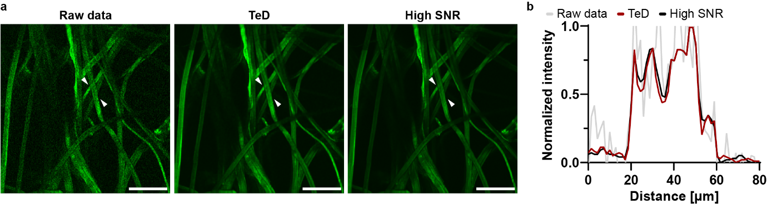
Figure S15: Intensity profile comparison based on a lens paper image acquired using 2P fluorescence microscopy.
a, TeD-denoised lens paper imaging data. b, Intensity profiles between the white arrows in a. All scale bars are 100 µm.

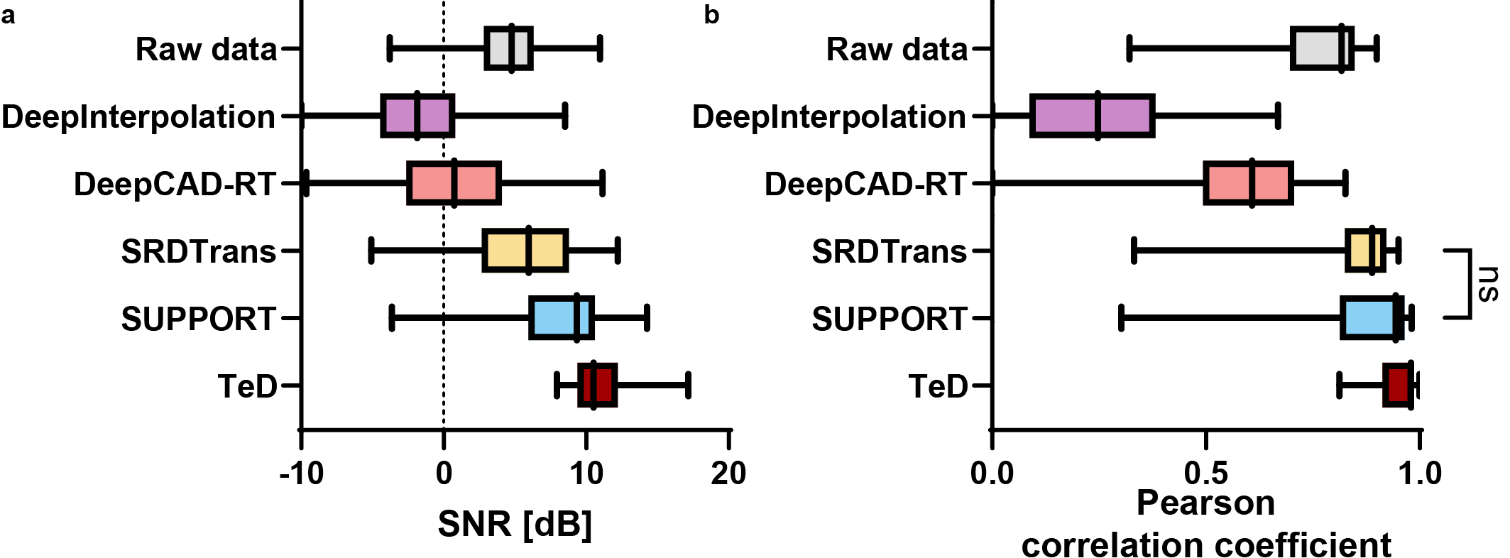
Figure S16: Quantitative evaluation results of TeD and previous methods on 2P fluorescence microscopy images using frame-averaged high SNR images.
a SNR and b Pearson correlation coefficient (R) evaluation results for 2P fluorescence microscopy images with simulated dynamic and stationary data. The raw data and denoised results from each model were analyzed based on the high SNR reference images. The multiple comparison results yielded statistically significant differences in all cases (P<0.0001), except where specified otherwise (P>0.9999, denoted by ns), as determined by Dunn’s post hoc tests following a Kruskal-Wallis test (n = 1000 independent frames). Importantly, TeD and other previous approaches showed statistically significant differences (P<0.0001). TeD outperformed other methods by achieving an SNR of 11.0 dB, compared to 3.9 dB in the raw data. In contrast, DeepInterpolation, DeepCAD-RT, SRDTrans, and SUPPORT recorded SNR values of -1.6 dB, 0.7 dB, 5.3 dB, and 7.2 dB, respectively. Additionally, TeD achieved an R of 0.95, significantly improving upon the 0.76 correlation observed in noisy data and demonstrating substantial similarity to the high-SNR reference. In comparison, methods DeepInterpolation, DeepCAD-RT, SRDTrans, and SUPPORT recorded R of 0.25, 0.52, 0.85, and 0.87, respectively.

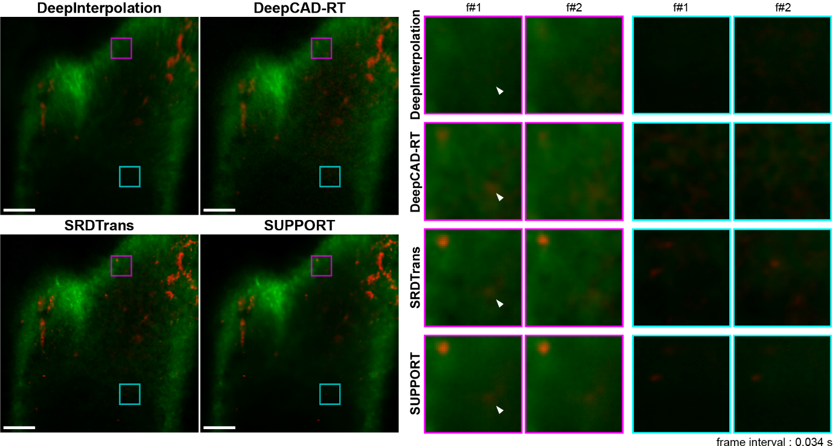
Figure S17: Comparative study on denoising performance over temporal gradients.
a, Comparison of TeD’s denoising performance with and without temporal gradient (TG) against previous methods. These results were obtained from the same time-lapse data as Fig.6 in the main manuscript. From top left to right: DeepInterpolation, DeepCAD-RT, SRDTrans, and SUPPORT. The magnified view (4$×$) of the enclosed region in each image highlights the temporal dynamics at the corresponding location (frame interval: 0.034 seconds). The frame number above each magnified view indicates the relative frame index. The magnified view of the original image corresponds to frame #1. Scale bars, 100 µm.

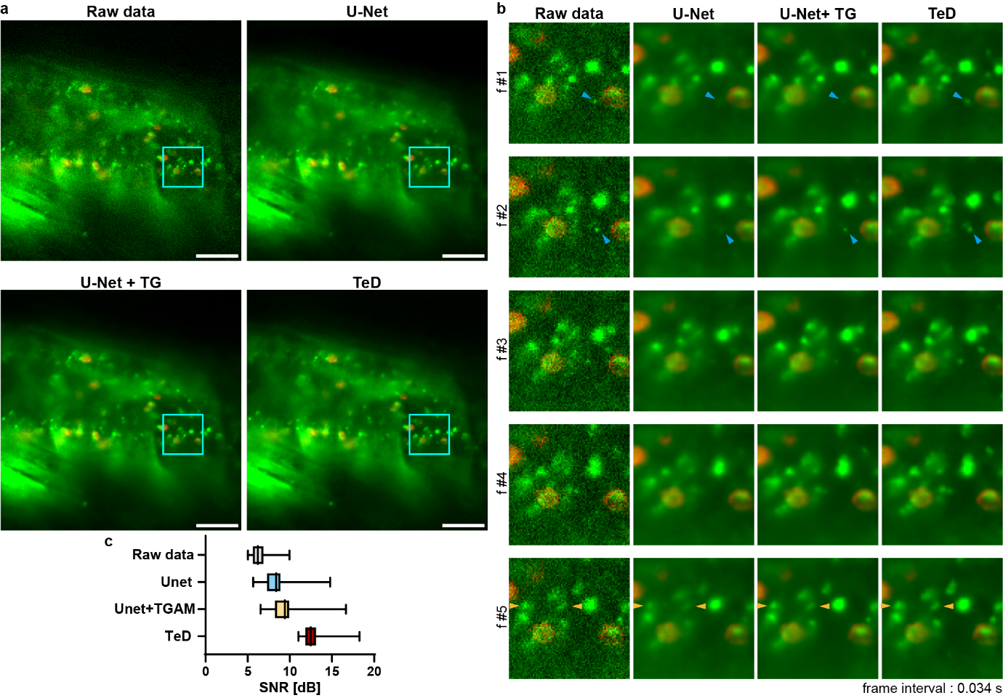
Figure S18: Validation of performance improvements in U-Net via TG.
a, Evaluation of improvements in denoising performance for U-Net-based models on in vivo venule images in the cremaster muscles (red, CD11b-Alex Fluor 647; green, rhodamine 6G). From top left to bottom right: raw data, vanilla U-Net, U-Net leveraging TG (U-Net+TG), and TeD. Both U-Net and U-Net+TG were used to denoise the central frame utilizing time-lapse data consisting of 41 frames. Detailed implementation is provided in Fig.S25. Scale bars, 100 µm. b, Magnified views (3$×$) showing the temporal variations in the boxed area (frame interval, 0.034 seconds). Rapidly fluctuating cells appear oversmoothed in the U-Net results. In contrast, U-Net+TG demonstrates better feature preservation, although slightly less effective than TeD. The cell features, pointed by the blue arrowhead, highlight these differences. c, SNR evaluation for dynamic in vivo fluorescence images. Quantitative analysis was performed using in vivo vascular images of mice, with SNR evaluated without clean data. Statistically significant differences were observed between U-Net and U-Net+TG, with TeD showing statistically significant improvements over both models (P<0.0001). The multiple comparison results yielded statistically significant differences in all cases (P<0.0001), except where indicated as non-significant (P>0.9999, denoted by ns), as determined by Dunn’s post hoc tests following a Kruskal-Wallis test (n = 513 independent frames).

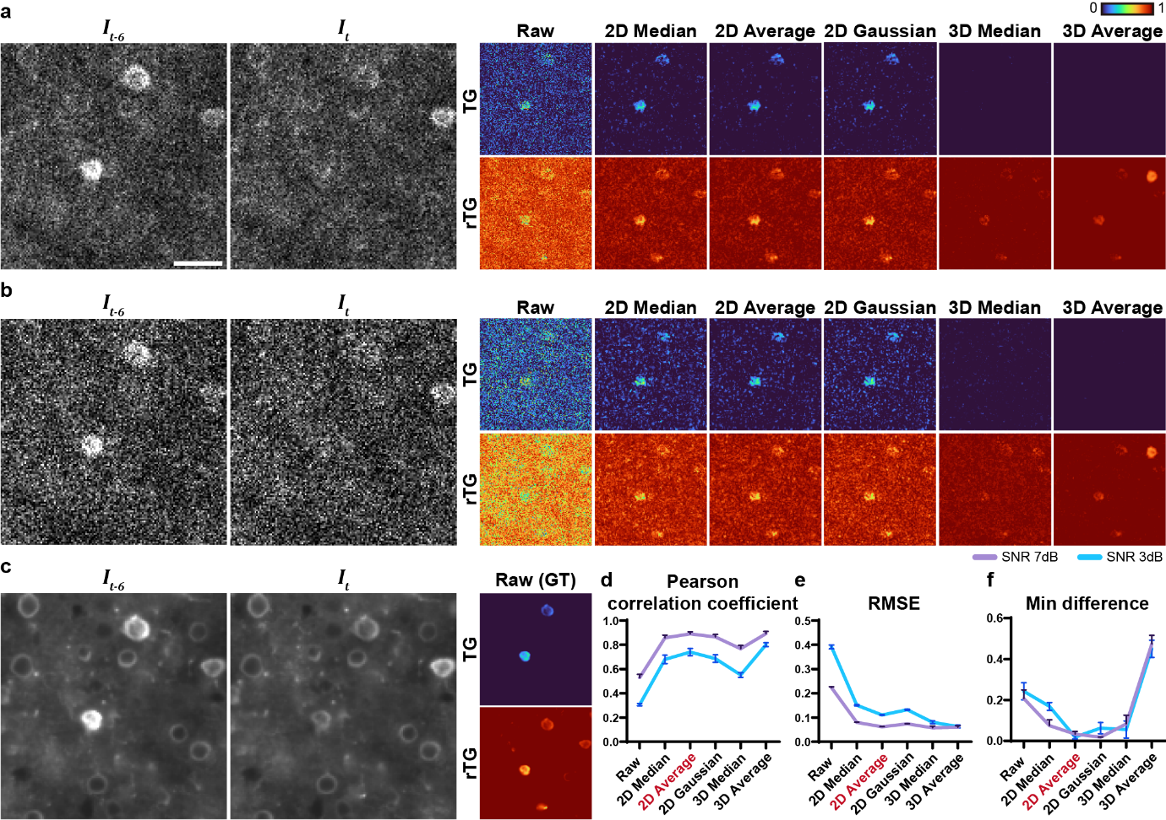
Figure S19: Exploration of temporal gradient computation outcomes derived from various image preprocessing methods.
We explored filtering methods to be applied to all image frames before temporal gradient (TG) calculation in order to reduce noise-induced fluctuations without incurring excessive computational costs. To quantify the deviation of TG calculated after filtering from the reference TG, we utilized synthetic neuronal data. Although this dataset does not contain spatial dynamics, it includes temporal kinetics, such as spikes, which can still be captured through TG defined by pixel-wise differences. More importantly, the availability of noise-free clean data allowed us to obtain the reference TG for accurate comparison. For comparison with the reference, noisy data with SNR levels of a 3 dB and b 7 dB were employed. Next to each image, the TG and redundant TG (rTG) obtained from unfiltered raw data (denoted as raw), as well as those acquired after applying five pre-selected filtering methods (2D median, 2D average, 2D gaussian, 3D median, and 3D average) are presented. The kernel size for all filters was fixed at 3 to prevent excessive loss of spatial feature information. For the Gaussian filter, the sigma value was set to 0.8. The corresponding clean image, along with the reference TG and rTG, is presented in c. Each calculated rTG is quantitatively compared to the reference rTG using the following metrics: d Pearson correlation coefficient, e RMSE, and f min difference. The min difference is the disparity between the least value of the reference rTG and that of the rTG provided by each filtering. TeD operates by assigning lower weights to temporal information in regions with dynamic changes through rTG. Therefore, ensuring that the minimum rTG value—representing the weight reduction due to dynamics—is not distorted is crucial. This was evaluated through quantitative comparison of the minimum difference. As a result, 3D average filtering minimized overall discrepancies from the reference caused by noise, as evidenced by the highest and lowest values in d and e, respectively. However, due to the considerable smoothing introduced by this filtering, it was less effective at accurately reflecting weight variations caused by dynamic changes (highest value in f). Consequently, we established that 2D average filtering was employed as the preprocessing method, as it successfully reduces noise-induced discrepancies while having minimal impact on the minimum rTG value. This was supported by its second-highest value in d (following the 3D average) and the lowest value in f. Scale bars, 30 µm.

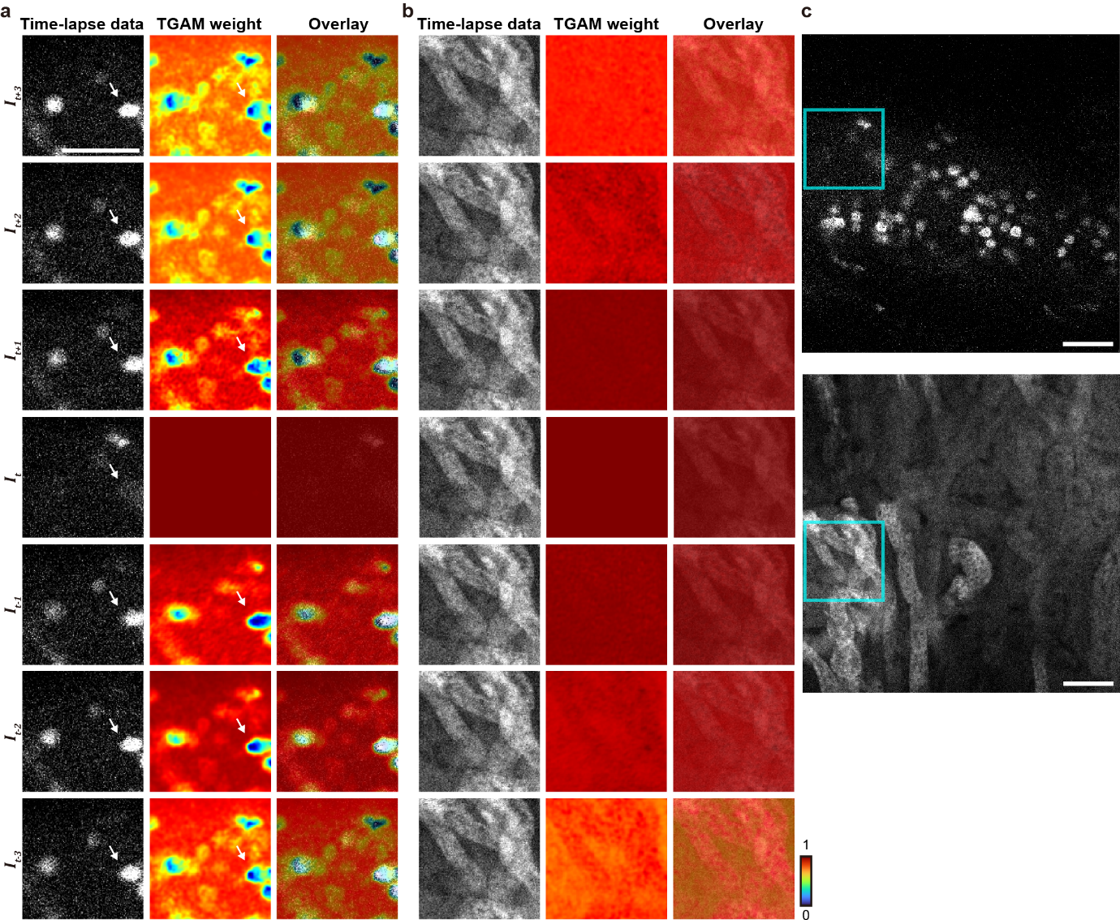
Figure S20: Visualization of TGAM weighting values.
Visualizations of TGAM weights for both a spatially dynamic and b stationary samples. The TGAM weights were extracted after processing the rTG values through two convolutional layers followed by a sigmoid activation. For each case, the original image, TGAM weight map, and their overlay are displayed in sequence. In both a and b, the middle row shows the denoising target (central frame), and sequential frames along the temporal axis are arranged vertically. In a, white arrowheads indicate a region exhibiting dynamic motion induced by cardiac movement, where TGAM adaptively assigns lower weights. Conversely, in b, representing a static sample, the attention weights remain relatively consistent across frames, indicating greater reliance on temporal information. These results provide supporting evidence that the weighting values are adaptively modulated according to the sample’s intrinsic dynamics. c, Original images corresponding to the regions shown in a (top) and b (bottom). Scale bars, 100 µm.
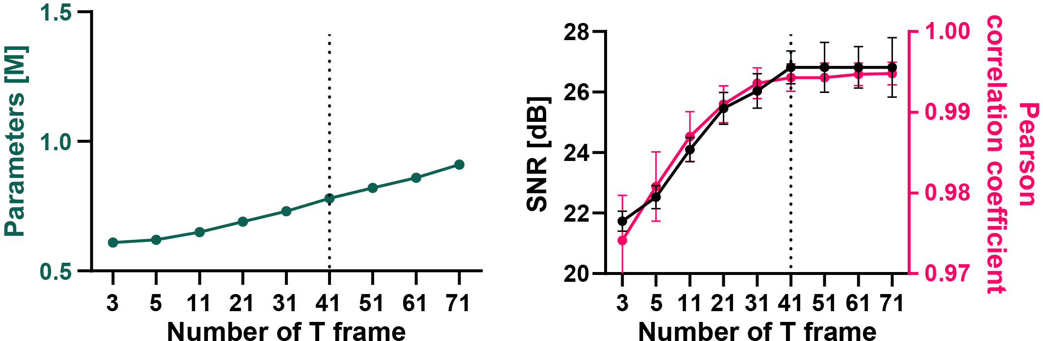
Figure S21: Optimization analysis for determining the input temporal frames of TeD.
To determine the optimal number of temporal frames for TeD's input, we conducted a quantitative performance evaluation using synthetic neuronal data (1000 frames, 30 Hz frame rate, SNR = 7 dB). Since TeD leverages both past and future temporal frames to denoise the center frame, the model was trained and assessed using various odd numbers of temporal frames. The left plot shows the relationship between the number of temporal frames (T) and the total number of model parameters, while the right plot displays the evaluation results for SNR (left y-axis) and the Pearson correlation coefficient (right y-axis) across different T numbers. Based on these findings, 41 temporal frames were identified as the optimal input, providing a balance between computational efficiency and stable denoising performance. The black dotted line indicates the selected number of T.

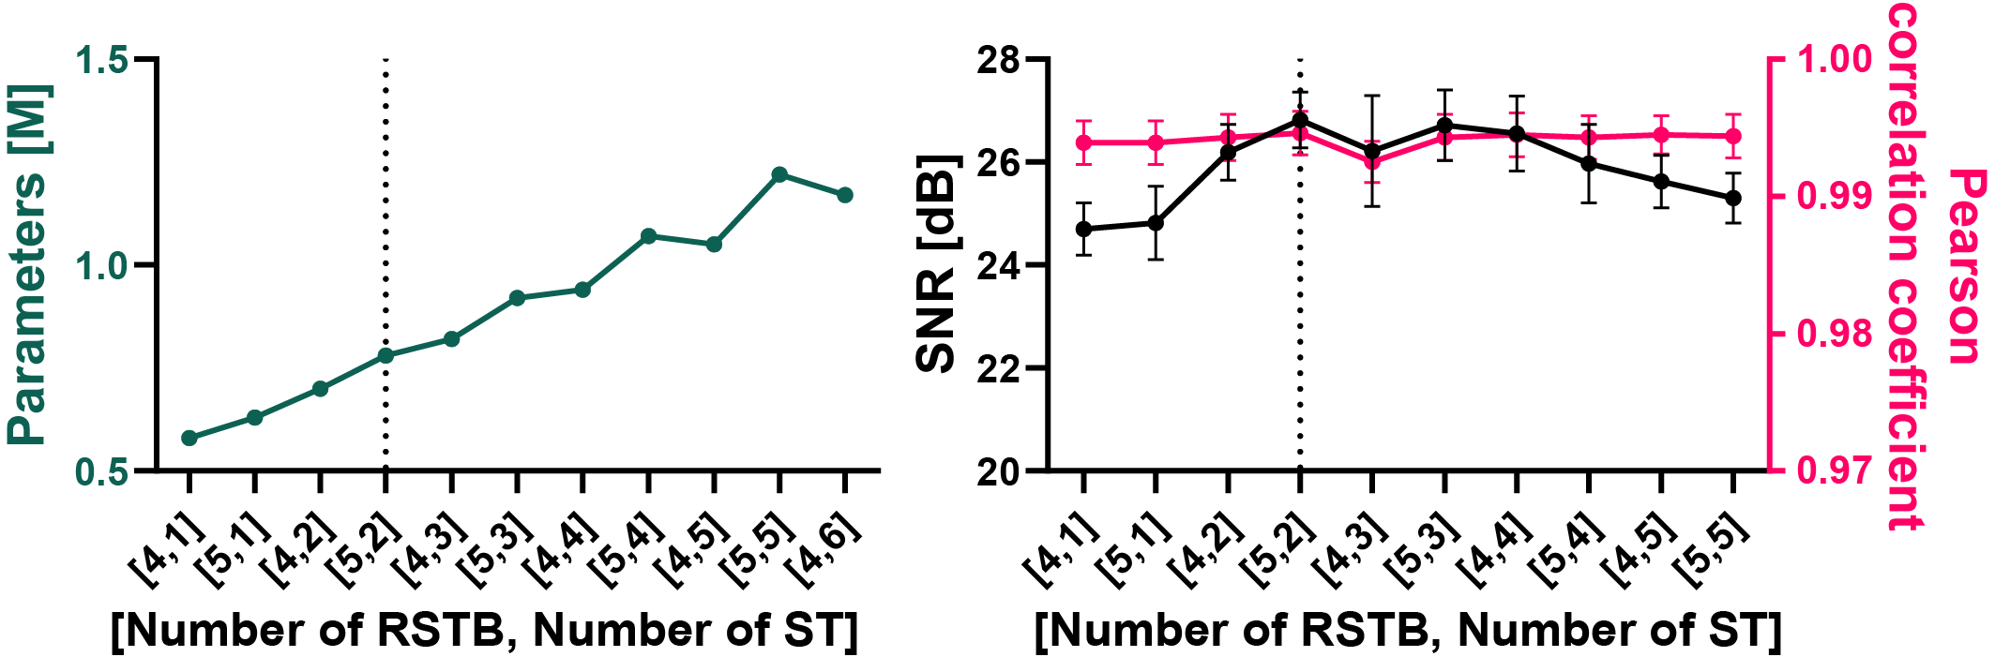
Figure S22: Ablation study for optimizing the DFE architecture of TeD.
A quantitative performance evaluation was conducted using synthetic neuronal data (1000 frames, 30 Hz frame rate, SNR = 7 dB) to optimize the deep feature extractor (DFE) architecture of TeD. The DFE was designed based on the Swin Transformer (ST) to effectively capture high-level features associated with non-local and long-range dependencies. However, an optimization procedure was carried out to achieve a balance between computational cost and denoising performance because ST has higher processing demands than convolutional layers. To determine the optimal configuration, a grid search was performed by varying the number of STs per residual ST block (RSTB) and the overall number of RSTBs, as the DFE consists of multiple RSTBs, each comprising several STs. Each configuration was trained independently, and its performance was subsequently evaluated. The left figure illustrates the relationship between the total number of model parameters for each configuration, while the right figure shows the evaluation results for SNR (left y-axis) and the Pearson correlation coefficient (right y-axis). In the X-axis labels, the number on the left represents the count of RSTBs, whereas the number on the right denotes the count of STs. Based on these results, a structure comprising five RSTBs, each containing two STs, was selected to achieve an optimal trade-off between computational efficiency and stable denoising performance. Consequently, TeD contains a total of 0.78M parameters, representing only 6% of the 11.8M parameters in the previous backbone model [2]. The black dotted line indicates the selected configuration.

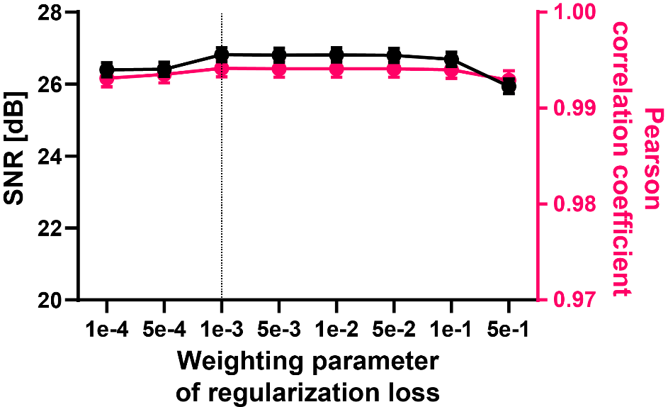
Figure S23: Optimization study for determining the weighting parameter of the regularization loss.
To account for potential inconsistencies between noisy data pairs during the self-supervised denoising training process, we introduced the regularization loss ($L_{reg}$) as an additional correction factor in the loss function. This loss was incorporated into the original loss function by applying a weighting parameter ($γ$). The detailed numerical definitions of each loss term are provided in the "Methods" section of the main manuscript. To find the ideal setting, an optimization study was performed by adjusting the weighting parameter's value because it can have varying influences on TeD's performance. A quantitative performance evaluation was conducted using synthetic neuronal data (1000 frames, 30 Hz frame rate, SNR = 7 dB). Each model, trained with different weighting parameters, was independently trained and subsequently evaluated for performance. Through this study, the weighting parameter of ${10}^{-3}$ was identified as the optimal value for maximizing TeD’s performance. The black dotted line indicates the selected weighting parameter.

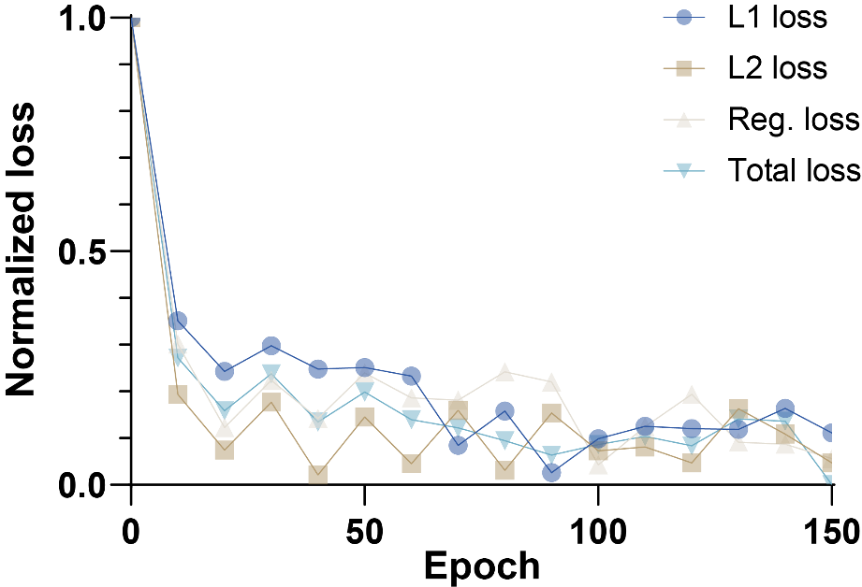
Figure S24: Training loss curve.
This plot shows the curve of each loss (L1 loss, L2 loss, regularization loss, and total loss) over epochs as TeD was trained. Here, the sum of L1 and L2 equals ${Loss}_{0}$. Every plot was displayed on a scale of 0 to 1. As the model was trained across 150 epochs, each loss value converged.
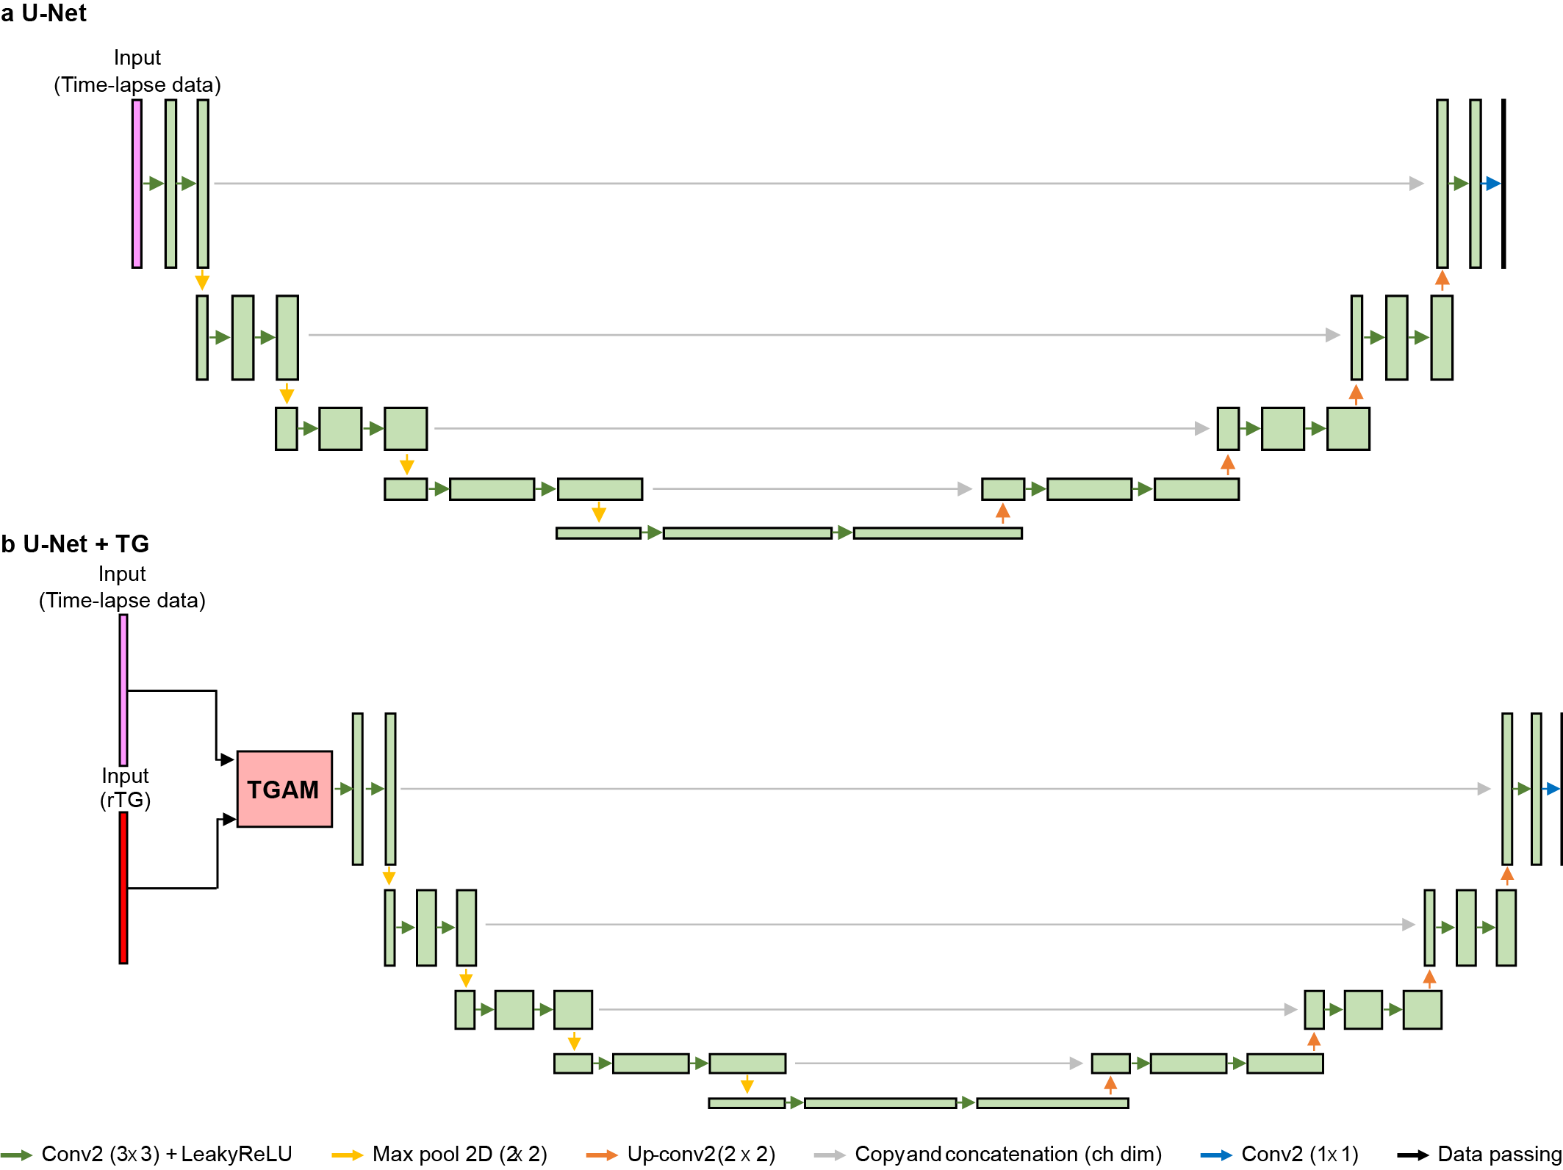
Figure S25: U-Net architectures for performance comparison across TGs.
The U-net architecture employed in Fig.S18 is presented; a, vanilla U-Net [7], b, U-Net incorporated with TG (U-Net+TG). The U-Net in both a and b encodes the input image into multi-scale features, which are subsequently decoded to the original scale, leveraging a U-shaped structure based on a 2D convolutional layers. In our implementation, the 41-channel input (representing the temporal dimension) was encoded by expanding the channel dimensions to [32, 64, 128, 256, 512], with the decoding process in reverse order. To produce the final channel dimension to 1, an additional 1×1 convolutional layer is included at the end of the network. All layers, except the final layer, utilize LeakyReLU activation, omitting batch normalization. In b, the overall architecture remains unchanged compared to the vanilla U-Net; however TGAM from TeD's TFE is integrated at the head of the network. The loss function and training data remain consistent with the implementation used for TeD, and the model is trained over 300 epochs.
Table S1: Comparison of total parameter numbers with previous studies
 | Total parameters [M] | Architecture
DeepInterpolation [8] | 15.70 | CNN-based
DeepCAD-RT [9] | 1.02 | CNN-based
SRDTrans [6] | 1.79 | ViT-based
SUPPORT [10] | 1.37 | CNN-based
TeD | 0.78 | ViT-based

Supplementary Videos

Supplementary Movie S1: TeD-denoised results for in vivo venule images in the cremaster muscles of mice. The intravital imaging was performed at a frame rate of 29.2 Hz, but the video is displayed at 10 Hz to provide more detailed visualization.

Supplementary Movie S2: Comparison of the denoising performance between TeD and previous methods on in vivo venule images from cremaster muscles of mice.

Supplementary Movie S3: TeD-denoised results for in vivo venule images of atherosclerotic regions in the carotid artery, representing heartbeat induced macroscopic spatial dynamics.

Supplementary Movie S4: TeD-denoised results for synthetic population calcium imaging data, showing the temporal kinetics of the fluorescence signal. The image was synthesized at a frame rate of 30 Hz, and the video is displayed at the same rate.

Supplementary Movie S5: TeD-denoised results of intravital imaging of mouse kidney vasculature.

Supplementary Movie S6: TeD-denoised results of intravital imaging of mouse cerebral vasculature.

Supplementary Movie S7: Denoising outcomes of TeD on in vivo venule images from the cremaster muscles of mice.

References
1. Liu Z, Lin Y, Cao Y, Hu H, Wei Y, Zhang Z, et al. Swin transformer: Hierarchical vision transformer using shifted windows. Proceedings of the IEEE/CVF international conference on computer vision2021. p. 10012-22.
2. Liang J, Cao J, Sun G, Zhang K, Van Gool L, Timofte R. Swinir: Image restoration using swin transformer. Proceedings of the IEEE/CVF international conference on computer vision2021. p. 1833-44.
3. Huang T, Li S, Jia X, Lu H, Liu J. Neighbor2neighbor: Self-supervised denoising from single noisy images. Proceedings of the IEEE/CVF conference on computer vision and pattern recognition2021. p. 14781-90.
4. Qu L, Zhao S, Huang Y, Ye X, Wang K, Liu Y, et al. Self-inspired learning for denoising live-cell super-resolution microscopy. Nature Methods. 2024;21(10):1895-908.
5. Lequyer J, Philip R, Sharma A, Hsu W-H, Pelletier L. A fast blind zero-shot denoiser. Nature Machine Intelligence. 2022;4(11):953-63.
6. Li X, Hu X, Chen X, Fan J, Zhao Z, Wu J, et al. Spatial redundancy transformer for self-supervised fluorescence image denoising. Nature Computational Science. 2023;3(12):1067-80.
7. Ronneberger O, Fischer P, Brox T. U-net: Convolutional networks for biomedical image segmentation. Medical image computing and computer-assisted intervention–MICCAI 2015: 18th international conference, Munich, Germany, October 5-9, 2015, proceedings, part III 18: Springer; 2015. p. 234-41.
8. Lecoq J, Oliver M, Siegle JH, Orlova N, Ledochowitsch P, Koch C. Removing independent noise in systems neuroscience data using DeepInterpolation. Nature methods. 2021;18(11):1401-8.
9. Li X, Li Y, Zhou Y, Wu J, Zhao Z, Fan J, et al. Real-time denoising enables high-sensitivity fluorescence time-lapse imaging beyond the shot-noise limit. Nature Biotechnology. 2023;41(2):282-92.
10. Eom M, Han S, Park P, Kim G, Cho E-S, Sim J, et al. Statistically unbiased prediction enables accurate denoising of voltage imaging data. Nature Methods. 2023;20(10):1581-92.

