Supplementary Information

Colorless and Unidirectional Diffractive-type Solar Concentrators Compatible with Existing Windows

Dewei Zhang, ^{1,3,†} Zhenghao Guo, ^{1,†} Chunting Xu,¹ Jianqing Li,^{1,3} Yan-qing Lu, ^{1,2,}* Wei Hu^{1,2,3,}*

D. Zhang, Z. Guo, C. Xu, J. Li, Y.-q. Lu, W. Hu
¹ National Laboratory of Solid State Microstructures, Key Laboratory of Intelligent Optical Sensing and Manipulation, College of Engineering and Applied Sciences, Nanjing University, Nanjing 210023, China
² Jiangsu Physical Science Research Center, Nanjing University, Nanjing 210023, China
³ Wujin-NJU Institute of Future Technology, Changzhou 213100, China
*Corresponding author: yqlu@nju.edu.cn; huwei@nju.edu.cn
†These authors contributed equally to this work.

The PDF file includes:
Supplementary Notes S1 to S5;
Supplementary Figures S1 to S16;
Supplementary Tables S1 to S4;
Supplementary References

Supplementary Note 1. Derivation of the formula for submicron-periodic CLCs
The horizontal period (Λ) corresponds to the periodicity in the x-direction, and the longitudinal period (Λ_{y}) corresponds to the periodicity in the y-direction. The Bragg period is denoted as p_{G} = P/2, and the slanted angle of the periodic refractive index planes is α. These parameters are geometrically related as follows [1]:
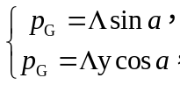 (S1)
The Bragg period p_{G} and the center wavelength (λ_{b}) of the incident light satisfy the Bragg condition at different angles of incidence:
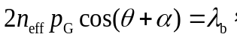 (S2)
where n_{eff} is the effective refractive index of the LC. For normal incidence (θ = 0), substituting Eq. (S1) into Eq. (S2) gives:
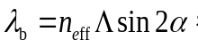 (S3)
The n_{eff} is a function of the ordinary (n_{o}) and extraordinary (n_{e}) refractive indices:
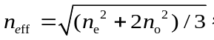 (S4)
To extend the photonic band across the entire visible spectrum, a series of CLC layers with varying helical pitches are stacked. The horizontal period (Λ) remains constant for all grating layers, and the variation in the slanted angle is achieved by adjusting p_{G} of the CLC.
Under Bragg diffraction conditions, the relationship between the diffraction angle (φ_{CLC}) and the incident angle (θ_{CLC}) in the CLC is as follows (Fig. S8):
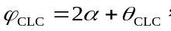 (S5)
The critical diffraction angle (φ_{c}) in the glass is determined by the TIR condition at the air interface:
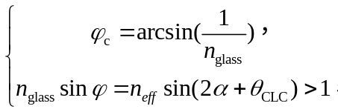 (S6)
where n_{glass} = 1.52, φ is diffractive angle in the glass. This inequality establishes the condition for total internal reflection, ensuring that light remains confined within the waveguide.

Supplementary Note 2. Derivation of phase gradients for CLCs with slanted Bragg planes
We derive the phase gradients for CLC with slanted Bragg planes and analyze the Pancharatnam–Berry (PB) phase effect of circularly polarized light during Bragg reflection. The grating phase is imprinted in the CLC polymer via a photoalignment technique.
For a planar right-handed CLC layer, the PB phase introduced during Bragg reflection is given by:
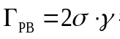 (S7)
where σ = ±1 represents left- and right-handed circularly polarized light, respectively, and γ is the azimuthal angle of the LC molecules. This PB phase arises purely from geometric effects resulting from the transformation that preserves the helicity of the CP during propagation reversal and the rotation of the CLC superstructure. Notably, the geometric phase effect of the transmission component cancels out, leading to no net geometric phase.
In a fixed coordinate system, the incident, reflected, and transmitted circularly polarized waves are expressed as follows [2,3]:
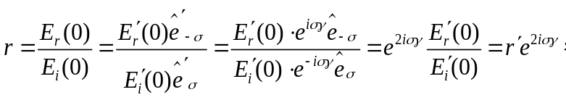 (S8)
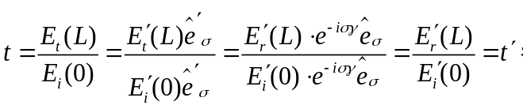 (S9)
where in a fixed coordinate system (x, y), r and t represent the reflection and transmission coefficients, respectively. E_{i}(0) denotes the incident CP plane wave, E_{r}(0) is the CP reflected wave, and E_{t}(L) is the CP transmitted wave. Similarly, the symbol (.′) indicates quantities defined in the local coordinate system (x′, y′).
The polarization grating spatially modulates the polarization of the incident light, introducing a gradient-tilted phase distribution that results in beam diffraction and deflection. The structural characteristic of the grating is defined by the periodic variation in the liquid crystal director (local optical axis) within the substrate plane. The director varies continuously from 0° to 180° within each grating period, while remaining parallel to the direction perpendicular to the substrate. This satisfies the equation:
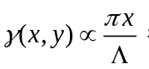 (S10)
Combining equations S3, S7, and S10, the PB phase gradient for Bragg reflection and transmission are derived as:
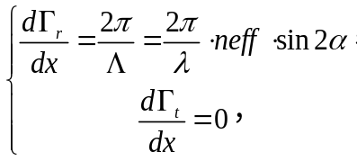 (S11)
The Bragg reflection PB phase gradient dГ_{r}/dx results in beam diffraction and deflection, corresponding to the periodic modulation of the LC director. In contrast, the transmission phase gradient dГ_{t}/dx cancels out, indicating that there is no net geometric phase in the transmitted wave.

Supplementary Note 3. Numerical simulation model for director distribution in CLCs
The liquid crystal (LC) director configuration is described by a unit vector field n(x,y,z) = (n_{x}, n_{y}, n_{z}). The Frank-Oseen free energy density has the following expression [4]:
(S12)
where k₁₁, k₂₂, and k₃₃ are the splay, twist, and bend elastic constants, respectively, and p denotes the helical pitch (0–2π) of the CLC. The total free energy 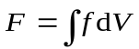 can be minimized via the relaxation method on the basis of dynamics. The iterative equation is as follows:
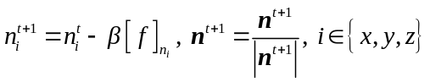 (S13)
where t is the iteration number, 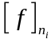 is the gradient of f, and β is the iteration step. is the Euler‒Lagrange equation and is defined as:
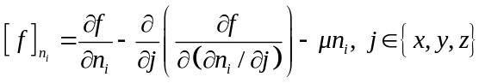 (S14)
During each iteration, vector normalization (Eq. (S13)) is performed to replace the constraint of the Lagrange multiplier μ. The finite difference method is employed to discretize the LC model, with weak surface anchoring conditions applied [5]. A random director configuration initializes the simulation.
To match the experimental results, the simulation parameters used were k₁₁ = 11.1 pN, k₂₂ = 7.0 pN, k₃₃ = 17.1 pN, and β = 10⁻⁷; the anchoring strengths of the surface were w_{b} = 10⁻³ J/m² (bottom side) and w_{t} = 10⁻⁴ J/m² (top side); the surface anchoring period Λ (0 ~ 2π) was 460 nm; the cell thickness was 7.5 μm; 5 layers of 2π/P were evenly divided from P_{b} = 335 nm (bottom side) to P_{t} = 450 nm (top side); and the mesh resolution (cubic mesh) was 10 nm. Fig S5 presents the calculated LC director configuration across six periodic units.

Supplementary Note 4. Derivation of the diffraction formula
The analysis of diffractive optical systems is optimally conducted in k-vector space, where the diffraction grating equation for periodic structures is expressed as:
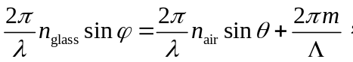 (S15)
where λ represents the wavelength of light and n_{glass} denotes the refractive index of the glass substrate. φ and θ denote the angles of the k-vector of the diffracted light within the substrate and the angle of incidence in air, respectively. m represents the diffraction order (0, 1, 2, ...). For CLCs, m = 1 corresponds to the spin-selective Bragg reflection property, which is intrinsic to these materials [6].
To simplify, we add and subtract an inclination angle to/from both diffraction angles and use trigonometric addition and subtraction formulas for sine:
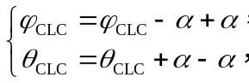 (S16)
where, θ_{CLC}, φ_{CLC} are the incident angle and the diffraction angle in the CLC, respectively. Combining equations S5 and S16, we obtain
(S17)
For a CLC with a slanted Bragg plane at an angle α = arcsin(p_{G}/Λ), we derive:
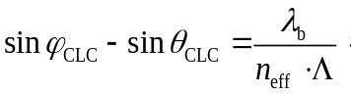 (S18)
The incident and diffracted beams undergo refraction according to Snell’s law when passing through the air‒glass interface and the glass‒CLC interface. A diffraction formula equivalent to Eq. 2 in the manuscript can be obtained.
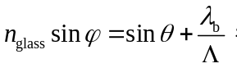 (S19)

Supplementary Note 5. Estimation of green energy
We estimate the potential increase in green energy supply and reduction in carbon emissions achievable by retrofitting existing architectural glass with CUSC technology based on the following factors, as reported in a wall glazing forecast by Global Industry Analysts Inc.:
(1) The annual average solar radiation transmitted through architectural glass is approximately 1,000 kWh·m⁻².
(2) The global building floor area in 2024 is estimated at approximately 300 billion m², with architectural glass accounting for approximately 15% of this area (i.e., 45 billion m²).
(4) The carbon emission intensity of global thermal power generation is approximately 0.65 tones·MWh⁻¹ (Data from International Energy Agency).
(5) The global per capita annual electricity consumption for residential use is approximately 1,200 kWh (Data from International Energy Agency).
(6) The PCE of our CUSU-PV is 3.7%.
Therefore, the available green energy power is (1000 kWh·m⁻² × 4.5 × 10¹¹ m² × 3.7%) / 8760 h = 1.9 × 10¹² W = 1.9 TW; The annual green energy supply is 190 × 10¹⁰ W × 8760 h = 1.66 × 10¹⁶ Wh = 1.66 × 10¹⁰ MWh; The annual carbon emission reduction is 1.66 × 10¹⁰ MWh × 0.65 tones·MWh⁻¹ = 1.08 × 10¹⁰ tones; The residential electricity supply capacity is 1.66 × 10¹⁰ MWh / 1.2 MWh = 1.38 × 10¹⁰ people.

Figure S1 Sunlight and polarization of light. Sunlight is naturally unpolarized. In experiments, it can be approximated by two orthogonal linearly polarized light beams with equal intensity and random relative phases. Polarized light can be divided into LCP (|𝐿⟩) and RCP (|𝑅⟩) components.

Figure S2 Operational principle of CUCCs and stacked CLCs with slanted Bragg planes. (a) The CUSC window consists of CLC layers stacked with submicron gratings and varying helical pitches, which transmit left-circularly polarized (LCP) light and diffract right-circularly polarized (RCP) light (b).

Figure S3 Fabrication of the CUSC. (a) Fabrication of CLC polymer multilayer patterns with initial orientation (Λ) and varying helix pitches (p_{G}) involves sequentially coating the photoalignment SD1, exposing it to polarized holographic patterns, and repeating the process of coating CLCs with different pitches and UV polymerization 14 times. The detailed material compositions are provided in Table S1. (b) Experimental optical setup for fabricating CLC patterns with initial orientation (Λ). BE, HWP, QWP, and PBS indicate beam expansion, the half-waveplate, the quarter-waveplate, and the polarization beam splitter, respectively. Here, when the angle β is set to 26.1°, the initial orientation period Λ is calculated as 460 nm (Λ = λ/(2 sinβ), where λ = 405 nm).

Figure S4 Dependence of reflection on the angle of incidence for the CUSC.

Figure S5 Simulated director field. The spatial variation of (a) azimuthal angle (tan⁻¹(n_{y}/n_{x})) and (b) tilt angle (sin⁻¹(n_{z})) profile.

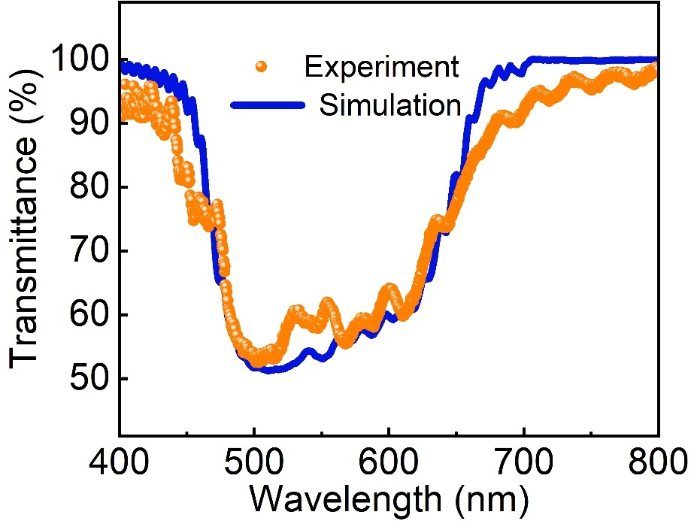
Figure S6 Experimental and simulated transmittance spectra of the CUSC at normal incidence.

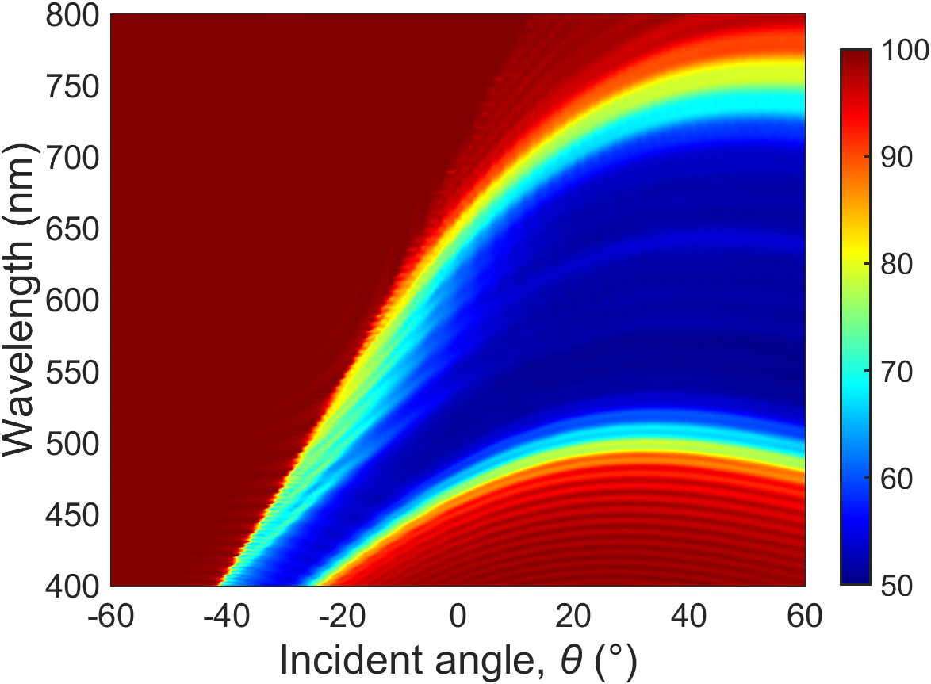
Figure S7 Simulation result of the dependency between photon bands and incidence angle θ. The color bar indicates that the transmittance varies from 50% to 100%.

Figure S8 RGB light unidirectional waveguiding in the CUSC at normal incidence. The wavelengths are λ_{R} = 630 nm, λ_{G} = 530 nm, and λ_{B} = 470 nm. The scale bar is 1 cm.

Figure S9 Simulation result for the dependence of φ on θ and λ. The color bar indicates that φ varies from 0° to -90°.

Figure S10 Diffraction angle (φ_{CLC}) as a function of the incidence angle (θ_{CLC}) and wavelength (λ). The cyan box indicates mirror reflection (φ_{CLC} = θ_{CLC}), whereas the yellow box indicates Bragg reflection (φ_{CLC} = 2α + θ_{CLC}).

Figure S11 Angle-dependent functions of the CUSC. For the range of -60° ≤ θ < θ_{t}, where θ_{t} = sin⁻¹(n_{g} − λ/Λ) and n_{g} = 1.52, the Bragg condition is not met as the incident angle in the glass substrate approaches the Bragg plane. In this regime, the CLC film acts as a waveplate instead of a grating, leading to mirror reflection governed by n_{g}sinφ = sinθ. Additionally, the polarization state evolves with variations in the film thickness. When θ_{t} ≤ θ ≤ 60°, the CLC film acts as a polarization volume grating with slanted Bragg planes. These gratings exhibit CP-selective Bragg reflection satisfying Equation 2.

Figure S12 Variation in the Stokes parameter S₃ of transmitted light with the CLC multilayer polymer thickness. The birefringence of the CLC polymer for simulation is 0.17 (n_{e} = 1.68; n_{o} = 1.51), with both the input and output media being glass (n_{glass} = 1.52). The horizontal period Λ of the CLC is 440 nm, and the slanted angle α varies from 21° to 30°. The incident angle θ is -44°, and the considered wavelengths (λ) are 471 nm, 527 nm, 582 nm, and 632 nm. The polarization parameter S₃ is defined as S₃ = (I_{L} − I_{R})/(I_{L}² + I_{R}²), where I_{L} and I_{R} are the left and right circularly polarized intensities, respectively. S₃ = 1 corresponds to the LCP, whereas S₃ = -1 corresponds to the RCP.

Figure S13 Analysis of unidirectional waveguiding in the CUSC. The incident linearly polarized (LP) light undergoes spin-selective Bragg reflection at the first interaction (φ_{CLC} = 2α + θ_{CLC}), where RCP light is deflected into the glass substrate, while LCP light is transmitted (indicated by the first blue arrow). After this interaction, the polarization state of the light changes to LCP due to total internal reflection (TIR), which occurs as a result of the reversal of the propagation direction (represented by the second blue arrow). During the second interaction with the CLC, the light undergoes a polarization conversion without altering its propagation direction. Specifically, if the CLC thickness satisfies the half-wave condition, the light transitions to RCP, as shown in Figs. S11 and S12. After another TIR at the top boundary of the CLC, the light becomes LCP and is transmitted through the CLC owing to the polarization selectivity of the CUSC. Ultimately, the light propagates directionally within the waveguide while preserving the high efficiency of the concentrators.

Figure S14 Experimental setup for characterization of CUSCs. The J–V curves and EQE_{λ} were measured under standard AM 1.5G simulated sunlight. The current density (J = I/A_{CUSC}) is calculated on the basis of the top surface area of the CUSC-PV light guide (A_{CUSC} = A_{top}), not the total edge area (A_{edge}) of the edge-mounted PV cells. A matte black background was used to minimize ambient light and reflections during both the J–V and EQE_{λ} measurements [7, 8].

Figure S15 (a) J-V characteristics and (b) EQE spectra of strip-shaped photovoltaic.

Figure S16 Performance of CUSC-PV. (a) LUE versus AVT; (b) PCE versus AVT. PSC: Perovskite single junction photovoltaic cell; OPV: Organic photovoltaic material-based single junction photovoltaic cell; DSSC: Dye sensitized single junction photovoltaic cell; TLSC: Transparent luminescent solar concentrator. Light utilization efficiency (LUE = AVT × PCE). The blue solid lines represent the detailed balance efficiency limit for non-wavelength-selective photovoltaics. a, b adapted from ref. [9]

Table S1 Detailed weight parameters of the precursors and solutions in the CUSC
Identification number | Desired wavelength | Precursor composition |  |  |  | Precursor: PGMEA  (w:w) | Coating speed  (rpm) | Curing layers
Identification number | Desired wavelength | RM257 | R5011 | Omnirad651 | Zonyl8857A | Precursor: PGMEA  (w:w) | Coating speed  (rpm) | Curing layers
#1 | 420–470 | 92.32 | 2.38 | 5 | 0.3 | 1:6 | 1600  (30 s) | 2
#2 | 470–530 | 92.56 | 2.14 | 5 | 0.3 | 1:6 | 1600  (30 s) | 3
#3 | 530–580 | 92.76 | 1.94 | 5 | 0.3 | 1:6 | 1600  (30 s) | 3
#4 | 580–640 | 92.90 | 1.78 | 5 | 0.3 | 1:6 | 1600  (30 s) | 3
#5 | 640–750 | 93.06 | 1.64 | 5 | 0.3 | 1:6 | 1600  (30 s) | 3

Table S2 Figures of merit [10]
Figures of merit | Description
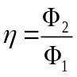 | Ratio of edge-emitted photons (Φ₂) to total incident photons (Φ₁)in a CUSC.
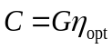,  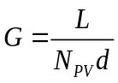 | Owing to the implementation of directional waveguides, N_{PV} = 1. Where L and d denote the length and thickness of the CUSC, respectively.
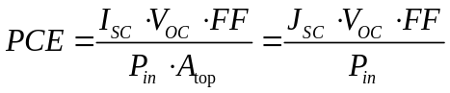 | PCE, power conversion efficiency; P_{in}, incoming power density; V_{OC}, open-circuit voltage; I_{sc}, short-circuit current; J_{sc}, short-circuit current density; FF, fill factor; A_{top}, lightguide front surface area.
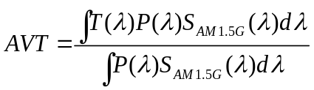 | AVT, average visible transmittance; T, transmittance; P, photopic response of the human eye; S, solar spectrum.
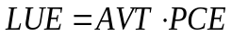 | LUE, light utilization efficiency.
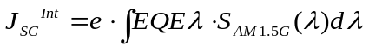 | J_{SC}^{Int}, integrated current density from EQE_{λ}; e, elementary charge; EQE_{λ}, the number of electrons generated per incident photon on the front surface of the lightguide at each wavelength, commonly position-dependent for CUSC-PV.

Table S3 Per-m² cost of the CUSC at the lab scale.
Raw Materials | Cost/m²
CLC mixture | $0.5
Solvents | $0.2
Protective coating | $0.4
Architectural glass | $3.0
Other materials | $0.5
Total | $4.6
The price of architectural glass is from Alibaba, whereas other material prices are from Sigma‒Aldrich and Alfa Aesar.
Table S4: Performance Comparison of CUSC, LSC, and SSC
Performance Metric | CUSC  （Our Work） | Luminescent solar concentrator (LSC) | Scattering solar concentrator (SSC)
Visual quality | Colorless and transparent | Colored or tinted | Hazy or milky
Wavelength range | Full visible spectrum | Affected by absorption/fluorescence | Scattering visible light
Guiding directionality | Unidirectionally | Omnidirectionally | Randomly
PV Cell cost | PV cell required on a single edge (75% reduction) | PV cells required on all edges | PV cells required on all edges
Optical efficiency | 18.1% on average in vis band under AM 1.5G | 2–10% due to reabsorption and other losses | ~10%, highly dependent on scattering
Stability | Good | Photobleaching/thermal degradation | Good
Aesthetics | Good | Poor (Colored) | Poor (Scattering)
Temperature dependency | Good | Poor (Dye degradation) | Median
Integration feasibility | Post-coating, excellent | Hard | Hard

Supplementary References
1. Ding Y, Yang Q, Li Y, Yang Z, Wang Z, Liang H, et al. Waveguide-based augmented reality displays: perspectives and challenges. eLight. 2023;3(1):1-24.
2. Barboza R, Bortolozzo U, Clerc MG, Residori S. Berry phase of light under bragg reflection by chiral liquid-crystal media. Phys Rev Lett. 2016;117(5):053903.
3. Rafayelyan M, Tkachenko G, Brasselet E. Reflective spin-orbit geometric phase from chiral anisotropic optical media. Phys Rev Lett. 2016;116(25):253902.
4. Mori H, Gartland E, Kelly JR, J. BP. Multidimensional director modeling using the Q tensor representation in a liquid crystal cell and its application to the π cell with patterned electrodes. Jpn J Appl Phys 1999;38(1):135-146.
5. Xiong J, Chen R, Wu ST. Device simulation of liquid crystal polarization gratings. Opt Express. 2019;27(13):18102-18112.
6. Stebryte M, Nys I, Beeckman J, Neyts K. Single order diffraction at a negative angle based on a chiral liquid crystal with an inclined helix. ACS Appl Opt Mater. 2024;2(10):2067-2074.
7. Debije MG, Evans RC, Griffini G. Laboratory protocols for measuring and reporting the performance of luminescent solar concentrators. Energy Environ Sci. 2021;14(1):293-301.
8. Yang C, Atwater HA, Baldo MA, Baran D, Barile CJ, Barr MC, et al. Consensus statement: Standardized reporting of power-producing luminescent solar concentrator performance. Joule. 2022;6(1):8-15.
9. Almora O, Cabrera CI, Erten‐Ela S, Forberich K, Fukuda K, Guo F, et al. Device performance of emerging photovoltaic materials (Version 4). Adv Energy Mater. 2023;14(4):2303173.
10. Yang C, Liu D, Bates M, Barr MC, Lunt RR. How to accurately report transparent solar cells. Joule. 2019;3(8):1803-1809.

