Supplementary Materials for
Harnessing forward scattering effect for high dynamic imaging

Minda Qiao¹, Yuhan Zhang¹, Haodong Yang¹, Linge Bai¹, Xue Dong^{1,2}, Tong Zhang^{1,2}, Jinpeng Liu^{1,}*, Fei Liu^{1,2,}* and Xiaopeng Shao^{3,}*

*Correspondence:
liujinpeng@xidian.edu.cn;
feiliu@xidian.edu.cn;
xpshao@opt.ac.cn

¹ School of Optoelectronic Engineering, Xidian University, Xi’an 710071, China
² Xi’an Key Laboratory of Computational Imaging, Xi’an 710071, China
³ Chinese Academy of Sciences, Institute of Optics and Precision Mechanics, Xi’an 710119, China

Supplementary Note S1: Objects used in experiments
In our experiments, the objects (Fig. S1a1, Fig. S1a2 and Fig. S1a3) seemed on the blackboard which was used only as a controlled experimental tool to simulate extreme HDR scenes. The role of the blackboard was to physically separate the intense frontal light from the faint details, ensuring that the performance of the proposed method could be evaluated under reproducible conditions. Since our aim was to verify the method’s feasibility for real-world reflective targets, we employed a reflective rather than a transmissive object. This choice required a supporting substrate, for which we selected a black surface based on two key considerations: 1. Contrast enhancement – the black substrate absorbs non-target light while maximizing the reflectance of target details, thereby improving the overall scene contrast. 2. Light-blocking capability – the opaque surface prevents the intense frontal light from penetrating through the target area, avoiding unwanted illumination in the faint-detail region.
Fig. S1 Objects used in experiments.

Supplementary Note S2: Conventional imaging in HDR scenes
To verify the capability of a conventional camera (Basler a2A4096-30um industrial camera, 4096×3000 pixels) in observing the HDR scene, we employed the conventional imaging approach to record under different exposure times, as shown in Fig. S2. Even if the exposure time was reduced to ensure that most pixels were not saturated, the corresponding decreased in signal level in the dark region would still cause the faint object information to be buried in detector noise, making it unobservable. To capture as much faint object information as possible, we set the exposure to ensure that faint details were detectable. Under this condition, due to the limited dynamic range of the camera, the bright region inevitably became saturated, resulting in overexposure.
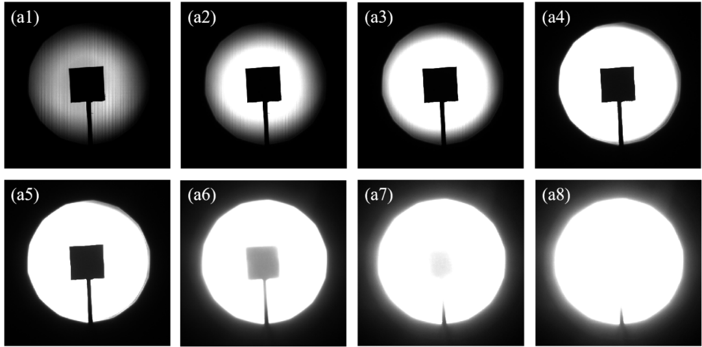
Fig. S2 Images captured by conventional photoelectric imaging under different exposure times. (a1-a8) The exposure times are $13μs$, $50μs$,$100μs$, $500μs$, $1ms$,$5ms$,$8ms$and $10ms$, respectively.

