Supplementary Information for
Transformer-Based Neural Network Enabled Subpixel-Resolution in Wide-Field Meta-Microscope
Shanshan Hu¹, Zihan Wang¹, Jian Li¹, Junyi Wang¹, Wenjing Shen¹, Jiacheng Sun¹, Jitao Ji¹, Xian Long¹, Xu Liu², Chen Chen^{1*}, Shining Zhu¹, and Tao Li^{1*}

¹National Laboratory of Solid State Microstructures, Key Laboratory of Intelligent Optical Sensing and Manipulation, Jiangsu Key Laboratory of Artificial Functional Materials, Collaborative Innovation Center of Advanced Microstructures, School of Physics, College of Engineering and Applied Sciences, Nanjing University, Nanjing 210093, China.

²ZJU-Hangzhou Global Scientific and Technological Innovation Center, College of Optical Science and Engineering, State Key Laboratory of Extreme Photonics and Instrumentation, Zhejiang University, Hangzhou 310027, China.

*Corresponding authors. Email: chenchen2021@nju.edu.cn; taoli@nju.edu.cn
Supplementary Note 1. The Effective Field of View Characterization.
Supplementary Note 2. Two-stage Image Registration Procedure.
Supplementary Note 3. Network Training Details.
Supplementary Note 4. Image Stitching Procedure.
Supplementary Note 5. Model generalizability: cross-tissue evaluation

Supplementary Note 1. The Effective Field of View Characterization.
As shown in Fig. S1, a grid distortion target (grid spacing: 10 μm, Thorlabs, R1L3S3P) was used to calibrate the effective field of view (FOV) of the two metalenses. Figure. S1(a) and Fig. S1(b) display the imaging results of the metalens (1×) and the metalens (3×), both with a FOV of 320 μm × 320 μm. Due to aberration and distortion, the imaging contrast and luminance uniformity degrade radially from the center. The metalens (3×) exhibits more pronounced aberration and pincushion distortion. To quantitatively assess the effective FOV, the intensity profile along the central line of the grid was analyzed, and regions where the peak-to-valley contrast exceeded 70 were considered valid, as shown in Fig. S1(c) and Fig. S1(d). Based on this criterion, the effective FOVs were determined to be 205 μm and 140 μm for the metalens (1×) and the metalens (3×), respectively, highlighted by red circles in Fig. S1(a) and Fig. S1(b). To ensure sufficient resolution and minimal aberration, the square inscribed within the effective FOV circle was designated as the optimal imaging region (99 μm × 99 μm), shown by the yellow dashed box in Fig. S1(b). Based on this reference, with slight margins retained, a cropped region of 198 × 198 pixels was selected as the ground truth for model training.
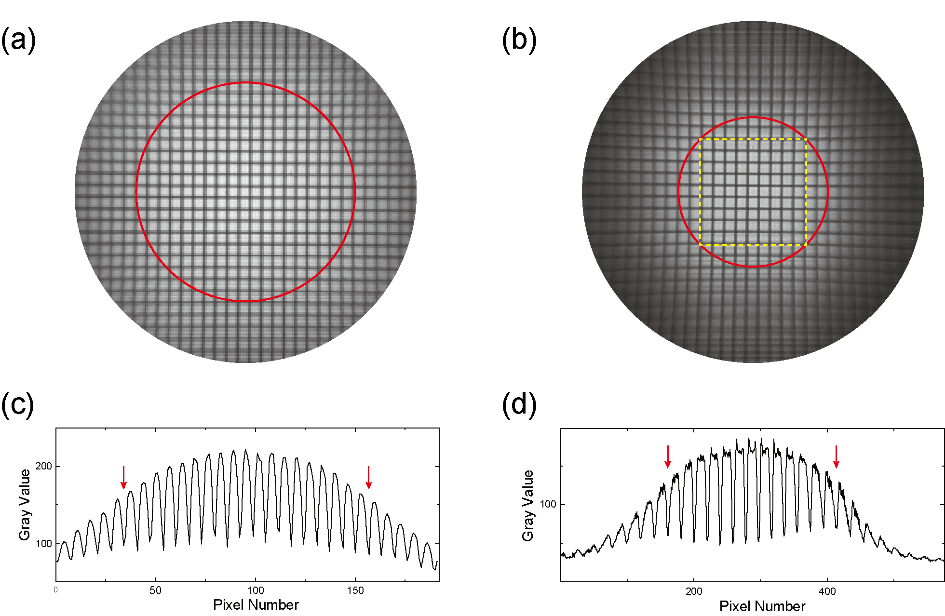
Fig.S1 Characterization of the effective FOV. (a) Imaging result of the grid distortion target captured by the metalens (1×) with a red circle denoting the effective FOV. (b) Imaging result of the grid distortion target captured by the metalens (3×). The red circle marks the effective FOV, and the yellow dashed box outlines the optimal imaging area. (c) The intensity distributions of the center line of the (a) with red arrows indicating the effective FOV. (d) The intensity distributions of the center line of the (b) with red arrows indicating the effective FOV.
To quantitatively evaluate the spatial resolution of the metalens (3×) and verify its uniformity across the effective field of view, we performed slanted-edge MTF measurements and resolution-target imaging under identical illumination conditions.
Fig. S2 compares the imaging performance of the metalens (3×) and a conventional Olympus 40×/0.65NA objective using a positive 1951 United States Air Force (USAF) resolution test chart. Due to the much higher magnification and NA, the 40× objective exhibits a substantial reduction in image brightness and contrast, and the extended exposure time required introduces additional noise. By contrast, the metalens (3×) achieves high resolution while maintaining a higher signal-to-noise ratio across its effective FOV.
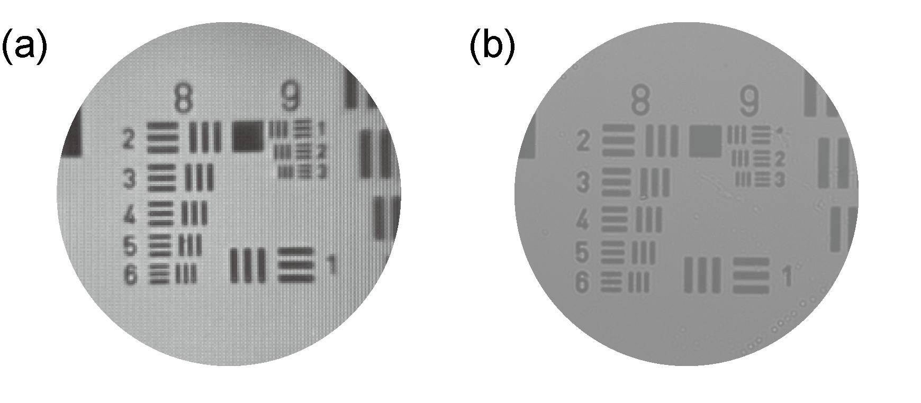
Fig. S2 Comparison of imaging performance between the metalens (3×) and a conventional Olympus 40×/0.65NA objective. (a) Image of the USAF resolution chart captured by the metalens (3×). (b) Image of the same USAF resolution chart captured by the 40× objective under identical illumination.
Figs. S3(a)-(g) shows the slanted-edge MTF results of the metalens (3×) measured at seven field positions (object heights: 0-55 μm). The diffraction-limited MTF was used as a theoretical benchmark. Since the effective pixel size under 3× magnification is bigger than the theoretical diffraction-limited resolution of the metalens, the measured MTF shows a slightly earlier cutoff. The red pentagrams indicate the MTF values at the spatial frequency corresponding to a half-pitch resolution of 0.87 μm (element 2, group 9 (g9e2)), where a clear contrast is preserved throughout the effective FOV. Figs. S4(a)-(g) further presents the corresponding images and intensity profiles of the line pairs of g9e2, with the yellow dashed boxes indicating the effective FOV (110 μm × 110 μm). The results confirm that the metalens (3×) achieves consistent resolution of approximately 0.87 μm across its entire effective FOV.
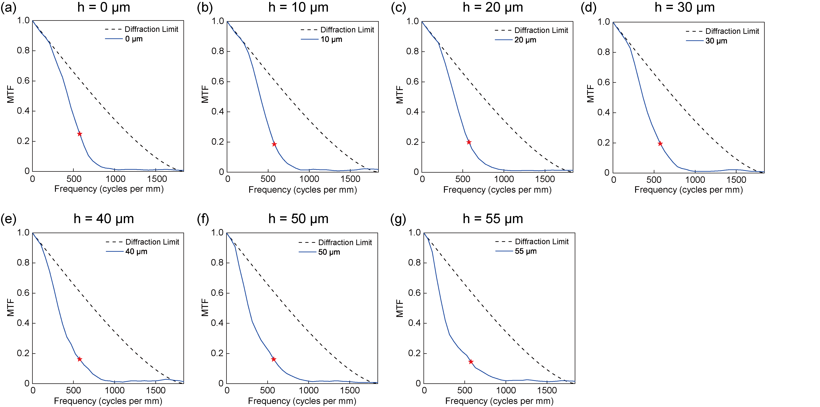
Fig. S3 Field-dependent slanted-edge MTF measurements of the metalens (3×). (a-g) The experimental and theoretically limited MTF of the metalens (3×) measured at object heights of 0, 10, 20, 30, 40, 50, and 55 μm, respectively. The red pentagrams mark the spatial frequency corresponding to a half-pitch resolution of 0.87 μm (g9e2 of the USAF resolution chart).
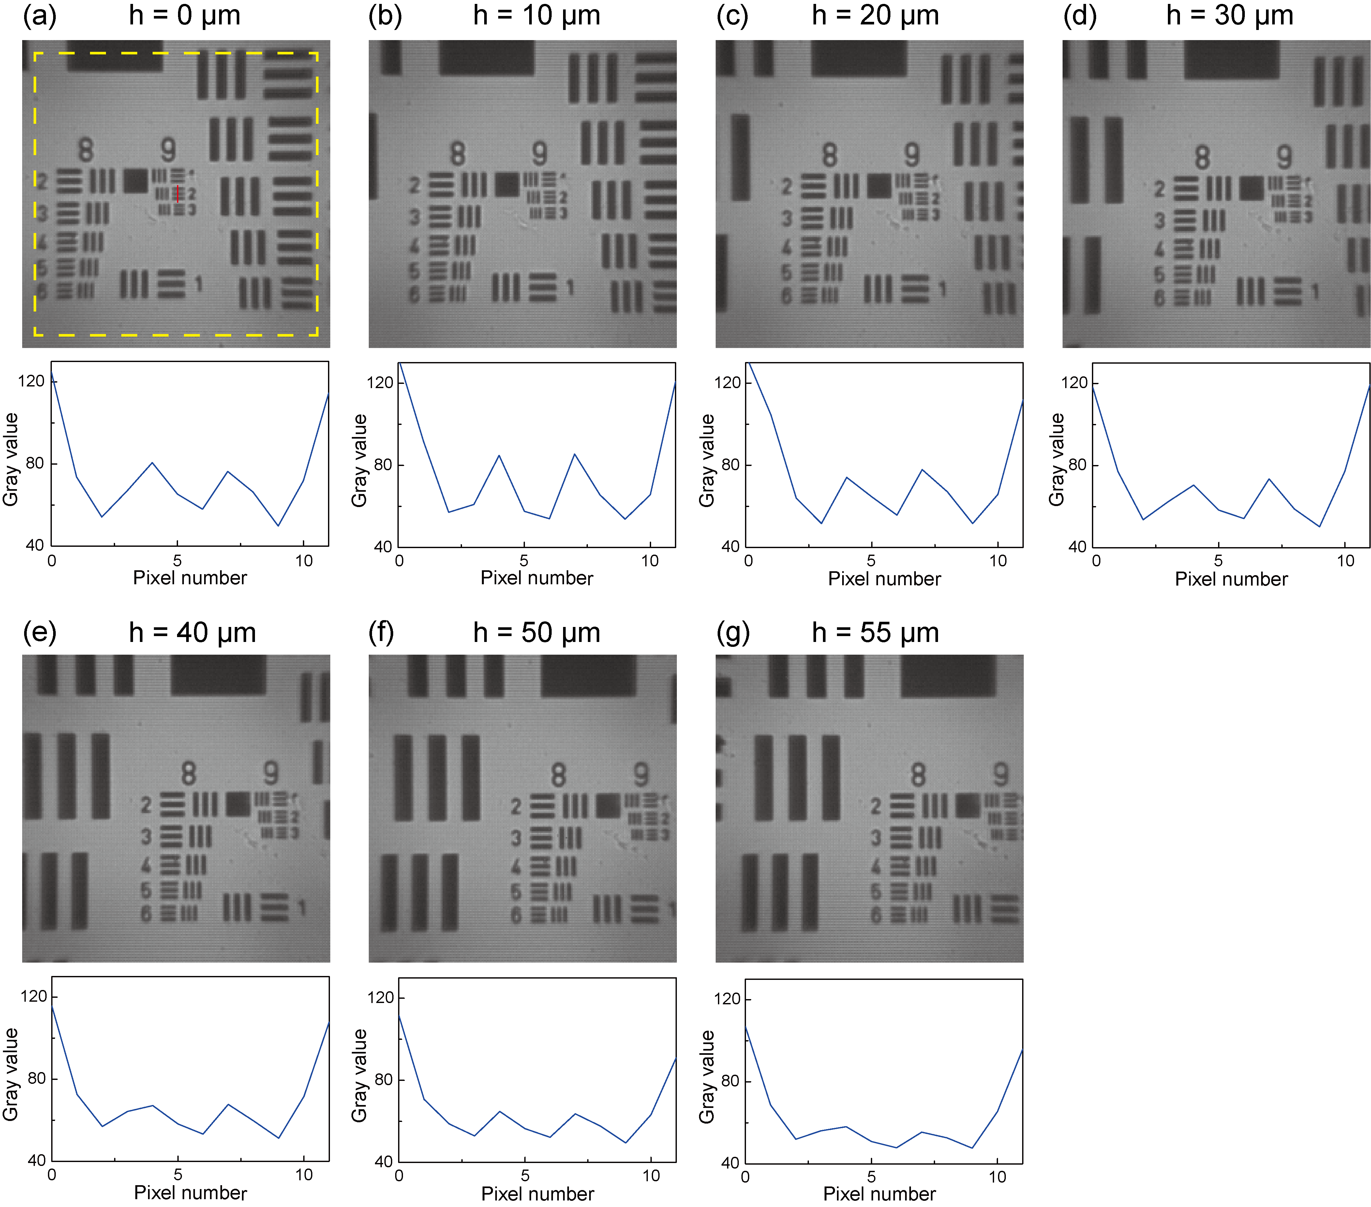
Fig. S4 Field-dependent resolution verification of the metalens (3×) using the horizontal line pairs of g9e2. (a-g) Captured images and corresponding vertical intensity profiles of the line pairs of g9e2 at object heights of 0, 10, 20, 30, 40, 50, and 55 μm, respectively. The yellow dashed box of (a) indicates the effective FOV (110 μm × 110 μm). The red vertical line of (a) marks the position of the extracted intensity profiles.

Supplementary Note 2. Two-stage Image Registration Procedure.
Accurate image registration is essential for effective end-to-end supervised network training. We adopt a two-stage registration process to align low-resolution (LR) input images with their corresponding ground truth counterparts. In the first stage, rigid registration is performed to achieve pixel-level alignment. Ground truth images are initially down-sampled by a factor of 3 to match the effective pixel size of the LR input. The down-sampled ground truth is then used as a template to locate the region with the highest correlation in the raw LR image using the template matching algorithm [1, 2]. This region is cropped from the LR image and paired with the raw high-resolution ground truth for the next step. Due to residual optical aberrations and local distortions, rigid alignment alone may not ensure perfect correspondence. Therefore, in the second stage, we apply elastic registration using the DeepFlow algorithm [3], which estimates dense optical flow fields to model pixel-wise deformations. The resulting flow field is used to warp the ground truth image, enabling subpixel alignment while preserving the raw LR input. This ensures accurate spatial correspondence without altering the raw input. The resulting registered image pairs are used for both network training and evaluation.

Supplementary Note 3. Network Training Details.
The model is implemented using the PyTorch 1.7.0 framework with CUDA 10.1 support and is trained using the Adam [4] optimizer with parameters β₁ = 0.9 and β₂ = 0.999. The initial learning rate is set to 0.0002. The training epoch is 100, with a batch size of 4 per GPU. Distributed training is performed on a workstation equipped with four NVIDIA Titan V GPUs using data parallelism, which improves memory efficiency and accelerates convergence. The total training time with this multi-GPU setup is approximately 39 hours. The training loss exhibits a steady decline and converges over time, demonstrating stable and effective model optimization, with consistent improvements also observed on the validation set.

Supplementary Note 4. Image Stitching Procedure.
a. The sample is sequentially translated nine times following a zigzag scanning trajectory (Fig. S5(a)) to acquire nine raw images using the metalens array-integrated microscope.
b. A background image is acquired using a clean glass slide for subsequent subtraction.
c. Sub-images corresponding to each sub-metalens are extracted from the nine raw images as well as from the background image.
d. Each extracted sub-image is enhanced using the trained neural network model. (This step can be skipped if only raw images are to be stitched.)
e. Following background subtraction, a Gaussian mask (see Fig. S5(b)) is applied to isolate the central region of each sub-image, reducing edge aberrations and improving overall image quality.
f. For each of the nine raw images, the sub-images are first processed with Gaussian masks to retain their central high-quality regions while suppressing peripheral aberrations. These masked sub-images are then positioned on the stitching canvas according to the relative spatial arrangement of the sub-metalenses within the array. Subsequently, the nine sets of sub-images are sequentially placed onto the final stitched image based on the global displacements defined by the zigzag scanning trajectory in step a. The corresponding Gaussian mask images are stitched in the same manner to generate a composite mask for subsequent normalization.
g. The stitched image is normalized by dividing it by the composite mask, yielding a final wide-field, high-resolution stitched image with improved visual quality, as shown in Fig. 5(c). Fig. S5(c) presents the corresponding raw stitched full-field image.
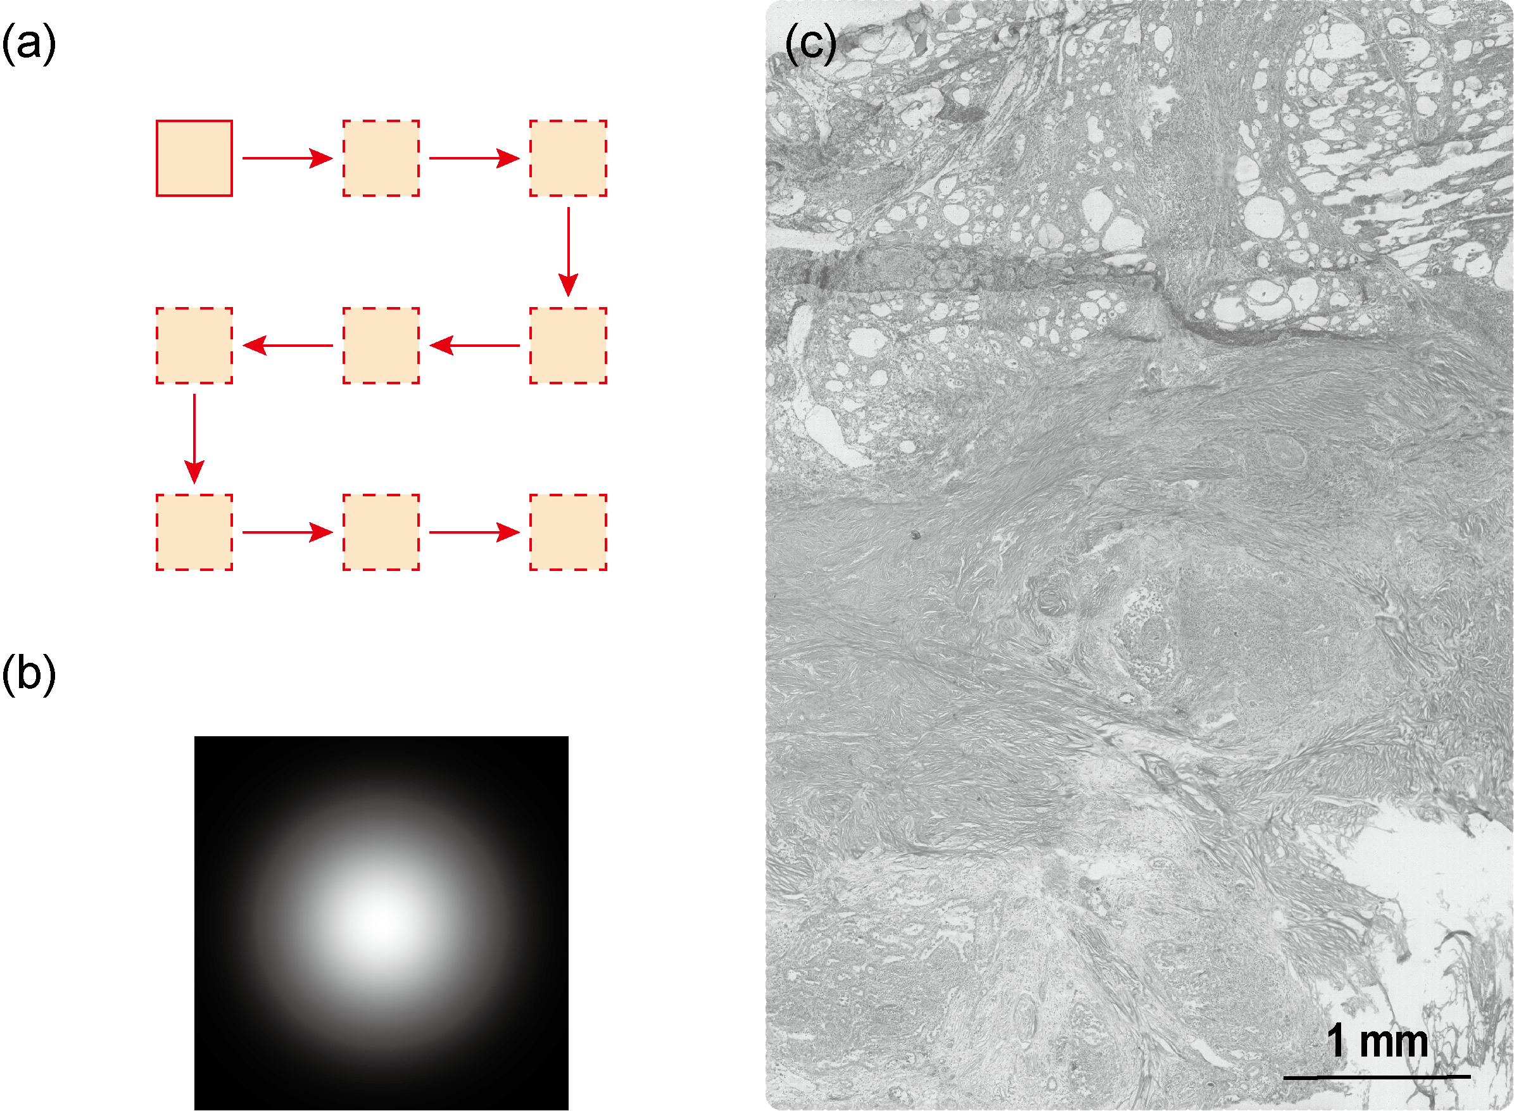
Fig. S5 Full-Field Image Reconstruction via Zigzag Scanning. (a) Schematic diagram of the zigzag scanning trajectory used for full-field coverage. (b) Gaussian mask image. (c) Raw stitched full-field image of a stained thyroid pathological section.

Supplementary Note 5. Model generalizability: cross-tissue evaluation
To evaluate the cross-tissue generalizability of the model trained on thyroid pathological sections, we acquired matched unit-magnification and 3-fold magnification images from five additional tissue types: stomach, lymph node, pancreas, spleen, and rectum. For each tissue type, we captured two independent regions of interest (ROIs) under the same imaging settings used for the thyroid pathological sections dataset in the main text. Importantly, the network was trained only on the thyroid dataset and not fine-tuned for these new tissues. The unit-magnification images were input to the thyroid-trained model, and the outputs were compared against the corresponding 3-fold magnification images (as ground truth) using the peak signal-to-noise ratio (PSNR) and structural similarity index measure (SSIM) for quantitative evaluation.
As shown in Figures S6-S9, for the stomach, lymph node, pancreas, and spleen samples, the network outputs exhibited notable enhancement in image resolution and effective suppression of grid artifacts compared with the inputs. Quantitatively, the network achieved PSNR ≥ 24.17 dB and SSIM ≥ 0.83 across these tissues, indicating appreciable transferability to samples with similar micro-morphological characteristics. In contrast, the performance on rectum tissues (Fig. S10) was lower (PSNR: 22.33 dB and 21.23 dB; SSIM: 0.75 and 0.73), due to larger differences in morphology and texture relative to thyroid tissue. These results provide preliminary evidence that a model trained on thyroid samples can generalize reasonably well to other tissues with comparable microscopic structures, while notable domain shifts (tissue type, particularly in morphological differences) can lead to performance degradation.
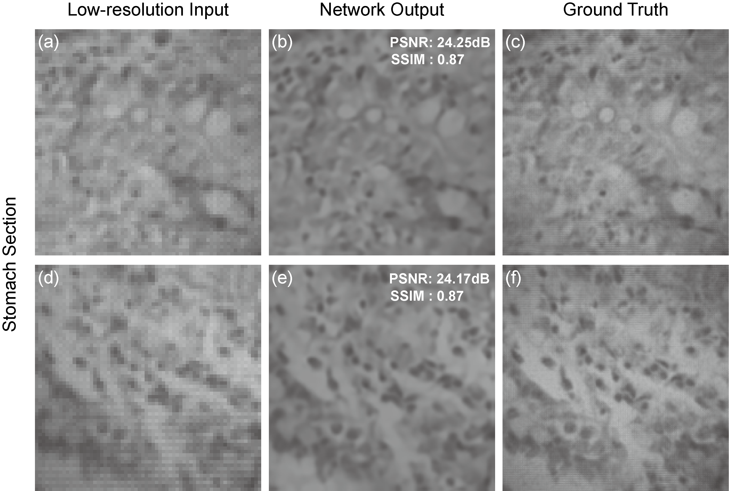
Fig. S6 Assessment of model robustness in reconstructing stomach section images. (a, d) ROI 1 and ROI 2 of the network input images captured by the metalens (1×). (b, e) ROI 1 and ROI 2 of the network output images. The network was trained exclusively on the thyroid pathological section dataset. The corresponding PSNR and SSIM values are indicated in the upper-right corner. (c, f) ROI 1 and ROI 2 of the ground truth images captured by the metalens (3×).
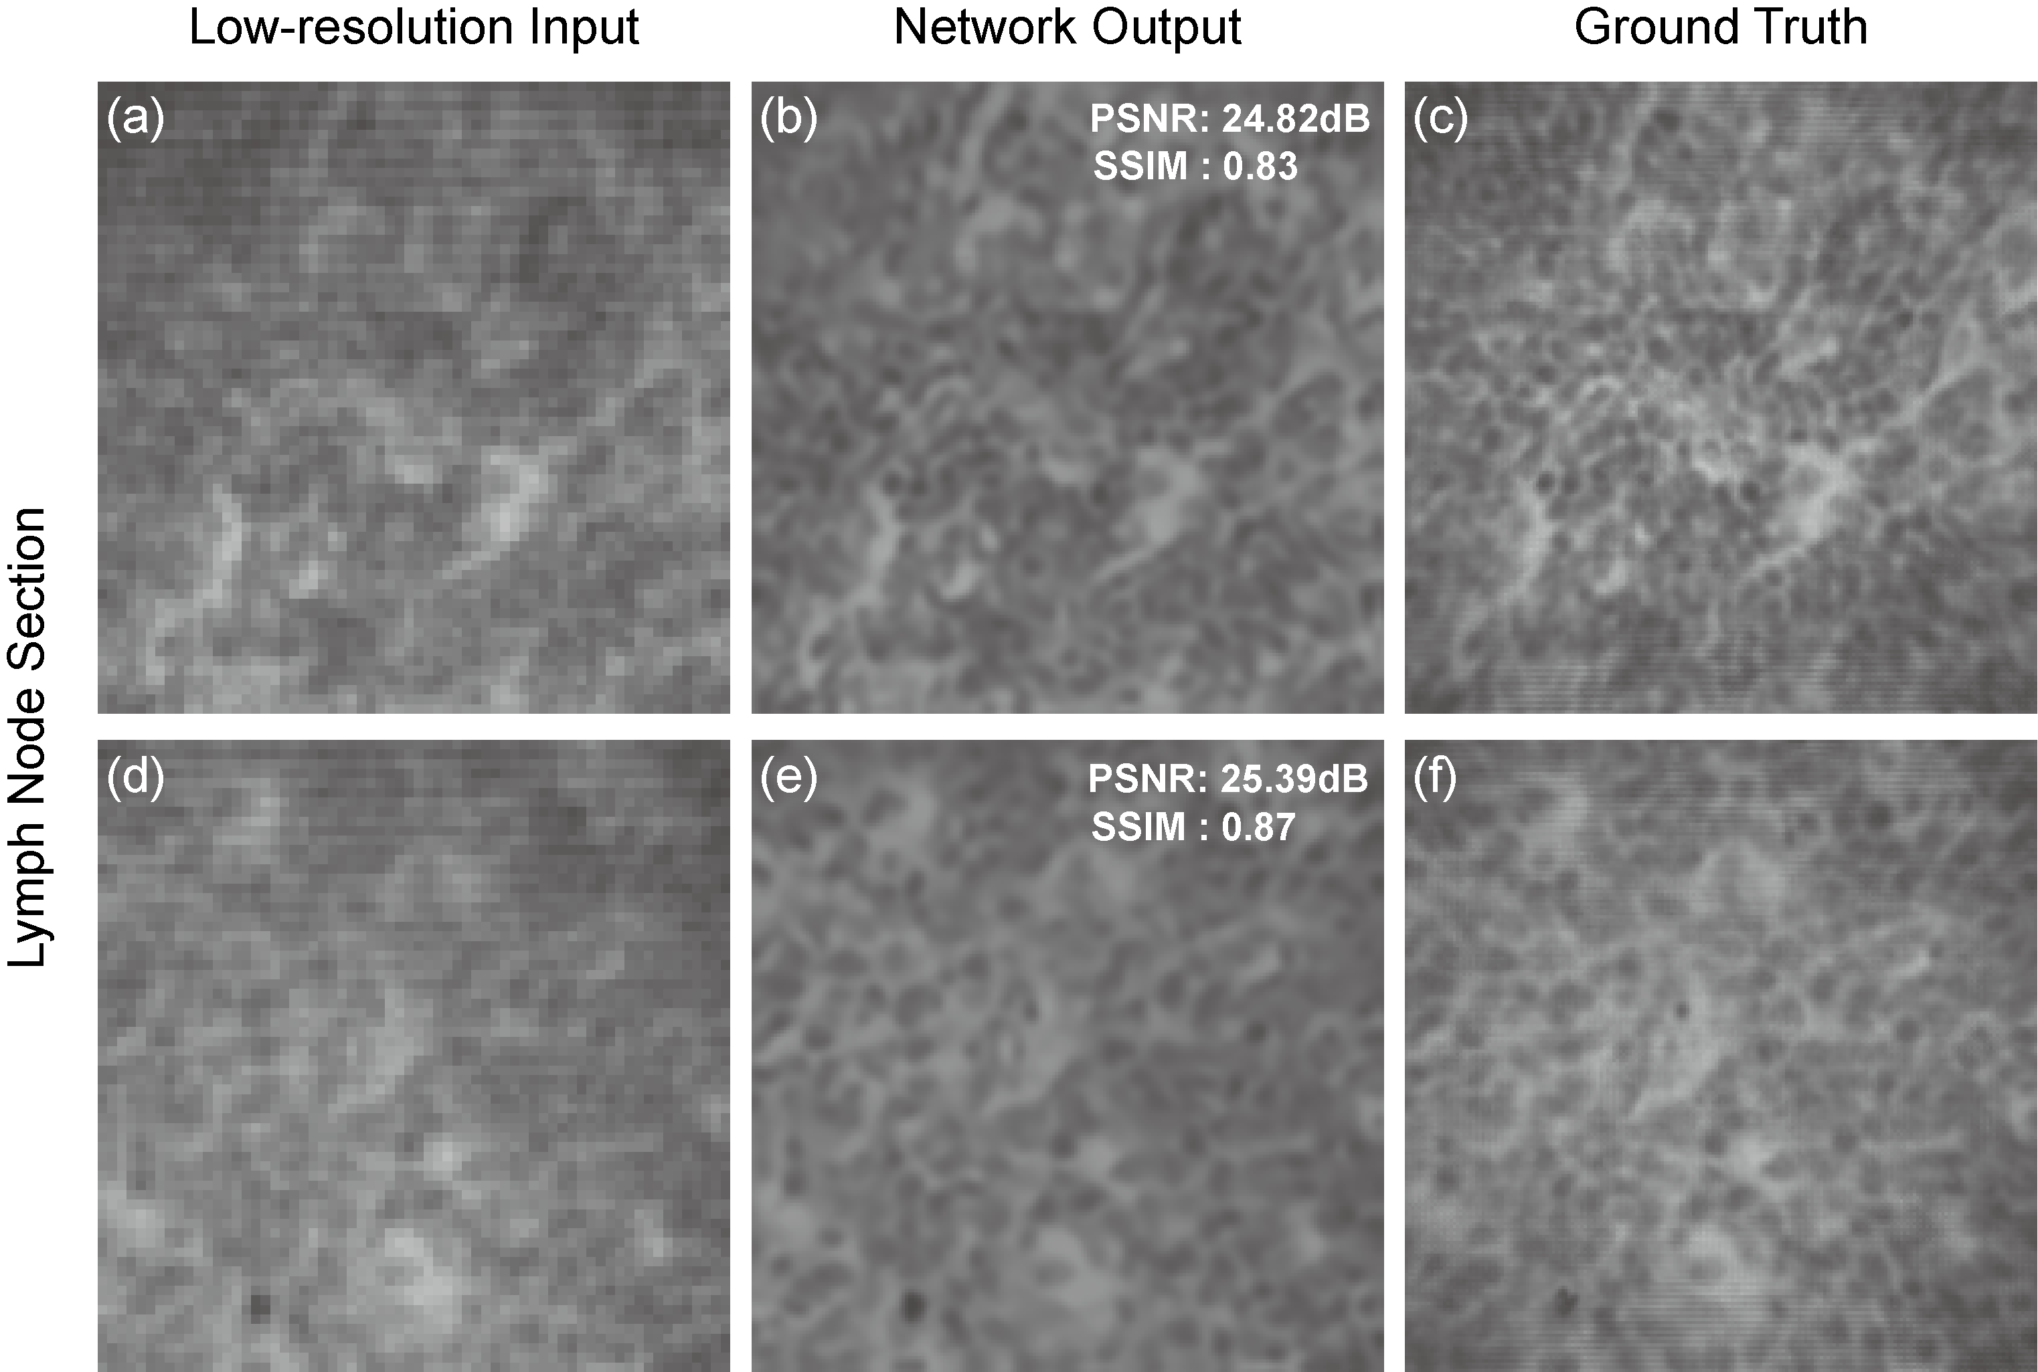
Fig. S7 Assessment of model robustness in reconstructing lymph node section images. (a, d) ROI 1 and ROI 2 of the network input images captured by the metalens (1×). (b, e) ROI 1 and ROI 2 of the network output images. The network was trained exclusively on the thyroid pathological section dataset. The corresponding PSNR and SSIM values are indicated in the upper-right corner. (c, f) ROI 1 and ROI 2 of the ground truth images captured by the metalens (3×).
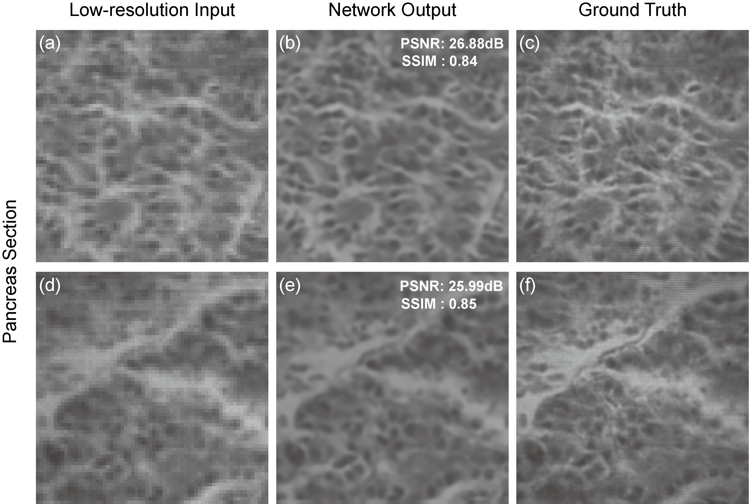
Fig. S8 Assessment of model robustness in reconstructing pancreas section images. (a, d) ROI 1 and ROI 2 of the network input images captured by the metalens (1×). (b, e) ROI 1 and ROI 2 of the network output images. The network was trained exclusively on the thyroid pathological section dataset. The corresponding PSNR and SSIM values are indicated in the upper-right corner. (c, f) ROI 1 and ROI 2 of the ground truth images captured by the metalens (3×).
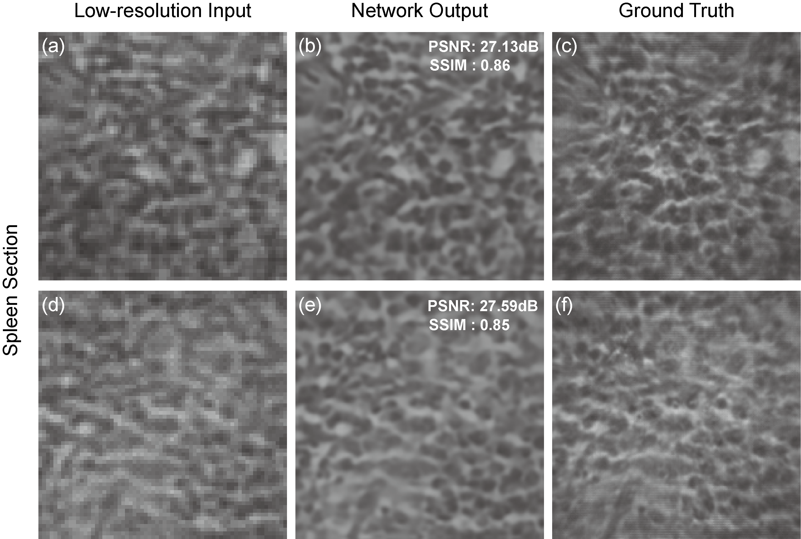
Fig. S9 Assessment of model robustness in reconstructing spleen section images. (a, d) ROI 1 and ROI 2 of the network input images captured by the metalens (1×). (b, e) ROI 1 and ROI 2 of the network output images. The network was trained exclusively on the thyroid pathological section dataset. The corresponding PSNR and SSIM values are indicated in the upper-right corner. (c, f) ROI 1 and ROI 2 of the ground truth images captured by the metalens (3×).
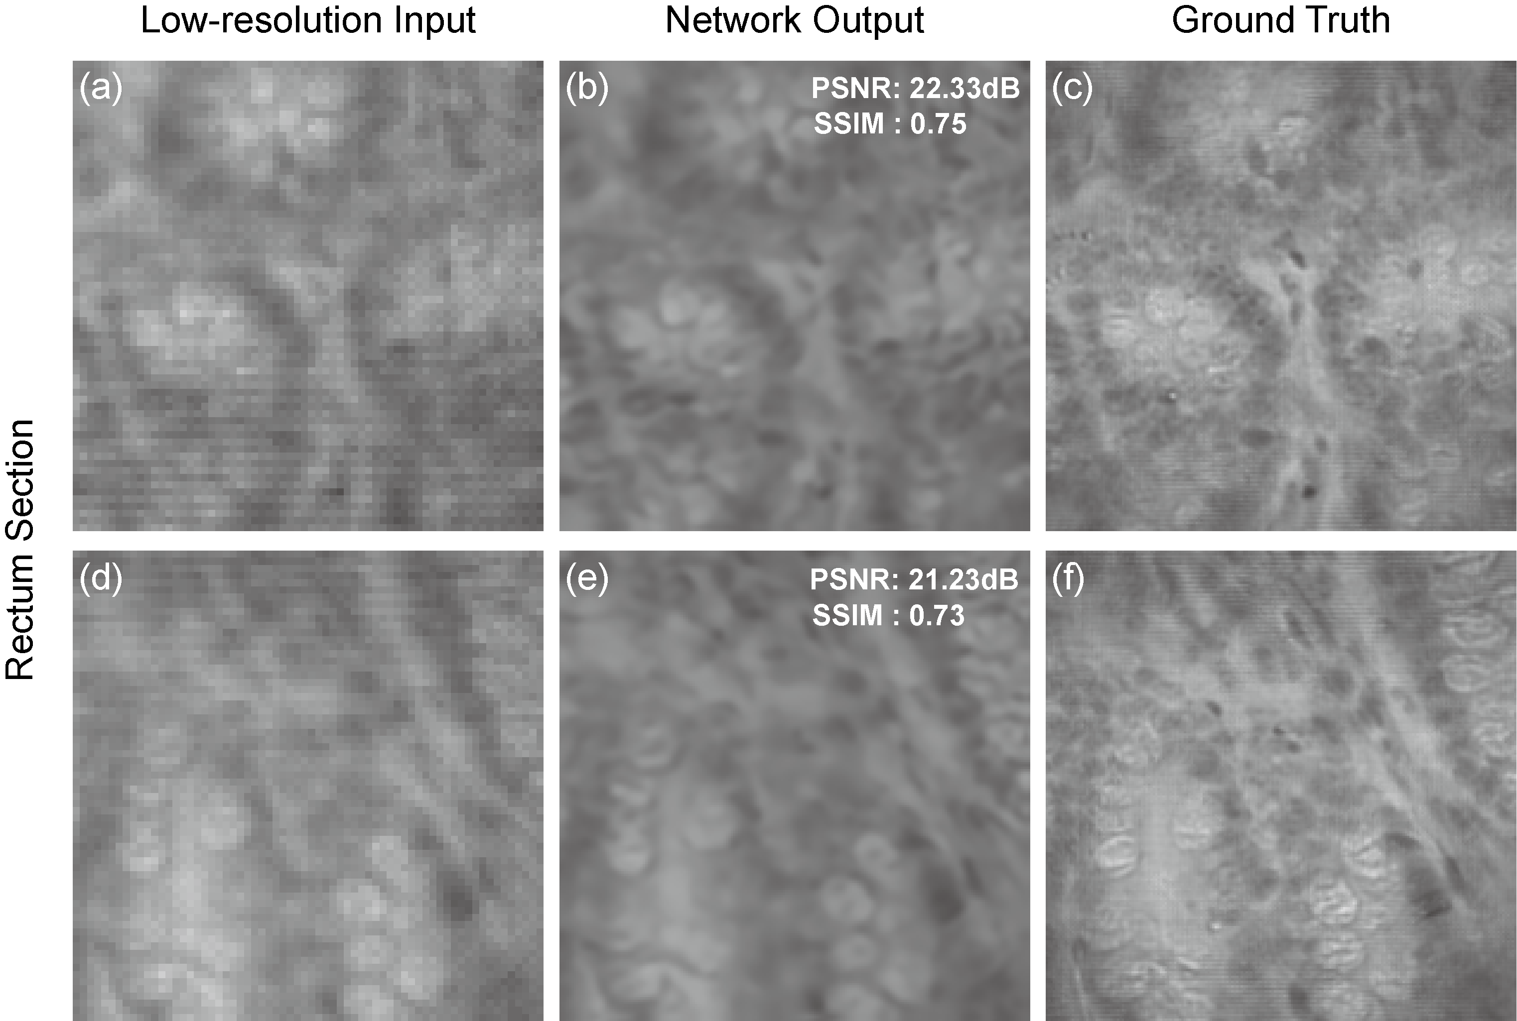
Fig. S10 Assessment of model robustness in reconstructing rectum section images. (a, d) ROI 1 and ROI 2 of the network input images captured by the metalens (1×). (b, e) ROI 1 and ROI 2 of the network output images. The network was trained exclusively on the thyroid pathological section dataset. The corresponding PSNR and SSIM values are indicated in the upper-right corner. (c, f) ROI 1 and ROI 2 of the ground truth images captured by the metalens (3×).

References
1. A. K. Jain, Fundamentals of Digital Image Processing (Prentice-Hall, Inc., 1989).
2. G. Bradski, "The opencv library.," Dr. Dobb’s J. Softw. Tools Prof. Program. 25, 120–123 (2000).
3. P. Weinzaepfel, J. Revaud, Z. Harchaoui, and C. Schmid, "DeepFlow: Large displacement optical flow with deep matching," in Proceedings of the IEEE International Conference on Computer Vision (2013), pp. 1385–1392.
4. D. Kingma and J. Ba, "Adam: A Method for Stochastic Optimization," Comput. Sci. (2014).

