SUPPLEMENTARY INFORMATION
AI-enhanced mid-infrared photothermal imaging reveals distinct spatial molecular signatures for label-free cancer staging
Authors: Xin Ye^{1,2†}, Pengcheng Fu^{1,4†}, Xiaobin Tang^{1†}, Zhichao Liu², Siming Wang¹, Shaolong Wang², Yu Liu², Wenquan Zhao⁵, Ziyu Zhu², Huiming Wang², Hyeon Jeong Lee³*, Delong Zhang¹*, Mengfei Yu²*

Contents
Supplementary Fig. 1 | MIP spectra of protein, nucleic acid, and lipid standards.
Supplementary Fig. 2 | PCA results of HN02 sample.
Supplementary Fig. 3 | Quantitative assessment of lipid contents in various patients.
Supplementary Fig. 4 | TCGA-based transcriptomic profiling of lipid metabolism dysregulation.
Supplementary Fig. 5 | Representative MIP images of malignant region, SDTZ, and benign region in HN09.
Supplementary Fig. 6 | Unsupervised segmentation of HNSCC margin from different tissue sites.
Supplementary Fig. 7 | Metabolic analysis of HN10 by MIP, snRNA-seq analysis, and IHC staining.
Supplementary Fig. 8 | Pathologist annotation of ST-sample1.
Supplementary Fig. 9 | SREBF activated gene score, EMT score, pathologist annotation and cluster annotation of ST-sample2 to ST-sample12.
Supplementary Table 1 | Performance comparison of various mid-IR imaging methods.
Supplementary Table 2 | Patient clinical and pathologic information for all samples used for analysis.

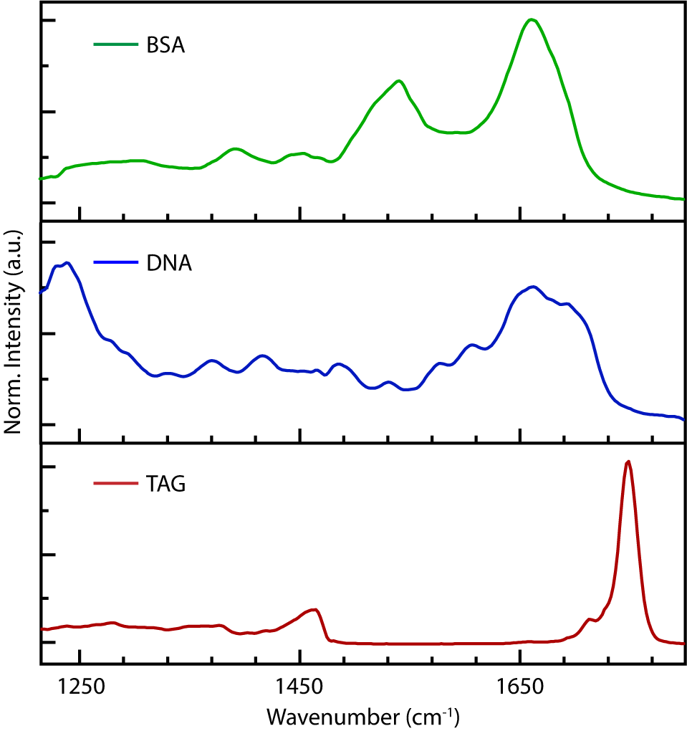
Supplementary Fig. 1 | MIP spectra of protein, nucleic acid, and lipid standards. BSA: bovine serum albumin; DNA: deoxyribonucleic acid; TAG: triglyceride.

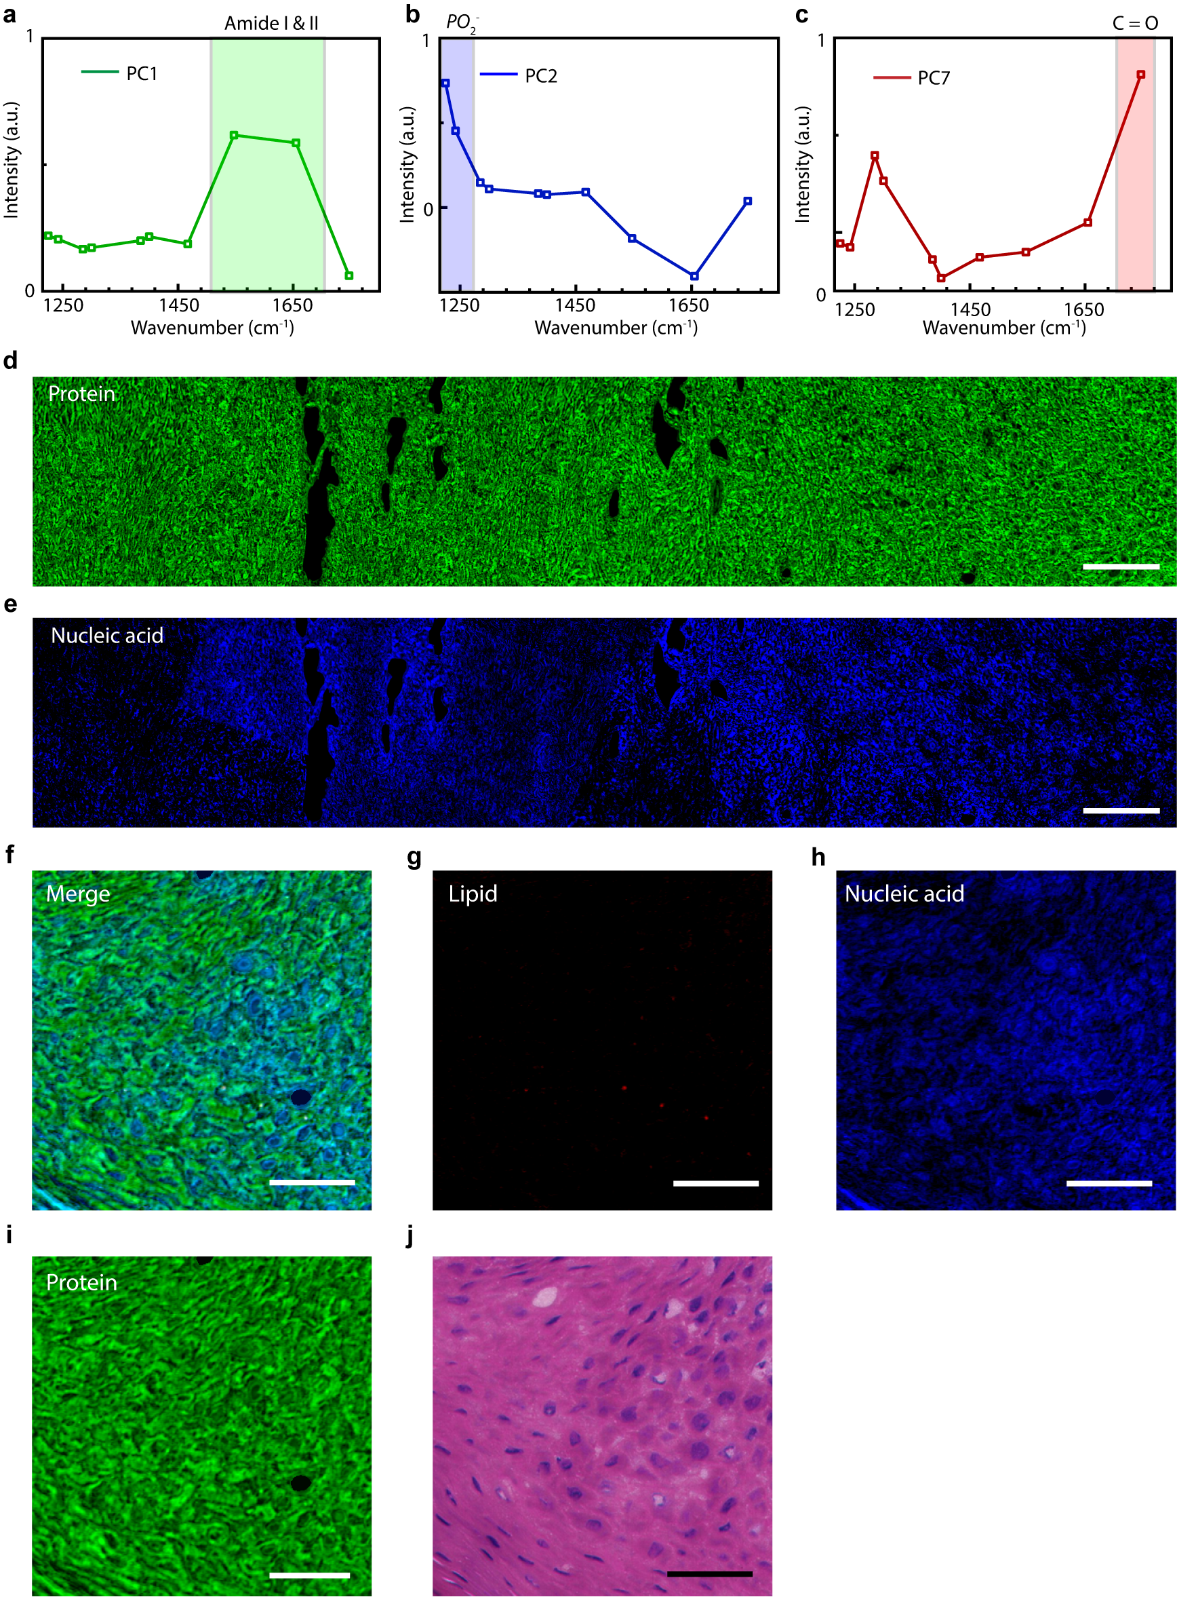
Supplementary Fig. 2 | PCA results of HN02 sample. (a-c) Spectra of principal components of proteins (a), nucleic acids (b), and lipids (c) extracted from PCA analysis. (d,e) Spatial distribution of proteins (d) and nucleic acids (e) in cancer and paracancerous region. Scale bars, 100 μm. (f-i) Composite MIP image (f) of normal epithelium from HN02 of major 3 components explained as lipids (red, g), nucleic acids (blue, h), and proteins (green, i). Scale bars, 50 μm. (j) H&E staining of adjacent frozen section. Scale bar, 50 μm.

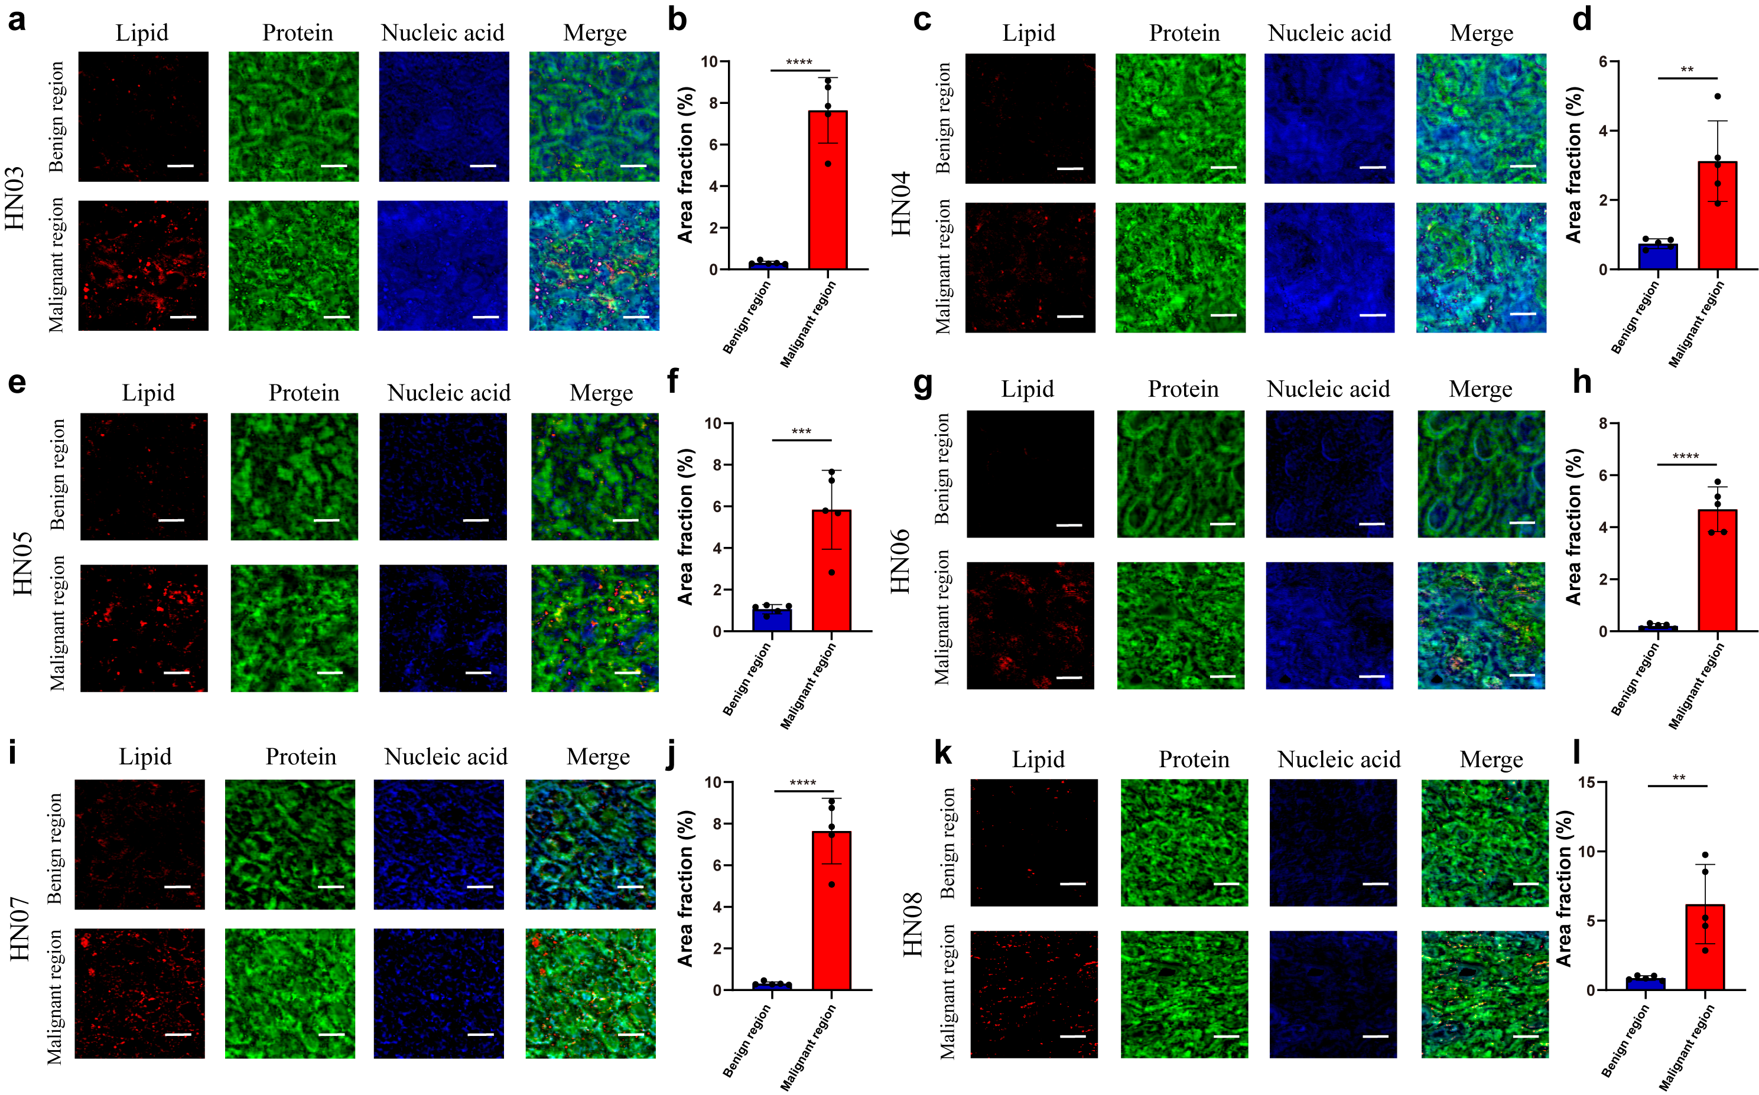
Supplementary Fig. 3 | Quantitative assessment of lipid contents in various patients. The red, green, and blue channels refers to lipids, proteins, and nucleic acids. Scale bars, 20 μm. (n=5, *P<0.05; **P<0.01; ***P<0.001; ****P<0.0001).

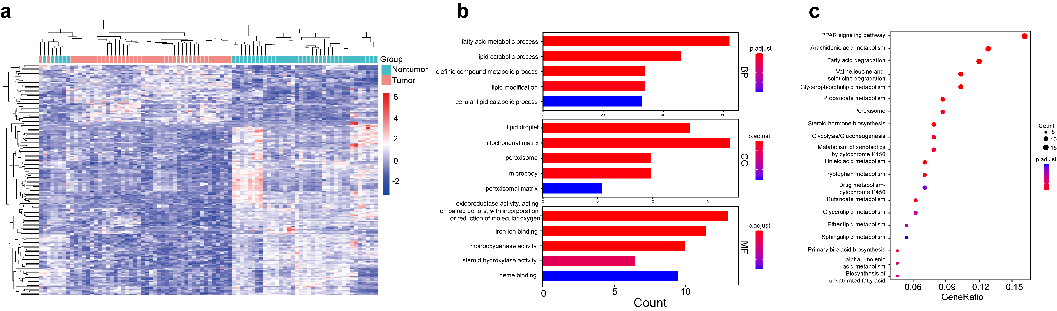
Supplementary Fig. 4 | TCGA-based transcriptomic profiling of lipid metabolism dysregulation. (a) Heatmap of lipid metabolism-related genes from RNA sequencing of HNSCC tumor regions and adjacent normal regions from the TCGA database. (b,c) GO (b) and KEGG (c) pathway enrichment analysis of differentially expressed genes.

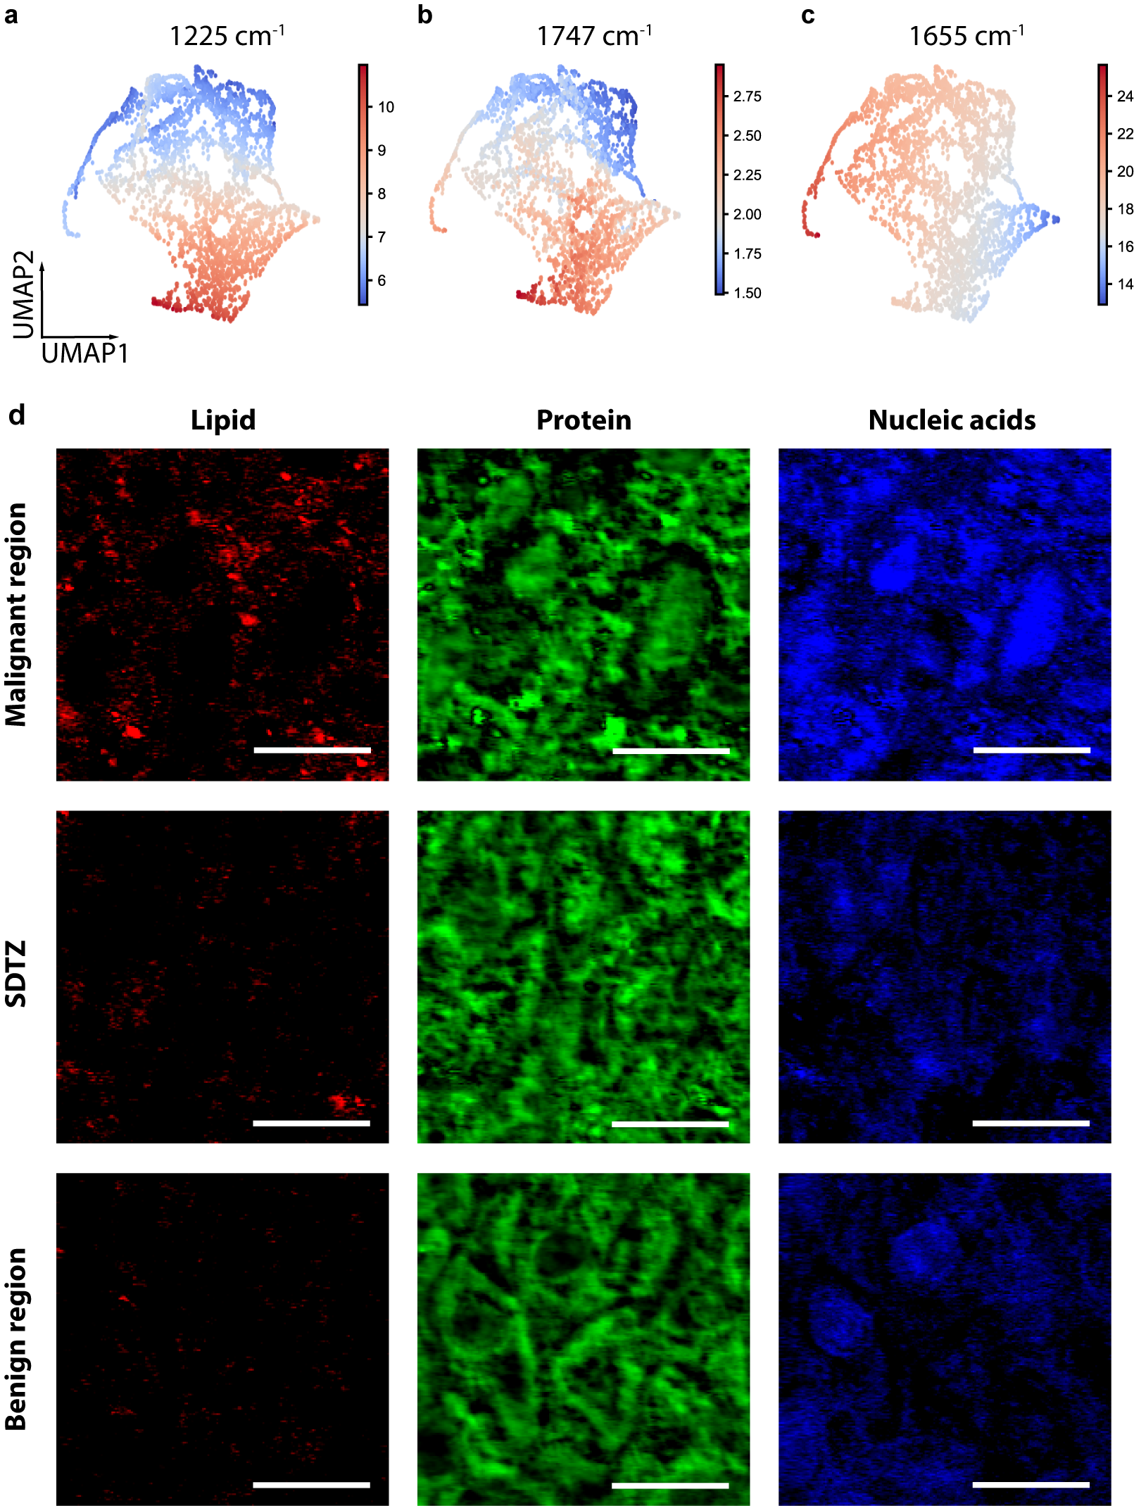
Supplementary Fig. 5 | Representative MIP images of malignant region, SDTZ, and benign region in HN09. (a-c) UMAP plot of relative intensities at 1225 cm⁻¹ (a), 1747 cm⁻¹ (b), and 1655 cm⁻¹ (c). (d) MIP images of malignant region, SDTZ and benign region, the red, green, blue channels refers to lipids, proteins, and nucleic acids. Scale bars, 20 μm.

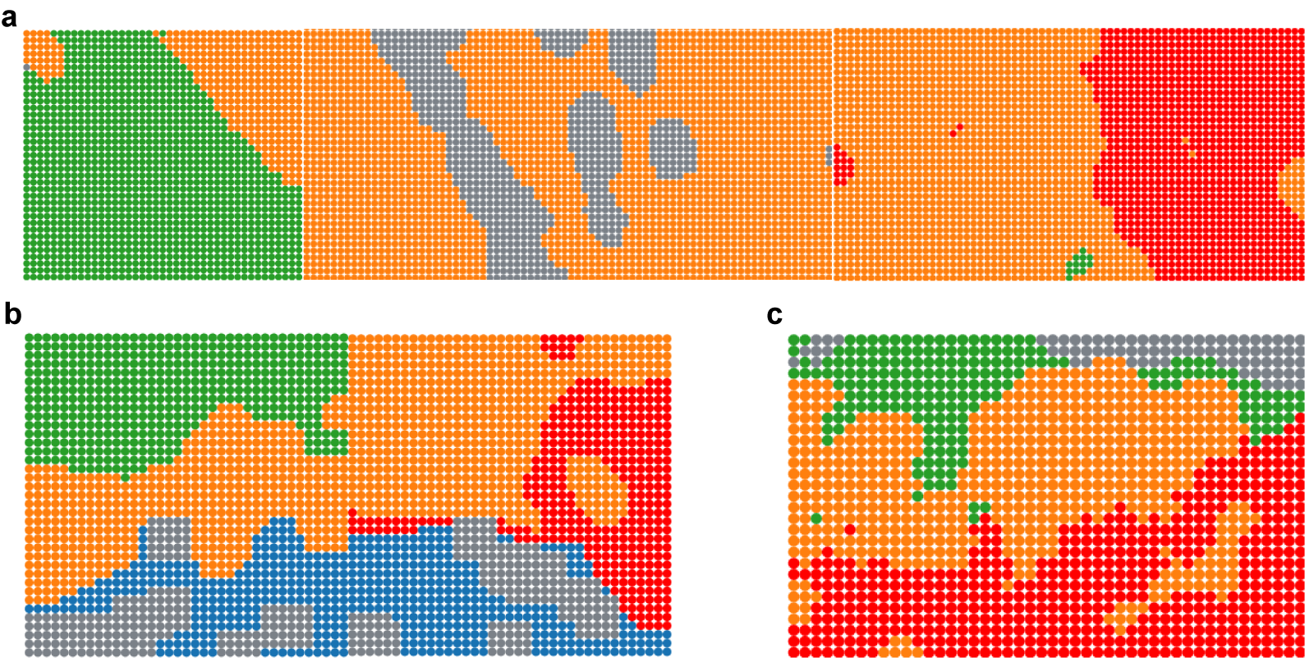
Supplementary Fig. 6 | Unsupervised segmentation of HNSCC margin from different tissue sites. (a-c) AI-enhanced MIP imaging divided the tissue section from tongue (a), larynx (b), and gingiva (c) into three regions: malignant region, SDTZ and benign region. Red dots: malignant region, yellow dots: SDTZ, green dots: benign region, blue dots: stromal region, gray dots: empty.

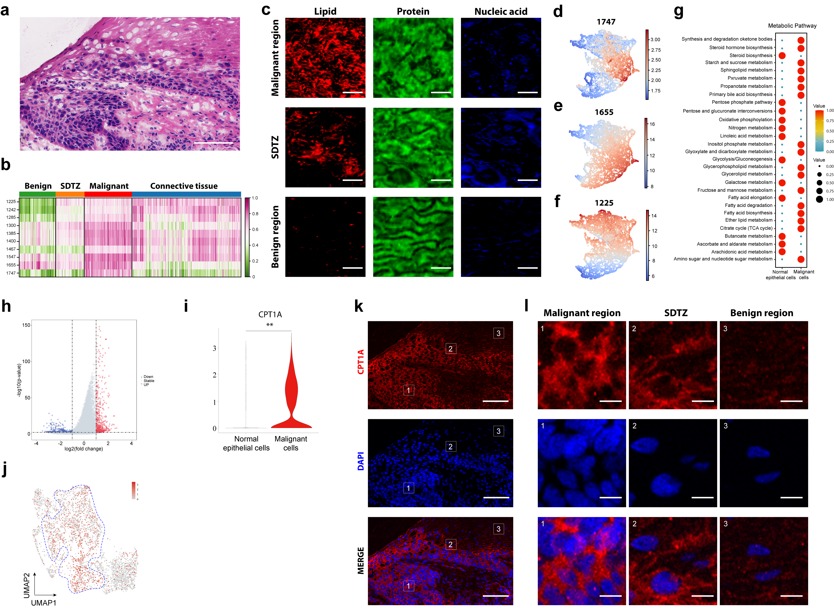
Supplementary Fig. 7 | Metabolic analysis of HN10 by MIP, snRNA-seq analysis, and IHC staining. (a) H&E staining of HNSCC frozen section from HN10. Scale bar, 100 μm. (b) Intensity distribution of dots at 10 wavenumbers. (c) MIP imaging of malignant region, SDTZ and benign region, the red, green, and blue channels refers to lipids, proteins, and nucleic acids (related to Fig. 4c-e). Scale bars, 10 μm. (d-f) UMAP plot of relative intensities at 1747 cm⁻¹ (d), 1655 cm⁻¹ (e), and 1225 cm⁻¹ (f). (g) Dot plot of metabolic activity in malignant cells and normal epithelial cells. (h) Volcano plot of differentially expressed genes between malignant and normal epithelial cells. (i) Violin plot of CPT1A in malignant cells compared with normal epithelial cells. (j) Expression of CPT1A in malignant and normal epithelial cells. (k) IHC images of CPT1A expression in adjacent section. Scale bars, 100 μm. (l) Zoom-in IHC images indicated in (k). Scale bars, 10 μm. *P<0.05, **P<0.01.

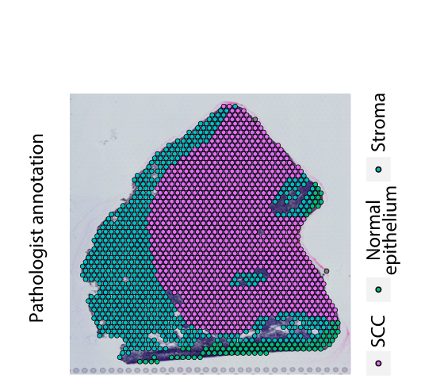
Supplementary Fig. 8 | Pathologist annotation of ST-sample1.

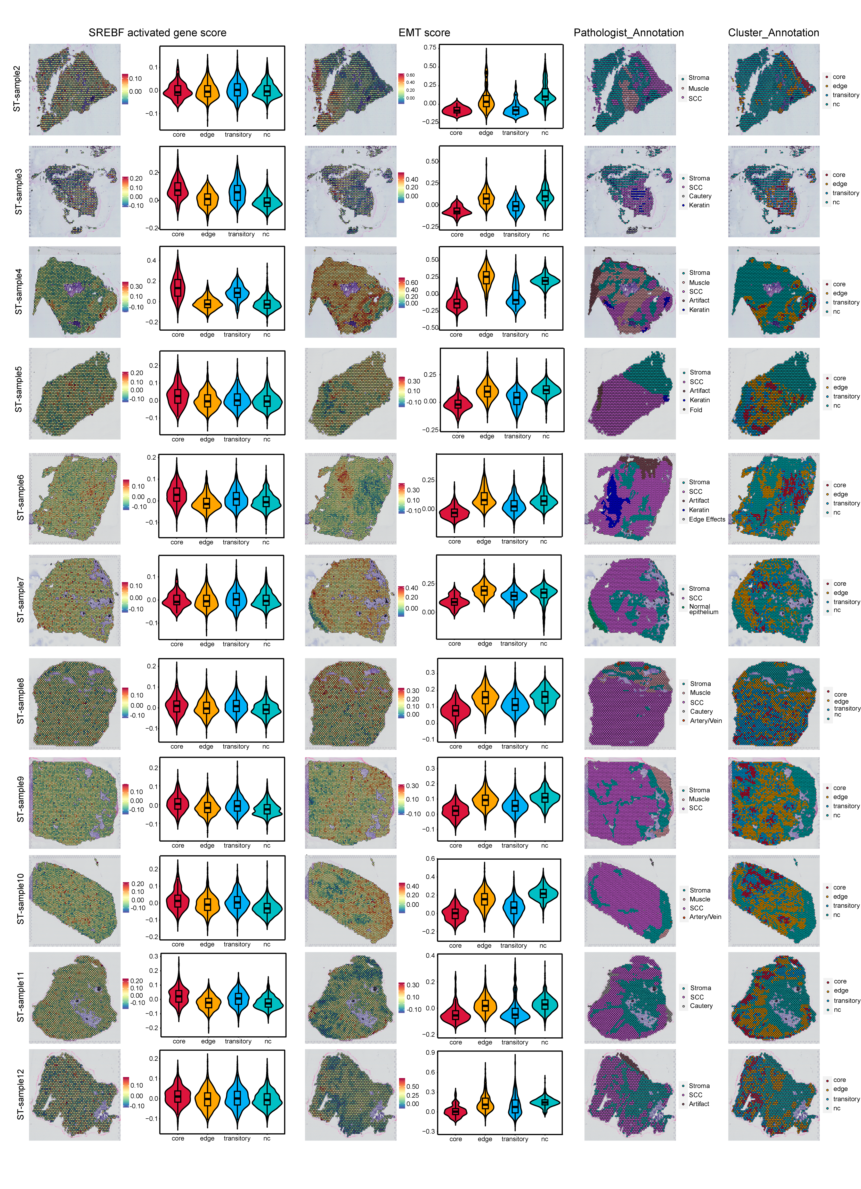
Supplementary Fig. 9 | SREBF activated gene score, EMT score, pathologist annotation and cluster annotation of ST-sample2 to ST-sample12.

Supplementary Table 1 | Performance comparison of various mid-IR imaging methods.
Methods | Modality | Spatial resolution | Sensitivity | Universal applicability | Label free | Throughput
Direct absorption | QCL-IR³² | 4-10μm | Low | √ | √ | Low
Nonlinear optics | Upconversion³³ | 4-10μm | Low | √ | √ | High
Nonlinear optics | ND-2PA^{34,35} | 4-10μm | Low | √ | √ | High
Nonlinear optics | VSFG^{36,37} | 1μm | Low |  | √ | Low
Nonlinear optics | TSFG³⁸ | 0.46μm | Low | √ | √ | Low
Photothermal based | Phase⁴⁴ | 0.45μm | High | √ | √ | High
Photothermal based | Fluorescence⁴⁶ | 0.3μm | High |  |  | Low
Photothermal based | Tomography⁴⁵ | 0.35μm | High | √ | √ | High
Photothermal based | Scattering OPTIR⁴⁰ | 0.4μm | High | √ | √ | Low

Supplementary Table 2 | Patient clinical and pathologic information for all samples used for analysis.
HN# | Gender | Age | Primary site | Pathologic T-Stage | Pathologic N-Stage | Pathologic M-Stage | Stage
1 | M | 54 | Left lateral tongue | T2 | N0 | M0 | Early-stage
2 | M | 44 | Right lateral tongue | T2 | N0 | M0 | Early-stage
3 | M | 64 | Left lateral tongue | T3 | N0 | M0 | Advanced-stage
4 | M | 66 | Left lateral tongue | T3 | N2b | M0 | Advanced-stage
5 | M | 53 | Left gingiva | T4a | N0 | M0 | Advanced-stage
6 | M | 68 | Left buccal mucosa | T3 | N0 | M0 | Advanced-stage
7 | M | 80 | hypopharynx | T3 | N1 | M0 | Advanced-stage
8 | M | 60 | Left gingiva | T4a | N0 | M0 | Advanced-stage
9 | FM | 81 | Palate | T2 | N0 | M0 | Early-stage
10 | FM | 58 | Right buccal mucosa | T2 | N0 | M0 | Early-stage
11 | M | 74 | Left ventral tongue | T1 | N2b | M0 | Advanced-stage
12 | FM | 57 | Left lateral tongue | T3 | N0 | M0 | Advanced-stage

