Supplementary materials
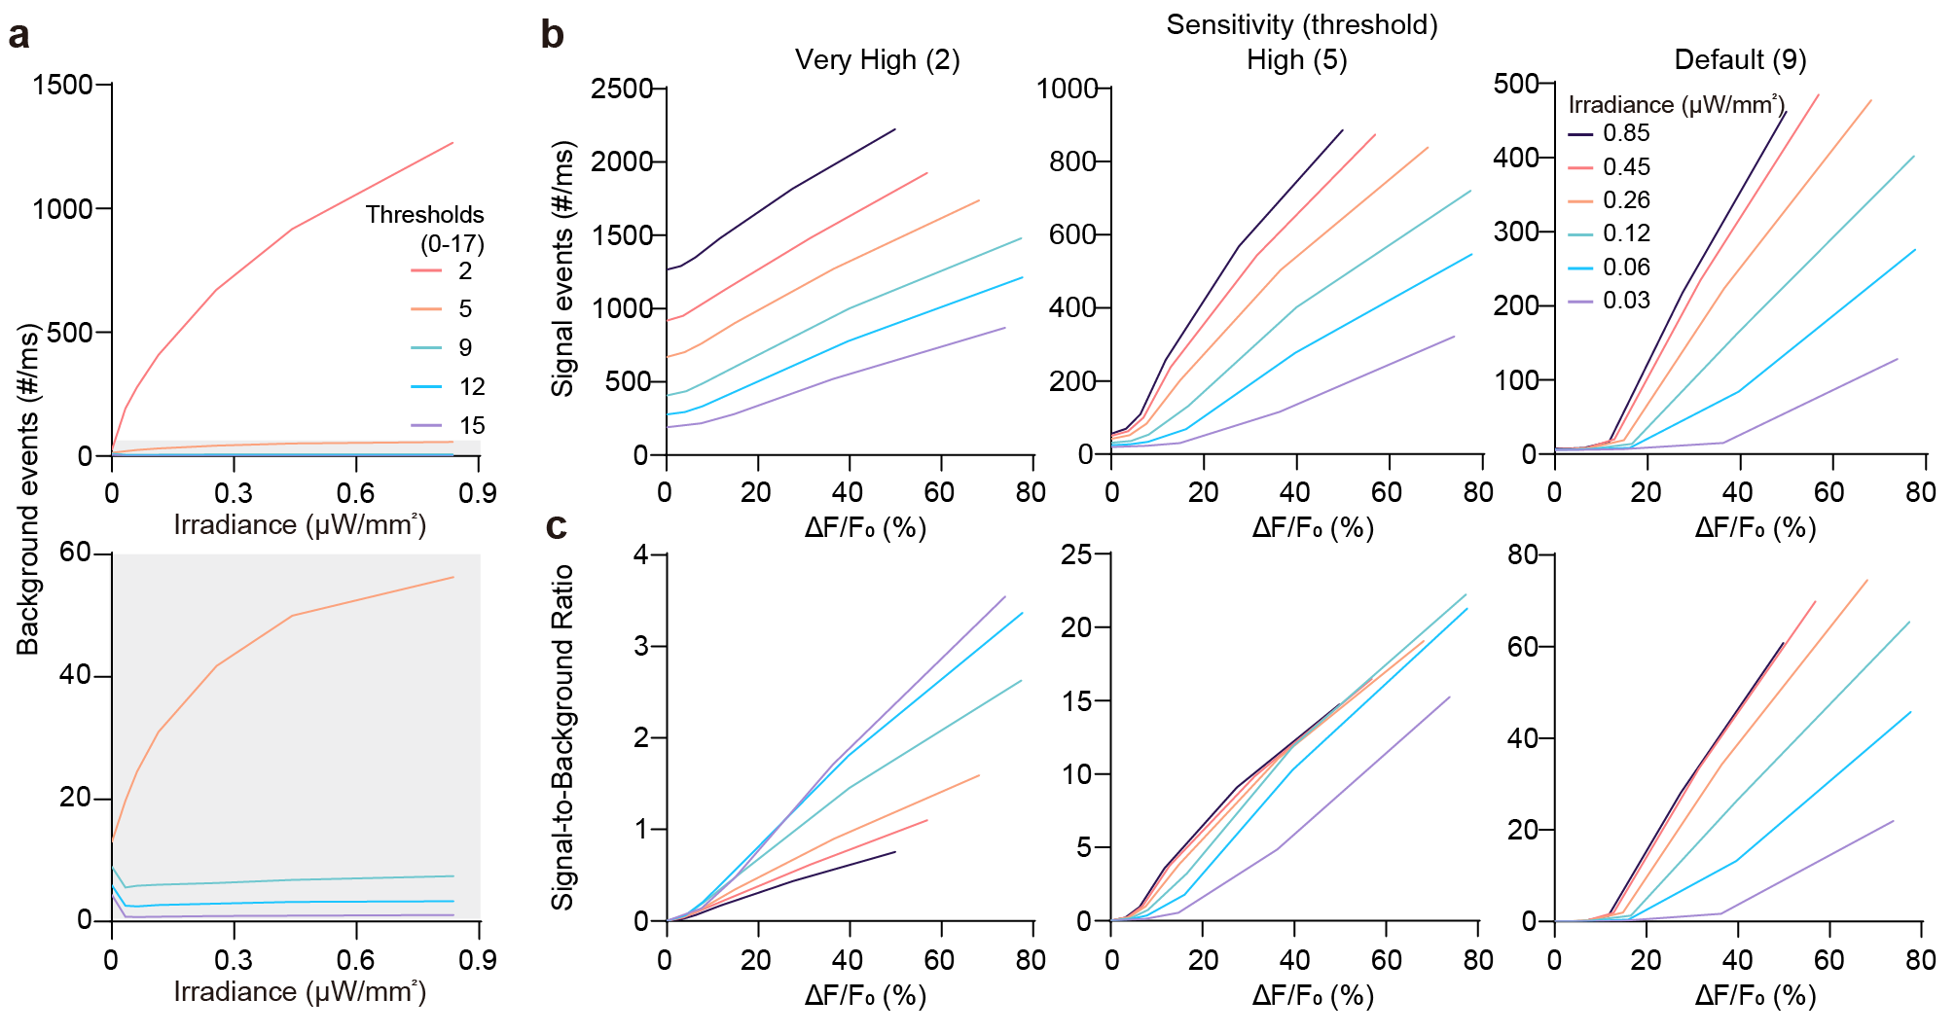
Figure S1. Optical characterization of event camera performance for threshold selection
a, Top, Background event rates measured under stable illumination across different irradiance levels and sensitivity thresholds. Lower thresholds produced more background events. Bottom, Background event rates for all thresholds except the highest. b, Event rates as a function of relative brightness change (ΔF/F₀) and irradiance at different sensitivity thresholds. c, Signal-to-background ratio (SBR) plotted against input ΔF/F₀ and irradiance for each threshold. At the lowest threshold, SBR decreased with increasing irradiance due to excessive background events.

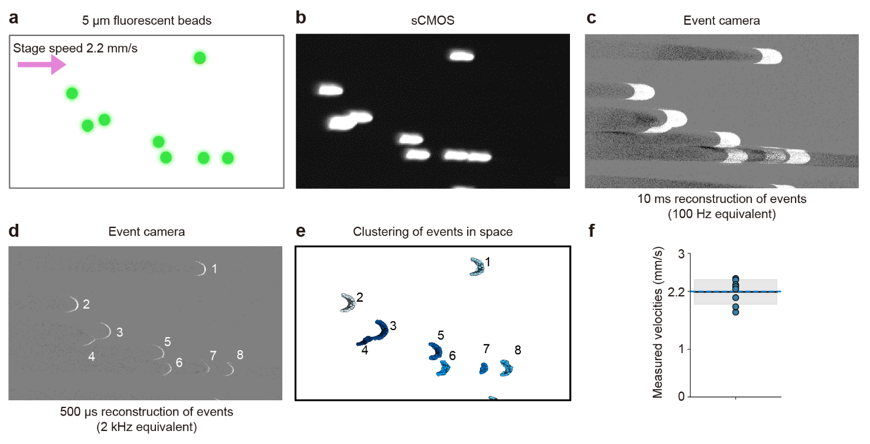
Figure S2. Validation of high-speed motion tracking using event-based imaging
a, 5 µm beads were imaged under controlled stage motion using an alternative event-based sensor model (IMX636, Sony) to confirm generalizability and high-speed tracking performance. b, Conventional sCMOS imaging shows motion blur at high speeds. c-d, Event-based imaging reconstructs motion at multiple temporal resolutions (10 ms ≈ 100 Hz; 500 µs ≈ 2 kHz), preserving bead edges and resolving overlapping trajectories. e, Individual bead trajectories were segmented by clustering in events within a 2 ms temporal window. f, Bead velocities were estimated by robust regression of spatiotemporal trajectories. Event-based velocity estimates closely matched the ground-truth stage speed (dashed line; mean: 2.19 ± 0.25 mm/s), confirming accurate, blur-free tracking. Minor inter-bead variations reflect expected differences in event density during translation.

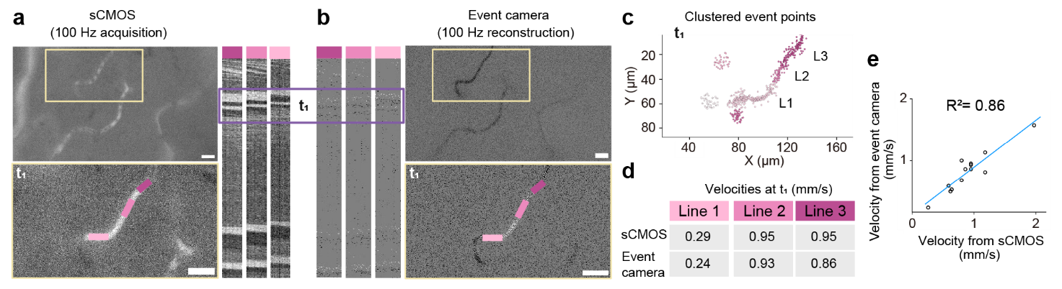
Figure S3. Validation of in vivo capillary blood flow velocity measured with an event-based camera.
a, Representative cortical capillaries in the mouse cortex recorded with an sCMOS camera at 100 Hz. The magnified region shows selected line profiles and their corresponding kymographs. b, Simultaneous acquisition from the same field of view using an event-camera recording (IMX636, Sony), reconstructed at 10ms intervals (100 Hz equivalent) to match the sCMOS frame rate. Both imaging modalities exhibit comparable streak patterns in kymographs, representing RBC trajectories. A representative streak at time point $t_{1}$ was selected for velocity estimation. c, Event points within a window at $t_{1}$were clustered based on local spatiotemporal velocity, revealing three distinct flow regions corresponding to the annotated line profiles in a and b. d, Velocity measurements for three representative flow paths derived from sCMOS and event-based data show close agreement. e, Correlation between sCMOS- and event-based velocity estimates across 13 streaks from two ROIs confirms robust consistency (R² = 0.86). Scale bars, 20 µm.

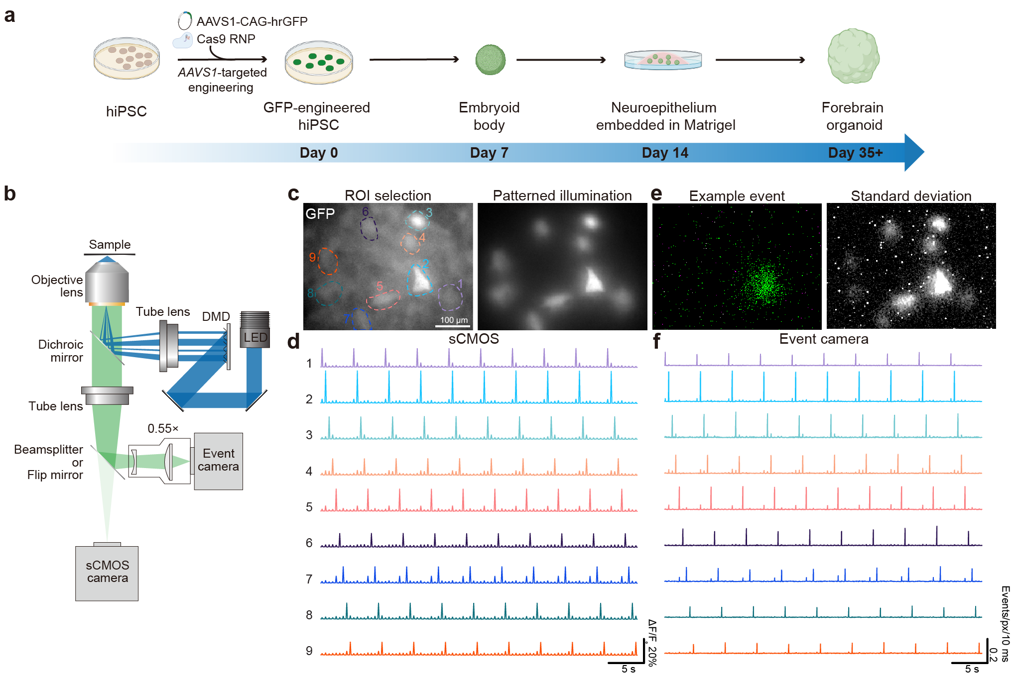
Figure S4. Feasibility study for imaging in scattering tissues with brain organoids
a, Generation of the GFP-engineered forebrain organoid for the feasibility study. b, Schematic illustration of the optical configuration. DMDs were used for patterned illumination. c, ROI selection and corresponding patterned illumination representative image acquired with sCMOS. d, Sequential patterned illumination of each ROIs imaged with sCMOS. e, Left, example event acquired with event cameras during sequential patterned illumination. Right, standard deviation image acquired from 100 Hz naïve reconstruction. Gaussian blur of 1 pixel was conducted prior to standard-deviation calculation. f, Sequential patterned illumination of each ROIs imaged with event cameras.

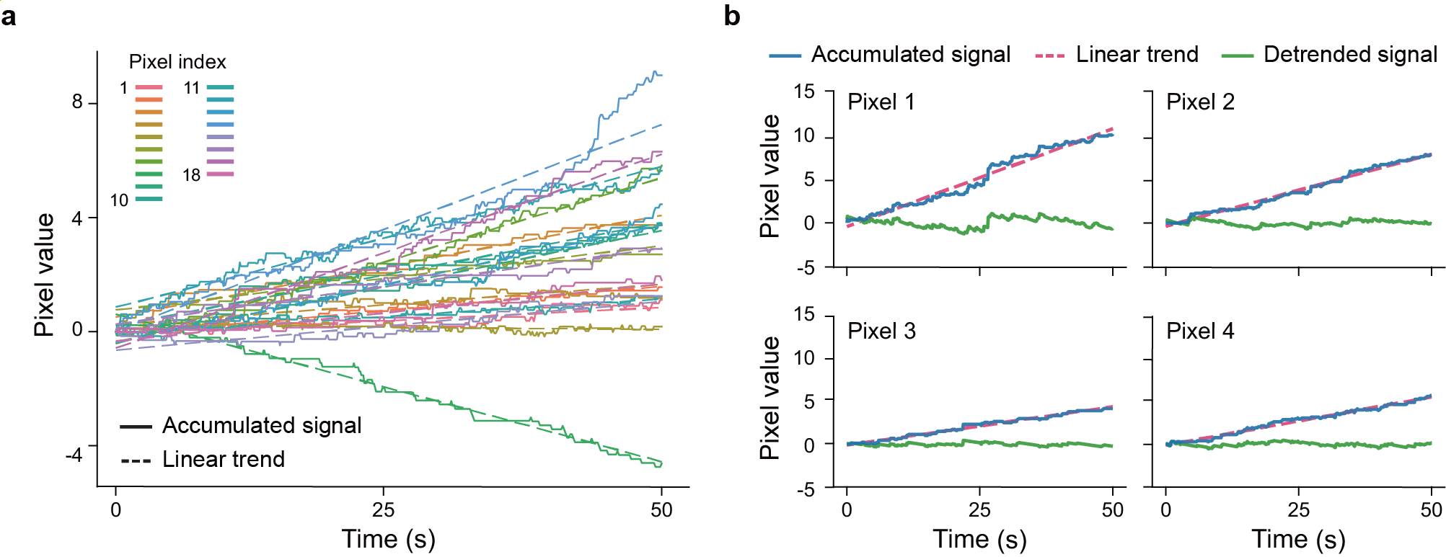
Figure S5. Linear detrending for baseline-drift removal in event-derived accumulated signals.
a, Accumulated signals (solid) from 18 representative pixels over a 50 s interval with least-squares linear fits (dashed) approximating baseline drift. b, Example detrending results for 4 representative pixels: accumulated signal (blue), fitted linear trend (magenta dashed), and detrended signal (green) obtained by subtracting the fitted trend.

