Supporting Information for

Miniaturized Computational Dispersion-Engineered Silicon Photonic Vernier Caliper Spectrometer

Hao Deng†, Tong Lin*†, Liu Li, Run Zhang, Yan Fan, Ziyang Xiong, Zelong Chen, Shihua Chen, Junpeng Lu*, and Zhenhua Ni

Hao Deng, Run Zhang, Yan Fan, Ziyang Xiong
School of Electronic Science and Engineering, Southeast University, Nanjing 210096, China.

Liu Li
School of Material Science and Engineering, Southeast University, Nanjing 211189, China.

Tong Lin
School of Electronic Science and Engineering, Southeast University, Nanjing 210096, China.
Key Lab of Modern Optical Technologies of Education Ministry of China, Soochow University, Suzhou 215006, China.
E-mail: lintong@seu.edu.cn

Zelong Chen
School of Integrated Circuits, Southeast University, Nanjing 210008, China.

Shihua Chen
School of Physics and Key Laboratory of Quantum Materials and Devices of Ministry of Education, Southeast University, Nanjing 210023, China.

Junpeng Lu, Zhenhua Ni
School of Electronic Science and Engineering, Southeast University, Nanjing 210096, China.
School of Physics and Key Laboratory of Quantum Materials and Devices of Ministry of Education, Southeast University, Nanjing 210023, China.

†These authors contributed equally.

Supplementary Note 1: FDTD simulations and theoretical model of the TSWG-MRR

This supplementary figure provides in-depth optical performance characterization of our designed TSWG-MRRs, highlighting the advantages over conventional microring resonator (MRR) designs and supporting the broadband, high-fidelity operation detailed in the main text. Figure S1a presents simulated time-integrated field profiles within the TSWG-MRR coupling region at three distinct operating wavelengths: 1.48 μm, 1.55 μm, and 1.64 μm. These simulations qualitatively illustrate the consistent light coupling from the bus waveguide into the resonator across the entire operational bandwidth. The uniform field distribution and coupling strength underscore the effectiveness of the trapezoid subwavelength grating design in achieving wavelength-insensitive coupling, which is critical for broadband spectral response.
A direct comparison of the wavelength-dependent performance between a normal MRR and our TSWG-MRR is presented in Fig. S1b. This plot quantitatively demonstrates the superior and more stable performance of the TSWG-MRR (blue trace with circles) across the 1.48 µm to 1.64 µm wavelength range, compared to a conventional MRR with a directional coupler (black trace with circles). The significantly lower and flatter FWHM curve for the TSWG-MRR indicates its enhanced spectral uniformity and reduced wavelength-dependent losses, crucial for maintaining high quality factor and consistent Vernier resonance over a broad spectrum. This result validates the benefits of our advanced TSWG design for mitigating performance degradation across an extended operational window.
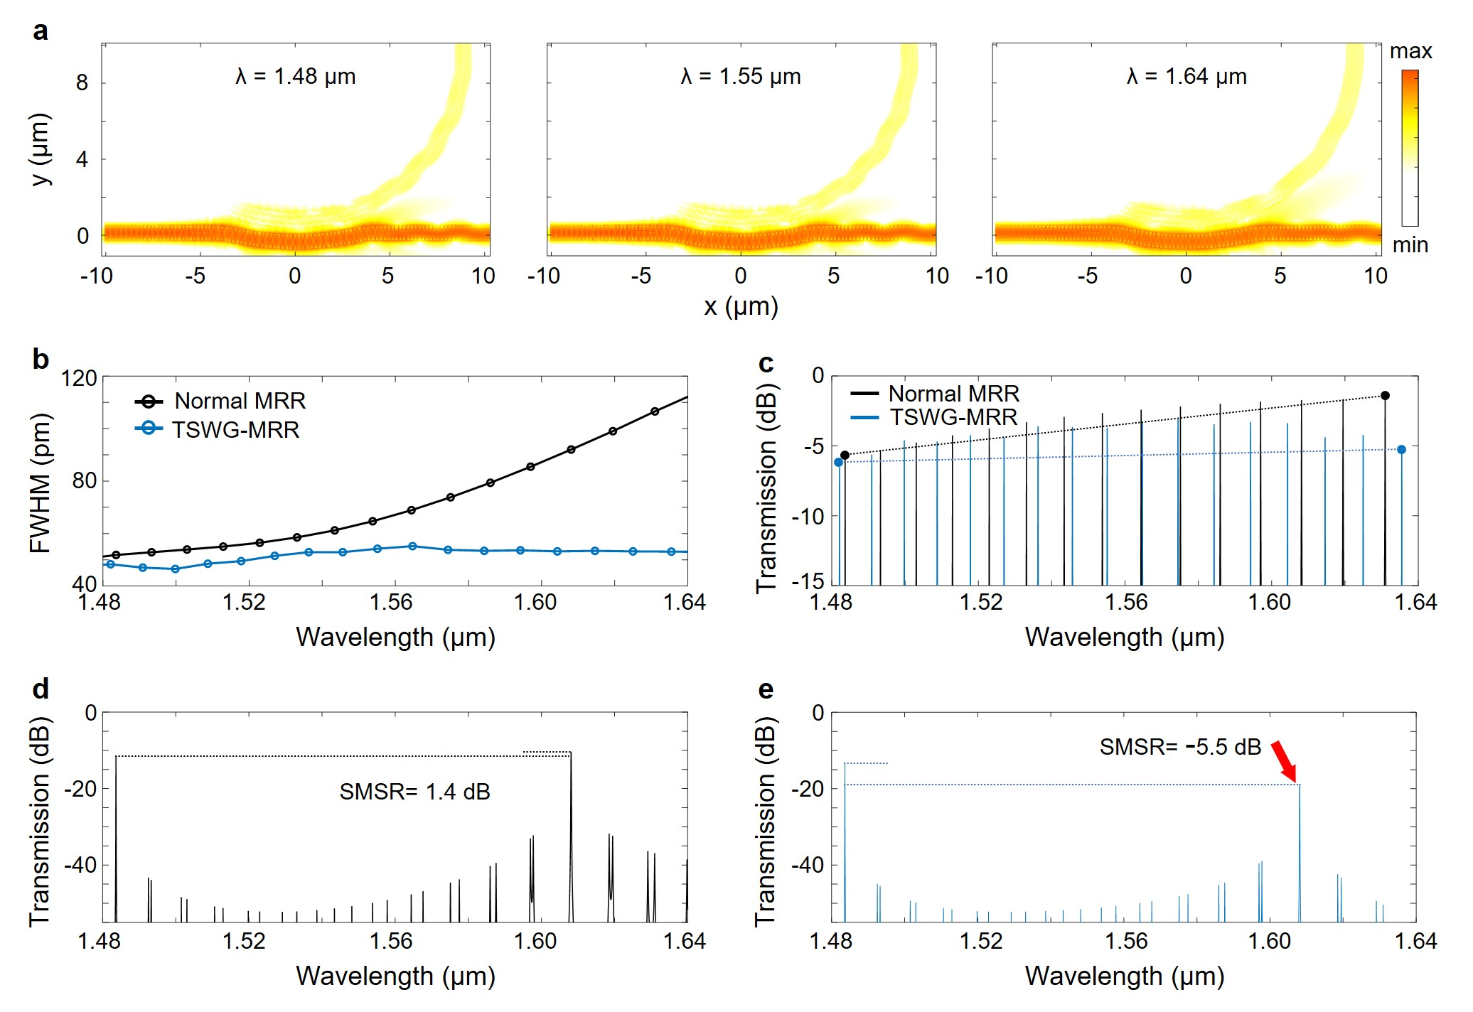
Fig. S1. a Simulated time-integrated field profiles in the coupling region of one TSWG-MRR at three different wavelengths and the coupling coefficients are around 0.006 to 0.007. b Simulated FWHM variations of the TSWG-MRR and one conventional MRR. c Simulated drop port transmission spectra of the TSWG-MRR and one conventional MRR. d Transmission spectrum of the cascaded normal MRRs when one Vernier resonance around 1.48 µm is enabled. e Transmission spectrum of the cascaded TSWG-MRRs when one Vernier resonance around 1.48 µm is enabled.

Figure S1c shows simulated transmission spectra of the TSWG-MRR’s drop port across the broad 1.48 µm to 1.64 µm range. The drop port transmission is calculated using the canonical model (Ref.29 in the main text) based on the simulated coupling coefficients from the FDTD method:
$$\begin{aligned}T_{drop}=\frac{k^{4}a}{1-2a\left(1-k^{2}\right)\cos\left(ϕ\right)+a^{2}{\left(1-k^{2}\right)}^{2}}\#\left(S1\right)\end{aligned}$$
where $k$ is the coupling coefficient between the waveguide and the MRR, $a$ is the round-trip loss factor inside the ring, $ϕ=\frac{2πn_{\text{eff}}L}{λ}$ is the round-trip phase shift inside the ring, L is the MRR circumference, n_{eff} is the effective refractive index of the waveguide mode, and $λ$ is the operating wavelength. Crucially, the uniformity of insertion loss at the wavelength edges (i.e., 1480 nm and 1640 nm) is of extreme importance for the effective generation of Vernier resonances and achieving a high SMSR. For a normal MRR, the insertion loss variation at these edges can be as high as 4.2 dB, which severely degrades the SMSR of the Vernier resonance. In contrast, our TSWG-MRR design provides significantly improved uniformity, exhibiting only approximately 1 dB variation at the wavelength edges. To show how the insertion loss variation affects the Vernier effect, Figs. S1c-e compares the simulated transmission spectra of cascaded conventional MRRs and TSWG-MRRs, with a targeted Vernier resonance peak at 1483.6 nm. For the conventional MRR cascade, a competing Vernier peak emerges at 1608.1 nm, resulting in a SMSR (1.4 dB) that impedes photodetection at the primary wavelength of 1483.6 nm. In contrast, the TSWG MRR cascade exhibits significantly enhanced SMSR (-5.5 dB) by suppressing the secondary peak at 1608.1 nm, thereby enabling ultrabroadband spectral scanning capabilities. This superior uniformity of our design experimentally corroborates the broadband and consistent coupling characteristics enabled by the TSWG, ensuring robust and high-performance Vernier operation across the full spectral range. The optimized structural parameters of two TSWG-MRRs are listed in table S1.
Table S1. Structural parameters for the two TSWG-MRRs
 | Width  [μm] | R₁  [μm] | R₂  [μm] | gap  [nm] | α  [°] | d₁  [nm] | d₂  [nm] | g₁  [nm] | g₂  [nm]
TSWG-MRR_{a} | 0.75 | 9.625 | 10.751 | 376 | 44.8 | 127 | 140 | 82 | 80
TSWG-MRR_{b} | 0.75 | 8.875 | 10.011 | 440 | 44.4 | 120 | 140 | 84 | 80

Supplementary Note 2: Simulation of the TE-pass polarizer

To ensure only TE-polarized light entering the spectrometer, we designed a compact TE-pass polarizer using adiabatically-bent waveguides^{[1]}. It consists of 10 cascaded adiabatic Euler bends with constant width of 0.5 μm; each bend features a minimum radius of 1.5 μm (R) curvature and a bending angle of 105° (β), yielding a compact footprint of approximately 62 × 9.3 μm². Figure S2 shows the simulated transmission spectra for both TE and TM modes. Within the wavelength range from 1.48 μm to 1.64 μm, the polarizer exhibits an average insertion loss of 0.42 dB for the TE mode and an average polarization extinction ratio of 38.06 dB. Such a compact and efficient polarizer ensures that most TM-polarized light can be suppressed, without affecting the spectrometer’s signal-to-noise ratio.
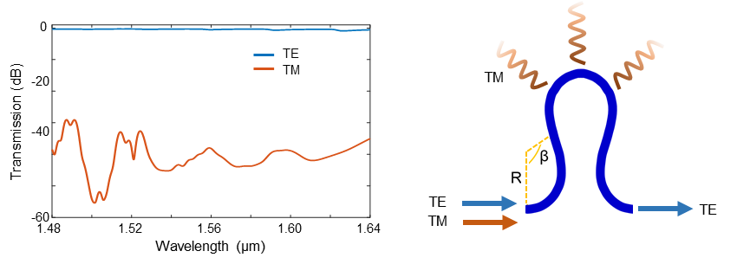
Fig. S2. Simulated insertion loss and polarization extinction ratio of the TE-pass polarizer for the wavelength from 1.48 μm to 1.64 μm. The right panel shows a unit of the adiabatic Euler bend.

Supplementary Note 3: The peak deconvolution algorithm optimization process

This optimization process proceeds in multiple stages. Starting with an initial guess for the spectral intensity S, typically derived from low-resolution measurements, the L-BFGS algorithm iteratively updates the spectral model by minimizing the objective function. Each iteration adjusts the spectral amplitude and smoothness, progressively improving the spectral resolution. $R_{\text{smooth}}\left(S\right)$ and $R_{\text{sharp}}\left(S\right)$ represent smoothness and sharpness regularization terms and are calculated using:
$$\begin{aligned}R_{\text{smooth}}\left(S\right)=\frac{1}{N-1}\sum_{i=1}^{N-1}{{\left(S_{i+1}-S_{i}\right)}^{2}}\#\left(S2\right)\end{aligned}$$
$$\begin{aligned}R_{\text{sharp}}\left(S\right)=\frac{1}{N-2}\sum_{i=1}^{N-2}{w_{i}{\left(Δ^{2}S_{i}\right)}^{2}}\#\left(S3\right)\end{aligned}$$
where N denotes the total number of sampled wavelengths, S_{i} is the reconstructed spectral intensity at the i_{th} wavelength, and the adaptive weight $w_{i}$ is defined as:
$$\begin{aligned}w_{i} = \frac{1}{1 + {\left(\frac{S_{i}}{S_{max}}\right)}^{2}},S_{max}=\max_{1≤j≤N}{{(S}_{j})}\#\left(S4\right)\end{aligned}$$
and is used to modulate the second-order finite-difference penalty ($Δ^{2}S_{i}=S_{i+2}-2S_{i+1}+S_{i}$) so as to preserve large-amplitude peaks while still enforcing smoothness. The regularization weights W_{reg} and W_{sharp} are meticulously selected to balance noise suppression and spectral detail preservation.
A three-stage L-BFGS strategy is adopted, in which the soft-max smoothing parameter α—which governs how closely the soft-max operation approximates a hard maximum, balancing differentiability and sharpness—is progressively reduced to emphasize fine spectral features while still maintaining a reasonable fit to the measured data. Here the soft-max operator is defined component-wise for any vector v by
$$\begin{aligned}\text{softmax}{\left(v\right)}_{k}=\frac{\exp\left(v_{k}\right)}{\sum_{j}{\exp\left(v_{j}\right)}}\#\left(S5\right)\end{aligned}$$
Once the optimization converges, the final optimized spectral intensity S(λ) is normalized to yield the final reconstructed power spectrum. This reconstructed spectrum successfully resolves closely spaced spectral peaks that would otherwise remain unresolved, thus demonstrating the effectiveness of the optimization-based reconstruction method in surpassing the conventional resolution limits of chip-scale spectrometers.

Supplementary Note 4: Progressive investigation of the spectrometer resolution using two tunable lasers

Figure S3(a) shows the optical test setup for characterizing the device optical properties and the two tunable laser sources that are used to produce the dual peak signals.
Figure S3(b) presents the spectrometer's reconstruction results for various wavelength separations between two narrow input peaks using both physically and algorithmically reconstructed methods. The top panel shows that the test spectrum with a wavelength spacing of 90 pm is clearly distinguished using either method. The linewidth of the retrieved spectrum is not as narrow as that of the laser sources, which is consistent with the device's intrinsic physical resolution (around 90 pm). Upon algorithm implementation, the spectrometer resolves a 3.6-pm-spaced dual-peak spectrum with a relative reconstruction error $ε$of 0.0203 as compared with the physical method; it also resolves this peak separation without presence of any unwanted artifact.
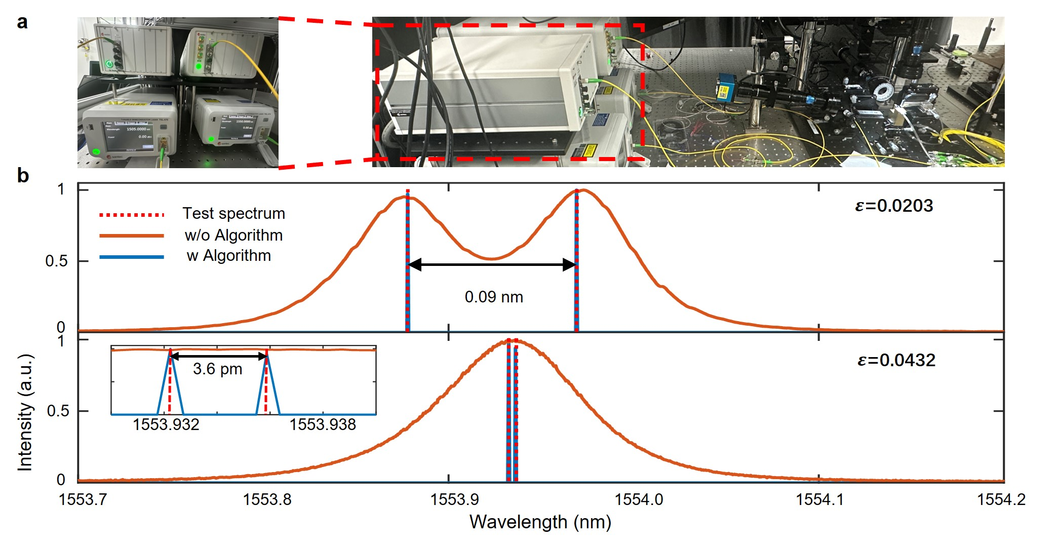
Fig. S3. a Photograph of the optical testing platform and two of the tunable lasers. b Retrieved spectra with two different double peak signals; their wavelength spacings are 90 pm and 3.6 pm respectively. The red dotted line is the input source; the orang solid line is the physical reconstruction; the blue solid line is the algorithmically reconstruction.

Supplementary Note 5: Analysis of the spectral scanning time

The measurement time of the chip-scale silicon photonic spectrometer was evaluated by characterizing the thermo-optic response time of the integrated microheater, demonstrating its fast-scanning capability. Initially, the resonant wavelengths of both TSWG-MRRs were aligned by applying appropriate bias voltages. The laser wavelength was then set near the FWHM of TSWG-MRR_{a}, namely in the linear small-signal thermo-optic response region ^{[2,3]}. A 1 V peak-to-peak square-wave signal was applied to the microheater positioned above TSWG-MRR_{a}. The resulting resonator response was monitored using an external photodetector connected directly to an oscilloscope. As shown in Fig. S4, the measured response time of this resonator/microheater system is approximately 0.154 ms. Given the microheater electrode resistance of 202 Ω, the corresponding applied power was calculated as 4.95 mW. Furthermore, the thermal tuning efficiency for a TSWG-MRR was measured to be 92.9 pm/mW. Under an applied electrical power of 109.2 mW, a resonant wavelength shift of 10.2 nm was achieved. Based on the measured response time and the tuning range per unit power, the scanning speed of our spectrometer is derived to be 0.335 ms/nm, enabling fast spectral measurements.
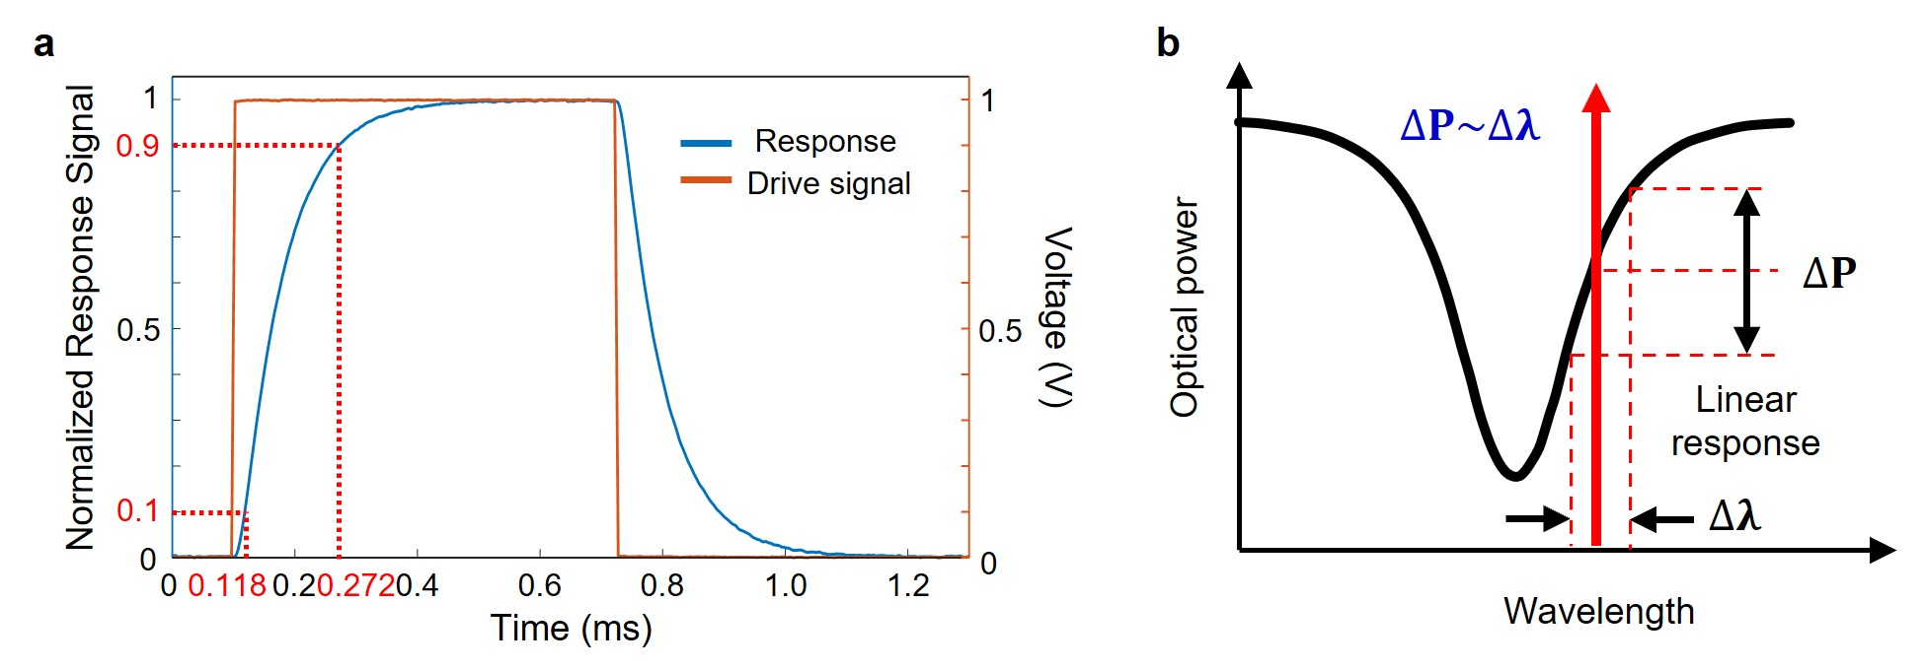
Fig. S4. The square-wave signal applied to the heating electrode above the microring resonator and the response signal of the TSWG-MRR_{a} microheater.

Supplementary Note 6: Details of the electro-photonic system

To enable system-level integration of the spectrometer, we packaged the photonic chip and developed the complementary electronic modules. Figure S5 shows a photograph of the packaged chip, the necessary electronic circuits, the AI development board and a 2.4-inch screen color display, with complex wiring omitted for clarity.
We employ an STM32 microcontroller (model STM32F103) as the main control unit to coordinate various electronic modules. Via the SPI interface, the MCU drives a digital-to-analog converter (DAC8568) to generate an electrical signal with linearly ramping power, which tunes the resonance peaks of the spectrometer chip for spectral scanning. The optical output from the chip is converted into an electrical signal by a photodetector (PD) and then digitized by a 16-bit analog-to-digital converter (AD7606). This ADC also communicates with the STM32 through SPI. Using the digitized data acquired from the ADC, the MCU reconstructs a preliminary measurement spectrum. For results requiring a higher resolution, the STM32 transfers the data to a Jetson Nano for advanced processing, retrieves the optimized results, and finally displays them on a screen. Communication with both the Jetson Nano and the display is accomplished via a UART serial link.

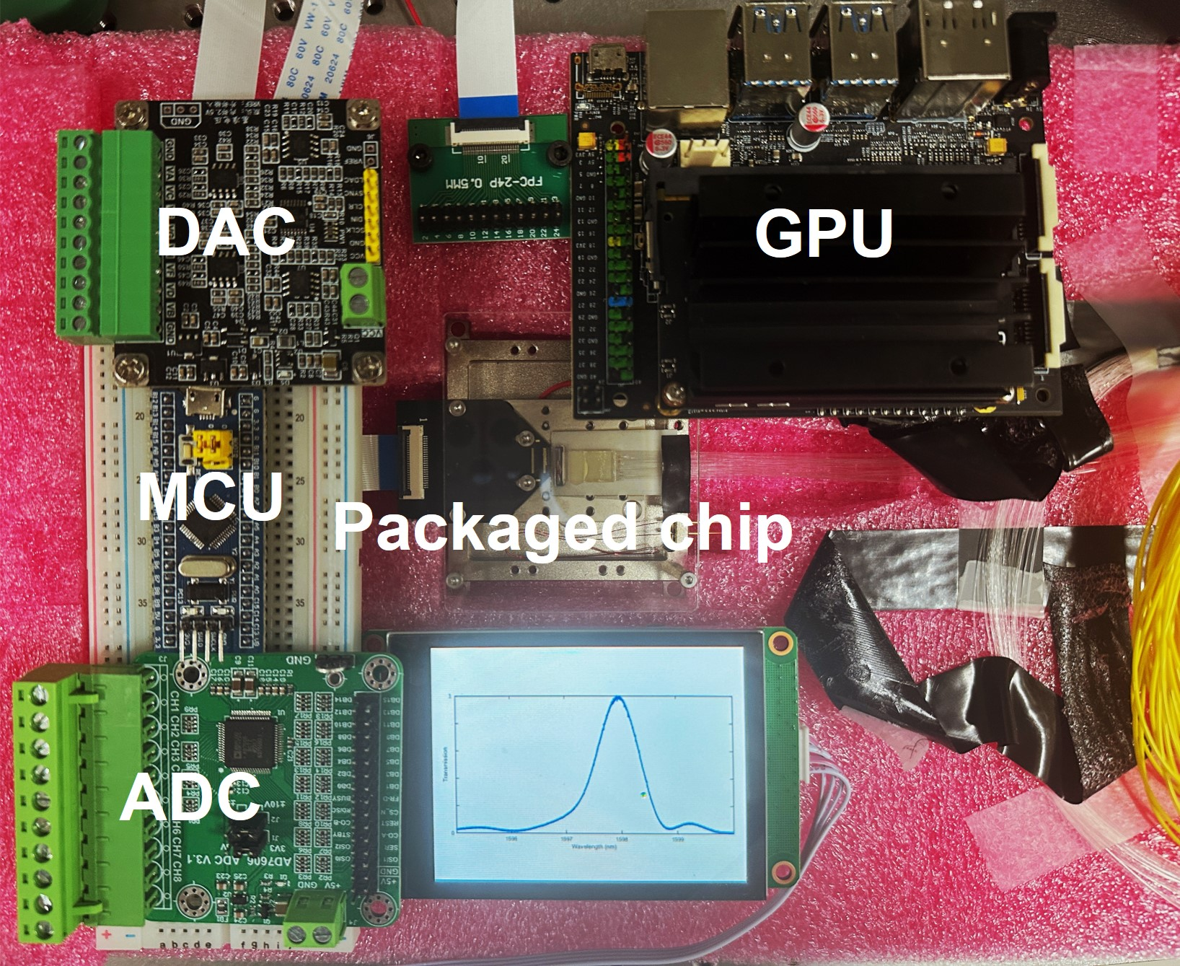
Fig. S5. The photograph of the NVIDIA AI module (Jetson Nano Develop Kit B01) and the packaged photonic chip with electrical/optical interfaces and the heater sink.

Supplementary Note 7: Optical micrograph images of the MZI lattice filter and AWG photonic chips

Figure S6 shows a micrograph of the on-chip MZI array and AWGs used to generate the spectrum for reconstruction. They are fabricated in another Silicon MPW run provided by Applied Nanotools Inc.
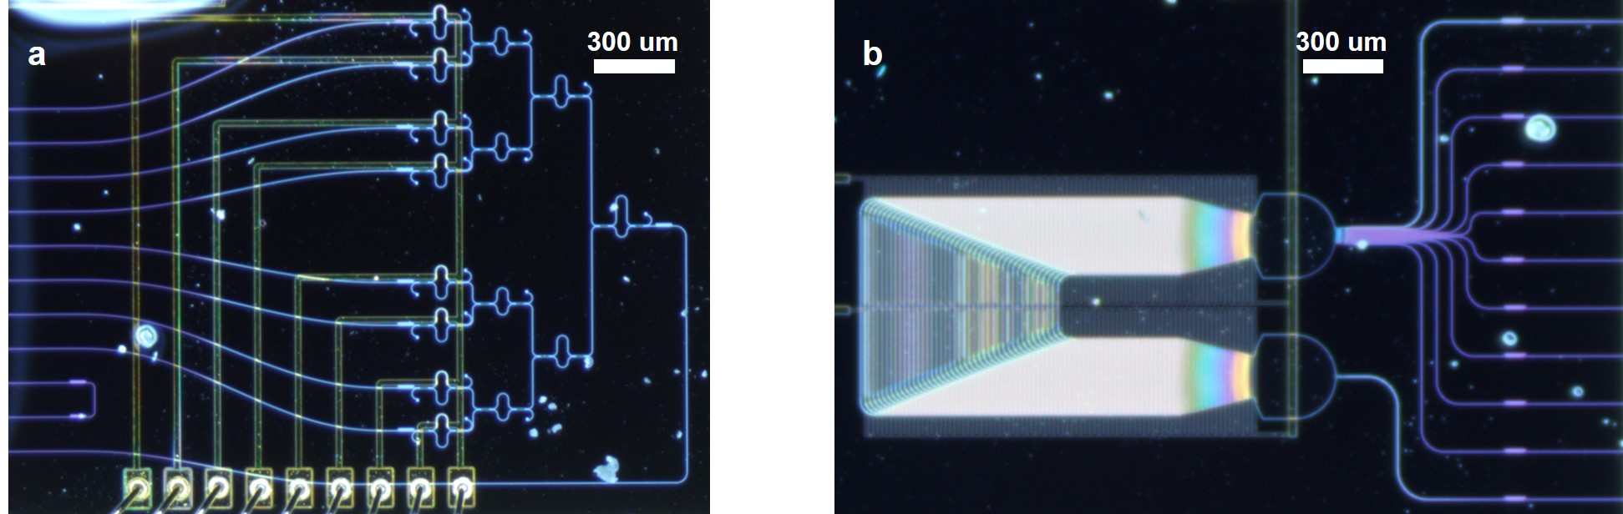
Fig. S6. Micrograph of the silicon photonic MZI lattice filter and the AWG.

References
[1] H. Zafar, P. Moreira, A. M. Taha, B. Paredes, M. S. Dahlem, A. Khilo, Opt. Express 2018, 26, 31850.
[2] U. D. Dave, G. R. Bhatt, J. R. Rodrigues, I. Datta, M. Lipson, Nanophotonics 2024, 13, 3945.
[3] M. Bahadori, A. Gazman, N. Janosik, S. Rumley, Z. Zhu, R. Polster, Q. Cheng, K. Bergman, J. Light. Technol. 2018, 36, 773.

