Supplementary Information for
High-fidelity in-situ spectroscopy under thermal extremes enables cross-scale validation of the Chang’e-6 landing area
Jinning Li^{1†}, Xuming Shi^{2,3†}, Bin Liu⁴, Rong Wang¹, Zhendong Wang¹, Meizhu Wang¹, Gang Lv¹, Liyin Yuan¹, Qian Ma^{2,3}, Guoliang Yuan², Rui Xu^{1*}, Chunlai Li^{1*}, Fang Wang^{2*}, Zhiping He¹*
- Key Laboratory of Space Active Optoelectronics Technology, Shanghai Institute of Technical Physics, Chinese Academy of Sciences, Shanghai 200083, China
- State Key Laboratory of Infrared Physics, Shanghai Institute of Technical Physics, Chinese Academy of Sciences, Shanghai, 200083, China
- Shanghai Research Institute for Intelligent Autonomous Systems, Tongji University, Shanghai, 201210, China
- Key Laboratory of Lunar and Deep Space Exploration, National Astronomical Observatories, Chinese Academy of Sciences, Beijing 100101, China
†These authors contributed equally to this work: Jinning Li, Xuming Shi.
*Email：xurui@mail.sitp.ac.cn; lichunlai@mail.sitp.ac.cn; fwang@mail.sitp.ac.cn; hzping@mail.sitp.ac.cn

Supplementary Text

Design of CE-6 LMS
The LMS mainly consists of an optical structure, an electronic unit, a two-dimensional scanner mechanism, and a dustproof calibration unit, as shown in Fig. S2. The optical lenses, detectors (including a CMOS array detector and three infrared detectors), and the AOTFs are all integrated onto the optical structure. AOTF is a solid-state device that uses acoustic waves to diffract specific light wavelengths via radio-frequency tuning, enabling rapid, precise spectral selection. Ideal for deep-space missions, its compactness, durability, fast response, and multi-wavelength capability support efficient analysis of celestial surfaces and atmospheres with minimal power and operational risk¹⁻¹¹.
To shield this assembly from external temperature fluctuations, it is thermally insulated and mounted within a dedicated mounting base structure. The two-dimensional (2D) scanner mechanism is driven by two ultrasonic motors to rotate the pointing mirror. It is thermally insulated and mounted on the underside of the mounting base, enclosed within the dustproof calibration unit. The dustproof calibration unit, thermally insulated and attached to the front of the base, remains closed before the instrument is operational, providing dust and thermal protection. Embedded within the unit are two calibrated diffuse panels (an aluminum diffuse and a gold-coated diffuse), which enable in-flight calibration when the unit is opened. The electronic unit consists of signal processing circuits, an FPGA main control circuit, and motor drive circuits, all designed in a plug-in board structure and fixed to the mounting base.
The LMS is installed on the inner side of the slanted +Z-Y panel of the CE-6 lander with a mounting height of about 1.4 m, and the exterior is clad with heat-insulating multilayers, as shown in Fig.5b. Upon landing on the lunar surface, the dustproof calibration unit is in a closed state. Once the operation commences, the dustproof calibration unit opens, revealing the two-dimensional scanner mechanism, which is then utilized to perform spectral detection of the regions of interest on the lunar surface.
The main working principle of the LMS is that solar radiation is reflected by minerals on the lunar surface and then incident onto the field of the view of LMS, as shown in Fig. S3. Diffracted by an AOTF, quasi-monochromatic light of a certain wavelength is formed in the next step. The spectral information of the target is obtained when it converges to the unit detector through the converging mirror. A spectral image of the target is obtained when it converges with the area-array detector. By changing the modulation frequency of the AOTF, thus changing the wavelength of the light wave transmitted through it, the desired spectral curve and the spectral image of the specified wavelength are finally obtained. Simultaneously, through the integrated design of the two-dimensional rotating pointing mechanism, the pointing mirror is rotated according to the requirements of realizing the pointing adjustment detection of the sampling point and multipoint detection of the sampling area.

Temperature compensation factor
For the SWIR channel, the RF amplifier temperature compensation factor $ratio_{RF_SW }$is shown in Equation 1, where $λ$ is the wavelength, $T_{RF_SW}$ is the temperature of the SWIR channel RF power amplifier, and t₁-t₃ and p₁-p₄ are the coefficients of the model that can be obtained through independent temperature tests conducted on the ground.
$ratio_{\text{RF_SW}}(λ,T_{RF_SW})=(t1+t2*T_{RF_SW}+p1*λ+p2*λ^{2})/(1+t3*T_{RF_SW}+p3*λ+p4*λ^{2})$ (1)
The short-wave detector temperature compensation parameter $ratio_{D_SW}$ is given by Equation 2, where $T_{D_SW}$ is the temperature of the SWIR-channel detector, and k₁-k₃ and s₁ are the coefficients of the model.
$ratio_{D_SW}(λ,T_{D_SW})=k_{1}+k_{2}*T_{D_SW}+k_{3}*T_{D_SW}^{2}+s_{1}*λ$ (2)
The temperature compensation parameter for the MWIR-channel RF amplifier $ratio_{RF_MW}$ is given in Equation 3, where$T_{RF_MW}$is the temperature of the MWIR-channel RF power amplifier and n₁-n₇ are the coefficients of the model.
$ratio_{\text{RF_MW}}(T_{RF_MW}(λ))=(n1+n2*λ+n3*λ^{2}+n4*T_{RF_MW})/(1+n5*λ+n6*λ^{2}+n7*T_{RF_MW})$ (3)
The MWIR detector temperature compensation parameter $ratio_{D_MW}$ is shown in Equation 4, where$T_{RF_MW}$ is the temperature of the MWIR-channel detector, and o₁-o₇ are the coefficients of the model.
$ratio_{D_MW}(λ,T_{D_MW}(λ))=(o1+o2*TD+q1*λ+q2*λ^{2})*(o3*TD+q3*λ+q4*λ^{2})$ (4)
Hapke radiative transfer model for Single-Scattering Albedo
Single-Scattering Albedo (SSA) was calculated from the LMS reflectance spectra using the Hapke radiative transfer model:
$r(i,e,g)=\frac{{ω_{ave}μ}_{0}}{4(μ_{0}+μ)}\{[1+B(g)]P(g)+H(μ_{0})H(μ)-1\}$ (5)
where $μ_{0}$ and $μ$ are the cosine of the incidence angle i and emission angle e, respectively. g is phase angle. $r(i,e,g)$ and ω_{avg} are the average SSA of all the components. B(g) is the backscatter function that describes opposition effect. ϕ is the filling factor, which is set to 0.41 for lunar regolith.
$B\left(g\right)=\frac{B_{0}}{1+(1/h)tan⁡(g/2)}$ (6)
$h=-\frac{3}{8} ln⁡(1-φ)$ (7)
$H\left(μ\right)=\{1-ωμ[r_{0}+\frac{1-2r_{0}μ}{2}ln⁡(\frac{1+μ}{μ})]\}^{-1}$ (8)
$P\left(g\right)=1+bcos\left(g\right)+c(1.5cos^{2}\left(g\right)-0.5)$ (9)
P(g) is the single-particle phase function, which can be approximated by a second-order Legendre polynomial series. b, c was set to -0.4 and 0.25, respectively. H(x, ωavg) is the isotropic scattering function approximation.

K-means clustering for joint analysis of water content and optical maturity
To quantitatively characterize the spatial heterogeneity of the lunar regolith disturbed by the CE-6 landing plume, we applied k-means clustering, an unsupervised machine learning approach. This dual-feature (water content (in ppm) and OMAT) clustering enables the identification of distinct surface units that reflect variations in space weathering and volatile distribution, which are critical for understanding the lander-induced surface modifications. The k-means algorithm was chosen for its simplicity, computational efficiency, and interpretability. It partitions a dataset into k clusters by minimizing the within-cluster sum of squares (WCSS), also known as inertia. Given a set of observations X = {x₁, x₂, ..., xₙ}, where each observation is a two-dimensional vector consisting of normalized water content and OMAT values, the algorithm aims to find k cluster centers μ₁, μ₂, ..., μ_{k} that minimize:
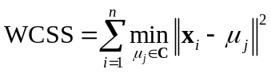 (10)
where C is the set of cluster centroids. The algorithm iteratively assigns each pixel to the nearest centroid and updates the centroids until convergence.

The optimal number of clusters k was set to 3^{13,} corresponding to the three distinct zones (C1, C2, C3) observed in the landing area. The three clusters identified by the algorithm correspond to:
C1 (Proximal Zone): Characterized by low OMAT and moderate water content, representing freshly exposed subsurface material that has undergone incipient space weathering.
C2 (Transitional Zone): Exhibits mixed OMAT values and relatively high water content, likely resulting from the deposition of both mature surface materials and relatively fresh subsurface ejecta.
C3 (Distal Zone): Shows higher OMAT and lower water content, consistent with undisturbed, mature regolith typical of the background lunar surface.
These clusters reveal a clear spatial stratification around the lander. The k-means approach thus provides an objective, data-driven classification that supports and refines the qualitative three-zone model proposed in the main text. Although it may not fully capture the complexity of the data, we validated the clustering results using visual inspection of the spatial distribution, confirming that the three clusters are geologically meaningful.

Supplementary Figures
Supplementary Figure.1 In-flight detection temperature of the LMS. Temperature variations for the optical structure and calibration diffuse reflection panels.

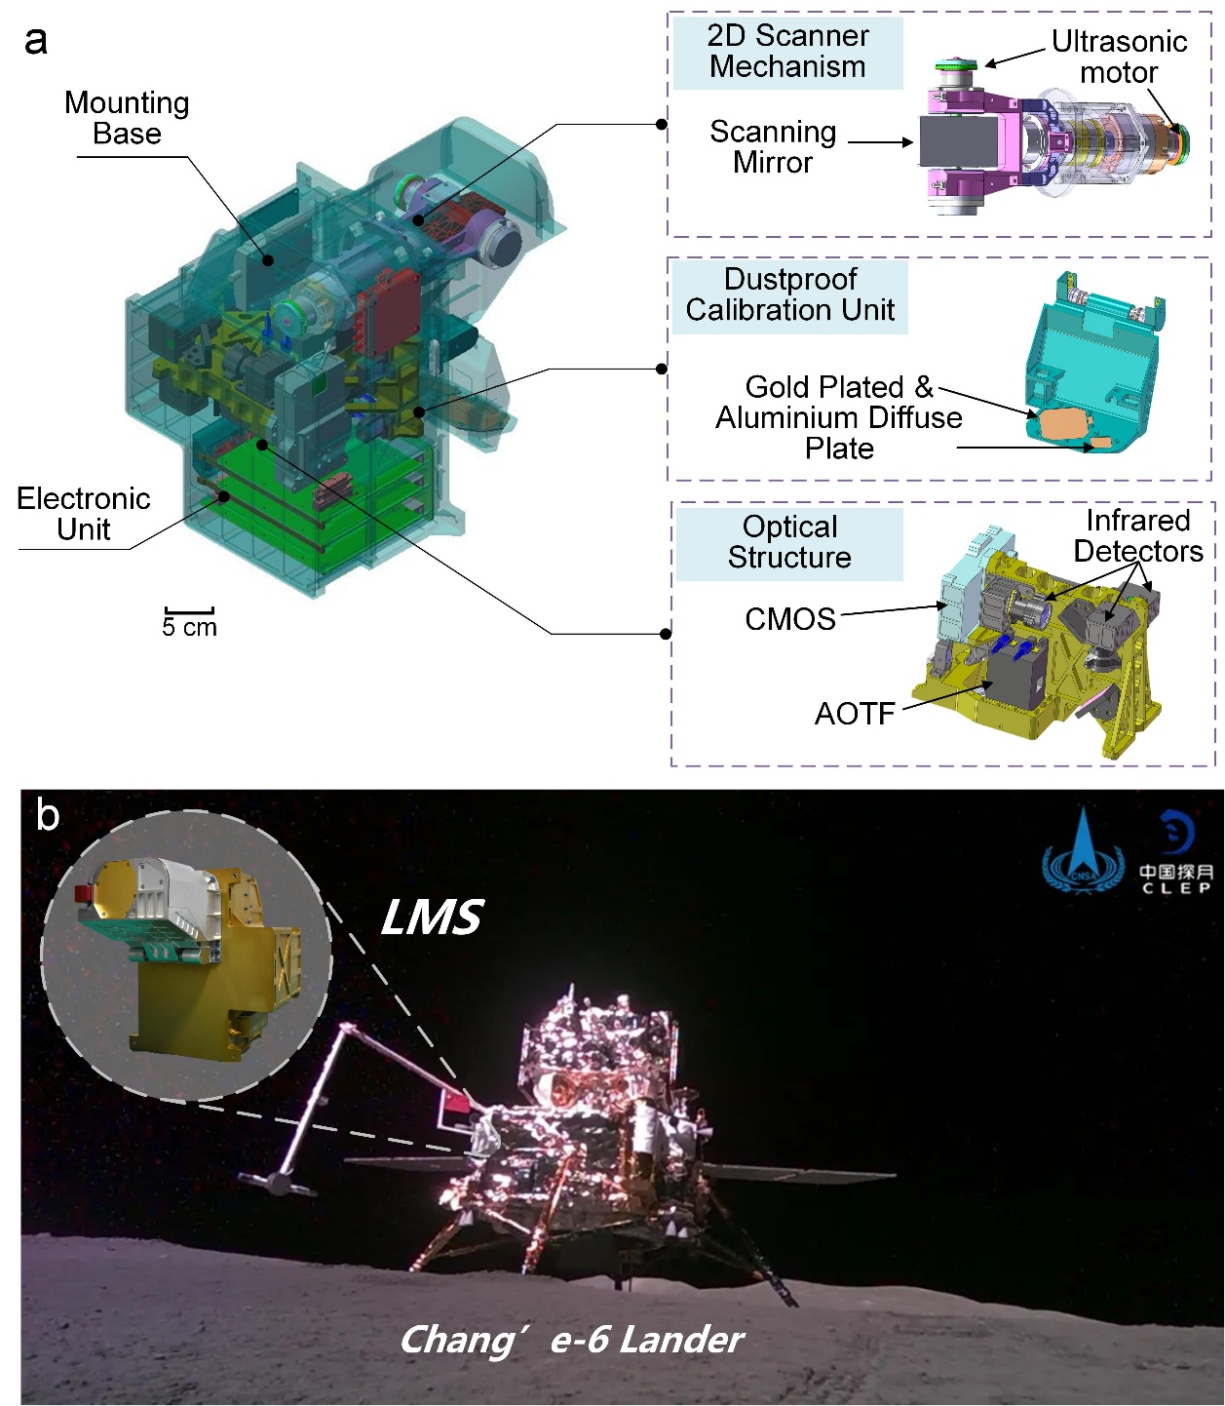
Supplementary Figure. 2 The Design of the CE-6 LMS. (a) The LMS is mainly composed of an optical structure, an electronic unit, a two-dimensional scanner mechanism and a dustproof calibration unit. (b) The LMS is installed on the inner side of the slanted panel of the CE-6 lander. The calibration dustproof unit and the two-dimensional scanning mechanism will protrude from the installation panel, while the remaining parts are housed within the lander's cabin. The installation height of the instrument is 1.4 m above the lunar surface. Through the two-dimensional scanning mechanism, the lunar surface can be scanned and probed, with a detection range that can cover most of the sample collection areas.

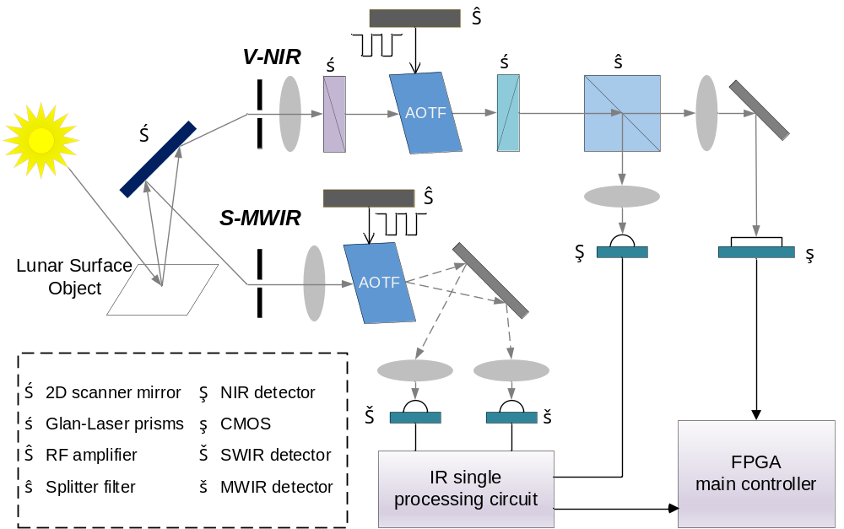
Supplementary Figure. 3 The operational principle of the LMS. Sunlight reflected by lunar surface targets and their thermal radiation is split into two paths after passing through a two-dimensional directional mirror, entering the visible-near infrared (V-NIR) module and the short-mid wave infrared (S-MWIR) module. In the V-NIR module, a Glan-Laser prism is placed before the AOTF to modulate the polarization of incoming light. The +1st-order diffracted light undergoes 90° polarization rotation, while the 0th-order light retains its polarization. A second Glan-Laser prism, orthogonal to the first, suppresses 0th-order light. A splitter filter directs the monochromatic light to respective detectors. The S-MWIR module does not require imaging and directs the ±1st-order diffracted light to infrared detectors. Modulating the RF signal input to the AOTF controls the output monochromatic light, enabling lock-in amplification to filter out 0th-order stray light and extract spectral signals.

Supplementary Tables

Supplementary Table 1 CE-6 LMS multispectral scanning mode spectral band settings
Channel | Wavelength | CE-6 multi-spectral band Settings (nm)
VIS | 480–950 nm | 485, 560, 640, 750, 900, 925
NIR | 900–1450 nm | 950, 970, 1000, 1050, 1100, 1250, 1450
SWIR | 1400–2300 nm | 1450, 1550, 1800, 1900, 2000, 2100, 2250
MWIR | 2200–3200 nm | 2250, 2540, 2750, 2850, 2950, 3000, 3100

References
- Chang, I. C. Noncollinear acousto-optic filter with large angular aperture. Appl. Phys. Lett. 1974; 25:370-372.
- Pustovoit, V. I., Pozhar, V. E. Acousto-optic spectrometers for Earth remote sensing. In Earth Observing Systems IV; SPIE, 1999; pp 243-249.
- Korablev, O., Bertaux, J. -L., Fedorova, A., Fonteyn, D., Stepanov, A., Kalinnikov, Y., et al. SPICAM IR acousto-optic spectrometer experiment on Mars Express. J. Geophys. Res. Planets. 2006; 111.
- Korablev, O., Fedorova, A., Bertaux, J. -L., Stepanov, A., Kiselev, A. SPICAV IR acousto-optic spectrometer experiment on Venus Express. Planet. Space Sci. 2012; 65: 38-57.
- Korablev, O., Ivanov, A., Fedorova, A., Kalinnikov, Y. K., Shapkin, A., Mantsevich, S., et al. Development of a mast or robotic arm-mounted infrared AOTF spectrometer for surface Moon and Mars probes. In Infrared Remote Sensing and Instrumentation XXIII; SPIE, 2015; pp 45–54.
- Bibring, J. -P., Hamm, V., Pilorget, C., Langevin, Y., Bouzit, M., et al. The MicrOmega investigation onboard ExoMars. Astrobiology. 2017.
- Bibring, J. -P., Hamm, V., Langevin, Y., Pilorget, C., Arondel, A., Bouzit, M., et al. The MicrOmega investigation onboard Hayabusa2. Space Sci. Rev. 2017; 208:401- 412.
- Korablev, O. I., Belyaev, D. A., Dobrolenskiy, Y. S., Trokhimovskiy, A. Y., Kalinnikov, Y. K. Acousto-optic tunable filter spectrometers in space missions. Appl. Opt. 2018; 57:C103-C119.
- Dobrolenskiy, Y., Mantsevich, S., Evdokimova, N., Korablev, O., Fedorova, A., Kalinnikov, Y., et al. Acousto-optic spectrometer ISEM for ExoMars-2020 space mission: ground measurements and calibrations. In Fourteenth School on Acousto-Optics and Applications; SPIE, 2019; pp 94-104.
- Fouchet, T., Reess, J.-M., Montmessin, F., Hassen-Khodja, R., Nguyen-Tuong, N., Humeau, O., et al. The SuperCam infrared spectrometer for the Perseverance rover of the Mars 2020 mission. Icarus.2022; 373:114773.
- Maurice, S., Wiens, R. C., Bernardi, P., Caïs, P., Robinson, S., Nelson, T., et al. The SuperCam instrument suite on the Mars 2020 rover: science objectives and mast-unit description. Space Sci. Rev. 2021; 217:1-108.
- Li, S. & Milliken, R. E. An empirical thermal correction model for Moon Mineralogy Mapper data constrained by laboratory spectra and Diviner temperatures. J. Geophys. Res. Planets. 2016; 121: 2081-2107.
- Liu, B., Zeng, X., Xu, R. et al. Lunar surface and subsurface water revealed by Chang’e-6. Nat. Astron. 2025; 9:1776-1784.

