Impact-ionization-engineered waveguide Ge/Si avalanche photodiode with a record-high gain-bandwidth product of 5580 GHz

Hengzhen Cao^{1*}, Jin Xie ^{1*}, Yuluan Xiang¹, Weichao Sun¹ , Liang Tang¹, Xu Wang⁴, Wenjun Chen⁵, Jingshu Guo^{1,2}, Gong Zhang¹, Yaocheng Shi¹, and Daoxin Dai^{1,2,3,} **

1State Key Laboratory of Extreme Photonics and Instrumentation, Zhejiang Key Laboratory of Optoelectronic Information Technology, College of Optical Science and Engineering, Zhejiang University, Hangzhou 310058, China
2Jiaxing Key Laboratory of Photonic Sensing & Intelligent Imaging, Intelligent Optics & Photonics Research Center, Zhejiang University, Jiaxing 314000, China
3Ningbo Research Institute, Zhejiang University, Ningbo 315100, China
⁴ Optical Research Department, Huawei Technologies Co., Ltd., Wuhan, 430000, China
⁵ Optical Research Department, Huawei Technologies Co., Ltd., Dongguan,523000, China
*These authors contribute equally to the work
**Corresponding author: dxdai@zju.edu.cn

- The impact ionization theory for the local model and non-local model
The impact ionization coefficients for electrons (α) and holes (β) are calculated by the classical Selberherr model¹,
$α=A_{n}\exp\left[{\left(\frac{B_{n}}{E}\right)}^{C_{n}}\right]$, (S1)
$β=A_{p}\exp\left[{\left(\frac{B_{p}}{E}\right)}^{C_{p}}\right]$, (S2)
where E is the electric field. The related coefficients for silicon under low and high electric fields are separately determined to describe the impact ionization coefficient. Table S1 lists the parameters of the Selberherr model.
Table S1 The parameters for the Selberherr model to describe the impact ionization in silicon.
Electric Field  (kV/cm) | A  (×10⁵ cm⁻¹) |  | B  (×10⁶ V/cm) |  | C |  | E_{the}  (eV) | E_{thh}  (eV)
 | A_{n} | A_{p} | B_{n} | B_{p} | C_{n} | C_{p} | 1.8 | 2.4
<4×10⁵ | 7.03 | 15.8 | 12.3 | 20.4 | 1 | 1 | 1.8 | 2.4
>4×10⁵ | 7.03 | 6.71 | 12.3 | 16.9 | 1 | 1 | 1.8 | 2.4
Impact ionization models are divided into two distinct categories: the local models and the non-local models. The local model indicates that the impact ionization coefficient exclusively depends on the local electric field at a given point. Conventionally, the simplistic local model is extensively utilized in avalanche photodiodes (APDs) featuring thick multiplication layers. However, this model ignores the process that the 'cool' carriers needed to obtain the energy before actual ionization. The distance carriers required to travel to attain the energy for impact ionization is referred to as the dead-space distance d and can be calculated by d=E_{th}/qF, where E_{th} is the threshold energy for the carriers (proportional to the bandgap of the material), and F is the electric field. In conventional APDs with thick multiplication layers, the dead-space distance is significantly shorter than the multiplication distance, allowing this energy accumulation process to be disregarded, thereby underscoring the local model's accuracy in such APDs. Within the local model, the probability distribution function (PDF) used to characterize the stochastic nature of impact ionization is defined as
$p\left(x\right)=α\exp\left(-αx\right).$ (S3)
Subsequently, high-performance APDs with thinner multiplication layers exhibited discrepancies between measured results and theoretical predictions, suggesting inaccuracies in the local model for these devices. In 1992, Hayat presented the dead-space multiplication theory (DSMT) to describe the non-local model for impact ionization precisely and gives the following formula as the PDF²,
$p\left(x\right)=\left\{\begin{aligned}0, x≤d \\ &α^{*}exp⁡[-α^{*}\left(x-d\right)], x>d\end{aligned}\right.$, (S4)
where α* represents the modified impact ionization coefficient under the non-local model. The coefficients α* and α calculated by the Selberherr model have a relationship and are explored in depth in ref. ³. When the multiplication layer's thickness is reduced to submicron scales, approaching the dead-space distance, or when introducing a non-uniform electric field into the multiplication layer, the non-local model should supplant the local model. This adaptation is particularly relevant for the proposed Ge/Si APD with an ultrahigh gain-bandwidth product (GBP). Upon obtaining the impact ionization coefficients for electrons and holes, the mean gain of the APD can be calculated using the following formula⁴.
$M=\frac{\exp\left[-\int_{x}^{w}{{[α}^{*}\left(x^{'}\right)-β^{*}\left(x^{'}\right)]dx^{'}}\right]}{1-\int_{0}^{w}{α^{*}\left(x^{'}\right)\exp\left[-\int_{x^{'}}^{w}{\left[α^{*}\left(x^{''}\right)-β^{*}\left(x^{''}\right)dx^{''}\right]}\right]dx^{'}}}$, (S5)
The GBP of the APD can be calculated using the classical Emmons theory^{5,6},
$GBP=\frac{1}{2πNk\frac{d_{m}}{V_{e}}}$ , (S6)
$N\left(k\right)=\frac{2(1+k)}{{(1-k)}^{2}}+\frac{4}{\left(1-k\right)Ink}$ , (S7)
where k is the effective k-factor of the APD, d_{m} is the width of the multiplication for actual impact ionization. N is the correction factor and depends on the k factor. V_{e} is the saturated drift velocity for electrons.

The theoretical results based on the above models show reasonable overall agreement with experimental measurements, though minor quantitative discrepancies exist. These deviations primarily arise from: (i) use of bulk‑silicon ionization parameters for the thin (220 nm) multiplication layer, (ii) differences between simulated ideal doping profiles and actual fabricated ones due to lithography overlay errors and lateral diffusion, and (iii) neglect of residual defects/impurities in the simulation. Despite these discrepancies, the theoretical framework reliably captures relative performance trends, such as the dependence of gain‑bandwidth product on structural parameters and doping concentrations. It therefore remains a valuable guide for device design, particularly for optimizing trade‑offs between gain and bandwidth.
- The evolution of the lateral Ge/Si waveguide SACM APD
As shown in Fig. S1a, the lateral Ge/Si SACM-APD was initially reported with a wide multiplication⁷. The width of the multiplication layer significantly exceeds the dead-space distance required to reach the threshold energy for impact ionization. Consequently, the conventional local model of the APD adequately describes the impact ionization process, disregarding the dead-space distance d. Although the wide multiplication layer facilitates easier fabrication in the lateral SACM APD, it entails a lengthy impact ionization distance, suggesting a broad probability distribution function (PDF) for impact ionization. Fig. S1a also depicts the electric field distribution for this lateral SACM-APD. Under the operation voltage of this APD, the electric field in the multiplication layer is not high enough for the wide multiplication layer to reach an acceptable gain and maintain a low dark current. The relatively low electric field for impact ionization results in a decrease in the impact ionization coefficient, and the PDF p(x) under the local model shown in Fig. S1d is wide with a large stochastic impact ionization process.
To reduce the excess noise from impact ionization, a narrower multiplication layer is selected⁸, as depicted in Fig. S1b.The corresponding electric field at the narrower multiplication layer must be higher to maintain the same gain, and the electric field is also shown in Fig. S1b. Under this condition, the dead-space distance is comparable to the width of the multiplication layer, and the impact ionization is not solely dependent on the electric field. An accurate non-local model is preferred for this APD. For the non-local model to describe the impact ionization, the coefficient α calculated by the Selberherr model¹ should be modified to α* to consider the effect of the dead-space distance⁹. Fig. S1e illustrates the PDF for the non-local model according to the dead-space multiplication theory (DSMT)², highlighting that carriers must traverse a specific distance to attain the threshold energy (E_{th}) prior to the impact ionization. The thin multiplication with a higher electric field results in a narrowed PDF shown in Fig. S1e with the short distance for the actual impact ionization process, reducing the excess noise and effective k factor of the APD.
As it might be noticed, these two APDs^{8,9} feature a uniform electric field distribution in the multiplication layer. By potentially reducing the width of this intrinsic region to zero, it is conceivable to develop an ultra-thin multiplication layer with a non-uniform electric field distribution, which forms the basis of our conceptual approach. Under its condition, the PN junction results in a non-uniform electric field, as shown in Fig. S1c. The electric field is predominantly localized within the lightly p-doped region, peaking at the P/N doping interface. As is shown in Fig. S1c, the electric field decreases almost linearly along the light p-doped region and reaches a low electric field near the absorption layer to prevent the impact ionization in the germanium. The extended dead-space distance, coupled with immediate impact ionization in the ultrathin multiplication region under an ultrahigh electric field, leads to a further narrowed PDF for our APD, as depicted in Fig. S1f. Furthermore, the reduction in hole impact ionization contributes beneficially to the overall reduction of excess noise.
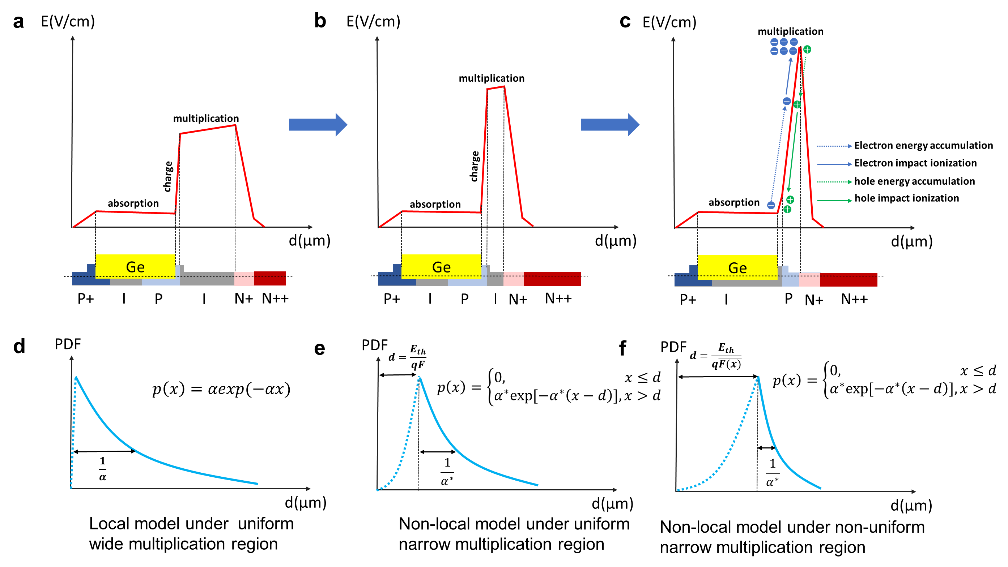
Fig. S1. The structure evolution of the lateral SACM Ge/Si waveguide APD. The cross-section view and the corresponding electric field distribution for the lateral SACM Ge/Si waveguide APD with a, wide multiplication layer⁶, b, thin multiplication layer⁷, and c, ultrathin multiplication layer with non-uniform electric field distribution (this paper). The probability distribution function (PDF) of the electron impact ionization for d, the local model in the wide multiplication layer, e, the non-local model in the thin multiplication layer, and f, the non-local model in the thin multiplication layer with non-uniform electric field distribution (this paper).
- Optical simulation for designing the Ge/Si APD
The internal quantum efficiencies (IQE) corresponding to varying germanium lengths were simulated using the three-dimensional finite-difference time-domain (3D-FDTD) method. APDs featuring both strip and ridge waveguides for optical coupling are compared. Fig. S2a illustrates the relationship between the IQE and the germanium length. The ridge waveguide features an IQE of 0.7 under 2-μm length and reaches 0.94 under 5-μm length. The requirement for only short lengths of germanium to achieve high IQE results from substantial absorption efficiency within the O-band, significantly reducing the dark current in the APD. In contrast, the strip waveguide exhibits a reduced IQE under the same germanium length. For instance, at a Ge length of 5 μm, the IQE of the strip-waveguide APD is only 0.83, which is significantly lower than the 0.94 achieved by the ridge-waveguide structure. The simulated results of the light propagation in the ridge and strip waveguide APDs are also shown in Fig. S2b, c. The APD with the strip waveguide exhibits significant optical field divergence due to the mode mismatch between the passive-active regions, thus reducing the light absorption by the photodetector. The enhanced optical confinement and mode matching afforded by the ridge waveguide (with a 150-nm-thick slab), as depicted in Fig. S2c, effectively suppresses the field divergence, thereby improving the light absorption and achieving a high responsivity for the APD.
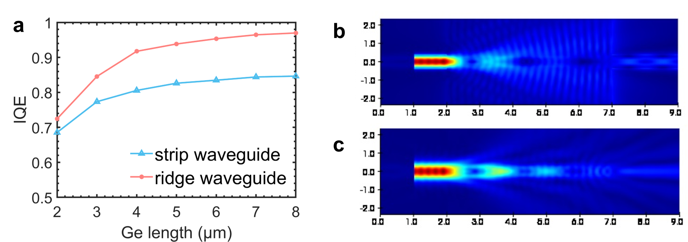
Fig. S2 Optical simulation results for the Ge/Si waveguide APD. a, The simulated IQE versus the germanium length with the strip waveguide and ridge waveguide. Simulated optical field propagation for the APD with b, strip waveguide, and c, ridge waveguide.
- The electric field manipulation with the assistance of the rib waveguide structure
The introduction of the ridge waveguide structure not only confines the optical mode to enhance the IQE but also facilitates the electrical shielding from the multiplication layer, which mitigates the impact ionization in germanium and helps reduce the effective k factor of the APD. While the electric field profile can also be tuned by modifying the widths doping parameters (W_{o} and W_{p}), the ridge structure provides a necessary conductive slab to minimize the parasitic sheet resistance, ensuring that the RC-limited bandwidth remains considerably larger than both the transit-time-limited and avalanche build-up-time-limited bandwidths. Fig. S3a, b shows the cross-section view of the APD with strip and ridge waveguide, respectively. On the other hand, the ridge waveguide slightly increases the parasitic sheet resistance with the reduced RC-limited bandwidth. Nevertheless, the RC-limited bandwidth is still considerably larger than both the transit-time-limited and avalanche build-up-time-limited bandwidths, suggesting that the ridge waveguide minimally impacts the bandwidth. To ensure a rigorous comparison, we conducted the simulations and extracted the electric field distribution along the X-axis of the APD's cross-section at the vertical position of z = 150 nm (denoted as a red dashed line in Fig. S3a, b) for both strip and ridge waveguides, as depicted in Fig. S3c. The dashed horizontal line represents the threshold electric field for generating the impact ionization in germanium (1×10⁷ V/m) and silicon (3×10⁷ V/m). The average electric fields within germanium for strip- and ridge-structured APDs are 8.5×10⁶ and 7.1×10⁶ V/m respectively. This comparison confirms that the ridge waveguide structure is more effective in shielding the high electric field away from the germanium absorption layer, when compared at the same Z-height.
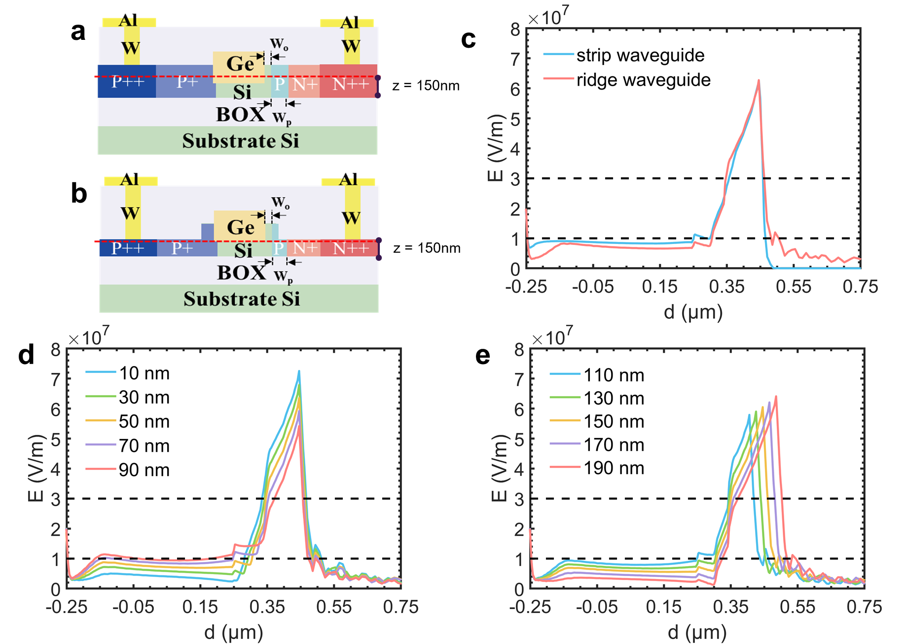
Fig. S3 Electric simulation for the Ge/Si waveguide APD under a reverse bias of -12 V. The cross-section view of the lateral APD with strip waveguide (a) and ridge waveguide (b). c, the extracted electric field distribution along the red dashed line (z=150 nm) in Fig. S3a, b for the APD with strip and ridge waveguide. The extracted electric field distribution along the red dashed line (z=150 nm) in Fig. S3a, b versus the offset W_{o} ranges from 10 nm to 90 nm (d), and the width W_{p} varies from 110 nm to 190 nm (e).
Based on the above simulation analyses, we summarize the design guidelines for achieving the non-uniform “triangular” electric field distribution desired for the APD. First, the peak electric field at the PN junction interface should exceed the impact ionization threshold in silicon (3×10⁷ V/m) to guarantee sufficient ionization gain in the ultra-narrow multiplication region, while the average electric field in the absorption layer must be kept below the impact ionization threshold for germanium (1×10⁷ V/m) to prevent germanium ionization and the associated excess noise. Second, the electric field in the absorption layer should be maintained above 1×10⁶ V/m so that the photo-generated carriers reach their saturated drift velocity, thereby minimizing the transit time demanded for achieving a high bandwidth. Third, the offset W_{o} and the width W_{p} of the lightly P-doped region jointly govern the electric field gradient: increasing W_{o} raises the Ge-side field but reduce the Si-side peak field, while increasing W_{p} lowers the Ge-side field but increases the actual ionization distance. Here we choose the optimal design with W_{o} = 50 nm and W_{p} = 150 nm by making a balance so that the impact ionization events happen in an ultra-narrow region near the PN junction. The resulting steep electric field gradient extends the dead-space distance by forcing the carriers to accumulate energy over a low-field region before reaching the high-field ionization zone. Finally, the extended dead space, combined with the concentrated ionization in the ultra-thin high-field region, produces a highly deterministic impact ionization process with significantly narrowed PDF, directly leading to an ultra-low effective k-factor of 0.011 and a record-high GBP of 5580 GHz.
To better visualize our engineered highly non-uniform electric field structure, we provide two-dimensional cross-sectional simulations of the electric field and energy band diagrams in Fig. S20. The electric field distribution under a reverse bias of 0 V is shown in Fig. S20a. The band diagrams are extracted along the x-axis across both Si and Si/Ge regions at two different vertical positions: z = 100 nm (Si interface) and z = 140 nm (Si/Ge interface), with z = 0 defined at the bottom of the silicon photonic waveguide.
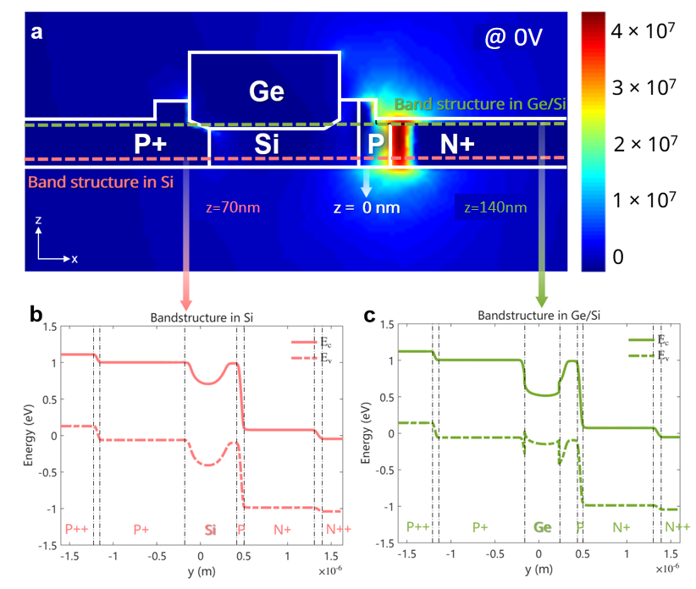
Fig.S20. Simulation results at 0 V bias. (a) Simulation of the 2D cross-sectional electric field. The band structures in (b) Si and in (c) Ge/Si interface.

Furthermore, to explicitly demonstrate that a low bias voltage narrows the effective impact ionization zone, we give comparative simulations under the conditions with a low-bias of -5 V and a high bias of -12 V. As shown in Fig.S22, both the spatial span of the high-field regions in the 2D maps and the steepness of the energy bands are significantly compressed at lower bias voltages, directly supporting our theoretical analysis in the main text. At a low bias of –5 V, the high-field region (E > 2×10⁷ V/m, the typical impact ionization threshold in silicon) is tightly confined near the junction interface, resulting in a narrow multiplication region. Consequently, the number of impact ionization events per carrier transit is limited, leading to a low gain but a high bandwidth due to the short avalanche build‑up time.
In contrast, at –12 V, the region where E > 2×10⁷ V/m expands significantly into the multiplication layer. This spatial expansion increases the number of ionization events per carrier pass, thereby enhancing the gain. However, the extended avalanche region also prolongs the avalanche build‑up time and intensifies the space‑charge effect, which in turn limits the bandwidth. This trade‑off explains why both gain and bandwidth peaks occur at bias voltages beyond –10 V: a sufficiently high bias is required to extend the high‑field region into the multiplication layer for appreciable gain, while further increases in bias eventually degrade the bandwidth due to the dynamic effects.
As discussed in the main text (Section III, B), the gain‑bandwidth product (GBP) of an APD is fundamentally constrained by the avalanche build‑up time. The transition from low‑gain/high‑bandwidth at –5 V to high‑gain/low‑bandwidth at –12 V observed here is consistent with the GBP‑limited behavior, where the product of gain and bandwidth remains approximately constant. The optimal operating bias (beyond –10 V) represents a balance where the gain is sufficiently high for practical applications while the bandwidth remains at a level suitable for high‑speed operation.
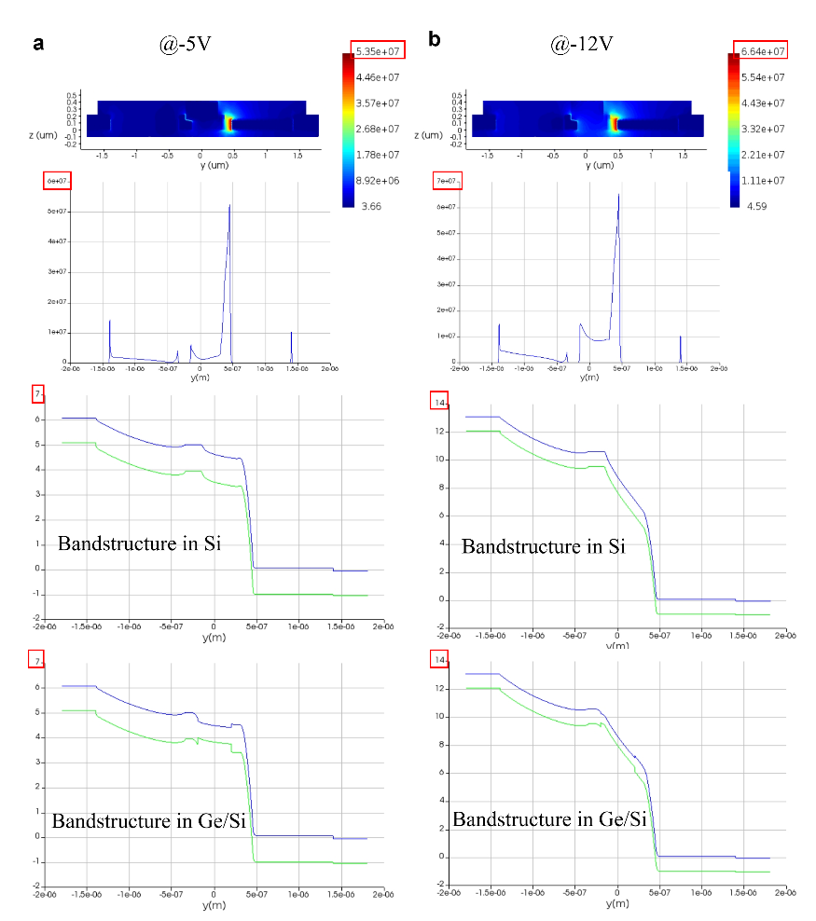
Fig. S22. Simulation of the 2D cross-sectional electric field with the band structures in Si and in Ge/Si interface at -5 V (a) and -12V(b).
It is worth noticing that a localized electric field peak under -12 V bias appears around d = -0.25 um, corresponding to the P+/Ge interface under the -12 V bias, , which is optimally designed by making a trade-off to minimize the parasitic resistance and ensure the high-speed operation for the APD. This peak originates from the abrupt doping transition. Although the peak reaches roughly 1×10⁷ V/m, its highly localized spatial distribution prevents it from triggering massive band-to-band tunneling or excess dark current, which is consistent with the measurement results with low dark current.
- The electric field manipulation with the p-type light doping optimization
We undertake a comprehensive analysis to optimize the proposed Ge/Si waveguide APD. As mentioned in the main text, the parameters W_{o} and W_{p} labeled in Fig. S3b should be carefully optimized to manipulate the electric field distribution in the multiplication and absorption layers. The adaptable manipulation of the electric field in the absorption and multiplication layers, achieved by modifying the doping position, exhibits high design flexibility for developing lateral Ge/Si waveguide APDs without additional silicon epitaxy layers for multiplication and charge separation. We set the charge-layer doping concentration to be about 3×10¹⁷cm⁻³. For the germanium epitaxial growth, a specific buffer layer is utilized to overcome the 4.2% lattice mismatch between Si and Ge, which naturally results in this low-level p-type background while effectively suppressing the dislocation formation and minimizing surface defects. To accurately reflect the actual foundry manufacturing conditions in our TCAD simulations, the Ge layer is set with an unintentional p-type background doping concentration of about5 × 10¹⁵ cm⁻³, rather than being an ideal intrinsic material, according to the foundry process. The device design and modelling with such a specific concentration represents the realistic physical characteristics of the regrown Ge layer. For the fabricated PDs on the same chip, the measured dark current as low as <20 nA, verifying the high quality of the germanium growth.
Fig. S3d shows the extracted electric field distribution along the red dotted line in Fig. 1a (and Fig. S3b) under different offsets of the lightly p-doped region (i.e., the parameter W_{o} in Fig. S3a). As the offset W_{o} ranges from 10 nm to 90 nm, the electric field decreases and increases in the absorption (germanium) and multiplication (silicon) layers. Reducing the electric field within the absorption layer can effectively inhibit the impact ionization in germanium, albeit at the cost of extended transition times, constricting the APD bandwidth. An enhanced electric field in the multiplication layer leads to higher gains and diminished space-charge effects under high operating voltages, facilitating the APDs with high gain-bandwidth products (GBP). Therefore, the offset parameter W_{o} is set to 50 nm to balance the high gain and bandwidth trade-off.
Fig. S3e shows the extracted electric field distribution along the red dotted line in Fig. 1a under different widths of the lightly p-doped region (i.e., the parameter W_{p} in Fig. 1a). The width W_{p} can effectively manipulate the electric field in the absorption layer and the actual distance for the impact ionization. For the case with a width W_{p} as large as 190 nm, the electric field in the absorption layer is low enough to avoid the impact ionization in germanium to lower the effective k factor. At the same time, it also leads to a thick multiplication layer characterized by a wide PDF for actual impact ionization, indicating less reduction of the effective k factor induced by the dead-space effect. When the width W_{p} is as small as 110 nm, a thin multiplication layer with the narrowed PDF can be obtained to reduce the effective k factor further. However, the corresponding higher electric field in the absorption layer results in some impact ionization in germanium to counteract the reduction of the effective k factor due to the thinned multiplication layer. Considering these, the parameter W_{p} is chosen to be 150 nm to achieve a thin multiplication layer and maintain a relatively low electric field in the absorption layer simultaneously.
- The reference photodetector to assess the primary responsivity of the present APD
To determine the primary responsivity of the APD, we designed a reference photodetector for testing. Fig. S4a shows the schematic configuration of the reference photodetector, in which the lightly P-doping region is removed. There is negligible multiplication (i.e., M=1) when operating within the low voltage range. As a result, the responsivity with no multiplication obtained for this reference photodetector can be considered the primary responsivity of the Si/Ge APD. Fig. S4b, c shows the measured dark-current and photocurrent I-V curves and the measured responsivity for the reference photodetector under 1310 nm wavelength. Here, we define the primary responsivity as the responsivity of the reference detector under −4 V, i.e., 0.91 A/W. The reference PIN PD exhibits constant responsivity, which is independent of the input optical power almost.
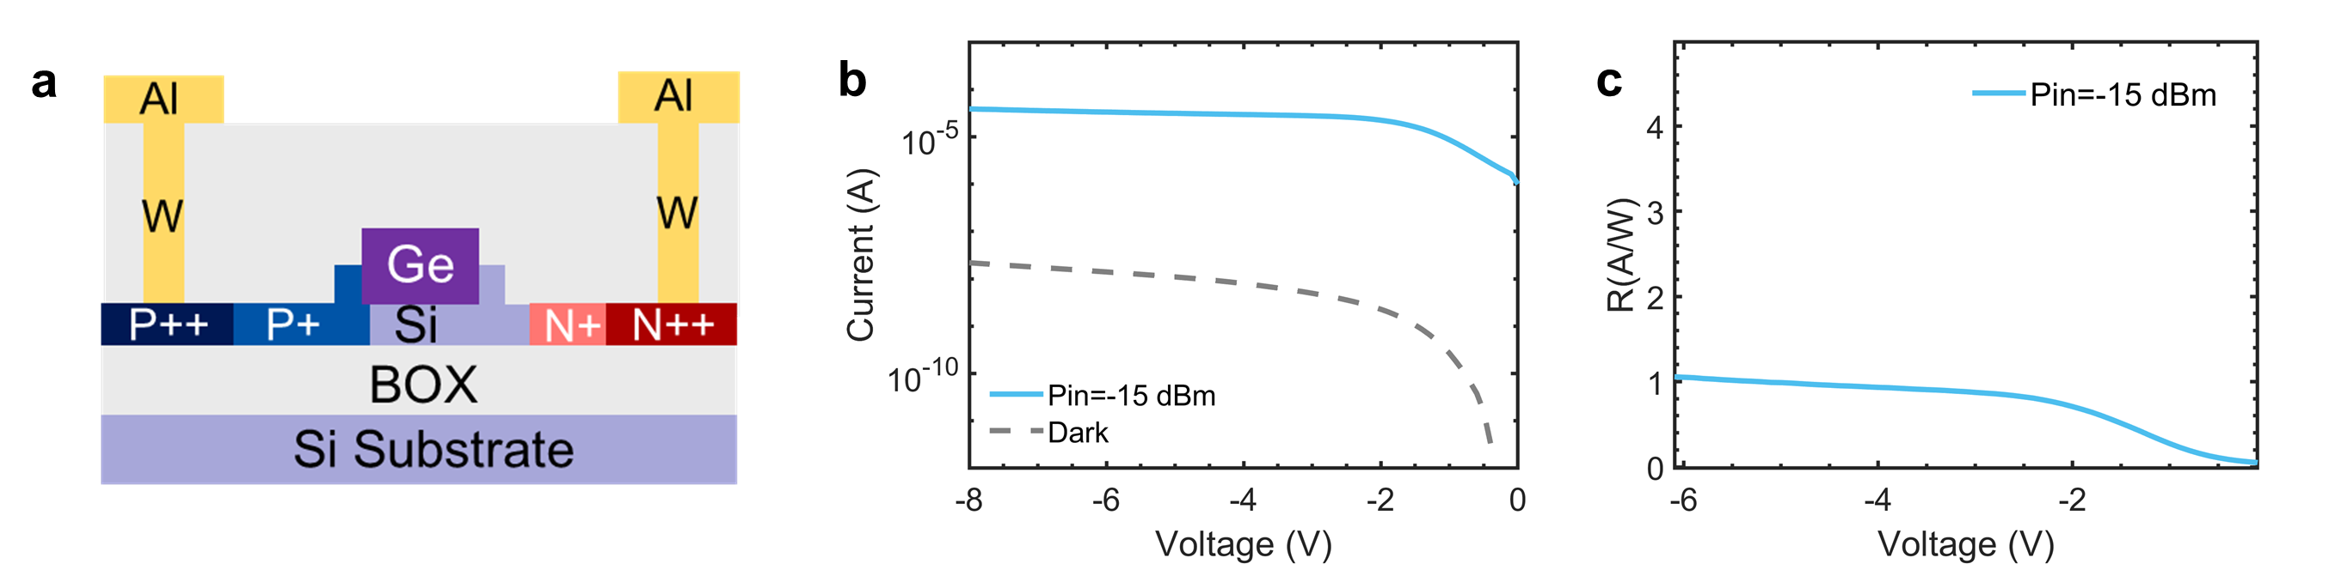
Fig. S4 Characterization of the reference photodetector for assessing the primary responsivity of the present APD. a, Cross-section view of the reference photodetector. b, Measured dark-current and photocurrent I-V curves under −15 dBm optical power. c, Measured responsivity of the reference photodetector.
- Measurement results for the photocurrent and gain under different optical powers
Fig. S5a, b shows the measured photocurrent and gain when the optical power varies from −15 dBm to −30 dBm, with a step of 1 dB. The gain G(V) can be calculated using the following formula,
$G\left(V\right)=\frac{I_{p}\left(V\right)-I_{d}(V)}{I_{p}\left(V_{ph}\right)-I_{d}(V_{ph})}$ , (S8)
where I_{p} and I_{d} represent the dark current and the photocurrent, V_{ph} is the punch-through voltage of the APD. The extracted maximum gains versus the optical power are displayed in Fig. S5c. The gain appears almost inversely proportional to the optical power, as shown by the fitted curve in Fig. S5c. Therefore, we could calculate the output net photocurrent for the APD using the formula I_{net}=P_{in} G(P_{in}) R₀, where P_{in} is the optical power, and R₀ is the primary responsivity. This result indicates that the Ge/Si APD maintains a constant output net photocurrent of 0.21 mA across varying optical powers. This observation may confirm the occurrence of the space-charge effect in the present Ge/Si waveguide APD, which limits the maximum net photocurrent for the APD with a small-size multiplication layer.
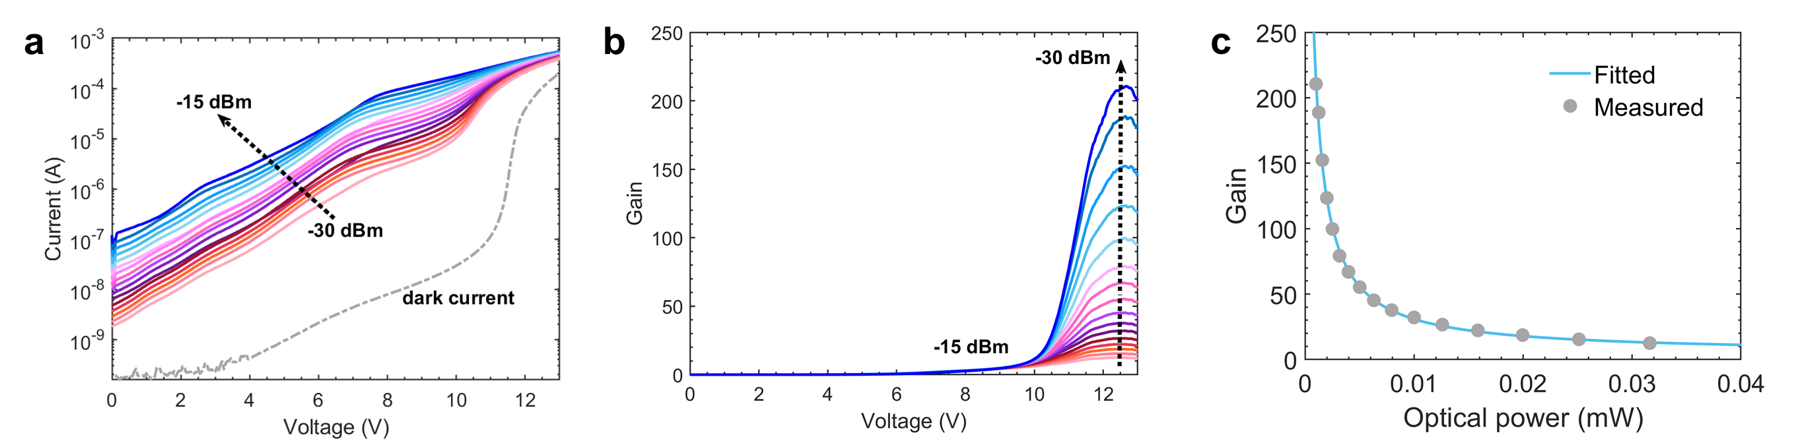
Fig. S5 Measured results for the photocurrent and gain under different optical powers. a, the dark-current & photocurrent I-V curves and b, the gains with the optical power varying from −15 dBm to −30 dBm by a step of 1 dB. c, Extracted maximum gain versus the optical power. The blue line represents the fitted inverse-proportion curve.
- The bandwidth of the APD under different optical powers
Fig. S6 shows the measured S21 curves under different reverse voltages when the optical power varies from −15 dBm to −30 dBm. The bandwidth generally becomes smaller at lower optical powers due to the prolonged avalanche build-up time required to achieve high gain. As the voltage increases, there is an initial decrease in bandwidth, a consequence of silicon impact ionization that subtly reduces the electric field in the absorption layer, thereby extending the transit time. Subsequently, as the voltage surpasses 10.5 V, the bandwidth keeps increasing. The S21 curve’s lifting at high frequency under low optical power (−27 dBm~−30 dBm) is mainly due to the digital noise of the Light Component Analyzer.
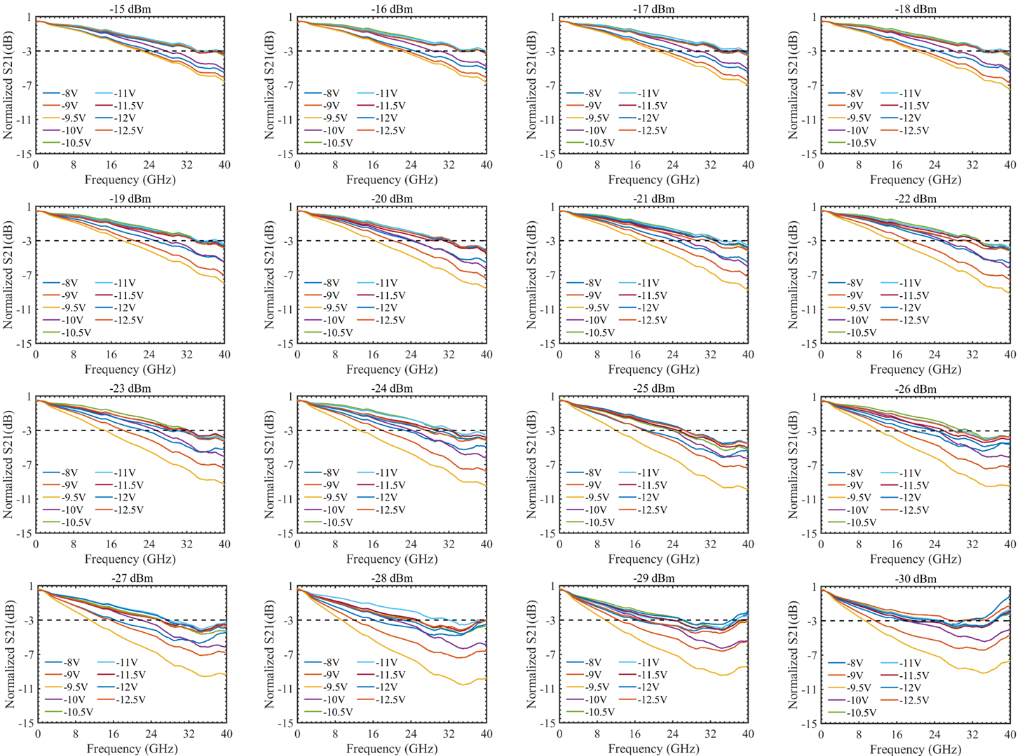
Fig. S6 Measured S21 curves under different reverse voltages when the optical power varies from −15 dBm to −30 dBm.
Fig. S7 shows the extracted bandwidth versus the input power under different voltages. As the input power decreases, the gain increases accordingly, resulting in a longer build-up time for multiplication. As a result, the bandwidth decreases under lower optical powers.
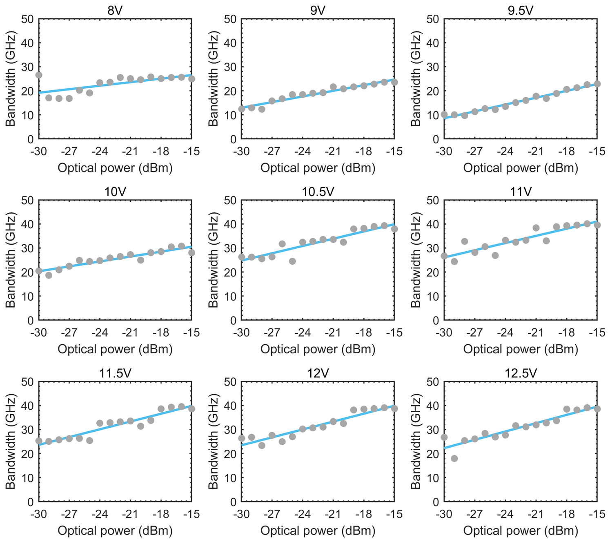
Fig. S7 Extracted bandwidth versus the input power under different voltages.
Under strong electric fields, the accelerated impact ionization of charge carriers enables them to bypass numerous photon scattering processes⁴³. This phenomenon effectively enhances the equivalent carrier mobility and saturation drift velocity during transport. Consequently, the avalanche buildup time in the APD is significantly reduced, allowing the device to maintain high bandwidth even when operating at substantial gain levels.

- The bandwidth and GBP versus gain under different optical powers
Fig. S8 shows the measured GBP and the corresponding gain and bandwidth as the optical power varies from −15 dBm to −30 dBm. The bandwidth first increases with gain and remains almost unchanged under high gain. As a result, the GBP keeps increasing with gain and lower optical power. Specifically, the maximum GBPs under −15 dBm to −30 dBm input powers increase from 480 GHz to 5580 GHz. The summarized results can also be found in Fig. 2d in the main text.
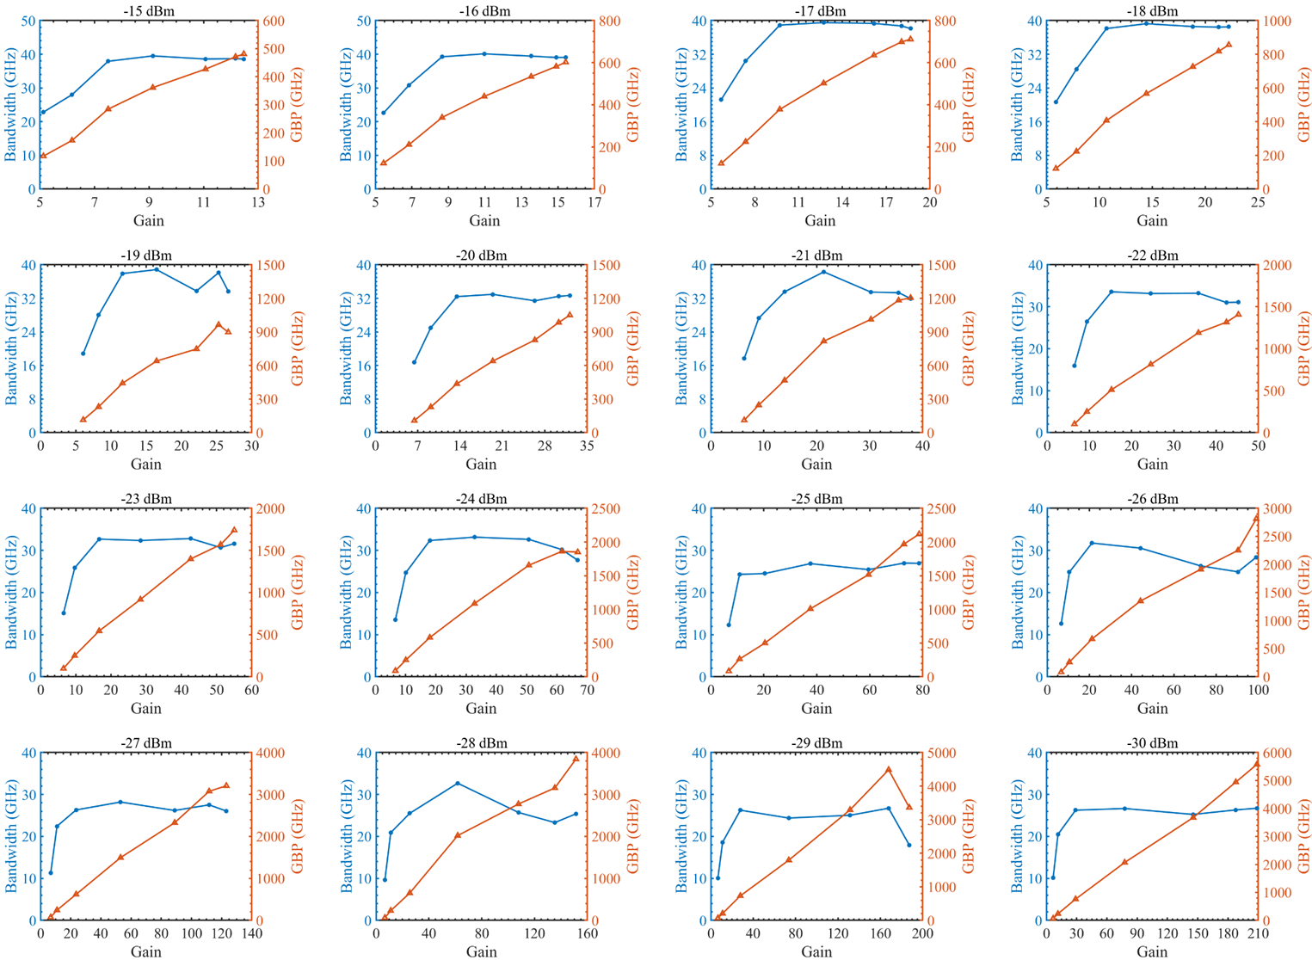
Fig. S8 The measured bandwidth and GBP versus the gain for the optical power varying from −15 to −30 dBm.
Bandwidth fluctuations under high-gain and low-power conditions: In Fig. S8, certain fluctuations, including apparent peaks (e.g., at –21 dBm and –28 dBm) and drops (e.g., at –29 dBm) in the extracted 3-dB bandwidth, are observed. These variations are attributed to the combined effects of space-charge dynamics and instrumental noise limits. Operating at a high gain generates a density of multiplying carriers that induce a space-charge effect. This effect can introduce an equivalent inductance that partially compensates for the RC time constant, creating a transient LC resonance and temporarily enhancing the extracted RF bandwidth. Simultaneously, at these low optical powers, the amplitude of the high-frequency RF signal approaches the noise floor of the lightwave component analyzer (LCA). As shown in Fig. S6, while the overall frequency response trend remains highly consistent, the instrument’s digital noise can cause slight lifting and distortions at high frequencies. The interplay of these space-charge resonances and noise-induced curve distortions causes stochastic volatility when extracting the exact –3 dB threshold. Despite these measurement uncertainties, the device’s intrinsic high-speed capability is well-validated by the successful 50-Gbps data transmission at –30 dBm (Fig. 4d), confirming that these fluctuations originate primarily from complex measurement dynamics rather than fundamental device degradation.
- The performance evaluation for the O-/C-band operation
The present Ge/Si waveguide APDs were measured with two wavelengths of 1310 nm and 1550 nm to demonstrate the broadband operation capability. The APD employed an edge coupler with a broad optical bandwidth, while the measured coupling losses for the wavelength-bands of 1310/1550 nm were about 3dB/2.5dB. Fig. S9a shows the gain versus the voltage for the 1310 nm and 1550 nm wavelengths with the same input optical power of −20 dBm. The corresponding bandwidths were also measured, as shown in Fig. S9b. Finally, Fig. S9c shows the GBP versus the gain. It can be seen that the APD features a higher gain at 1550 nm than 1310 nm. Since the absorption coefficient in 1550 nm is weaker than 1310 nm, a longer absorption distance with a reduced photo-generated carrier density is expected. A more uniform distributed photo-generated carrier can significantly suppress the space-charge effect. As a result, the diminished space-charge effect at the longer wavelength of 1550 nm is helpful to achieve higher gains.
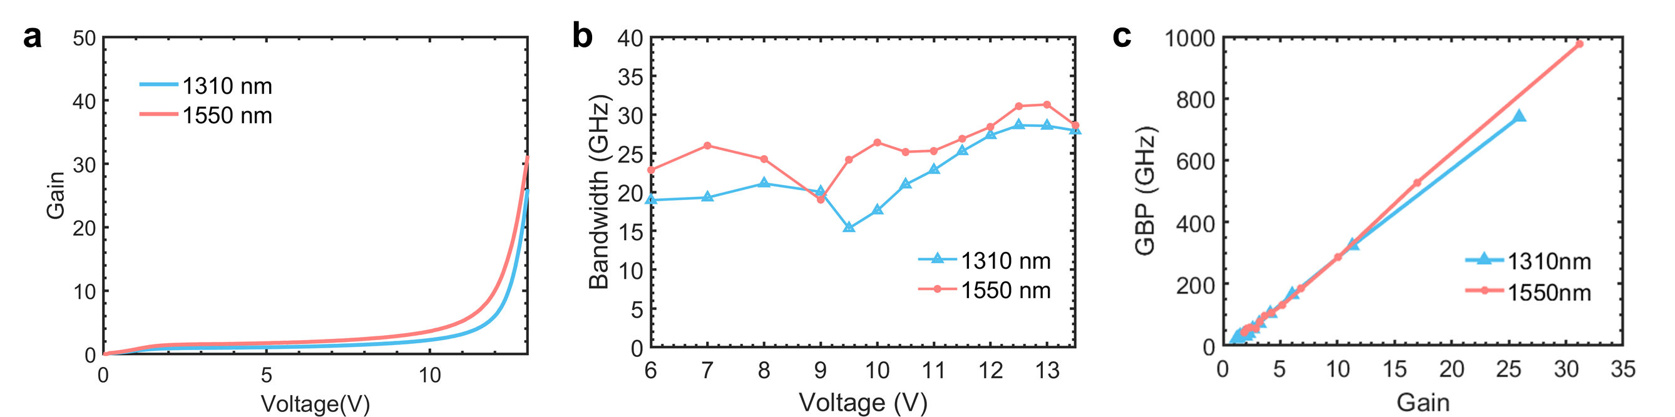
Fig. S9 APD’s performance at 1310/1550 nm versus the voltage. a, gain; b, bandwidth. c, GBP.
- Temperature-dependence of the dark-current and wide-temperature-range stability
We also measured the dark current under different temperatures to extract the temperature coefficient for the breakdown voltage (ΔV_{br}/ΔT). Fig. S10a shows the measured breakdown voltage versus temperature and the linear fitted results to extract the ΔV_{br}/ΔT. The breakdown voltage increases with temperature, a phenomenon attributable to enhanced phonon scattering that decelerates the carrier's energy accumulation and diminishes impact ionization. The presented Ge/Si waveguide APD has a low-temperature coefficient of 12.6 mV/K, comparatively lower than conventional Ⅲ-Ⅴ APDs^{10,11}. The low-temperature coefficient indicates that the present APD possesses a thin multiplication layer for impact ionization, as the thinner multiplication layer features a higher electric field with a shorter dead-space distance. Consequently, the augmented phonon scattering exerts minimal influence on this swift energy accumulation process, thereby enhancing the APD's temperature-insensitive performance¹². Additionally, we determined the activation energy of the APD under different voltages. The temperature-dependent dark current of the photodetector can be expressed as¹³:
$I_{d}\left(T\right)=I_{d0}\exp\left(-\frac{E_{a}}{kT}\right),$ (S9)
where I_{d0} is the dark current at 300 K, while E_{a} denotes the activation energy (correlating with the bandgap (E_{g}) of the material in the absorption layer). Fig. S9b illustrates the measured dark current as a function of inverse temperature (1/T), plotted on a logarithmic Y-axis. We fitted this formula at different voltages to obtain the corresponding activation energy, as shown in Fig. S10c. The parameter n is the ratio of the bandgap energy (E_{g}) to the activation energy (E_{a}), expressed as n = E_{g}/E_{a}. For the Ge/Si APD, E_{g}=0.8 eV. At lower voltages where n ranges from 1 to 2, the dark current predominantly originates from Shockley-Read-Hall (SRH) recombination and diffusion currents. Under high voltages, n increases rapidly to n>2. For the situation with n>2, the dark current is mainly dominated by the band-to-band tunneling arising from the high electric field in the PN-type multiplication layer¹⁴. When further increasing the voltage with a large gain, the activation is even negative, and it can be explained as the gain that dominates the dark current decreasing with the temperature.
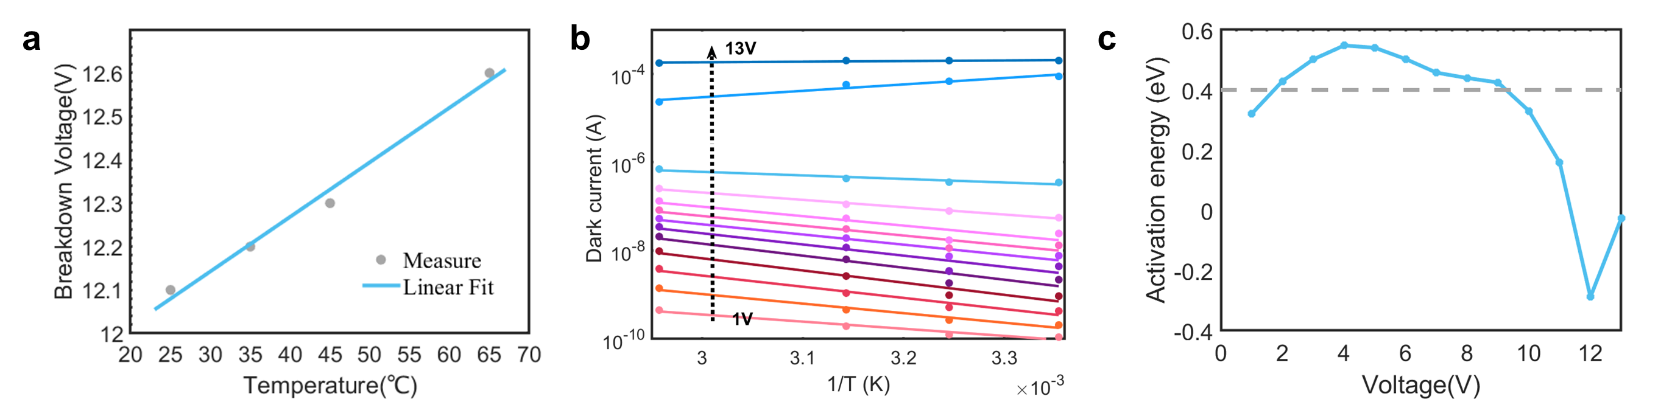
Fig. S10 Temperature-dependence of the dark current. a, Breakdown voltage under different temperatures to obtain the temperature coefficient (ΔV_{br}/ΔT) of the APD. b, Measured dark current versus the inverse temperature (1/T) under different voltages; c, Extracted activation energy of the APD to assess the mechanism of the dark current under different voltages.
To further evaluate the wide-temperature-range stability, we measured the 3-dB bandwidth from 25 °C to 85 °C (Fig. S24). The device maintains a highly stable bandwidth, which, along with the marginal sensitivity penalty observed at 85 °C (Fig. 4d), indicates robust high-temperature operation. Since high temperatures represent a more stringent condition for APDs due to enhanced phonon scattering, the device performance is expected to be well-maintained down to −40 °C, where such thermal effects are substantially suppressed. Furthermore, the present APDs are fabricated using a mature monolithic silicon photonics foundry process, which inherently ensures excellent material stability and reliable interface passivation for long-term operation.

T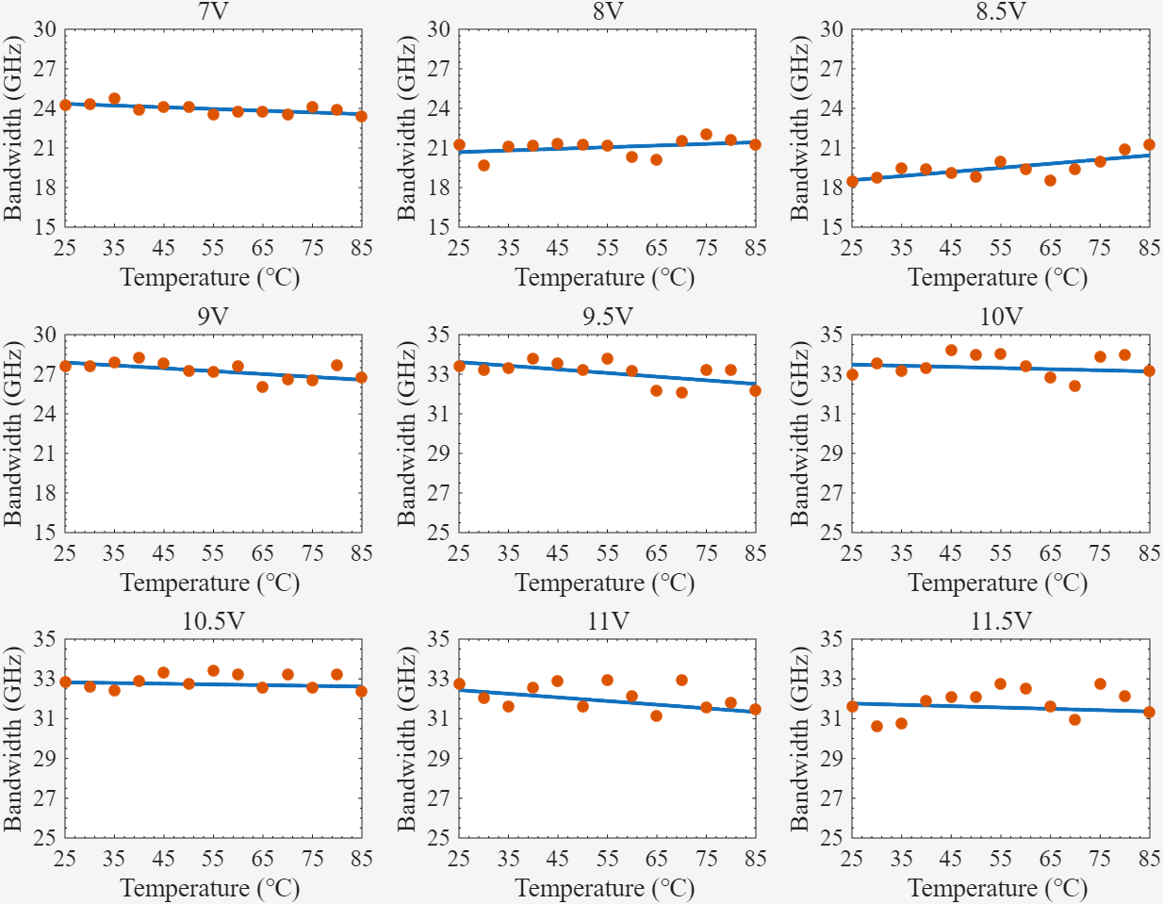
Fig.S24 Measured 3-dB bandwidth from 25 °C to 85 °C at different reverse bias voltage
- The noise measurement to extract the effective k factor of the APD
The effective k factor k_{eff} of the APD was extracted from the measured excess noise of the APD under different gains. The gain-dependent noise factor F(M) of the APD is given by¹⁵
$F\left(M\right)=\frac{S_{p}}{S_{p0}M^{2}}$, (S10)
where S_{p} is the net photocurrent noise power spectral density with the gain of M, S_{p0} is the net photocurrent noise power spectral density with unit gain. The effective k factor k_{eff} is then extracted by fitting McIntyre's model⁴,
${F\left(M\right)=k}_{eff}M+\left(1-k_{eff}\right)\left(2-\frac{1}{M}\right)$, (S11)
Fig. S11 shows the experimental setup for the excess noise measurement. A low-noise tunable laser (Santec, TL550) served as the light source for the experiment. A bias-T (Anritsu, K250) was interfaced with the APD, where its DC-port was linked to a sourcemeter (Keithley, 2400) to supply the reverse voltage. The RF-port of the bias-T was connected to the low-noise amplifier to amplify the weak current signal before input to the noise analyzer (Keysight, 8970B). The measurement was conducted under the modulation frequency of 130 MHz to eliminate the influence of the high 1/f noise of the APD under low frequency. The intrinsic noise of APD was calibrated by deducting the noise generated by the experimental setup. The APD's noises with and without illumination are also measured to determine the net photocurrent noise power density.
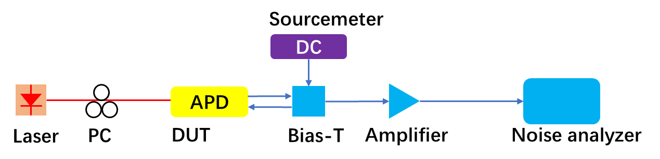
Fig. S11 Experimental setup for the noise measurement of the APD. DUT, device under test. PC, polarization controller.
The effective k-factor (k_{eff}) was extracted over an experimentally measured gain range of M = 5 to 30. The noise measurement was conducted at a modulation frequency of 130 MHz to strictly eliminate the influence of the high 1/f noise of the APD at lower frequencies. The intrinsic APD noise was precisely calibrated by measuring the total noise power spectral density and deducting the noise floor generated by the experimental setup, including the instrumental limits and the low-noise RF amplifier. Based on the McIntyre-type expression fitting bounds across the measured data, the uncertainty of the extracted effective k-factor is consistently bounded within the 0.01 to 0.03 range under these operating conditions.
- Experimental setup for the I-V, bandwidth, and eye-diagrams & sensitivity measurement
Fig. S12a-c shows the experimental setup for the static I-V, bandwidth, and eye diagrams & sensitivity measurement, respectively. Details are covered in the Methods section in main text.
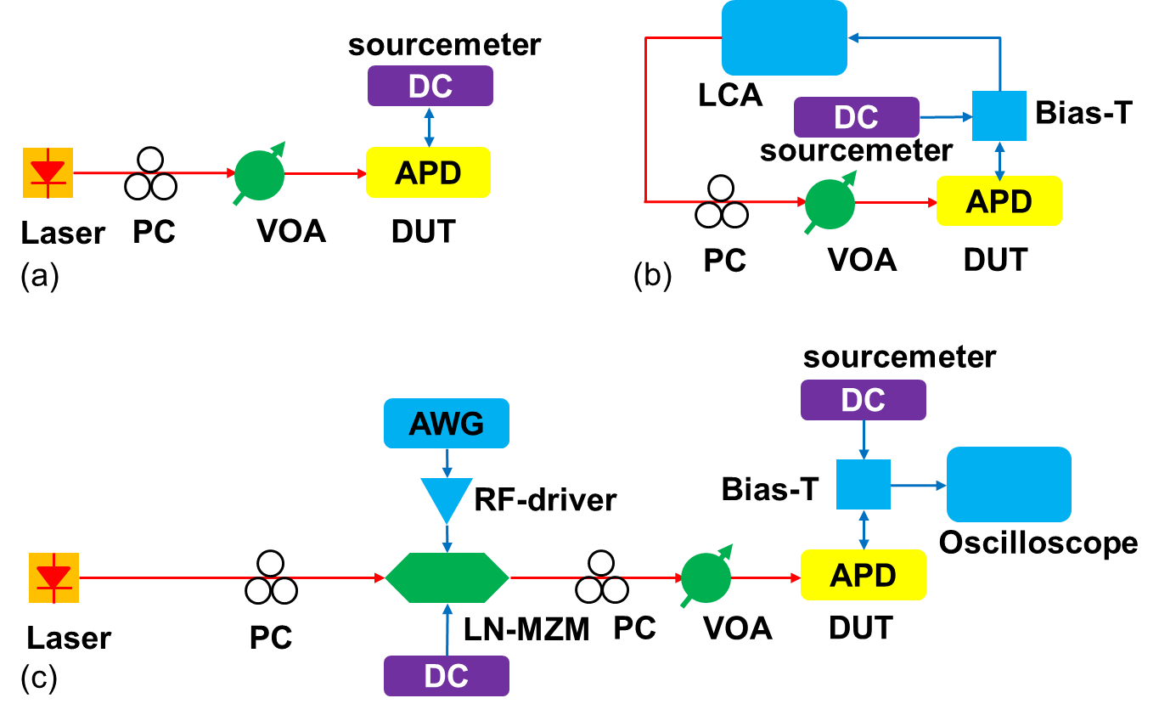
Fig. S12 Experimental setup for the measurement of a, static I-V, b, bandwidth, and c, eye-diagrams & BER. PC: polarization controller; VOA: variable optical attenuator; DC: direct current; DUT: device under test; LCA: Lightwave component Analyzer; LN-MZM: lithium niobite Mach−Zehnder modulator; AWG: arbitrary wave generator. The blue and red lines in the figure represent the electrical and optical connections, respectively.
- Small-signal equivalent circuit of the APD
Fig. S13a shows the small-signal equivalent circuit¹⁶ of the Ge/Si waveguide APD. In the absorption region, the parasitic parameters include a junction resistance R_{a} and a junction capacitance C_{a}. The avalanche region can be modeled with a resistance R_{m} representing the leakage current, an avalanche capacitance C_{m}, and an inductance L_{m} accompanied by a series resistance R_{am} due to the space-charge effect. The series resistance of the photodiode is denoted as R_{s}. The electrode's parasitic elements consist of a capacitance C_{p}, a resistance R_{p}, and an inductance L_{p}. The load resistance is represented by R_{L} (50 Ω). These electrical parameters can either be determined from the geometric and doping characteristics of the APD or can be fitted using the measured S22 curves at a specific gain¹⁶. The parameters in Fig. S13a are extracted through the measured S22 curves at -12.5 V of the APD. The S22 fitting curves are shown in Fig. S13b, and the extracted parameters are shown in Table 2.
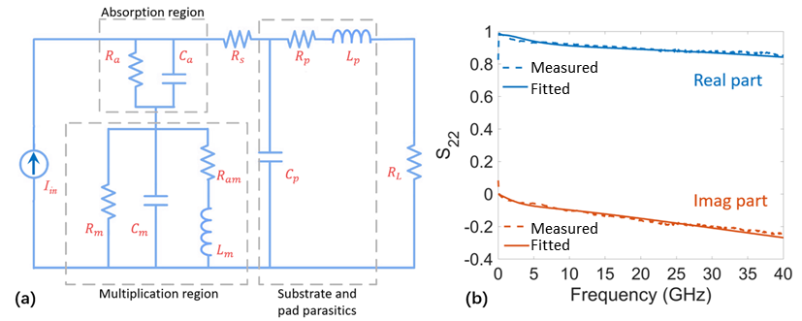
Fig. S13 The equivalent circuit extraction for the proposed APD. a, The small-signal equivalent circuit of the Ge/Si waveguide APD. b, The measured and fitting S22 curves for Ge/Si APD.
Table 2 Extracted parameters for the equivalent circuit of the Ge/Si APD
Parameter | R_{a}  (Ω) | C_{a}  (fF) | R_{m}  (kΩ) | C_{m}  (fF) | L_{m}  (μH)
Value | 841.8 | 2.9 | 4.7 | 39.6 | 2.5
Parameter | R_{am}  (kΩ) | R_{s}  (Ω) | C_{p}  (fF) | R_{p}  (Ω) | L_{p}  (pH)
Value | 23.3 | 10 | 9.5 | 20.9 | 40
- Wafer-scale measurements for the gain, bandwidth, and GBP under −10 dBm and −15 dBm
We also did the wafer-scale measurements with 13 chips under −15 dBm and −20 dBm to validate its reliability and stability. Fig. S14a-c shows the wafer-scale measurement results for the gain and the bandwidth, as well as the corresponding GBP under −15 dBm, respectively. The statistical median values for the gain, bandwidth, and GBP at maximum bias voltage are 12.6, 33.1 GHz, and 417 GHz. Fig. S14d-f gives the measurement results for the case of −20 dBm, showing that the statistical median values for the gain, bandwidth, and GBP at maximum bias voltage are 24.7, 33.2 GHz, and 822 GHz, respectively.
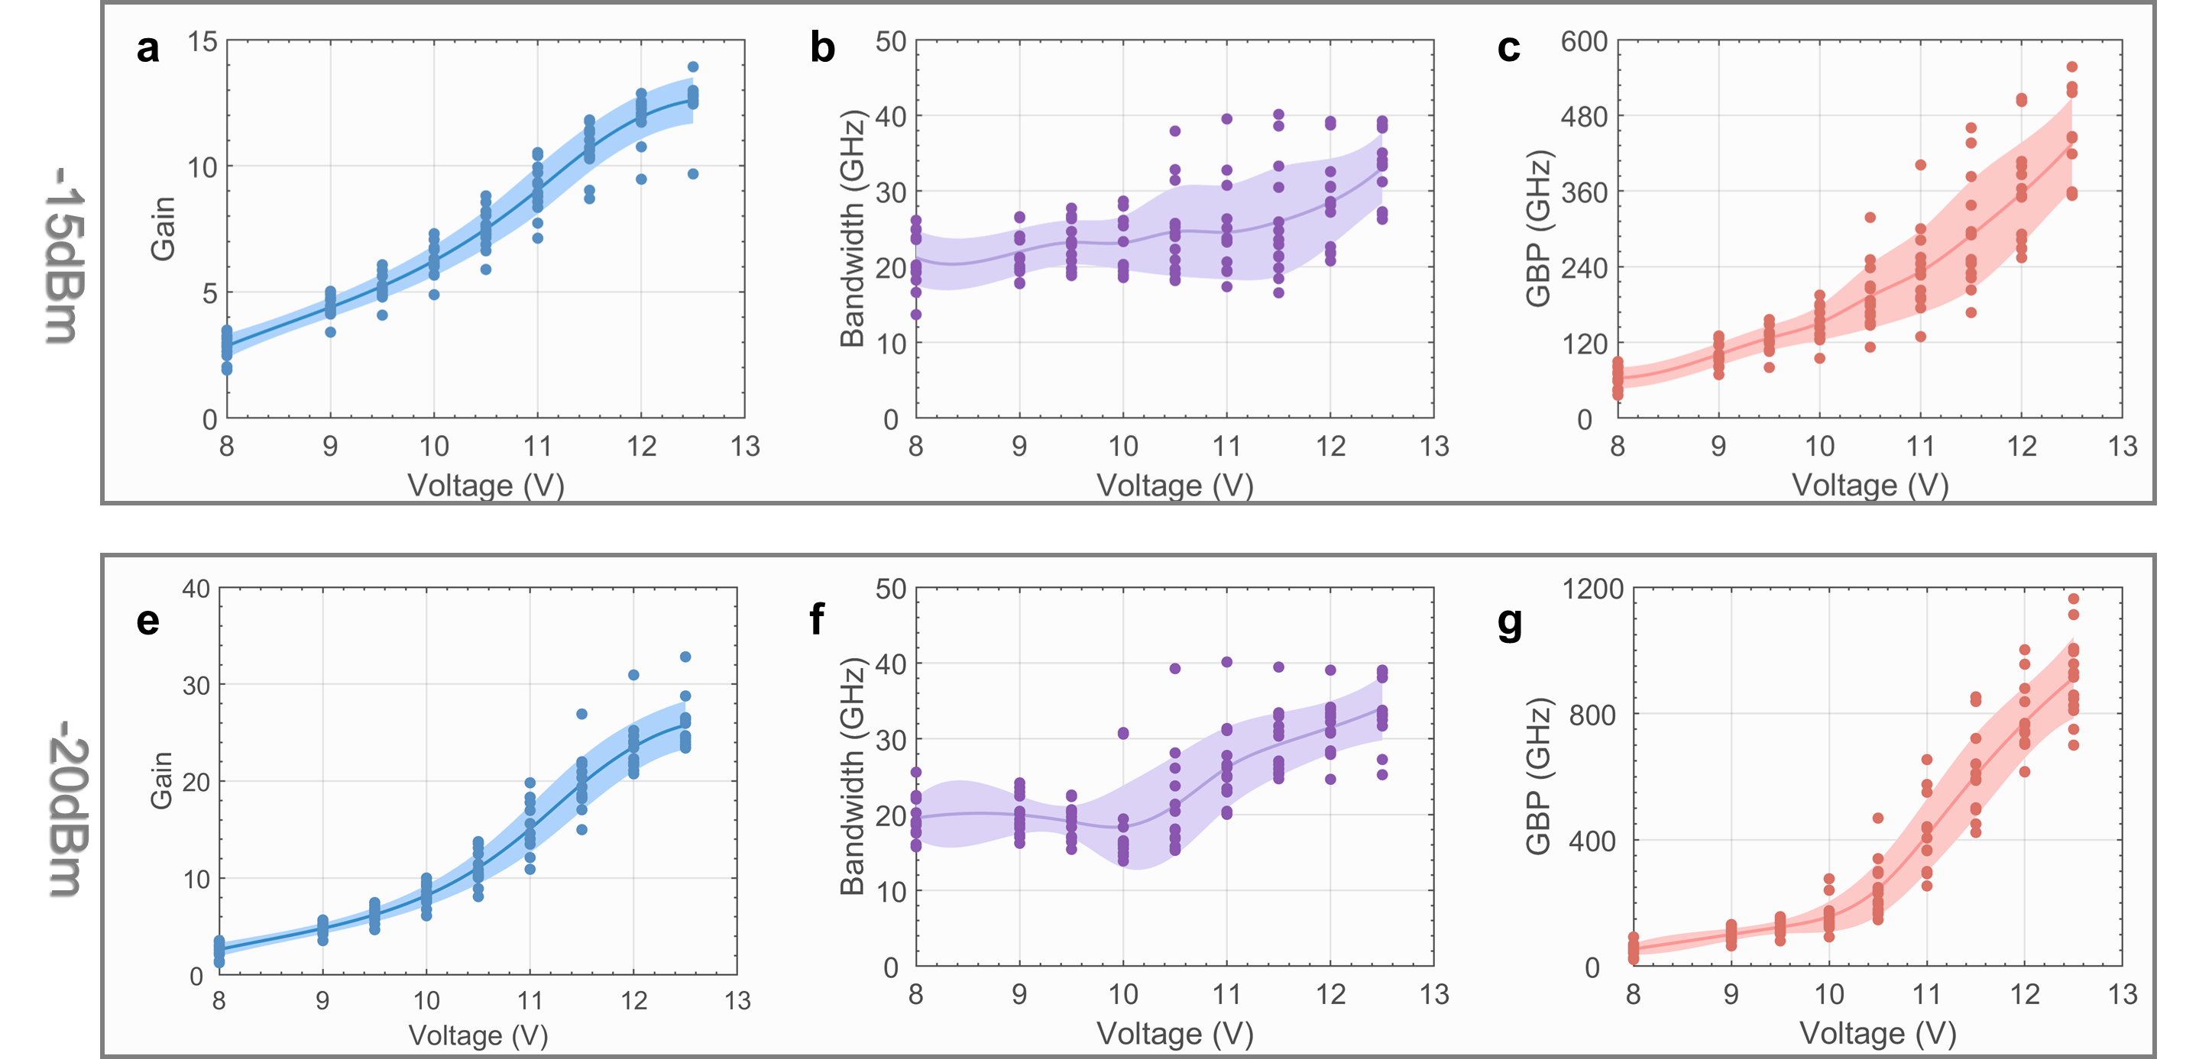
Fig. S14 Wafer-scale measurements under -15 dBm (a, b, c) and -20 dBm (e, f, g). a, e, gain; b, f, bandwidth; and c, g, GBP.
The performance dispersion observed at high bias voltages primarily originates from the fabrication variation of the offset W_{o} and the width W_{p} of the lightly doped P region. For the present device, the impact ionization in silicon is sensitive to the misalignment of the lightly p-doping overlay. As shown in Figs. S3d and S3e, both the peak electric field at the PN interface and the electric field in the Ge absorption layer are sensitive to W_{o} and W_{p}, which explains the chip-to-chip performance dispersion at high bias voltages. Despite these variations, all APD samples function reliably with satisfactory overall performance. The performance consistency of these APDs is expected to be further improved with more advanced foundry fabrication controls in the future.

- Influence of the k factor on the sensitivity of the APD
The influence of the k factor on the receiver sensitivity is analyzed by calculating the quality factor Q of the signal under different optical powers¹⁷. The Q-factor is described as¹⁸
$Q=\frac{ECP×OMA×M×R_{0}}{σ_{1}+σ_{0}}$ , (S12)
where ECP is the eye closure penalty that depends on the measurement condition. Here, we choose ECP=0.8 to keep better consistency between the measured and simulated results. OMA is the optical modulation amplitude determined by the optical power P_{in} and extinction ratio ER using the formula OMA=P_{in}(1-1/ER). M is the gain, and R₀ is defined as the primary responsivity of the APD. σ₁ and σ₀ represent the RMS noise for level '1' and level '0' signals, respectively. After obtaining the Q-factor under different optical powers, we could get the corresponding BER to determine the sensitivity of the APD with the following equation,
$BER=0.5∙erfc\left(\frac{Q}{\sqrt{2}}\right)$, (S13)
where erfc is the complementary error function. The k factor is varied from 0.01 to 0.11 to evaluate the sensitivity (BER=3.8e-3) under different gains, as shown in Fig. S15a. One should note that the maximum gain is usually not exactly the same as the optimal gain for achieving the highest sensitivity47. For example, in our recent work46, the peak gain was achieved at 10.4 V, while the highest sensitivity measurements were all taken at 10.2 V. A lower effective k-factor (corresponding to a higher GBP) is helpful to improve the optimal gain corresponding to the highest sensitivity for data receiving, as shown in Fig. S15a. The reduction of the k factor greatly improves the sensitivity of the receiver. Fig. S15b shows the optimum sensitivity and gain when the k factor reduces from 0.11 to 0.01, where a 2.8 dB optimum sensitivity improvement is observed. We also noted that the optimal gain for achieving the best sensitivity increases as the k factor decreases, which verifies that a low k factor is crucial for the sensitivity improvement of an APD. More specifically, the optimal gain for an APD with a k factor of 0.1 is 20, but for the present APD with an ultra-low k factor of 0.011, the optimal gain increases to as high as 80, which is also in accordance with the high-gain performance of the present APD. Furthermore, we simulated the BER curve versus the received optical power based on the performances of the APD and TIA, as detailed in Table 3. As shown in Fig. S15c, the simulated curve is well-matched with the measured value, verifying the validity of our sensitivity simulation. Here, we also provide the simulated BER versus received optical power for 10 Gbps, 25 Gbps, and 100 Gbps signals to further estimate the APD's sensitivity under different bit rates, as shown in Fig. S15c. The simulated sensitivities under the HD-FEC limit for 10 Gbps, 25 Gbps, and 100 Gbps are −32 dBm, −29 dBm, and −21 dBm, respectively. For the 10 and 25 Gbps sensitivity measurements, a TIA with a lower bandwidth is required to reduce the input-referred noise (IRN). For the 100 Gbps sensitivity measurement, a TIA with higher bandwidth and internally integrated continuous-time linear equalizer (CTLE) is needed to compensate for the bandwidth-limited receiver. Compared with the other reported APDs operating at 10/25/100 Gbps, as shown in Table 4, the present APD also shows a better sensitivity under these bit rates, showing its superb performance in high-sensitive receiving.
Table 3 Parameters used for the sensitivity simulation. I_{dark}: dark current; R₀: primary responsivity; BW: 3 dB bandwidth; RIN: relative intensity noise for the laser; ER: extinction ratio for the transmitter; ECP: eye closure penalty for the receiver's eye-diagram; IRN: input-referred noise of the TIA.
I_{dark}  (μA) | R₀  (A/W) | BW  (GHz) | k factor | RIN  (dBc/Hz) | ER  (dB) | ECP | IRN  pA/$\sqrt{Hz}$
38 | 0.91 | 30 | 0.011 | -140 | 5.5 | 0.8 | 15

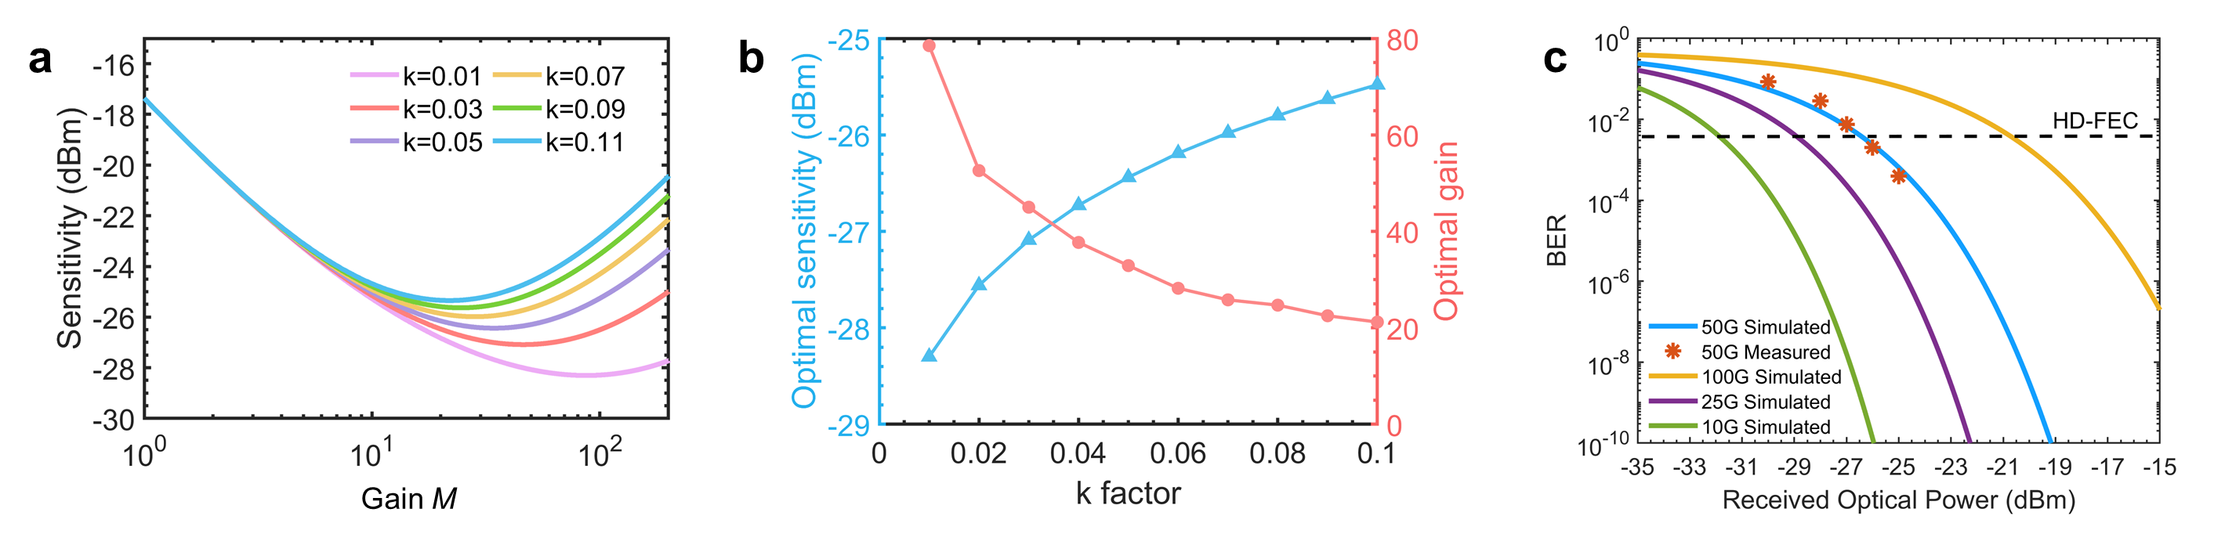
Fig. S15 Sensitivity analysis of the APD. a, Simulated sensitivity (@BER=3.8e-3) versus the gain under different k factors. b, Extracted optimal gain and the corresponding best sensitivity for the cases with different k factors. c, Simulated and measured BER versus the received optical power for 50 Gbps receiving, and the simulated results for 10 Gbps, 25 Gbps and 100 Gbps receiving.
To quantitatively evaluate the receiver's noise performance at the 50G-PON sensitivity point (an input optical power of −26.5 dBm), a detailed noise budget analysis was conducted. Under this condition, the APD operates at a bias voltage of 12 V, corresponding to a multiplication gain of M≈80 and a dark current of Idark=38 μA. The primary unmultiplied photocurrent is approximately 2 μA, which is amplified to a total signal current of ∼160 μA. In our receiver model, the integrated input-referred noise of the transimpedance amplifier (TIA) is approximately 2.6 μA over a 30-GHz bandwidth. In contrast, the multiplied shot noise originating from the photocurrent and the dark-current noise are each on the order of tens of microamperes. This quantitative comparison demonstrates that the high avalanche gain of the present APD successfully elevates the signal current well above the TIA noise floor. Consequently, the receiver system is effectively shifted into an APD-noise-limited regime rather than being bottlenecked by the thermal noise of the TIA, thereby ensuring the superior sensitivity required for 50G-PON applications.
For comparison, the receiver performance was also estimated assuming a PIN photodiode (M = 1) using the same receiver model and parameters listed in Table S3. Under identical TIA noise, bandwidth, and DSP conditions, the simulated PIN-receiver sensitivity is approximately −17.5 dBm, which is about 9 dB worse than the measured APD-based receiver sensitivity of −26.5 dBm. This result is consistent with typical sensitivities reported for PIN-based receivers and confirms that avalanche multiplication plays a critical role in overcoming the TIA noise floor and enabling the high receiver sensitivity demonstrated in this work.
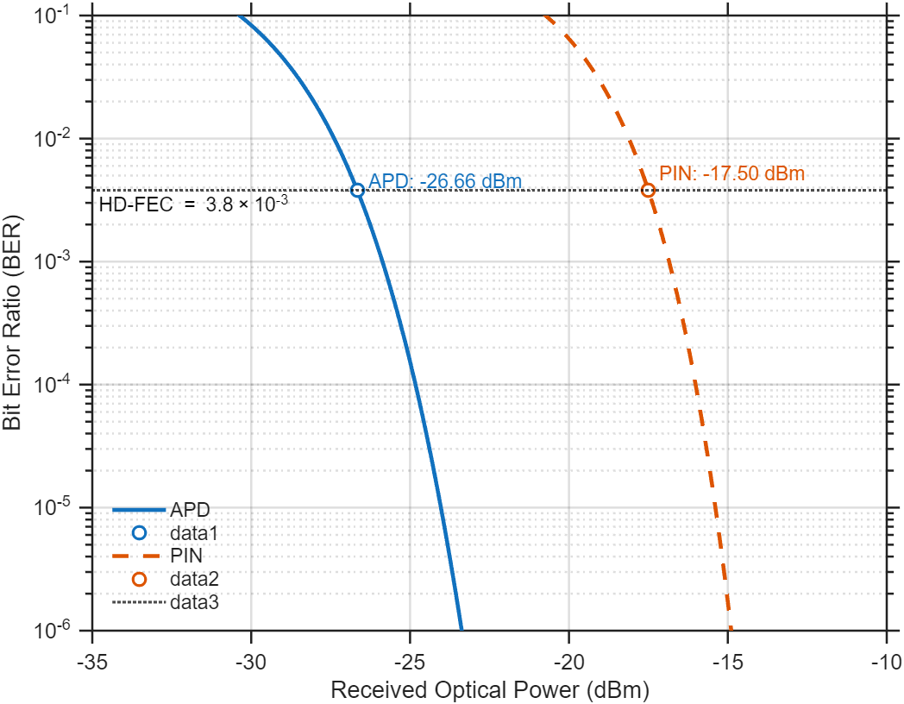
Fig. S23 Simulated BER vs received power for APD (M=17) and PIN (M=1)
- Eye-diagrams of the present APD under different optical powers
We measured the 10-Gbps and 25-Gbps eye diagrams under different optical powers ranging from −10 dBm to −30 dBm, as shown in Fig. S16 and Fig. S17, respectively.
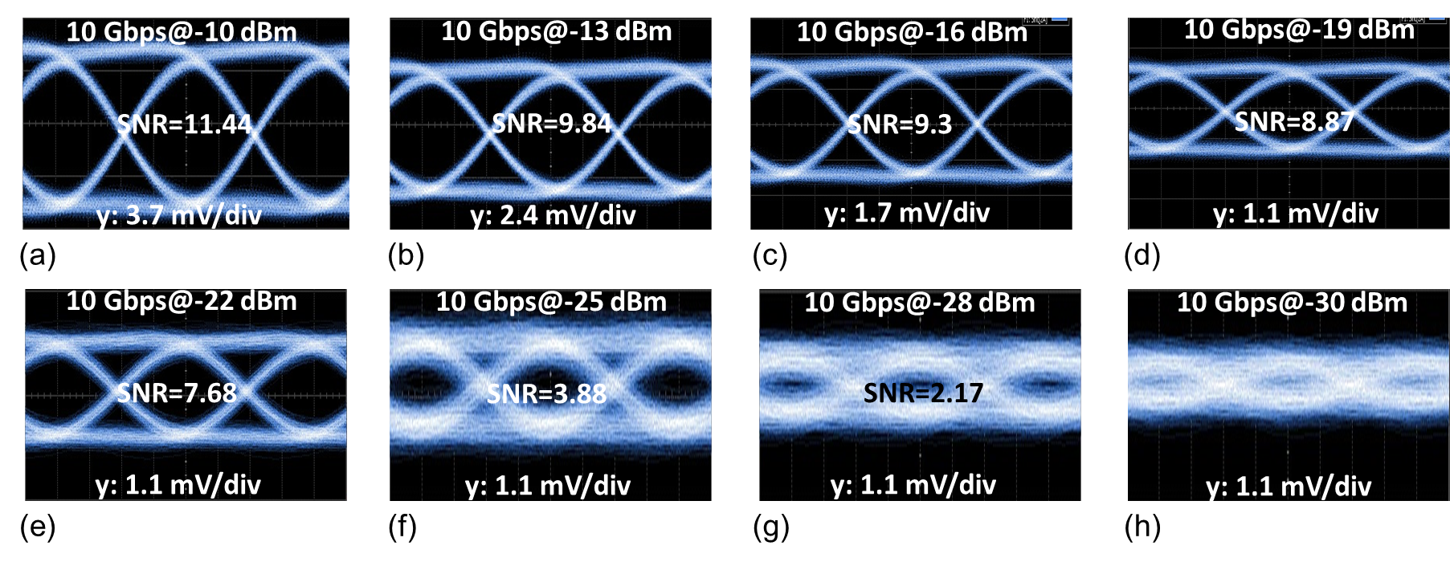
Fig. S16 Measured 10-Gbps eye diagrams under different optical powers. a, −10 dBm. b, −13 dBm. c, −16 dBm. d, −19 dBm. e, −22dBm. f, −25 dBm. g, −28 dBm. h, −30 dBm.

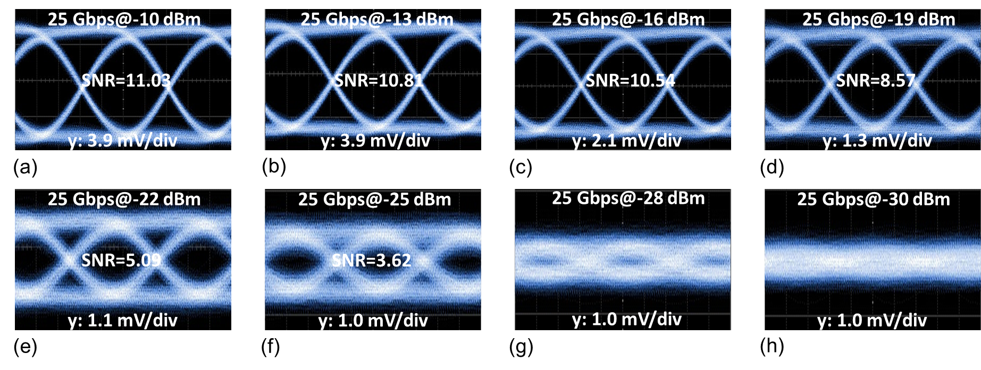
Fig. S17 Measured 25-Gbps eye diagrams under different optical powers. a, −10 dBm. b, −13 dBm. c, −16 dBm. d, −19 dBm. e, −22dBm. f, −25 dBm. g, −28 dBm. h, −30 dBm.

The clear eye-opening in the eye diagrams under low optical power (e.g., −25 dBm) validate the high-sensitivity detection capability of the present APD. Note that the eye diagrams are observed to be closed when the optical power further decreases to −30 dBm. We believe it was limited by the intrinsic noise of the high-speed sampling oscilloscope (275 μV noise for the Keysight N1000A DCA-X oscilloscope) rather than the sensitivity performance of the APD, regarding that the amplitude of the APD’s output signal is less than 1 mV when the optical power is −30 dBm, which is hard to be directly detected by the oscilloscope. By packaging the APD with a TIA to further amplify the signal, the eye diagrams under lower optical power should be expected.
- The state-of-the-art APDs
Table 4 gives detailed performance summaries of the previously reported Ⅲ-Ⅴ APDs and Ge/Si APDs with different structures. In summary, the present Ge/Si waveguide APD shows impressive performances with an ultrahigh GBP, an ultralow effective k factor, and high sensitivity for 50-Gbps data receiving.
Table 4 Literature overview of the reported APDs. TN: top-illuminated normal incident; SACM: separate absorption charge multiplication; BN: back-illuminated normal incident; SAGM: separate absorption grading multiplication; SAGCMCT: separate absorption grading charge multiplication charge transit; SAGCMCMCT: separate absorption grading charge multiplication charge multiplication charge transit; SAGCM: separate absorption grading charge multiplication; BW: butt-joint coupled waveguide; SACMC: separate absorption charge multiplication charge; EW: evanescent coupled waveguide; MSM: metal-semiconductor-metal; LPIN: lateral PIN; VPIN: vertical PIN; VSACM: vertical SACM; LSACM: lateral SACM; LSAM: Lateral separate absorption multiplication.
Ref | Material | Structure | V_{br}  (V) | I_{dark}  (μA) | R₀  (A/W) | Gain | Bandwidth  (GHz) | GBP  (GHz) | k factor | Sensitivity  (dBm) | Sensitivity  With TIA
[19] | Ⅲ-Ⅴ | TN-SACM | 30 | 2 | 0.7 | 40 | 6.75 | 270 | 0.1 | −20.8 (56 Gbps) | Yes
[20] | Ⅲ-Ⅴ | BN-SAGM | 28 | 0.06 | 0.9 | 20 | 12 | 240 | 0.13 | /
[21] | Ⅲ-Ⅴ | TN-SACM | / | / | 0.86 | 30 | 9.7 | 290 | 0.18 | /
[22] | Ⅲ-Ⅴ | TN-SAGCMCT | 28 | / | 0.55 | 20 | 10.5 | 210 | / | /
[23] | Ⅲ-Ⅴ | TN-SAGCMCMCT | 26 | 0.2 | 0.3 | 150 | 5 | 750 | / | /
[24] | Ⅲ-Ⅴ | TN-SAGCM | / | / | 0.18 | 30.3 | 14 | 424 | / | /
[25] | Ⅲ-Ⅴ | BW-SACMC | 21 | / | 0.9 | 16 | 16.6 | 265 | / | /
[26] | Ⅲ-Ⅴ | TN-SACMC | 30 | / | 0.7 | 27 | 10 | 270 | 0.2 | −16 (50 Gbps) | Yes
[27] | Ge/Si | EW-MSM | 2.8 | 50 | 0.4 | 8 | 37.5 | 300 | 0.1 | −15.5 (10 Gbps) | No
[28] | Ge/Si | BW-LPIN | 6.5 | 600 | 0.4 | 17 | 11 | 187 | / | −28 (10 Gbps) | No
[29] | Ge/Si | EW-LPIN | 12.5 | 100 | 0.95 | 16 | 22 | 352 | 0.2 | −3 (64 Gbps) | No
[30] | Ge/Si | EW-VPIN | 5.1 | / | 0.3 | 9.2 | 15.2 | 140 | 0.2 | −20 (25 Gbps) | Yes
[31] | Ge/Si | BW-LPIN | 10 | 600 | 0.49 | 11.4 | 18.4 | 210 | 0.25 | −14.5 (40 Gbps) | Yes
[32] | Ge/Si | TN-SACM | 25 | 10 | 0.55 | 30 | 11.3 | 340 | 0.09 | −30.5 (10 Gbps) | yes
[33] | Ge/Si | TN-SACM | 29 | 30 | 0.3 | 39 | 8 | 310 | / | /
[34] | Ge/Si | EW-VSACM | 10 | 100 | 1.05 | 12 | 23 | 276 | 0.05 | −20 (25 Gbps) | Yes
[35] | Ge/Si | TN-SACMC | 26.6 | 3 | 0.9 | 8 | 21 | 168 | / | −28.5 (25 Gbps) | Yes
[36] | Ge/Si | EW-VSACM | 6 | 1000 | 0.48 | 15 | 18.9 | 284 | / | −12.5 (25 Gbps) | No
[37] | Ge/Si | EW-VSACM | 18 | 0.27 | 0.6 | 10 | 36 | 360 | / | /
[38] | Ge/Si | EW-VSACM | 16.5 | 1 | 0.75 | 9 | 27.5 | 260 | / | −18.9  (100 Gbps) | Yes
[7] | Ge/Si | EW-LSACM | 10 | 30 | 0.65 | 10.5 | 22.7 | 238 | 0.25 | −18.6 (56 Gbps) | Yes
[39] | Ge/Si | EW-LSACM | 13 | 1.8 | 0.96 | 14.4 | 27 | 383 | / | /
[40] | Ge/Si | EW-LSAM | 22 | 30 | 1.12 | 40 | 9 | 360 | / | /
[41] | Ge/Si | EW-LSACM | 14 | 10 | 0.93 | 12.8 | 48 | 615 | / | −12.6  (100 Gbps) | No
[42] | Ge/Si | EW-LSACM | 8.9 | 12 | 0.87 | 19.5 | 53 | 1033 | / | −14 (100 Gbps) | No
This work | Ge/Si | EW-LSACM | 12.5 | 0.25 | 0.91 | 209 | 26.7 | 5580 | 0.011 | −26.5 (50 Gbps) | Yes
V_{br}, breakdown voltage; I_{dark}, dark current; R₀, primary responsivity under unit gain.

- The process flows
A key advantage of lateral waveguide APDs lies in their inherent compatibility with standard CMOS processes. Globally, multiple mature silicon photonics foundry platforms are available, including international services such as IMEC, AMF (Advanced Micro Foundry), GF (GlobalFoundries), and VTT, as well as domestic platforms like CUMEC (China United Microelectronics Center) and IMECAS (Institute of Microelectronics, Chinese Academy of Sciences). All devices presented in this work were fabricated through Multi-Project Wafer (MPW) processes on these platforms. Although specific process details may vary slightly across different foundries, the overall fabrication flow remains largely consistent. The MPW services enable integrated manufacturing of various components, including grating couplers, passive waveguides, modulators, photodetectors, heating electrodes, and deep silicon etching (for edge coupling and adiabatic slots), as illustrated in Fig. S18:
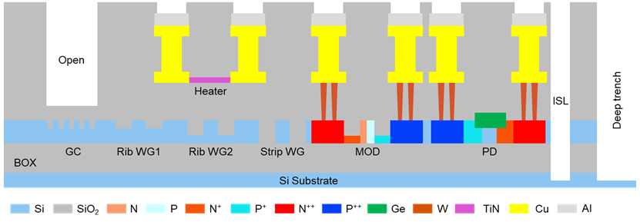
Fig.S18 Cross-sectional view of standard MPW fabrication process
The MPW fabrication process for silicon photonic devices, shown schematically in Fig.S19, consists of multiple intricate steps. For brevity, we have grouped several highly detailed procedures—including the waveguide patterning sequence (photoresist spin-coating, soft-baking, exposure, development, post-exposure baking, descum, etching, and resist stripping)—under the general term "waveguide etching." The simplified fabrication flow includes the following key stages:
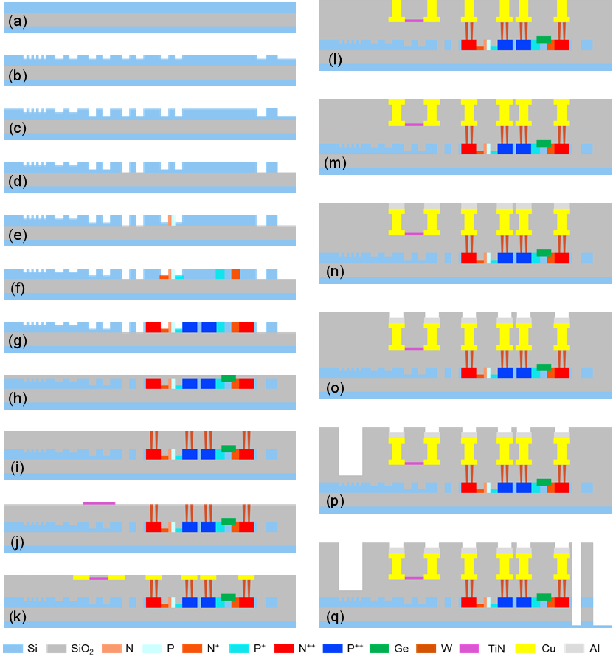
Fig.S19 Silicon-based opto-electronic device fabrication process flow (MPW process)
i. Wafer preparation (Fig. S19a): Silicon-on-insulator (SOI) wafers commonly employed across various fabrication platforms are typically 8 inches in diameter. The top silicon layer thickness is generally 220 nm, though some platforms use 170 nm (e.g., GlobalFoundries) or 310 nm (e.g., CEA-Leti), with a resistivity of approximately 10 Ω∙cm. The buried oxide (BOX) layer is typically 2–3 μm thick; a greater BOX thickness helps reduce parasitic capacitance and improves the bandwidth of optoelectronic devices. The silicon substrate is approximately 725 μm thick, with resistivity values ranging from ∼14 Ω·cm (low-resistivity) to ∼750 Ω·cm (high-resistivity). High-resistivity substrates help minimize microwave absorption, thereby enhancing the operating bandwidth of electro-optic devices such as modulators.
ii. Waveguide etching (Fig.S19 b-d): A hard mask is typically employed in this step. As an example, an etching sequence of 70 nm, 60 nm, and 90 nm can be performed to fabricate, respectively: a 70 nm shallow-etched grating coupler; a 70 nm shallow-etched ridge waveguide; a 130 nm shallow-etched ridge waveguide; and a 220 nm fully etched waveguide. Alternatively, some platforms perform waveguide etching directly using a photoresist mask without a hard mask. In such cases, a single etch step with depths of 70 nm, 150 nm, and 220 nm can be used to produce a 70 nm shallow-etched grating coupler; a 70 nm shallow-etched ridge waveguide; a 150 nm shallow-etched ridge waveguide; and a 220 nm fully etched waveguide. Compared to the latter approach, the hard mask method offers improved compatibility with finer feature sizes by mitigating issues such as pattern distortion due to photoresist overflow, albeit at the cost of greater process complexity.
iii. Ion implantation doping (Fig. S19(e)-(g)): Ion implantation achieves a single doping concentration (P or N) per cycle, typically using photoresist as the blocking layer. Fig. S19 (e)-(g) show low-concentration P/N doping, medium-concentration P/N doping, and high-concentration P/N doping, respectively. In total, it requires six steps of ion implantation processes. After ion implantation, thermal annealing is required to activate the ions and repair the lattice defects caused by ion implantation. The carrier concentrations are 1 × 10²⁰ cm⁻³, 2 × 10¹⁸ cm⁻³ and 5 × 10¹⁷ cm⁻³ for the P⁺⁺/N⁺⁺ layer, the P⁺/ N⁺ layer and the P/N layer.
iv. Germanium epitaxial growth (Fig.S19h): Germanium is deposited via a two-step epitaxial growth process ^{44,45}, followed by rapid thermal annealing to minimize lattice dislocations and enhance material quality. Finally, chemical mechanical polishing (CMP) is employed to planarize the surface and achieve the target germanium thickness.
v. Silicon contact via electrode deposition (Fig.S19i): The oxide layer on the silicon surface is first etched to open contact vias. These are then filled with tungsten (W), followed by thermal annealing to form a stable ohmic contact with the underlying heavily doped silicon. Finally, CMP is applied to planarize the surface.
vi. TiN heating electrode deposition (Fig.S19j): Titanium nitride (TiN) films are typically deposited via metal evaporation or sputtering. The resulting heating electrode enables thermal tuning of the operating wavelength or phase in silicon photonic devices.
vii. Cu electrode and via deposition (Fig.S19 k-m): Copper electrodes are fabricated via the Damascene electroplating process to ensure high-quality metallization and enhance device performance. While some platforms utilize aluminum (Al) electrodes, Cu offers superior electrical conductivity. In contrast, Al exhibits higher microwave loss, which can limit the bandwidth of certain optoelectronic devices.
viii. Aluminum bonding pads and pad openings (Fig.S19 n-o): Aluminum is a suitable material for bonding pads due to its good electrical conductivity and excellent mechanical compliance. Although its conductivity is lower than that of gold, this difference has a negligible impact on its performance as a bonding pad, while offering a substantial advantage in cost-effectiveness.
ix. After each metal electrode process, a Si₃N₄ passivation layer is typically deposited to protect the metal interconnects. To enhance the coupling efficiency of the grating coupler, a window is opened in the oxide layer above the grating, leaving only a few hundred nanometers of oxide remaining.
x. Deep silicon etching (Fig.S19q): Deeply etched silicon trenches serve as thermal isolation structures between devices, effectively reducing thermal crosstalk and improving heating efficiency in thermally tuned photonic devices. Furthermore, the deep etching process yields nearly vertical sidewalls with minimal roughness, eliminating the need for post-etch polishing prior to optical testing. These trenches are typically etched several hundred micrometers into the silicon substrate to accommodate optical coupling fibers.
- The device designed parameters
As shown in Fig. S21, the parameters for the designed device are provided.
The offset parameter W_{o} is set to 50 nm to balance the gain and bandwidth trade-off. The parameter Wp is chosen to be 150 nm to achieve a thin multiplication layer and maintain a relatively low electric field in the absorption layer simultaneously.
W_{o} = 50 nm
W_{p} = 150 nm
A 260-nm-thick Ge-strip is selectively grown on the SOI ridge with low dislocation to guarantee low dark current density. Considering the high absorption coefficient of Ge in the 1310 nm wavelength-band, the length of the germanium strip is set to as short as 6.5 μm, which helps minimize the dark current while preserving a high primary responsivity. To reduce the transit time in the absorption layer and achieve high primary bandwidth, the width of the germanium strip is chosen to be as narrow as 500 nm, limited by the high-quality Ge-epitaxy fabrication process.
H_{Ge}: the thickness of the Ge layer is 260 nm.
W_{Ge}: the width of the Ge layer is 500 nm.
L_{Ge}: the length of the Ge layer is 6.5 μm.
The Si slab refers to the thin planar layer beneath the rib structure, while the Si rib denotes the raised strip that confines the optical mode laterally. Together, they form the core of the silicon waveguide for light propagation. A bi-level tapered waveguide connects the input 380-nm-wide strip waveguide and the APD’s 700-nm-wide ridge waveguide. The total thickness of the silicon layer is 220 nm. A ridge waveguide featuring a 150-nm-thick slab is implemented to enhance optical confinement in the active region and thereby improve the internal quantum efficiency
H_{Si}: the Thickness of the Si layer is 220 nm.
H_{Si-slab}: the Thickness of the Si slab is 70 nm.
H_{Si-rib}: the Thickness of the Si rib is 150 nm.
W_{Si-slab}: the Width of the Si slab is 700 nm.
W_{Si-rib}: the Width of the Si rib is 380 nm.
H_{Cladding}: the Thickness of the Cladding layer is about 6 μm.
H_{Box}: the Thickness of the BOX (Buried Oxide) is 2 μm.
H_{Si-Substrate}: the Thickness of the Si Substrate is 200 mm.
The heavily doped P++ and N++ regions are in Ohmic contact, contacted to the tungsten vias (W) connected with the aluminum pads (Al). A lightly doped P region with a width of W_{p} is selectively ion-implanted to function as the charge and multiplication layers simultaneously. The moderately doped P+ and N+ regions are introduced on the rib to reduce the sheet resistance of the APD and achieve a high RC-limited bandwidth. The carrier concentrations are 1 × 10²⁰ cm⁻³, 2 × 10¹⁸ cm⁻³ and 5 × 10¹⁷ cm⁻³ for the P⁺⁺/N⁺⁺ layer, the P⁺/ N⁺ layer and the P/N layer.
P++/N++: the carrier concentrations of the heavily doped P++ and N++ region are 1 × 10²⁰ cm⁻³
P+/N+: the carrier concentrations of the moderately doped P+ and N+ regions are 2 × 10¹⁸ cm⁻³
P: the carrier concentrations of the lightly doped P regions is 5 × 10¹⁷ cm⁻³
G_{pad}: the center-to-center distance (pitch) between two adjacent pads is 100 μm.
W_{pad}: the width of the single Pad is 60 μm.
L_{pad}: the length of the single Pad is 80 μm.
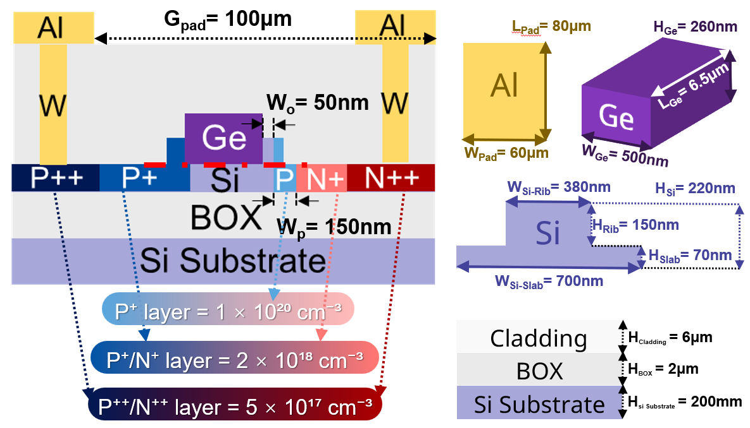
Fig.S21 The device designed parameters.
References
1. Selberherr, S. Analysis and Simulation of Semiconductor Devices. (Springer Vienna, Vienna, 1984). doi:10.1007/978-3-7091-8752-4.
2. Hayat, M. M., Saleh, B. E. A. & Teich, M. C. Effect of dead space on gain and noise of double-carrier-multiplication avalanche photodiodes. IEEE Trans. Electron Devices 39, 546–552 (1992).
3. Jeng Shiuh Cheong, Hayat, M. M., Xinxin Zhou & David, J. P. R. Relating the Experimental Ionization Coefficients in Semiconductors to the Nonlocal Ionization Coefficients. IEEE Trans. Electron Devices 62, 1946–1952 (2015).
4. McIntyre, R. J. Multiplication noise in uniform avalanche diodes. IEEE Trans. Electron Devices ED-13, 164–168 (1966).
5. Emmons, R. B. Avalanche-Photodiode Frequency Response. Journal of Applied Physics 38, 3705–3714 (1967).
6. Zou, M. et al. Ultra‐large bandwidth and ultra‐high sensitivity germanium/silicon avalanche photodiode. Laser Photonics Rev. 2401574 (2024) doi:10.1002/lpor.202401574.
7. Srinivasan, S. A. et al. 56 Gb/s NRZ O-Band Hybrid BiCMOS-Silicon Photonics Receiver Using Ge/si Avalanche Photodiode. J. Lightwave Technol. 39, 1409–1415 (2021).
8. Chowdhury, A. et al. High Performance Avalanche Photodiode in a Monolithic Silicon Photonics Technology. in Optical Fiber Communication Conference (OFC) 2022 W3D.1 (Optica Publishing Group, San Diego, California, 2022). doi:10.1364/OFC.2022.W3D.1.
9. Spinelli, A. & Lacaita, A. L. Mean gain of avalanche photodiodes in a dead space model. IEEE Trans. Electron Devices 43, 23–30 (1996).
10. Tan, L. J. J. et al. Temperature Dependence of Avalanche Breakdown in InP and InAlAs. IEEE J. Quantum Electron. 46, 1153–1157 (2010).
11. Zhao, Y. et al. Temperature dependence simulation and characterization for InP/InGaAs avalanche photodiodes. Front. Optoelectron. 11, 400–406 (2018).
12. Harrison, C. N., David, J. P. R., Hopkinson, M. & Rees, G. J. Temperature dependence of avalanche multiplication in submicron Al0.6Ga0.4As diodes. Journal of Applied Physics 92, 7684–7686 (2002).
13. Rouvie, A. et al. High Gain $\times$ Bandwidth Product Over 140-GHz Planar Junction AlInAs Avalanche Photodiodes. IEEE Photon. Technol. Lett. 20, 455–457 (2008).
14. Meier, H. T. J. Design, characterization and simulation of avalanche photodiodes. 1 Band (ETH Zurich, 2011). doi:10.3929/ETHZ-A-006445001.
15. Liu, Y., Yang, X., Wang, R. & Tang, Y. Excess noise factor measurement for low-noise high-speed avalanche photodiodes. Phys. Scr. 98, 105517 (2023).
16. Wang, B. et al. A Compact Model for Si-Ge Avalanche Photodiodes Over a Wide Range of Multiplication Gain. J. Lightwave Technol. 37, 3229–3235 (2019).
17. Agrawal, G. P. Fiber-Optic Communication Systems. (Wiley, Hoboken, NJ, 2022).
18. Wang, B. et al. A Low-Voltage Si-Ge Avalanche Photodiode for High-Speed and Energy Efficient Silicon Photonic Links. J. Lightwave Technol. 38, 3156–3163 (2020).
19. Nada, M., Yamada, Y. & Matsuzaki, H. Responsivity-Bandwidth Limit of Avalanche Photodiodes: Toward Future Ethernet Systems. IEEE J. Select. Topics Quantum Electron. 24, 1–11 (2018).
20. Lahrichi, M. et al. 240-GHz gain-bandwidth product back-side illuminated AlInAs avalanche photodiodes. IEEE Photonics Technol. Lett. 22, 1373–1375 (2010).
21. Lenox, C. et al. Resonant-cavity InGaAs-InAlAs avalanche photodiodes with gain-bandwidth product of 290 GHz. IEEE Photon. Technol. Lett. 11, 1162–1164 (1999).
22. Wang, R., Yang, X., Wang, H., He, T. & Tang, Y. A modified equivalent circuit model for high-speed InGaAs/InAlAs avalanche photodiodes. J. Lightwave Technol. 40, 2944–2951 (2022).
23. Naseem et al. Top-Illuminated Avalanche Photodiodes With Cascaded Multiplication Layers for High-Speed and Wide Dynamic Range Performance. J. Lightwave Technol. 40, 7893–7900 (2022).
24. Xie, S. et al. InGaAs/AlGaAsSb avalanche photodiode with high gain-bandwidth product. Opt. Express 24, 24242 (2016).
25. Okimoto, T. et al. 106-gb/s waveguide AlInAs/GaInAs avalanche photodiode with butt-joint coupling structure. in Optical Fiber Communication Conference (OFC) 2022 W3D.2 (Optica Publishing Group, San Diego, California, 2022). doi:10.1364/OFC.2022.W3D.2.
26. Nada, M., Yoshimatsu, T., Muramoto, Y., Yokoyama, H. & Matsuzaki, H. Design and Performance of High-Speed Avalanche Photodiodes for 100-Gb/s Systems and Beyond. J. Lightwave Technol. 33, 984–990 (2015).
27. Assefa, S., Xia, F. & Vlasov, Y. A. Reinventing germanium avalanche photodetector for nanophotonic on-chip optical interconnects. Nature 464, 80–84 (2010).
28. Virot, L. et al. Germanium avalanche receiver for low power interconnects. Nat. Commun. 5, 4957 (2014).
29. Zhang, J., Kuo, B. P.-P. & Radic, S. 64Gb/s PAM4 and 160Gb/s 16QAM modulation reception using a low-voltage Si-Ge waveguide-integrated APD. Opt. Express 28, 23266 (2020).
30. Chen, H. T. et al. 25-Gb/s 1310-nm Optical Receiver Based on a Sub-5-V Waveguide-Coupled Germanium Avalanche Photodiode. IEEE Photonics J. 7, 1–9 (2015).
31. Benedikovic, D. et al. 40 gbps heterostructure germanium avalanche photo receiver on a silicon chip. Optica 7, 775 (2020).
32. Kang, Y. et al. Monolithic germanium/silicon avalanche photodiodes with 340 GHz gain–bandwidth product. Nat. Photonics 3, 59–63 (2009).
33. Duan, N., Liow, T.-Y., Lim, A. E.-J., Ding, L. & Lo, G. Q. 310 GHz gain-bandwidth product Ge/Si avalanche photodetector for 1550 nm light detection. Opt. Express 20, 11031 (2012).
34. Huang, Z. et al. 25 gbps low-voltage waveguide Si–Ge avalanche photodiode. Optica 3, 793 (2016).
35. Huang, M. et al. Germanium on Silicon Avalanche Photodiode. IEEE J. Select. Topics Quantum Electron. 24, 1–11 (2018).
36. Zeng, X. et al. Silicon–germanium avalanche photodiodes with direct control of electric field in charge multiplication region. Optica 6, 772 (2019).
37. Huang, M. et al. 56GHz waveguide Ge/Si avalanche photodiode. in Optical Fiber Communication Conference W4D.6 (OSA, San Diego, California, 2018). doi:10.1364/OFC.2018.W4D.6.
38. Huang, M. et al. Recess-type waveguide integrated germanium on silicon avalanche photodiode. in Optical Fiber Communication Conference (OFC) 2021 F2C.3 (Optica Publishing Group, Washington, DC, 2021). doi:10.1364/OFC.2021.F2C.3.
39. Xiang, Y., Cao, H., Liu, C. & Dai, D. High-performance waveguide Ge/Si avalanche photodiode with a lateral separate-absorption-charge-multiplication structure. Opt. Express 30, 11288 (2022).
40. Pang, Y. et al. High-performance waveguide-coupled lateral Ge/Si avalanche photodetector. Opt. Lett. 47, 4463 (2022).
41. Xiang, Y., Cao, H., Liu, C., Guo, J. & Dai, D. High-speed waveguide Ge/Si avalanche photodiode with a gain-bandwidth product of 615 GHz. Optica 9, 762 (2022).
42. Shi, Y. et al. Avalanche photodiode with ultrahigh gain–bandwidth product of 1,033 GHz. Nat. Photon. 18, 610–616 (2024).
43. Sze, S. M. & Ng, K. K. Physics of Semiconductor Devices. Wiley (2007).
44. Luan, H.-C., Lim, D. R., Lee, K. K. et al. High-quality Ge epilayers on Si with low threading-dislocation densities. Appl. Phys. Lett. 75, 2909–2911 (1999).
45. Osmond, J., Isella, G., Chrastina, D. et al. Ultralow dark current Ge/Si(100) photodiodes with low thermal budget. Appl. Phys. Lett. 94, 201106 (2009).
46.Cao, H. et al. Ge/Si APD receiver with record-high sensitivity exceeding −30 dBm for 50G PON. Opt. Fiber Commun. Conf. (OFC) M4K.4 (2025).
47.Srinivasan, S. A. et al. 27 GHz Silicon-Contacted Waveguide-Coupled Ge/Si Avalanche Photodiode. J. Lightwave Technol. 38, 3044–3050 (2020).

