Supplementary Information

Laser induced damage threshold test of the SiC DOE
The silicon carbide (SiC) diffractive optical element (DOE) serves as the first beam splitting component in the multi-beam optical setup. Because it is positioned before power division, the DOE is exposed to the full incident beam and therefore provides a relevant test case at the device level for evaluating the high power tolerance of patterned SiC diffractive optics. A high power laser operating at a wavelength of 1030 nm was used for the laser induced damage threshold (LIDT) measurements.
The experimental setup for the LIDT test is shown in Figure S1a. The high power laser beam was directed onto the SiC DOE. The diffracted beams then propagated to a power meter. A light barrier was positioned to block back reflections from the DOE, ensuring experimental safety. Throughout the experiment, the laser operational parameters were held constant. The laser power was incrementally increased to identify the threshold at which macroscopic, visually observable damage occurred on the sample. A cooling interval of one minute was implemented after each irradiation step to allow for heat dissipation and for the sample to return to ambient temperature.
In the pulsed irradiation test, the laser was operated in a dual pulse mode at a wavelength of 1030 nm. The beam was shaped into a 1 mm × 1 mm square profile, with a pulse width of 90 ns and a dual pulse repetition frequency of 100 kHz. No observable damage was found at an incident average power of 300 W, corresponding to a fluence of 0.30 J/cm² per pulse pair and an average power density of 30 kW/cm². Dividing the pulse pair fluence by 90 ns gives a nominal power density of 3.33 MW/cm². This condition is therefore reported as the highest tested nondamaging pulsed irradiation condition for the SiC DOE. When the incident average power was increased to the next tested level of 500 W, macroscopic ablation was observed, as shown in Figure S1c. Subsequent characterization using a three dimensional digital microscope confirmed penetration damage through the 500 μm thick SiC DOE, as shown in Figure S1d. These observations distinguish the tested 300 W nondamaging condition from the 500 W damaging condition under the present pulsed irradiation protocol.
To assess the damage resistance of the SiC DOE under continuous wave (CW) irradiation, a separate test was conducted using a 1030 nm CW laser with a beam diameter of 10 mm defined by the intensity full width at half maximum (FWHM). The highest tested nondamaging CW condition was 4.8 kW for 20 s, corresponding to a nominal irradiance of 6.11 kW/cm². This value was calculated by dividing the total incident power by the circular area defined by the intensity FWHM diameter. Fracture was observed at 5 kW after 5 s.
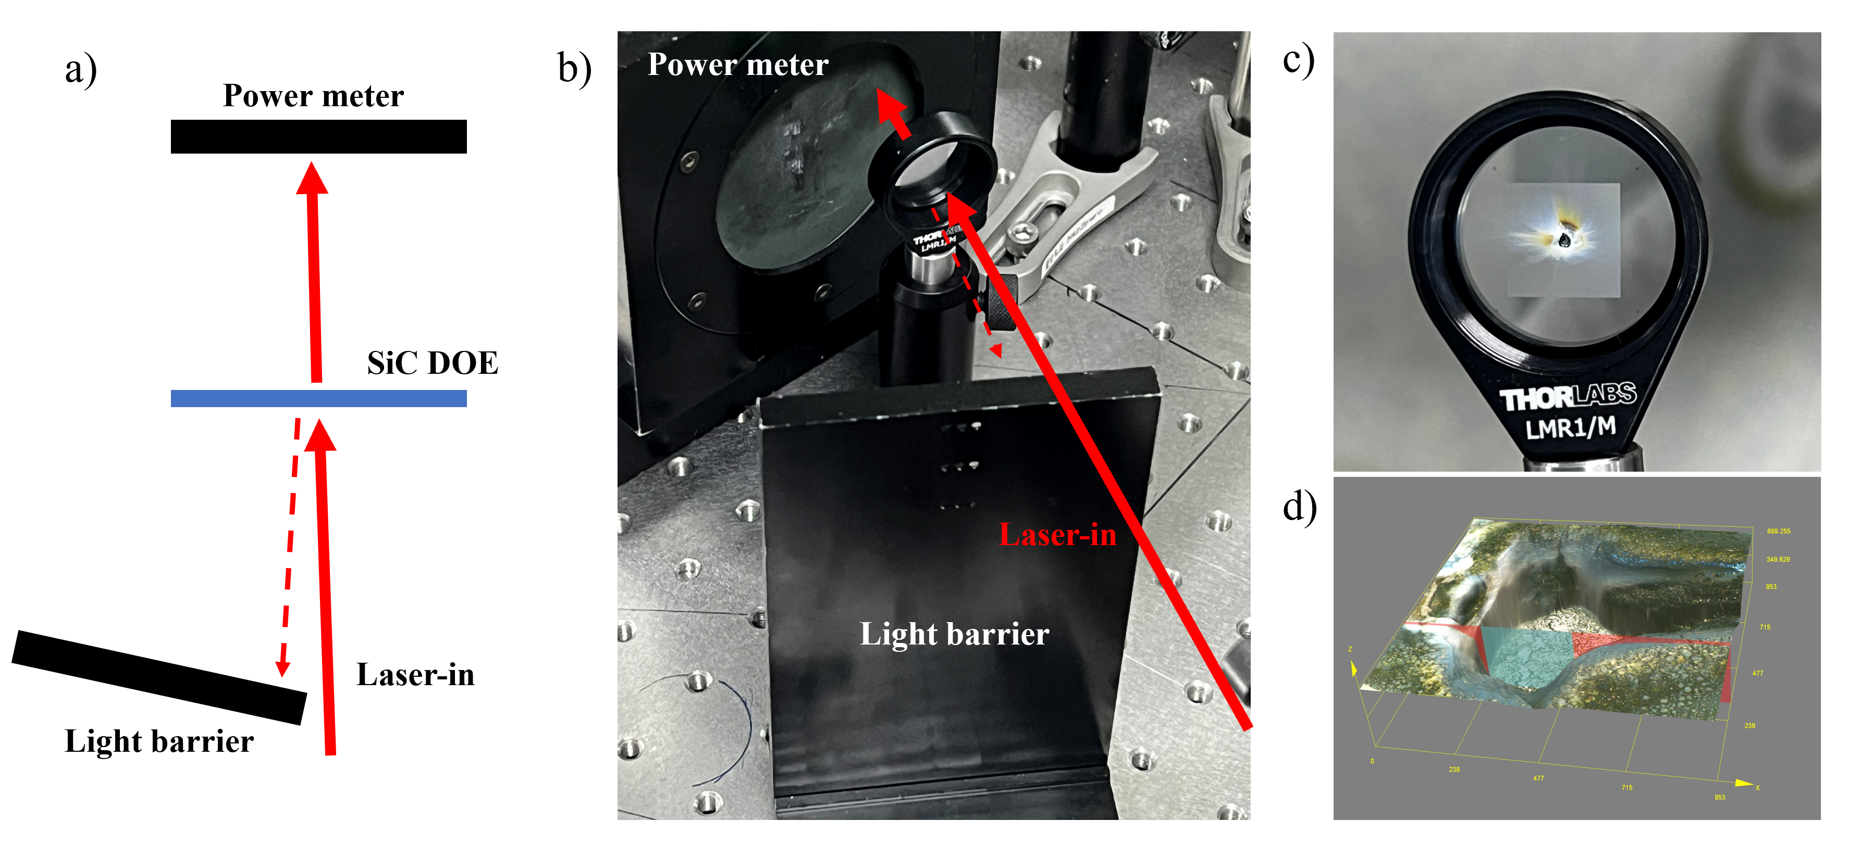
Figure S1. LIDT test of the SiC DOE. (a) Schematic diagram of the LIDT test setup. (b) Photograph of the experimental optical path for the LIDT test. (c) Photograph of the ablated SiC DOE sample after damage. (d) three dimensional digital microscopy image of the region damaged by the laser, showing penetration damage through the 500 μm thick SiC DOE.

Effects of fabrication errors on SiC DOE performance
The effects of fabrication errors on beam splitting were evaluated numerically for the 1 × 4, 1 × 9, and 1 × 26 SiC DOE designs. The target beams of the 1 × 4 and 1 × 9 designs were arranged in 2 × 2 and 3 × 3 arrays, respectively. The eight level relief structures were fabricated through three aligned contact photolithography and etching steps. Their fidelity depends on lithographic resolution, overlay accuracy, and etch depth control. Global relief depth errors and local in-plane displacement errors were evaluated separately to examine their effects on the phase distribution and target beam energy allocation.
The numerical tolerance analysis used a weighted Gerchberg-Saxton (G-S) algorithm with mixed region amplitude constraints. The far field complex amplitude was calculated using a normalized two dimensional fast Fourier transform (FFT), with an inverse FFT for the phase update. The input amplitude was fixed within a circular aperture. Target weights were adjusted using the integrated powers of the individual beams, with a weighting exponent of 0.65. A phase relaxation factor of 0.85 was applied, and the field outside the signal region was scaled by 0.08. Eight level phase quantization was applied from iteration 130, with two samples of the global phase scaling factor per iteration drawn from a normal distribution with mean 1 and standard deviation 0.015. The final phase profile was quantized into eight levels and converted into a relief height distribution.
The beam splitting efficiency was defined as
$$\text{η = }\frac{{\text{P}}_{\text{target}}}{{\text{P}}_{\text{in}}}$$ | (S1)
where P_{target} is the summed power in the target regions and P_{in} is the incident power. Each target power was integrated within a circular region of radius 4 FFT pixels. Beam nonuniformity was defined as
$$\text{U = }\frac{{\text{P}}_{\text{max}} \text{- }{\text{P}}_{\text{min}}}{{\text{P}}_{\text{max}}\text{ + }{\text{P}}_{\text{min}}}$$ | (S2)
where P_{max} and P_{min} are the largest and smallest integrated target beam powers. A smaller U indicates more uniform power allocation. The on-axis power fraction was defined as
$${\text{f}}_{\text{axis}}\text{ = }\frac{{\text{P}}_{\text{axis}}}{{\text{P}}_{\text{trans}}}$$ | (S3)
where P_{axis} was integrated within a radius of 4 FFT pixels about the optical axis, and P_{trans} was integrated over the full calculated far field grid. The isolated error sweeps used a model with phase modulation only and unit amplitude transmission inside the aperture.
Global relief depth errors were modeled by uniformly scaling all relief heights as
$${\text{h}}_{\text{ε}}\text{(x,y) = (1 + ε)}{\text{h}}_{\text{0}}\text{(x,y)}$$ | (S4)
where h₀(x,y) is the designed height distribution, and ε is the relative depth error, varied from −15% to 15%. Local in plane errors were described by a two dimensional random displacement field with a combined root mean square (RMS) amplitude defined as
$$\text{σ = }\sqrt{\text{⟨}{\text{Δx}}^{\text{2}}\text{ + }{\text{Δy}}^{\text{2}}\text{⟩}}$$ | (S5)
where Δx and Δy are the local displacements along the two coordinate directions. The angle brackets denote the spatial average over the full computational grid, consistent with the displacement field normalization in the code. Two independent Gaussian random fields were smoothed using a Gaussian kernel with a standard deviation of 25 μm and normalized jointly to unit combined RMS. The perturbed relief profile was obtained by coordinate remapping with bilinear interpolation, with σ varied from 0 to 2 μm in 0.1 μm steps. The same displacement pattern and smoothing kernel were retained throughout the sweep, and only the displacement amplitude was scaled.
The simulated effects of global relief depth errors are shown in Figure S2. At zero depth error, the beam splitting efficiencies of the 1 × 4, 1 × 9, and 1 × 26 designs were 84.80%, 81.55%, and 82.15%, respectively. The minimum efficiencies over the −15% to 15% range were 79.40%, 78.38%, and 76.83%, respectively, as shown in Figure S2a. The corresponding maximum nonuniformities were 1.71%, 32.86%, and 8.35%, as shown in Figure S2b. For the 1 × 9 design, nonuniformities of 18.89% and 32.86% were obtained at depth errors of −15% and 15%, respectively, indicating an asymmetric response. These results show that sensitivity to depth errors depends on both the DOE configuration and the performance metric.
The on axis power fractions under global relief depth errors are shown in Figure S2c. For the 1 × 4 and 1 × 26 designs, the on axis zero order is outside the target beam set. Their maximum zero order power fractions were 2.94% and 2.96%, respectively, over the scanned range. For the 1 × 9 design, the intended central beam spatially overlaps the zero order. The reported quantity therefore represents the total on axis power of the superposed fields. The intended central channel power and zero order leakage cannot be separated using this quantity. It was used only to describe changes in total on axis power and was excluded from direct comparisons of zero order suppression among the three designs.
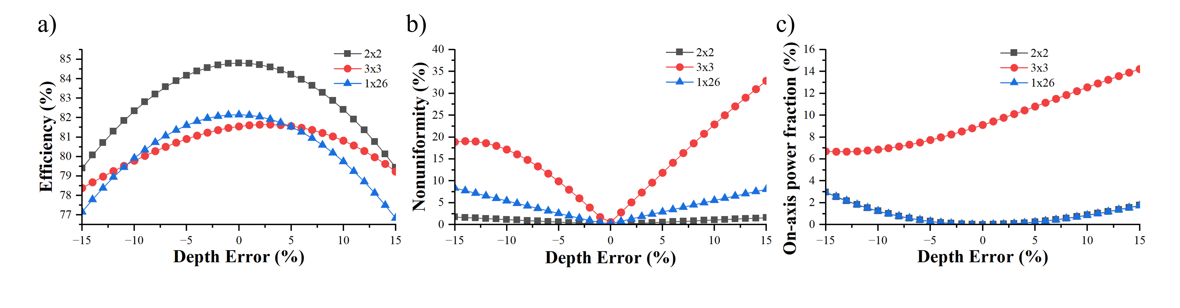
Figure S2. Simulated effects of global relief depth errors on SiC DOE performance. (a) Target order diffraction efficiency. (b) Beam nonuniformity. (c) Zero order power fraction for the 1 × 4 and 1 × 26 designs and total on axis power fraction for the 1 × 9 design.
The simulated effects of local in plane displacement errors are shown in Figure S3. As the displacement RMS increased from 0 to 2 μm, the 1 × 4, 1 × 9, and 1 × 26 efficiencies decreased to 74.62%, 62.85%, and 50.58%, respectively, as shown in Figure S3a. Their initial efficiencies were 84.80%, 81.55%, and 82.15%, respectively. The largest efficiency reduction was obtained for the 1 × 26 design over the investigated range. The maximum nonuniformity of the 1 × 4 design was 1.40%. For the 1 × 26 design, nonuniformity increased continuously to 50.10% at 2 μm, as shown in Figure S3b. For the 1 × 9 design, nonuniformity reached 11.27% at 0.9 μm and then decreased to 8.07% at 2 μm. Its efficiency continued to decrease over this interval. The reduced relative power difference among the target beams therefore did not indicate recovery of the total target beam power.
At an in plane displacement RMS of 2 μm, the simulated zero order power fractions of the 1 × 4 and 1 × 26 designs were 0.57% and 4.42%, respectively, as shown in Figure S3c. For the 1 × 9 design, the total on axis power fraction decreased from 9.11% to 6.46%. Because this quantity includes the superposed central beam and zero order, the decrease cannot establish suppression of zero order leakage.
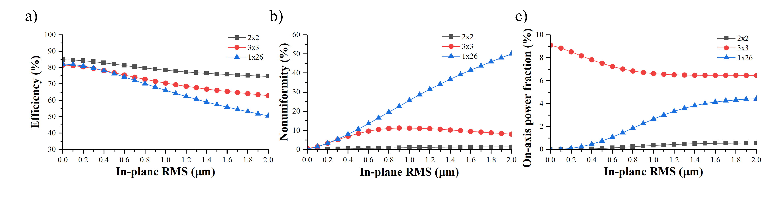
Figure S3. Simulated effects of local in-plane displacement errors on SiC DOE performance. (a) Target order diffraction efficiency. (b) Beam nonuniformity. (c) Zero order power fraction for the 1 × 4 and 1 × 26 designs and total on-axis power fraction for the 1 × 9 design.
Under the investigated in plane error conditions, efficiency retention decreased in the order 1 × 4, 1 × 9, and 1 × 26. The 1 × 26 design was therefore more sensitive to local displacement errors. This trend is qualitatively consistent with the better beam splitting observed for the 1 × 4 device and the pronounced zero order spot observed for the 1 × 26 device. The contact photolithography tool used here has a resolution of 1 μm. Repeated alignment steps can introduce local offsets of relief boundaries, while pattern transfer can produce corner rounding and local dimensional deviations. Improved patterning resolution, overlay accuracy, and etch depth control provide routes toward DOE fabrication with higher fidelity at increased channel counts.

Measured beam profiles of the SiC DOE
The spatial intensity distributions of the SiC DOE output beams were characterized at 1070 nm using a beam profiler. Measurements were performed at the collimating lens plane, where adjacent beams were separated by 1.5 cm. Individual beams were recorded sequentially under identical conditions because the complete array exceeded the detector area. Relative intensity distributions were reconstructed from JPEG images exported from BeamGage by matching pixel colors to the corresponding color bars. After annotation removal and background subtraction, the profiles were fitted to a rotated elliptical Gaussian function using a robust soft L₁ loss. The FWHM was extracted along each principal axis.
The profiles of the 1 × 4 and 1 × 9 DOEs are shown in Figures S4a and S4b, respectively. Ellipticity was defined as the ratio of the minor axis FWHM to the major axis FWHM. Beam size variation was quantified by the coefficient of variation (CV), defined as the population standard deviation divided by the mean FWHM and expressed as a percentage. CV was calculated separately for each principal axis.
The mean coefficients of determination were 0.992 and 0.990 for the 1 × 4 and 1 × 9 DOEs, respectively. The corresponding mean ellipticities were 0.977 and 0.903. For the 1 × 4 DOE, the FWHM CVs were 2.59% along the major axis and 2.17% along the minor axis. Those for the 1 × 9 DOE were 7.33% and 6.81%. These metrics indicate more circular profiles and greater size consistency for the 1 × 4 DOE under the applied analysis conditions.
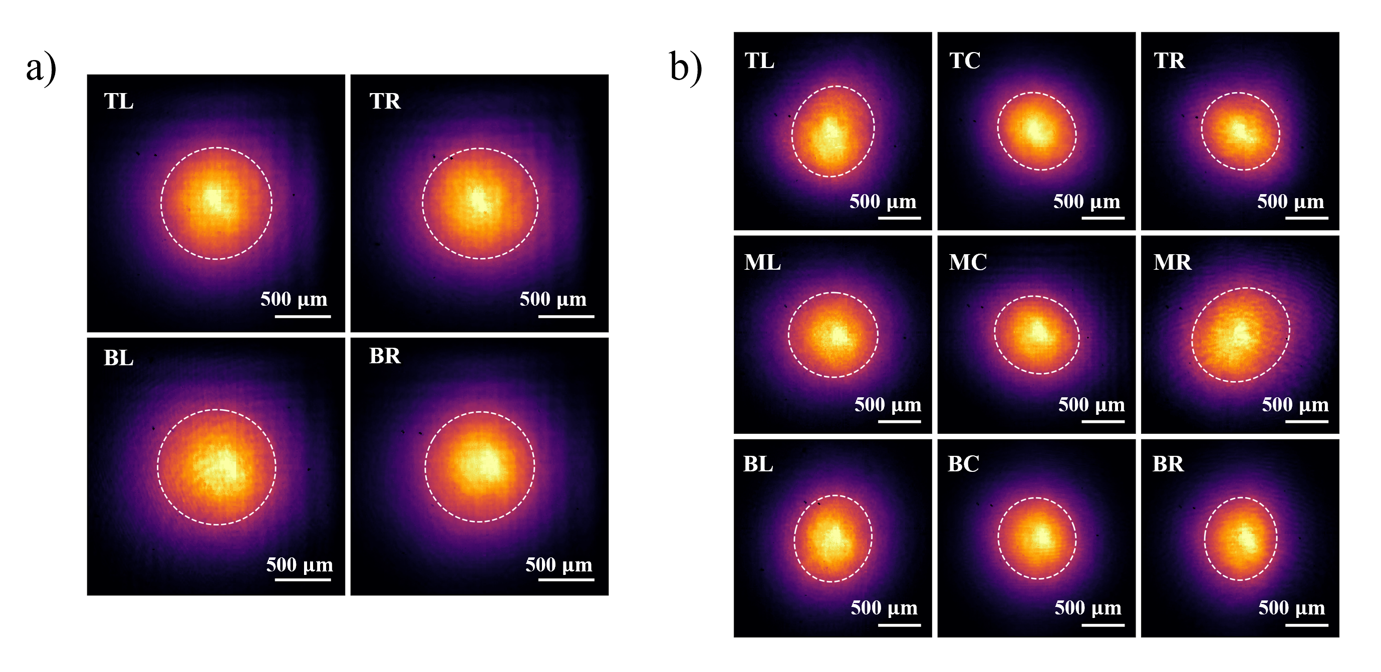
Figure S4. Measured output beam profiles of the SiC DOEs at 1070 nm. (a) DOE with a 2 × 2 beam arrangement. (b) DOE with a 3 × 3 beam arrangement. White dashed contours indicate the fitted contours at half maximum. T, M, and B denote top, middle, and bottom rows, and L, C, and R denote left, center, and right columns.

Efficiency test of the multi-beam parallel laser processing system
The optical performance of the integrated multi-beam parallel laser processing system was evaluated. The experimental setup, shown in Figure S5, comprised a 1030 nm laser source, the SiC DOE, an intermediate collimating relay lens, the SiC metalens array, and a processing sample. A laser power meter (S121C power sensor with PM100D2 power meter, Thorlabs) was used to measure the optical power at various points along the optical path. For each measurement, the beam was centered on the detector and fully contained within its active area. Because the 1.5 cm spacing between adjacent beams exceeded the detector dimensions, the four output beams were measured sequentially under identical conditions and their powers were summed. The manufacturer specified measurement uncertainty of the S121C sensor is ±7% over the wavelength range of 981-1100 nm.
Initially, the output from the laser was precisely attenuated to 200 mW. The power measured immediately before the SiC DOE was 190 mW. After passing through the SiC DOE, the incident beam was split into four distinct beams with a total power of 81.7 mW (the sum of 13.9 mW, 20.1 mW, 23.0 mW, and 24.7 mW). These beams then passed through the intermediate collimating lens, after which the total power was measured to be 80.4 mW (the sum of 13.6 mW, 19.6 mW, 22.4 mW, and 24.8 mW). Subsequently, after passing through the metalens array, the final powers of the beams were 5.0 mW, 7.6 mW, 9.1 mW, and 9.1 mW.
The stage power ratios and the overall power utilization efficiency were calculated as:
$${\text{η}}_{\text{DOE}}\text{ = }\frac{{\text{P}}_{\text{DOE}}}{{\text{P}}_{\text{in}}}\text{ = }\frac{\text{81.7}}{\text{190}}\text{ ≈ 43.0\%}$$ | (S6)
$${\text{T}}_{\text{relay}}\text{ = }\frac{{\text{P}}_{\text{relay}}}{{\text{P}}_{\text{DOE}}}\text{ = }\frac{\text{80.4}}{\text{81.7}}\text{ ≈ 98.4\%}$$ | (S7)
$${\text{T}}_{\text{ML}}\text{ = }\frac{{\text{P}}_{\text{out}}}{{\text{P}}_{\text{relay}}}\text{ = }\frac{\text{30.8}}{\text{80.4}}\text{ ≈ 38.3\%}$$ | (S8)
$${\text{η}}_{\text{sys}}\text{ = }\frac{{\text{P}}_{\text{out}}}{{\text{P}}_{\text{in}}}\text{ = }\frac{\text{30.8}}{\text{190}}\text{ ≈ 16.2\%}$$ | (S9)
where P_{in} is the power incident on the DOE, P_{DOE} and P_{relay} are the summed powers in the four selected channels after the DOE and the relay lens, respectively, and P_{out} is the total power at the final processing plane. The numerical power values in Equations (S6-S9) are expressed in mW. η_{DOE} is the DOE efficiency based on power collected in the selected channels, T_{relay} is the relay lens transmission, T_{ML} is the combined transmission efficiency of the four metalens channels, and η_{sys} is the system power utilization efficiency. Power outside the four selected channels was excluded. The 38.3% value is the ratio of summed output and input powers across these channels.
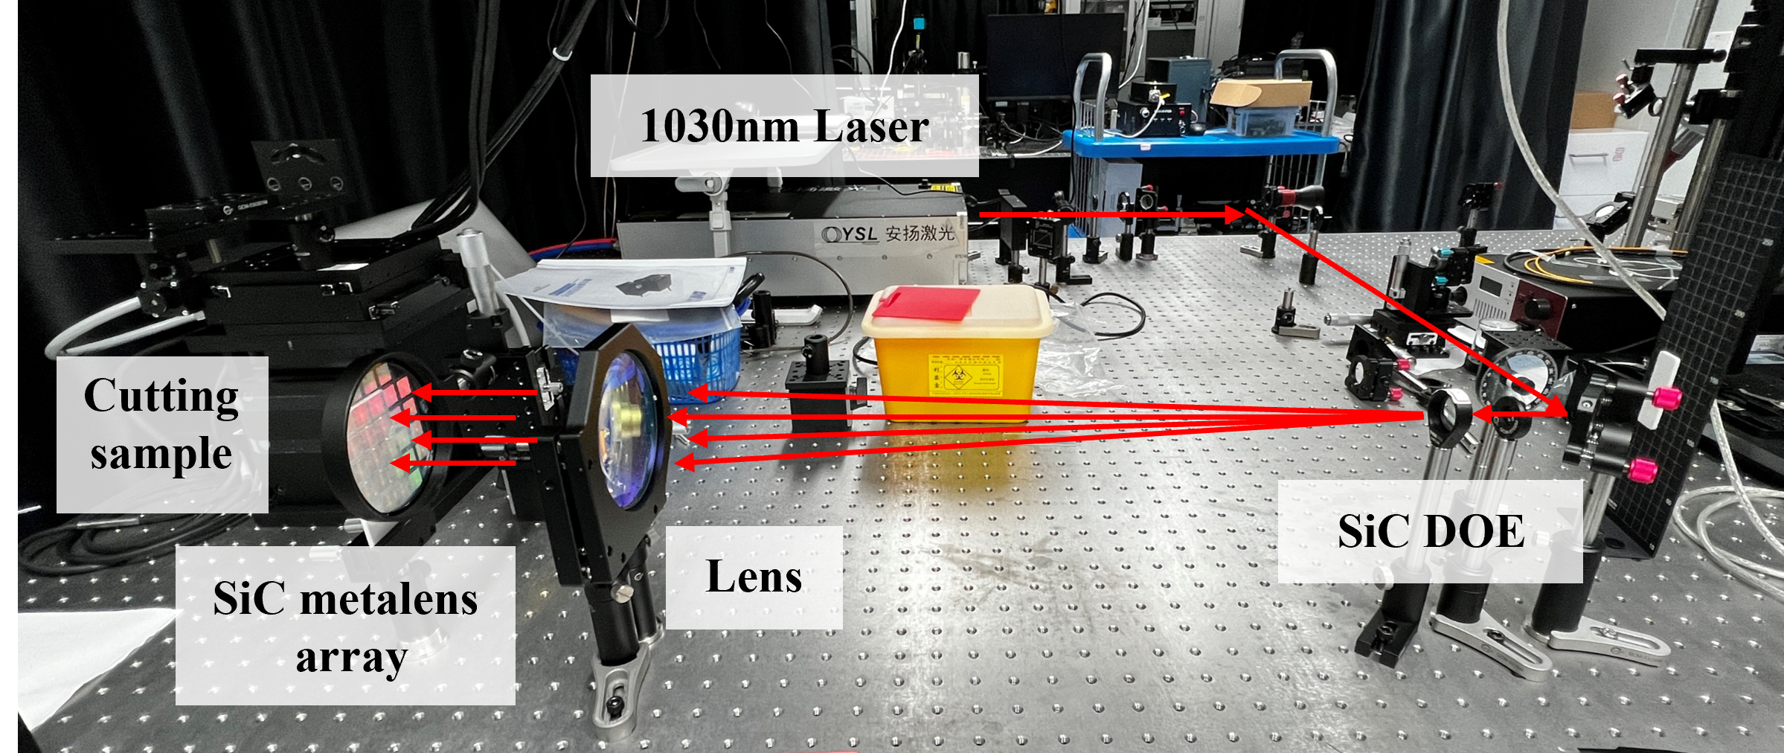
Figure S5. Annotated photograph of the optical path used for the power utilization measurement of the four beam processing setup at 1030 nm.

Optical properties and antireflection test of SiC wafers
The optical properties of the 4H-SiC wafers used for the DOE and metalens array were characterized using an ultraviolet, visible, and near infrared spectrophotometer (LAMBDA 1050, PerkinElmer). The transmittance and reflectance spectra of an uncoated wafer were measured over 400–2500 nm, as shown in Figure S6a.
SiO₂/Ta₂O₅ antireflection coatings were deposited by physical vapor deposition on one or both wafer surfaces to improve transmission near the operating wavelength. The coating stacks were optimized for a central wavelength of 1064 nm. At 1064 nm, the measured transmittances of uncoated wafers, wafers coated on one side, and wafers coated on both sides were 67.823%, 81.22%, and 98.956%, respectively, as shown in Figure S6b. These measurements demonstrate improved SiC wafer transmission after antireflection treatment. The measurements were performed on planar SiC wafers and provide experimental support for applying antireflection coatings to the optical components.
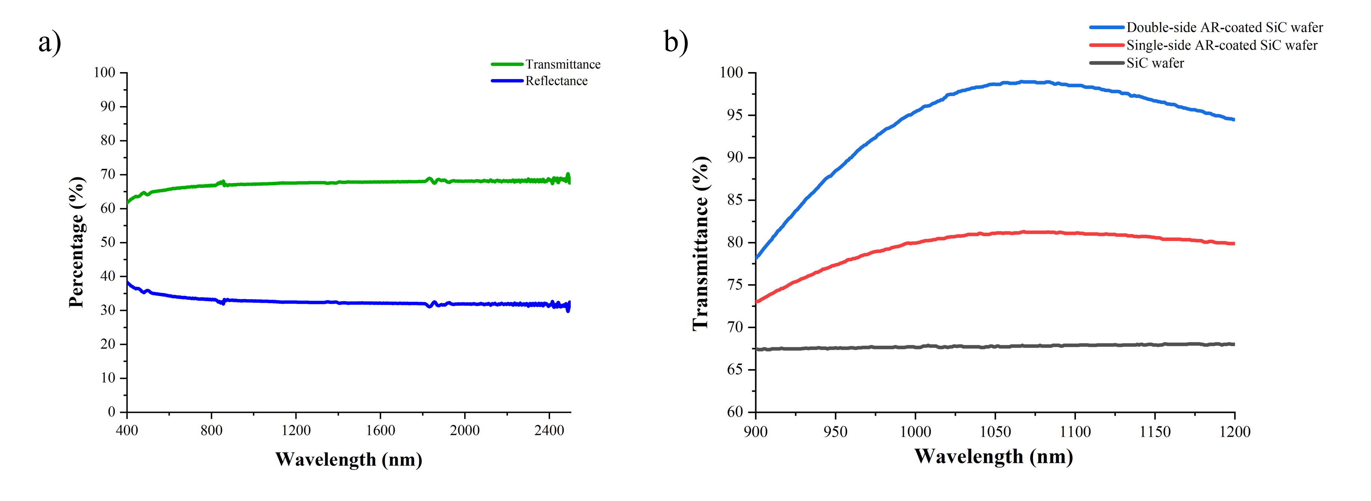
Figure S6. Optical performance and antireflection test of SiC wafers. (a) Measured transmittance and reflectance spectra of an uncoated SiC wafer over 400–2500 nm. (b) Measured transmittance spectra of uncoated SiC wafers and SiC wafers with antireflection coatings on one or both sides.

Temperature characterization before and after high power processing
The temperatures of the SiC DOE and metalens array were characterized using an infrared camera (PS610, Guide Sensmart) before and after high power parallel laser processing, as shown in Figure S7. The optical configuration was the same as that shown in Figure 5. The 1070 nm CW laser power incident on the DOE was 586.0 W. Thermal images were recorded before scribing and after the laser was switched off. The camera emissivity setting was 1. The black aluminum alloy holder of the metalens array was used as the temperature reference. The DOE was mounted in a custom water cooled holder, while the metalens array was secured to the optical platform using a metal wafer holder.
At the marked measurement positions, the apparent DOE temperature increased from 27.0 °C to 30.6 °C, corresponding to a rise of 3.6 °C. The apparent metalens array temperature increased from 26.2 °C to 41.3 °C, corresponding to a rise of 15.1 °C. The two components had different thermal boundary conditions. Active water cooling was applied to the DOE, while heat was transferred from the metalens array through contact between the wafer edge and its metal holder. The holder also appeared warmer after processing, consistent with heat transfer from the wafer to the holder.
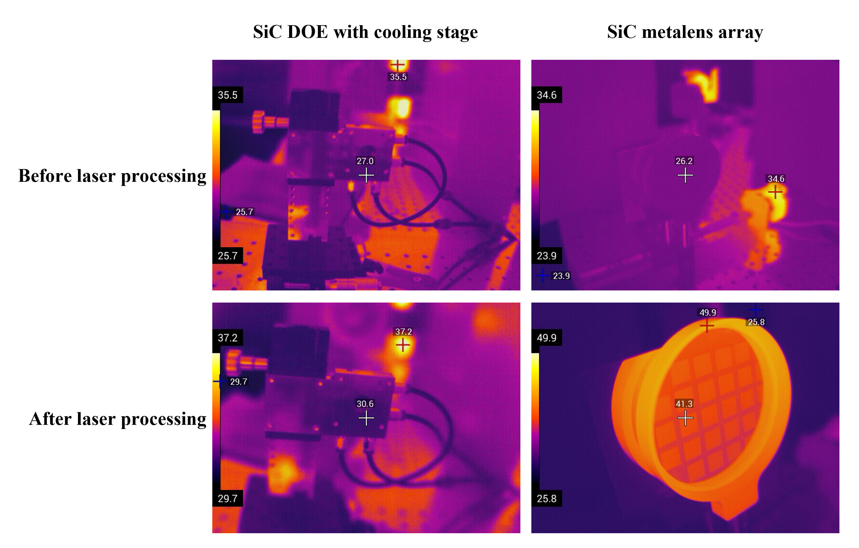
Figure S7. Infrared thermal images of the SiC DOE and SiC metalens array before and after high power laser processing. The water cooled DOE and metalens array are shown in the left and right columns, respectively. Images were recorded before (top) and after the laser was switched off (bottom) following a single experiment at a DOE incident power of 586.0 W. All temperatures are in °C.

Parallel laser processing for thin stainless steel plate
Processing through the thickness of a thin metal plate was evaluated using the high power parallel processing setup shown in Figure 5. A 0.1 mm thick 304 stainless steel plate was irradiated simultaneously at four fixed beam positions. The laser wavelength was 1070 nm, the power measured immediately before the DOE was 293.0 W, and the irradiation duration was 3 s. A photograph of the processed sample and three dimensional digital microscopy images of the four processed sites are shown in Figure S8.
A through hole was formed at the top right position, while different morphologies were observed at the other three positions. Local deformation of the thin plate occurred during processing. Such deformation may shift the surface relative to the focal plane and affect the processed morphology. The test demonstrates processing through the plate thickness by at least one channel under the stated conditions.
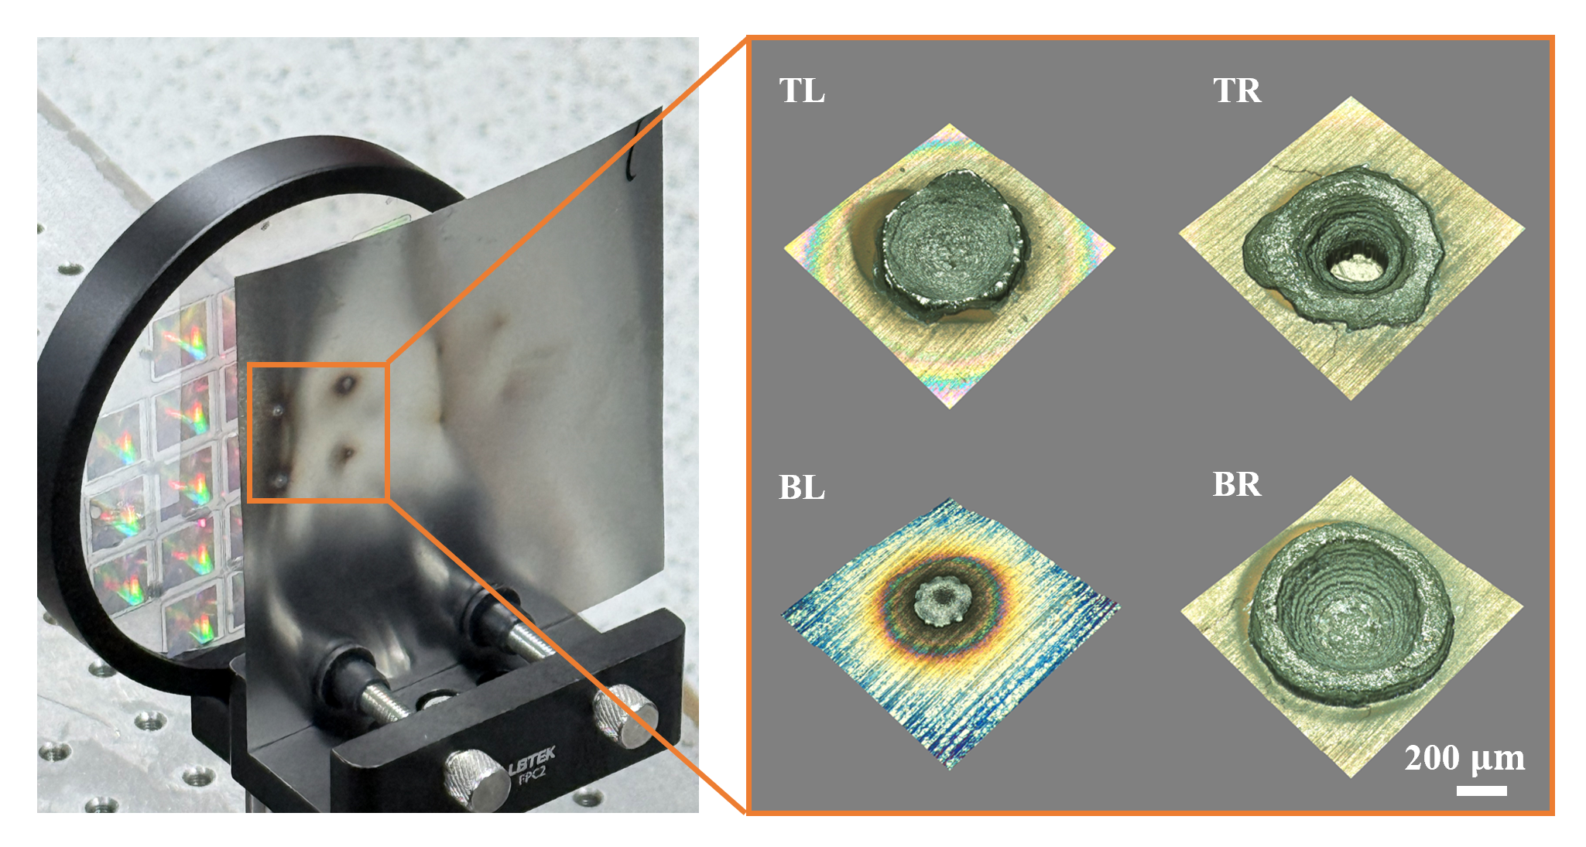
Figure S8. Four beam parallel laser processing of 0.1 mm thick 304 stainless steel plate. Left: photograph of the processed sample. Right: three dimensional digital microscopy images of the four processed sites. TL, TR, BL, and BR denote top left, top right, bottom left, and bottom right beam positions, respectively.

Comparison of representative parallel laser processing technologies
In Table S1, the SiC platform is compared with representative laser processing systems, including recent approaches to parallel nanofabrication¹⁻⁹. In this work, the SiC DOE beam splitter tested under kilowatt level CW irradiation is combined with dedicated large aperture focusing for each beam and wafer-scale replication. Each metalens was designed with an aperture of 11.5 mm, a focal length of 10 mm, and a numerical aperture (NA) of 0.5. With this geometry, multiple independent millimeter scale beams can be accommodated by a planar focusing array on a substrate with a thickness of 0.5 mm. Across the 26 metalenses, a mean focal spot FWHM of 2.93 μm was measured at 1030 nm. A 3σ focal length deviation of 10.73 μm was obtained.
Independent focusing of parallel beams can also be achieved with other architectures. Multiple focal spots are generated through shared focusing optics in spatial light modulator (SLM) and DOE systems. In glass lens arrays and metalens arrays, a separate lens element is assigned to each focal spot³. In the metalens platform⁴, elements with apertures of 100 or 200 μm and NAs of 0.8 or 1.0 were used for parallel two-photon lithography. Uniform focal spots with a lateral FWHM of 2.5 μm have also been produced through spatiotemporal shaping with a shared objective⁶. The SiC platform is therefore distinguished by the larger input aperture provided for each beam and the reproducible focusing performance achieved across the array. Its design focal length of 10 mm is shorter than those used in the scanning systems included in Table S1. In those systems, optics with focal lengths of 100-320 mm are typically used.
The operating conditions of the architecture were established through power testing. No visible damage was observed in the SiC DOE after 20 s of CW irradiation at 1030 nm and 4.8 kW, corresponding to a nominal irradiance of 6.11 kW/cm². Four channel steel processing was also demonstrated at 1070 nm, with DOE input powers of 732.5 W for stationary irradiation and 586.0 W for scribing. Five spot processing at 300 W and kilowatt level component exposure have been demonstrated with cooled SLMs¹. In single spot scanning, a power of 2.64 kW has been delivered to the workpiece².
Advantages for specific tasks are also offered by other approaches. Pattern reconfiguration is supported by programmable SLM and digital micromirror device (DMD) systems^{1,4-6}. More simultaneous focal spots can be generated with dense arrays⁷, while periodic structures can be fabricated efficiently using interference based methods^{8,9}. The SiC array presented here was fabricated using step and repeat nanoimprint lithography to provide fixed, dedicated focusing channels. Repeated patterning and parallel scribing using uniform focusing elements with centimeter scale apertures are supported by this fabrication route and the demonstrated four channel CW processing capability. The technical advantage of the platform is defined by this combination of input aperture, power handling capability, and wafer-scale fabrication.

Table S1. Representative laser processing technologies
Feature | This work | Cooled SLM + galvo¹ | Galvo  + f-theta² | Glass MLA³ | SLM + metalens  array⁴ | DMD holography  + objective⁵ | SLM spatiotemporal  shaping⁶ | DOE + galvo  + f-theta⁷ | Two beam  DLIP⁸ | Four beam  DLIP⁹
Laser conditions | 1070 nm  CW | 1070 nm  CW | 1070 nm  CW | 1064 nm  ns; 50 kHz | 800 nm  35 fs; 1 kHz | 800 nm  100 fs; 1 kHz | 1030 nm  350 fs; 50 kHz | 1030 nm  1.2 ps; 100 kHz | 1064 nm  10 ns; 5 kHz | 532 nm  300 ps; 1 kHz
Power density limit | 6.11 kW/cm²  (1030 nm) | ~4.8 kW/cm²  (1070 nm) | Not reported | Not reported | Not reported | Not reported | Not reported | Not reported | Not reported | Not reported
Integrated focusing channels | 26 | 5 | 1 | 200 × 200 | >120,000 | 2000 | 5 × 5 | 2601 | 2 | 4
Processing power / pulse energy | 732.5 W | 300 W | 2.64 kW | 8 W | 7 W | 4 W | Not reported | 200 W | 16 mJ/pulse | Not reported
Per-channel wavefront control | Dedicated  metalens | Shared aspheric lens | Single f-theta lens | Dedicated  microlens | Dedicated  metalens | Shared  objective lens | Shared  objective lens | Shared  f-theta lens | Cylindrical shaping | Shared optics
Supported beam diameter per channel | 11.5 mm  diameter | 6.7 mm | Not reported | 47.89 μm | 200 μm | Not report | 4.95 mm | 8 mm | Not reported | 1.9 mm
Focusing optics | NA 0.5  f = 10 mm | f = 320 mm | f = 230 mm | f = 0.510 mm | NA 1.0 | NA 1.3  f = 10 mm | NA 0.75 | f = 100 mm | Not reported | f = 100 mm
Pattern control | Fixed | Programmable | Programmable | Fixed | Programmable | Programmable | Programmable | Fixed | Adjustable  structure period | Adjustable  structure period
Processed material | Stainless steel | Mild steel | Stainless steel | Stainless steel | Photoresist | Photoresist | Glass | Stainless steel | Aluminum alloy | Thin film on wafer

References

1 Zuo, S. et al. High-Performance NIR Laser-Beam Shaping and Materials Processing at 350 W with a Spatial Light Modulator. Photonics 12, 544 (2025).
2 Exner, H. et al. High Speed Laser Micro Processing Using High Brilliance Continuous Wave Laser Radiation. Journal of Laser Micro/Nanoengineering 7, 115 (2012).
3 Nieto, D. et al. Laser-based microstructuring of surfaces using low-cost microlens arrays. Journal of Micro/Nanolithography, MEMS, and MOEMS 11, 023014-023014 (2012).
4 Gu, S. et al. 3D nanolithography with metalens arrays and spatially adaptive illumination. Nature 648, 591-599 (2025).
5 Ouyang, W. et al. Ultrafast 3D nanofabrication via digital holography. Nature communications 14, 1716 (2023).
6 Sun, B. et al. Four-dimensional light shaping: manipulating ultrafast spatiotemporal foci in space and time. Light: Science & Applications 7, 17117-17117 (2018).
7 Hauschwitz, P. et al. LIPSS-based functional surfaces produced by multi-beam nanostructuring with 2601 beams and real-time thermal processes measurement. Scientific reports 11, 22944 (2021).
8 Lang, V., Voisiat, B. & Lasagni, A. F. High throughput direct laser interference patterning of aluminum for fabrication of super hydrophobic surfaces. Materials 12, 1484 (2019).
9 Berzins, J. et al. Direct and high-throughput fabrication of Mie-resonant metasurfaces via single-pulse laser interference. ACS nano 14, 6138-6149 (2020).

