Supplementary data:

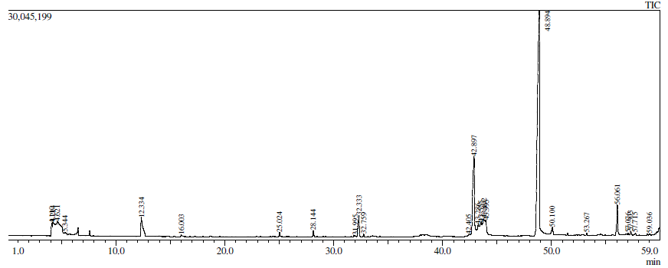
Figure 1. Citrus honey chromatogram by GC-MS analysis coupled with HD technique.
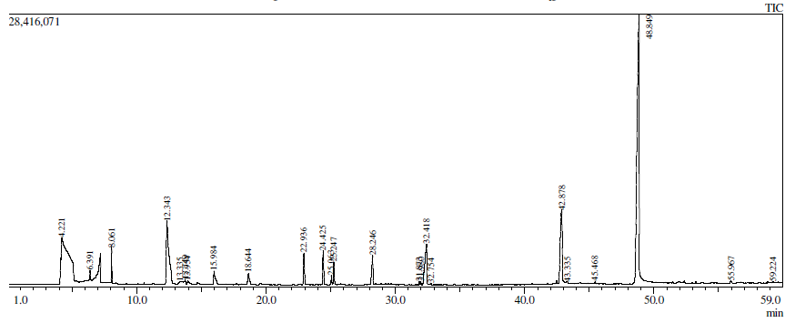
Figure 2. Marjoram honey chromatogram by GC-MS analysis coupled with HD technique.
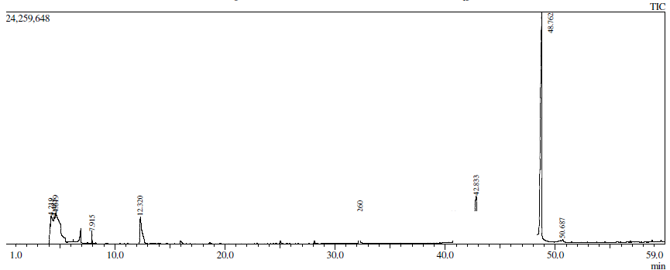
Figure 3. Trifolium honey chromatogram by GC-MS analysis coupled with HD technique.
Table 1: Volatile compounds characterized by GC-MS analysis coupled with HD technique in the most popular honeys in Egypt (Marjoram honey, Trifolium honey and Citrus honey).
Peak | Name | R. Time | M. Wt. | H.M | H. T | H.C
1 | Methane, tetranitro | 4.221 | 196 | + | - | -
2 | Formic acid | 6.391 | 46 | + | - | -
3 | Hydroxy acetone | 8.061 | 74 | + | + | -
4 | *Furfural | 12.343 | 96 | + | + | +
5 | *Furfuryl alcohol | 13.335 | 98 | + | - | -
6 | *2-Furanmethanol | 13.749 | 98 | + | - | -
7 | *2(3H)-Furanone, 5-methyl | 13.954 | 98 | + | - | -
8 | *2-Acetylfuran | 15.984 | 110 | + | + | +
9 | *5-METHYL FURFURAL | 18.644 | 110 | + | - | -
10 | Hyacinthin | 22.936 | 120 | + | - | -
11 | LINALOOL OXIDE (2) | 24.42 | 170 | + | - | -
12 | Methyl furoate | 25.06 | 126 | + | + | -
13 | 2,3-Dihydro-3,5-dihydroxy-6-methyl-4H-pyran-4-one | 28.248 | 144 | + | + | +
14 | TRANS-LINALOOL OXIDE | 25.24 | 170 | + | - | -
15 | 1-p-Menthen-9-al | 31.8 | 152 | + | - | +
16 | Tricyclo[3.3.0.0(2,8)]octan-3-one, 8-methyl | 31.98 | 136 | + | - | -
17 | *2-FURANCARBOXALDEHYDE, 5-(HYDROXYMETHYL) | 32.418 | 126 | + | + | +
18 | Fenchyl acetate | 32.754 | 196 | + | - | +
19 | methyl anthranilate | 42.878 | 194 | - | - | +
20 | Dodecanol | 43.33 | 186 | + | - | -
21 | 3-Buten-2-one, 1-(2,3,6-trimethylphenyl | 45.468 | 188 | + | - | -
22 | Ethyl phthalate | 48.849 | 222 | + | + | +
23 | 1-Dodecene | 55.967 | 168 | + | - | -
24 | E-11-Tetradecen-1-ol acetate | 59.22 | 254 | + | - | -
25 | TRANS-BETA-IONON-5,6-EPOXIDE | 4.219 | 193 | - | + | +
26 | Ethanol (CAS) | 4.485 | 46 | - | + | +
27 | Dimethyl ether | 4.619 | 46 | - | + | -
28 | 1,2-Benzenedicarboxylic acid | 42.833 | 194 | - | + | -
29 | 1,2-Benzenedicarboxylic acid, diethyl ester | 48.762 | 222 | - | + | -
30 | Hexacosane (CAS) | 50.687 | 366 | - | + | -
31 | 7-Hydroxy-7-phenyl-3,9-diisopropyl-2,10-dioxadispiro[3.3.3.1]dodecan-1,11-dione | 4.214 | 372 | - | - | +
32 | Methanamine, N-methyl- (CAS) | 5.344 | 45 | - | - | +
33 | *2-Furancarboxylic acid, methyl ester | 25.024 | 126 | - | - | +
34 | n-Pentadecanoic acid | 42.405 | 242 | - | - | +
35 | Tetradecano | 43.286 | 214 | - | - | +
36 | Palmitic acid | 43.555 | 256 | - | - | +
37 | Stearic acid | 43.802 | 284 | - | - | +
38 | Tridecanoic acid | 43.998 | 214 | - | - | +
39 | Nonyl methoxyacetate | 50.100 | 216 | - | - | +
40 | Methyl myristate | 53.267 | 242 | - | - | +
41 | 1-Hexadecanol (CAS) | 56.061 | 242 | - | - | +
42 | Heneicosane (CAS) | 57.076 | 296 | - | - | +
43 | METHYL OLEATE | 57.303 | 296 | - | - | +
44 | Gamma-Stearolactone | 57.715 | 282 | - | - | +
45 | Methyl stearate | 59.036 | 298 | - | - | +
*(sight for byproduct compounds)
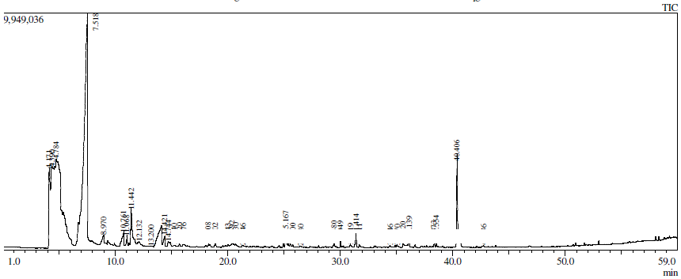
Figure 4. Citrus honeybees’ chromatogram by GC-MS analysis coupled with HD technique.
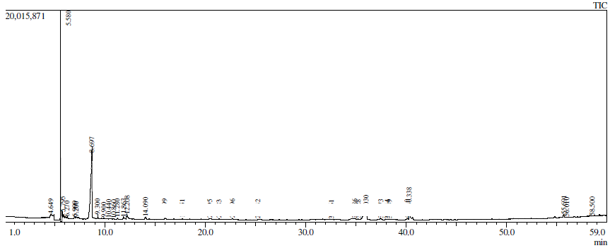
Figure 5. Marjoram honeybees’ chromatogram by GC-MS analysis coupled with HD technique.
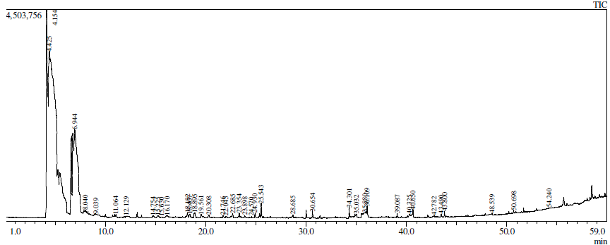
Figure 6. Trifolium honeybees’ chromatogram by GC-MS analysis coupled with HD technique.
Table 2: Volatile compounds characterized by head space analysis in three worker honeybees in Egypt (Marjoram honeybees, Trifolium honeybees and Citrus honeybees).
Peak | Name | R. Time | M. Wt. | BeM | BeT | BeC
1 | l-Alanine ethyl amide, (S) | 4.649 | 116 | + | - | -
2 | Ammonium acetate | 5.580 | 77 | + | - | -
3 | HEXANOIC ACID | 5.795 | 116 | + | - | -
4 | Cyclobutene-3,4-dione, 1-dimethylamino -2-hydroxy | 6.270 | 141 | + | - | -
5 | Butanal, 3-methyl- (CAS) | 6.999 | 86 | + | - | -
6 | Butanal, 2-methyl- (CAS) | 7.200 | 86 | + | + | -
7 | Acetic acid (CAS) | 8.67 | 60 | + | - | +
8 | 2-Propanone, 1-hydroxy- (CAS) | 9.300 | 74 | + | - | -
9 | Propanoic acid (CAS) | 9.900 | 74 | + | - | +
10 | FORMAMIDE | 10.440 | 45 | + | - | -
11 | Propanoic acid, 2-methyl- (CAS) | 10.761 | 88 | + | - | +
12 | 1,2-Propanediol (CAS) | 10.860 | 76 | + | - | -
13 | 2,3-Butanediol | 11.863 | 90 | + | - | +
14 | 2-hydroxymethyl-3-methyl-oxirane | 12.208 | 88 | + | - | -
15 | BUTANOIC ACID, 3-METHYL | 14.090 | 102 | + | - | -
16 | Oxime-, methoxy-phenyl | 15.999 | 151 | + | - | +
17 | Camphene (CAS)or (LIMONEN) | 17.751 | 136 | + | + | -
18 | 1,2,3-Propanetriol (CAS) | 20.495 | 92 | + | - | -
19 | Pentanamide (CAS) | 21.383 | 101 | + | - | -
20 | ISO AMYL PHENYL ACETATE | 22.696 | 206 | + | - | -
21 | 2-Pyrrolidinone (CAS) | 25.242 | 85 | + | - | +
22 | 1-DECANOL, 2-ETHYL- | 32.561 | 186 | + | - | -
23 | E,E-2,4-dodecadienal | 34.886 | 180 | + | - | +
24 | 2,4-Decadienal, (E,E)- (CAS) | 35.228 | 152 | + | + | +
25 | 9-HYDROXY-LINALOOL | 37.473 | 170 | + | - | -
26 | 2-Undecenal (CAS) | 38.114 | 168 | + | - | -
27 | 1-HYDROXYLINALOOL | 38.349 | 170 | + | - | -
28 | Carbamic acid, (1-phenylethyl)-, 2-methyl-5-(1-methylethyl) cyclohexyl ester (CAS) | 40.110 | 303 | + | - | -
29 | methyl N-methyl anthranilate | 40.338 | 165 | + | + | +
30 | TRICOSANE | 55.691 | 324 | + | - | -
31 | OCTADECAMETHYLCYCLONON | 56.010 | 914 | + | - | -
32 | Piperazine | 4.154 | 86 | - | + | -
33 | Methane, tetranitro- (CAS) | 4.425 | 196 | - | + | +
34 | Amylene dichloride | 8.040 | 140 | - | + | -
35 | Disulfide, dimethyl (CAS) | 9.039 | 94 | - | + | -
36 | 2-Pentanol, 3-methyl- (CAS) | 11.064 | 102 | - | + | -
37 | Pyrazine, methyl- (CAS) | 12.129 | 94 | - | + | +
38 | 2-HEPTANONE | 14.754 | 114 | - | + | +
39 | 2-Heptanol (CAS) | 15.225 | 116 | - | + | -
40 | Propanal, 3-(methylthio)- (CAS) | 15.630 | 104 | - | + | -
41 | Pyrazine, 2,5-dimethyl- (CAS) | 16.170 | 108 | - | + | +
42 | gamma-Valerolactone | 18.182 | 100 | - | + | +
43 | Benzaldehyde (CAS) | 18.407 | 106 | - | + | -
44 | Trisulfide, dimethyl (CAS) | 18.895 | 126 | - | + | +
45 | 1-Pentanol, 2-ethyl-4-methyl- (CAS) | 19.561 | 130 | - | + | -
46 | Octanal (CAS) | 20.308 | 128 | - | + | -
47 | 1-Butanamine, 2-methyl-N-(2-methy butylidene)- (CAS) | 22.045 | 155 | - | + | -
48 | Hyacinthin | 22.685 | 120 | - | + | -
49 | Isoartemisia ketone | 23.354 | 152 | - | + | -
50 | carveol 1 | 23.898 | 152 | - | + | -
51 | Pyrazine, 3-ethyl-2,5-dimethyl- (CAS) | 24.570 | 136 | - | + | -
52 | 2-Nonanone (CAS) | 24.930 | 142 | - | + | -
53 | Nonanal (CAS) | 25.543 | 142 | - | + | -
54 | Isoborneol | 28.685 | 154 | - | + | -
55 | Decanal (CAS) | 30.654 | 156 | - | + | -
56 | 1-Nonen-3-ol (CAS) | 34.301 | 142 | - | + | -
57 | 6-Methyl-bicyclo[4.2.0]octan-7-one | 35.880 | 138 | - | + | -
58 | Isobornyl acrylate | 39.087 | 208 | - | + | -
59 | Dimethyl anthranilate | 40.325 | 165 | - | + | -
60 | Hexadecane, 1-chloro- (CAS) | 42.782 | 260 | - | + | -
61 | Pentadecane (CAS) | 43.800 | 268 | - | + | -
62 | Nonadecane (CAS) | 48.539 | 266 | - | + | -
63 | 9,12-Octadecadien-1-ol (CAS) | 50.698 | 886 | - | + | -
64 | TRANS-BETA-IONON-5,6-EPOXId | 4.171 | 208 | - | - | +
65 | ETHENE, (2-METHOXYETHOXY) | 4.784 | 102 | - | - | +
66 | Acetamide (CAS) | 11.442 | 59 | - | - | +
67 | 1,3-Propanediol (CAS) | 13.200 | 76 | - | - | +
68 | Butanoic acid, 2-methyl- (CAS) | 14.421 | 102 | - | - | +
69 | 2-Hexanol, 5-methyl- (CAS) | 15.240 | 116 | - | - | +
70 | Hexanoic acid (CAS) | 20.043 | 116 | - | - | +
71 | Pyrazine, 2-ethyl-6-methyl- (CAS) | 20.392 | 122 | - | - | +
72 | Pyrazine, 2-ethyl-3-methyl- (CAS) | 20.730 | 122 | - | - | +
73 | Benzenemethanamine, N-(4-methylphenyl) | 21.346 | 153 | - | - | +
74 | 5-METHYL-2-ISOPROPYL-2-HEXanal | 25.800 | 154 | - | - | +
75 | Acrylic acid, 3- [1-hydroxy-N-(3-phen ylpropyl) formimidoyl]-, cyclic anhydride (CAS) | 26.480 | 215 | - | - | +
76 | Octanoic acid (CAS) | 29.480 | 144 | - | - | +
77 | 2-Decanone (CAS) | 30.049 | 156 | - | - | +
78 | Piperidinone (CAS) | 30.919 | 99 | - | - | +
79 | Berbenon | 31.414 | 150 | - | - | +
80 | 4-(1-hydroxy-ethyl) gamma. butanolactone | 31.711 | 130 | - | - | +
81 | TRANS, TRANS-2,4-DODECADIENAL | 34.446 | 180 | - | - | +
82 | 2,4-Undecadienal | 36.139 | 166 | - | - | +
83 | 9-HYDROXY-LINALOOL | 38.373 | 170 | - | - | +
84 | 2-Nonanone, 9-hydroxy- (CAS) | 38.554 | 158 | - | - | +
85 | Piperidine, 2,3-dimethyl- (CAS) | 42.736 | 113 | - | - | +
*(sight for byproduct compounds)
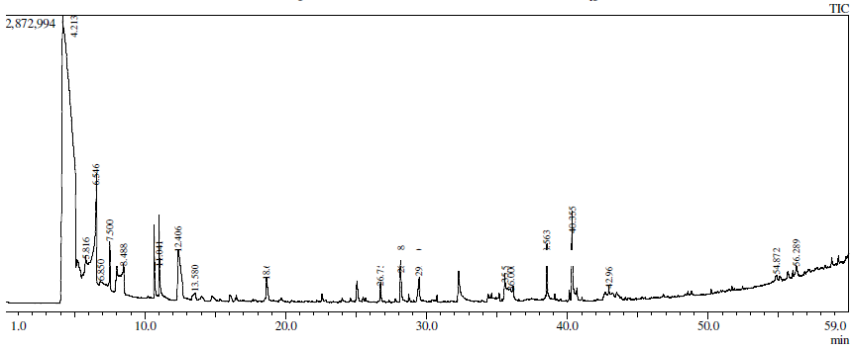
Figure 7. Citrus royal jelly chromatogram by GC-MS analysis coupled with HD technique.
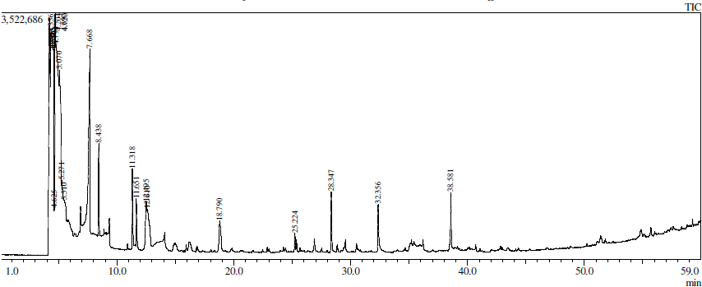
Figure 8. Marjoram royal jelly chromatogram by GC-MS analysis coupled with HD technique.
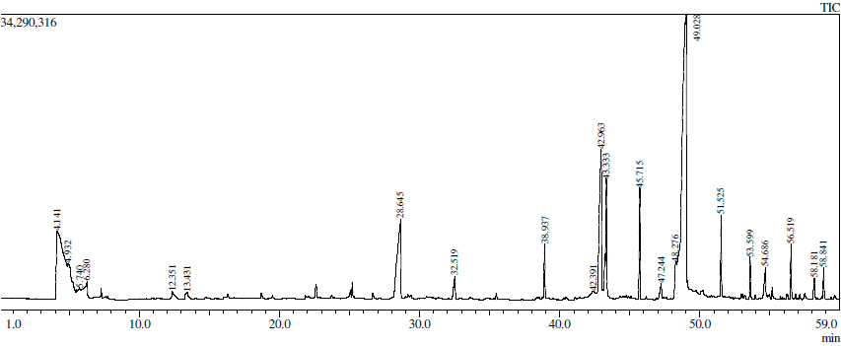
Figure 9. Trifolium royal jelly chromatogram by GC-MS analysis coupled with HD technique.
Table 3: Volatile compounds characterized by H.D. analysis in the three types of royal jelly (Marjoram, Trifolium and Citrus royal jelly).
Peak | Name | R. Time | M. Wt. | PM | PT | PC
1 | TRANS-BETA-IONON-5,6-EPOXID | 4.204 | 208 | + | - | -
2 | Methane, tetranitro- (CAS) | 4.356 | 196 | + | - | -
3 | Oxirane (CAS) | 4.515 | 44 | + | - | -
4 | Propiolic acid | 4.555 | 70 | + | - | -
5 | TRANS-BETA-IONON-5,6-EPOXI | 4.580 | 208 | + | - | -
6 | ISOBUTANE | 4.625 | 58 | + | - | -
7 | FORMAMIDINE ACETATE | 4.697 | 104 | + | - | -
8 | 2,3-Butanediol (CAS) | 4.720 | 90 | + | - | +
9 | DIMETHYLAMINE-D1 | 4.794 | 45 | + | - | -
10 | d-Alanine | 5.070 | 89 | + | - | -
11 | 2,3-Dihydro-3,5-dihydroxy-6-methyl- 1-Piperazinecarboxylic acid (CAS) | 5.271 | 144 | + | - | -
12 | Ethanol (CAS) | 5.510 | 46 | + | - | -
13 | Acetic acid (CAS) | 7.668 | 60 | + | + | +
14 | 2-Propanone, 1-hydroxy- (CAS) | 8.438 | 74 | + | - | -
15 | 1,3-Butylene glycol | 11.318 | 90 | + | - | -
16 | 2,3-Butylene glycol | 11.651 | 90 | + | - | -
17 | *Furfural | 12.495 | 96 | + | + | +
18 | *2-Furancarboxaldehyde (CAS) | 12.610 | 96 | + | - | -
19 | *5-Methylfurfural | 18.790 | 110 | + | - | +
20 | 2-Nonanone (CAS) | 25.224 | 142 | + | - | -
21 | 2,3-Dihydro-3,5-dihydroxy-6-methyl-4H-pyran-4-one | 28.347 | 144 | + | + | +
22 | *2-FURALDEHYDE, 5- (HYDROXY METHYL) | 32.356 | 126 | + | + | -
23 | 8-Nonen-2-one (CAS) | 38.581 | 140 | + | + | +
24 | Ammonium carbamate | 4.141 | 78 | - | + | -
25 | Cyclopropane, 1,1-dibromo-2-chloro-2-fluoro- (CAS) | 4.932 | 250 | - | + | -
26 | Vinyl fluoride | 5.740 | 46 | - | + | -
27 | *Furfur alcohol | 13.421 | 98 | - | + | +
28 | Octanoic acid, 8-hydroxy- (CAS) | 42.391 | 160 | - | + | -
29 | Methyl phthalate | 42.963 | 194 | - | + | -
30 | 1-Dodecanol (CAS) | 43.333 | 186 | - | + | -
31 | Lauric acid | 47.244 | 200 | - | + | -
32 | Ethyl phthalate | 48.276 | 222 | - | + | -
33 | Diethyl phthalate | 49.028 | 222 | - | + | -
34 | 1-Tetradecanol (CAS) | 51.525 | 214 | - | + | -
35 | Myristic alcohol | 53.599 | 214 | - | + | -
36 | Myristic acid | 54.686 | 228 | - | + | -
37 | 2-Hexadecanol (CAS) | 56.519 | 242 | - | + | -
38 | Pentadecanoic acid (CAS) | 58.181 | 242 | - | + | -
39 | 1-Hexadecanol (CAS) | 58.841 | 242 | - | + | -
40 | Tetranitromethane | 4.213 | 196 | - | - | +
41 | AMMONIUM OXALATE | 5.816 | 124 | - | - | +
42 | 2-Pentanone, 4,4-dimethyl- (CAS) | 6.850 | 114 | - | - | +
43 | Hydroxyacetone | 7.500 | 74 | - | - | +
44 | Acetoin | 8.488 | 88 | - | - | +
45 | 2,3-Butanediol (CAS) | 11.041 | 90 | - | - | +
46 | 3,4,5,6,7,8-Hexahydro-2H-chromene | 26.754 | 138 | - | - | +
47 | Octanoic acid (CAS) | 29.490 | 144 | - | - | +
48 | 2,4-Decadienal, (E, E)- (CAS) | 35.593 | 152 | - | - | +
49 | trans, trans-2,4-Decadienal | 36.000 | 152 | - | - | +
50 | methyl N-methyl anthranilate | 40.355 | 165 | - | - | +
51 | 2-Hexyl-1-octanol | 42.968 | 214 | - | - | +
52 | (R)-(-)-14-Methyl-8-hexadecyn-1-ol | 54.872 | 252 | - | - | +
53 | Methyl linolenate | 56.289 | 292 | - | - | +
*(sight for byproduct compounds)

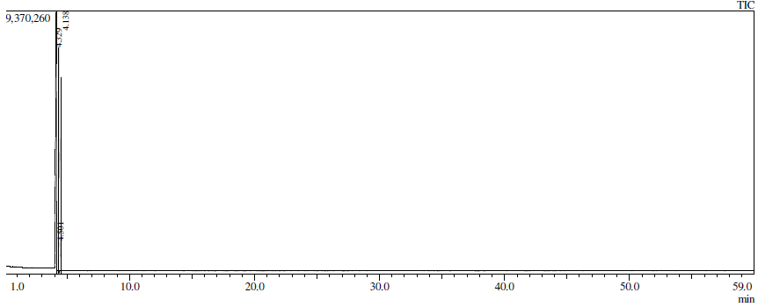
Figure 10. Citrus bee bread chromatogram by GC-MS analysis coupled with HD technique.
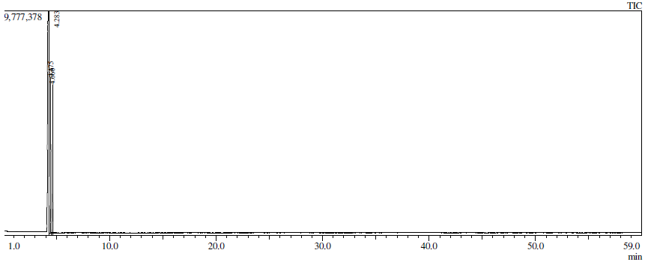
Figure 11. Marjoram bee bread chromatogram by GC-MS analysis coupled with HD technique.
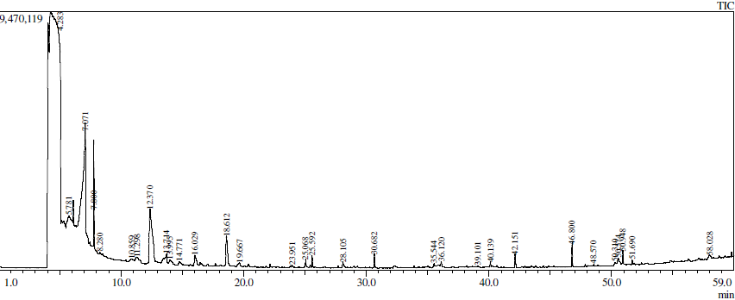
Figure 12. Trifolium bee bread chromatogram by GC-MS analysis coupled with HD technique.
Table 4: Volatile compounds characterized by H.D. analysis in bee bread of (Marjoram, Trifolium and Citrus) in Egypt.
Peak | Name | R. Time | M. Wt. | BRM | BRT | BRC
1 | l-Alanine ethyl amide, (S)- | 4.283 | 116 | + | - | -
2 | Ethylene oxide | 4.475 | 44 | + | - | -
3 | Dimethylamine | 4.660 | 45 | + | - | +
4 | Carbamic acid, monoammonium salt | 4.283 | 78 | - | + | +
5 | Oxirane, 2,3-dimethyl-, cis- (CAS) | 5.781 | 72 | - | + | -
6 | Acetic acid (CAS) | 7.071 | 60 | - | + | -
7 | 2-Propanone, 1-hydroxy- (CAS) | 7.800 | 74 | - | + | -
8 | Hexanal | 10.895 | 100 | - | + | -
9 | *3(2H)-Furanone, dihydro-2-methyl | 11.298 | 100 | - | + | -
10 | *Furfural | 12.370 | 96 | - | + | -
11 | *Furfuryl alcohol | 13.714 | 98 | - | + | -
12 | *2(3H)-Furanone, 5-methyl- (CAS) | 3.995 | 98 | - | + | -
13 | 2-cyclopentene-1,4-dione | 14.771 | 96 | - | + | -
14 | *2-Furyl methyl ketone | 16.029 | 110 | - | + | -
15 | 5-Methyl-2-furfural | 18.612 | 110 | - | + | -
16 | Nonanoic acid (CAS) | 19.667 | 158 | - | + | -
17 | Methyl pyrrol-2-yl ketone | 23.951 | 109 | - | + | -
18 | 2,3-Dihydro-5-hydroxy-6-methyl-4H-pyran-4-one | 25.068 | 128 | - | + | -
19 | Nonanal (CAS) | 25.592 | 142 | - | + | -
20 | 2,3-Dihydro-3,5-dihydroxy-6-methyl--4H-pyran-4-one | 28.105 | 144 | - | + | -
21 | Decanal (CAS) | 30.682 | 156 | - | + | -
22 | 1-Tetradecyne | 35.544 | 194 | - | + | -
23 | 2,4-Decadienal, (E, E)- (CAS) | 36.120 | 152 | - | + | -
24 | Acetic acid, 1,7,7-trimethyl-bicyclo [2.2.1] hept-2-yl ester | 39.101 | 196 | - | + | -
25 | Dodecanal (CAS) | 40.139 | 184 | - | + | -
26 | (Z)-Geranylacetone | 42.151 | 194 | - | + | -
27 | Nerolidol 1 | 46.800 | 222 | - | + | -
28 | 1-Pentacontanol (CAS) | 50.310 | 260 | - | + | -
29 | Cetyl chloride | 50.310 | 260 | - | + | -
30 | Cholest-14-en-3-ol, | 50.575 | 386 | - | + | -
31 | 9-EICOSENE, (E)- | 50.948 | 280 | - | + | -
32 | NONADECANE | 51.690 | 268 | - | + | -
33 | 4-EPIDEHYDROABIETOL | 58.028 | 286 | - | + | -
34 | Pyridine-3-carboxamide, 1,2-dihydro-4,6-dimethyl-2-thioxo | 4.501 | 182 | - | - | +
*(sight for byproduct compounds)

