Network pharmacology, molecular docking study, and in-vivo validation of the wound healing activity of the Red Sea soft coral Paralemnalia thyrsoides (Ehrenberg 1834) ethanolic extract and bioactive metabolites

1. Materials and Methods
1.1. Main experimental methodology
The equipment used in this study included a Rotary evaporator (Laborota Heidolph WB eco, Germany), (Stuart, UK) and (Hahnshin, Korea), a portable UV lamp for detecting fluorescent spots with short and long wavelengths (254 and 365 nm, UVP, LLC, USA), TLC G60F254 plates (20 x 20 cm, 0.25 mm Aluminum sheets, E-Merck, Germany), and spots were visualized by spraying a 10% H2SO4 solution followed by heating. Silica gel 60 with a particle size of 60-120 mesh, obtained from NICE and SDFCL sd fine-Chem Limited, India, was used for column chromatography. The following chemicals were acquired from El-Nasr Company for Pharmaceuticals and Chemicals, Egypt: light petroleum ether (60-80 ˚C), dichloromethane, ethyl acetate, and ethanol. NMR spectroscopic analyses were conducted using a Bruker Avance HD III 400 MHz spectrometer (400 MHz for 1H-NMR and 100 MHz for 13C-NMR) from Switzerland. Chloroform (CDCl3) from Sigma-Aldrich, Germany was used as the deuterated solvent for the NMR spectroscopic analyses.

¹H-NMR and ¹³C-NMR spectrum of the isolated compounds:
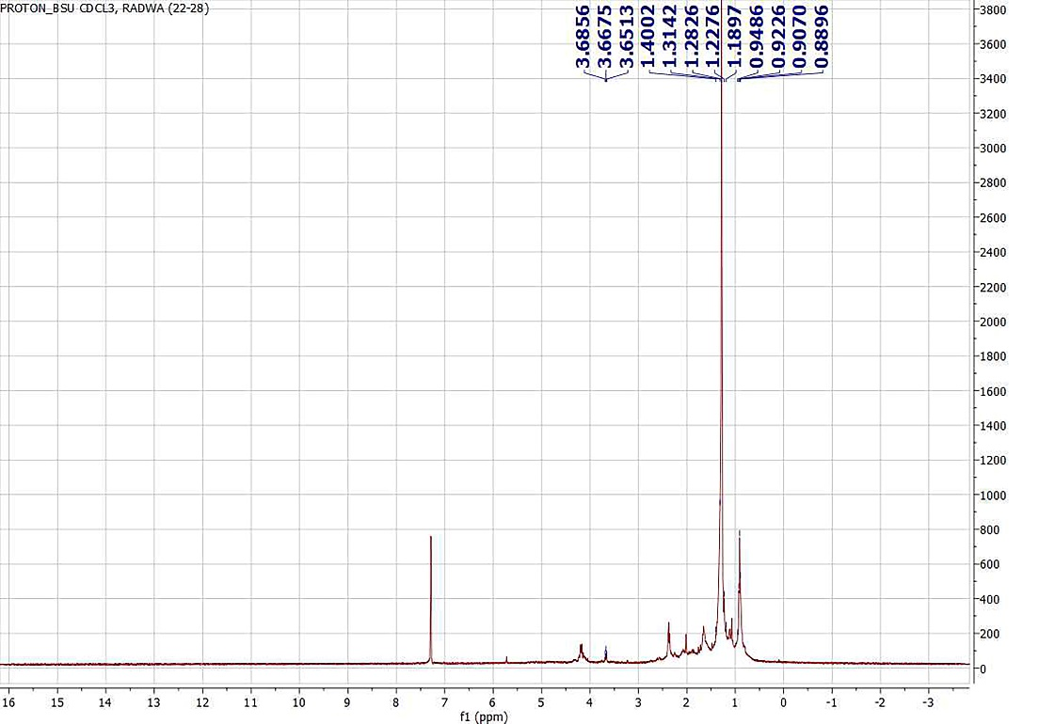
Figure S1:¹H-NMR spectrum of compound (1)

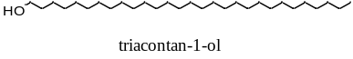

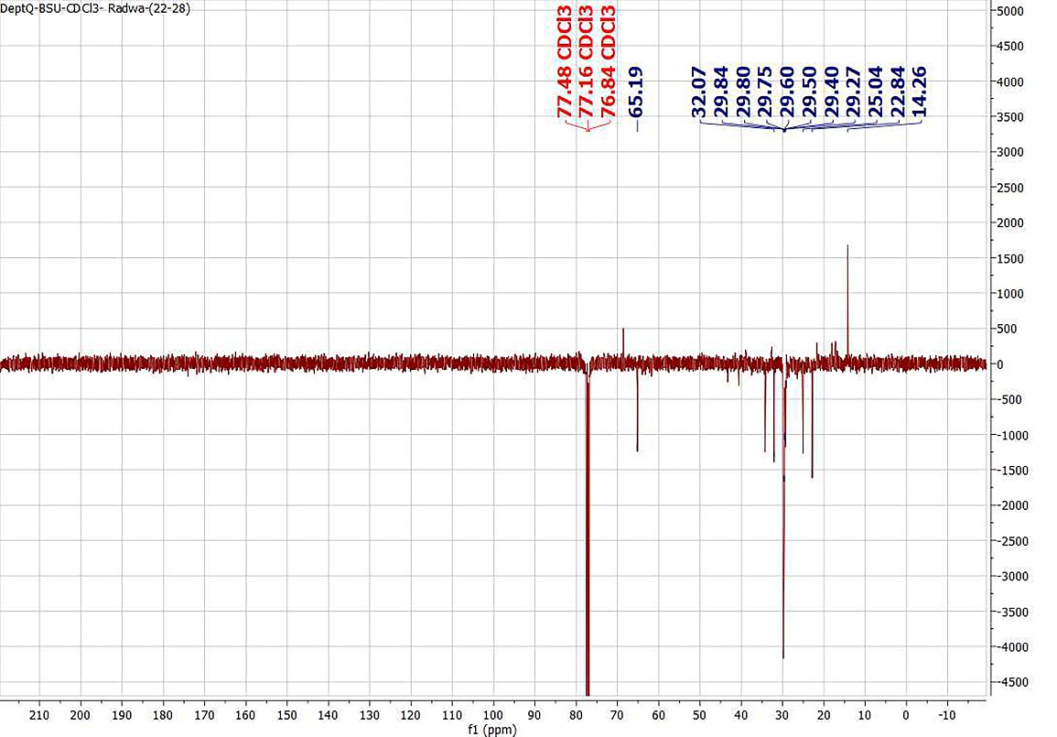
Figure S2: dept-Q ¹³C-NMR spectrum of compound (1)

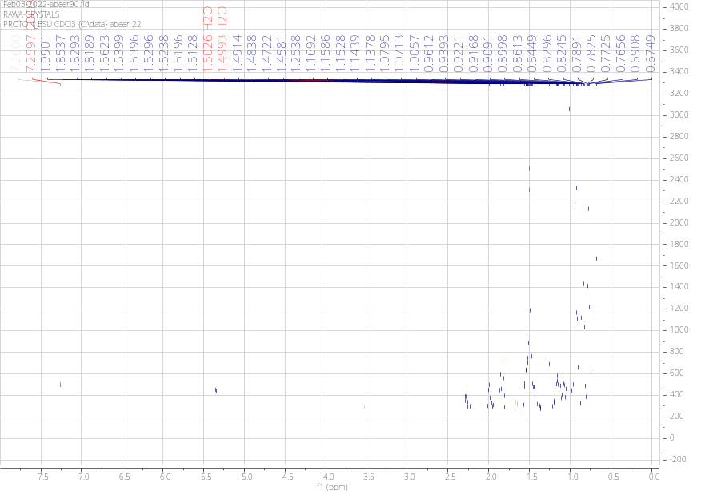
Figure S3:¹H-NMR spectrum of compound (2)

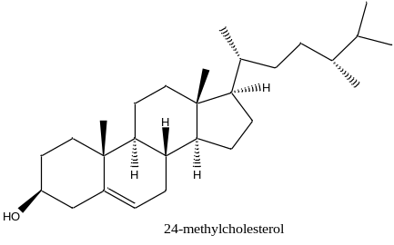

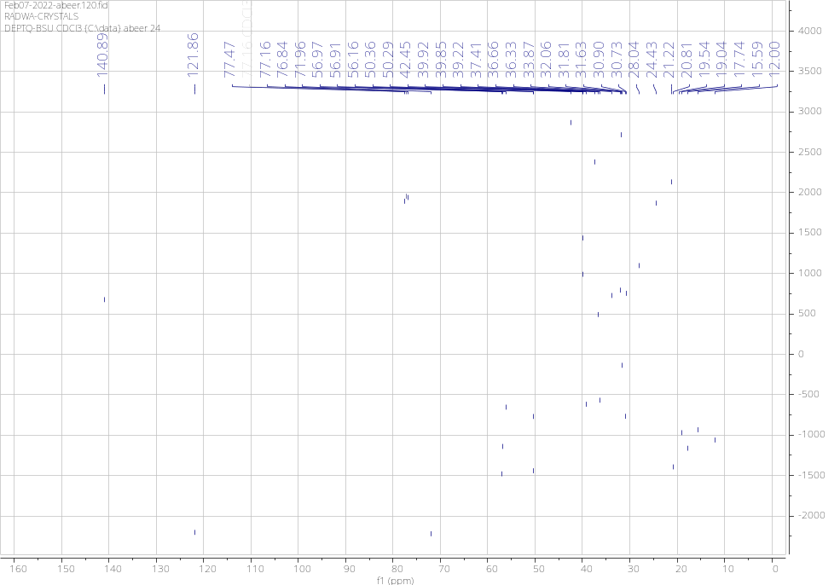

Figure S4: dept-Q ¹³C-NMR spectrum of compound (2)

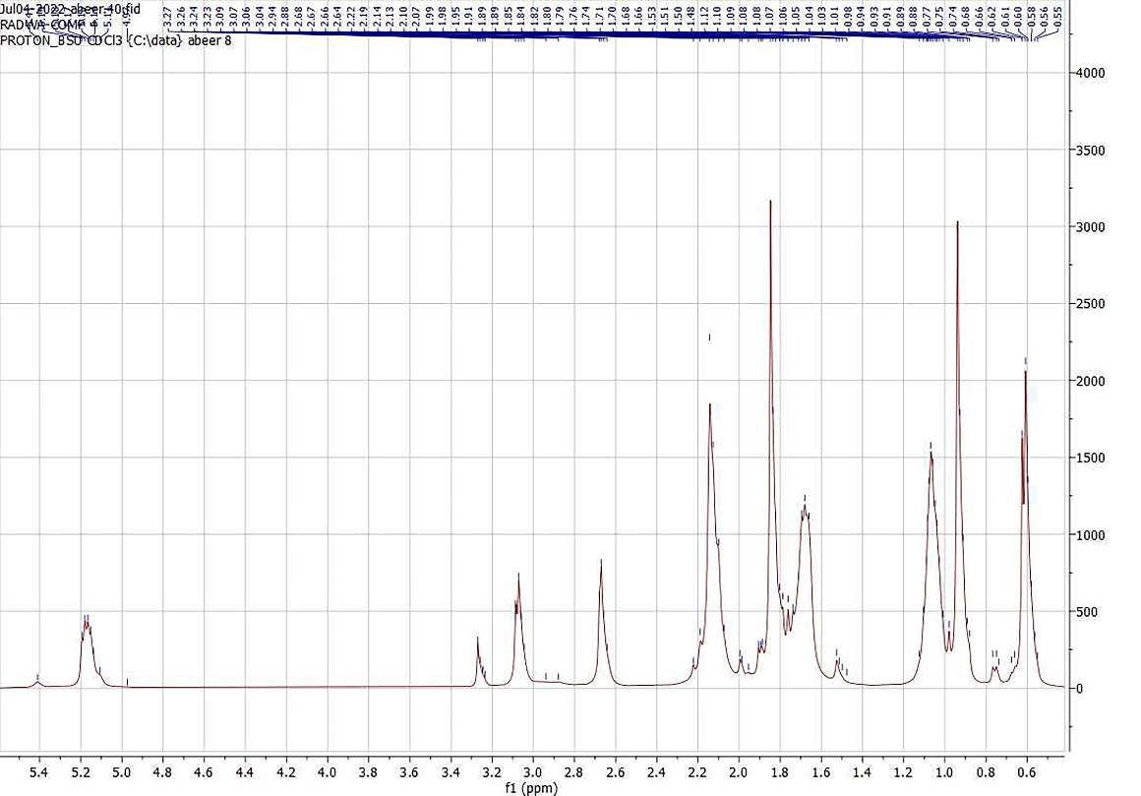

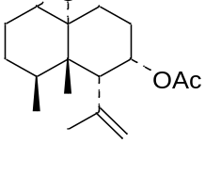
6α-acetyl-7α-acetate-1(10)-α-13-nornardosine

Figure S5:¹H-NMR spectrum of compound (3)

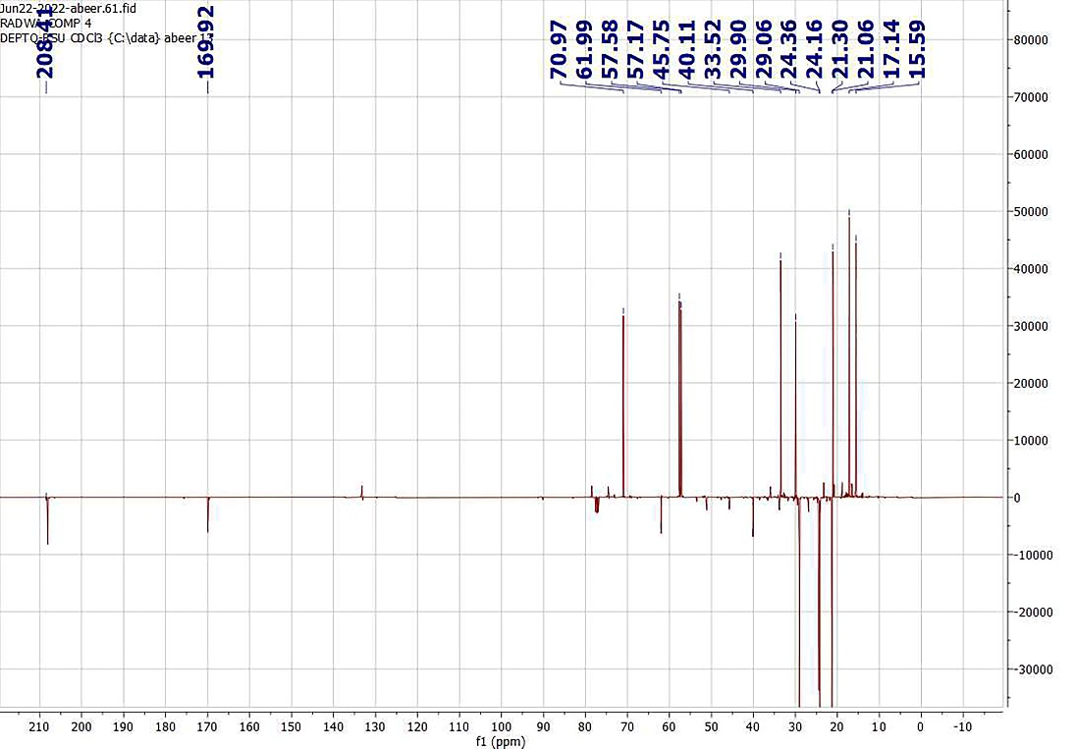

Figure S6: dept-Q ¹³C-NMR spectrum of compound (3)

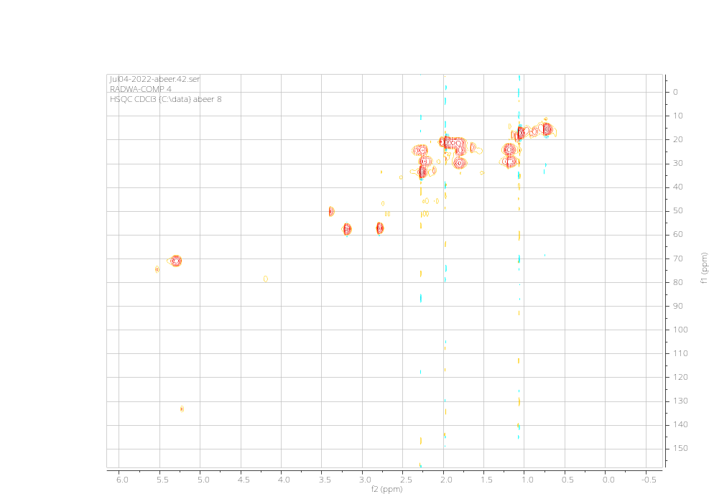

Figure S7: HSQC-NMR spectrum of compound (3)

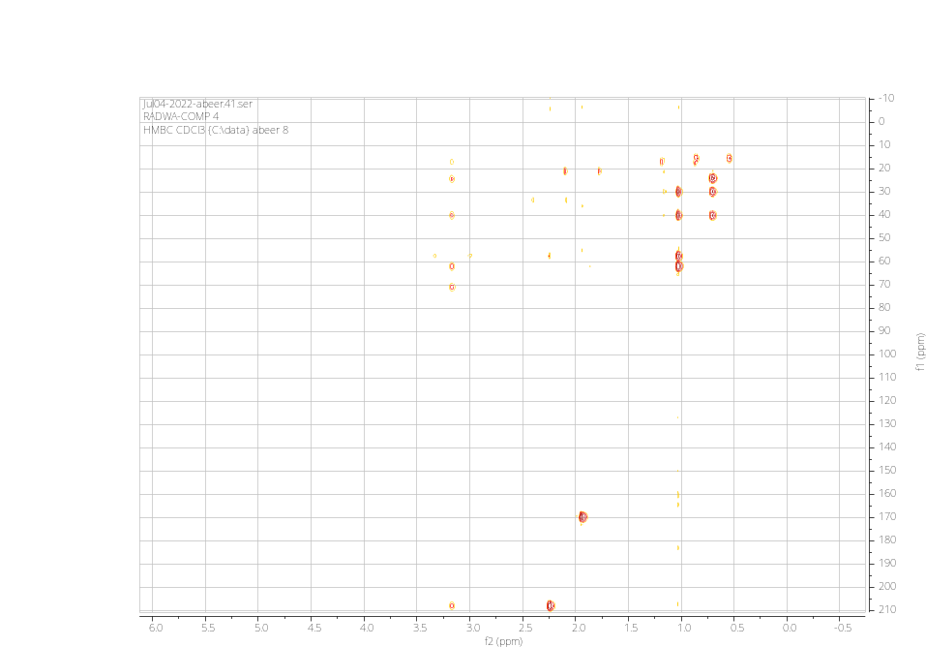
Figure S8: HMBC-NMR spectrum of compound (3)

Table. S1: The primer sequences of studied genes
Name of gene | Accession number |  | Primer sequence
IL- 1β | NM_031512.2 | Forward | 5'-GTG ATG AAA GAC GGC ACA CC-3'
IL- 1β | NM_031512.2 | Reverse | 5'-TCC TGG GGA AGG CAT TAG GA-3'
GAPDH | NM_017008.4 | Forward | 5'-CTC TCT GCT CCT CCC TGT TC-3'
GAPDH | NM_017008.4 | Reverse | 5'-CGA CAT ACT CAG CAC CAG CA-3'
TGF-β | NM_021578.2 | Forward | 5'-GCT GAA CCA AGG AGA CGG AA-3'
TGF-β | NM_021578.2 | Reverse | 5'-GAA GTT GGC ATG GTA GCC CT-3'
TNF-α | NM_012675.3 | Forward | 5'-CCT CTC TGC CAT CAA GAG CC-3'
TNF-α | NM_012675.3 | Reverse | 5'-GGC TGG GTA GAG AAC GGA TG-3'
IL-10 | NM_012854.2 | Forward | 5'-GCT GGA GTG AAG ACC AGC AA-3'
IL-10 | NM_012854.2 | Reverse | 5'-TTC TTC ACC TGC TCC ACT GC-3'
NF-KB | NM_001276711.2 | Forward | 5'-CAG CAG ATG GCC CAT ACC TT-3'
NF-KB | NM_001276711.2 | Reverse | 5'-CTG TCA TCC GTG CTT CCA GT-3'
INF-ϒ | NM_138880.3 | Forward | 5'-TGA AAG ACA ACC AGG CCA TCA-3'
INF-ϒ | NM_138880.3 | Reverse | 5'-CAC CGA CTC CTT TTC CGC T-3'
Cox-1 | NM_017043.4 | Forward | 5'-TTC CGT GTG CCA GAT TAC CC-3'
Cox-1 | NM_017043.4 | Reverse | 5'-GTT GCC AAC AAG GAG CCA AG-3'
Cox-2 | NM_017232.4 | Forward | 5'-TTC GGG AGC ACA ACA GAG TG-3'
Cox-2 | NM_017232.4 | Reverse | 5'-CAG CGG ATG CCA GTG ATA GA-3'

Table. S2: Superimposed poses of the native ligand for each protein

Cpd | Binding Energy score (S) (kcal/mol)
Cpd | AKT1 | IL6 | MAPK3 | MMP9 | HIF1A | IL-1β | TGF-β | TNF-α | NF-KB
Co-crystallized ligand | -12.06  RMSD= 1.034 A° | -5.14  RMSD= 1.46 A° | -7.65  RMSD= 0.37 A° | -6.39  RMSD= 1.42 A° | -5.11  RMSD= 0.58 A° | -5.62  RMSD= 0.193 A° | -11.69  RMSD= 0.193 A° | -5.17  RMSD= 1.40 A° | ------

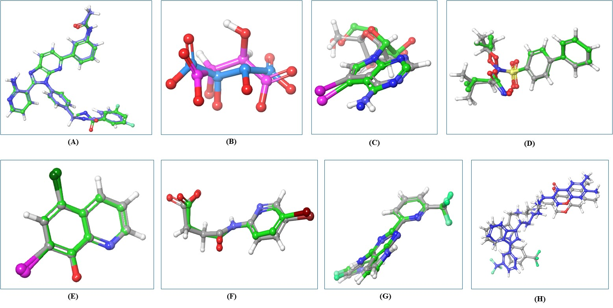
Figure S9: 3D view of redocked co-crystallized ligand for (A) AKT-1, (B) IL6, (C) MAPK3, (D) MMP9, (E) HIF1A, (F) IL-1B, (G) TGF-B and (H) TNF-A.

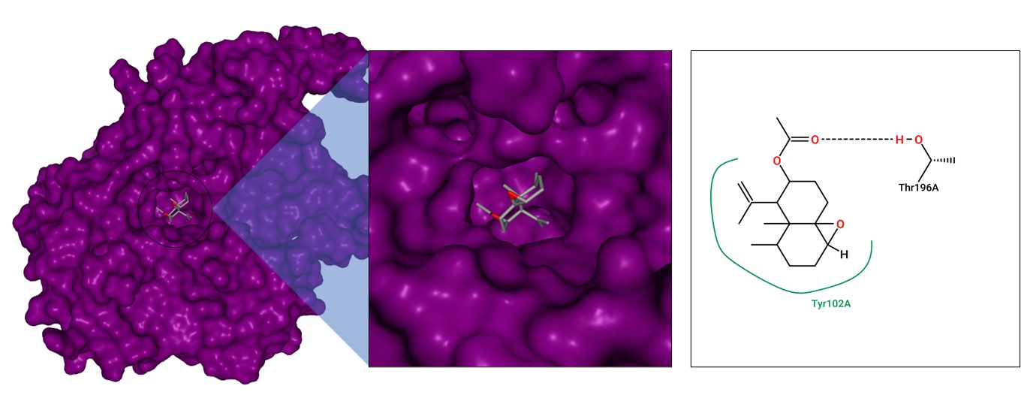

(A)

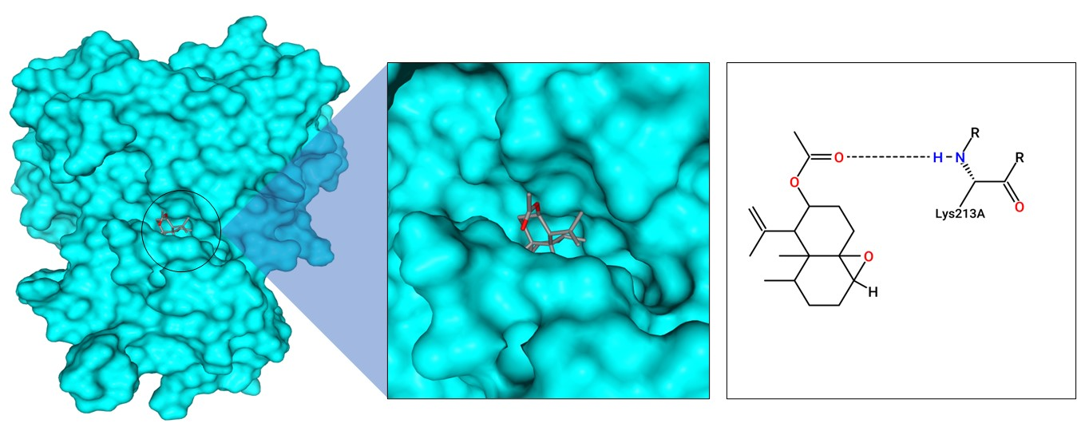

(B)

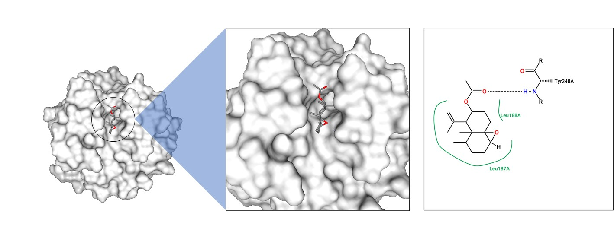

(C)
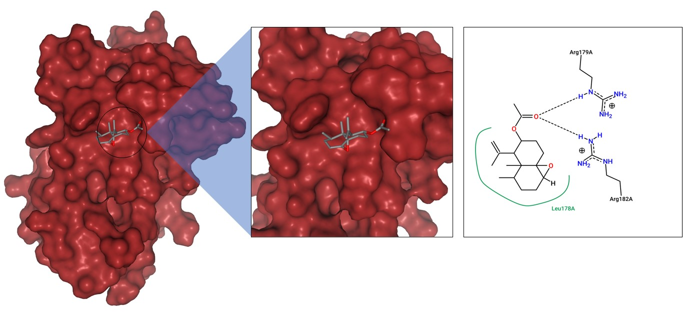
(D)

Figure (S10): 3D Molecular docking and binding pose of C₁₆H₂₄O₄ with (A) HAF1A (B) TGF-B (C) MMP9 (D) IL6.

