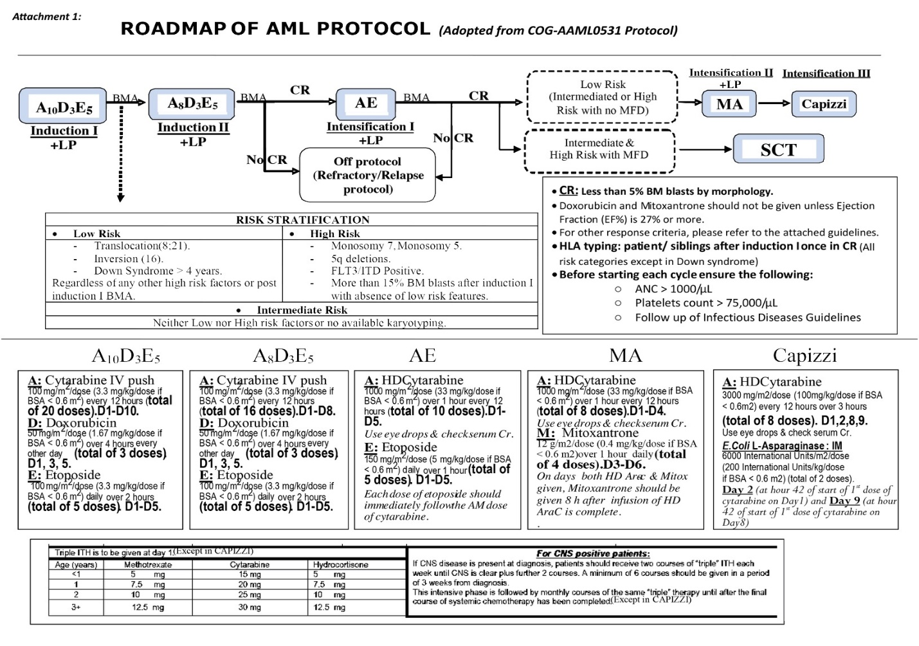

Supplementary figure 1: Roadmap of AML protocol (adopted from COG-AAML0531 protocol)

Supplementary figure 2: Roadmap of AML protocol (adopted from COG-AAML1031 protocol

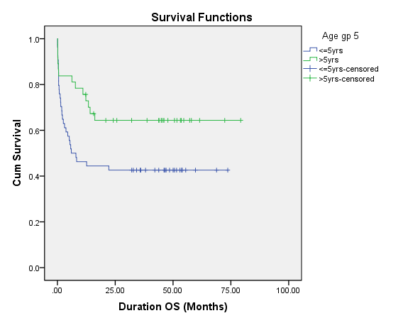
Supplementary figure 3: 5y overall survival according to age above and below 5 years old, which were 64.3%, and 42.6% respectively with P-value 0.031.

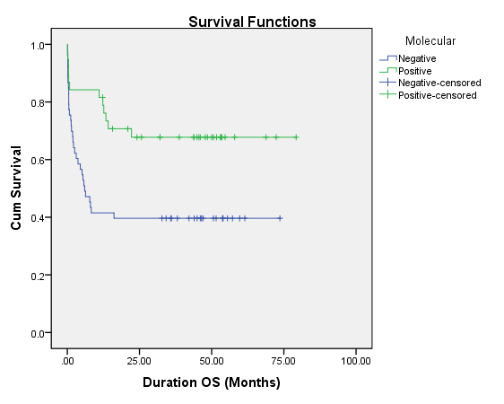

Supplementary figure 4: 5y overall survival according to positive or negative initial molecular result, which were 67.8%, and 39.6% respectively with P-value 0.005.

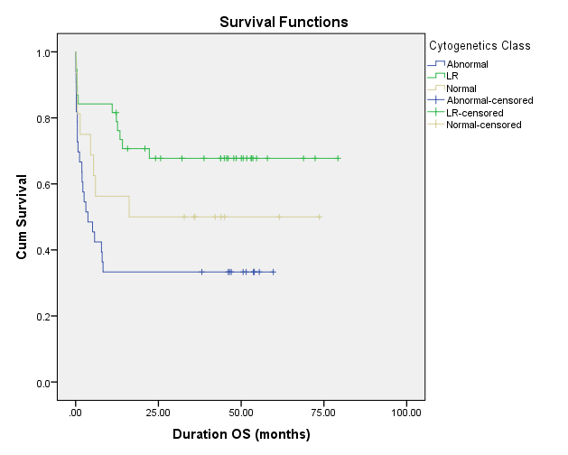

Supplementary figure 5: 5y Overall Survival according to initial Cytogentic result, where LR include (inv 16 & t(8;21)) , other abnormality which include (MLL gene rearrangment, complex caryotype, t(1;22), or any other abnormality) and Normal karyotype, which was 67.8%, 33.3% and 50.0% respectively with P-value 0.005.

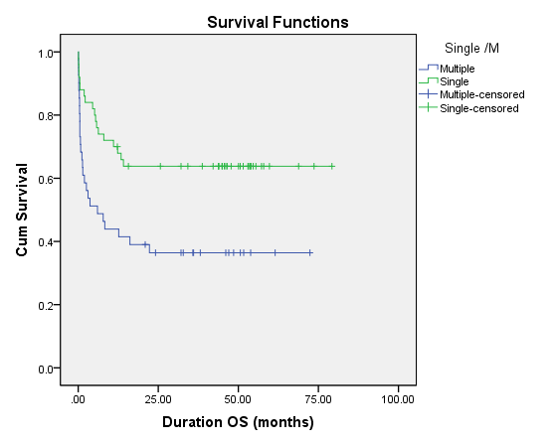

Supplementary figure 6: 5y overall survival according to number of the initial site of myeloid sarcoma, which was single or multiple lesions, which was 63.8%, 36.4%, respectively with P-value 0.005.

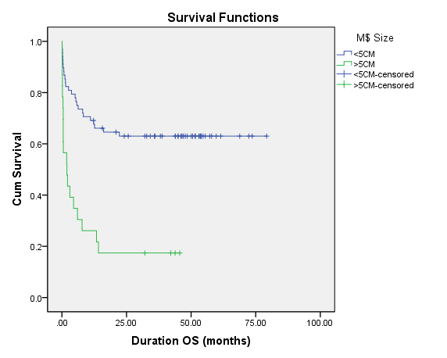

Supplementary figure 7: 5y overall survival according to size of the initial myeloid sarcoma lesion, which was > or < 5 cm, which was 17.4%, 63.0%, respectively with P-value 0.000.
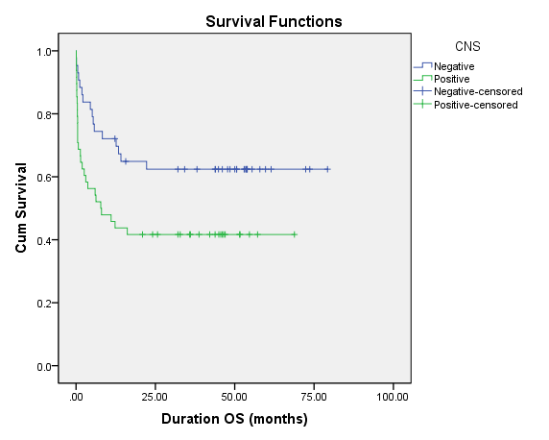

Supplementary figure 8 : 5y overall survival according to CNS infilteration or not, which was 41.7%, 62.8%, respectively with P-value 0.022.

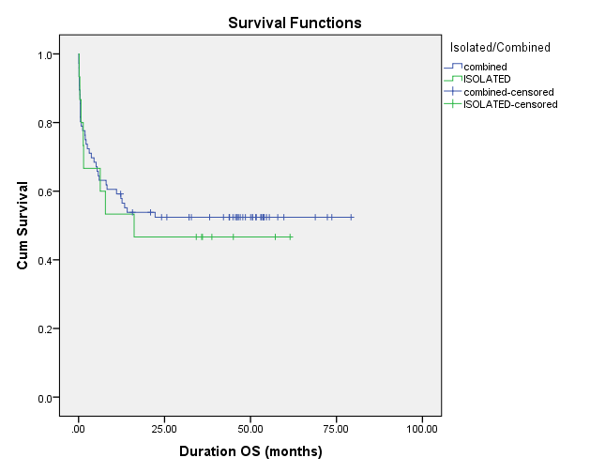

Supplementary figure 9: 5y overall survival according to Isolated Myeloid Sarcoma lesions or combined with BM infilteration, which was 46.7%, 52.6%, respectively with P-value 0.721.
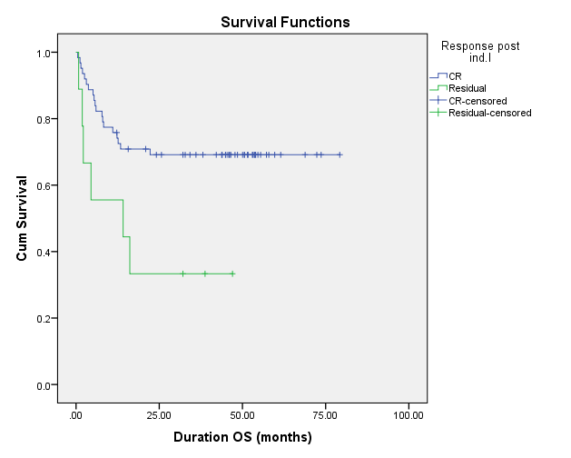

Supplementary figure 10: 5y overall survival according to Morphilogical response post Induction 1 in form of Complete Resmission (CR) or Partial Response with residual disease (PR), which was 69.1% and 33.3%, respectively with P-value 0.018.
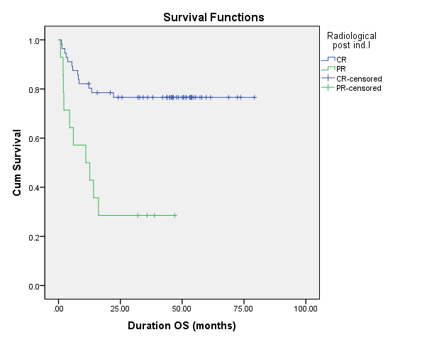

Supplementary figure 11: 5y overall survival according to Radiological response post induction I in the form of Complete Resmission (CR) or Partial Response with residual disease (PR), which was 76.6 % and 28.6%, respectively with P-value 0.000.

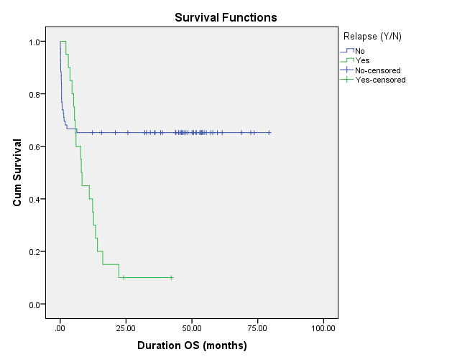

Supplementary figure 12: 5y overall survival according to relapse or not, which was 10.0%, 65.2%, respectively with P-value 0.002.

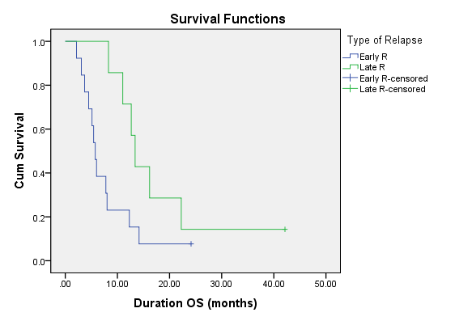
Supplementary figure 13: 5y overall survival according to time of relapse which was early or late, which was 7.4%, 14.3%, respectively with P-value 0.046.

