SUPPLEMENTARY MATERIAL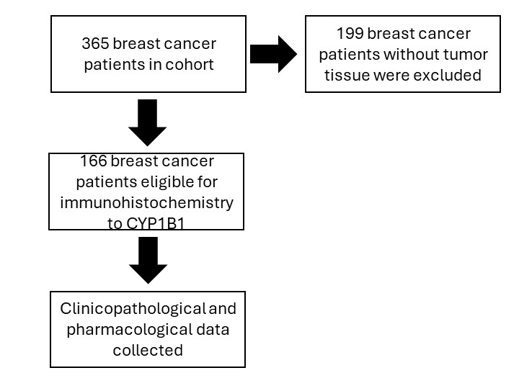
Supplementary Figure 1. Summary of patient selection and analyses.
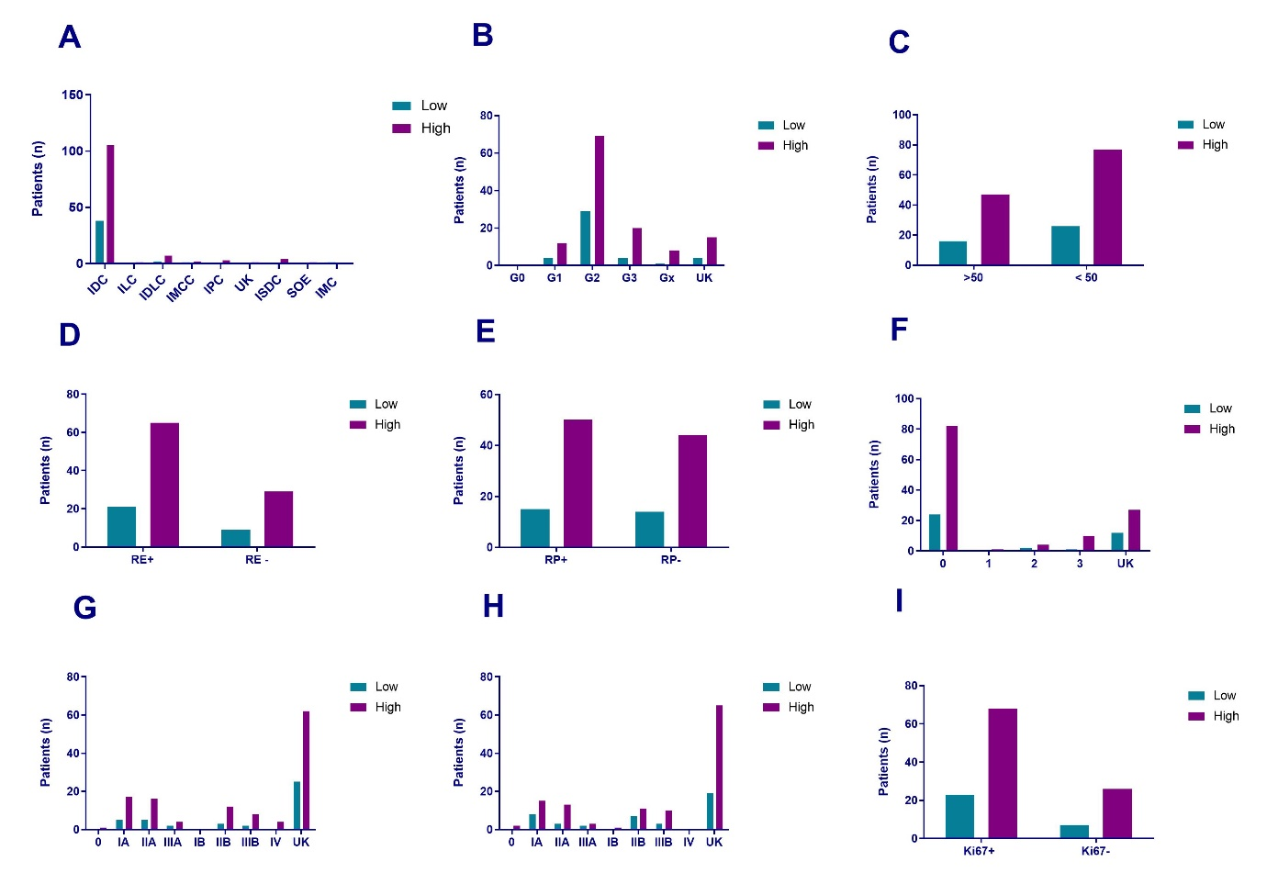
Supplementary Figure 2. Clinicopathological data and CYP1B1 expression. The representations are related to low or high CYP1B1 expression. (A) Histology. (B) Histological degree. (C) Under and over the age of 50 years. (D) Estrogen receptor-positive (ER+) and negative (ER-). (E) Progesterone receptor-positive (PR+) and negative (PR-). (F) HER2 expression degree (0 to 3) or unknown (UK). (G, H) TNM classification of right and left breast, respectively. (I) Ki67-positive (+) and negative (-). Legend: IDC (infiltrating ductal carcinoma); ILC (infiltrating lobular carcinoma); ICDL (infiltrating ductal-lobular carcinoma); IMCC (infiltrating mucinous carcinoma - colloid); IPC (infiltrating papillary carcinoma); UK (unknown); ISIC (In situ ductal carcinoma); IMC (Invasive medullar carcinoma); SOE (infiltrating carcinoma SOE).

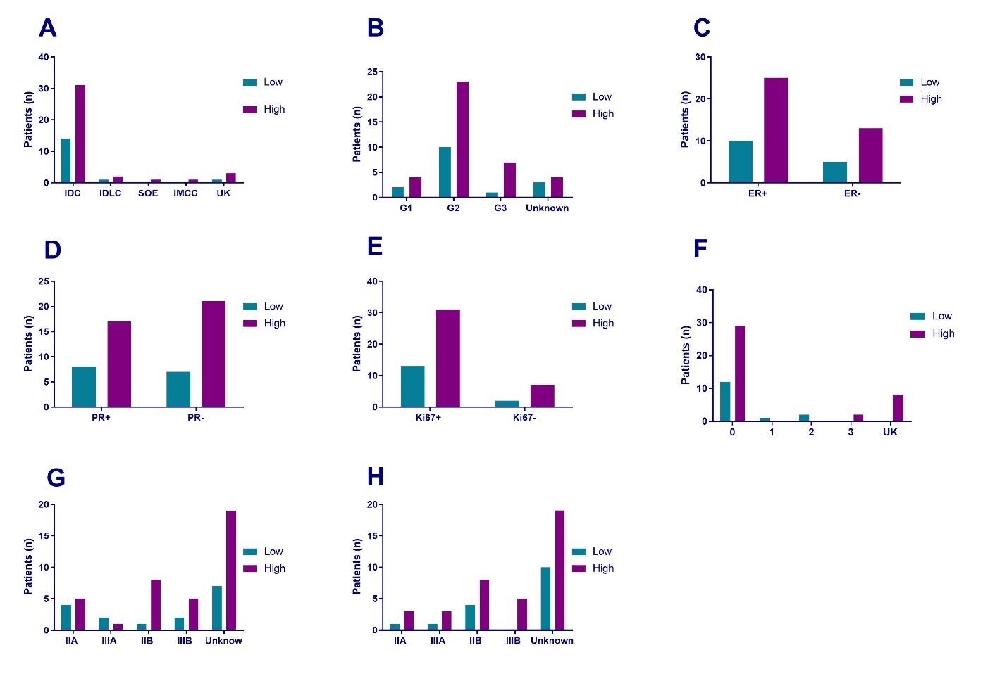
Supplementary Figure 3. Clinicopathological data and CYP1B1 expression in neoadjuvant treatments. The representations are related to low or high CYP1B1 expression. (A) Histology. (B) Histological degree. (C) Estrogen receptor-positive (ER+) and -negative (ER-). (D) Progesterone receptor-positive (PR+) and -negative (PR-). (E) Ki67-positive (+) and -negative (-). (F) HER2 expression degree (0 to 3) or unknown (NC). (G, H) TNM classification of right and left breast, respectively. Legend: IDC (infiltrating ductal carcinoma); ICDL (infiltrating ductal-lobular carcinoma); IMCC (infiltrating mucinous carcinoma - colloid); SOE (infiltrating carcinoma SOE).

Supplementary Table 1. Cross-tabulation of estrogen receptor and CYP1B1 expression.
Cross-tabulation of ER × CYP1B1
 |  |  | CYP1B1 |  |  |  | Total
 |  |  | 0.00 | 1.00 | 2.00 | 3.00 | Total
ER | Negative | Count | 2 | 7 | 13 | 16 | 38
ER | Negative | Count | 3.0 | 6.6 | 18.3 | 10.1 | 38.0
ER | Negative | Adjusted standardized | -0.7 | 0.2 | -2.0 | 2.5
ER | Positive | Count | 9 | 12 | 46 | 19 | 86
ER | Positive | Expected count | 6.7 | 15.0 | 41.4 | 22.8 | 86.0
ER | Positive | Adjusted standardized | 1.3 | -1.2 | 1.4 | -1.3
ER | Unknown | Count | 2 | 10 | 21 | 9 | 42
ER | Unknown | Expected count | 3.3 | 7.3 | 20.2 | 11.1 | 42.0
ER | Unknown | Adjusted standardized | -0.9 | 1.3 | 0.3 | -0.9
Total |  | Count | 13 | 29 | 80 | 44 | 166
 |  | Expected count | 13.0 | 29.0 | 80.0 | 44.0 | 166.0
The statistical analysis was performed using SPSS software. Adjusted standardized: If the value is > 1.96 or < -1.96, then the observed count is significantly higher or lower than expected. Higher values indicate a higher likelihood that the column variable is associated with the row variable.

