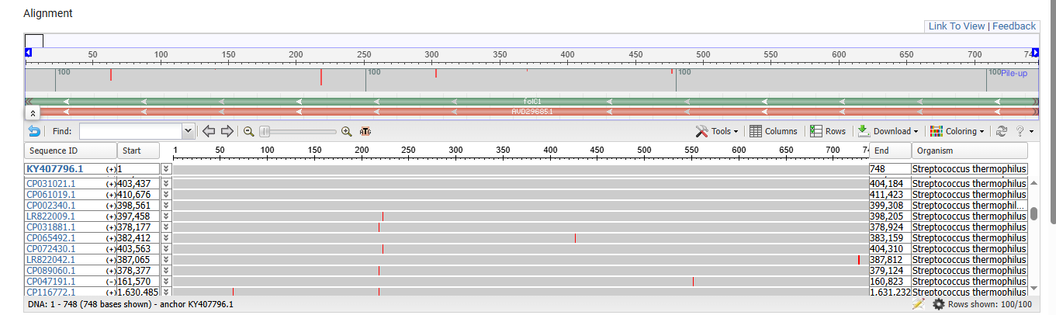
Figure 1: MSA Viewer of Alignment Results of The Isolated Fragment of FOlC1 (KY407796.1) Showing the mismatches with 100 of nucleotide sequences in Red lines.

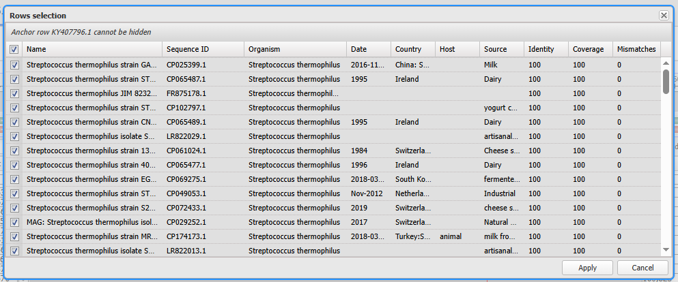
Figure 2:The Results Of The Alignment Of The Isolated Fragment Of Folc1 (KY407796.1) Showing The Number Of Mismatches with Each Sequence.

