Table S1: Chemical structures and in vitro cytotoxic properties of the ligands against MCF-7
Ligand | Structure | IC₅₀  (nM) | jIC₅₀  (nM) | Ligand | Structure | IC₅₀  (nM) | jIC₅₀  (nM)
*1 | 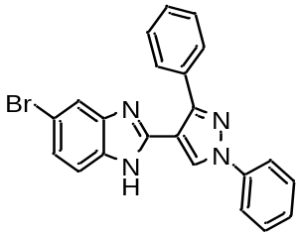 | 830 | 2.919 | 23 | 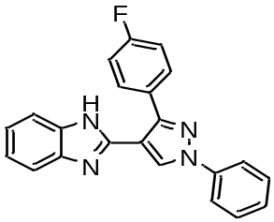 | 3200 | 3.505
2 | 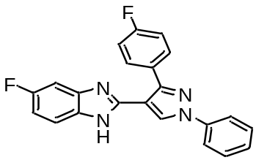 | 950 | 2.978 | 24 | 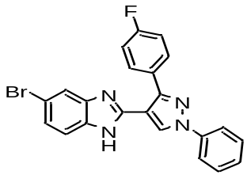 | 3210 | 3.507
3 | 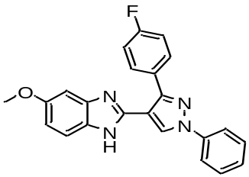 | 970 | 2.987 | 25 | 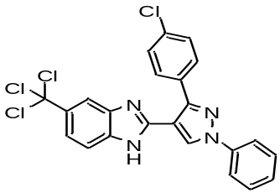 | 4210 | 3.624
4 | 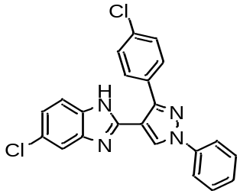 | 1170 | 3.068 | 26 | 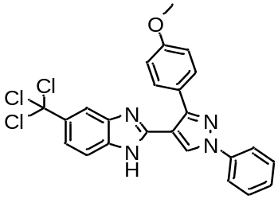 | 5730 | 3.758
5 | 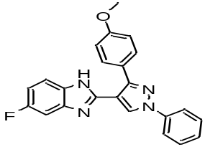 | 1510 | 3.179 | 27 | 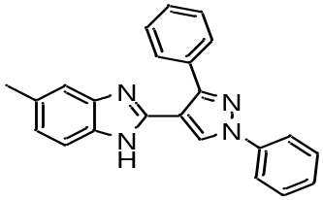 | 5940 | 3.774
6 | 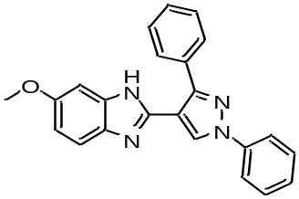 | 1590 | 3.201 | 28 | 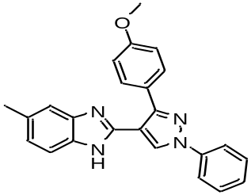 | 6610 | 3.820
7 | 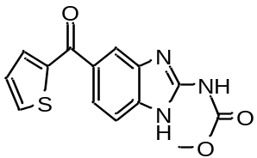 | 1600 | 4.207 | 29 | 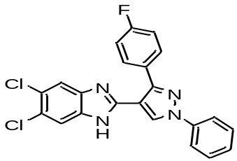 | 6930 | 3.841
8 | 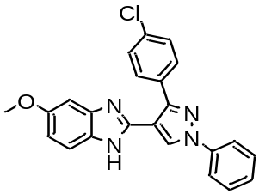 | 1760 | 3.246 | 30 | 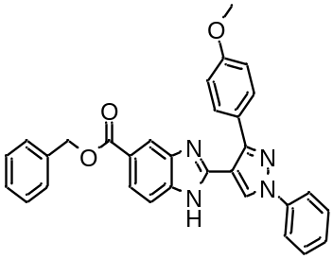 | 7460 | 3.873
9 | 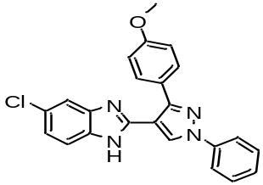 | 1760 | 3.246 | 31 | 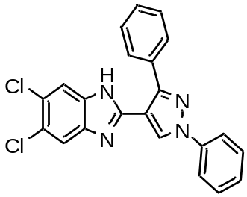 | 7560 | 3.879
10 | 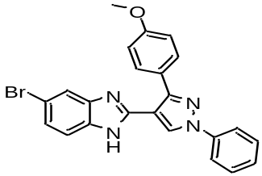 | 1830 | 3.262 | 32 | 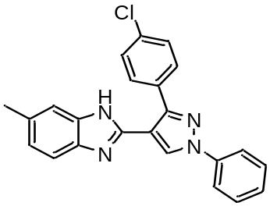 | 8230 | 3.915
11 | 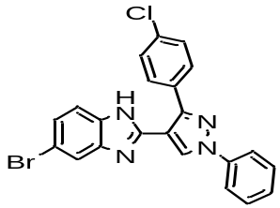 | 1720 | 3.283 | 33 | 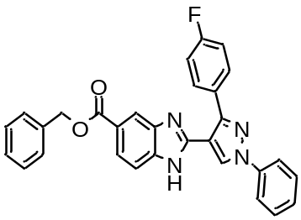 | 9240 | 3.966
12 | 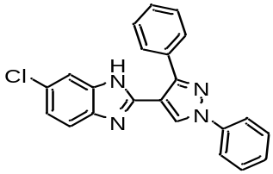 | 1960 | 3.292 | 34 | 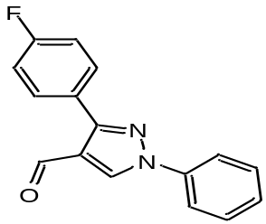 | 9650 | 3.985
13 | 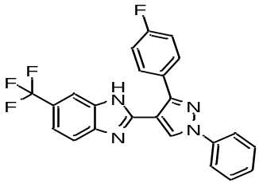 | 2130 | 3.328 | 35 | 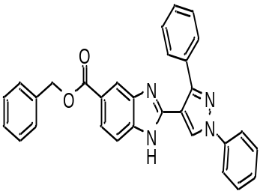 | 12600 | 4.100
14 | 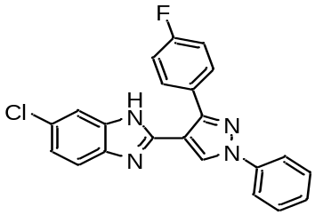 | 2230 | 3.348 | 36 | 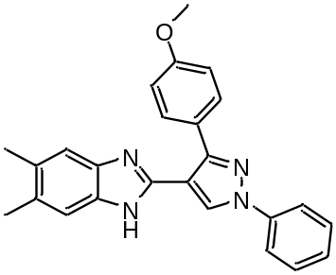 | 12800 | 4.107
15 | 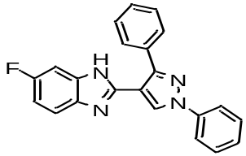 | 2430 | 3.386 | 37 | 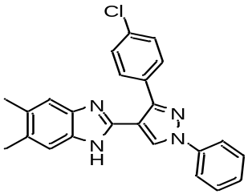 | 13000 | 4.114
16 | 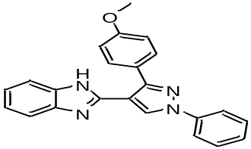 | 2540 | 3.405 | 38 | 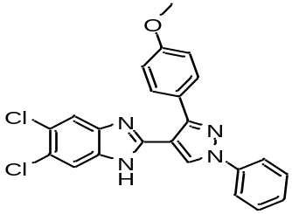 | 13200 | 4.121
17 | 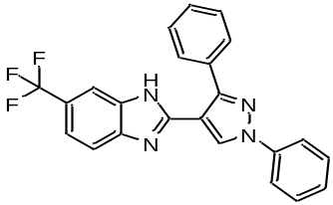 | 2660 | 3.425 | 39 | 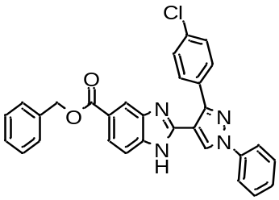 | 13900 | 4.143
18 | 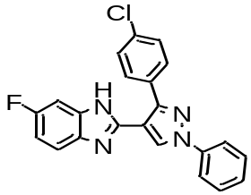 | 2830 | 3.452 | 40 | 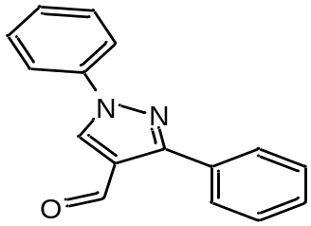 | 18240 | 4.261
19 | 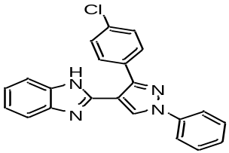 | 3030 | 3.481 | 41 | 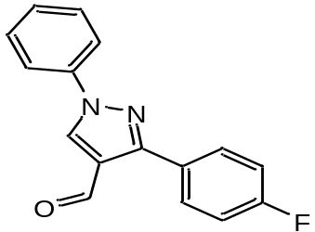 | 24760 | 4.394
20 | 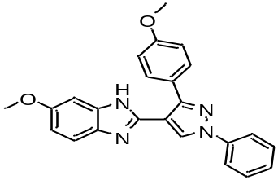 | 3130 | 3.496 | 42 | 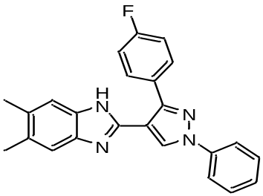 | 27200 | 4.435
21 | 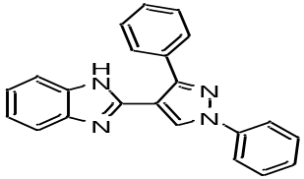 | 3190 | 3.504 | 43 | 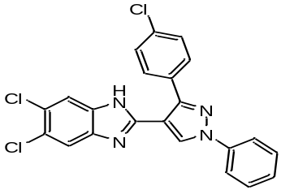 | 48300 | 4.684
22 | 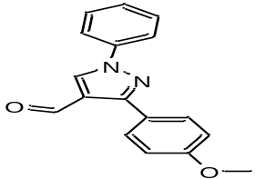 | 3190 | 3.504 | 44 | 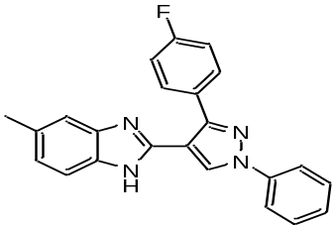 | 1120 | 3.049
*Template/lead molecule

