Appendices
Appendix 1 : Calculation of financial ratios for the global sample of 30 SMEs
- Based on 2021 financial statements –

ES = Healthy Enterprise / ED = Defaulting Enterprise
Appendix 2: Calculation of financial ratios for the global sample of 30 SMEs
- Based on 2020 financial statements -

Appendix 3: Calculation of financial ratios for the global sample of 30 SMEs
- Based on 2019 financial statements –

Appendix 4 : DATASET 2021_.CSV
Nom,R01,R02,R03,R04,R05,R06,R07,R08,R09,R10,R11,R12,R13,R14,R15,R16,R17,R18,R19,R20,R21,R22,R23,R24,R25,R26,R27,Y
ES1,2,0.58,,0,0,385.43,1.61,0.69,0,,8.45,1,3.87,0.54,0,0,,0,4.36,4.09,4.36,0.13,0.14,0.35,0.22,0.24,0.24,0
ES2,-0.8,0.02,256.29,0,1.4,428.62,232.45,-34.05,0,1.62,1.3,1,221.86,1.59,0,0.01,36.83,0.01,0.05,1.25,0.05,0,0.01,-0.02,0.2,0.29,0.34,0
ES3,-0.71,0.32,1.08,201.5,0,542.14,394.53,-0.12,0.4,0.75,0.94,1,-1.1,-0.08,-0.03,0,73.32,0.39,0.95,-0.02,0.6,0.03,0.2,0.11,0.1,0.06,0.11,0
ES4,0.76,0.95,2746.67,0,0.13,0,135.35,-0.38,0.23,1.13,1.2,1,2.02,0.69,0,0,1545.6,0.24,0.02,1.18,0.02,0.31,0.5,1.59,0.33,0.33,0.44,0
ES5,0.35,1.83,9.64,37.34,0,0,96.86,-0.22,0.41,,1.79,1,6.59,1.92,0,0,705.32,0.5,0.29,1.5,0.01,0.13,0.29,-0.4,0.07,0.09,0.16,0
ES6,5.23,1.09,77,4.68,0,123.43,318.56,-1,0,-1.93,0.41,1,-2.87,-0.23,0,0,,1.19,0.33,0.09,0.32,-0.05,0.08,0.04,-0.05,-0.03,-0.03,0
ES7,2.6,0.17,1526.11,0,0.24,0,160.25,-2.58,0.34,0.47,0.35,-0.13,15.45,-9.36,0.07,0.18,-3.31,0.03,0.32,0.03,0.32,-0.14,3.04,0.19,-0.85,0.39,0.65,0
ES8,0.42,0.74,60.95,0,5.91,0,16.3,-0.03,0,33.49,27.2,0.97,2.77,1.05,0,0,363.83,0.02,0.35,26.85,0,0.36,0.38,65.49,0.48,0.51,0.54,0
ES9,0.33,5.36,44.7,8.05,0,0,46.18,-0.65,0.5,-5.22,0.11,1,-0.13,-0.02,0.03,0,203.01,0.65,0.1,0.02,0.07,-0.57,0.2,-0.18,-0.11,0.1,0.21,0
ES10,0.22,0.66,1.06,388.27,0,38.11,80.09,0.56,0.5,25.88,1.59,1,0.07,0.01,0,0,,0.14,1.59,0,0.34,0.05,0.14,0.16,0.08,0.09,0.19,0
ES11,5.09,0.33,,0,0,208.68,415.76,-1.84,0.28,0.27,0.32,1,1.07,0.34,0,0,,0.25,0.24,0.09,0.24,0.03,0.17,0.49,0.1,0.19,0.45,0
ES12,0.35,0.86,6.02,0,35.78,75.18,87.71,0.09,0.46,1.14,1.28,0.6,3.83,0.78,0.16,0.06,2.35,0.16,1.28,0.12,0.59,0.1,0.24,0.24,0.12,0.2,0.45,0
ES13,0.05,0.83,4.91,0,46.02,80.35,124.45,0.1,0.5,1.12,1.24,0.6,2.93,0.71,0.1,0.03,5.23,0.16,1.3,0.08,0.61,0.1,0.24,0.33,0.12,0.28,0.57,0
ES14,0.76,0.72,11.47,9.29,0,427.71,80.69,0.76,0.71,11.55,1.89,1,5.72,0.56,0,0,,0.12,2.73,0.23,1.59,0.04,0.07,0.11,0.05,0.09,0.31,0
ES15,-0.33,1.16,,0,0,0,26.56,-20.67,-34.62,-26.34,0.01,1,-0.02,0,0,0,,0.11,0,0,0,-2.76,0.12,0.11,-2.37,-2.16,-0.06,0
ED1,0.41,0.27,31.65,0,11.38,928.11,651.84,-1.81,-0.31,-0.98,0.61,1,-0.07,-0.04,0.18,0.01,-134.06,0.82,0.61,0,0.59,-0.22,0.92,0.63,-0.83,-0.56,-0.41,1
ED2,-0.22,1.69,224.87,0,1.6,0,0,-1.07,0,-2.37,0.2,1,-0.12,-0.1,0.12,0.01,-77.12,0,0.18,0.02,0.18,-1.24,0.96,0.81,-0.73,-0.6,-0.6,1
ED3,0.24,0.01,,0,0,36360.71,14035.1,38.32,8.11,12.79,1.2,1,-7.2,0.81,0,0,,0.27,1.47,0,1.2,-0.02,-0.13,-0.06,-2.87,-2.49,0.3,1
ED4,-0.53,1.53,4,0,27.75,27.88,117.95,-0.47,3.63,-1.79,0.26,2.62,-1.59,-0.91,0.04,0.06,-13.4,0.23,0.4,0,0.26,-1.51,0.64,5.21,-0.99,-0.75,0.28,1
ED5,-0.17,9.11,,0,0,16.49,396.82,-3.09,2.12,-247.91,0.03,1.14,-0.82,-0.14,0,0,,6.25,0.01,0.02,0.01,-5.51,0.18,0.19,-0.6,-0.57,0.48,1
ED6,-0.36,0.01,0.07,0,4008.95,701.04,1430.71,7.9,0,1.58,1.04,-0.12,-199.97,-7.19,0,0,,0.03,1.06,-0.02,0.96,-0.01,0.49,0,-0.81,-0.04,0.03,1
ED7,8.2,0,0.02,16484.17,454.7,38182,630847.33,143.46,0,-0.35,0.74,1.92,399.29,-6.41,0,0,-2716.92,0.14,3.33,0.01,0.56,0,0,0,-0.09,0.61,0.98,1
ED8,-0.73,0.01,0.4,0,0,20227.75,,-19.73,0,-0.09,0.72,1,5.96,-2.56,0,0,,0,0.77,0,0.7,0.01,-0.43,0.31,0.9,1,1,1
ED9,0.05,0.19,21.67,0,16.61,174.14,233.34,-2.95,-3.72,0.42,0.81,1,-3.96,5.48,0.01,0.03,-39.37,0.17,0.26,0.59,0.22,-0.2,-1.71,0.53,-1.08,-0.76,-0.16,1
ED10,0.12,1.32,6.85,0,52.57,0,181.1,-5.46,0.08,-7.24,0.02,1,0,0,,0,,0.52,0.02,0,0,-8.72,1.38,-0.07,-6.61,0.32,0.34,1
ED11,-0.52,0.03,3.72,0,96.9,392.05,4822.56,-181.91,1.65,-5.28,0.01,1.39,-32.37,-0.3,0.03,1.82,0.03,0.23,0.01,0,0.01,-0.06,0.01,0,-1.98,-0.36,0.55,1
ED12,-0.51,0.04,6.32,32.76,24.21,0,1493.71,-50.39,0.37,-1.5,0.06,1.51,-4.74,-0.38,0,0,,0.11,0.05,0.01,0.05,-0.16,0.08,0.03,-3.74,-1.02,0.5,1
ED13,-0.47,0.03,0.73,0,493.49,5536.7,1407.03,-4.74,-2.56,-0.65,0.86,1,-0.02,-0.07,2.29,0.29,-23.09,0.19,0.85,0,0.81,-0.27,4.4,0.46,-8.01,-0.89,-0.23,1
ED14,0.5,0.16,0.27,1350.75,2.55,0,92.23,-1.23,3.33,0.31,0.84,1,-0.28,0.77,0,0,,0.03,0.79,0.05,0.09,-0.22,-3.2,-7.02,-1.34,-0.83,0.35,1
ED15,-0.11,0.19,0.2,0,0,31.29,116.18,-3.8,-4.64,-37.85,0.65,1,-0.03,-0.01,0.22,0,-182.23,0.08,0.65,0,0.02,-0.16,0.23,0.22,-0.87,-0.82,-0.13,1

Appendix 5: DATASET 2020_.CSV

Nom,R01,R02,R03,R04,R05,R06,R07,R08,R09,R10,R11,R12,R13,R14,R15,R16,R17,R18,R19,R20,R21,R22,R23,R24,R25,R26,R27,Y
ES1,-0.67,0.22,,0,0,1157.36,5.62,2.18,0,,8.78,1,6.02,0.46,0,0,,0,5.18,3.6,5.18,0.07,0.08,0.16,0.31,0.35,0.35,0
ES2,-0.7,0.08,538.31,0,0.67,0,56.93,-7.21,1.42,1.61,1.3,1,-25.72,1.64,0,0,-173.92,0.01,0.02,1.28,0.02,-0.03,-0.06,0.09,-0.37,-0.31,0.44,0
ES3,-0.37,1,4.49,48.96,0,206.25,53.96,0.22,0.45,2.22,1.4,1,0.38,0.04,0.05,0,19.36,0.17,1.38,0.03,0.91,0.01,0.02,0.12,0.01,0.05,0.09,0
ES4,-0.32,1.34,1562.67,0,0.23,0,30.04,-0.1,0.11,137.23,4.62,1,1.94,1.16,0,0,725.6,0.07,0.4,4.21,0.4,0.47,0.6,-4.55,0.35,0.42,0.49,0
ES5,-0.21,1.58,7.77,46.34,0,0,102.74,-0.15,0.46,,1.99,1,5.45,1.47,0,0,2159.24,0.43,0.54,1.46,0.01,0.13,0.27,-0.66,0.09,0.1,0.2,0
ES6,-0.52,0.37,10.81,33.3,0,159.83,172.92,-0.52,0,0.87,0.79,1,-0.39,0.17,0,0,,0.3,0.54,0.25,0.45,-0.26,-0.44,-0.32,-0.7,-0.43,-0.42,0
ES7,0.92,0.07,423.33,0,0.85,0,175.14,-7.72,-1.36,0.35,0.32,0.5,-1.49,1.17,0.05,0.11,-36.83,0.06,0.29,0.03,0.29,-0.29,-2.13,-0.39,-4.27,-1.42,-0.59,0
ES8,-0.25,0.77,60.13,0,5.99,0,24.33,-0.07,0,10.88,13.34,0.93,5.17,1.1,0,0,103.83,0.04,0.25,13.09,0,0.19,0.21,6.23,0.24,0.28,0.32,0
ES9,0.12,3.19,32.65,11.03,0,0,71.89,-0.82,0.43,-3.87,0.18,1,0.52,-0.1,0.01,0,174.66,0.53,0.11,0.06,0.08,0.29,-0.16,-0.19,0.09,0.13,0.23,0
ES10,-0.23,0.82,1.25,288.62,0,46.59,43.31,0.58,0.61,21.05,1.97,1,0.14,0.02,0.05,0,87.64,0.1,1.97,0.01,0.54,0.06,0.13,0.09,0.08,0.05,0.14,0
ES11,-0.85,0.06,,0,0,654.06,2066.65,-12.6,0.43,0.18,0.21,1,19.9,0.39,0,0,,0.26,0.14,0.07,0.14,-0.03,-0.2,0.03,-0.51,0.05,0.35,0
ES12,-0.41,0.82,3.74,0,45.61,80.32,132.53,0.1,0.51,1.16,1.27,0.7,1.82,0.5,0.16,0.05,3.61,0.18,1.27,0.2,0.72,0.1,0.22,0.31,0.12,0.25,0.61,0
ES13,-0.18,1.02,4.79,0,43.23,76.31,145.27,0.14,0.49,1.37,1.54,0.71,1.85,0.4,0.08,0.02,11.64,0.22,1.45,0.2,0.79,0.1,0.22,0.47,0.1,0.29,0.58,0
ES14,-0.3,0.43,7.03,12.79,0,540.26,141.34,0.86,1.23,9.42,1.84,1,-11.6,0.75,0,0,,0.17,2.05,0.47,1.26,-0.04,-0.09,-0.05,-0.1,-0.05,0.19,0
ES15,-0.62,1.44,,0,0,0,21.97,-12.39,2.63,-19.96,0.01,1,-0.12,-0.01,0,0,,0.07,0,0.01,0,-0.89,0.05,0.04,-0.62,-0.52,0.32,0
ED1,-0.78,0.18,,0,0,1311.3,395.91,-1.52,-0.09,0.01,0.72,-5.21,-0.09,-1.6,0.16,0.03,-79.62,0.58,0.72,0,0.72,-0.4,22.24,-46.59,-2.22,-1.61,-1.46,1
ED2,-0.61,2.13,159.73,0,2.25,0,0,-0.35,0,-0.08,0.27,1,-0.15,-1.5,0.08,0,-114.59,0,0.25,0.03,0.23,-0.77,14.15,11.24,-0.36,-0.23,-0.23,1
ED3,-0.58,0.01,,0,0,44804.85,7192.5,50.75,-4.91,11.92,1.23,1,-4.15,0.72,0,0.02,-368.73,0.29,1.51,0,1.23,-0.04,-0.2,-0.1,-6.08,-5.33,-0.82,1
ED4,-0.43,1.49,4.1,14.32,12.97,20.35,87.48,0.18,1.31,0.85,0.93,-1.35,-2.62,-2.6,0.03,0.02,-11.98,0.11,1.7,0.01,0.43,-0.44,1.12,-0.57,-0.29,-0.23,0.73,1
ED5,0.15,1.17,,0,0,13.74,164.39,-0.98,1.6,-141.42,0.28,1.1,-1.4,-0.21,0.01,0.01,-72.93,0.32,0.29,0.01,0.27,-0.47,0.17,0.17,-0.41,-0.33,0.49,1
ED6,-0.18,0.01,0.12,0,2576.53,450.56,928.36,5.57,0,1.66,1.04,-0.06,-528.19,-13.71,0,0,,0.03,1.07,-0.02,0.96,-0.01,0.91,0,-0.51,0,0.04,1
ED7,-0.67,0,0,151654.32,4183.2,351274.36,261136.64,1314.02,0,-0.35,0.73,1.93,-1109.66,-6.43,0,0.01,-1693.1,0.14,3.3,0.01,0.56,0,0.03,0,-10.77,-1.82,0.61,1
ED8,-0.9,0.06,1.1,0,0,5547.41,0,-0.36,-0.01,-0.82,0.9,1,-0.29,-1.79,0,0,,0,0.98,0,0.87,-0.34,7.35,-7.77,-6.05,-5.01,-4.95,1
ED9,-0.95,0.08,11.85,0,30.39,184.3,217.19,-2.81,-0.25,1.34,1.07,1,-2.18,1.86,0.01,0.03,-76.93,0.16,0.69,0.42,0.63,-0.2,-0.95,2.62,-2.52,-2.17,-1.74,1
ED10,-0.85,0.12,5.22,0,68.99,0,788.07,-6.04,0.16,0.25,0.03,1,-0.98,0.04,0,0,,0.24,0.04,0,0,-0.18,-0.72,0.09,-1.47,0.2,0.24,1
ED11,-0.72,0.04,4.27,0,84.3,469.64,3577.69,-72.1,0.85,-4.38,0.07,1.39,-747.04,-0.3,0.02,0.56,-6.76,0.69,0.07,0,0.06,-0.2,0.04,0,-4.44,0.11,0.71,1
ED12,-0.34,0.06,7.5,27.36,20.66,0,740.14,-24.83,0.17,-1.16,0.15,1.58,-11.26,-0.45,0,0,,0.08,0.12,0.03,0.11,-0.14,0.1,0.06,-2.15,-0.81,0.5,1
ED13,-0.73,0.04,1.05,0,341.55,3996.79,1701.66,-2.28,-1.9,-0.29,0.92,1,-0.03,-0.23,1.4,0.16,-21.96,0.25,0.91,0,0.88,-0.15,8.02,0.82,-3.91,-0.49,-0.15,1
ED14,-0.24,0.11,0.18,2024.32,4.65,0,115,-0.05,4.6,1.15,1.06,1,-0.28,0.16,0.02,0.01,-195.3,0.03,0.99,0.07,0.12,-0.2,-0.67,-0.64,-1.76,-1.44,0.27,1
ED15,-0.63,0.2,0.2,0,0,34.51,118.67,-2.38,-0.47,-16.78,0.59,1.12,-0.2,-0.11,0,0,,0.09,0.6,0,0.02,-0.3,0.59,0.61,-1.48,-1.37,-0.92,1

Appendix 6 : DATASET 2019_.CSV
Nom,R01,R02,R03,R04,R05,R06,R07,R08,R09,R10,R11,R12,R13,R14,R15,R16,R17,R18,R19,R20,R21,R22,R23,R24,R25,R26,R27,Y
ES1,0.5,0.56,,0,0,385.43,1.61,0.69,0,,8.61,1,4.02,0.56,0,0,,0,4.36,4.24,4.36,0.12,0.14,0.35,0.22,0.24,0.24,0
ES2,0.17,0.25,1156.23,0,0.31,0,4.53,-2.13,0.42,1.71,1.35,1,7.37,1.59,0,0,698.82,0,0.01,1.34,0.01,0.1,0.22,-0.41,0.39,0.44,0.82,0
ES3,0.69,1.41,6.26,35.9,0,181.24,64.41,-0.04,0.39,0.71,0.94,1,0.2,0.09,0.05,0,50.22,0.27,0.94,0.01,0.76,0.03,0.2,0.52,0.02,0.05,0.08,0
ES4,-0.3,1.81,1380,0,0.26,133.04,3.42,0.44,0.11,174.77,11.66,1,0.22,0.13,0,0,1431.59,0.01,10.26,1.4,10.24,0.52,0.57,0.83,0.29,0.37,0.42,0
ES5,0.18,2.09,14.09,25.54,0,0,58.52,-0.12,0.35,,2.42,1,4.12,1.44,0,0,2031.74,0.32,0.38,2.04,0.01,0.21,0.35,-1.03,0.1,0.13,0.21,0
ES6,-0.14,0.54,20.04,17.97,0,76.65,315.15,-1.45,0,-0.08,0.5,1,-0.91,-7.34,0,0,,0.74,0.24,0.26,0.22,-0.3,8.04,0.51,-0.54,-0.29,-0.29,0
ES7,0.65,0.04,94.29,0,3.82,0,166.01,-8.34,-4.37,0.6,0.4,1,-0.37,0.04,0,0,,0.03,0.37,0.03,0.37,-0.13,-0.27,-0.09,-3.25,-1,-0.19,0
ES8,0.03,1.2,48,0,7.5,0,2.97,-0.03,0,6.34,16.8,0.84,6.44,1.25,0.01,0,36.44,0.01,0.2,16.6,0,0.15,0.19,1.73,0.13,0.16,0.16,0
ES9,0.11,3.37,28.75,12.52,0,0,52.37,-0.97,0.65,-4.63,0.13,1,0.95,-0.08,0.02,0,64.11,0.44,0.07,0.06,0.04,0.16,-0.07,-0.1,0.05,0.08,0.25,0
ES10,0.11,1.26,1.78,202.75,0,31.73,26.93,0.39,0.48,17.27,2.02,1,0.02,0,0.29,0,248.47,0.09,2.01,0,0.5,0.09,0.18,0.21,0.07,0.09,0.17,0
ES11,0.06,0.37,,0,0,106.78,295.58,-1.84,0.3,0.25,0.25,1,1.19,0.39,0,0,,0.2,0.15,0.1,0.15,0.04,0.18,0.54,0.1,0.18,0.44,0
ES12,0.05,1.13,5.25,0,30.29,63.21,119.44,0.08,0.37,1.31,1.32,0.69,1.85,0.68,0.12,0.03,5.53,0.28,1.23,0.25,0.55,0.13,0.32,0.45,0.11,0.21,0.4,0
ES13,0.12,1.09,5.93,0,35.23,78.24,139.73,0.12,0.42,1.36,1.43,0.74,1.22,0.35,0.08,0.01,11.09,0.23,1.38,0.16,0.81,0.14,0.29,0.57,0.13,0.32,0.59,0
ES14,-0.02,0.63,12.42,3.9,0,390.76,100.71,0.6,0.71,8.25,2.04,1,6.7,0.61,0,0,,0.15,2.14,0.53,1.46,0.04,0.07,0.12,0.06,0.09,0.3,0
ES15,-0.06,9.53,,0,0,0,24.35,-4.27,0.52,-48.11,0,1,0.02,0,0,0,,0.3,0,0,0,2.25,-0.06,-0.07,0.24,0.28,0.62,0
ED1,-0.13,0.73,,0,0,290.56,205.67,0.09,0.31,1.19,1.1,0.91,0.7,0.13,0.18,0.01,2.29,0.43,1.1,0,1.09,0.01,0.03,0.17,0.01,0.09,0.13,1
ED2,0.86,1.93,360.22,0,1,116.38,74.6,0.06,0,1.3,1.18,0.57,-1.85,0.85,0.03,0,-23.01,0.51,1.2,0.02,1.16,-0.14,-0.54,-0.25,-0.07,-0.06,-0.06,1
ED3,-0.76,0.02,252.23,0,1.43,18392.6,3333.17,23.87,-4.79,11.32,1.29,1,-2.22,0.63,0.01,0.07,-71.25,0.28,1.62,0,1.29,-0.08,-0.32,-0.15,-4.9,-3.71,-0.59,1
ED4,0.01,2.23,7.41,14.8,15.79,31.34,57.12,0.18,0.93,1.57,1.34,0.08,14.16,17.76,0.04,0.01,2.18,0.1,2.53,0.02,0.69,0.01,0.26,0.14,0,0.05,0.79,1
ED5,0.12,1,,0,0,7.39,124.13,-2.06,2.16,-28.93,0.28,1,-0.77,-0.15,0,0,,0.28,0.3,0.01,0.27,-0.6,0.27,0.21,-0.6,-0.41,0.33,1
ED6,-0.6,0.01,0.14,0,2102.95,367.74,764.52,4.54,0,1.6,1.04,0,-528.19,-160.23,0,0,,0.03,1.07,-0.02,0.96,-0.01,10.99,0,-0.42,0,0.05,1
ED7,1.5,0,0.01,50551.44,1394.4,116918.65,107131.63,438.71,0,-0.32,0.74,1.99,530.93,-6.64,0,0,,0.15,3.31,0.01,0.56,0,0.02,0,-1.97,-0.05,0.67,1
ED8,0.09,0.58,9.87,0,0,492.48,0,0.44,0.29,2.58,1.26,1,1.1,0.31,0,0,,0,1.41,0.01,1.15,0.03,0.09,0.24,0.04,0.15,0.21,1
ED9,-0.1,0.34,313.18,0,1.15,134.44,191.71,1.14,0,16.43,5.6,1,1.8,0.52,0,0,261.17,0.04,3.65,2.42,3.18,0.23,0.28,0.65,0.68,0.83,0.83,1
ED10,1.32,0.92,39.48,0,9.12,0,113.88,-0.5,0.85,0.5,0.04,1,-15.44,0.07,0,0,,0.27,0.05,0,0,-0.01,-0.02,0.06,-0.01,0.03,0.23,1
ED11,-0.18,0.13,25.1,0,14.34,123.93,1144.3,-25.44,0.94,-3.27,0.06,1.42,1070.36,-0.31,0.02,0.16,-7.44,0.13,0.06,0,0.05,-0.18,0.05,0,-1.36,0.05,0.74,1
ED12,-0.26,0.09,8.9,22.69,17.77,0,466.01,-15.52,0.13,-0.87,0.14,1.7,-12.79,-0.48,0,0,,0.08,0.12,0.02,0.11,-0.14,0.13,0.06,-1.57,-0.45,0.44,1
ED13,-0.09,0.14,3.06,0,117.75,1084.57,3686.21,0.36,0.11,1.72,1.06,1,0.04,0.03,0.86,0.02,-3.92,0.17,1.06,0,1.01,0.08,0.65,0.87,0.6,0.78,0.9,1
ED14,0,0.14,0.22,1663.53,4.42,0,57.7,1.12,0,1.71,1.36,1,-0.31,0.09,0,0,,0.04,1.29,0.07,0.12,-0.13,-0.28,-0.23,-0.93,-0.7,-0.41,1
ED15,-0.04,0.4,0.49,0,0,133.48,203.53,-0.47,3.87,-4.18,0.83,1,-0.03,-0.02,0,0,,0.23,0.83,0,0.14,-0.1,0.64,0.48,-0.24,-0.18,0.06,1

Appendix 7: Corr_matrix - Pearson correlation matrices for 2021

 | R01 | R02 | R03 | R04 | R05 | R06 | R07 | R08 | R09 | R10 | R11 | R12 | R13 | R14 | R15 | R16 | R17 | R18 | R19 | R20 | R21 | R22 | R23 | R24 | R25 | R26 | R27
R01 | 1 | 0,11 | 0,08 | 0,69 | 0,04 | 0,39 | 0,69 | 0,54 | 0,08 | 0,09 | 0 | 0,11 | 0,54 | 0,36 | 0,13 | 0,13 | 0,58 | 0,02 | 0,38 | 0,02 | 0,13 | 0,15 | 0,01 | 0,04 | 0,23 | 0,3 | 0,29
R02 | 0,11 | 1 | 0,05 | 0,11 | 0,13 | 0,19 | 0,11 | 0,03 | 0,03 | 0,81 | 0,07 | 0,09 | 0,08 | 0,11 | 0,11 | 0,12 | 0,13 | 0,86 | 0,24 | 0,04 | 0,18 | 0,5 | 0 | 0,02 | 0,1 | 0,02 | 0
R03 | 0,08 | 0,05 | 1 | 0,06 | 0,07 | 0,11 | 0,06 | 0,01 | 0,04 | 0,06 | 0,04 | 0,23 | 0,01 | 0,21 | 0,06 | 0,02 | 0,44 | 0,07 | 0,2 | 0,01 | 0,13 | 0,12 | 0,23 | 0,01 | 0,14 | 0,21 | 0,15
R04 | 0,69 | 0,11 | 0,06 | 1 | 0,07 | 0,65 | 1 | 0,62 | 0,03 | 0,04 | 0,05 | 0,35 | 0,79 | 0,4 | 0,05 | 0,05 | 0,85 | 0,06 | 0,46 | 0,05 | 0,01 | 0,07 | 0,09 | 0,05 | 0,09 | 0,2 | 0,38
R05 | 0,04 | 0,13 | 0,07 | 0,07 | 1 | 0,02 | 0,07 | 0,11 | 0,02 | 0,05 | 0,04 | 0,4 | 0,36 | 0,5 | 0,07 | 0,02 | 0,09 | 0,08 | 0,09 | 0,06 | 0,11 | 0,07 | 0,1 | 0,04 | 0,06 | 0,05 | 0,1
R06 | 0,39 | 0,19 | 0,11 | 0,65 | 0,02 | 1 | 0,67 | 0,53 | 0,18 | 0,1 | 0,07 | 0,24 | 0,51 | 0,28 | 0,01 | 0,07 | 0,6 | 0,09 | 0,4 | 0,09 | 0,15 | 0,13 | 0,06 | 0,07 | 0,05 | 0,13 | 0,39
R07 | 0,69 | 0,11 | 0,06 | 1 | 0,07 | 0,67 | 1 | 0,62 | 0,03 | 0,03 | 0,04 | 0,35 | 0,79 | 0,41 | 0,05 | 0,04 | 0,85 | 0,05 | 0,46 | 0,05 | 0,02 | 0,07 | 0,05 | 0,04 | 0,08 | 0,2 | 0,38
R08 | 0,54 | 0,03 | 0,01 | 0,62 | 0,11 | 0,53 | 0,62 | 1 | 0,07 | 0,03 | 0,06 | 0,05 | 0,47 | 0,26 | 0 | 0,74 | 0,5 | 0,01 | 0,47 | 0,02 | 0,17 | 0,02 | 0,01 | 0,02 | 0,15 | 0,1 | 0,07
R09 | 0,08 | 0,03 | 0,04 | 0,03 | 0,02 | 0,18 | 0,03 | 0,07 | 1 | 0,05 | 0,05 | 0,07 | 0,01 | 0,05 | 0,05 | 0,07 | 0,01 | 0,1 | 0,16 | 0,03 | 0,13 | 0,17 | 0,04 | 0,02 | 0,13 | 0,34 | 0,26
R10 | 0,09 | 0,81 | 0,06 | 0,04 | 0,05 | 0,1 | 0,03 | 0,03 | 0,05 | 1 | 0,21 | 0,06 | 0,03 | 0 | 0,03 | 0,02 | 0,02 | 0,94 | 0,2 | 0,18 | 0,14 | 0,53 | 0,01 | 0,17 | 0,02 | 0,16 | 0,04
R11 | 0 | 0,07 | 0,04 | 0,05 | 0,04 | 0,07 | 0,04 | 0,06 | 0,05 | 0,21 | 1 | 0,05 | 0,02 | 0,13 | 0,06 | 0,09 | 0,13 | 0,12 | 0,15 | 0,99 | 0,17 | 0,17 | 0,01 | 0,94 | 0,21 | 0,23 | 0,14
R12 | 0,11 | 0,09 | 0,23 | 0,35 | 0,4 | 0,24 | 0,35 | 0,05 | 0,07 | 0,06 | 0,05 | 1 | 0,43 | 0,27 | 0,03 | 0,11 | 0,3 | 0,07 | 0,05 | 0,02 | 0,1 | 0,11 | 0,19 | 0,03 | 0,08 | 0,18 | 0,11
R13 | 0,54 | 0,08 | 0,01 | 0,79 | 0,36 | 0,51 | 0,79 | 0,47 | 0,01 | 0,03 | 0,02 | 0,43 | 1 | 0,1 | 0,04 | 0,1 | 0,66 | 0,05 | 0,3 | 0,01 | 0,06 | 0,06 | 0,05 | 0,02 | 0,13 | 0,23 | 0,37
R14 | 0,36 | 0,11 | 0,21 | 0,4 | 0,5 | 0,28 | 0,41 | 0,26 | 0,05 | 0 | 0,13 | 0,27 | 0,1 | 1 | 0,02 | 0,04 | 0,41 | 0,06 | 0,17 | 0,14 | 0,04 | 0,03 | 0,38 | 0,09 | 0,03 | 0,26 | 0,34
R15 | 0,13 | 0,11 | 0,06 | 0,05 | 0,07 | 0,01 | 0,05 | 0 | 0,05 | 0,03 | 0,06 | 0,03 | 0,04 | 0,02 | 1 | 0,12 | 0,01 | 0,05 | 0 | 0,06 | 0,06 | 0,06 | 0,65 | 0,04 | 0,64 | 0,17 | 0,31
R16 | 0,13 | 0,12 | 0,02 | 0,05 | 0,02 | 0,07 | 0,04 | 0,74 | 0,07 | 0,02 | 0,09 | 0,11 | 0,1 | 0,04 | 0,12 | 1 | 0 | 0,05 | 0,15 | 0,06 | 0,1 | 0,08 | 0,09 | 0,05 | 0,18 | 0,04 | 0,13
R17 | 0,58 | 0,13 | 0,44 | 0,85 | 0,09 | 0,6 | 0,85 | 0,5 | 0,01 | 0,02 | 0,13 | 0,3 | 0,66 | 0,41 | 0,01 | 0 | 1 | 0,02 | 0,48 | 0,15 | 0,1 | 0,02 | 0,04 | 0,12 | 0,04 | 0,04 | 0,22
R18 | 0,02 | 0,86 | 0,07 | 0,06 | 0,08 | 0,09 | 0,05 | 0,01 | 0,1 | 0,94 | 0,12 | 0,07 | 0,05 | 0,06 | 0,05 | 0,05 | 0,02 | 1 | 0,2 | 0,09 | 0,15 | 0,5 | 0 | 0,07 | 0,03 | 0,08 | 0,04
R19 | 0,38 | 0,24 | 0,2 | 0,46 | 0,09 | 0,4 | 0,46 | 0,47 | 0,16 | 0,2 | 0,15 | 0,05 | 0,3 | 0,17 | 0 | 0,15 | 0,48 | 0,2 | 1 | 0 | 0,83 | 0,28 | 0,07 | 0,09 | 0,2 | 0,19 | 0,19
R20 | 0,02 | 0,04 | 0,01 | 0,05 | 0,06 | 0,09 | 0,05 | 0,02 | 0,03 | 0,18 | 0,99 | 0,02 | 0,01 | 0,14 | 0,06 | 0,06 | 0,15 | 0,09 | 0 | 1 | 0,01 | 0,13 | 0 | 0,98 | 0,18 | 0,22 | 0,14
R21 | 0,13 | 0,18 | 0,13 | 0,01 | 0,11 | 0,15 | 0,02 | 0,17 | 0,13 | 0,14 | 0,17 | 0,1 | 0,06 | 0,04 | 0,06 | 0,1 | 0,1 | 0,15 | 0,83 | 0,01 | 1 | 0,21 | 0,04 | 0,1 | 0,1 | 0,09 | 0
R22 | 0,15 | 0,5 | 0,12 | 0,07 | 0,07 | 0,13 | 0,07 | 0,02 | 0,17 | 0,53 | 0,17 | 0,11 | 0,06 | 0,03 | 0,06 | 0,08 | 0,02 | 0,5 | 0,28 | 0,13 | 0,21 | 1 | 0,14 | 0,1 | 0,48 | 0,11 | 0,03
R23 | 0,01 | 0 | 0,23 | 0,09 | 0,1 | 0,06 | 0,05 | 0,01 | 0,04 | 0,01 | 0,01 | 0,19 | 0,05 | 0,38 | 0,65 | 0,09 | 0,04 | 0 | 0,07 | 0 | 0,04 | 0,14 | 1 | 0,07 | 0,47 | 0,08 | 0,17
R24 | 0,04 | 0,02 | 0,01 | 0,05 | 0,04 | 0,07 | 0,04 | 0,02 | 0,02 | 0,17 | 0,94 | 0,03 | 0,02 | 0,09 | 0,04 | 0,05 | 0,12 | 0,07 | 0,09 | 0,98 | 0,1 | 0,1 | 0,07 | 1 | 0,15 | 0,19 | 0,13
R25 | 0,23 | 0,1 | 0,14 | 0,09 | 0,06 | 0,05 | 0,08 | 0,15 | 0,13 | 0,02 | 0,21 | 0,08 | 0,13 | 0,03 | 0,64 | 0,18 | 0,04 | 0,03 | 0,2 | 0,18 | 0,1 | 0,48 | 0,47 | 0,15 | 1 | 0,45 | 0,24
R26 | 0,3 | 0,02 | 0,21 | 0,2 | 0,05 | 0,13 | 0,2 | 0,1 | 0,34 | 0,16 | 0,23 | 0,18 | 0,23 | 0,26 | 0,17 | 0,04 | 0,04 | 0,08 | 0,19 | 0,22 | 0,09 | 0,11 | 0,08 | 0,19 | 0,45 | 1 | 0,47
R27 | 0,29 | 0 | 0,15 | 0,38 | 0,1 | 0,39 | 0,38 | 0,07 | 0,26 | 0,04 | 0,14 | 0,11 | 0,37 | 0,34 | 0,31 | 0,13 | 0,22 | 0,04 | 0,19 | 0,14 | 0 | 0,03 | 0,17 | 0,13 | 0,24 | 0,47 | 1

Appendix 8: Corr_matrix - Pearson correlation matrices for 2020

 | R01 | R02 | R03 | R04 | R05 | R06 | R07 | R08 | R09 | R10 | R11 | R12 | R13 | R14 | R15 | R16 | R17 | R18 | R19 | R20 | R21 | R22 | R23 | R24 | R25 | R26 | R27
R01 | 1 | 0,33 | 0,18 | 0,11 | 0,05 | 0,13 | 0,12 | 0,11 | 0,06 | 0,13 | 0,04 | 0,06 | 0,12 | 0,01 | 0,13 | 0,06 | 0,2 | 0,04 | 0,11 | 0,07 | 0,14 | 0,17 | 0,32 | 0,16 | 0,2 | 0,22 | 0,28
R02 | 0,33 | 1 | 0,13 | 0,16 | 0,23 | 0,18 | 0,16 | 0,15 | 0,22 | 0 | 0,01 | 0,01 | 0,26 | 0,14 | 0,12 | 0,21 | 0,37 | 0,16 | 0,18 | 0,07 | 0,19 | 0,03 | 0,05 | 0,18 | 0,48 | 0,38 | 0,25
R03 | 0,18 | 0,13 | 1 | 0,06 | 0,09 | 0,07 | 0,06 | 0,06 | 0,03 | 0,65 | 0,18 | 0,06 | 0,1 | 0,18 | 0,07 | 0,05 | 0,21 | 0,23 | 0,19 | 0,26 | 0,1 | 0,34 | 0,06 | 0,02 | 0,14 | 0,15 | 0,11
R04 | 0,11 | 0,16 | 0,06 | 1 | 0,84 | 0,99 | 1 | 1 | 0,03 | 0 | 0,06 | 0,19 | 0,76 | 0,38 | 0,05 | 0,04 | 0,6 | 0,05 | 0,4 | 0,06 | 0,01 | 0,09 | 0,06 | 0,03 | 0,68 | 0,15 | 0,12
R05 | 0,05 | 0,23 | 0,09 | 0,84 | 1 | 0,84 | 0,85 | 0,85 | 0,07 | 0 | 0,08 | 0,1 | 0,84 | 0,78 | 0,01 | 0,04 | 0,53 | 0,12 | 0,35 | 0,1 | 0,03 | 0,12 | 0,06 | 0,04 | 0,56 | 0,07 | 0,13
R06 | 0,13 | 0,18 | 0,07 | 0,99 | 0,84 | 1 | 0,99 | 0,99 | 0,12 | 0 | 0,07 | 0,19 | 0,75 | 0,37 | 0,05 | 0,04 | 0,62 | 0,04 | 0,41 | 0,07 | 0,01 | 0,09 | 0,06 | 0,03 | 0,73 | 0,24 | 0,09
R07 | 0,12 | 0,16 | 0,06 | 1 | 0,85 | 0,99 | 1 | 1 | 0,05 | 0 | 0,07 | 0,19 | 0,77 | 0,38 | 0,05 | 0,03 | 0,61 | 0,04 | 0,4 | 0,07 | 0,01 | 0,09 | 0,06 | 0,03 | 0,69 | 0,16 | 0,12
R08 | 0,11 | 0,15 | 0,06 | 1 | 0,85 | 0,99 | 1 | 1 | 0,07 | 0 | 0,05 | 0,18 | 0,74 | 0,38 | 0,05 | 0,09 | 0,6 | 0,07 | 0,42 | 0,06 | 0,01 | 0,1 | 0,06 | 0,03 | 0,68 | 0,18 | 0,11
R09 | 0,06 | 0,22 | 0,03 | 0,03 | 0,07 | 0,12 | 0,05 | 0,07 | 1 | 0,18 | 0,06 | 0,02 | 0 | 0,01 | 0,27 | 0,06 | 0,07 | 0,13 | 0,1 | 0,03 | 0,21 | 0,18 | 0,13 | 0,03 | 0,39 | 0,45 | 0,28
R10 | 0,13 | 0 | 0,65 | 0 | 0 | 0 | 0 | 0 | 0,18 | 1 | 0,26 | 0,02 | 0,02 | 0,07 | 0,01 | 0,03 | 0,19 | 0,19 | 0,07 | 0,26 | 0,05 | 0,51 | 0 | 0,06 | 0,04 | 0,06 | 0,01
R11 | 0,04 | 0,01 | 0,18 | 0,06 | 0,08 | 0,07 | 0,07 | 0,05 | 0,06 | 0,26 | 1 | 0,06 | 0,13 | 0,16 | 0,07 | 0,15 | 0,14 | 0,29 | 0,33 | 0,94 | 0,41 | 0,43 | 0,11 | 0,13 | 0,27 | 0,22 | 0,12
R12 | 0,06 | 0,01 | 0,06 | 0,19 | 0,1 | 0,19 | 0,19 | 0,18 | 0,02 | 0,02 | 0,06 | 1 | 0,16 | 0,17 | 0,06 | 0,06 | 0,05 | 0,3 | 0,03 | 0,07 | 0,04 | 0,22 | 0,7 | 0,86 | 0,11 | 0,05 | 0,19
R13 | 0,12 | 0,26 | 0,1 | 0,76 | 0,84 | 0,75 | 0,77 | 0,74 | 0 | 0,02 | 0,13 | 0,16 | 1 | 0,61 | 0,08 | 0,45 | 0,49 | 0,18 | 0,24 | 0,11 | 0,04 | 0,07 | 0,1 | 0,05 | 0,62 | 0,03 | 0,18
R14 | 0,01 | 0,14 | 0,18 | 0,38 | 0,78 | 0,37 | 0,38 | 0,38 | 0,01 | 0,07 | 0,16 | 0,17 | 0,61 | 1 | 0,03 | 0,05 | 0,33 | 0,14 | 0,19 | 0,19 | 0,05 | 0,08 | 0,14 | 0,07 | 0,25 | 0,03 | 0,01
R15 | 0,13 | 0,12 | 0,07 | 0,05 | 0,01 | 0,05 | 0,05 | 0,05 | 0,27 | 0,01 | 0,07 | 0,06 | 0,08 | 0,03 | 1 | 0,24 | 0,02 | 0,1 | 0,01 | 0,09 | 0,06 | 0,03 | 0,33 | 0,04 | 0,14 | 0,05 | 0,01
R16 | 0,06 | 0,21 | 0,05 | 0,04 | 0,04 | 0,04 | 0,03 | 0,09 | 0,06 | 0,03 | 0,15 | 0,06 | 0,45 | 0,05 | 0,24 | 1 | 0,04 | 0,53 | 0,16 | 0,11 | 0,09 | 0,07 | 0 | 0 | 0,29 | 0,07 | 0,11
R17 | 0,2 | 0,37 | 0,21 | 0,6 | 0,53 | 0,62 | 0,61 | 0,6 | 0,07 | 0,19 | 0,14 | 0,05 | 0,49 | 0,33 | 0,02 | 0,04 | 1 | 0,2 | 0,31 | 0,18 | 0,1 | 0,23 | 0,04 | 0,01 | 0,58 | 0,31 | 0,02
R18 | 0,04 | 0,16 | 0,23 | 0,05 | 0,12 | 0,04 | 0,04 | 0,07 | 0,13 | 0,19 | 0,29 | 0,3 | 0,18 | 0,14 | 0,1 | 0,53 | 0,2 | 1 | 0,25 | 0,23 | 0,2 | 0,09 | 0,2 | 0,42 | 0,08 | 0,08 | 0,1
R19 | 0,11 | 0,18 | 0,19 | 0,4 | 0,35 | 0,41 | 0,4 | 0,42 | 0,1 | 0,07 | 0,33 | 0,03 | 0,24 | 0,19 | 0,01 | 0,16 | 0,31 | 0,25 | 1 | 0,02 | 0,84 | 0,23 | 0,08 | 0 | 0,17 | 0,05 | 0,06
R20 | 0,07 | 0,07 | 0,26 | 0,06 | 0,1 | 0,07 | 0,07 | 0,06 | 0,03 | 0,26 | 0,94 | 0,07 | 0,11 | 0,19 | 0,09 | 0,11 | 0,18 | 0,23 | 0,02 | 1 | 0,09 | 0,38 | 0,1 | 0,15 | 0,25 | 0,23 | 0,13
R21 | 0,14 | 0,19 | 0,1 | 0,01 | 0,03 | 0,01 | 0,01 | 0,01 | 0,21 | 0,05 | 0,41 | 0,04 | 0,04 | 0,05 | 0,06 | 0,09 | 0,1 | 0,2 | 0,84 | 0,09 | 1 | 0,18 | 0,02 | 0,05 | 0,04 | 0,02 | 0,06
R22 | 0,17 | 0,03 | 0,34 | 0,09 | 0,12 | 0,09 | 0,09 | 0,1 | 0,18 | 0,51 | 0,43 | 0,22 | 0,07 | 0,08 | 0,03 | 0,07 | 0,23 | 0,09 | 0,23 | 0,38 | 0,18 | 1 | 0,38 | 0,08 | 0,14 | 0,24 | 0,25
R23 | 0,32 | 0,05 | 0,06 | 0,06 | 0,06 | 0,06 | 0,06 | 0,06 | 0,13 | 0 | 0,11 | 0,7 | 0,1 | 0,14 | 0,33 | 0 | 0,04 | 0,2 | 0,08 | 0,1 | 0,02 | 0,38 | 1 | 0,65 | 0,09 | 0,18 | 0,4
R24 | 0,16 | 0,18 | 0,02 | 0,03 | 0,04 | 0,03 | 0,03 | 0,03 | 0,03 | 0,06 | 0,13 | 0,86 | 0,05 | 0,07 | 0,04 | 0 | 0,01 | 0,42 | 0 | 0,15 | 0,05 | 0,08 | 0,65 | 1 | 0,11 | 0,21 | 0,33
R25 | 0,2 | 0,48 | 0,14 | 0,68 | 0,56 | 0,73 | 0,69 | 0,68 | 0,39 | 0,04 | 0,27 | 0,11 | 0,62 | 0,25 | 0,14 | 0,29 | 0,58 | 0,08 | 0,17 | 0,25 | 0,04 | 0,14 | 0,09 | 0,11 | 1 | 0,69 | 0,37
R26 | 0,22 | 0,38 | 0,15 | 0,15 | 0,07 | 0,24 | 0,16 | 0,18 | 0,45 | 0,06 | 0,22 | 0,05 | 0,03 | 0,03 | 0,05 | 0,07 | 0,31 | 0,08 | 0,05 | 0,23 | 0,02 | 0,24 | 0,18 | 0,21 | 0,69 | 1 | 0,75
R27 | 0,28 | 0,25 | 0,11 | 0,12 | 0,13 | 0,09 | 0,12 | 0,11 | 0,28 | 0,01 | 0,12 | 0,19 | 0,18 | 0,01 | 0,01 | 0,11 | 0,02 | 0,1 | 0,06 | 0,13 | 0,06 | 0,25 | 0,4 | 0,33 | 0,37 | 0,75 | 1

Appendix 9: Corr_matrix - Pearson correlation matrices for 2019

 | R01 | R02 | R03 | R04 | R05 | R06 | R07 | R08 | R09 | R10 | R11 | R12 | R13 | R14 | R15 | R16 | R17 | R18 | R19 | R20 | R21 | R22 | R23 | R24 | R25 | R26 | R27
R01 | 1 | 0,01 | 0,11 | 0,54 | 0,05 | 0,48 | 0,52 | 0,52 | 0,08 | 0,17 | 0,11 | 0,31 | 0,23 | 0,26 | 0,1 | 0,28 | 0,08 | 0,08 | 0,05 | 0,03 | 0,15 | 0,09 | 0,32 | 0,14 | 0,07 | 0,23 | 0,09
R02 | 0,01 | 1 | 0,02 | 0,12 | 0,18 | 0,14 | 0,13 | 0,12 | 0,15 | 0,18 | 0,03 | 0,13 | 0,09 | 0,14 | 0,09 | 0,15 | 0,1 | 0,25 | 0,06 | 0,01 | 0,03 | 0,87 | 0,15 | 0,13 | 0,28 | 0,18 | 0,17
R03 | 0,11 | 0,02 | 1 | 0,08 | 0,11 | 0,06 | 0,08 | 0,06 | 0,11 | 0,72 | 0,36 | 0,01 | 0,05 | 0,08 | 0,13 | 0,06 | 0,53 | 0,24 | 0,57 | 0,05 | 0,64 | 0,12 | 0,08 | 0,01 | 0,09 | 0,07 | 0,17
R04 | 0,54 | 0,12 | 0,08 | 1 | 0,53 | 0,99 | 1 | 1 | 0,02 | 0,03 | 0,08 | 0,53 | 0,39 | 0,01 | 0,07 | 0,06 | 0,07 | 0,05 | 0,17 | 0,06 | 0,05 | 0,04 | 0,06 | 0,09 | 0,25 | 0 | 0,18
R05 | 0,05 | 0,18 | 0,11 | 0,53 | 1 | 0,52 | 0,53 | 0,54 | 0,03 | 0,04 | 0,1 | 0,13 | 0,16 | 0,85 | 0,05 | 0,08 | 0,1 | 0,18 | 0,06 | 0,09 | 0,04 | 0,05 | 0,64 | 0,1 | 0,13 | 0,03 | 0,03
R06 | 0,48 | 0,14 | 0,06 | 0,99 | 0,52 | 1 | 0,99 | 0,99 | 0,12 | 0,03 | 0,08 | 0,53 | 0,38 | 0,01 | 0,07 | 0,01 | 0,08 | 0,03 | 0,18 | 0,07 | 0,04 | 0,05 | 0,07 | 0,1 | 0,36 | 0,13 | 0,13
R07 | 0,52 | 0,13 | 0,08 | 1 | 0,53 | 0,99 | 1 | 1 | 0,04 | 0,03 | 0,08 | 0,54 | 0,39 | 0,01 | 0,04 | 0,04 | 0,07 | 0,05 | 0,17 | 0,07 | 0,05 | 0,04 | 0,05 | 0,08 | 0,27 | 0,01 | 0,19
R08 | 0,52 | 0,12 | 0,06 | 1 | 0,54 | 0,99 | 1 | 1 | 0,05 | 0,02 | 0,06 | 0,5 | 0,34 | 0,02 | 0,06 | 0,09 | 0,06 | 0,04 | 0,19 | 0,05 | 0,03 | 0,03 | 0,05 | 0,08 | 0,26 | 0,04 | 0,16
R09 | 0,08 | 0,15 | 0,11 | 0,02 | 0,03 | 0,12 | 0,04 | 0,05 | 1 | 0,1 | 0,04 | 0,03 | 0,08 | 0,03 | 0,02 | 0,15 | 0,04 | 0,09 | 0,05 | 0,02 | 0,08 | 0,02 | 0,03 | 0,15 | 0,71 | 0,65 | 0,42
R10 | 0,17 | 0,18 | 0,72 | 0,03 | 0,04 | 0,03 | 0,03 | 0,02 | 0,1 | 1 | 0,53 | 0,01 | 0,04 | 0,02 | 0,01 | 0,04 | 0,52 | 0,27 | 0,85 | 0,08 | 0,87 | 0,02 | 0 | 0,28 | 0,08 | 0,07 | 0,01
R11 | 0,11 | 0,03 | 0,36 | 0,08 | 0,1 | 0,08 | 0,08 | 0,06 | 0,04 | 0,53 | 1 | 0,08 | 0,09 | 0,07 | 0,09 | 0,14 | 0,29 | 0,39 | 0,53 | 0,85 | 0,56 | 0,12 | 0,07 | 0,61 | 0,23 | 0,18 | 0,02
R12 | 0,31 | 0,13 | 0,01 | 0,53 | 0,13 | 0,53 | 0,54 | 0,5 | 0,03 | 0,01 | 0,08 | 1 | 0,6 | 0,42 | 0,03 | 0,17 | 0,03 | 0,03 | 0,01 | 0,05 | 0,04 | 0,03 | 0,4 | 0,07 | 0,3 | 0,08 | 0,13
R13 | 0,23 | 0,09 | 0,05 | 0,39 | 0,16 | 0,38 | 0,39 | 0,34 | 0,08 | 0,04 | 0,09 | 0,6 | 1 | 0,42 | 0,03 | 0,73 | 0,05 | 0,01 | 0,02 | 0,04 | 0,09 | 0,09 | 0,39 | 0,07 | 0,22 | 0,02 | 0,32
R14 | 0,26 | 0,14 | 0,08 | 0,01 | 0,85 | 0,01 | 0,01 | 0,02 | 0,03 | 0,02 | 0,07 | 0,42 | 0,42 | 1 | 0,07 | 0,06 | 0,07 | 0,14 | 0,04 | 0,07 | 0,01 | 0,05 | 0,82 | 0,08 | 0,02 | 0,01 | 0,15
R15 | 0,1 | 0,09 | 0,13 | 0,07 | 0,05 | 0,07 | 0,04 | 0,06 | 0,02 | 0,01 | 0,09 | 0,03 | 0,03 | 0,07 | 1 | 0,07 | 0,09 | 0,02 | 0,03 | 0,1 | 0,03 | 0,01 | 0,05 | 0,27 | 0,21 | 0,23 | 0,28
R16 | 0,28 | 0,15 | 0,06 | 0,06 | 0,08 | 0,01 | 0,04 | 0,09 | 0,15 | 0,04 | 0,14 | 0,17 | 0,73 | 0,06 | 0,07 | 1 | 0,13 | 0 | 0,12 | 0,1 | 0,09 | 0,13 | 0,1 | 0,08 | 0,38 | 0,28 | 0,1
R17 | 0,08 | 0,1 | 0,53 | 0,07 | 0,1 | 0,08 | 0,07 | 0,06 | 0,04 | 0,52 | 0,29 | 0,03 | 0,05 | 0,07 | 0,09 | 0,13 | 1 | 0,09 | 0,38 | 0,09 | 0,4 | 0,16 | 0,05 | 0,29 | 0,22 | 0,19 | 0,12
R18 | 0,08 | 0,25 | 0,24 | 0,05 | 0,18 | 0,03 | 0,05 | 0,04 | 0,09 | 0,27 | 0,39 | 0,03 | 0,01 | 0,14 | 0,02 | 0 | 0,09 | 1 | 0,34 | 0,27 | 0,29 | 0,04 | 0,18 | 0,17 | 0,01 | 0,13 | 0,3
R19 | 0,05 | 0,06 | 0,57 | 0,17 | 0,06 | 0,18 | 0,17 | 0,19 | 0,05 | 0,85 | 0,53 | 0,01 | 0,02 | 0,04 | 0,03 | 0,12 | 0,38 | 0,34 | 1 | 0,03 | 0,95 | 0,12 | 0,06 | 0,26 | 0,11 | 0,12 | 0,13
R20 | 0,03 | 0,01 | 0,05 | 0,06 | 0,09 | 0,07 | 0,07 | 0,05 | 0,02 | 0,08 | 0,85 | 0,05 | 0,04 | 0,07 | 0,1 | 0,1 | 0,09 | 0,27 | 0,03 | 1 | 0,06 | 0,06 | 0,06 | 0,56 | 0,17 | 0,13 | 0,01
R21 | 0,15 | 0,03 | 0,64 | 0,05 | 0,04 | 0,04 | 0,05 | 0,03 | 0,08 | 0,87 | 0,56 | 0,04 | 0,09 | 0,01 | 0,03 | 0,09 | 0,4 | 0,29 | 0,95 | 0,06 | 1 | 0,15 | 0,02 | 0,29 | 0,15 | 0,13 | 0,09
R22 | 0,09 | 0,87 | 0,12 | 0,04 | 0,05 | 0,05 | 0,04 | 0,03 | 0,02 | 0,02 | 0,12 | 0,03 | 0,09 | 0,05 | 0,01 | 0,13 | 0,16 | 0,04 | 0,12 | 0,06 | 0,15 | 1 | 0,12 | 0,01 | 0,26 | 0,24 | 0,29
R23 | 0,32 | 0,15 | 0,08 | 0,06 | 0,64 | 0,07 | 0,05 | 0,05 | 0,03 | 0 | 0,07 | 0,4 | 0,39 | 0,82 | 0,05 | 0,1 | 0,05 | 0,18 | 0,06 | 0,06 | 0,02 | 0,12 | 1 | 0,05 | 0,04 | 0,04 | 0,21
R24 | 0,14 | 0,13 | 0,01 | 0,09 | 0,1 | 0,1 | 0,08 | 0,08 | 0,15 | 0,28 | 0,61 | 0,07 | 0,07 | 0,08 | 0,27 | 0,08 | 0,29 | 0,17 | 0,26 | 0,56 | 0,29 | 0,01 | 0,05 | 1 | 0,29 | 0,27 | 0,16
R25 | 0,07 | 0,28 | 0,09 | 0,25 | 0,13 | 0,36 | 0,27 | 0,26 | 0,71 | 0,08 | 0,23 | 0,3 | 0,22 | 0,02 | 0,21 | 0,38 | 0,22 | 0,01 | 0,11 | 0,17 | 0,15 | 0,26 | 0,04 | 0,29 | 1 | 0,89 | 0,5
R26 | 0,23 | 0,18 | 0,07 | 0 | 0,03 | 0,13 | 0,01 | 0,04 | 0,65 | 0,07 | 0,18 | 0,08 | 0,02 | 0,01 | 0,23 | 0,28 | 0,19 | 0,13 | 0,12 | 0,13 | 0,13 | 0,24 | 0,04 | 0,27 | 0,89 | 1 | 0,68
R27 | 0,09 | 0,17 | 0,17 | 0,18 | 0,03 | 0,13 | 0,19 | 0,16 | 0,42 | 0,01 | 0,02 | 0,13 | 0,32 | 0,15 | 0,28 | 0,1 | 0,12 | 0,3 | 0,13 | 0,01 | 0,09 | 0,29 | 0,21 | 0,16 | 0,5 | 0,68 | 1

Appendix 10: Results of the 2021 Shapiro Wilk test

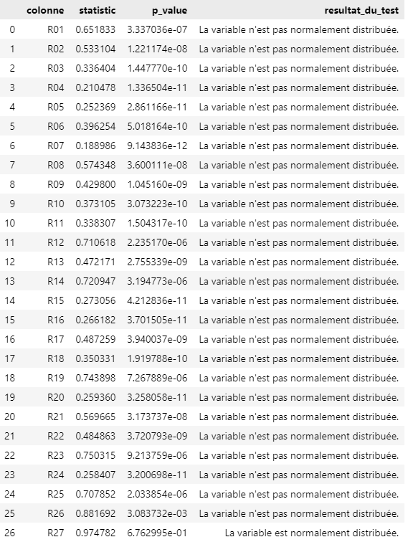
Appendix 11: Shapiro Wilk test results for 2020 and 2019
2020 | 2019
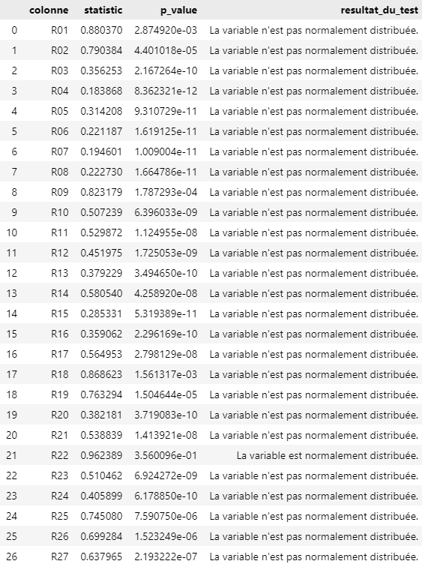 | 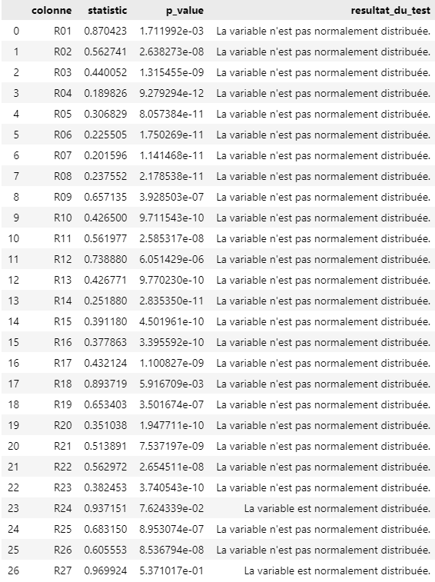

Appendix 12 : Extract from the 2021 standardized DataFrame
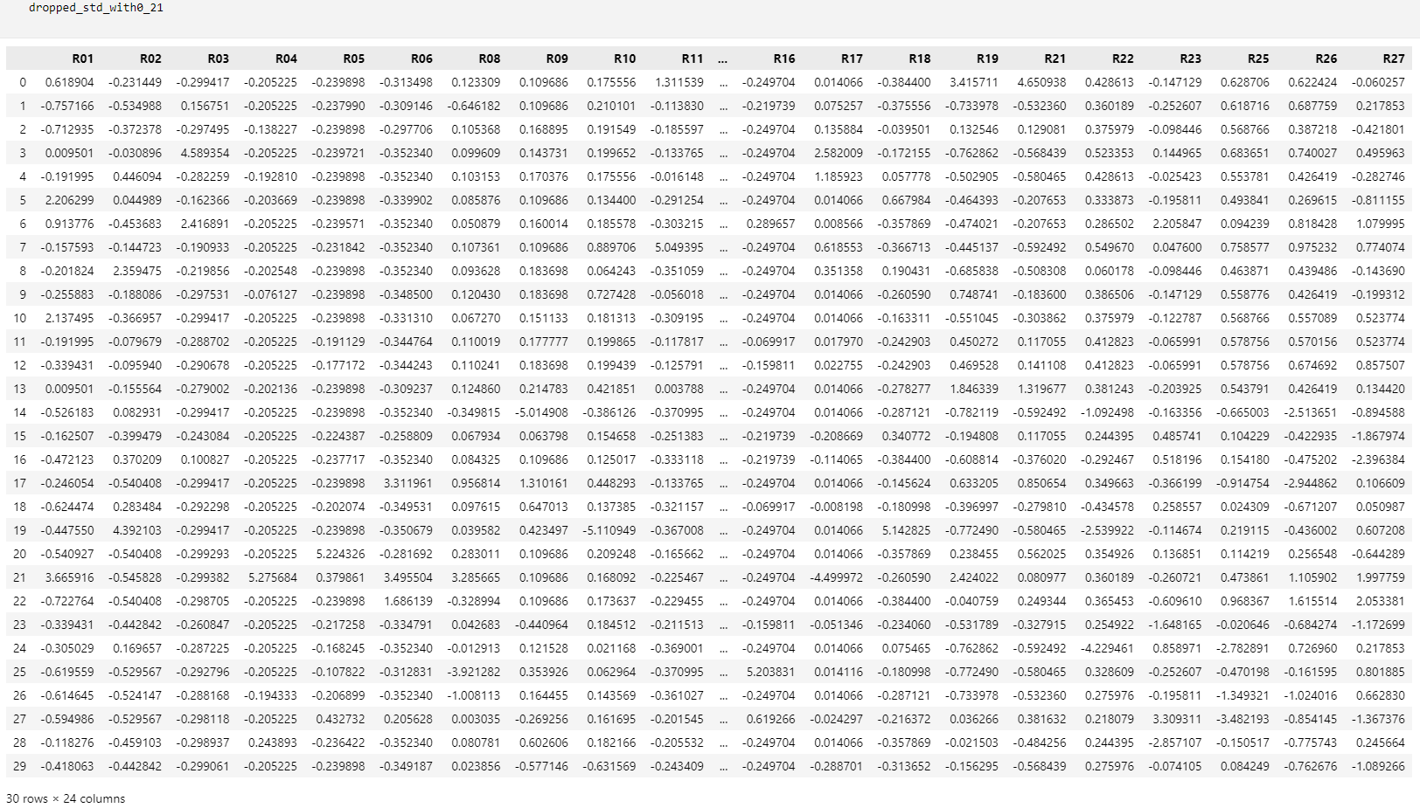

Appendix 13: Extract from the 2020 standardized DataFrame

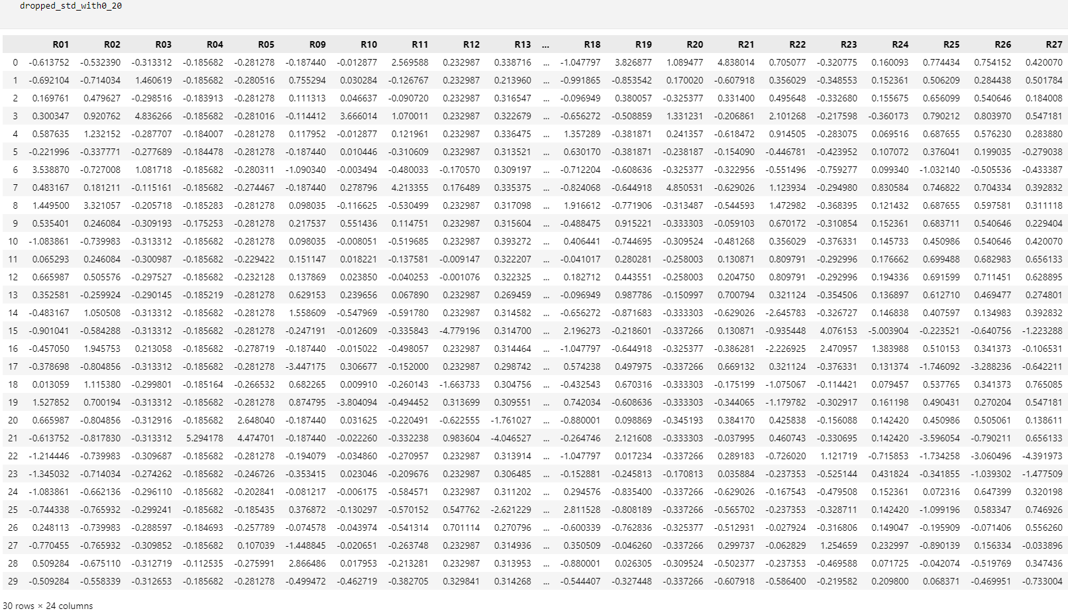

Appendix 14: Extract from the 2019 standardized DataFrame

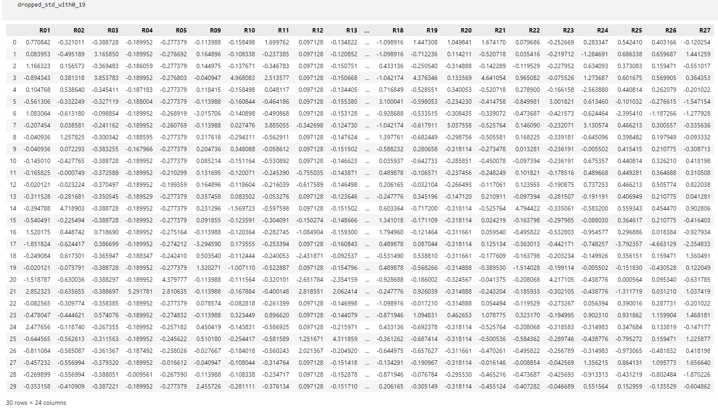

Appendix 15: Covariance matrix for 2021 standardized data
2021 | R01 | R02 | R03 | R04 | R05 | R06 | R08 | R09 | R10 | R11 | R12 | R13 | R14 | R15 | R16 | R17 | R18 | R19 | R21 | R22 | R23 | R25 | R26 | R27
R01 | 1,00 | -0,11 | 0,08 | 0,69 | -0,04 | 0,39 | 0,54 | 0,08 | 0,09 | 0,00 | 0,11 | 0,54 | -0,36 | -0,13 | -0,13 | -0,58 | -0,02 | 0,38 | 0,13 | 0,15 | -0,01 | 0,23 | 0,30 | 0,29
R02 | -0,11 | 1,00 | -0,05 | -0,11 | -0,13 | -0,19 | 0,03 | 0,03 | -0,81 | -0,07 | 0,09 | -0,08 | 0,11 | -0,11 | -0,12 | 0,13 | 0,86 | -0,24 | -0,18 | -0,50 | 0,00 | 0,10 | -0,02 | 0,00
R03 | 0,08 | -0,05 | 1,00 | -0,06 | -0,07 | -0,11 | 0,01 | 0,04 | 0,06 | -0,04 | -0,23 | 0,01 | -0,21 | -0,06 | -0,02 | 0,44 | -0,07 | -0,20 | -0,13 | 0,12 | 0,23 | 0,14 | 0,21 | 0,15
R04 | 0,69 | -0,11 | -0,06 | 1,00 | 0,07 | 0,65 | 0,62 | 0,03 | 0,04 | -0,05 | 0,35 | 0,79 | -0,40 | -0,05 | -0,05 | -0,85 | -0,06 | 0,46 | 0,01 | 0,07 | -0,09 | 0,09 | 0,20 | 0,38
R05 | -0,04 | -0,13 | -0,07 | 0,07 | 1,00 | 0,02 | 0,11 | 0,02 | 0,05 | -0,04 | -0,40 | -0,36 | -0,50 | 0,07 | -0,02 | -0,09 | -0,08 | 0,09 | 0,11 | 0,07 | 0,10 | -0,06 | 0,05 | -0,10
R06 | 0,39 | -0,19 | -0,11 | 0,65 | 0,02 | 1,00 | 0,53 | 0,18 | 0,10 | -0,07 | 0,24 | 0,51 | -0,28 | 0,01 | -0,07 | -0,60 | -0,09 | 0,40 | 0,15 | 0,13 | -0,06 | -0,05 | -0,13 | 0,39
R08 | 0,54 | 0,03 | 0,01 | 0,62 | 0,11 | 0,53 | 1,00 | 0,07 | 0,03 | 0,06 | 0,05 | 0,47 | -0,26 | 0,00 | -0,74 | -0,50 | 0,01 | 0,47 | 0,17 | 0,02 | 0,01 | 0,15 | 0,10 | 0,07
R09 | 0,08 | 0,03 | 0,04 | 0,03 | 0,02 | 0,18 | 0,07 | 1,00 | 0,05 | 0,05 | 0,07 | 0,01 | -0,05 | -0,05 | 0,07 | 0,01 | 0,10 | 0,16 | 0,13 | 0,17 | -0,04 | 0,13 | 0,34 | 0,26
R10 | 0,09 | -0,81 | 0,06 | 0,04 | 0,05 | 0,10 | 0,03 | 0,05 | 1,00 | 0,21 | -0,06 | 0,03 | 0,00 | 0,03 | 0,02 | 0,02 | -0,94 | 0,20 | 0,14 | 0,53 | 0,01 | 0,02 | 0,16 | -0,04
R11 | 0,00 | -0,07 | -0,04 | -0,05 | -0,04 | -0,07 | 0,06 | 0,05 | 0,21 | 1,00 | -0,05 | -0,02 | 0,13 | -0,06 | -0,09 | 0,13 | -0,12 | 0,15 | 0,17 | 0,17 | -0,01 | 0,21 | 0,23 | 0,14
R12 | 0,11 | 0,09 | -0,23 | 0,35 | -0,40 | 0,24 | 0,05 | 0,07 | -0,06 | -0,05 | 1,00 | 0,43 | 0,27 | -0,03 | 0,11 | -0,30 | 0,07 | 0,05 | -0,10 | -0,11 | -0,19 | -0,08 | -0,18 | 0,11
R13 | 0,54 | -0,08 | 0,01 | 0,79 | -0,36 | 0,51 | 0,47 | 0,01 | 0,03 | -0,02 | 0,43 | 1,00 | -0,10 | -0,04 | -0,10 | -0,66 | -0,05 | 0,30 | -0,06 | 0,06 | -0,05 | 0,13 | 0,23 | 0,37
R14 | -0,36 | 0,11 | -0,21 | -0,40 | -0,50 | -0,28 | -0,26 | -0,05 | 0,00 | 0,13 | 0,27 | -0,10 | 1,00 | 0,02 | -0,04 | 0,41 | 0,06 | -0,17 | -0,04 | -0,03 | -0,38 | -0,03 | -0,26 | -0,34
R15 | -0,13 | -0,11 | -0,06 | -0,05 | 0,07 | 0,01 | 0,00 | -0,05 | 0,03 | -0,06 | -0,03 | -0,04 | 0,02 | 1,00 | 0,12 | -0,01 | -0,05 | 0,00 | 0,06 | 0,06 | 0,65 | -0,64 | -0,17 | -0,31
R16 | -0,13 | -0,12 | -0,02 | -0,05 | -0,02 | -0,07 | -0,74 | 0,07 | 0,02 | -0,09 | 0,11 | -0,10 | -0,04 | 0,12 | 1,00 | 0,00 | -0,05 | -0,15 | -0,10 | 0,08 | 0,09 | -0,18 | -0,04 | 0,13
R17 | -0,58 | 0,13 | 0,44 | -0,85 | -0,09 | -0,60 | -0,50 | 0,01 | 0,02 | 0,13 | -0,30 | -0,66 | 0,41 | -0,01 | 0,00 | 1,00 | 0,02 | -0,48 | -0,10 | 0,02 | 0,04 | 0,04 | -0,04 | -0,22
R18 | -0,02 | 0,86 | -0,07 | -0,06 | -0,08 | -0,09 | 0,01 | 0,10 | -0,94 | -0,12 | 0,07 | -0,05 | 0,06 | -0,05 | -0,05 | 0,02 | 1,00 | -0,20 | -0,15 | -0,50 | 0,00 | 0,03 | -0,08 | 0,04
R19 | 0,38 | -0,24 | -0,20 | 0,46 | 0,09 | 0,40 | 0,47 | 0,16 | 0,20 | 0,15 | 0,05 | 0,30 | -0,17 | 0,00 | -0,15 | -0,48 | -0,20 | 1,00 | 0,83 | 0,28 | -0,07 | 0,20 | 0,19 | 0,19
R21 | 0,13 | -0,18 | -0,13 | 0,01 | 0,11 | 0,15 | 0,17 | 0,13 | 0,14 | 0,17 | -0,10 | -0,06 | -0,04 | 0,06 | -0,10 | -0,10 | -0,15 | 0,83 | 1,00 | 0,21 | 0,04 | 0,10 | 0,09 | 0,00
R22 | 0,15 | -0,50 | 0,12 | 0,07 | 0,07 | 0,13 | 0,02 | 0,17 | 0,53 | 0,17 | -0,11 | 0,06 | -0,03 | 0,06 | 0,08 | 0,02 | -0,50 | 0,28 | 0,21 | 1,00 | -0,14 | 0,48 | 0,11 | 0,03
R23 | -0,01 | 0,00 | 0,23 | -0,09 | 0,10 | -0,06 | 0,01 | -0,04 | 0,01 | -0,01 | -0,19 | -0,05 | -0,38 | 0,65 | 0,09 | 0,04 | 0,00 | -0,07 | 0,04 | -0,14 | 1,00 | -0,47 | 0,08 | -0,17
R25 | 0,23 | 0,10 | 0,14 | 0,09 | -0,06 | -0,05 | 0,15 | 0,13 | 0,02 | 0,21 | -0,08 | 0,13 | -0,03 | -0,64 | -0,18 | 0,04 | 0,03 | 0,20 | 0,10 | 0,48 | -0,47 | 1,00 | 0,45 | 0,24
R26 | 0,30 | -0,02 | 0,21 | 0,20 | 0,05 | -0,13 | 0,10 | 0,34 | 0,16 | 0,23 | -0,18 | 0,23 | -0,26 | -0,17 | -0,04 | -0,04 | -0,08 | 0,19 | 0,09 | 0,11 | 0,08 | 0,45 | 1,00 | 0,47
R27 | 0,29 | 0,00 | 0,15 | 0,38 | -0,10 | 0,39 | 0,07 | 0,26 | -0,04 | 0,14 | 0,11 | 0,37 | -0,34 | -0,31 | 0,13 | -0,22 | 0,04 | 0,19 | 0,00 | 0,03 | -0,17 | 0,24 | 0,47 | 1,00

Appendix 16: Covariance matrix for 2020 standardized data
2020 | R01 | R02 | R03 | R04 | R05 | R09 | R10 | R11 | R12 | R13 | R14 | R15 | R16 | R17 | R18 | R19 | R20 | R21 | R22 | R23 | R24 | R25 | R26 | R27
R01 | 1,00 | 0,33 | 0,18 | -0,11 | -0,05 | 0,06 | -0,13 | 0,04 | 0,06 | 0,12 | 0,01 | -0,13 | -0,06 | 0,20 | -0,04 | -0,11 | 0,07 | -0,14 | 0,17 | -0,32 | 0,16 | 0,20 | 0,22 | 0,28
R02 | 0,33 | 1,00 | 0,13 | -0,16 | -0,23 | 0,22 | 0,00 | 0,01 | 0,01 | 0,26 | 0,14 | -0,12 | -0,21 | 0,37 | 0,16 | -0,18 | 0,07 | -0,19 | 0,03 | 0,05 | 0,18 | 0,48 | 0,38 | 0,25
R03 | 0,18 | 0,13 | 1,00 | -0,06 | -0,09 | -0,03 | 0,65 | 0,18 | 0,06 | 0,10 | 0,18 | -0,07 | -0,05 | 0,21 | -0,23 | -0,19 | 0,26 | -0,10 | 0,34 | -0,06 | -0,02 | 0,14 | 0,15 | 0,11
R04 | -0,11 | -0,16 | -0,06 | 1,00 | 0,84 | -0,03 | 0,00 | -0,06 | 0,19 | -0,76 | -0,38 | -0,05 | -0,04 | -0,60 | -0,05 | 0,40 | -0,06 | -0,01 | 0,09 | -0,06 | 0,03 | -0,68 | -0,15 | 0,12
R05 | -0,05 | -0,23 | -0,09 | 0,84 | 1,00 | -0,07 | 0,00 | -0,08 | 0,10 | -0,84 | -0,78 | -0,01 | -0,04 | -0,53 | -0,12 | 0,35 | -0,10 | 0,03 | 0,12 | -0,06 | 0,04 | -0,56 | -0,07 | 0,13
R09 | 0,06 | 0,22 | -0,03 | -0,03 | -0,07 | 1,00 | -0,18 | -0,06 | 0,02 | 0,00 | 0,01 | -0,27 | -0,06 | 0,07 | -0,13 | -0,10 | -0,03 | -0,21 | -0,18 | -0,13 | 0,03 | 0,39 | 0,45 | 0,28
R10 | -0,13 | 0,00 | 0,65 | 0,00 | 0,00 | -0,18 | 1,00 | 0,26 | -0,02 | 0,02 | 0,07 | -0,01 | -0,03 | 0,19 | -0,19 | 0,07 | 0,26 | 0,05 | 0,51 | 0,00 | -0,06 | 0,04 | 0,06 | 0,01
R11 | 0,04 | 0,01 | 0,18 | -0,06 | -0,08 | -0,06 | 0,26 | 1,00 | 0,06 | 0,13 | 0,16 | -0,07 | -0,15 | 0,14 | -0,29 | 0,33 | 0,94 | 0,41 | 0,43 | -0,11 | 0,13 | 0,27 | 0,22 | 0,12
R12 | 0,06 | 0,01 | 0,06 | 0,19 | 0,10 | 0,02 | -0,02 | 0,06 | 1,00 | -0,16 | 0,17 | -0,06 | 0,06 | -0,05 | -0,30 | 0,03 | 0,07 | -0,04 | 0,22 | -0,70 | 0,86 | -0,11 | 0,05 | 0,19
R13 | 0,12 | 0,26 | 0,10 | -0,76 | -0,84 | 0,00 | 0,02 | 0,13 | -0,16 | 1,00 | 0,61 | 0,08 | -0,45 | 0,49 | -0,18 | -0,24 | 0,11 | 0,04 | -0,07 | 0,10 | -0,05 | 0,62 | 0,03 | -0,18
R14 | 0,01 | 0,14 | 0,18 | -0,38 | -0,78 | 0,01 | 0,07 | 0,16 | 0,17 | 0,61 | 1,00 | 0,03 | 0,05 | 0,33 | 0,14 | -0,19 | 0,19 | -0,05 | 0,08 | -0,14 | 0,07 | 0,25 | 0,03 | 0,01
R15 | -0,13 | -0,12 | -0,07 | -0,05 | -0,01 | -0,27 | -0,01 | -0,07 | -0,06 | 0,08 | 0,03 | 1,00 | 0,24 | -0,02 | 0,10 | -0,01 | -0,09 | 0,06 | -0,03 | 0,33 | -0,04 | -0,14 | 0,05 | -0,01
R16 | -0,06 | -0,21 | -0,05 | -0,04 | -0,04 | -0,06 | -0,03 | -0,15 | 0,06 | -0,45 | 0,05 | 0,24 | 1,00 | -0,04 | 0,53 | -0,16 | -0,11 | -0,09 | -0,07 | 0,00 | 0,00 | -0,29 | 0,07 | 0,11
R17 | 0,20 | 0,37 | 0,21 | -0,60 | -0,53 | 0,07 | 0,19 | 0,14 | -0,05 | 0,49 | 0,33 | -0,02 | -0,04 | 1,00 | 0,20 | -0,31 | 0,18 | -0,10 | 0,23 | -0,04 | -0,01 | 0,58 | 0,31 | 0,02
R18 | -0,04 | 0,16 | -0,23 | -0,05 | -0,12 | -0,13 | -0,19 | -0,29 | -0,30 | -0,18 | 0,14 | 0,10 | 0,53 | 0,20 | 1,00 | -0,25 | -0,23 | -0,20 | 0,09 | 0,20 | -0,42 | -0,08 | 0,08 | 0,10
R19 | -0,11 | -0,18 | -0,19 | 0,40 | 0,35 | -0,10 | 0,07 | 0,33 | 0,03 | -0,24 | -0,19 | -0,01 | -0,16 | -0,31 | -0,25 | 1,00 | 0,02 | 0,84 | 0,23 | -0,08 | 0,00 | -0,17 | -0,05 | 0,06
R20 | 0,07 | 0,07 | 0,26 | -0,06 | -0,10 | -0,03 | 0,26 | 0,94 | 0,07 | 0,11 | 0,19 | -0,09 | -0,11 | 0,18 | -0,23 | 0,02 | 1,00 | 0,09 | 0,38 | -0,10 | 0,15 | 0,25 | 0,23 | 0,13
R21 | -0,14 | -0,19 | -0,10 | -0,01 | 0,03 | -0,21 | 0,05 | 0,41 | -0,04 | 0,04 | -0,05 | 0,06 | -0,09 | -0,10 | -0,20 | 0,84 | 0,09 | 1,00 | 0,18 | 0,02 | -0,05 | 0,04 | -0,02 | -0,06
R22 | 0,17 | 0,03 | 0,34 | 0,09 | 0,12 | -0,18 | 0,51 | 0,43 | 0,22 | -0,07 | 0,08 | -0,03 | -0,07 | 0,23 | 0,09 | 0,23 | 0,38 | 0,18 | 1,00 | -0,38 | 0,08 | 0,14 | 0,24 | 0,25
R23 | -0,32 | 0,05 | -0,06 | -0,06 | -0,06 | -0,13 | 0,00 | -0,11 | -0,70 | 0,10 | -0,14 | 0,33 | 0,00 | -0,04 | 0,20 | -0,08 | -0,10 | 0,02 | -0,38 | 1,00 | -0,65 | -0,09 | -0,18 | -0,40
R24 | 0,16 | 0,18 | -0,02 | 0,03 | 0,04 | 0,03 | -0,06 | 0,13 | 0,86 | -0,05 | 0,07 | -0,04 | 0,00 | -0,01 | -0,42 | 0,00 | 0,15 | -0,05 | 0,08 | -0,65 | 1,00 | 0,11 | 0,21 | 0,33
R25 | 0,20 | 0,48 | 0,14 | -0,68 | -0,56 | 0,39 | 0,04 | 0,27 | -0,11 | 0,62 | 0,25 | -0,14 | -0,29 | 0,58 | -0,08 | -0,17 | 0,25 | 0,04 | 0,14 | -0,09 | 0,11 | 1,00 | 0,69 | 0,37
R26 | 0,22 | 0,38 | 0,15 | -0,15 | -0,07 | 0,45 | 0,06 | 0,22 | 0,05 | 0,03 | 0,03 | 0,05 | 0,07 | 0,31 | 0,08 | -0,05 | 0,23 | -0,02 | 0,24 | -0,18 | 0,21 | 0,69 | 1,00 | 0,75
R27 | 0,28 | 0,25 | 0,11 | 0,12 | 0,13 | 0,28 | 0,01 | 0,12 | 0,19 | -0,18 | 0,01 | -0,01 | 0,11 | 0,02 | 0,10 | 0,06 | 0,13 | -0,06 | 0,25 | -0,40 | 0,33 | 0,37 | 0,75 | 1,00

Appendix 17: Covariance matrix for 2019 standardized data
2019 | R01 | R02 | R03 | R04 | R05 | R09 | R10 | R11 | R12 | R13 | R14 | R15 | R16 | R17 | R18 | R19 | R20 | R21 | R22 | R23 | R24 | R25 | R26 | R27
R01 | 1,00 | -0,01 | -0,11 | 0,54 | 0,05 | 0,08 | -0,17 | -0,11 | 0,31 | 0,23 | 0,26 | -0,10 | -0,28 | -0,08 | 0,08 | -0,05 | -0,03 | -0,15 | -0,09 | -0,32 | -0,14 | 0,07 | 0,23 | 0,09
R02 | -0,01 | 1,00 | -0,02 | -0,12 | -0,18 | 0,15 | -0,18 | -0,03 | -0,13 | -0,09 | 0,14 | -0,09 | -0,15 | 0,10 | 0,25 | -0,06 | -0,01 | -0,03 | 0,87 | -0,15 | -0,13 | 0,28 | 0,18 | 0,17
R03 | -0,11 | -0,02 | 1,00 | -0,08 | -0,11 | -0,11 | 0,72 | 0,36 | -0,01 | -0,05 | 0,08 | -0,13 | -0,06 | 0,53 | -0,24 | 0,57 | 0,05 | 0,64 | 0,12 | -0,08 | 0,01 | 0,09 | 0,07 | 0,17
R04 | 0,54 | -0,12 | -0,08 | 1,00 | 0,53 | -0,02 | -0,03 | -0,08 | 0,53 | 0,39 | -0,01 | -0,07 | -0,06 | -0,07 | -0,05 | 0,17 | -0,06 | -0,05 | -0,04 | -0,06 | -0,09 | -0,25 | 0,00 | 0,18
R05 | 0,05 | -0,18 | -0,11 | 0,53 | 1,00 | -0,03 | -0,04 | -0,10 | -0,13 | -0,16 | -0,85 | -0,05 | -0,08 | -0,10 | -0,18 | 0,06 | -0,09 | -0,04 | -0,05 | 0,64 | -0,10 | -0,13 | 0,03 | 0,03
R09 | 0,08 | 0,15 | -0,11 | -0,02 | -0,03 | 1,00 | -0,10 | -0,04 | -0,03 | 0,08 | 0,03 | 0,02 | -0,15 | 0,04 | 0,09 | -0,05 | -0,02 | -0,08 | 0,02 | 0,03 | 0,15 | 0,71 | 0,65 | 0,42
R10 | -0,17 | -0,18 | 0,72 | -0,03 | -0,04 | -0,10 | 1,00 | 0,53 | -0,01 | -0,04 | 0,02 | -0,01 | -0,04 | 0,52 | -0,27 | 0,85 | 0,08 | 0,87 | -0,02 | 0,00 | 0,28 | 0,08 | 0,07 | 0,01
R11 | -0,11 | -0,03 | 0,36 | -0,08 | -0,10 | -0,04 | 0,53 | 1,00 | -0,08 | -0,09 | 0,07 | -0,09 | -0,14 | 0,29 | -0,39 | 0,53 | 0,85 | 0,56 | 0,12 | -0,07 | 0,61 | 0,23 | 0,18 | 0,02
R12 | 0,31 | -0,13 | -0,01 | 0,53 | -0,13 | -0,03 | -0,01 | -0,08 | 1,00 | 0,60 | 0,42 | -0,03 | 0,17 | 0,03 | -0,03 | 0,01 | -0,05 | -0,04 | -0,03 | -0,40 | -0,07 | -0,30 | -0,08 | 0,13
R13 | 0,23 | -0,09 | -0,05 | 0,39 | -0,16 | 0,08 | -0,04 | -0,09 | 0,60 | 1,00 | 0,42 | -0,03 | 0,73 | -0,05 | -0,01 | -0,02 | -0,04 | -0,09 | -0,09 | -0,39 | -0,07 | -0,22 | 0,02 | 0,32
R14 | 0,26 | 0,14 | 0,08 | -0,01 | -0,85 | 0,03 | 0,02 | 0,07 | 0,42 | 0,42 | 1,00 | 0,07 | 0,06 | 0,07 | 0,14 | 0,04 | 0,07 | 0,01 | 0,05 | -0,82 | 0,08 | 0,02 | -0,01 | 0,15
R15 | -0,10 | -0,09 | -0,13 | -0,07 | -0,05 | 0,02 | -0,01 | -0,09 | -0,03 | -0,03 | 0,07 | 1,00 | 0,07 | -0,09 | 0,02 | -0,03 | -0,10 | -0,03 | -0,01 | -0,05 | 0,27 | 0,21 | 0,23 | 0,28
R16 | -0,28 | -0,15 | -0,06 | -0,06 | -0,08 | -0,15 | -0,04 | -0,14 | 0,17 | 0,73 | 0,06 | 0,07 | 1,00 | -0,13 | 0,00 | -0,12 | -0,10 | -0,09 | -0,13 | -0,10 | -0,08 | -0,38 | -0,28 | 0,10
R17 | -0,08 | 0,10 | 0,53 | -0,07 | -0,10 | 0,04 | 0,52 | 0,29 | 0,03 | -0,05 | 0,07 | -0,09 | -0,13 | 1,00 | -0,09 | 0,38 | 0,09 | 0,40 | 0,16 | -0,05 | -0,29 | 0,22 | 0,19 | 0,12
R18 | 0,08 | 0,25 | -0,24 | -0,05 | -0,18 | 0,09 | -0,27 | -0,39 | -0,03 | -0,01 | 0,14 | 0,02 | 0,00 | -0,09 | 1,00 | -0,34 | -0,27 | -0,29 | -0,04 | 0,18 | -0,17 | 0,01 | -0,13 | -0,30
R19 | -0,05 | -0,06 | 0,57 | 0,17 | 0,06 | -0,05 | 0,85 | 0,53 | 0,01 | -0,02 | 0,04 | -0,03 | -0,12 | 0,38 | -0,34 | 1,00 | 0,03 | 0,95 | 0,12 | -0,06 | 0,26 | 0,11 | 0,12 | 0,13
R20 | -0,03 | -0,01 | 0,05 | -0,06 | -0,09 | -0,02 | 0,08 | 0,85 | -0,05 | -0,04 | 0,07 | -0,10 | -0,10 | 0,09 | -0,27 | 0,03 | 1,00 | 0,06 | 0,06 | -0,06 | 0,56 | 0,17 | 0,13 | -0,01
R21 | -0,15 | -0,03 | 0,64 | -0,05 | -0,04 | -0,08 | 0,87 | 0,56 | -0,04 | -0,09 | 0,01 | -0,03 | -0,09 | 0,40 | -0,29 | 0,95 | 0,06 | 1,00 | 0,15 | -0,02 | 0,29 | 0,15 | 0,13 | 0,09
R22 | -0,09 | 0,87 | 0,12 | -0,04 | -0,05 | 0,02 | -0,02 | 0,12 | -0,03 | -0,09 | 0,05 | -0,01 | -0,13 | 0,16 | -0,04 | 0,12 | 0,06 | 0,15 | 1,00 | -0,12 | -0,01 | 0,26 | 0,24 | 0,29
R23 | -0,32 | -0,15 | -0,08 | -0,06 | 0,64 | 0,03 | 0,00 | -0,07 | -0,40 | -0,39 | -0,82 | -0,05 | -0,10 | -0,05 | 0,18 | -0,06 | -0,06 | -0,02 | -0,12 | 1,00 | 0,05 | 0,04 | 0,04 | -0,21
R24 | -0,14 | -0,13 | 0,01 | -0,09 | -0,10 | 0,15 | 0,28 | 0,61 | -0,07 | -0,07 | 0,08 | 0,27 | -0,08 | -0,29 | -0,17 | 0,26 | 0,56 | 0,29 | -0,01 | 0,05 | 1,00 | 0,29 | 0,27 | 0,16
R25 | 0,07 | 0,28 | 0,09 | -0,25 | -0,13 | 0,71 | 0,08 | 0,23 | -0,30 | -0,22 | 0,02 | 0,21 | -0,38 | 0,22 | 0,01 | 0,11 | 0,17 | 0,15 | 0,26 | 0,04 | 0,29 | 1,00 | 0,89 | 0,50
R26 | 0,23 | 0,18 | 0,07 | 0,00 | 0,03 | 0,65 | 0,07 | 0,18 | -0,08 | 0,02 | -0,01 | 0,23 | -0,28 | 0,19 | -0,13 | 0,12 | 0,13 | 0,13 | 0,24 | 0,04 | 0,27 | 0,89 | 1,00 | 0,68
R27 | 0,09 | 0,17 | 0,17 | 0,18 | 0,03 | 0,42 | 0,01 | 0,02 | 0,13 | 0,32 | 0,15 | 0,28 | 0,10 | 0,12 | -0,30 | 0,13 | -0,01 | 0,09 | 0,29 | -0,21 | 0,16 | 0,50 | 0,68 | 1,00

Appendix 18 : Eigenvectors 2021

Eigenvector  2021 | Vector  1 | Vector  2 | Vector  3 | Vector  4 | Vector  5 | Vector  6 | Vector  7 | Vector  8 | Vector  9 | Vector  10 | Vector  11 | Vector  12 | Vector  13 | Vector  14 | Vector  15 | Vector  16 | Vector  17 | Vector  18 | Vector  19 | Vector  20 | Vector  21 | Vector  22 | Vector  23 | Vector  24
R01 | 0,331 | 0,065 | 0,022 | -0,082 | 0,072 | 0,111 | -0,040 | -0,051 | -0,215 | 0,182 | -0,092 | -0,241 | 0,648 | 0,024 | 0,441 | -0,119 | -0,135 | 0,127 | 0,044 | -0,012 | -0,098 | 0,059 | -0,165 | 0,072
R02 | -0,129 | 0,440 | 0,139 | -0,146 | -0,113 | -0,064 | -0,105 | -0,009 | -0,035 | 0,119 | 0,086 | -0,050 | -0,102 | -0,083 | -0,002 | -0,362 | 0,552 | 0,391 | 0,231 | 0,032 | -0,015 | -0,103 | -0,148 | -0,043
R03 | -0,032 | -0,090 | 0,144 | -0,268 | 0,299 | 0,316 | -0,230 | 0,331 | -0,270 | -0,243 | 0,153 | -0,313 | -0,058 | 0,332 | -0,166 | 0,100 | 0,049 | -0,097 | 0,068 | 0,001 | -0,045 | -0,192 | -0,145 | -0,256
R04 | 0,393 | 0,140 | -0,099 | 0,031 | 0,118 | 0,051 | 0,077 | -0,074 | -0,011 | 0,099 | 0,057 | -0,121 | -0,071 | 0,288 | -0,123 | -0,016 | 0,239 | -0,084 | -0,074 | -0,501 | 0,350 | -0,130 | 0,277 | 0,345
R05 | 0,019 | -0,124 | -0,122 | -0,380 | -0,136 | -0,097 | 0,460 | -0,041 | 0,254 | 0,145 | 0,081 | -0,250 | -0,238 | 0,390 | 0,056 | -0,145 | -0,253 | 0,302 | -0,108 | 0,011 | -0,114 | 0,006 | -0,096 | -0,082
R06 | 0,315 | 0,069 | -0,152 | 0,075 | 0,020 | -0,054 | 0,064 | 0,323 | 0,194 | -0,263 | 0,348 | 0,183 | 0,073 | -0,113 | -0,140 | -0,523 | -0,239 | -0,175 | 0,200 | 0,036 | 0,090 | -0,014 | -0,210 | 0,032
R08 | 0,307 | 0,107 | -0,052 | -0,130 | -0,291 | 0,354 | -0,107 | 0,110 | 0,190 | 0,011 | 0,017 | -0,035 | -0,014 | 0,025 | 0,015 | -0,071 | 0,197 | -0,164 | -0,217 | 0,428 | -0,277 | 0,057 | 0,471 | -0,012
R09 | 0,082 | -0,020 | 0,165 | -0,096 | 0,062 | -0,354 | -0,213 | 0,509 | 0,496 | 0,205 | -0,220 | -0,113 | 0,196 | -0,060 | -0,190 | 0,231 | 0,048 | 0,080 | -0,014 | -0,125 | -0,107 | -0,010 | -0,021 | 0,071
R10 | 0,111 | -0,470 | -0,038 | 0,155 | 0,082 | 0,136 | -0,022 | -0,039 | 0,170 | -0,042 | -0,180 | -0,091 | 0,054 | -0,113 | -0,001 | -0,279 | 0,249 | 0,190 | 0,009 | -0,177 | 0,227 | 0,254 | 0,139 | -0,532
R11 | 0,033 | -0,140 | 0,189 | 0,013 | -0,123 | -0,071 | -0,311 | -0,539 | 0,336 | -0,057 | 0,527 | -0,241 | 0,173 | 0,020 | -0,147 | 0,133 | -0,008 | -0,034 | 0,092 | 0,014 | -0,016 | -0,006 | -0,063 | 0,010
R12 | 0,101 | 0,196 | -0,053 | 0,434 | 0,111 | -0,094 | -0,146 | 0,050 | 0,071 | 0,046 | -0,055 | -0,585 | -0,456 | -0,134 | 0,298 | -0,025 | -0,152 | -0,098 | 0,038 | 0,097 | -0,005 | 0,019 | -0,041 | -0,037
R13 | 0,327 | 0,156 | -0,026 | 0,177 | 0,191 | 0,139 | -0,189 | -0,081 | -0,109 | 0,070 | -0,028 | 0,198 | -0,145 | 0,130 | -0,366 | 0,158 | -0,251 | 0,530 | 0,100 | 0,127 | -0,103 | 0,323 | -0,010 | 0,012
R14 | -0,188 | 0,018 | 0,115 | 0,463 | -0,195 | 0,031 | -0,251 | 0,041 | 0,043 | 0,084 | -0,062 | 0,141 | 0,122 | 0,437 | -0,014 | -0,296 | -0,147 | 0,104 | -0,361 | -0,075 | -0,078 | -0,352 | -0,027 | -0,086
R15 | -0,062 | -0,068 | -0,460 | -0,078 | 0,000 | -0,072 | -0,363 | 0,036 | 0,017 | 0,293 | 0,152 | 0,257 | -0,134 | 0,257 | 0,277 | 0,025 | 0,094 | -0,204 | 0,251 | -0,239 | -0,268 | 0,208 | -0,038 | -0,114
R16 | -0,089 | -0,067 | -0,086 | 0,108 | 0,427 | -0,499 | 0,129 | -0,059 | -0,240 | 0,096 | 0,137 | -0,130 | 0,173 | 0,134 | -0,224 | -0,228 | 0,166 | -0,106 | -0,121 | 0,273 | -0,224 | 0,119 | 0,269 | -0,005
R17 | -0,349 | -0,152 | 0,211 | -0,069 | -0,004 | 0,095 | -0,198 | 0,182 | 0,011 | -0,161 | 0,076 | -0,083 | -0,045 | 0,121 | 0,167 | -0,236 | -0,067 | 0,115 | -0,045 | -0,016 | 0,150 | 0,516 | 0,147 | 0,505
R18 | -0,104 | 0,469 | 0,087 | -0,164 | -0,094 | -0,155 | -0,062 | 0,069 | -0,053 | 0,123 | 0,163 | 0,018 | 0,121 | 0,059 | 0,026 | 0,079 | -0,254 | -0,111 | -0,154 | -0,020 | 0,447 | 0,265 | 0,213 | -0,455
R19 | 0,303 | -0,108 | -0,010 | -0,019 | -0,349 | -0,286 | -0,107 | 0,014 | -0,246 | -0,139 | -0,077 | -0,020 | -0,103 | 0,116 | -0,064 | 0,066 | 0,262 | -0,121 | -0,380 | 0,092 | 0,104 | 0,283 | -0,485 | 0,018
R21 | 0,132 | -0,171 | -0,005 | -0,076 | -0,432 | -0,368 | -0,171 | 0,059 | -0,336 | -0,257 | -0,090 | -0,101 | -0,029 | 0,001 | -0,002 | -0,019 | -0,187 | 0,173 | 0,349 | -0,092 | -0,041 | -0,190 | 0,402 | -0,026
R22 | 0,127 | -0,359 | 0,135 | 0,074 | 0,006 | -0,017 | 0,005 | 0,251 | -0,155 | 0,456 | 0,409 | 0,151 | -0,122 | -0,094 | 0,203 | 0,127 | 0,050 | 0,168 | -0,022 | 0,286 | 0,317 | -0,215 | 0,037 | 0,054
R23 | -0,051 | -0,050 | -0,357 | -0,346 | 0,139 | 0,004 | -0,379 | -0,098 | -0,083 | 0,057 | 0,009 | -0,069 | -0,082 | -0,426 | -0,112 | -0,188 | -0,185 | 0,152 | -0,458 | -0,104 | 0,029 | -0,196 | 0,007 | 0,077
R25 | 0,122 | -0,041 | 0,518 | -0,029 | -0,071 | 0,061 | 0,104 | 0,006 | -0,207 | 0,279 | 0,126 | 0,033 | -0,191 | -0,239 | -0,108 | -0,178 | -0,126 | -0,191 | -0,097 | -0,407 | -0,403 | 0,150 | 0,023 | -0,083
R26 | 0,146 | -0,078 | 0,299 | -0,276 | 0,187 | -0,094 | -0,225 | -0,281 | 0,091 | 0,171 | -0,419 | 0,168 | -0,183 | 0,165 | 0,011 | -0,267 | -0,131 | -0,275 | 0,194 | 0,263 | 0,214 | -0,107 | -0,039 | 0,034
R27 | 0,208 | 0,075 | 0,229 | -0,082 | 0,321 | -0,221 | -0,030 | -0,050 | 0,137 | -0,439 | 0,126 | 0,302 | -0,130 | 0,030 | 0,484 | 0,096 | 0,078 | 0,184 | -0,242 | -0,090 | -0,147 | -0,082 | 0,110 | -0,097

Appendix 19: Eigenvectors 2020

Eigenvector  2020 | Vector  1 | Vector  2 | Vector  3 | Vector  4 | Vector  5 | Vector  6 | Vector  7 | Vector  8 | Vector  9 | Vector  10 | Vector  11 | Vector  12 | Vector  13 | Vector  14 | Vector  15 | Vector  16 | Vector  17 | Vector  18 | Vector  19 | Vector  20 | Vector  21 | Vector  22 | Vector  23 | Vector  24
R01 | 0,143 | 0,111 | -0,177 | 0,036 | -0,024 | 0,112 | 0,409 | 0,211 | 0,385 | 0,410 | 0,443 | -0,145 | 0,205 | 0,108 | 0,131 | -0,230 | 0,037 | -0,160 | -0,126 | -0,039 | -0,052 | -0,038 | -0,033 | -0,047
R02 | 0,231 | 0,008 | -0,179 | 0,130 | -0,135 | 0,141 | 0,217 | -0,019 | 0,274 | -0,551 | -0,070 | -0,445 | -0,010 | 0,251 | -0,049 | 0,244 | -0,104 | 0,046 | 0,284 | 0,036 | -0,064 | 0,073 | 0,025 | 0,019
R03 | 0,152 | 0,126 | 0,122 | 0,155 | 0,314 | 0,386 | 0,032 | -0,212 | -0,165 | 0,082 | 0,304 | -0,245 | -0,029 | -0,341 | -0,442 | 0,228 | -0,022 | 0,157 | -0,173 | -0,073 | 0,122 | 0,038 | 0,003 | 0,029
R04 | -0,340 | 0,227 | -0,054 | 0,105 | -0,007 | 0,130 | -0,019 | 0,057 | 0,045 | -0,388 | 0,192 | 0,089 | 0,154 | -0,217 | 0,116 | -0,159 | -0,153 | 0,086 | 0,004 | 0,058 | 0,086 | -0,656 | -0,129 | 0,054
R05 | -0,353 | 0,238 | -0,066 | 0,176 | -0,076 | 0,167 | 0,036 | -0,050 | 0,145 | 0,028 | -0,151 | 0,086 | 0,077 | -0,144 | -0,032 | 0,030 | -0,100 | -0,069 | -0,154 | 0,136 | -0,472 | 0,253 | 0,420 | 0,380
R06 | 0,111 | 0,041 | -0,265 | 0,071 | -0,328 | 0,129 | -0,322 | 0,033 | -0,396 | -0,007 | 0,110 | -0,021 | 0,586 | 0,227 | -0,038 | 0,172 | 0,159 | -0,109 | -0,170 | 0,138 | 0,043 | 0,016 | 0,001 | 0,007
R08 | 0,082 | 0,143 | 0,271 | 0,196 | 0,322 | 0,267 | 0,050 | -0,260 | -0,278 | -0,048 | -0,100 | -0,095 | -0,073 | 0,335 | 0,487 | -0,100 | -0,090 | -0,353 | -0,122 | -0,017 | -0,048 | -0,041 | -0,014 | -0,016
R09 | 0,157 | 0,272 | 0,350 | 0,076 | -0,054 | -0,118 | -0,313 | 0,236 | 0,219 | 0,012 | 0,001 | -0,071 | 0,038 | 0,010 | 0,024 | 0,076 | 0,003 | -0,046 | -0,023 | -0,138 | 0,006 | 0,114 | -0,482 | 0,524
R10 | 0,014 | 0,318 | -0,192 | -0,378 | 0,222 | -0,103 | -0,013 | -0,098 | -0,017 | -0,157 | -0,139 | -0,079 | 0,164 | -0,079 | -0,255 | -0,205 | 0,221 | -0,438 | 0,157 | -0,417 | 0,031 | -0,023 | 0,123 | 0,055
R11 | 0,347 | -0,196 | 0,164 | -0,242 | -0,094 | 0,017 | 0,101 | -0,103 | 0,056 | -0,044 | 0,124 | 0,202 | -0,028 | 0,061 | 0,027 | 0,050 | -0,028 | -0,072 | -0,041 | 0,127 | 0,314 | -0,246 | 0,455 | 0,516
R12 | 0,268 | -0,081 | 0,059 | -0,196 | 0,232 | -0,203 | -0,062 | 0,116 | -0,179 | -0,392 | 0,452 | 0,101 | 0,076 | -0,128 | 0,105 | -0,217 | -0,076 | 0,096 | -0,040 | 0,127 | -0,442 | 0,239 | 0,022 | -0,026
R13 | -0,045 | -0,110 | 0,066 | 0,082 | 0,143 | -0,305 | -0,063 | -0,621 | 0,393 | 0,008 | 0,123 | 0,213 | 0,364 | 0,086 | -0,013 | 0,258 | -0,116 | -0,029 | -0,039 | -0,077 | -0,073 | -0,023 | -0,103 | -0,109
R14 | -0,086 | -0,067 | -0,176 | 0,191 | 0,355 | -0,403 | -0,200 | 0,044 | -0,133 | 0,255 | 0,047 | -0,442 | 0,033 | 0,169 | 0,045 | -0,028 | -0,005 | 0,237 | 0,190 | 0,014 | -0,079 | -0,249 | 0,236 | 0,249
R15 | 0,333 | -0,082 | 0,008 | 0,097 | 0,103 | -0,021 | 0,178 | 0,049 | 0,006 | 0,058 | -0,436 | -0,074 | 0,404 | -0,568 | 0,338 | 0,036 | 0,095 | 0,087 | 0,071 | 0,063 | 0,004 | -0,033 | -0,010 | -0,014
R16 | -0,018 | -0,224 | -0,170 | 0,355 | 0,200 | -0,312 | 0,172 | 0,308 | -0,014 | -0,243 | -0,094 | 0,068 | -0,056 | -0,012 | -0,154 | 0,115 | -0,073 | -0,296 | -0,536 | -0,094 | 0,170 | 0,013 | -0,002 | 0,034
R17 | -0,158 | 0,234 | 0,279 | 0,010 | -0,295 | -0,261 | 0,256 | -0,040 | -0,174 | -0,116 | 0,111 | -0,149 | 0,127 | 0,017 | 0,209 | 0,010 | 0,010 | 0,339 | -0,175 | -0,447 | 0,200 | 0,184 | 0,242 | -0,062
R18 | 0,179 | 0,238 | 0,255 | 0,095 | 0,058 | 0,005 | -0,447 | 0,287 | 0,318 | -0,010 | -0,007 | -0,001 | -0,004 | -0,011 | 0,007 | 0,097 | -0,045 | -0,080 | -0,036 | 0,033 | 0,056 | -0,089 | 0,458 | -0,457
R19 | -0,044 | 0,134 | 0,366 | -0,028 | -0,263 | -0,363 | 0,239 | -0,075 | -0,171 | 0,068 | 0,030 | -0,282 | -0,015 | -0,129 | -0,231 | 0,062 | -0,018 | -0,369 | 0,051 | 0,440 | -0,131 | -0,168 | -0,049 | -0,113
R21 | 0,101 | 0,297 | 0,162 | 0,220 | 0,242 | -0,045 | 0,302 | 0,111 | -0,047 | -0,042 | -0,157 | 0,386 | 0,176 | 0,342 | -0,305 | -0,120 | 0,282 | 0,290 | 0,148 | 0,207 | 0,022 | -0,013 | -0,004 | -0,010
R22 | -0,079 | -0,346 | 0,208 | 0,249 | -0,124 | 0,085 | -0,166 | -0,190 | 0,197 | -0,171 | 0,014 | -0,216 | 0,012 | -0,040 | -0,087 | -0,483 | 0,551 | 0,001 | -0,127 | 0,029 | 0,009 | 0,025 | 0,046 | 0,023
R23 | 0,079 | 0,319 | -0,221 | -0,360 | 0,079 | -0,102 | -0,061 | -0,197 | 0,160 | -0,046 | -0,191 | -0,196 | -0,135 | 0,067 | 0,084 | -0,072 | 0,084 | 0,262 | -0,537 | 0,363 | 0,107 | 0,002 | -0,094 | -0,022
R25 | 0,395 | 0,015 | -0,038 | 0,094 | -0,273 | -0,015 | 0,000 | -0,106 | -0,078 | 0,086 | -0,175 | 0,074 | -0,165 | 0,062 | -0,169 | -0,080 | -0,060 | 0,133 | -0,223 | -0,358 | -0,501 | -0,425 | -0,020 | -0,039
R26 | 0,235 | 0,187 | -0,210 | 0,340 | -0,177 | -0,139 | -0,118 | -0,228 | -0,047 | 0,038 | -0,008 | 0,070 | -0,055 | -0,109 | -0,097 | -0,492 | -0,442 | -0,035 | 0,141 | 0,087 | 0,292 | 0,222 | 0,018 | 0,009
R27 | 0,116 | 0,271 | -0,275 | 0,272 | -0,089 | -0,168 | -0,011 | -0,144 | -0,035 | -0,030 | 0,253 | 0,191 | -0,384 | -0,187 | 0,267 | 0,274 | 0,496 | -0,100 | 0,134 | 0,025 | 0,003 | -0,004 | 0,022 | 0,023

Appendix 20: Eigenvectors 2019

Eigenvector  2019 | Vector  1 | Vector  2 | Vector  3 | Vector  4 | Vector  5 | Vector  6 | Vector  7 | Vector  8 | Vector  9 | Vector  10 | Vector  11 | Vector  12 | Vector  13 | Vector  14 | Vector  15 | Vector  16 | Vector  17 | Vector  18 | Vector  19 | Vector  20 | Vector  21 | Vector  22 | Vector  23 | Vector  24
R01 | -0,059 | 0,240 | -0,037 | -0,265 | -0,056 | 0,387 | 0,292 | -0,065 | -0,022 | 0,037 | 0,538 | 0,015 | 0,288 | -0,205 | -0,165 | -0,227 | 0,300 | -0,144 | -0,129 | 0,013 | 0,039 | -0,015 | -0,009 | 0,002
R02 | 0,036 | 0,180 | 0,213 | 0,247 | -0,320 | 0,211 | -0,383 | -0,097 | 0,178 | 0,031 | 0,058 | -0,057 | -0,076 | -0,128 | -0,100 | -0,074 | 0,186 | 0,520 | 0,108 | 0,370 | 0,084 | 0,143 | -0,016 | 0,018
R03 | 0,310 | -0,062 | -0,167 | 0,033 | -0,231 | -0,088 | 0,061 | 0,111 | -0,095 | -0,044 | 0,105 | 0,717 | -0,158 | -0,377 | 0,166 | 0,127 | 0,053 | -0,043 | 0,175 | 0,031 | 0,092 | -0,004 | 0,020 | 0,052
R04 | -0,055 | 0,100 | -0,156 | -0,501 | -0,084 | 0,282 | -0,058 | -0,140 | 0,136 | -0,119 | -0,047 | -0,016 | -0,401 | 0,068 | 0,005 | 0,298 | -0,153 | -0,112 | 0,067 | 0,121 | -0,042 | 0,280 | -0,278 | -0,317
R05 | -0,055 | -0,288 | 0,114 | -0,484 | -0,080 | 0,082 | -0,203 | -0,021 | -0,001 | -0,062 | 0,052 | -0,054 | -0,146 | -0,117 | 0,006 | -0,141 | -0,180 | 0,048 | 0,033 | -0,001 | -0,119 | 0,022 | 0,547 | 0,445
R06 | 0,073 | 0,227 | 0,313 | -0,143 | 0,015 | -0,147 | 0,173 | 0,287 | 0,226 | 0,234 | -0,316 | -0,190 | -0,314 | -0,450 | -0,045 | -0,093 | 0,256 | -0,068 | -0,045 | -0,246 | -0,016 | 0,050 | -0,031 | -0,016
R08 | 0,369 | -0,137 | -0,208 | -0,027 | -0,099 | -0,123 | 0,120 | -0,058 | 0,148 | -0,017 | 0,007 | -0,011 | 0,060 | -0,141 | -0,484 | 0,030 | -0,303 | 0,306 | -0,510 | -0,084 | -0,130 | 0,040 | -0,042 | -0,070
R09 | 0,356 | -0,055 | -0,061 | 0,058 | 0,305 | 0,237 | -0,128 | 0,139 | 0,066 | -0,130 | 0,072 | -0,123 | -0,038 | -0,030 | 0,234 | -0,027 | 0,074 | 0,058 | -0,077 | -0,069 | 0,196 | -0,039 | 0,482 | -0,537
R10 | -0,054 | 0,271 | -0,298 | -0,203 | -0,014 | 0,097 | -0,019 | -0,011 | 0,103 | -0,195 | -0,621 | 0,137 | 0,421 | -0,087 | 0,176 | -0,211 | 0,004 | 0,055 | -0,127 | 0,155 | 0,133 | 0,019 | 0,046 | 0,086
R11 | -0,068 | 0,320 | -0,280 | -0,190 | 0,055 | -0,204 | -0,213 | 0,221 | 0,225 | -0,003 | 0,182 | -0,065 | 0,106 | -0,025 | -0,038 | 0,300 | 0,048 | 0,201 | 0,226 | -0,050 | -0,290 | -0,515 | 0,048 | -0,011
R12 | 0,039 | 0,411 | -0,217 | 0,256 | 0,052 | 0,052 | 0,188 | -0,090 | 0,029 | 0,014 | -0,023 | 0,023 | -0,204 | 0,237 | -0,064 | 0,327 | 0,181 | -0,067 | -0,140 | -0,032 | -0,129 | 0,325 | 0,420 | 0,317
R13 | 0,018 | 0,090 | 0,106 | -0,031 | 0,158 | -0,343 | 0,036 | -0,584 | -0,157 | -0,531 | 0,057 | -0,152 | -0,054 | -0,313 | 0,110 | 0,068 | 0,179 | 0,084 | -0,008 | -0,048 | -0,031 | -0,031 | -0,028 | -0,009
R14 | -0,115 | 0,062 | -0,243 | 0,001 | 0,097 | -0,459 | -0,372 | 0,207 | 0,152 | 0,002 | 0,301 | -0,107 | 0,059 | -0,138 | 0,013 | -0,128 | -0,050 | -0,266 | -0,128 | 0,152 | 0,239 | 0,432 | -0,034 | 0,028
R15 | 0,244 | 0,000 | -0,061 | 0,046 | -0,319 | -0,018 | 0,105 | 0,363 | -0,145 | -0,551 | -0,067 | -0,267 | -0,049 | 0,145 | -0,329 | -0,131 | 0,092 | -0,206 | 0,282 | 0,092 | 0,022 | -0,021 | 0,005 | 0,031
R16 | -0,194 | 0,045 | 0,095 | 0,180 | -0,153 | -0,007 | 0,216 | -0,049 | 0,674 | -0,317 | 0,159 | 0,152 | -0,150 | 0,144 | 0,181 | -0,250 | -0,229 | -0,030 | -0,034 | -0,179 | 0,064 | -0,116 | 0,027 | 0,012
R17 | 0,369 | -0,084 | -0,179 | -0,120 | -0,134 | -0,024 | 0,035 | -0,205 | 0,154 | 0,206 | 0,030 | -0,288 | -0,105 | 0,151 | 0,179 | 0,115 | 0,130 | -0,061 | -0,052 | 0,035 | 0,535 | -0,289 | -0,146 | 0,323
R18 | 0,185 | 0,004 | 0,020 | 0,078 | 0,444 | 0,336 | -0,189 | 0,274 | -0,012 | -0,274 | 0,084 | 0,024 | -0,110 | -0,041 | 0,156 | -0,030 | 0,002 | 0,098 | -0,175 | -0,101 | -0,147 | 0,029 | -0,413 | 0,417
R19 | 0,387 | -0,112 | -0,156 | -0,017 | -0,126 | -0,074 | 0,030 | -0,162 | 0,171 | 0,171 | 0,033 | -0,143 | 0,164 | 0,097 | 0,330 | -0,271 | 0,135 | -0,033 | 0,235 | -0,052 | -0,555 | 0,268 | -0,089 | -0,026
R21 | 0,124 | 0,141 | 0,161 | 0,152 | -0,291 | 0,190 | -0,513 | -0,192 | 0,022 | -0,015 | -0,075 | 0,021 | 0,174 | -0,100 | -0,076 | 0,142 | -0,083 | -0,487 | -0,144 | -0,368 | -0,086 | -0,115 | 0,008 | -0,012
R22 | -0,042 | -0,389 | 0,236 | -0,172 | -0,018 | -0,100 | -0,055 | 0,106 | 0,294 | -0,161 | -0,052 | 0,192 | 0,228 | 0,220 | -0,060 | 0,327 | 0,559 | -0,023 | -0,216 | 0,056 | -0,043 | 0,090 | -0,009 | -0,026
R23 | 0,215 | 0,012 | 0,074 | -0,005 | 0,493 | 0,010 | -0,066 | -0,260 | 0,288 | 0,084 | -0,100 | 0,222 | 0,008 | 0,033 | -0,483 | -0,143 | -0,013 | -0,214 | 0,378 | 0,177 | 0,053 | -0,045 | 0,025 | 0,054
R25 | 0,230 | 0,187 | 0,405 | -0,018 | 0,010 | -0,082 | 0,160 | 0,091 | 0,032 | 0,002 | 0,061 | -0,051 | 0,111 | -0,032 | 0,213 | 0,178 | -0,292 | -0,237 | -0,202 | 0,613 | -0,178 | -0,132 | 0,047 | 0,014
R26 | 0,212 | 0,240 | 0,342 | -0,212 | 0,012 | -0,089 | 0,076 | 0,078 | -0,025 | -0,036 | 0,104 | 0,039 | 0,360 | 0,160 | 0,033 | 0,200 | -0,253 | 0,251 | 0,273 | -0,347 | 0,265 | 0,329 | -0,019 | 0,059
R27 | 0,153 | 0,312 | 0,144 | -0,248 | -0,031 | -0,241 | -0,202 | -0,025 | -0,229 | 0,026 | 0,039 | 0,284 | -0,255 | 0,464 | -0,015 | -0,398 | 0,138 | 0,063 | -0,264 | -0,037 | -0,030 | -0,134 | -0,023 | -0,098

Appendix 21: Eigenvalues for the years 2019, 2020 and 2021.
2021 | 2020 | 2019
  PC | Initial eigenvalues |  |  | Sums extracted from squared loadings
  PC | Total | % of variance | Cumulative  % | Total | % of variance
  1 | 5.078 | 21.1617 | 21.1617 | 21.1617 | 21.1617
  2 | 3.310 | 13.7957 | 34.9574 | 13.7957 | 34.9574
  3 | 2.615 | 10.8998 | 45.8572 | 10.8998 | 45.8572
  4 | 2.209 | 9.2082 | 55.0654 | 9.2082 | 55.0654
  5 | 1.905 | 7.9375 | 63.0029 | 7.9375 | 63.0029
  6 | 1.532 | 6.3841 | 69.3870 | 6.3841 | 69.3870
  7 | 1.445 | 6.0212 | 75.4082 | 6.0212 | 75.4082
  8 | 0.993 | 4.1365 | 79.5447 | 4.139 | 79.547
  9 | 0.926 | 3.8638 | 83.4085 | 3.861 | 83.409
  10 | 0.826 | 3.4446 | 86.8531 | 3.445 | 86.853
  11 | 0.745 | 3.1057 | 89.9588 | 3.106 | 89.959
  12 | 0.516 | 2.1536 | 92.1124 | 2.154 | 92.112
  13 | 0.475 | 1.9816 | 94.0940 | 1.982 | 94.094
  14 | 0.401 | 1.6738 | 95.7678 | 1.674 | 95.768
  15 | 0.321 | 1.339 | 97.1068 | 1.339 | 97.107
  16 | 0.221 | 0.9221 | 98.0289 | 0.922 | 98.029
  17 | 0.165 | 0.6906 | 98.7195 | 0.691 | 98.72
  18 | 0.118 | 0.4925 | 99.2120 | 0.492 | 99.212
  19 | 0.080 | 0.3363 | 99.5483 | 0.336 | 99.548
  20 | 0.002 | 0.0101 | 99.5584 | 0.01 | 99.558
  21 | 0.039 | 0.1626 | 99.7210 | 0.163 | 99.721
  22 | 0.032 | 0.1360 | 99.8570 | 0.136 | 99.857
  23 | 0.014 | 0.0625 | 99.9195 | 0.062 | 99.92
  24 | 0.019 | 0.0805 | 100 | 0.08 | 100
  PC | Initial eigenvalues |  |  | Sums extracted from squared loadings
  PC | Total | % of variance | Cumulative  % | Total | % de la variance
  1 | 4.759 | 19.831 | 19.831 | 19.831 | 0.198
  2 | 3.607 | 15.169 | 35.00 | 15.169 | 0.350
  3 | 2.758 | 11.495 | 46.495 | 11.495 | 46.495
  4 | 2.106 | 8.775 | 55.27 | 8.775 | 55.270
  5 | 1.958 | 8.1598 | 63.4298 | 8.1598 | 63.429
  6 | 1.684 | 7.0202 | 70.45 | 7.0202 | 70.450
  7 | 1.174 | 4.8957 | 75.3457 | 4.8957 | 75.345
  8 | 1.129 | 4.7074 | 80.0531 | 4.7074 | 80.053
  9 | 1.041 | 4.3404 | 84.3935 | 4.3404 | 84.393
  10 | 0.826 | 3.4423 | 87.8358 | 3.4420 | 87.8360
  11 | 0.776 | 3.2342 | 91.07 | 3.2340 | 91.0700
  12 | 0.656 | 2.7351 | 93.8051 | 2.7350 | 93.8050
  13 | 0.500 | 2.0843 | 95.8894 | 2.0840 | 95.8890
  14 | 0.306 | 1.2752 | 97.1646 | 1.2750 | 97.1650
  15 | 0.264 | 1.102 | 98.2666 | 1.1020 | 98.2670
  16 | 0.159 | 0.6637 | 98.9303 | 0.6640 | 98.9300
  17 | 0.106 | 0.4439 | 99.3742 | 0.4440 | 99.3740
  18 | 0.073 | 0.307 | 99.6812 | 0.3070 | 99.6810
  19 | 0.029 | 0.1223 | 99.8035 | 0.1220 | 99.8040
  20 | 0.026 | 0.1101 | 99.9136 | 0.1100 | 99.9140
  21 | 0.016 | 0.0695 | 99.9831 | 0.0690 | 99.9830
  22 | 0.0019 | 0.0081 | 99.9912 | 0.0080 | 99.9910
  23 | 0.0007 | 0.0031 | 99.9943 | 0.0030 | 99.9940
  24 | 0.0013 | 0.0057 | 100 | 0.0060 | 100
  PC | Initial eigenvalues |  |  | Sums extracted from squared loadings
  PC | Total | % of variance | Cumulative  % | Total | % of variance
  1 | 4.667 | 19.4498 | 19.4498 | 19.4498 | 19.4498
  2 | 3.336 | 13.90 | 33.3498 | 13.90 | 33.3498
  3 | 3.262 | 13.5953 | 46.9451 | 13.5953 | 46.9451
  4 | 2.375 | 9.8975 | 56.8426 | 9.8975 | 56.8426
  5 | 2.130 | 8.8787 | 65.7213 | 8.8787 | 65.7213
  6 | 1.707 | 7.1157 | 72.8370 | 7.1157 | 72.8370
  7 | 1.510 | 6.2931 | 79.1301 | 6.2931 | 79.1301
  8 | 1.145 | 4.7745 | 83.9046 | 4.7745 | 83.9046
  9 | 1.003 | 4.1797 | 88.0843 | 4.1797 | 88.0843
  10 | 0.772 | 3.2178 | 91.3021 | 3.2180 | 91.3020
  11 | 0.563 | 2.349 | 93.6511 | 2.3490 | 93.6510
  12 | 0.451 | 1.8828 | 95.5339 | 1.8830 | 95.5340
  13 | 0.325 | 1.356 | 96.8899 | 1.3560 | 96.8900
  14 | 0.252 | 1.0504 | 97.9403 | 1.0500 | 97.9400
  15 | 0.151 | 0.6312 | 98.5717 | 0.6310 | 98.5720
  16 | 0.121 | 0.5067 | 99.0784 | 0.5070 | 99.0780
  17 | 0.096 | 0.3396 | 99.4780 | 0.4000 | 99.4780
  18 | 0.065 | 0.272 | 99.7500 | 0.2720 | 99.7500
  19 | 0.031 | 0.1285 | 99.8785 | 0.1280 | 99.8790
  20 | 0.019 | 0.0807 | 99.9592 | 0.0810 | 99.9590
  21 | 0.005 | 0.0217 | 99.9809 | 0.0220 | 99.9810
  22 | 0.004 | 0.0161 | 99.9970 | 0.0160 | 99.9970
  23 | 0.0002 | 0.0009 | 99.9979 | 0.0010 | 99.9980
  24 | 0.0004 | 0.0021 | 100 | 0.0020 | 100

Appendix 22 : Assigning line names to the DataFrame for 2021, 2020 and 2019
2021 | 2020 | 2019
Ratios = ['R04', 'R10', 'R25', 'R14', 'R21', 'R16', 'R05'] | Ratios = ['R03', 'R09', 'R11', 'R12', 'R15', 'R16', 'R20', 'R23', 'R25'] | Ratios = ['R04', 'R14', 'R15', 'R16', 'R18', 'R21', 'R22', 'R24', 'R25']
  PC | ratios | % of variance | Cumulative  %
  1 | R04 | 21,162 | 21,162
  2 | R10 | 13,796 | 34,957
  3 | R25 | 10,9 | 45,857
  4 | R14 | 9,208 | 55,065
  5 | R21 | 7,938 | 63,003
  6 | R16 | 6,384 | 69,387
  7 | R05 | 6,021 | 75,408
  PC | ratios | % of variance | Cumulative  %
  1 | R25 | 19,831 | 19,831
  2 | R23 | 15,17 | 35,001
  3 | R11 | 11,494 | 46,495
  4 | R12 | 8,776 | 55,27
  5 | R16 | 8,159 | 63,43
  6 | R03 | 7,02 | 70,45
  7 | R20 | 4,896 | 75,346
  8 | R15 | 4,707 | 80,053
  9 | R09 | 4,34 | 84,394
  PC | ratios | % of variance | Cumulative  %
  1 | R21 | 19,45 | 19,45
  2 | R14 | 13,9 | 33,35
  3 | R25 | 13,595 | 46,945
  4 | R04 | 9,898 | 56,843
  5 | R24 | 8,879 | 65,721
  6 | R16 | 7,116 | 72,837
  7 | R22 | 6,293 | 79,13
  8 | R15 | 4,775 | 83,905
  9 | R18 | 4,18 | 88,084

Appendix 23: Extract of Python code for training the RL-Stepwise model for fiscal year 2021
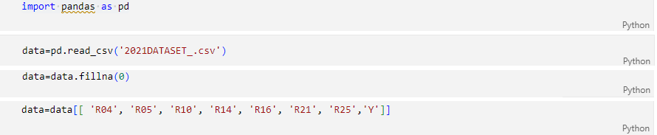
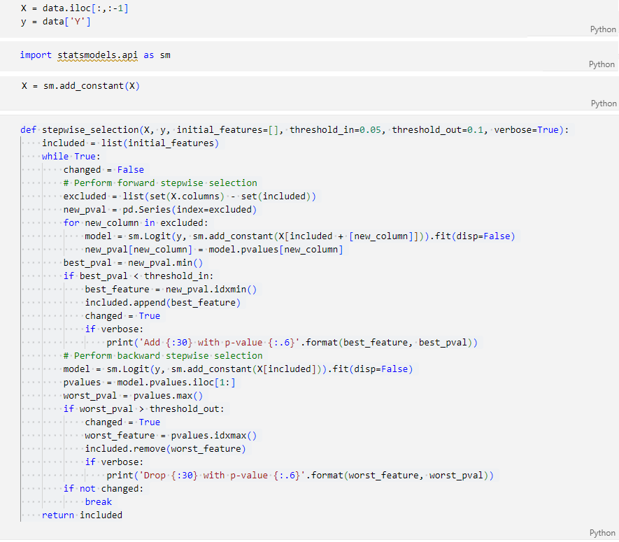
Appendix 24 : Bidirectional Stepwise RL results for 2021
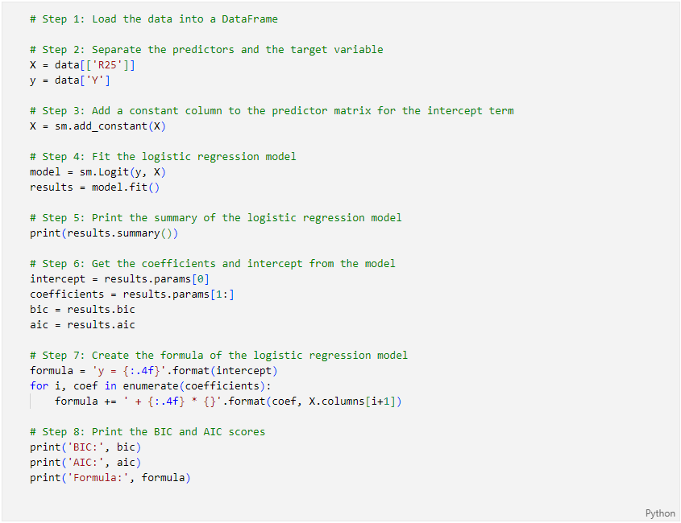
Logit Regression Results
==============================================================================
Dep. Variable: Y No. Observations: 30
Model: Logit Df Residuals: 28
Method: MLE Df Model: 1
Date: Wed, 25 Oct 2023 Pseudo R-squ.: 0.2743
Time: 16:52:13 Log-Likelihood: -15.091
converged: True LL-Null: -20.794
Covariance Type: nonrobust LLR p-value: 0.0007317
==============================================================================
coef std err z P>|z| [0.025 0.975]
------------------------------------------------------------------------------
const -0.8752 0.514 -1.703 0.089 -1.883 0.132
R25 -1.4630 0.661 -2.212 0.027 -2.760 -0.167
==============================================================================
BIC: 36.98431896478582
AIC: 34.18192420146151
Formula: y = -0.8752 + -1.4630 * R25

Appendix 25: Extract of Python code for training the RL-Stepwise model for fiscal year 2020

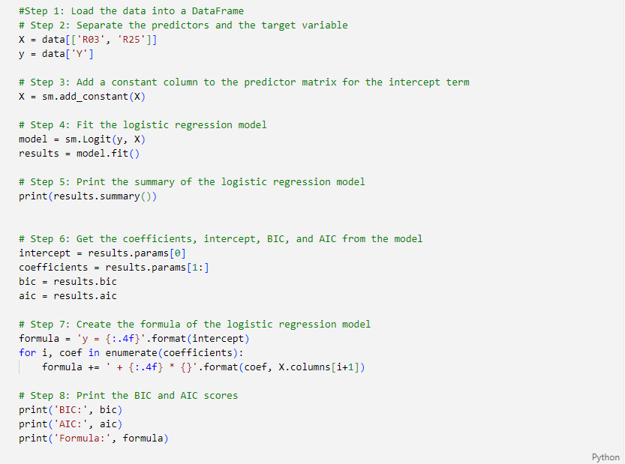
Logit Regression Results
==============================================================================
Dep. Variable: Y No. Observations: 30
Model: Logit Df Residuals: 27
Method: MLE Df Model: 2
Date: Wed, 25 Oct 2023 Pseudo R-squ.: 0.4734
Time: 16:44:53 Log-Likelihood: -10.951
converged: True LL-Null: -20.794
Covariance Type: nonrobust LLR p-value: 5.309e-05
==============================================================================
coef std err z P>|z| [0.025 0.975]
------------------------------------------------------------------------------
const -1.1354 0.650 -1.746 0.081 -2.410 0.139
R03 -0.0175 0.009 -2.033 0.042 -0.034 -0.001
R25 -1.8299 0.789 -2.320 0.020 -3.376 -0.284
==============================================================================
BIC: 32.10541583973062
AIC: 27.901823694744152
Formula: y = -1.1354 + -0.0175 * R03 + -1.8299 * R25
Appendix 26 : Extract of Python code for training the RL-Stepwise model for fiscal year 2019

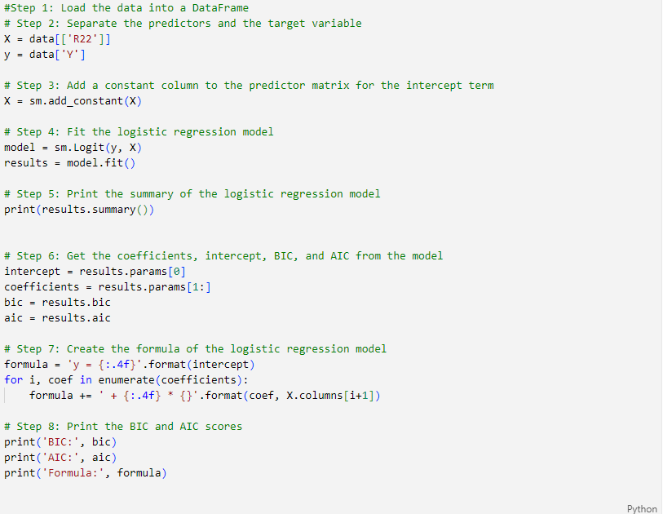
Logit Regression Results
==============================================================================
Dep. Variable: Y No. Observations: 30
Model: Logit Df Residuals: 28
Method: MLE Df Model: 1
Date: Wed, 25 Oct 2023 Pseudo R-squ.: 0.1870
Time: 16:54:23 Log-Likelihood: -16.906
converged: True LL-Null: -20.794
Covariance Type: nonrobust LLR p-value: 0.005293
==============================================================================
coef std err z P>|z| [0.025 0.975]
------------------------------------------------------------------------------
const 0.1877 0.422 0.445 0.656 -0.639 1.014
R22 -6.7853 3.421 -1.983 0.047 -13.490 -0.080
==============================================================================
BIC: 40.61474049405188
AIC: 37.81234573072757
Formula: y = 0.1877 + -6.7853 * R22
Appendix 27: Extract of Python code - Command formulation for Stepwise RL model validation

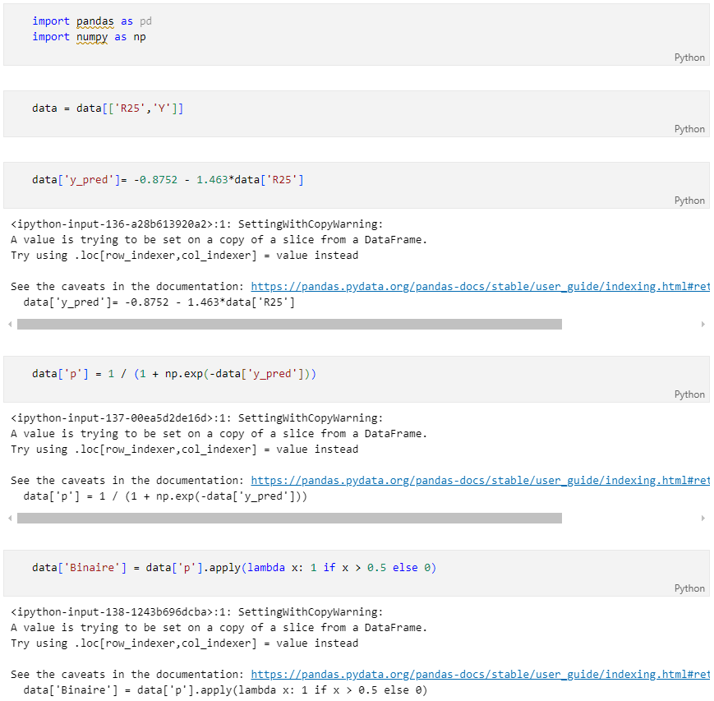

Appendix 28 : Stepwise determination of « p » prediction values

  2021 | R25 | Y | Y  y_pred | p | Binary
  0 | 0.22 | 0 | -1.197 | 0.232 | 0
  1 | 0.20 | 0 | -1.168 | 0.237 | 0
  2 | 0.10 | 0 | -1.022 | 0.265 | 0
  3 | 0.33 | 0 | -1.358 | 0.205 | 0
  4 | 0.07 | 0 | -0.978 | 0.273 | 0
  5 | -0.05 | 0 | -0.802 | 0.310 | 0
  6 | -0.85 | 0 | 0.368 | 0.591 | 1
  7 | 0.48 | 0 | -1.577 | 0.171 | 0
  8 | -0.11 | 0 | -0.714 | 0.329 | 0
  9 | 0.08 | 0 | -0.992 | 0.270 | 0
  10 | 0.10 | 0 | -1.022 | 0.265 | 0
  11 | 0.12 | 0 | -1.051 | 0.259 | 0
  12 | 0.12 | 0 | -1.051 | 0.259 | 0
  13 | 0.05 | 0 | -0.948 | 0.279 | 0
  14 | -2.37 | 0 | 2.592 | 0.930 | 1
  15 | -0.83 | 1 | 0.339 | 0.584 | 1
  16 | -0.73 | 1 | 0.193 | 0.548 | 1
  17 | -2.87 | 1 | 3.324 | 0.965 | 1
  18 | -0.99 | 1 | 0.573 | 0.639 | 1
  19 | -0.60 | 1 | 0.003 | 0.501 | 1
  20 | -0.81 | 1 | 0.310 | 0.577 | 1
  21 | -0.09 | 1 | -0.744 | 0.322 | 0
  22 | 0.90 | 1 | -2.192 | 0.100 | 0
  23 | -1.08 | 1 | 0.705 | 0.669 | 1
  24 | -6.61 | 1 | 8.795 | 1.000 | 1
  25 | -1.98 | 1 | 2.022 | 0.883 | 1
  26 | -3.74 | 1 | 4.596 | 0.990 | 1
  27 | -8.01 | 1 | 10.843 | 1.000 | 1
  28 | -1.34 | 1 | 1.085 | 0.747 | 1
  29 | -0.87 | 1 | 0.398 | 0.598 | 1
  2020 | R03 | R25 | Y | Y’  y_pred | p’ | Binary
  0 | 0 | 0.31 | 0 | -1.703 | 0.154 | 0
  1 | 538.31 | -0.37 | 0 | -9.879 | 0.000 | 0
  2 | 4.49 | 0.01 | 0 | -1.232 | 0.226 | 0
  3 | 1562.67 | 0.35 | 0 | -29.123 | 0.000 | 0
  4 | 7.77 | 0.09 | 0 | -1.436 | 0.192 | 0
  5 | 10.81 | -0.7 | 0 | -0.044 | 0.489 | 0
  6 | 423.33 | -4.27 | 0 | -0.730 | 0.325 | 0
  7 | 60.13 | 0.24 | 0 | -2.627 | 0.067 | 0
  8 | 32.65 | 0.09 | 0 | -1.871 | 0.133 | 0
  9 | 1.25 | 0.08 | 0 | -1.304 | 0.214 | 0
  10 | 0 | -0.51 | 0 | -0.202 | 0.450 | 0
  11 | 3.74 | 0.12 | 0 | -1.420 | 0.195 | 0
  12 | 4.79 | 0.1 | 0 | -1.402 | 0.197 | 0
  13 | 7.03 | -0.1 | 0 | -1.075 | 0.254 | 0
  14 | 0 | -0.62 | 0 | -0.001 | 0.500 | 0
  15 | 0 | -2.22 | 1 | 2.927 | 0.949 | 1
  16 | 159.73 | -0.36 | 1 | -3.272 | 0.037 | 0
  17 | 0 | -6.08 | 1 | 9.990 | 1.000 | 1
  18 | 4.1 | -0.29 | 1 | -0.676 | 0.337 | 0
  19 | 0 | -0.41 | 1 | -0.385 | 0.405 | 0
  20 | 0.12 | -0.51 | 1 | -0.204 | 0.449 | 0
  21 | 0 | -10.77 | 1 | 18.573 | 1.000 | 1
  22 | 1.1 | -6.05 | 1 | 9.916 | 1.000 | 1
  23 | 11.85 | -2.52 | 1 | 3.269 | 0.963 | 1
  24 | 5.22 | -1.47 | 1 | 1.463 | 0.812 | 1
  25 | 4.27 | -4.44 | 1 | 6.915 | 0.999 | 1
  26 | 7.5 | -2.15 | 1 | 2.668 | 0.935 | 1
  27 | 1.05 | -3.91 | 1 | 6.001 | 0.998 | 1
  28 | 0.18 | -1.76 | 1 | 2.082 | 0.889 | 1
  29 | 0.2 | -1.48 | 1 | 1.569 | 0.828 | 1
  2019 | R22 | Y | Y’’  y_pred | p’’ | Binary
  0 | 0.12 | 0 | -0.63 | 0.35 | 0
  1 | 0.1 | 0 | -0.49 | 0.38 | 0
  2 | 0.03 | 0 | -0.02 | 0.50 | 0
  3 | 0.52 | 0 | -3.34 | 0.03 | 0
  4 | 0.21 | 0 | -1.24 | 0.22 | 0
  5 | -0.3 | 0 | 2.22 | 0.90 | 1
  6 | -0.13 | 0 | 1.07 | 0.74 | 1
  7 | 0.15 | 0 | -0.83 | 0.30 | 0
  8 | 0.16 | 0 | -0.90 | 0.29 | 0
  9 | 0.09 | 0 | -0.42 | 0.40 | 0
  10 | 0.04 | 0 | -0.08 | 0.48 | 0
  11 | 0.13 | 0 | -0.69 | 0.33 | 0
  12 | 0.14 | 0 | -0.76 | 0.32 | 0
  13 | 0.04 | 0 | -0.08 | 0.48 | 0
  14 | 2.25 | 0 | -15.08 | 0.00 | 0
  15 | 0.01 | 1 | 0.12 | 0.53 | 1
  16 | -0.14 | 1 | 1.14 | 0.76 | 1
  17 | -0.08 | 1 | 0.73 | 0.67 | 1
  18 | 0.01 | 1 | 0.12 | 0.53 | 1
  19 | -0.6 | 1 | 4.26 | 0.99 | 1
  20 | -0.01 | 1 | 0.26 | 0.56 | 1
  21 | 0 | 1 | 0.19 | 0.55 | 1
  22 | 0.03 | 1 | -0.02 | 0.50 | 0
  23 | 0.23 | 1 | -1.37 | 0.20 | 0
  24 | -0.01 | 1 | 0.26 | 0.56 | 1
  25 | -0.18 | 1 | 1.41 | 0.80 | 1
  26 | -0.14 | 1 | 1.14 | 0.76 | 1
  27 | 0.08 | 1 | -0.36 | 0.41 | 0
  28 | -0.13 | 1 | 1.07 | 0.74 | 1
  29 | -0.1 | 1 | 0.87 | 0.70 | 1

Appendix 29: Extract of the Python code for the graphical representation of the 2021 AUC-ROC curve according to RL Stepwise
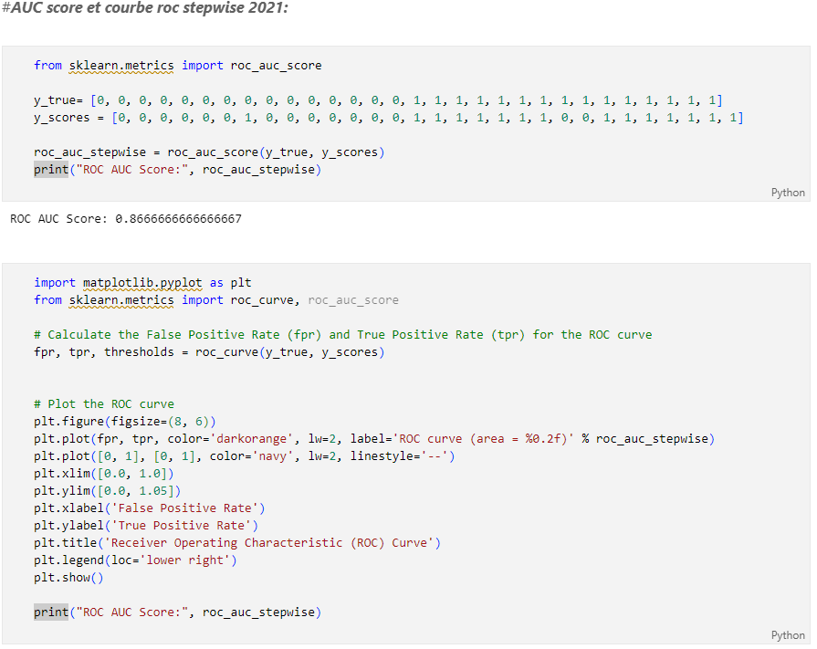
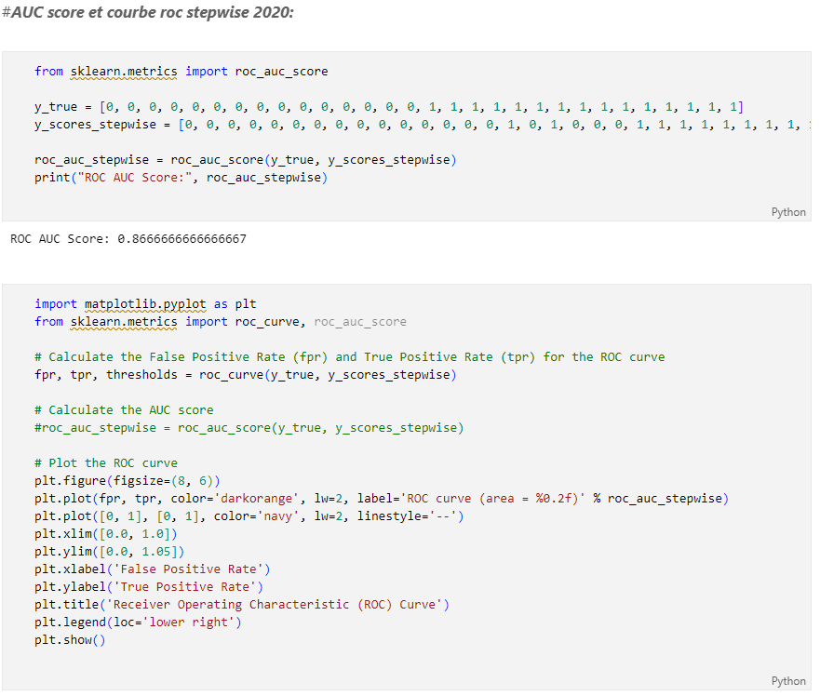
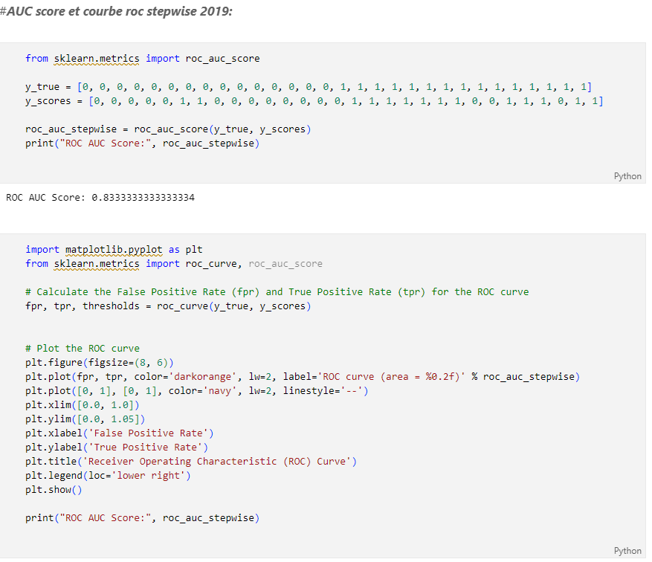

Appendix 30: Excerpt from Python code for 10-fold cross-validation
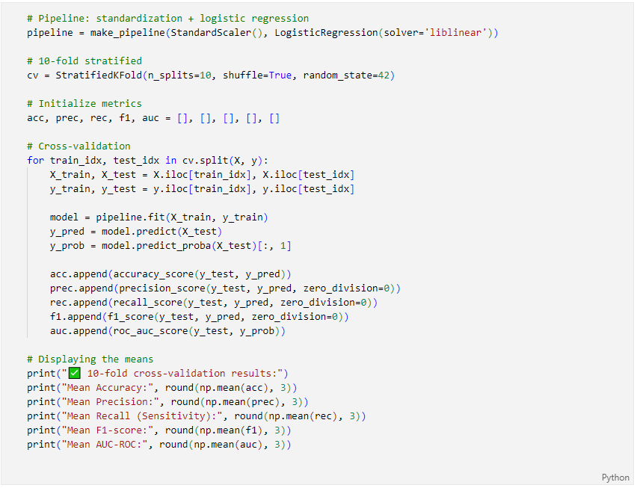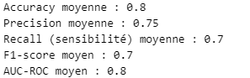
Appendix 31: Ratios retained by ACP and RL Stepwise (Period 2019-2021)
Catégorie de Ratio | Ratios | ACP |  |  | RL Stepwise
Catégorie de Ratio | Ratios | 2021 | 2020 | 2019 | 2021 | 2020 | 2019
Activity and Management (AM) | R01
Activity and Management (AM) | R02
Activity and Management (AM) | R03 |  | x |  |  | x
Activity and Management (AM) | R04 | x |  | x
Activity and Management (AM) | R05 | x
Activity and Management (AM) | R06
Activity and Management (AM) | R07
Activity and Management (AM) | R08
Activity and Management (AM) | R09 |  | x
Structure  (S) | R10 | x
Structure  (S) | R11 |  | x
Structure  (S) | R12 |  | x
Structure  (S) | R13
Structure  (S) | R14 | x |  | x
Structure  (S) | R15 |  | x | x
Structure  (S) | R16 | x | x | x
Structure  (S) | R17
Structure  (S) | R18 |  |  | x
Liquidity  (L) | R19
Liquidity  (L) | R20 |  | x
Liquidity  (L) | R21 | x |  | x
Profitability  (P) | R22 |  |  | x |  |  | x
Profitability  (P) | R23 |  | x
Profitability  (P) | R24 |  |  | x
Profitability  (P) | R25 | x | x | x | x | x
Profitability  (P) | R26
Profitability  (P) | R27

