Additional file 1
Table SM 1: The chemical structure, Pubchem IUPAC Name, Pubchem SID, Pubchem CID, and chemical bioactivity of the study compound
S/No | Chemical Structure | Pubchem IUPAC Name | Pubchem SID | Pubchem CID | EC₅₀ [µM]
1 | 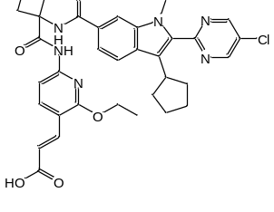 | (E)-3-[6-[[1-[[2-(5-chloropyrimidin-2-yl)-3-cyclopentyl-1-methyl-indole-6-carbonyl]amino]cyclobutanecarbonyl]amino]-2-ethoxy-3-pyridyl]prop-2-enoic acid | 312380708 | 118728143 | 0.013
2 | 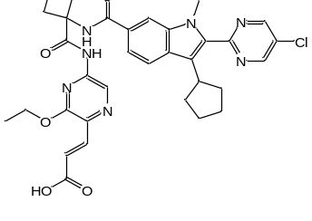 | (E)-3-[5-[[1-[[2-(5-chloropyrimidin-2-yl)-3-cyclopentyl-1-methyl-indole-6-carbonyl]amino]cyclobutanecarbonyl]amino]-3-ethoxy-pyrazin-2-yl]prop-2-enoic acid | 312380713 | 118728148 | 0.02
3 | 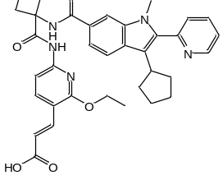 | (E)-3-[6-[[1-[[3-cyclopentyl-1-methyl-2-(2-pyridyl)indole-6-carbonyl]amino]cyclobutanecarbonyl]amino]-2-ethoxy-3-pyridyl]prop-2-enoic acid | 312384938 | 118730993 | 0.011
4 | 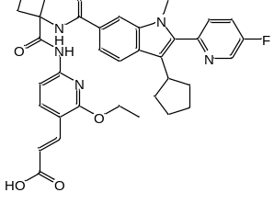 | (E)-3-[6-[[1-[[3-cyclopentyl-2-(5-fluoro-2-pyridyl)-1-methyl-indole-6-carbonyl]amino]cyclobutanecarbonyl]amino]-2-ethoxy-3-pyridyl]prop-2-enoic acid | 312384939 | 118730994 | 0.01
5 | 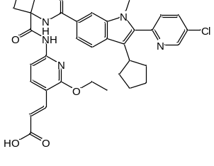 | (E)-3-[6-[[1-[[2-(5-chloro-2-pyridyl)-3-cyclopentyl-1-methyl-indole-6-carbonyl]amino]cyclobutanecarbonyl]amino]-2-ethoxy-3-pyridyl]prop-2-enoic acid | 312384940 | 118730995 | 0.013
6 | 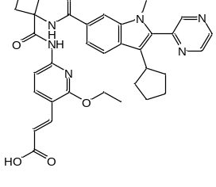 | (E)-3-[6-[[1-[(3-cyclopentyl-1-methyl-2-pyrazin-2-yl-indole-6-carbonyl)amino]cyclobutanecarbonyl]amino]-2-ethoxy-3-pyridyl]prop-2-enoic acid | 312384941 | 118730996 | 0.008
7 | 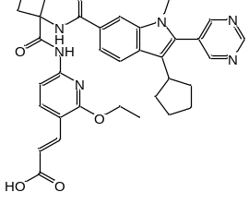 | (E)-3-[6-[[1-[(3-cyclopentyl-1-methyl-2-pyrimidin-5-yl-indole-6-carbonyl)amino]cyclobutanecarbonyl]amino]-2-ethoxy-3-pyridyl]prop-2-enoic acid | 312384942 | 118730997 | 0.015
8 | 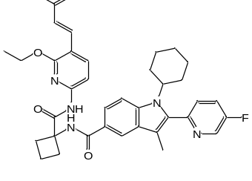 | (E)-3-[6-[[1-[[1-cyclohexyl-2-(5-fluoro-2-pyridyl)-3-methyl-indole-5-carbonyl]amino]cyclobutanecarbonyl]amino]-2-ethoxy-3-pyridyl]prop-2-enoic acid | 312384944 | 118730999 | 0.009
9 | 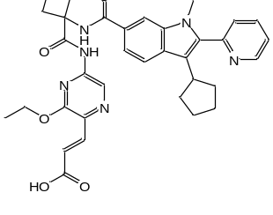 | (E)-3-[5-[[1-[[3-cyclopentyl-1-methyl-2-(2-pyridyl)indole-6-carbonyl]amino]cyclobutanecarbonyl]amino]-3-ethoxy-pyrazin-2-yl]prop-2-enoic acid | 312384945 | 118731000 | 0.013
10 | 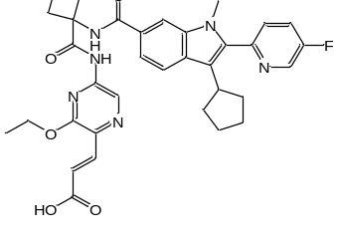 | (E)-3-[5-[[1-[[3-cyclopentyl-2-(5-fluoro-2-pyridyl)-1-methyl-indole-6-carbonyl]amino]cyclobutanecarbonyl]amino]-3-ethoxy-pyrazin-2-yl]prop-2-enoic acid | 312385158 | 118731179 | 0.02
11 | 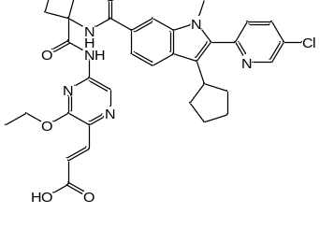 | (E)-3-[5-[[1-[[2-(5-chloro-2-pyridyl)-3-cyclopentyl-1-methyl-indole-6-carbonyl]amino]cyclobutanecarbonyl]amino]-3-ethoxy-pyrazin-2-yl]prop-2-enoic acid | 312385159 | 118731180 | 0.053
12 | 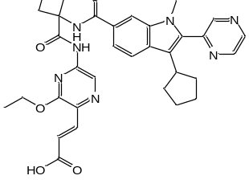 | (E)-3-[5-[[1-[(3-cyclopentyl-1-methyl-2-pyrazin-2-yl-indole-6-carbonyl)amino]cyclobutanecarbonyl]amino]-3-ethoxy-pyrazin-2-yl]prop-2-enoic acid | 312385160 | 118731181 | 0.022
13 | 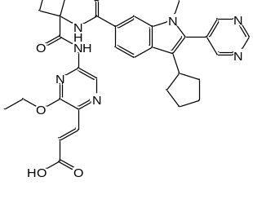 | (E)-3-[5-[[1-[(3-cyclopentyl-1-methyl-2-pyrimidin-5-yl-indole-6-carbonyl)amino]cyclobutanecarbonyl]amino]-3-ethoxy-pyrazin-2-yl]prop-2-enoic acid | 312385161 | 118731182 | 0.089
14 | 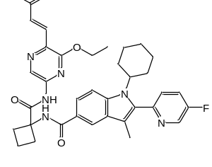 | (E)-3-[5-[[1-[[1-cyclohexyl-2-(5-fluoro-2-pyridyl)-3-methyl-indole-5-carbonyl]amino]cyclobutanecarbonyl]amino]-3-ethoxy-pyrazin-2-yl]prop-2-enoic acid | 312385163 | 118731184 | 0.012
15 | 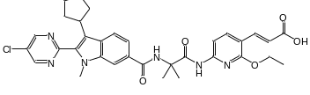 | (E)-3-[6-[[2-[[2-(5-chloropyrimidin-2-yl)-3-cyclopentyl-1-methyl-indole-6-carbonyl]amino]-2-methyl-propanoyl]amino]-2-ethoxy-3-pyridyl]prop-2-enoic acid | 312385164 | 118731185 | 0.006
16 | 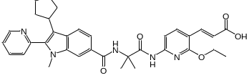 | (E)-3-[6-[[2-[[3-cyclopentyl-1-methyl-2-(2-pyridyl)indole-6-carbonyl]amino]-2-methyl-propanoyl]amino]-2-ethoxy-3-pyridyl]prop-2-enoic acid | 312385165 | 118731186 | 0.002
17 | 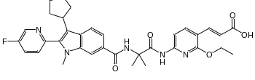 | (E)-3-[6-[[2-[[3-cyclopentyl-2-(5-fluoro-2-pyridyl)-1-methyl-indole-6-carbonyl]amino]-2-methyl-propanoyl]amino]-2-ethoxy-3-pyridyl]prop-2-enoic acid | 312385166 | 118731187 | 0.005
18 | 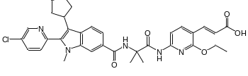 | (E)-3-[6-[[2-[[2-(5-chloro-2-pyridyl)-3-cyclopentyl-1-methyl-indole-6-carbonyl]amino]-2-methyl-propanoyl]amino]-2-ethoxy-3-pyridyl]prop-2-enoic acid | 312385167 | 118731188 | 0.005
19 | 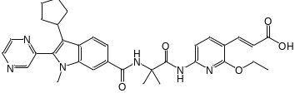 | (E)-3-[6-[[2-[(3-cyclopentyl-1-methyl-2-pyrazin-2-yl-indole-6-carbonyl)amino]-2-methyl-propanoyl]amino]-2-ethoxy-3-pyridyl]prop-2-enoic acid | 312385168 | 118731189 | 0.007
20 | 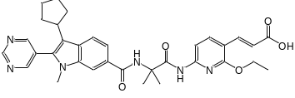 | (E)-3-[6-[[2-[(3-cyclopentyl-1-methyl-2-pyrimidin-5-yl-indole-6-carbonyl)amino]-2-methyl-propanoyl]amino]-2-ethoxy-3-pyridyl]prop-2-enoic acid | 312385169 | 118731190 | 0.012
21 | 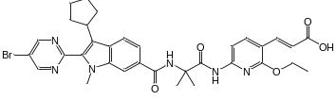 | (E)-3-[6-[[2-[[2-(5-bromopyrimidin-2-yl)-3-cyclopentyl-1-methyl-indole-6-carbonyl]amino]-2-methyl-propanoyl]amino]-2-ethoxy-3-pyridyl]prop-2-enoic acid | 312385170 | 118731191 | 0.005
22 | 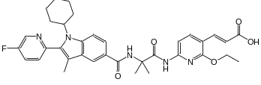 | (E)-3-[6-[[2-[[1-cyclohexyl-2-(5-fluoro-2-pyridyl)-3-methyl-indole-5-carbonyl]amino]-2-methyl-propanoyl]amino]-2-ethoxy-3-pyridyl]prop-2-enoic acid | 312385171 | 118731192 | 0.003
23 | 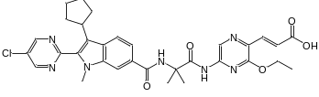 | (E)-3-[5-[[2-[[2-(5-chloropyrimidin-2-yl)-3-cyclopentyl-1-methyl-indole-6-carbonyl]amino]-2-methyl-propanoyl]amino]-3-ethoxy-pyrazin-2-yl]prop-2-enoic acid | 312385172 | 118731193 | 0.012
24 | 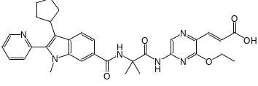 | (E)-3-[5-[[2-[[3-cyclopentyl-1-methyl-2-(2-pyridyl)indole-6-carbonyl]amino]-2-methyl-propanoyl]amino]-3-ethoxy-pyrazin-2-yl]prop-2-enoic acid | 312385173 | 118731194 | 0.044
25 | 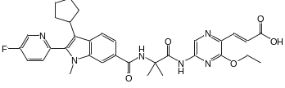 | (E)-3-[5-[[2-[[3-cyclopentyl-2-(5-fluoro-2-pyridyl)-1-methyl-indole-6-carbonyl]amino]-2-methyl-propanoyl]amino]-3-ethoxy-pyrazin-2-yl]prop-2-enoic acid | 312385174 | 118731195 | 0.018
26 | 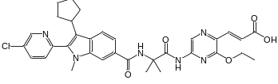 | (E)-3-[5-[[2-[[2-(5-chloro-2-pyridyl)-3-cyclopentyl-1-methyl-indole-6-carbonyl]amino]-2-methyl-propanoyl]amino]-3-ethoxy-pyrazin-2-yl]prop-2-enoic acid | 312385175 | 118731196 | 0.006
27 | 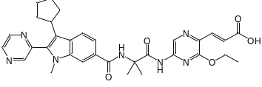 | (E)-3-[5-[[2-[(3-cyclopentyl-1-methyl-2-pyrazin-2-yl-indole-6-carbonyl)amino]-2-methyl-propanoyl]amino]-3-ethoxy-pyrazin-2-yl]prop-2-enoic acid | 312385176 | 118731197 | 0.036
28 | 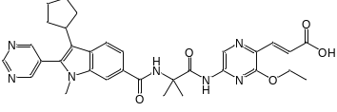 | (E)-3-[5-[[2-[(3-cyclopentyl-1-methyl-2-pyrimidin-5-yl-indole-6-carbonyl)amino]-2-methyl-propanoyl]amino]-3-ethoxy-pyrazin-2-yl]prop-2-enoic acid | 312385177 | 118731198 | 0.082
29 | 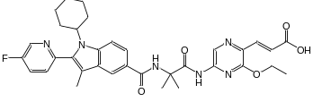 | (E)-3-[5-[[2-[[1-cyclohexyl-2-(5-fluoro-2-pyridyl)-3-methyl-indole-5-carbonyl]amino]-2-methyl-propanoyl]amino]-3-ethoxy-pyrazin-2-yl]prop-2-enoic acid | 312385179 | 118731200 | 0.012
30 | 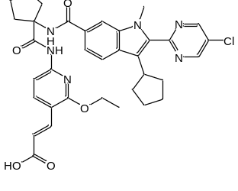 | (E)-3-[6-[[1-[[2-(5-chloropyrimidin-2-yl)-3-cyclopentyl-1-methyl-indole-6-carbonyl]amino]cyclopentanecarbonyl]amino]-2-ethoxy-3-pyridyl]prop-2-enoic acid | 312385180 | 118731201 | 0.003
31 | 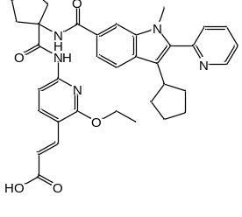 | (E)-3-[6-[[1-[[3-cyclopentyl-1-methyl-2-(2-pyridyl)indole-6-carbonyl]amino]cyclopentanecarbonyl]amino]-2-ethoxy-3-pyridyl]prop-2-enoic acid | 312385181 | 118731202 | 0.004
32 | 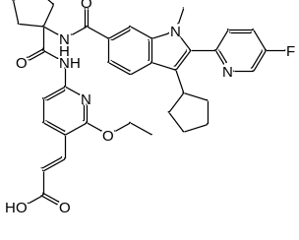 | (E)-3-[6-[[1-[[3-cyclopentyl-2-(5-fluoro-2-pyridyl)-1-methyl-indole-6-carbonyl]amino]cyclopentanecarbonyl]amino]-2-ethoxy-3-pyridyl]prop-2-enoic acid | 312385182 | 118731203 | 0.004
33 | 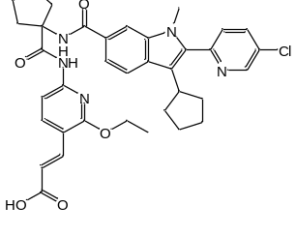 | (E)-3-[6-[[1-[[2-(5-chloro-2-pyridyl)-3-cyclopentyl-1-methyl-indole-6-carbonyl]amino]cyclopentanecarbonyl]amino]-2-ethoxy-3-pyridyl]prop-2-enoic acid | 312385183 | 118731204 | 0.004
34 | 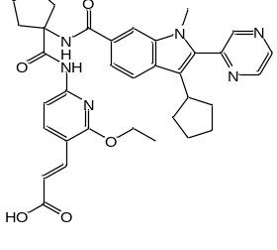 | (E)-3-[6-[[1-[(3-cyclopentyl-1-methyl-2-pyrazin-2-yl-indole-6-carbonyl)amino]cyclopentanecarbonyl]amino]-2-ethoxy-3-pyridyl]prop-2-enoic acid | 312385184 | 118731205 | 0.005
35 | 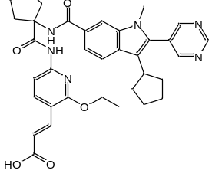 | (E)-3-[6-[[1-[(3-cyclopentyl-1-methyl-2-pyrimidin-5-yl-indole-6-carbonyl)amino]cyclopentanecarbonyl]amino]-2-ethoxy-3-pyridyl]prop-2-enoic acid | 312385185 | 118731206 | 0.005
36 | 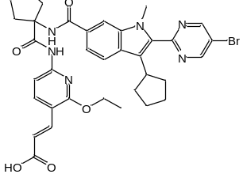 | (E)-3-[6-[[1-[[2-(5-bromopyrimidin-2-yl)-3-cyclopentyl-1-methyl-indole-6-carbonyl]amino]cyclopentanecarbonyl]amino]-2-ethoxy-3-pyridyl]prop-2-enoic acid | 312385186 | 118731207 | 0.005
37 | 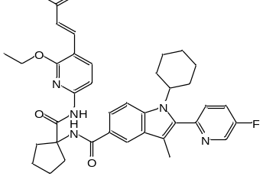 | (E)-3-[6-[[1-[[1-cyclohexyl-2-(5-fluoro-2-pyridyl)-3-methyl-indole-5-carbonyl]amino]cyclopentanecarbonyl]amino]-2-ethoxy-3-pyridyl]prop-2-enoic acid | 312385187 | 118731208 | 0.005
38 | 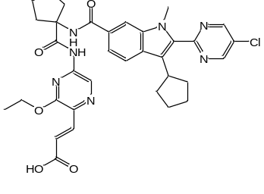 | (E)-3-[5-[[1-[[2-(5-chloropyrimidin-2-yl)-3-cyclopentyl-1-methyl-indole-6-carbonyl]amino]cyclopentanecarbonyl]amino]-3-ethoxy-pyrazin-2-yl]prop-2-enoic acid | 312385188 | 118731209 | 0.006
39 | 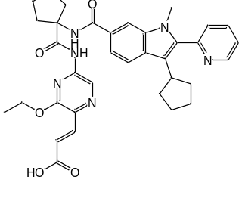 | (E)-3-[5-[[1-[[3-cyclopentyl-1-methyl-2-(2-pyridyl)indole-6-carbonyl]amino]cyclopentanecarbonyl]amino]-3-ethoxy-pyrazin-2-yl]prop-2-enoic acid | 312385189 | 118731210 | 0.016
40 | 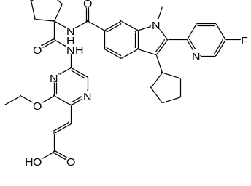 | (E)-3-[5-[[1-[[3-cyclopentyl-2-(5-fluoro-2-pyridyl)-1-methyl-indole-6-carbonyl]amino]cyclopentanecarbonyl]amino]-3-ethoxy-pyrazin-2-yl]prop-2-enoic acid | 312385190 | 118731211 | 0.011
41 | 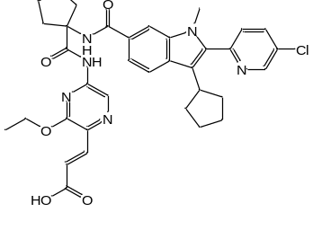 | (E)-3-[5-[[1-[[2-(5-chloro-2-pyridyl)-3-cyclopentyl-1-methyl-indole-6-carbonyl]amino]cyclopentanecarbonyl]amino]-3-ethoxy-pyrazin-2-yl]prop-2-enoic acid | 312385191 | 118731212 | 0.013
42 | 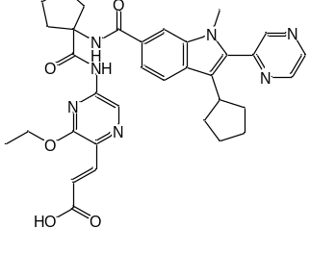 | (E)-3-[5-[[1-[(3-cyclopentyl-1-methyl-2-pyrazin-2-yl-indole-6-carbonyl)amino]cyclopentanecarbonyl]amino]-3-ethoxy-pyrazin-2-yl]prop-2-enoic acid | 312385192 | 118731213 | 0.005
43 | 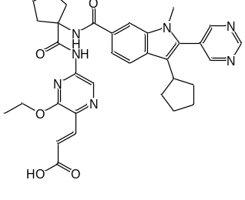 | (E)-3-[5-[[1-[(3-cyclopentyl-1-methyl-2-pyrimidin-5-yl-indole-6-carbonyl)amino]cyclopentanecarbonyl]amino]-3-ethoxy-pyrazin-2-yl]prop-2-enoic acid | 312385193 | 118731214 | 0.018
44 | 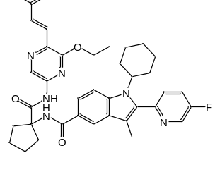 | (E)-3-[5-[[1-[[1-cyclohexyl-2-(5-fluoro-2-pyridyl)-3-methyl-indole-5-carbonyl]amino]cyclopentanecarbonyl]amino]-3-ethoxy-pyrazin-2-yl]prop-2-enoic acid | 312385195 | 118731216 | 0.006
45 | 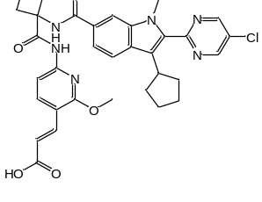 | (E)-3-[6-[[1-[[2-(5-chloropyrimidin-2-yl)-3-cyclopentyl-1-methyl-indole-6-carbonyl]amino]cyclobutanecarbonyl]amino]-2-methoxy-3-pyridyl]prop-2-enoic acid | 312385196 | 118731217 | 0.009
46 | 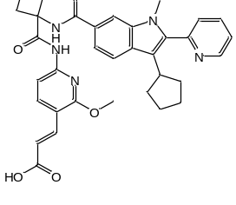 | (E)-3-[6-[[1-[[3-cyclopentyl-1-methyl-2-(2-pyridyl)indole-6-carbonyl]amino]cyclobutanecarbonyl]amino]-2-methoxy-3-pyridyl]prop-2-enoic acid | 312385197 | 118731218 | 0.015
47 | 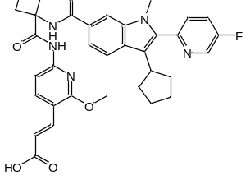 | (E)-3-[6-[[1-[[3-cyclopentyl-2-(5-fluoro-2-pyridyl)-1-methyl-indole-6-carbonyl]amino]cyclobutanecarbonyl]amino]-2-methoxy-3-pyridyl]prop-2-enoic acid | 312385198 | 118731219 | 0.012
48 | 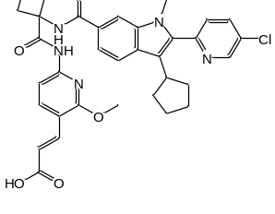 | (E)-3-[6-[[1-[[2-(5-chloro-2-pyridyl)-3-cyclopentyl-1-methyl-indole-6-carbonyl]amino]cyclobutanecarbonyl]amino]-2-methoxy-3-pyridyl]prop-2-enoic acid | 312385199 | 118731220 | 0.013
49 | 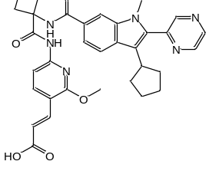 | (E)-3-[6-[[1-[(3-cyclopentyl-1-methyl-2-pyrazin-2-yl-indole-6-carbonyl)amino]cyclobutanecarbonyl]amino]-2-methoxy-3-pyridyl]prop-2-enoic acid | 312385200 | 118731221 | 0.013
50 | 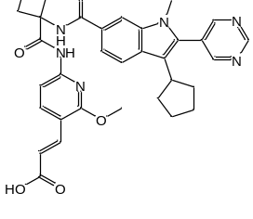 | (E)-3-[6-[[1-[(3-cyclopentyl-1-methyl-2-pyrimidin-5-yl-indole-6-carbonyl)amino]cyclobutanecarbonyl]amino]-2-methoxy-3-pyridyl]prop-2-enoic acid | 312385201 | 118731222 | 0.05
51 | 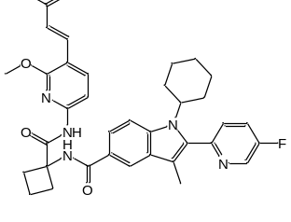 | (E)-3-[6-[[1-[[1-cyclohexyl-2-(5-fluoro-2-pyridyl)-3-methyl-indole-5-carbonyl]amino]cyclobutanecarbonyl]amino]-2-methoxy-3-pyridyl]prop-2-enoic acid | 312385203 | 118731224 | 0.01
52 | 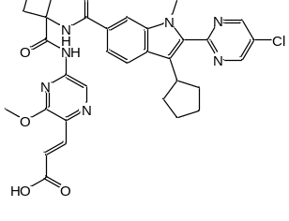 | (E)-3-[5-[[1-[[2-(5-chloropyrimidin-2-yl)-3-cyclopentyl-1-methyl-indole-6-carbonyl]amino]cyclobutanecarbonyl]amino]-3-methoxy-pyrazin-2-yl]prop-2-enoic acid | 312385204 | 118731225 | 0.032
53 | 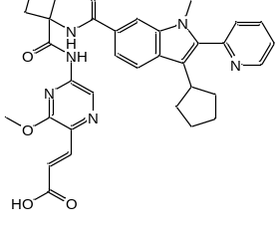 | (E)-3-[5-[[1-[[3-cyclopentyl-1-methyl-2-(2-pyridyl)indole-6-carbonyl]amino]cyclobutanecarbonyl]amino]-3-methoxy-pyrazin-2-yl]prop-2-enoic acid | 312385205 | 118731226 | 0.043
54 | 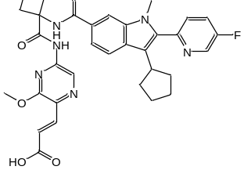 | (E)-3-[5-[[1-[[3-cyclopentyl-2-(5-fluoro-2-pyridyl)-1-methyl-indole-6-carbonyl]amino]cyclobutanecarbonyl]amino]-3-methoxy-pyrazin-2-yl]prop-2-enoic acid | 312385206 | 118731227 | 0.037
55 | 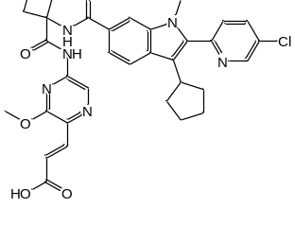 | (E)-3-[5-[[1-[[2-(5-chloro-2-pyridyl)-3-cyclopentyl-1-methyl-indole-6-carbonyl]amino]cyclobutanecarbonyl]amino]-3-methoxy-pyrazin-2-yl]prop-2-enoic acid | 312385207 | 118731228 | 0.056
56 | 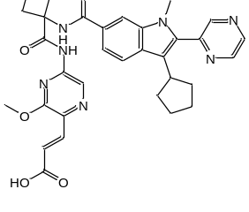 | (E)-3-[5-[[1-[(3-cyclopentyl-1-methyl-2-pyrazin-2-yl-indole-6-carbonyl)amino]cyclobutanecarbonyl]amino]-3-methoxy-pyrazin-2-yl]prop-2-enoic acid | 312385208 | 118731229 | 0.049
57 | 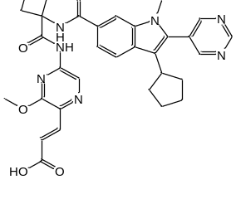 | (E)-3-[5-[[1-[(3-cyclopentyl-1-methyl-2-pyrimidin-5-yl-indole-6-carbonyl)amino]cyclobutanecarbonyl]amino]-3-methoxy-pyrazin-2-yl]prop-2-enoic acid | 312385209 | 118731230 | 0.185
58 | 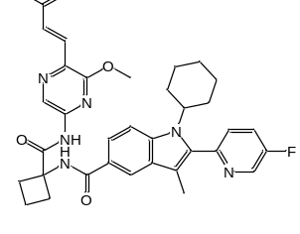 | (E)-3-[5-[[1-[[1-cyclohexyl-2-(5-fluoro-2-pyridyl)-3-methyl-indole-5-carbonyl]amino]cyclobutanecarbonyl]amino]-3-methoxy-pyrazin-2-yl]prop-2-enoic acid | 312385211 | 118731232 | 0.017
59 | 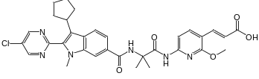 | (E)-3-[6-[[2-[[2-(5-chloropyrimidin-2-yl)-3-cyclopentyl-1-methyl-indole-6-carbonyl]amino]-2-methyl-propanoyl]amino]-2-methoxy-3-pyridyl]prop-2-enoic acid | 312385212 | 118731233 | 0.047
60 | 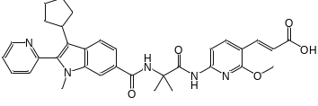 | (E)-3-[6-[[2-[[3-cyclopentyl-1-methyl-2-(2-pyridyl)indole-6-carbonyl]amino]-2-methyl-propanoyl]amino]-2-methoxy-3-pyridyl]prop-2-enoic acid | 312385213 | 118731234 | 0.021
61 | 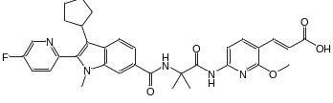 | (E)-3-[6-[[2-[[3-cyclopentyl-2-(5-fluoro-2-pyridyl)-1-methyl-indole-6-carbonyl]amino]-2-methyl-propanoyl]amino]-2-methoxy-3-pyridyl]prop-2-enoic acid | 312385214 | 118731235 | 0.012
62 | 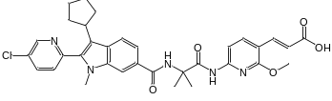 | (E)-3-[6-[[2-[[2-(5-chloro-2-pyridyl)-3-cyclopentyl-1-methyl-indole-6-carbonyl]amino]-2-methyl-propanoyl]amino]-2-methoxy-3-pyridyl]prop-2-enoic acid | 312385215 | 118731236 | 0.012
63 | 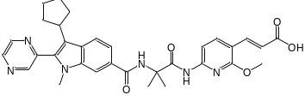 | (E)-3-[6-[[2-[(3-cyclopentyl-1-methyl-2-pyrazin-2-yl-indole-6-carbonyl)amino]-2-methyl-propanoyl]amino]-2-methoxy-3-pyridyl]prop-2-enoic acid | 312385216 | 118731237 | 0.016
64 | 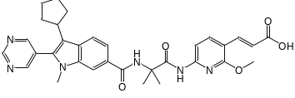 | (E)-3-[6-[[2-[(3-cyclopentyl-1-methyl-2-pyrimidin-5-yl-indole-6-carbonyl)amino]-2-methyl-propanoyl]amino]-2-methoxy-3-pyridyl]prop-2-enoic acid | 312385217 | 118731238 | 0.023
65 | 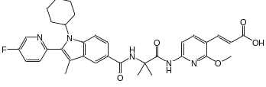 | (E)-3-[6-[[2-[[1-cyclohexyl-2-(5-fluoro-2-pyridyl)-3-methyl-indole-5-carbonyl]amino]-2-methyl-propanoyl]amino]-2-methoxy-3-pyridyl]prop-2-enoic acid | 312385219 | 118731240 | 0.003
66 | 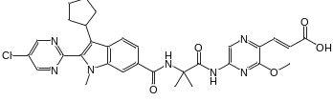 | (E)-3-[5-[[2-[[2-(5-chloropyrimidin-2-yl)-3-cyclopentyl-1-methyl-indole-6-carbonyl]amino]-2-methyl-propanoyl]amino]-3-methoxy-pyrazin-2-yl]prop-2-enoic acid | 312385220 | 118731241 | 0.017
67 | 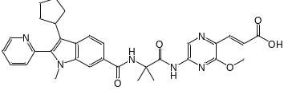 | (E)-3-[5-[[2-[[3-cyclopentyl-1-methyl-2-(2-pyridyl)indole-6-carbonyl]amino]-2-methyl-propanoyl]amino]-3-methoxy-pyrazin-2-yl]prop-2-enoic acid | 312385221 | 118731242 | 0.05
68 | 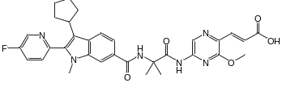 | (E)-3-[5-[[2-[[3-cyclopentyl-2-(5-fluoro-2-pyridyl)-1-methyl-indole-6-carbonyl]amino]-2-methyl-propanoyl]amino]-3-methoxy-pyrazin-2-yl]prop-2-enoic acid | 312385222 | 118731243 | 0.026
69 | 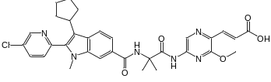 | (E)-3-[5-[[2-[[2-(5-chloro-2-pyridyl)-3-cyclopentyl-1-methyl-indole-6-carbonyl]amino]-2-methyl-propanoyl]amino]-3-methoxy-pyrazin-2-yl]prop-2-enoic acid | 312385223 | 118731244 | 0.044
70 | 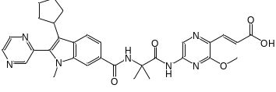 | (E)-3-[5-[[2-[(3-cyclopentyl-1-methyl-2-pyrazin-2-yl-indole-6-carbonyl)amino]-2-methyl-propanoyl]amino]-3-methoxy-pyrazin-2-yl]prop-2-enoic acid | 312385224 | 118731245 | 0.055
71 | 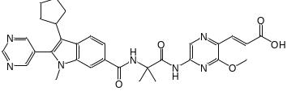 | (E)-3-[5-[[2-[(3-cyclopentyl-1-methyl-2-pyrimidin-5-yl-indole-6-carbonyl)amino]-2-methyl-propanoyl]amino]-3-methoxy-pyrazin-2-yl]prop-2-enoic acid | 312385225 | 118731246 | 0.33
72 | 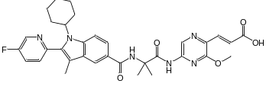 | (E)-3-[5-[[2-[[1-cyclohexyl-2-(5-fluoro-2-pyridyl)-3-methyl-indole-5-carbonyl]amino]-2-methyl-propanoyl]amino]-3-methoxy-pyrazin-2-yl]prop-2-enoic acid | 312385227 | 118731248 | 0.027
73 | 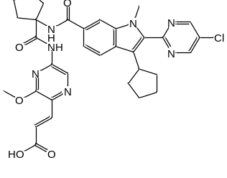 | (E)-3-[5-[[1-[[2-(5-chloropyrimidin-2-yl)-3-cyclopentyl-1-methyl-indole-6-carbonyl]amino]cyclopentanecarbonyl]amino]-3-methoxy-pyrazin-2-yl]prop-2-enoic acid | 312385228 | 118731249 | 0.029
74 | 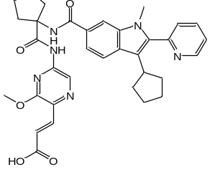 | (E)-3-[5-[[1-[[3-cyclopentyl-1-methyl-2-(2-pyridyl)indole-6-carbonyl]amino]cyclopentanecarbonyl]amino]-3-methoxy-pyrazin-2-yl]prop-2-enoic acid | 312385229 | 118731250 | 0.031
75 | 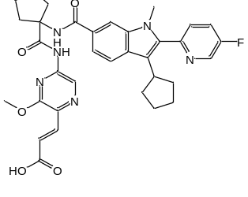 | (E)-3-[5-[[1-[[3-cyclopentyl-2-(5-fluoro-2-pyridyl)-1-methyl-indole-6-carbonyl]amino]cyclopentanecarbonyl]amino]-3-methoxy-pyrazin-2-yl]prop-2-enoic acid | 312385230 | 118731251 | 0.03
76 | 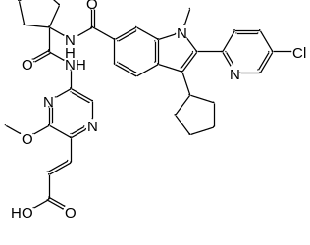 | (E)-3-[5-[[1-[[2-(5-chloro-2-pyridyl)-3-cyclopentyl-1-methyl-indole-6-carbonyl]amino]cyclopentanecarbonyl]amino]-3-methoxy-pyrazin-2-yl]prop-2-enoic acid | 312385231 | 118731252 | 0.04
77 | 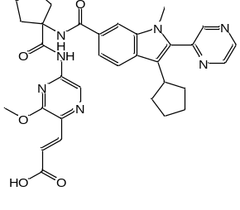 | (E)-3-[5-[[1-[(3-cyclopentyl-1-methyl-2-pyrazin-2-yl-indole-6-carbonyl)amino]cyclopentanecarbonyl]amino]-3-methoxy-pyrazin-2-yl]prop-2-enoic acid | 312385391 | 118731376 | 0.39
78 | 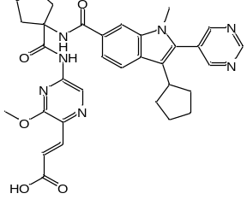 | (E)-3-[5-[[1-[(3-cyclopentyl-1-methyl-2-pyrimidin-5-yl-indole-6-carbonyl)amino]cyclopentanecarbonyl]amino]-3-methoxy-pyrazin-2-yl]prop-2-enoic acid | 312385392 | 118731377 | 0.575
79 | 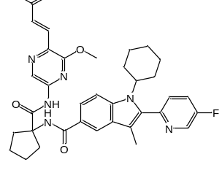 | (E)-3-[5-[[1-[[1-cyclohexyl-2-(5-fluoro-2-pyridyl)-3-methyl-indole-5-carbonyl]amino]cyclopentanecarbonyl]amino]-3-methoxy-pyrazin-2-yl]prop-2-enoic acid | 312385394 | 118731379 | 0.014

Table SM 2: The descriptor used in the model is described here
S/N | Descriptor | Description | Class
1 | $$VR2_{Dzi}$$ | Normalized Randic-like eigenvector-based index from Barysz matrix / weighted by first ionization potential | 2D
2 | $$GATS6p$$ | Geary autocorrelation - lag 6 / weighted by polarizabilities | 2D
3 | $$nX$$ | Number of halogen atoms (F, Cl, Br, I, At) | 2D
4 | $$GGI10$$ | Topological charge index of order 10 | 2D
5 | $$ATSC5e$$ | Centered Broto-Moreau autocorrelation - lag 5 / weighted by Sanderson electronegativities | 2D
6 | $$GATS2p$$ | Geary autocorrelation - lag 2 / weighted by polarizabilities | 2D
7 | $$MDEC-24$$ | Molecular distance edge between all secondary and quaternary carbons | 2D

Table SM 3: Numerical values of the descriptor used in the selected model
Training Set Compounds
ID | $$VR2_{Dzi}$$ | $$GATS6p$$ | $$nX$$ | $$GGI10$$ | $$ATSC5e$$ | $$GATS2p$$ | $$MDEC24$$ | pEC₅₀
2 | -0.29193 | 50.95904 | 10.66277 | 16.7662 | 3.609432 | 1.655976 | 1.724171 | 7.69897
3 | -0.48061 | 51.17866 | -3.7676 | 23.73958 | 3.596051 | 1.655976 | 1.724171 | 7.958607
4 | -0.39621 | 51.69407 | 7.817303 | 21.368 | 3.599425 | 1.655976 | 1.724171 | 8.00000
5 | -0.60032 | 50.50545 | -5.50711 | 21.368 | 3.609592 | 1.655976 | 1.724171 | 7.886057
6 | -0.52166 | 51.40545 | 2.615654 | 21.14941 | 3.593663 | 1.655976 | 1.724171 | 8.09691
7 | -0.15341 | 51.40545 | -25.2239 | 21.35823 | 3.593159 | 1.655976 | 1.724171 | 7.823909
8 | -0.62437 | 53.47487 | 13.06747 | 23.74463 | 3.59456 | 1.606107 | 1.830265 | 8.045757
9 | 0.389724 | 51.40545 | 13.83724 | 21.43385 | 3.596007 | 1.655976 | 1.724171 | 7.886057
10 | 0.182279 | 51.51525 | 23.42436 | 19.0902 | 3.601114 | 1.655976 | 1.724171 | 7.69897
11 | 0.25009 | 50.73225 | 12.20191 | 19.0902 | 3.609478 | 1.655976 | 1.724171 | 7.275724
12 | 0.324904 | 51.63225 | 19.90046 | 18.8796 | 3.593627 | 1.655976 | 1.724171 | 7.657577
13 | 0.710973 | 51.63225 | -7.48323 | 19.07975 | 3.593125 | 1.655976 | 1.724171 | 7.05061
14 | 0.273818 | 53.70166 | 29.54161 | 21.43894 | 3.594509 | 1.605842 | 1.805118 | 7.920819
15 | -0.91059 | 50.73225 | -11.2048 | 12.81699 | 3.580034 | 1.655976 | 1.724171 | 8.221849
16 | -0.32317 | 51.17866 | -8.52128 | 17.1038 | 3.578419 | 1.655976 | 1.724171 | 8.69897
17 | -0.47326 | 51.28845 | 2.14579 | 14.92285 | 3.579054 | 1.655976 | 1.724171 | 8.30103
19 | -0.35328 | 51.40545 | -1.81383 | 14.73654 | 3.57809 | 1.655976 | 1.724171 | 8.154902
21 | -0.87703 | 51.60225 | -18.2414 | 12.81699 | 3.59015 | 1.655976 | 1.724171 | 8.30103
22 | -0.44639 | 53.47487 | 8.512106 | 17.10898 | 3.577518 | 1.605007 | 1.780169 | 8.522879
23 | -0.09928 | 50.95904 | 6.277877 | 11.05725 | 3.579617 | 1.655976 | 1.724171 | 7.920819
24 | 0.557409 | 51.40545 | 9.249231 | 15.27894 | 3.578089 | 1.655976 | 1.724171 | 7.356547
26 | 0.43346 | 50.73225 | 7.541529 | 13.12059 | 3.579626 | 1.655976 | 1.724171 | 8.221849
27 | 0.503334 | 51.63225 | 15.6291 | 12.94095 | 3.577778 | 1.655976 | 1.724171 | 7.443697
31 | -0.81651 | 53.36507 | -13.8593 | 0.00000 | 3.595885 | 1.655976 | 1.724171 | 8.39794
32 | -0.77521 | 53.88049 | -2.28118 | 24.01493 | 3.599193 | 1.655976 | 1.724171 | 8.39794
33 | -0.96489 | 52.69187 | -15.589 | 24.01493 | 3.609001 | 1.655976 | 1.724171 | 8.39794
35 | -0.27901 | 53.99749 | -33.2444 | 24.00608 | 3.595743 | 1.655976 | 1.724171 | 8.30103
36 | -1.41264 | 53.78866 | -23.6592 | 21.56601 | 3.633257 | 1.655976 | 1.724171 | 8.30103
37 | -1.0229 | 55.66128 | 2.88812 | 0.00000 | 3.594382 | 1.655976 | 1.740693 | 8.30103
38 | -0.65597 | 53.14545 | 0.518579 | 19.19126 | 3.608838 | 1.655976 | 1.724171 | 8.221849
39 | 0.314803 | 53.99749 | 4.942558 | 23.99412 | 3.596772 | 1.655976 | 1.724171 | 7.79588
41 | -0.11618 | 52.91866 | 2.059677 | 21.59489 | 3.608882 | 1.655976 | 1.724171 | 7.886057
42 | -0.0274 | 53.81866 | 9.767747 | 21.37182 | 3.593504 | 1.655976 | 1.724171 | 8.30103
43 | 0.347794 | 53.81866 | -17.559 | 21.58537 | 3.593008 | 1.655976 | 1.724171 | 7.744727
44 | -0.12865 | 55.88807 | 19.37173 | 23.99922 | 3.59433 | 1.655976 | 1.733773 | 8.221849
46 | -0.30643 | 48.99225 | -15.3169 | 22.18104 | 3.596034 | 1.655976 | 1.724171 | 7.823909
47 | -0.44691 | 49.10204 | -4.35998 | 19.82331 | 3.601155 | 1.655976 | 1.724171 | 7.920819
49 | -0.33819 | 49.21904 | -8.49353 | 19.60357 | 3.593649 | 1.655976 | 1.724171 | 7.886057
50 | 0.040913 | 49.21904 | -36.4111 | 19.81261 | 3.593145 | 1.655976 | 1.724171 | 7.30103
58 | 0.434175 | 51.51525 | 19.28053 | 20.11865 | 3.594486 | 1.587428 | 1.799881 | 7.769551
61 | -0.25605 | 49.10204 | -8.45204 | 13.7552 | 3.578904 | 1.655976 | 1.724171 | 7.920819
63 | -0.16258 | 49.21904 | -12.7063 | 13.56577 | 3.577962 | 1.655976 | 1.724171 | 7.79588
64 | 0.217283 | 49.21904 | -40.3389 | 13.74055 | 3.577871 | 1.655976 | 1.724171 | 7.638272
65 | -0.20818 | 51.28845 | -1.97472 | 15.94077 | 3.577401 | 1.577623 | 1.779587 | 8.522879
66 | 0.023969 | 48.77262 | -4.23259 | 10.14159 | 3.579419 | 1.655976 | 1.724171 | 7.769551
67 | 0.666086 | 49.21904 | -1.60392 | 14.37019 | 3.577931 | 1.655976 | 1.724171 | 7.30103
68 | 0.519423 | 49.32883 | 9.143201 | 12.2016 | 3.578515 | 1.655976 | 1.724171 | 7.585027
70 | 0.970366 | 49.85145 | 7.23327 | 12.01571 | 3.581334 | 1.655976 | 1.724171 | 7.259637
71 | 1.35279 | 49.85145 | -19.4091 | 12.18573 | 3.581315 | 1.655976 | 1.724171 | 6.481486
72 | 0.937449 | 51.92087 | 16.38831 | 14.37593 | 3.581742 | 1.602904 | 1.778674 | 7.568636
74 | 0.138381 | 51.40545 | -7.30171 | 22.5663 | 3.595817 | 1.655976 | 1.724171 | 7.508638
75 | -0.08106 | 51.51525 | 2.982222 | 20.18025 | 3.600786 | 1.655976 | 1.724171 | 7.522879
76 | -0.0092 | 50.73225 | -9.04898 | 20.18025 | 3.608828 | 1.655976 | 1.724171 | 7.39794
77 | 0.067739 | 51.63225 | -0.80623 | 19.95427 | 3.593487 | 1.655976 | 1.724171 | 6.408935
79 | 0.013575 | 53.70166 | 9.144986 | 22.57167 | 3.594306 | 1.655976 | 1.731277 | 7.853872
Test set Compounds
ID | $$VR2_{Dzi}$$ | $$GATS6p$$ | $$nX$$ | $$GGI10$$ | $$ATSC5e$$ | $$GATS2p$$ | $$MDEC24$$ | pEC₅₀
1 | -1.09385 | 50.73225 | -6.66056 | 18.99823 | 3.609546 | 1.655976 | 1.724171 | 7.886057
18 | -0.4269 | 50.50545 | -10.3356 | 14.92285 | 3.580043 | 1.655976 | 1.724171 | 8.30103
20 | 0.015564 | 51.40545 | -29.378 | 14.90956 | 3.577997 | 1.655976 | 1.724171 | 7.920819
25 | 0.37501 | 51.51525 | 19.26156 | 13.12059 | 3.578689 | 1.655976 | 1.724171 | 7.744727
28 | 0.890233 | 51.63225 | -11.47 | 13.10647 | 3.57769 | 1.655976 | 1.724171 | 7.086186
29 | 0.462018 | 53.70166 | 25.12539 | 15.28423 | 3.577234 | 1.604677 | 1.766468 | 7.920819
30 | -1.45871 | 52.91866 | -16.7702 | 21.56601 | 3.608957 | 1.655976 | 1.724171 | 8.522879
34 | -0.62389 | 53.99749 | -5.95961 | 23.78387 | 3.59594 | 1.655976 | 1.724171 | 8.30103
40 | -0.20045 | 53.70166 | 13.29481 | 21.59489 | 3.600818 | 1.655976 | 1.724171 | 7.958607
45 | -0.90359 | 48.54583 | -17.88 | 17.4783 | 3.609502 | 1.655976 | 1.724171 | 8.045757
48 | -0.40463 | 48.31904 | -17.1796 | 19.82331 | 3.609548 | 1.655976 | 1.724171 | 7.886057
51 | -0.39392 | 51.28845 | 2.375626 | 22.18631 | 3.59454 | 1.588211 | 1.830256 | 8.00000
52 | -0.1767 | 48.77262 | -0.07335 | 15.47381 | 3.60938 | 1.655976 | 1.724171 | 7.49485
53 | 0.491377 | 49.21904 | 2.773016 | 20.11327 | 3.595986 | 1.655976 | 1.724171 | 7.366532
54 | 0.318462 | 49.32883 | 13.07101 | 17.77843 | 3.601083 | 1.655976 | 1.724171 | 7.431798
55 | 0.372879 | 48.54583 | 1.017584 | 17.77843 | 3.609426 | 1.655976 | 1.724171 | 7.251812
56 | 0.435141 | 49.44583 | 9.273787 | 17.56468 | 3.593611 | 1.655976 | 1.724171 | 7.309804
57 | 0.832982 | 49.44583 | -18.1712 | 17.76689 | 3.593109 | 1.655976 | 1.724171 | 6.732828
59 | -0.71258 | 48.54583 | -22.2132 | 11.66369 | 3.579863 | 1.655976 | 1.724171 | 7.327902
60 | -0.14231 | 48.99225 | -19.8744 | 15.93525 | 3.578283 | 1.655976 | 1.724171 | 7.677781
62 | -0.22377 | 48.31904 | -21.8162 | 13.7552 | 3.579871 | 1.655976 | 1.724171 | 7.920819
69 | 0.564023 | 48.54583 | -3.43587 | 12.2016 | 3.579427 | 1.655976 | 1.724171 | 7.356547
73 | -0.5561 | 50.95904 | -10.1605 | 17.79959 | 3.608784 | 1.655976 | 1.724171 | 7.537602
78 | 0.453808 | 51.63225 | -28.1899 | 20.16972 | 3.592992 | 1.655976 | 1.724171 | 6.240332

Table SM 4: Chemical Structure, predicted pEC₅₀, leverage values, and MolDock scores of template molecule (T), designed molecules (N), and reference Molecule (R)
S/No | Chemical Structure | Predicted pEC₅₀ | Leverage | MolDock score
 | Leverage threshold (h*) |  | 0.44
T | 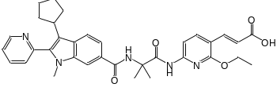 | 8.113 | 0.08 | -159.7
N1 | 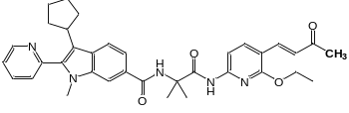 | 9.686 | 0.54 | -170.1
N2 | 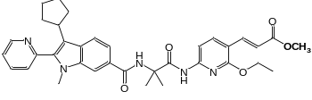 | 9.867 | 0.37 | -183.7
N3 | 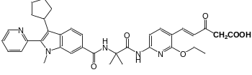 | 8.757 | 0.96 | -189.3
N4 | 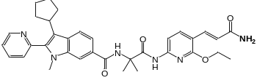 | 9.886 | 0.07 | -169.5
N5 | 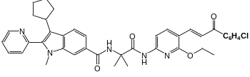 | 7.374 | 0.54 | -135.0
N6 | 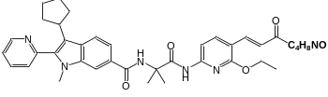 | 8.555 | 0.02 | -166.5
N7 | 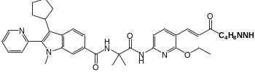 | 8.375 | 0.08 | -162.0
N8 | 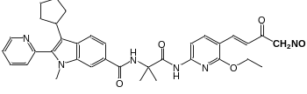 | 8.934 | 0.51 | -176.8
N9 | 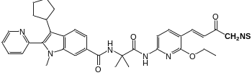 | 8.251 | 0.37 | -157.3
N10 | 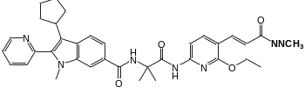 | 9.555 | 1.55 | -155.7
N11 | 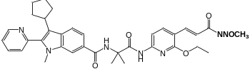 | 9.512 | 0.37 | -175.8
N12 | 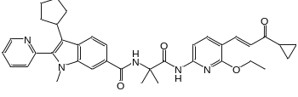 | 8.402 | 0.37 | -183.8
N13 | 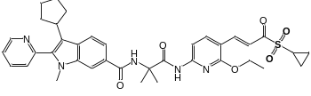 | 9.331 | 1.47 | -172.1
N14 | 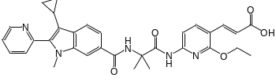 | 11.79 | 0.53 | -155.7
N15 | 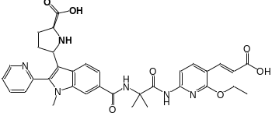 | 12.05 | 0.08 | -195.6
N16 | 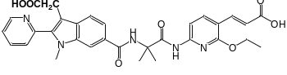 | 10.32 | 0.03 | -156.8
N17 | 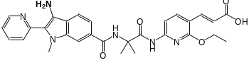 | 11.74 | 0.28 | -183.2
N18 | 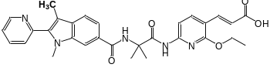 | 10.56 | 0.31 | -172.4
N19 | 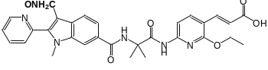 | 10.94 | 0.88 | -175.7
N20 | 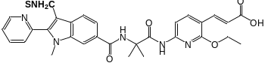 | 10.37 | 0.23 | -175.6
N21 | 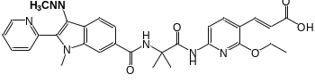 | 11.64 | 0.37 | -191.0
N22 | 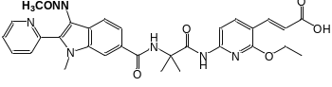 | 11.51 | 0.32 | -181.8
N23 | 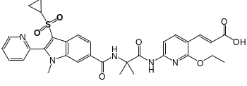 | 11.71 | 0.36 | -182.4
N24 | 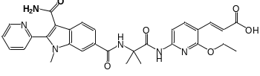 | 10.99 | 0.38 | -175.7
N25 | 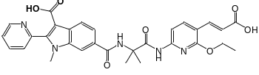 | 10.99 | 0.22 | -178.1
R | 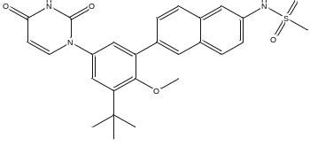 | 9.016 | 0.30 | -171.0
^{R}Reference Molecule, which is approved direct-acting antiviral agents (Dasabuvir), ^{T}Template molecule, ^{N}New Designed molecules

