Table 1. Structures for Training set and Test set.
Training sets
S/NO | Molecules | Experimental  IC₅₀ (µM) | Experi  mental  PIC₅₀ | Predicted PIC₅₀ | Residual
D 1 rm | 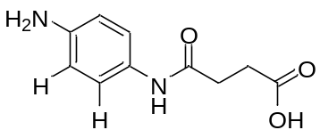 | 1.93 | 0.2856 | 0.4118 | 0.0668
D 2 rm | 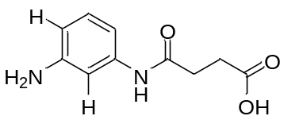 | 2.10 | 0.3222 | 0.2638 | 0.0106
D 3 rm | 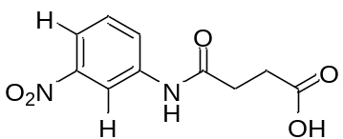 | 2.42 | 0.3838 | 0.4081 | -0.0410
D 4 rm | 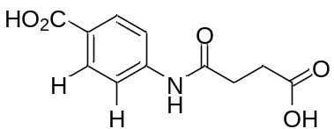 | 2.43 | 0.3856 | 0.5156 | -0.0696
D 5 rm | 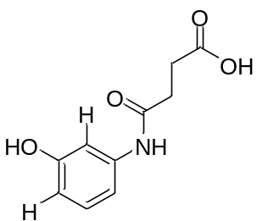 | 2.53 | 0.4031 | 0.5995 | 0.0837
D 6 rm | 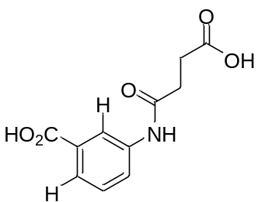 | 2.74 | 0.4378 | 0.4802 | 0.0924
D 7 rm | 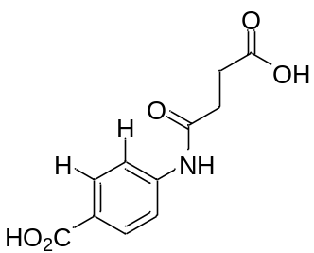 | 3.48 | 0.5416 | 0.5466 | 0.0668
10 rm | 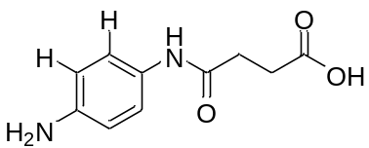 | 4.39 | 0.6425 | 0.5617 | 0.0106
11 rm | 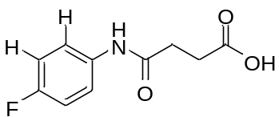 | 4.53 | 0.6561 | 0.8118 | -0.0410
12 rm | 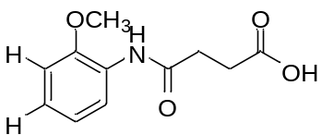 | 4.87 | 0.6875 | 0.7264 | -0.0696
13 rm | 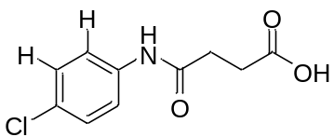 | 4.93 | 0.6928 | 0.7285 | 0.0837
14 rm | 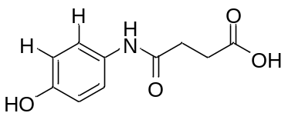 | 5.61 | 0.7490 | 0.5925 | 0.0924
15 rm | 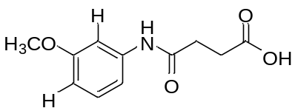 | 6.59 | 0.8189 | 0.8142 | 0.0668
18 rm | 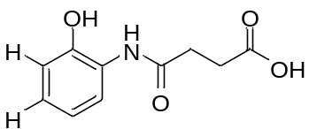 | 8.26 | 0.9170 | 0.5925 | 0.0106
19 rm | 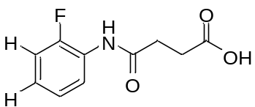 | 8.62 | 0.9355 | 0.9357 | -0.0410
20 rm | 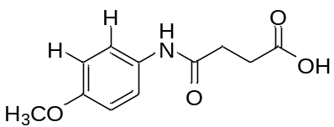 | 9.59 | 0.9818 | 0.7995 | -0.0696
23 rm | 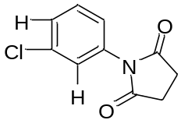 | 1.44 | 0.1584 | 0.2012 | 0.0837
29 rm | 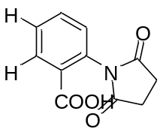 | 2.95 | 0.4698 | 0.7142 | 0.0924
30 rm | 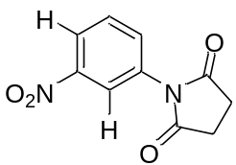 | 3.00 | 0.4771 | 0.5778 | 0.0668
31 rm | 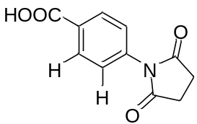 | 3.05 | 0.4843 | 0.5916 | 0.0106
32 rm | 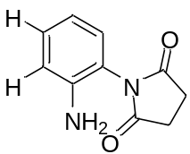 | 3.68 | 0.5658 | 0.4350 | -0.0410
33 rm | 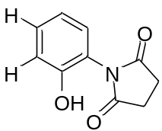 | 4.18 | 0.6212 | 0.7096 | -0.0696
34 rm | 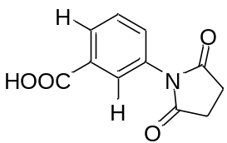 | 4.20 | 0.6232 | 0.5165 | 0.0837
35 rm | 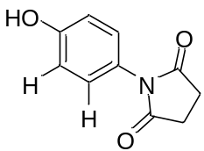 | 4.29 | 0.6325 | 0.6306 | 0.0924
36 rm | 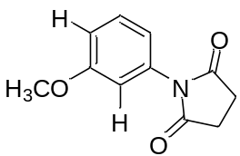 | 4.47 | 0.6503 | 0.7301 | 0.0668
37 rm | 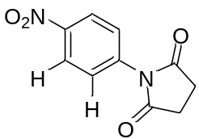 | 4.55 | 0.6580 | 0.6653 | 0.0106
38 rm | 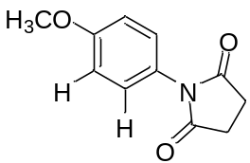 | 4.75 | 0.6767 | 0.8792 | -0.0410
39 rm | 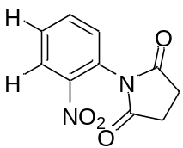 | 5.61 | 0.7490 | 0.5989 | -0.0696
40 rm | 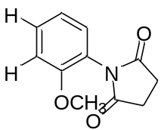 | 5.65 | 0.7520 | 0.7989 | 0.0837
41 rm | 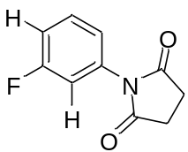 | 7.78 | 0.8910 | 0.8451 | 0.0924
42 rm | 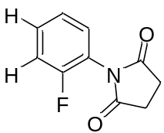 | 9.74 | 0.9886 | 0.6653 | 0.0668
47 rm | 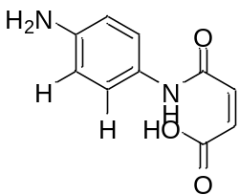 | 1.34 | 0.1271 | 0.2200 | 0.0106
48 rm | 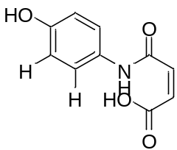 | 2.19 | 0.3404 | 0.4729 | -0.0410
49 rm | 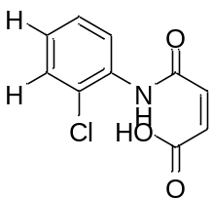 | 2.34 | 0.3692 | 0.3613 | -0.0696
50 rm | 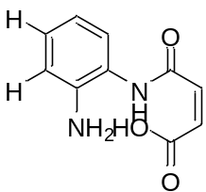 | 6.42 | 0.8075 | 0.7105 | 0.0837
51 rm | 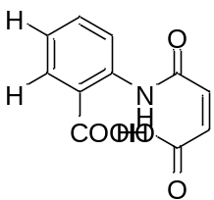 | 6.66 | 0.8235 | 0.8816 | 0.0924
52 rm | 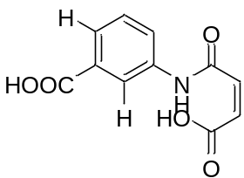 | 7.38 | 0.8681 | 0.7905 | 0.0668
53 rm | 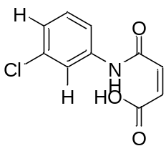 | 7.50 | 0.8751 | 0.8083 | 0.0106
54 rm | 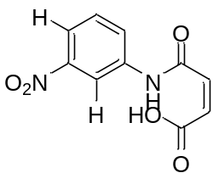 | 7.97 | 0.9015 | 0.8909 | -0.0410
55 rm | 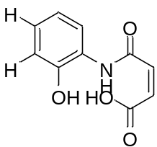 | 8.07 | 0.9069 | 0.9478 | -0.0696
56 rm | 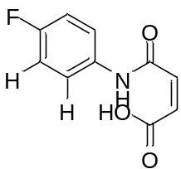 | 8.35 | 0.9217 | 0.9913 | 0.0837
57 rm | 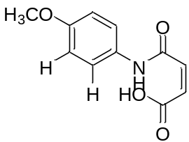 | 8.47 | 0.9279 | 0.8442 | 0.0924
58 rm | 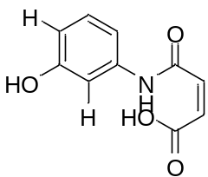 | 8.95 | 0.9518 | 0.8594 | 0.0668

Table 2: Test Set and the activities
S/No | Molecules | Experimental  IC₅₀ (µM) | Experi  mental  PIC₅₀ | Predicted PIC₅₀ | Residual
D^{test} 8 rm | 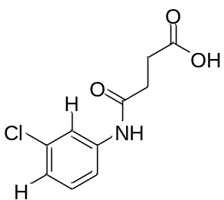 | 3.80 | 0.5798 | 0.4354 | 0.1444
D^{test}16 rm | 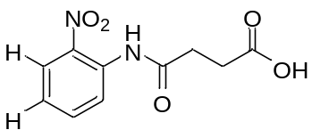 | 7.69 | 0.8859 | 0.6642 | 0.2218
D^{test}17 rm | 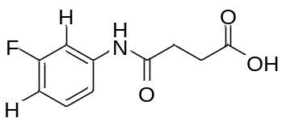 | 8.14 | 0.9106 | 0.8259 | 0.0847
D^{test}24 rm | 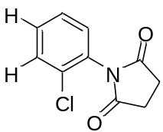 | 1.65 | 0.2175 | 0.1157 | 0.1018
D^{test}25 rm | 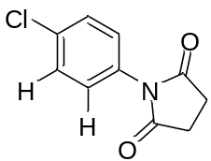 | 1.65 | 0.2175 | 0.2106 | 0.0069
D^{test}26 rm | 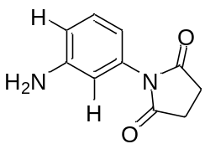 | 1.78 | 0.2504 | 0.4266 | -0.1762
D^{test}27 rm | 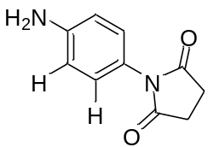 | 2.81 | 0.4487 | 0.7349 | -0.2862
D^{test}28 rm | 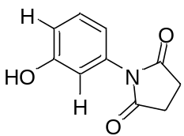 | 2.84 | 0.4533 | 0.5813 | -0.1280
D^{test}70 rm | 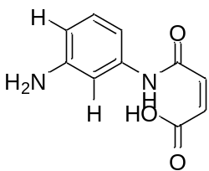 | 6.01 | 0.7789 | 0.6625 | 0.1164
D^{test}71 rm |  | 6.22 | 0.7938 | 0.6074 | 0.1864
D^{test}72 rm | 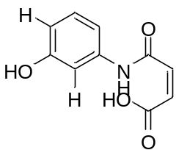 | 6.93 | 0.8407 | 0.9040 | -0.0633
D^{test}73 rm |  | 7.13 | 0.8531 | 0.8816 | -0.0285
D^{test}74 rm |  | 7.46 | 0.8727 | 0.6200 | 0.2528
D^{test}77 rm |  | 8.93 | 0.9509 | 0.7484 | 0.2025
D^{test}78 rm | 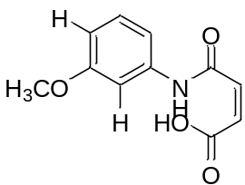 | 9.24 | 0.9657 | 1.0178 | -0.0521

