In-silico and in-vitro analysis of novel substituted benzimidazolyl derivatives for antimycobacterial potentials targeting enoyl acyl carrier protein reductase (InhA)

SPECTRAL DATA
Compound 4
Yield: 64%, (benzene/chloroform/methanol 60:20:20), Rf =0.580; mp 204-206˚C. λ _{max} 261nm, IR (KBR, ν cm⁻¹): 2935 (OH), 3255 (NH), 2819 (CH), 1600 (CO), 1355 (C=C_{Ar} 771 (CH_{Ar bend}). Analytical value calculated for C₂₃H₂₀N₃O₂Cl (405.00): C, 68.33; H, 4.95; N, 10.39. Found: C, 68.42; H, 4.91; N, 10.37. ¹H NMR (DMSO –d₆) δ (ppm):2.51 (3H, CH₃); 4.0-4.2 (3H, CH, OH, NH); 4.7 (1H, CH); 7.4 (Benzimidazole _{Ar}); 8.0 (9 H, Phenyl). ¹³C NMR (DMSO –d₆) δ (ppm):61 (C-Cl _{Ar}); 83(C); 115-140 (C_{Ar}); 201(C=O). ^{ADS}LC-MS (m/z) calculated for C₂₃H₂₀N₃O₂Cl: 406 [m⁺¹].

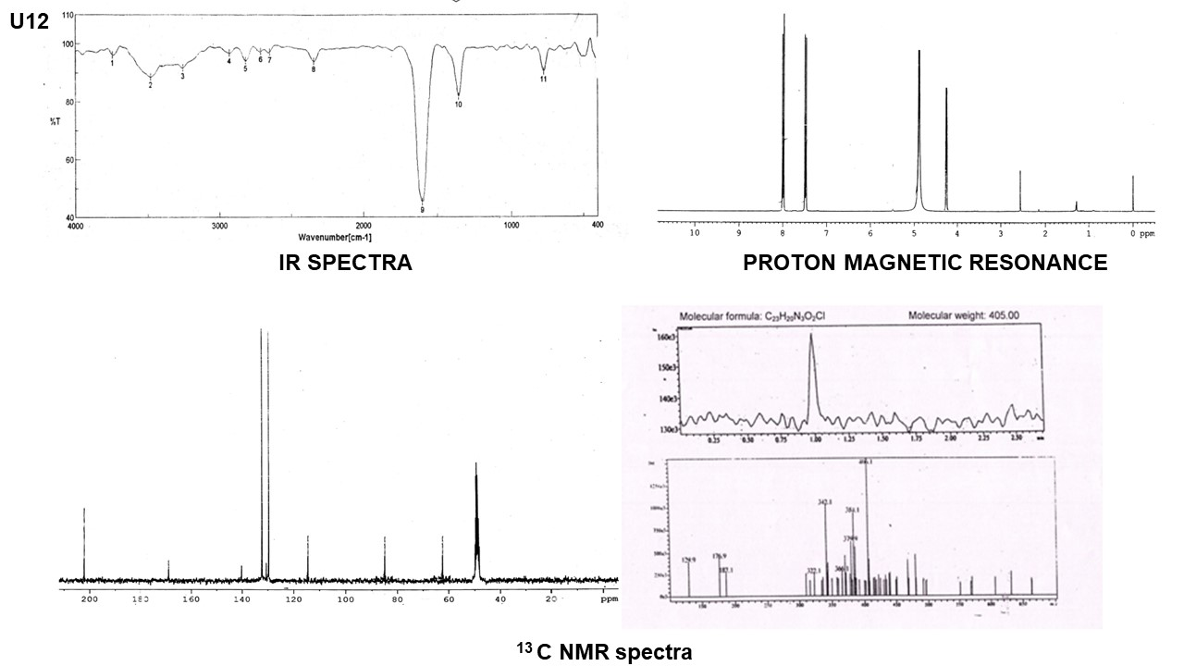

Compound 5a
Yield: 61%, (benzene/chloroform/methanol 60:20:20), Rf =0.498; mp 203˚C. λ _{max} 278nm, IR (KBR, ν cm⁻¹): 2988.9 (OH), 3058 (NH), 2843 (CH), 1687 (CO), 1587 (C=N), 1416 (C=C), 1178 (CN), 1093 (Cl_{Ar}), 1011 (CH₃). Analytical value calculated for C₂₃H₂₁N₄O₂Cl(420.89): C, 65.57; H, 4.98; N, 13.30. Found: C, 62.48; H, 4.93; N, 13.33. ¹H NMR (DMSO –d₆) δ (ppm): 2.1 (1H, NH); 2.5 (3H, CH₃); 4.14-4.21 (2H, OH); 4.7 (2H, CH); 7.4-8.2 (13 H, aromatic). ¹³C NMR (DMSO –d₆) δ (ppm):61 (C_{Clphe}); 81(C); 140 (C); 113-138 (C_{Ar}); 201 (C). ^{ADS}LC-MS (m/z) calculated for C₂₃H₂₁N₄O₂Cl:419.6 [m⁺¹].
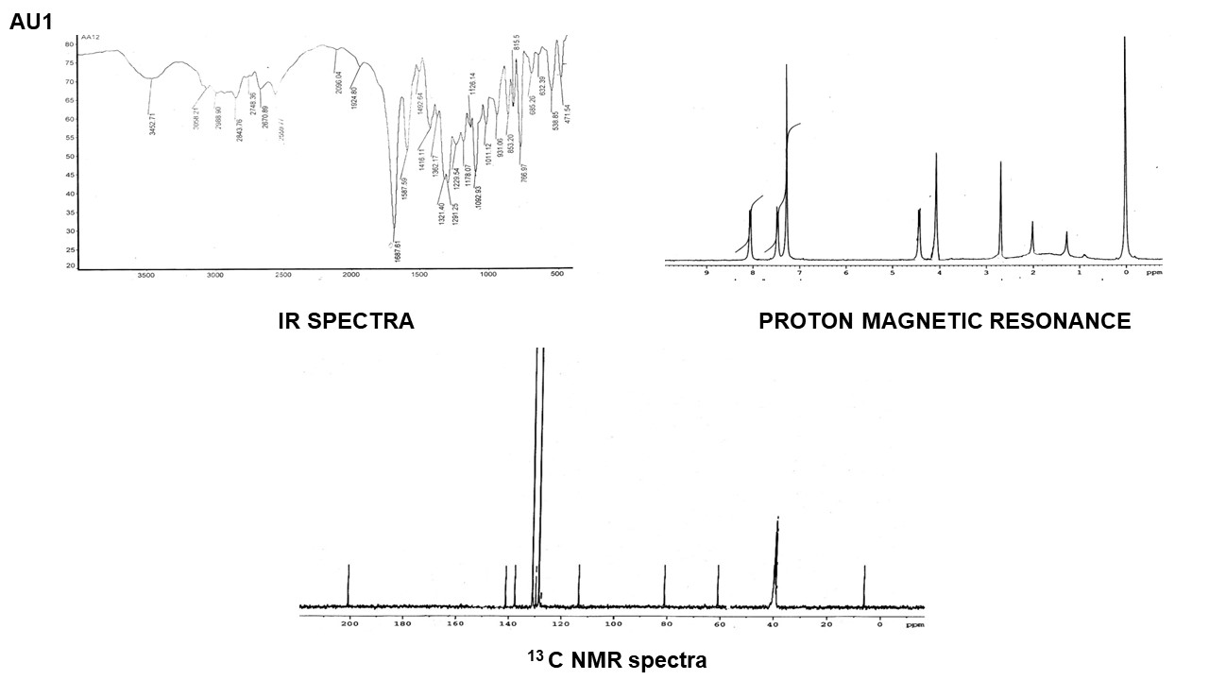

Compound 5b
Yield: 62%, (benzene/chloroform/methanol 60:20:20), Rf =0.528; mp 175-177˚C. λ _{max} 279nm, IR (KBR, ν cm⁻¹): 3453 (NH), 2729 (OH), 2811 (CH), 2350 (CO), 1594 (C=N), 1351 (C=C), 1089 (Cl_{Ar}), 1002 (CH₃). Analytical value calculated for C₂₄H₂₁N₄O₃Cl (448.90): C, 64.15; H, 4.67; N, 12.47. Found: C, 64.21; H, 4.72; N, 12.43. ¹H NMR (DMSO –d₆) δ (ppm): 2.0 (1H, NH); 2.51 (3H, CH₃); 4.1-4.2 (2H, CH, OH); 4.7 (1H, CH); 7.6 (5 H, Ar), 8.1 (5H, Ph Ar). ¹³C NMR (DMSO –d₆) δ (ppm):60 (C_{ClPhen}); 80 (C, C=O, CH); 141 (C, C=N); 115-140 (C_{Ar}); 168 (C, CONH); 201 (C, C=O). LC-MS (m/z) calculated for C₂₄H₂₁N₄O₃Cl: 448.90 [M+H] ₊. Found: 449.6[M-H] _{+.}
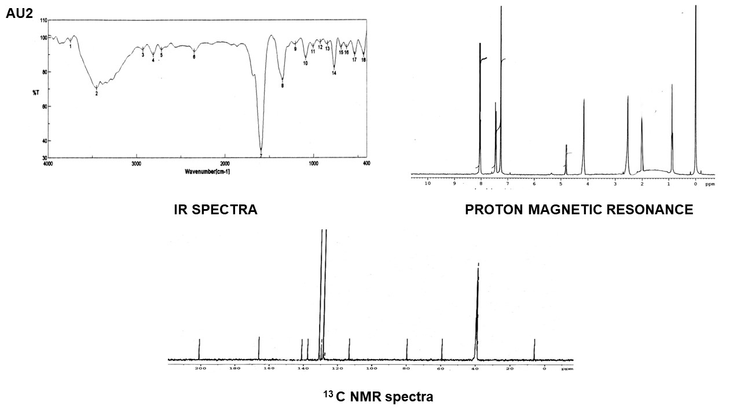

Compound 5c
Yield: 64%, (benzene/chloroform/methanol 60:20:20), Rf =0.462; mp 168-170˚C. IR (KBR, ν cm⁻¹): 2992.98 (OH), 3054 (NH), 2839 (CH), 1684 (CO), 1592 (C=N), 1425 (C=C), 1176 (CN), 1093 (Cl _{Ar}), 1019 (CH₃). Analytical value calculated for C₂₃H₂₀N₅O₃ Cl (449.5): C, 61.46; H, 4.45; N, 15.59. Found: C, 61.57; H, 4.40; N, 15.62. ¹H NMR (DMSO –d₆) δ (ppm): 2.0 (1H, NH); 2.5 (3H, CH₃); 4.0-4.3 (3H, CH, OH, NH); 7.3-7.5 (4 H, Ar); 8.0-8.2 (9H, Ar). ¹³C NMR (DMSO –d₆) δ (ppm):60 (C, CH); 80(C, C=O, CH); 115-140 (CAr); 150 (C pyridyl); 167 (C, CONH); 200 (C, CO). LC-MS (m/z) calculated for C₂₃H₂₀N₅O₃ Cl: 449.5[M+H] ₊. Found: 448.1[M-H] _{+.}
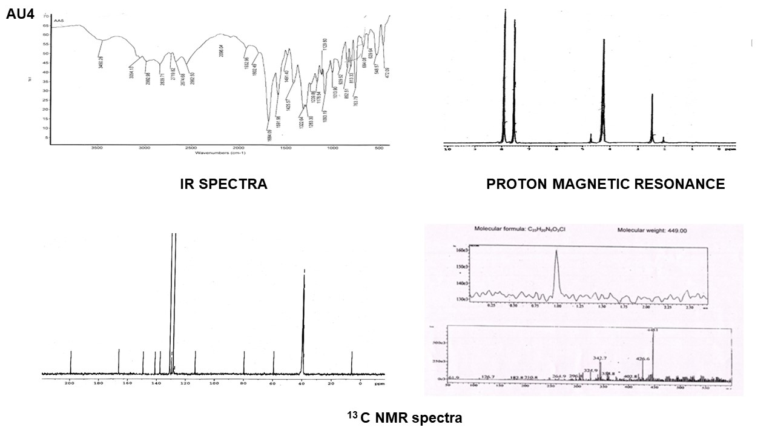
Compound 5d
Yield: 60%, (benzene/chloroform/methanol 60:20:20), Rf =0.523; mp 176˚C. λ _{max} 280nm, IR (KBR, ν cm⁻¹): 3444 (NH), 2811 (OH), 1685 (CO), 1594 (C=N), 1351 (C=C), 119.5 (F_{Ar bend}). ¹H NMR (DMSO –d₆) δ (ppm):2.0 (1H, NH); 2.5 (3H, CH₃); 5.5 (1H, 4.0-4.3 (3H, NH, OH, CH); 6.8-7.8 (13 H, Ar). ¹³C NMR (DMSO –d₆) δ (ppm): 83 (C); 140 (C); 114-139 (C_{Ar}); 16 (C, CONH); 201 (C). LC-MS (m/z) calculated for C₂₄H₂₁N₄O₃F: (432): [M+H] ₊. Found: 431[M-H]_{+.}
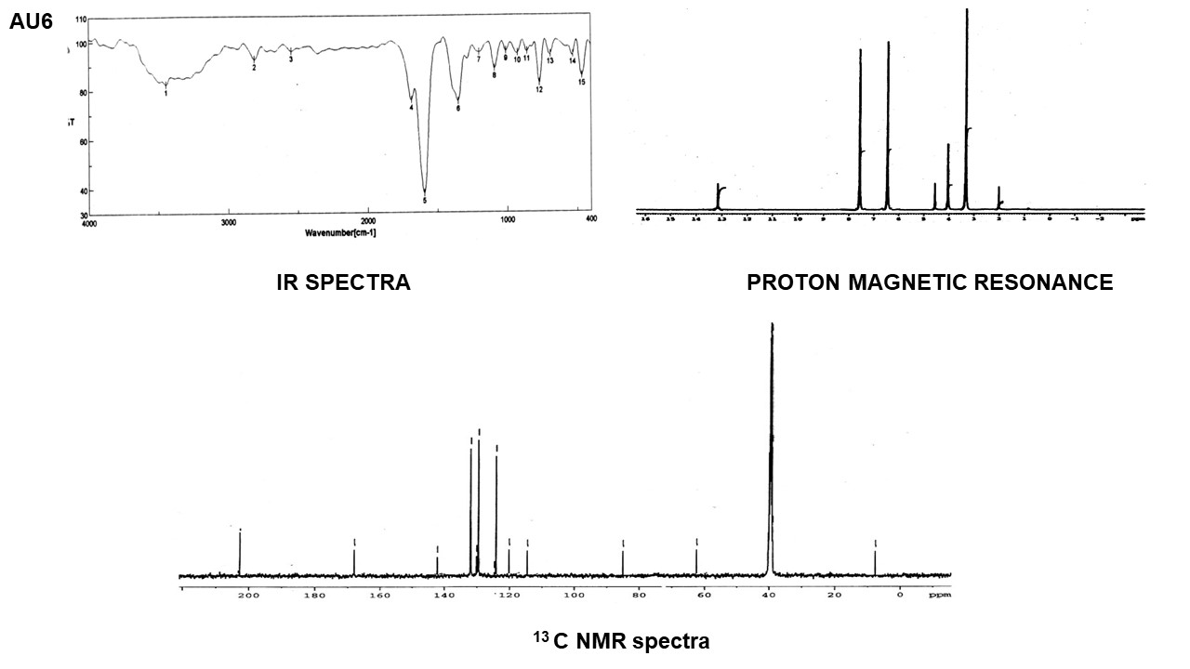

Compound 5e
Yield: 58%, (benzene/chloroform/methanol 60:20:20), Rf =0.568; mp 173-175˚C. λ _{max} 274nm, IR (KBR, ν cm⁻¹): 3089 (NH), 2935 (OH), 2859.9 (CH), 2679 (CO), 1587 (C=N), 1342 (C=C), 1009 (CH₃). ¹H NMR (DMSO –d₆) δ (ppm):2.51 (3H, CH₃); 2.0 (1H, NH); 4.14-4.21 (2H, OH, CH); 8.1 (1H, NH); 7.2-7.6 (8 H, Ar).¹³C NMR (DMSO –d₆) δ (ppm): 63 (C), 80 (C); 115-140 (C_{Ar}); 168 (C_{Ph}); 201 (C).
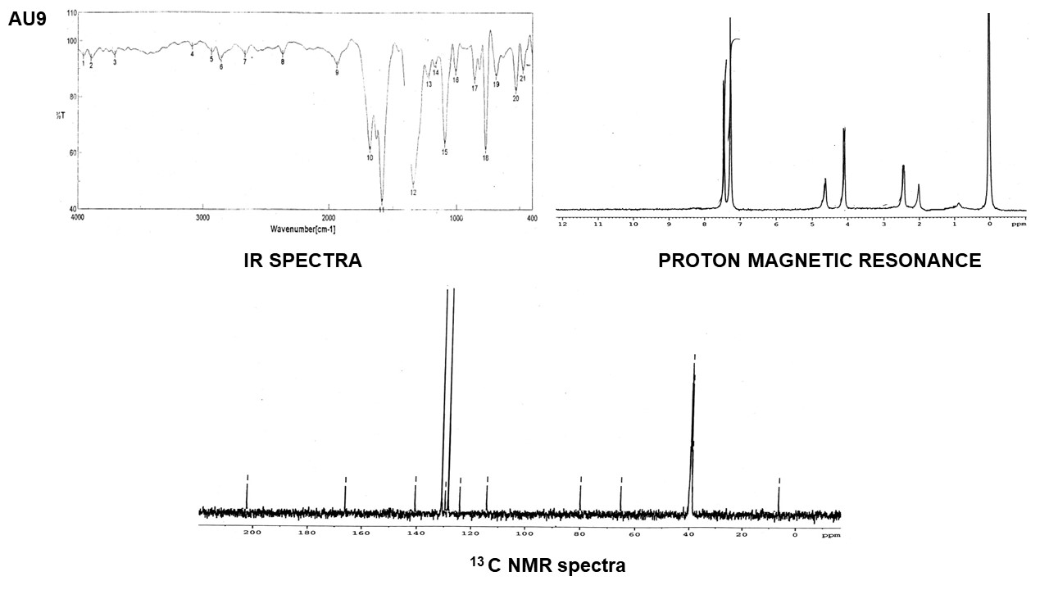
Compound 5f
Yield: 55%, (benzene/chloroform/methanol 60:20:20), Rf =0.535; mp 174-176˚C. λ _{max} 280nm, IR (KBR, ν cm⁻¹): 3482 (NH), 2929 (OH), 2811 (CH), 1594 (C=N), 1351 (C=C), 1039 (CH₃). ¹H NMR (DMSO –d₆) δ (ppm): 2.51 (3H, CH₃); 4.0-4.2 (3H, CH, OH, NH); 4.7 (1H, OH); 7.4-8.0 (13 H, aromatic). ¹³C NMR (DMSO –d₆) δ (ppm):61 (C); 83 (C); 115-140 (C_{Ar}); 120-130 (C_{Ph}); 201 (C).

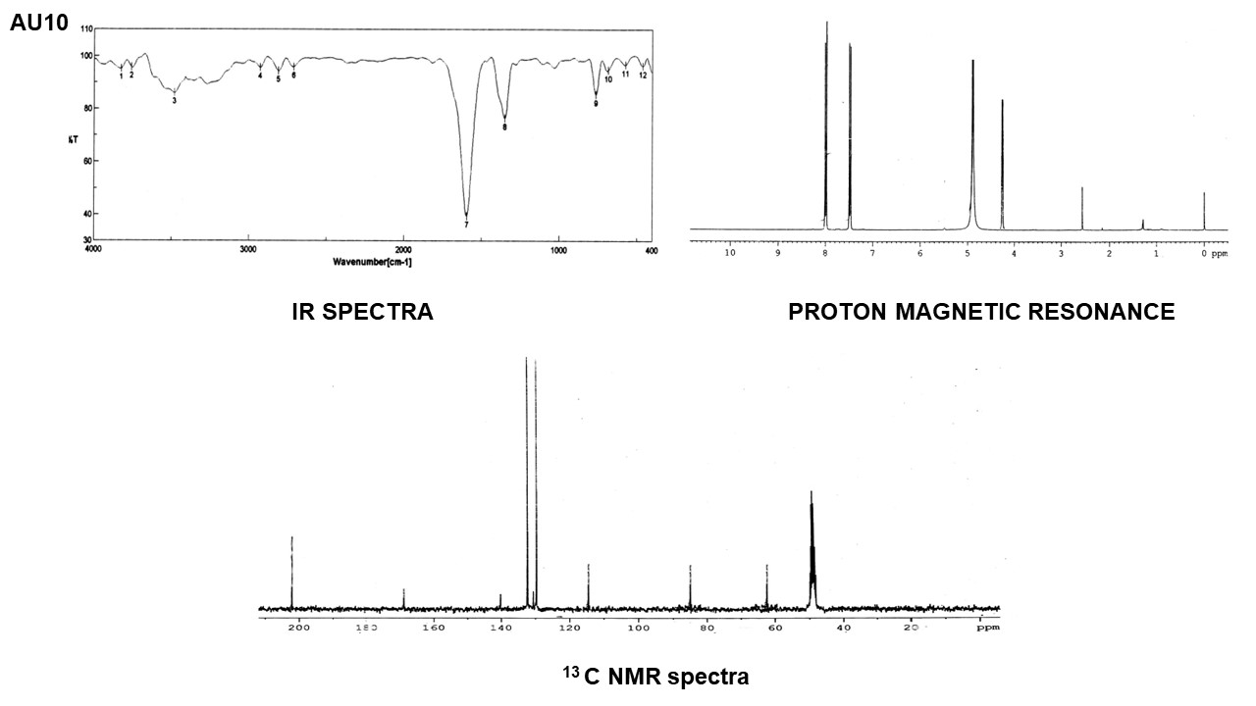

Mechanism of product formation

6 Steps of process happens to get the final novel compounds

Step - I
CH₃
+
Cl
C
CH₃
– HCl
CH₃
C=O
CH₃
O
N
N
N
N
N
H

This is a simple reaction between a secondary amine and acetyl chloride (acetylation).
Step - II
CH₃
C= O
CH
CH₃
C = O
CH₃
+
H
C
O
R
CH
R
N
N
N
N

This is typical Claisen-Schimdt reaction. The condensation takes place at the –COCH₃ group instead of –N=C–CH₃ group because the methyl group is more activated in –COCH₃ group, since oxygen is more electronegative. The mechanism is similar as in Step I.

Step - III
1.
CH₃
C= O
CH₂ – H
R
CH₃
C=O
CH₂
C
H
O
N
N
N
N

2.
CH₃
C = O
CH
R
CH
H₂O₂
CH₃
C=O
CH
R
CH
O
N
N
N
N
R
CH₃
C=O
CH₂
H
C
O
R
H
CH₃
C=O
CH₂
H
C
OH

CH₃
C=O
CH
R
CH
– H₂O
N
N
N
N
N
N
R

+
+

3.

It takes place by Cis-hydroxylation followed by dehydration.
Step IV
CH₃
C=O
CH
R
CH
H₂O₂
CH₃
C=O
CH
R
CH
OH
OH
N
N
N
N
CH₃
C=O
CH
R
CH
O
H₂O
N
N
Step - V
N
N
N
N
EtOH
R₁ NH₂
CH₃
CH₃
C
O
C = O
CH
CH
CH
R
CH
R
NH
OH
O
R₁

The reaction involves cleavage of the epoxy ring.
Step - VI
R
CH₃
C=O
CH
R
CH
O
CH₃
EtOH
CH
CH
O
C
R₁NH₂
O
+
H
R₁NH₂

N
CH₃
C=O
CH
R
CH
OH
NH
R₁
N
N
N
N
N
N

Spectral analysis to confirm the product formation of best leads

Spectral Details of compound 4 (Amino derivative)
Elemental analysis

Analysis | % C | % H | % N
Calculated | 68.33 | 4.95 | 10.39
Observed | 68.42 | 4.91 | 10.37

IR Spectral Data

S. No | Type of Vibration | Wave Number Cm⁻¹
 | OH Stretching | 3482.8
 | NH Stretching | 3255.25
 | CH aliphatic Stretching | 2819.42
 | C=O Stretching | 1600.63
 | C=C Aromatic Stretching | 1355.71
 | CH Aromatic Bending | 771.387

PMR data

S.No | δ Value | Type of proton | No of protons
1. | 2.4 – 2.6 | CH₃ | 3
2. | 3.9 | NH (Attached to phenyl) | 1
3. | 4.1 – 4.3 | OH, CH | 2
4. | 4.6 | CH (attached to OH and C=O) | 1
5. | 7.1 – 78.1 | Aromatic Protons | 13

¹³C NMR Data

S.No | ppm | Type of Carbon
1. | 7.9 | CH carbons attached to methyl
2. | 61 | CH carbons attached to chlorophenyl
3. | 83 | CH carbons attached to OH, C=O and CH
4. | 115 – 140 | Aromatic, imidazole and carbons
5. | 201 | C=O carbon

Mass Fragmentation Details

- Molecular ion peak (M⁺¹)⁺ peak at 406 corresponds to molecular weight.
- m/e Peaks observed at 314 correspond to the fragment ion.
- LCMS of compound 1 shows a single peak in the liquid chromatogram and m⁺¹ ion peak at 406 corresponds to the molecular weight.
Based on the above Spectral characterization, the structure of compound 4 is confirmed.

Spectral Details of compound 5c (Hydrazine derivative)
Elemental analysis

Analysis | % C | % H | % N
Calculated | 61.46 | 4.45 | 15.59
Observed | 61.57 | 4.40 | 15.62

IR Spectral Data

S. No | Type of Vibration | Wave Number cm⁻¹
 | OH- Stretching | 3450.28
 | NH Stretching | 3054.13
 | CH Stretching | 2839.71
 | C=O Stretching | 1684.09
 | C=N Stretching | 1591.96
 | C=C- Aromatic Stretching | 1425.57
 | CN- Vibration of aliphatic amine | 1176.54
 | Aromatic Chloro Substitution | 1093.19
 | CH₃ | 1019.90
 | CH Aromatic Bending | 852.51

PMR data

S.No | δ Value | Type of proton | No of protons
1 | 1.9 - 2.0 | NH (Attached to CH) | 1
2 | 2.9 – 3.2 | CH₃ | 3
3 | 3.7 – 3.9 | CH (Attached to NH) | 1
4 | 4.0 – 4.2 | OH | 1
5 | 4.6 – 4.7 | CH (Attached to OH) | 1
6 | 6.7 – 7.4 | Aromatic Protons | 12
7 | 8.1 | NH (Attached to CO) | 1

¹³C NMR Data

S.No | ppm | Type of Carbon
1. | 7.8 | CH carbon attached to methyl
2. | 60 | CH carbon attached to chloro phenyl
3. | 80 | CH carbon attached to OH and CO
4. | 115 – 140, 150 | Aromatic Carbons and benzimidazole Carbons
5. | 167 | C=O carbon attached to NH
6. | 200 | C=O carbonyl carbons

Mass Fragmentation Details

- Molecular ion peak (M⁺¹)⁺ peak at 449.
- m/e Peaks were observed at 343, 325, and 297 which represent three different fragments.
- LCMS of compound 4 shows a single peak in the liquid chromatogram and m⁺¹ ion peak at 525 corresponds to the molecular weight.
Based on the above Spectral characterization, the structure of compound 5c is confirmed.

