Supplementary data
- methyl4-((N-(1-(1-methyl-1H-indole-2-carbonyl)piperidin-4-yl)methylsulfonamido)methyl)benzoate(7b)
¹H NMR: δ 0.85-1.86 (4H, m, 0.90 (d, J = 13.4 Hz), 1.28 (d, J = 13.4 Hz), 1.30 (d, J = 13.4 Hz), 1.86 (d, J = 13.4 Hz)), 2.07-2.92 (8H, m, 2.07 (s), 2.13 (d, J = 15.6 Hz), 2.56 (d, J = 15.6 Hz), 2.90 (s)), 3.77-3.79 (4H, m, 3.77 (d, J = 15.2 Hz), 3.77 (d, J = 15.2 Hz), 3.78 (d, J = 15.2 Hz), 3.78 (d, J = 15.2 Hz)), 3.94 (3H, s), 4.13-4.15 (2H, 4.11 (t, J = 10.3 Hz), 4.11 (d, J = 6.7 Hz)), 4.50-4.67 (2H, 4.55 (s)), 6.54-7.37 (6H, m, 6.55 (d, J = 7.9 Hz), 7.16 (d, J = 8.1Hz), 7.28 (d, J = 7.9 Hz), 7.34 (d, J = 8.1Hz), 7.35 (d, J = 8.5 Hz)), 7.50-7.62 (2H, d, J = 8.5 Hz).LCMS m/z Cal. [M-H]⁺483.18 found [M-H]⁺483.23.
- N-(1-(1-methyl-1H-indole-2-carbonyl)piperidin-4-yl)-N-(pyridin-4-ylmethyl)methanesulfonamide (7 C)
¹H NMR δ 1.29-1.91 (4H, m, 1.45 (d, J = 13.4 Hz), 1.90 (d, J = 13.4 Hz)), 3.16 (3H, s), 3.21-3.69 (4H, m, 3.53 (d, J = 15.2 Hz), 3.53 (d, J = 15.2 Hz)), 3.82 (3H, s), 4.00 (1H, t, J = 10.3 Hz), 4.92 (2H, s), 6.78 (1H, d, J = 1.0 Hz), 7.31-7.36 (5H, q, 7.31 (d, J = 8.0 Hz), 7.31 (t, J = 7.7 Hz), 7.35 (d, J = 8.0 Hz), 7.35 (d, J = 7.8 Hz), 7.36 (d, J = 8.0 Hz)), 7.66 (1H, d, J = 8.0 Hz), 8.73-8.77 (2H, d, 8.76 (d, J = 4.7 Hz), 8.76 (d, J = 1.9 Hz)). LCMS m/z Cal. [M-H]⁺426.17 found [M-H]⁺427.28.
- N-((4-bromothiophen-3-yl)methyl)-N-(1-(1-methyl-1H-indole-2-carbonyl)piperidin-4-yl)methanesulfonamide (7 d)
¹H NMR: δ 1.61-1.94 (4H, m, 1.78 (d, J = 13.5 Hz), 1.87 (d, J = 13.5 Hz)), 2.98 (3H, s), 3.42-3.86 (4H, m, 3.45 (d, J = 15.0 Hz), 3.75 (d, J = 15.2 Hz)), 4.09 (3H, s), 4.40 (1H, t, J = 10.3 Hz), 6.61 (1H, d, J = 1.0 Hz), 7.18-7.67 (6H, m, 7.20 (d, J = 1.5 Hz), 7.30 (d, J = 1.5 Hz), 7.32 (d, J = 8.0 Hz), 7.33 (t, J = 7.7 Hz), 7.41 (d, J = 7.8 Hz), 7.65 (d, J = 8.0 Hz)). LCMS m/z Cal. [M+H]⁺511.04 found [M+H]⁺509.76.
- N-(1-(1-methyl-1H-indole-2-carbonyl)piperidin-4-yl)-N-(pyridin-4-ylmethyl)methanesulfonamide (7 e)
¹H NMR: δ 1.30-2.52 (4H, m,1.47 (d, J = 13.4 Hz), 2.09 (d, J = 13.4 Hz)), 3.07 (3H, s), 3.25-3.69 (4H, m, 3.30 (d, J = 15.2 Hz), 3.30 (d, J = 15.2 Hz)), 3.86 (3H, s), 4.18 (1H, t, J = 10.3 Hz), 4.72 (2H, s), 6.86 (1H, d, J = 1.0 Hz), 7.19-7.77 (6H, m, 7.20 (d, J = 4.8 Hz), 7.31 (d, J = 8.0 Hz), 7.35 (t, J = 7.7 Hz), 7.39 (d, J = 7.8 Hz), 7.54 (d, J = 8.0 Hz)), 8.76 (2H, d, J = 4.8 Hz). LCMS m/z Cal. [M-H]⁺526.17 found [M-H]⁺526.82.
- N-((4-bromothiophen-2-yl)methyl)-N-(1-(1-methyl-1H-indole-2-carbonyl)piperidin-4-yl)methanesulfonamide(7g)
¹H NMR: δ 1.30-2.15 (15H, m,1.30 (d, J = 13.2 Hz), 1.43 (d, J = 13.2 Hz), 1.50 (d, J = 13.0 Hz), 1.51 (d, J = 12.9 Hz), 1. 51 (d, J = 12.9 Hz), 1.65 (d, J = 13.0 Hz), 1.68 (d, J = 13.1Hz), 1.73 (d, J = 13.1 Hz), 1.76 (d, J = 13.4 Hz), 1.77 (d, J = 13.4 Hz), 1.89 (d, J = 13.4 Hz), 1.96 (d, J = 13.4 Hz), 1.99 (d, J = 13.6 Hz), 2.02 (d, J = 13.6 Hz), 2.02 (d, J = 9.6 Hz)), 2.93 (3H, s), 3.03 (3H, s), 3.28-3.55 (5H, q, 3.28 (d, J = 9.9 Hz), 3.28 (d, J = 15.2 Hz), 3.50 (d, J = 15.2 Hz), 3.55 (d , J = 15.2 Hz), 3.55 (d, J = 15.2 Hz)), 3.78 (1H, J = 7.4 Hz), 4.02 (1H, t, J = 10.3 Hz), 4.62 (2H, 4,62(s)), 7.05 (1H, d, J = 1.9 Hz), 7.67 (1H, d, J = 1.9 Hz). LCMS m/z Cal. [M-H]⁺511.04 found [M-H]⁺512.02.
- N-(2,2-diphenylethyl)-N-(1-(1-methyl-1H-indole-2-carbonyl)piperidin-4-yl)methanesulfonamide(7h)
¹H NMR: δ 1.23-1.29 (4H, m, 1.26 (d, J = 13.4 Hz), 1.29 (d, J = 13.4 Hz)), 1.64 (3H, s), 2.25-2.89 (4H, m, 2.57 (d, J = 15.2 Hz), 2.88 (d, J = 15.2 Hz)), 2.90-3.99 (5H, q, 3.86 (d, J = 6.1 Hz), 3.99 (s)), 4.00 (1H, tt, J = 10.3 Hz), 4.30 (1H, t, J = 6.1 Hz), 6.67 (1H, d, J = 0.9 Hz), 7.19-7.80 (14H, m, 7.19 (tt, J = 7.7, 1.3 Hz), 7.23 (d, J = 7.8 Hz), 7.30 (m, J = 7.7 Hz), 7.35 (m, J = 7.8 Hz), 7.37 (d, J = 8.0 Hz), 7.77 (d, J = 8.0Hz), 7.79 (d, J = 7.8Hz)). LCMS m/z Cal. [M-H]⁺515.22 found [M-H]⁺516.24.
- N-(cyclohexylmethyl)-N-(1-(1-methyl-1H-indole-2-carbonyl)piperidin-4-yl)methanesulfonamide(7i)
¹H NMR : δ 0.90-1.94 (10H, m, 0.92 (d, J = 12.1 Hz), 0.94 (d, J = 12.1 Hz), 1.25 (d, J = 12.8 Hz), 1.29 (d, J = 12.8 Hz), 1.37 (d, J = 13.3 Hz), 1.48 (d, J = 13.3 Hz)), 1.67-1.94 (5H, q, 1.68 (d, J = 13.5 Hz), 1.79 (t, J = 10.3 Hz), 1.85 (d, J = 13.5 Hz)), 2.92 (3H, s), 3.00-3.04 (4H, m, 3.028 (d, J = 15.2 Hz), 3.028 (d, J = 15.2 Hz)), 3.77-3.85 (5H, q, 3.77 (d, J = 5.7 Hz), 3.85 (s)), 4.00 (1H, tt, J = 10.3 Hz), 6.67 (1H, d , J = 1.0 Hz), 7.20-7.70 (4H, m, 7.21 (d J = 8.0 Hz), 7.33 (t, J = 7.7Hz), 7.42 (d, J = 7.8 Hz), 7.69 (d, J = 8.0, 1.2, 0.5 Hz)). LCMS m/z Cal. [M+H]+431.22 found [M+H]+431.19.
- N-(3,5-dichlorobenzyl)-N-(1-(1-methyl-1H-indole-2-carbonyl)piperidin-4-yl)methanesulfonamide (7j)
¹H NMR: δ 0.90-1.87 (4H, m, 1.45 (d, J = 13.4 Hz), 1.64 (d, J = 13.4 Hz)), 2.92 (3H, s), 2.97-3.00 (4H, m, 2.98 (d, J = 15.2 Hz), 2,98 (d, J = 15.2 Hz)), 3.17 (3H, s), 3.82 (1H, t, J = 10.3 Hz), 4.40 (2H, s), 6.58 (1H, d, J = 1.0, 0.5 Hz), 7.18 (2H, d, J = 1.6 Hz), 7.30-7.66 (5H, q, 7.30 (t, J = 1.6 Hz), 7.34 (d, J = 8.0 Hz), 7.36 (t, J = 7.7 Hz), 7.41 (d, J = 7.8 Hz), 7.64 (d, J = 8.0 Hz)). LCMS m/z Cal. [M-H]⁺ 493.10 found [M-H]⁺494.10.

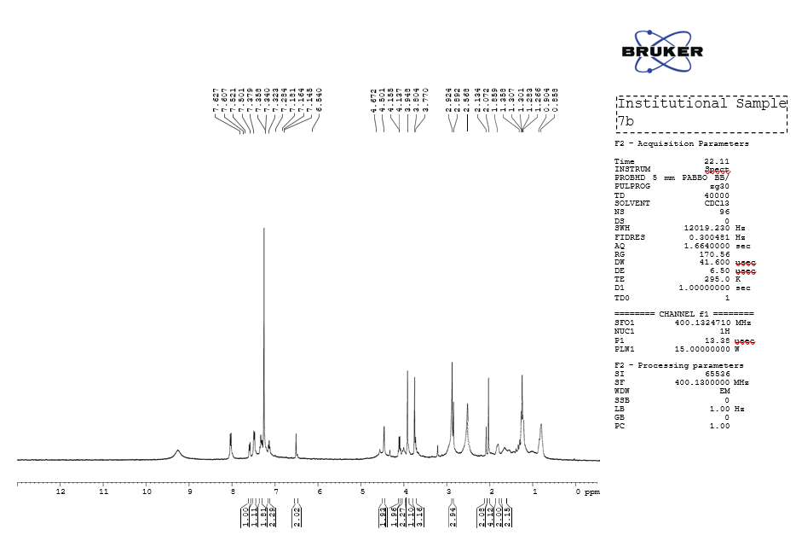
Fig:1 1 H NMR of compound 7b

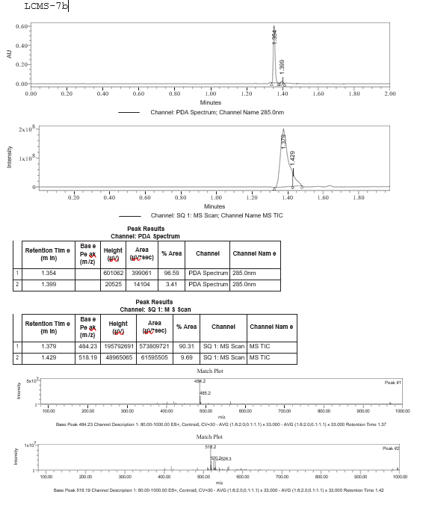
Figure 2 : LCMS data of compound 7b

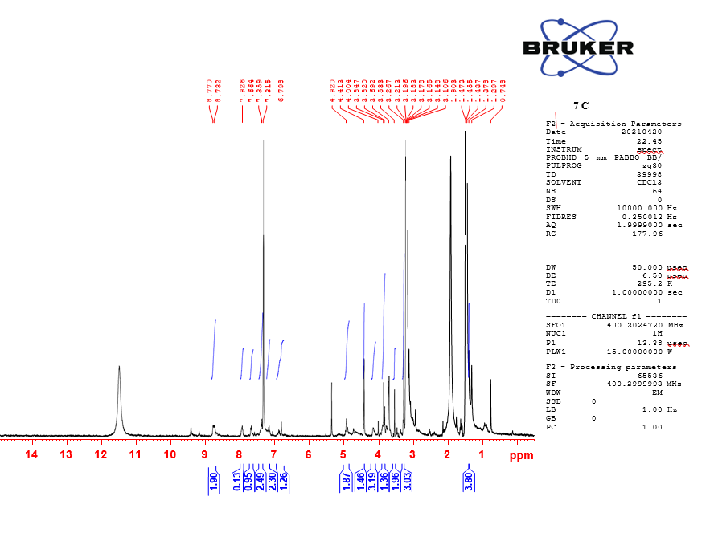
Fig:3 1 H NMR of compound 7c

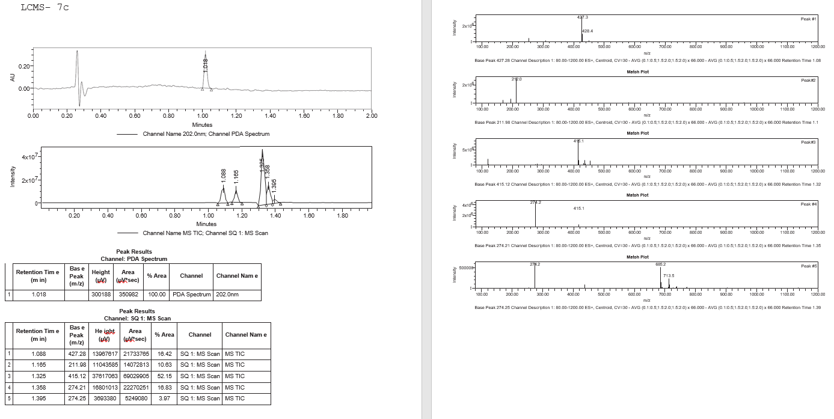

Figure 4: LCMS data of compound 7c

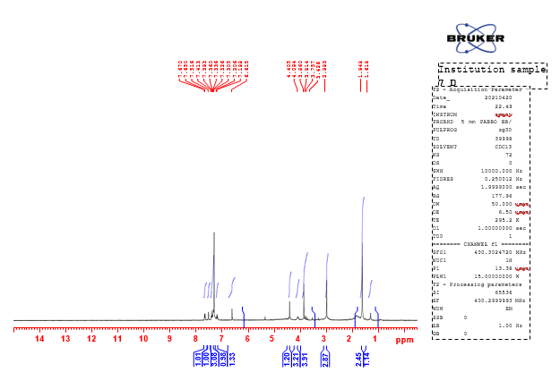

Fig:5 1 H NMR of compound 7d

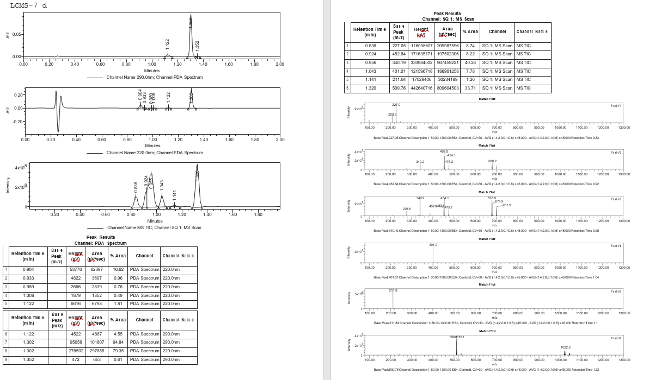

Figure 6: LCMS data of compound 7d
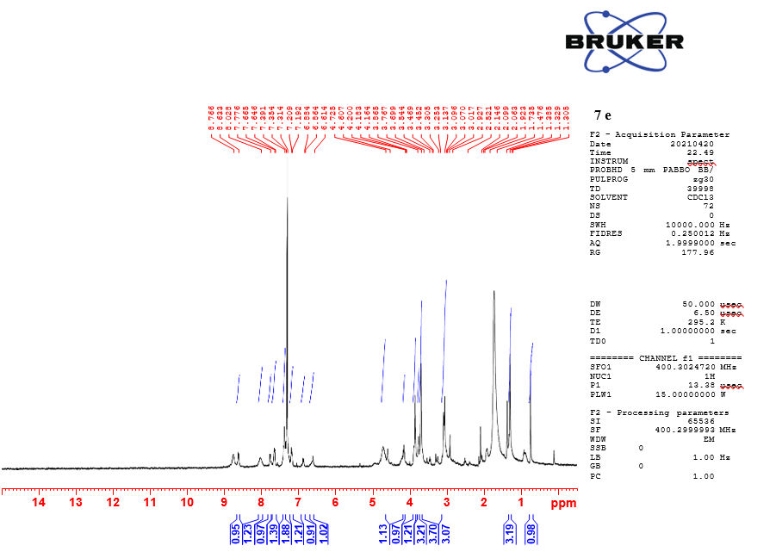

Fig:7 1 H NMR of compound 7e

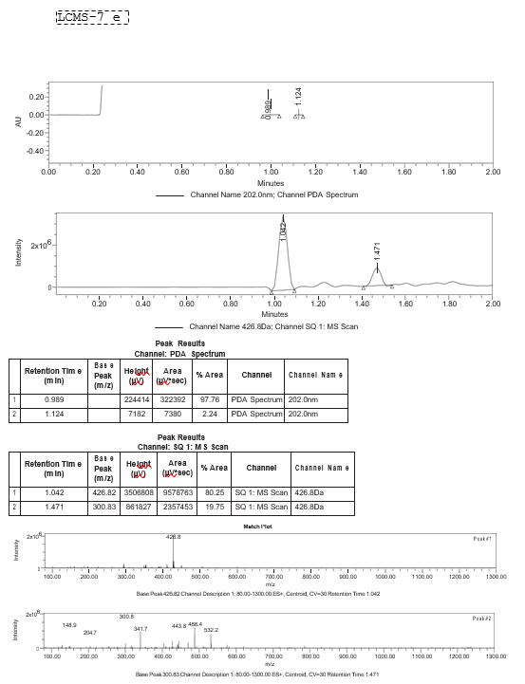

Figure 8: LCMS data of compound 7e

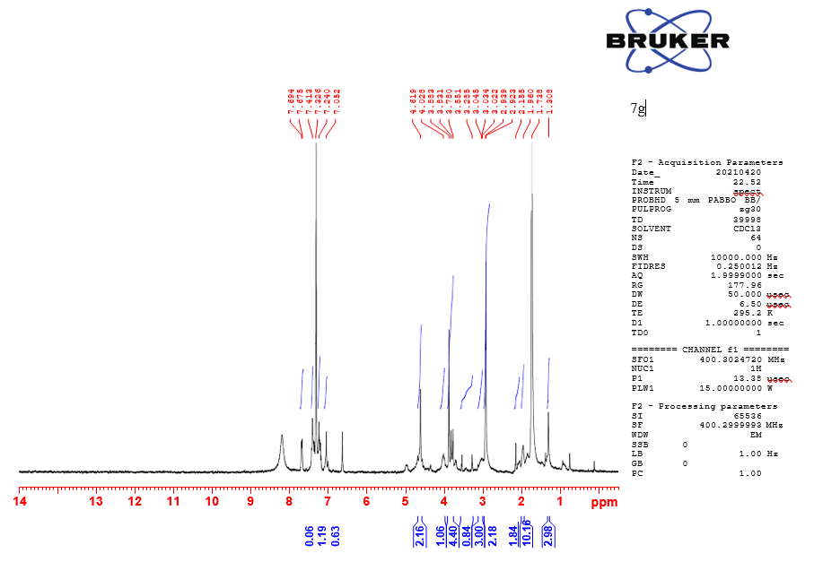

Fig:9 1 H NMR of compound 7g

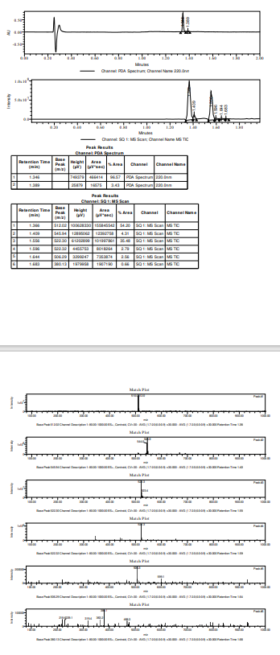

Figure 10 : LCMS data of compound 7g
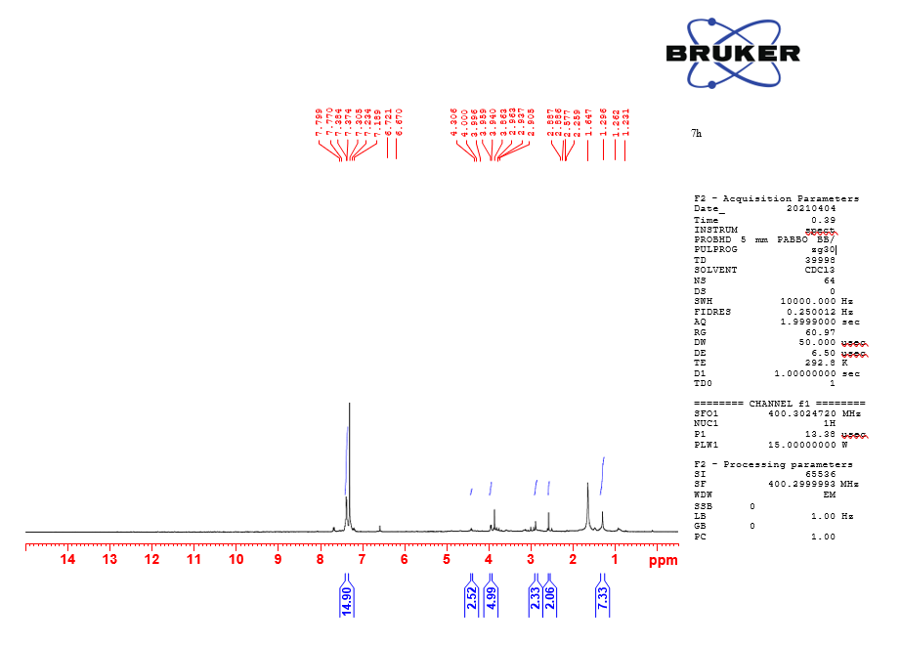
Fig:11 1 H NMR of compound 7h

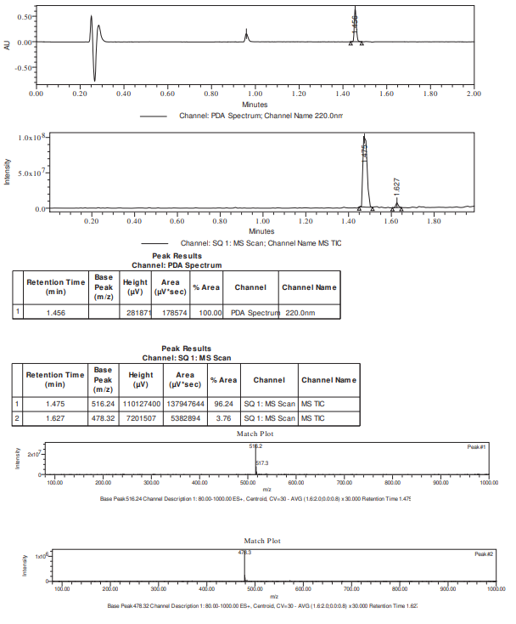
Figure 12 : LCMS data of compound 7h

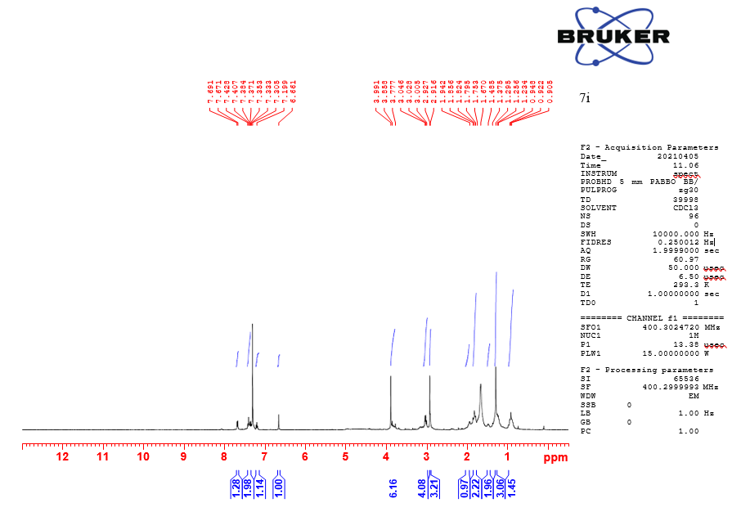

Fig:13 1 H NMR of compound 7i

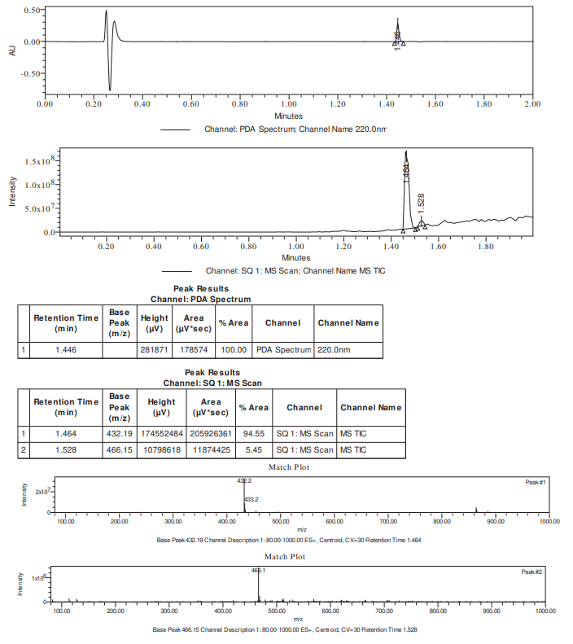
Figure 14 : LCMS data of compound 7i

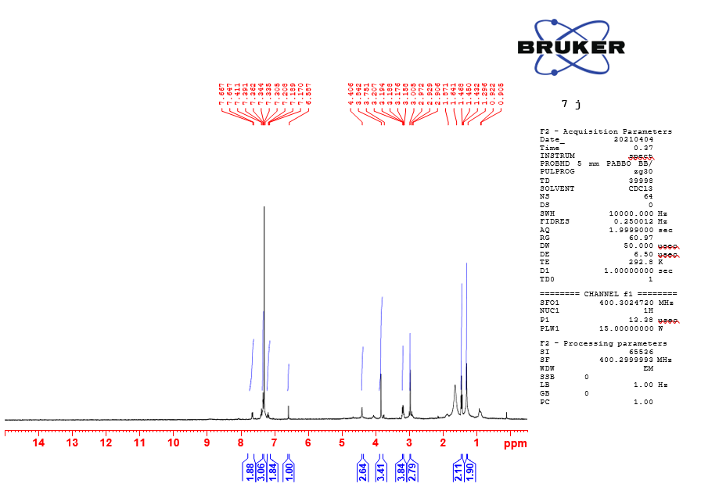
Fig:15 1 H NMR of compound 7j

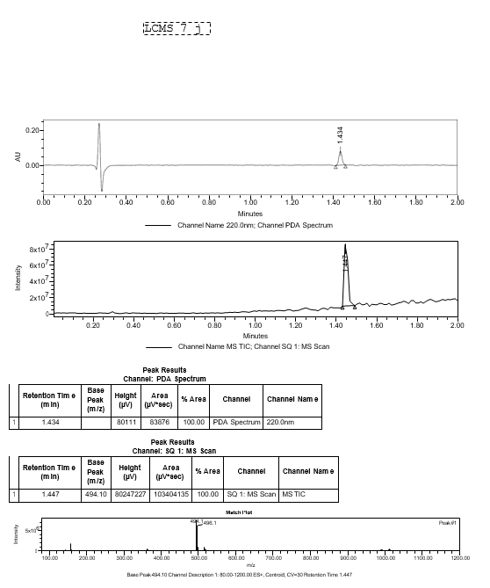
Figure 16: LCMS data of compound 7j

