Table 8: Absorbance reading of rasagiline and the synthesized compounds
Sample id | Concentration (µg /ml) | Absorbance at 425 nm  (MAO-A) | Absorbance at 465 nm  (MAO-B) | % Inhibition against MAO-A | % Inhibition against MAO-B
Control | - | 0.706 | 0.738
Rasagiline | 10 | 0.509 | 0.383 | 27.90368 | 48.10298
Rasagiline | 50 | 0.448 | 0.314 | 36.54391 | 57.45257
Rasagiline | 100 | 0.382 | 0.212 | 45.89235 | 71.27371
Rasagiline | 300 | 0.236 | 0.125 | 66.57224 | 83.06233
Rasagiline | 500 | 0.185 | 0.102 | 73.79603 | 86.17886
Rasagiline | 700 | 0.145 | 0.08 | 79.46176 | 89.15989
Rasagiline | 1000 | 0.137 | 0.062 | 80.5949 | 91.59892
MS-1 | 50 | 0.442 | 0.454 | 37.39377 | 38.48238
MS-1 | 100 | 0.442 | 0.389 | 37.39377 | 47.28997
MS-1 | 250 | 0.373 | 0.359 | 47.16714 | 51.35501
MS-1 | 500 | 0.38 | 0.32 | 46.17564 | 56.63957
MS-1 | 1000 | 0.341 | 0.266 | 51.69972 | 63.95664
MS-2 | 50 | 0.51 | 0.567 | 27.76204 | 23.17073
MS-2 | 100 | 0.485 | 0.532 | 31.30312 | 27.91328
MS-2 | 250 | 0.397 | 0.505 | 43.76771 | 31.57182
MS-2 | 500 | 0.371 | 0.442 | 47.45042 | 40.1084
MS-2 | 1000 | 0.342 | 0.432 | 51.55807 | 41.46341
MS-3 | 50 | 0.459 | 0.613 | 34.98584 | 16.93767
MS-3 | 100 | 0.406 | 0.548 | 42.49292 | 25.74526
MS-3 | 250 | 0.357 | 0.531 | 49.43343 | 28.04878
MS-3 | 500 | 0.364 | 0.443 | 48.44193 | 39.9729
MS-3 | 1000 | 0.344 | 0.44 | 51.27479 | 40.3794
MS-4 | 50 | 0.484 | 0.516 | 31.44476 | 30.0813
MS-4 | 100 | 0.449 | 0.49 | 36.40227 | 33.60434
MS-4 | 250 | 0.428 | 0.42 | 39.37677 | 43.08943
MS-4 | 500 | 0.399 | 0.378 | 43.48442 | 48.78049
MS-4 | 1000 | 0.37 | 0.331 | 47.59207 | 55.14905
MS-5 | 50 | 0.497 | 0.433 | 29.6034 | 41.32791
MS-5 | 100 | 0.444 | 0.431 | 37.11048 | 41.59892
MS-5 | 250 | 0.406 | 0.4 | 42.49292 | 45.79946
MS-5 | 500 | 0.415 | 0.389 | 41.21813 | 47.28997
MS-5 | 1000 | 0.396 | 0.36 | 43.90935 | 51.21951
MS-6 | 50 | 0.411 | 0.509 | 41.7847 | 31.02981
MS-6 | 100 | 0.407 | 0.49 | 42.35127 | 33.60434
MS-6 | 250 | 0.344 | 0.453 | 51.27479 | 38.61789
MS-6 | 500 | 0.327 | 0.463 | 53.68272 | 37.26287
MS-6 | 1000 | 0.293 | 0.437 | 58.49858 | 40.78591
MS-7 | 50 | 0.394 | 0.482 | 44.19263 | 34.68835
MS-7 | 100 | 0.359 | 0.455 | 49.15014 | 38.34688
MS-7 | 250 | 0.339 | 0.56 | 51.983 | 24.11924
MS-7 | 500 | 0.257 | 0.379 | 63.59773 | 48.64499
MS-7 | 1000 | 0.224 | 0.386 | 68.27195 | 47.69648
MS-8 | 50 | 0.486 | 0.612 | 31.16147 | 17.07317
MS-8 | 100 | 0.355 | 0.581 | 49.71671 | 21.27371
MS-8 | 250 | 0.346 | 0.53 | 50.9915 | 28.18428
MS-8 | 500 | 0.298 | 0.507 | 57.79037 | 31.30081
MS-8 | 1000 | 0.225 | 0.501 | 68.13031 | 32.11382

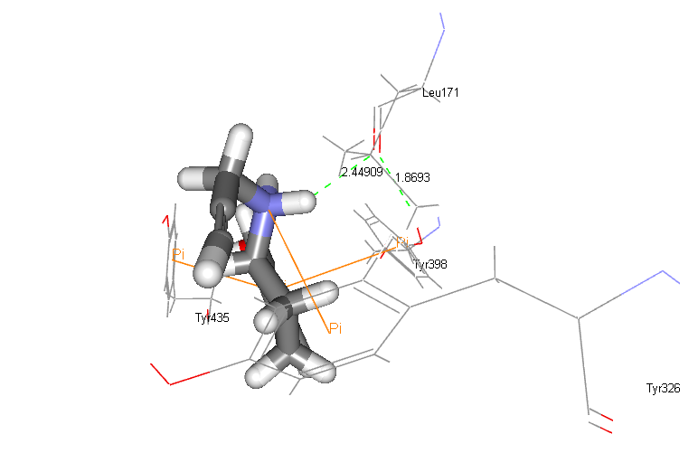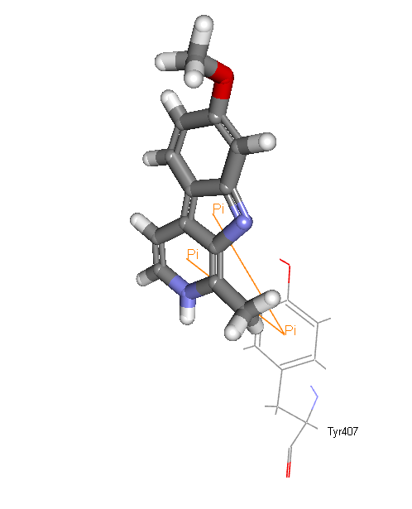
Harmine
RHP

Fig 5: Docking pose of RHP against 1S3E and Harmine against 2Z5X

Fig 7: Dose- Response curve between the % inhibition of MAO-A vs. log concentration (µg/mL) of Rasagiline and the test compounds (MS-1 to MS-8)

Fig 8: Dose- Response curve between the % inhibition of MAO-B vs. log concentration (µg/mL) of Rasagiline and the test compounds (MS-1 to MS-8)
Table 9: Summary of physicochemical properties and spectral data
Compound id | Physico-chemical properties | UV λ_{max} (DMSO) | FTIR data (cm⁻¹) | ¹H NMR data (300 MHz, DMSO): δ, ppm | ¹³C NMR data (100 MHz, DMSO-d6) δ ppm | Mass
MS-1 | Solubility: Ethanol, DMSO; R_{f} value: 0.38; M.P: 115-117°C; | 253 | 1446.67 (C=C stretch, aromatic), 1625.38 (C-C stretch, aromatic), 1281.60 (C-N stretch, aromatic), 2968.09 (C-H stretch, aromatic), 3418.46 (N-H stretch, primary), 1668.09 (C=C stretch, aliphatic), 2878.54 (C-H stretch, aliphatic), 764.59 (C-H bend, aromatic). | 5.23 (s, 2H, C-NH), 6.56, (d, J= 6 Hz, 2H, arom. H), 7.01 (d, J= 6 Hz, 2H, Ethylene), 7.37 (t, J= 3 Hz, 3H, arom. H), 7.44 (d, J= 6 Hz, 4H, Aniline), 7.68 (t, J= 3 Hz 2H, Benzimidazole), 7.61 (d, J= 6 Hz, 2H, Benzimidazole). | 142.73, 135.52, 123.92, 112.46, 133.82, 128.96, 131.30, 117.61, 124.75, 152.07 | 312.15
MS-2 | Solubility: Ethanol, DMSO; R_{f} value: 0.45; M.P: 215-218°C; | 274.902 | 1447.59 (C=C stretch, aromatic), 1626.22 (C-C stretch, aromatic), 1282.65 (C-N stretch, aromatic), 2967.50 (C-H stretch, aromatic), 1671.62 (C=C stretch, aliphatic), 2878.27 (C-H stretch, aliphatic), 764.19 (C-H bend, aromatic) 1416.27 (S=O stretch, sulfoxide). | 6.54, (d, J= 9 Hz, 2H, arom. H), 7.64 (d, J= 6 Hz, 2H, Ethylene), 7.33 (t, J= 3 Hz, 3H, arom. H), 7.44 (d, J= 6 Hz, 2H, Sulfonyl benzene), 7.55 (t, J= 3 Hz, 3H, Sulfonyl benzene), 7.77 (t, J= 3 Hz 2H, Benzimidazole), 7.68 (d, J= 6 Hz, 2H, Benzimidazole). | 142.02, 137.19, 135.70, 116.39 | 361.09
MS-3 | Solubility: Ethanol, DMSO; R_{f} value: 0.26; M.P: 189°C; | 260.60 | 1425.64 (C=C stretch, aromatic), 1526.05 (C-C stretch, aromatic), 1278.92 (C-N stretch, aromatic), 3054.26 (C-H stretch, aromatic), 1644.69 (C=C stretch, aliphatic), 2882.33 (C-H stretch, aliphatic), 739.88 (C-H bend, aromatic), 3389.24 (N-H stretch, primary), 1745.86 (C=O stretch, ketone) | 12.63 (s, 1H pyrimidine NH), 7.19 (s, 1H pyrimidine NH), 7.25 (s, 1H pyrimidinyl H), 7.20 (d, J= 3 Hz, 2H, arom. H), 7.37 (d, J= 3 Hz, 2H, Ethylene), 7.46 (t, J= 3 Hz, 3H, arom. H), 7.67 (t, J= 6 Hz 2H, Benzimidazole), 7.60 (d, J= 6 Hz, 2H, Benzimidazole). | 140.85, 135.75, 129.07, 150.28, 158.80, 113.27, 115.29, 119.48 | 331.11
MS-4 | Solubility: Ethanol, DMSO; R_{f} value: 0.79; M.P: 180-182°C | 219.40/ 262.20 | 1503.72 (C=C stretch, aromatic), 1577.32 (C-C stretch, aromatic), 1272.79 (C-N stretch, aromatic), 3023.42 (C-H stretch, aromatic), 1638.71 (C=C stretch, aliphatic), 2973.94 (C-H stretch, aliphatic), 743.72 (C-H bend, aromatic), 1223.22 (C-F stretch, halogen), 3056.78 (N-H stretch, primary) | 3.32 (s, 2H, NH₂, floroaniline), 7.15 (s, 1H, floroaniline), 7.20 (d, J= 3 Hz, 1H, floroaniline), 7.18 (d, J= 3 Hz, 1H, floroaniline), 7.23 (d, J= 12 Hz, 2H, arom. H), 7.49 (d, J= 6 Hz, 2H, Ethylene), 7.45 (t, J= 3 Hz, 3H, arom. H), 7.67 (t, J= 6 Hz 2H, Benzimidazole), 7.60 (d, J= 3 Hz, 2H, Benzimidazole). | 142.38, 135.67, 128.07, 133.59, 146.38, 123.97, 150.46, 115.93, 146.39 | 330.14
MS-5 | Solubility: Ethanol, DMSO; R_{f} value: 0.76; M.P: 130-134°C; | 262.80 | 1420.47 (C=C stretch, aromatic), 1522.82 (C-C stretch, aromatic), 1275.16 (C-N stretch, aromatic), 3026.31 (C-H stretch, aromatic), 1639.45 (C=C stretch, aliphatic), 2923.04 (C-H stretch, aliphatic), 741.21 (C-H bend, aromatic), 1701.75 (C=O stretch, ketone) | 2.42 (t, J= 3 Hz, 4H, pyrrolidone CH), 7.24 (d, J= 3 Hz, 2H, arom. H), 7.40 (d, J= 6 Hz, 2H, Ethylene), 7.46 (t, J= 6 Hz, 3H, arom. H), 7.58 (t, J= 3 Hz 2H, Benzimidazole), 7.70 (d, J= 3 Hz, 2H, Benzimidazole). | 139.90, 133.56, 129.44, 132.60, 132.88, 171.35, 128.96. | 318.12
MS-6 | Solubility: Ethanol, Acetone, DMSO, 1,4-dioxane; R_{f} value: 0.81; M.P: 187-190°C; | 262.40 | 1419.06 (C=C stretch, aromatic), 1522.88 (C-C stretch, aromatic), 1274.73 (C-N stretch, aromatic), 3058.58 (C-H stretch, aromatic), 1642.43 (C=C stretch, aliphatic), 2979.18 (C-H stretch, aliphatic), 746.76 (C-H bend, aromatic) | 2.52 (s, 3H, CH₃-toluene), 7.23 (d, J= 3 Hz, 4H, Toluene), 7.18 (d, J= 3 Hz, 2H, arom. H), 7.37 (d, J= 3 Hz, 2H, Ethylene), 7.45 (t, J= 3 Hz, 3H, arom. H), 7.67 (t, J= 3 Hz 2H, Benzimidazole), 7.55 (d, J= 3 Hz, 2H, Benzimidazole). | 137.51, 136.56, 128.96, 133.31, 137.51, 123.92, 129.44, 135.89, 112.46 | 311.15
MS-7 | Solubility: Ethanol, DMSO; R_{f} value: 0.26; M.P:175-177°C; | 208.60 | 1423.61 (C=C stretch, aromatic), 1522.54 (C-C stretch, aromatic), 1277.75 (C-N stretch, aromatic), 3051.80 (C-H stretch, aromatic), 1643.65 (C=C stretch, aliphatic), 2981.48 (C-H stretch, aliphatic), 736.25 (C-H bend, aromatic), 687.74 (C-Cl stretch, halogen) | 7.18 (d, J= 3 Hz, 4H, chlorobenzene), 7.52 (d, J= 9 Hz, 2H, arom. H), 7.37 (d, J= 3 Hz, 2H, Ethylene), 7.45 (t, J= 3 Hz, 3H, arom. H), 7.67 (t, J= 6 Hz 2H, Benzimidazole), 7.25 (d, J= 9 Hz, 2H, Benzimidazole). | 137.10, 135.89, 128.96, 133.31, 123.92, 126.60, 142.73 | 331.90
MS-8 | Solubility: Ethanol, Acetic acid, Chloroform, 1,4-dioxane, DMSO R_{f} value: 0.27; M.P: 210°C | 262.60/ 209.40 | 1494.01 (C=C stretch, aromatic), 1531.22 (C-C stretch, aromatic), 1282.24 (C-N stretch, aromatic), 3052.23 (C-H stretch, aromatic), 1621.52 (C=C stretch, aliphatic), 2968.07 (C-H stretch, aliphatic), 805.35 (C-H bend, aromatic), 695.53 (C-Br stretch, halogen). | 7.15 (d, J= 3 Hz, 4H, bromobenzene), 7.31 (d, J= 3 Hz, 2H, arom. H), 7.38 (d, J= 3 Hz, 2H, Ethylene), 7.54 (t, J= 3 Hz, 3H, arom. H), 7.69 (t, J= 3 Hz 2H, Benzimidazole), 7.47 (d, J= 3 Hz, 2H, Benzimidazole). | 142.73, 135.89, 126.63, 132.51, 137.74, 121.06, 112.46 | 376.04

FT-IR Spectra:
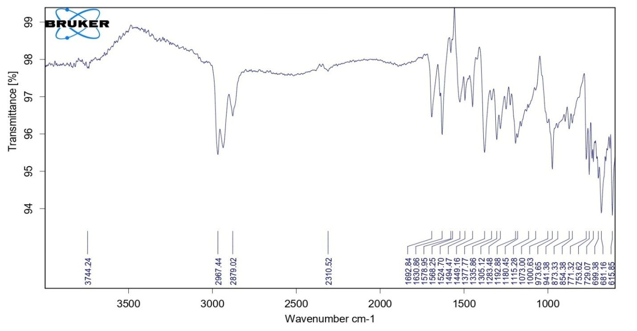
FT-IR Spectra of Intermediate Compound (2-styryl-1H-benzo[d]imidazole)

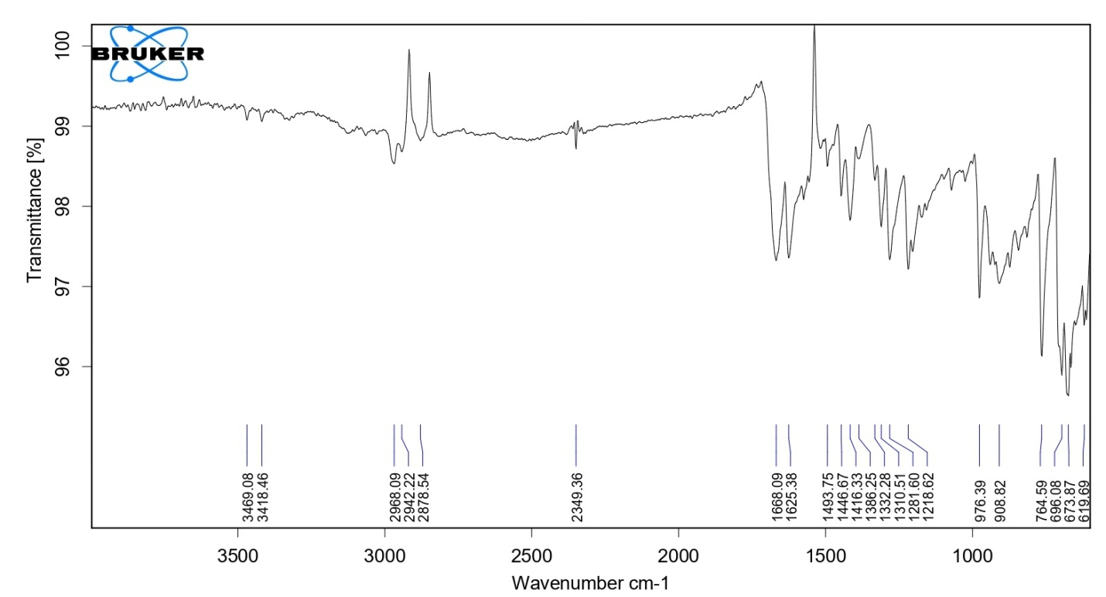
FT-IR Spectra of Compound MS-1

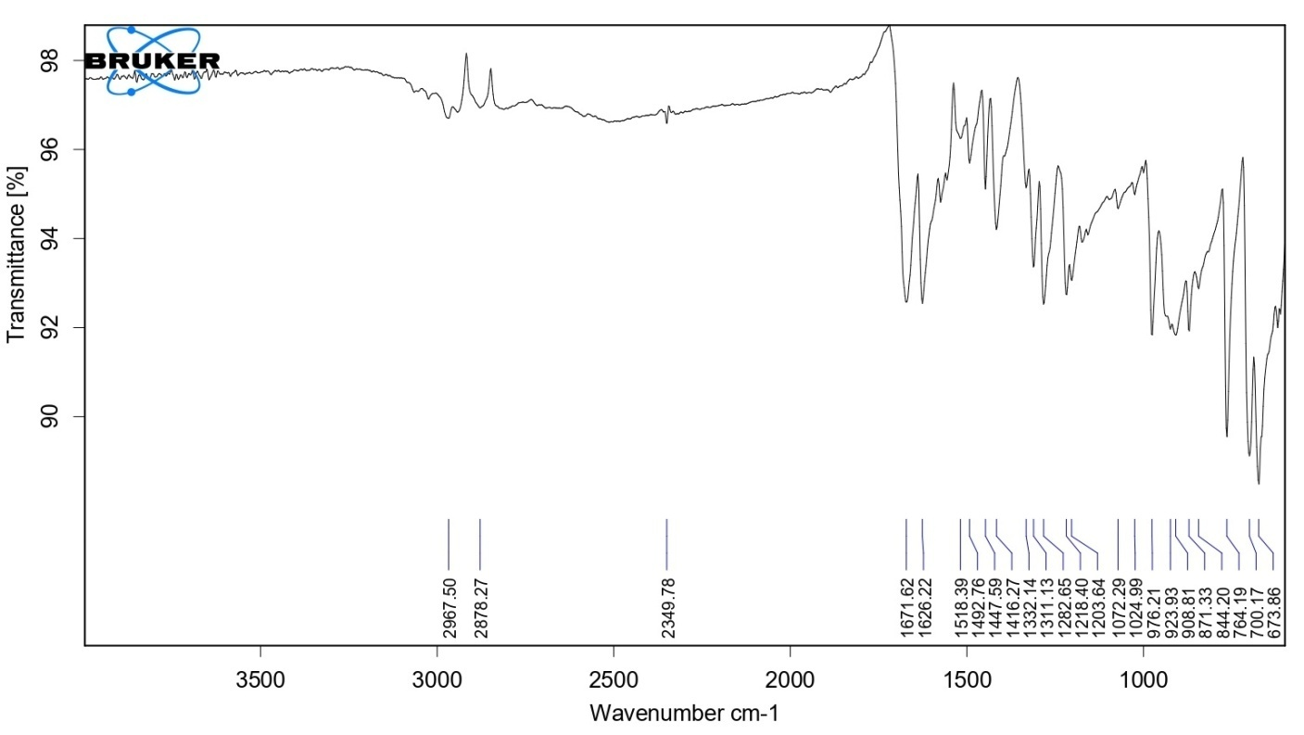
FT-IR Spectra of Compound MS-2

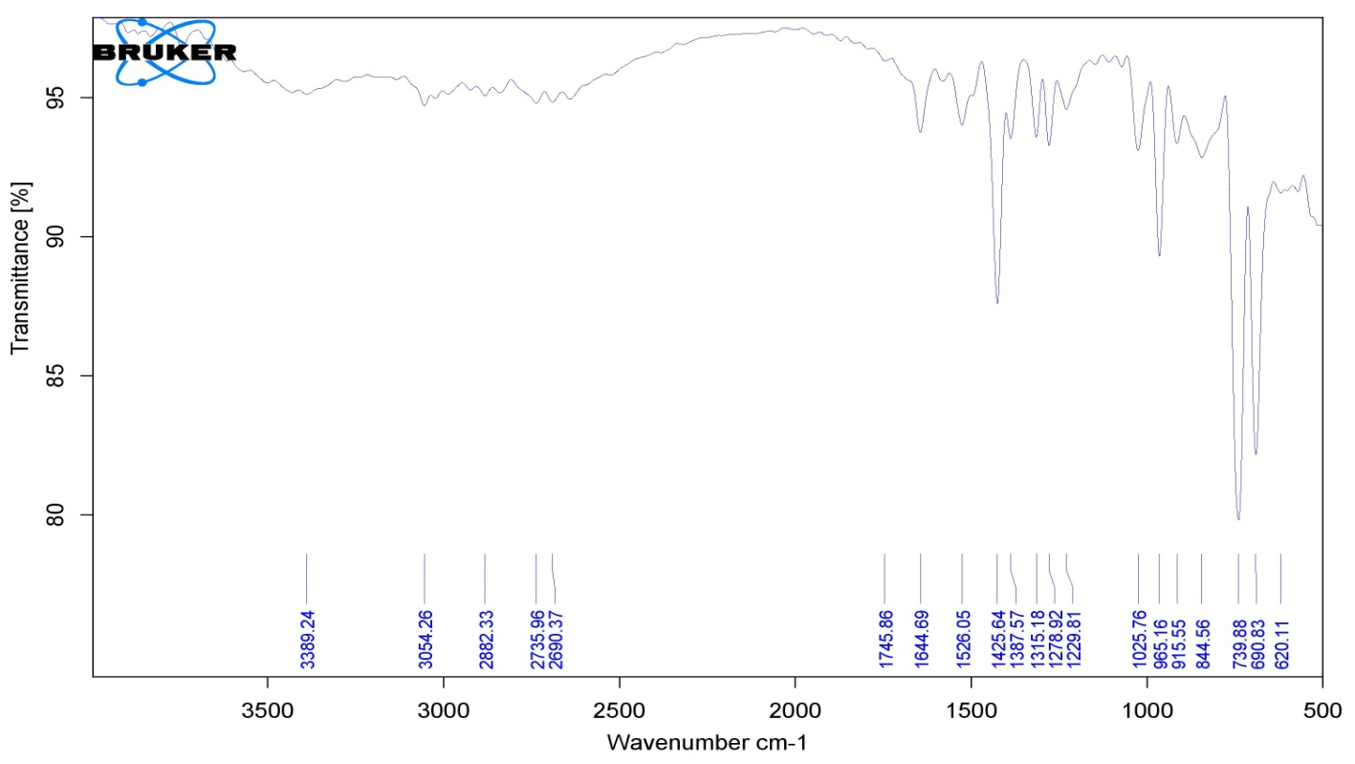
FT-IR Spectra of Compound MS-3

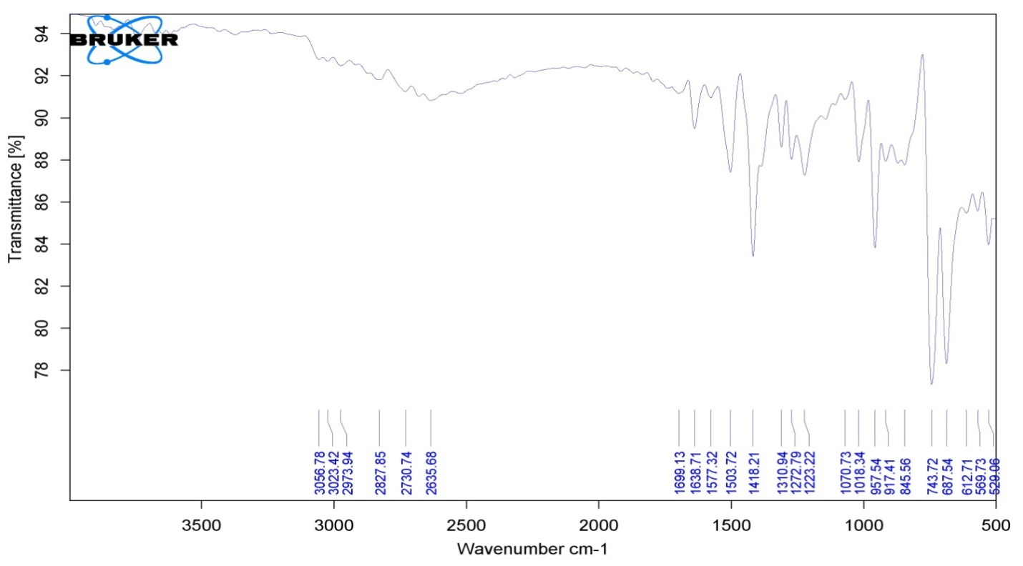
FT-IR Spectra of Compound MS-4

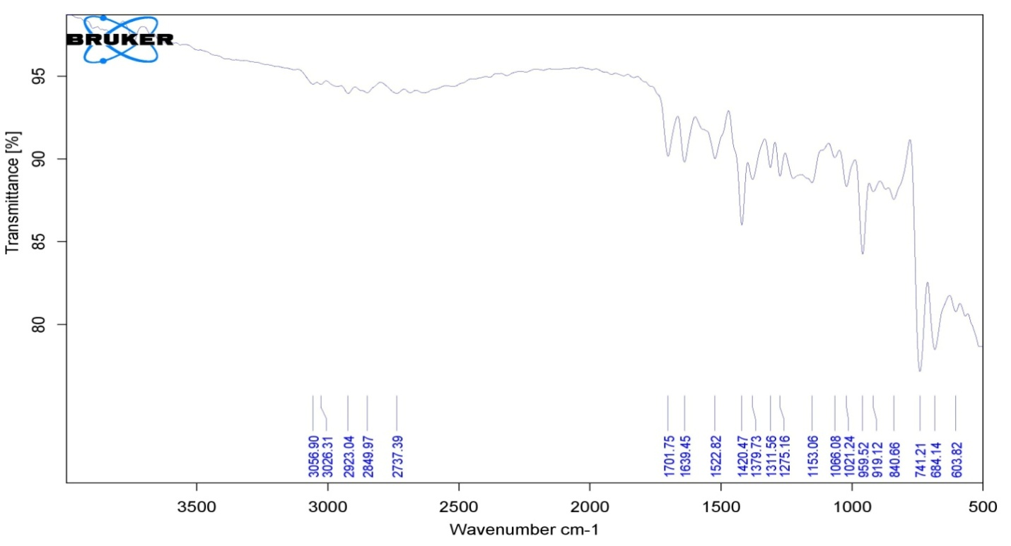
FT-IR Spectra of Compound MS-5

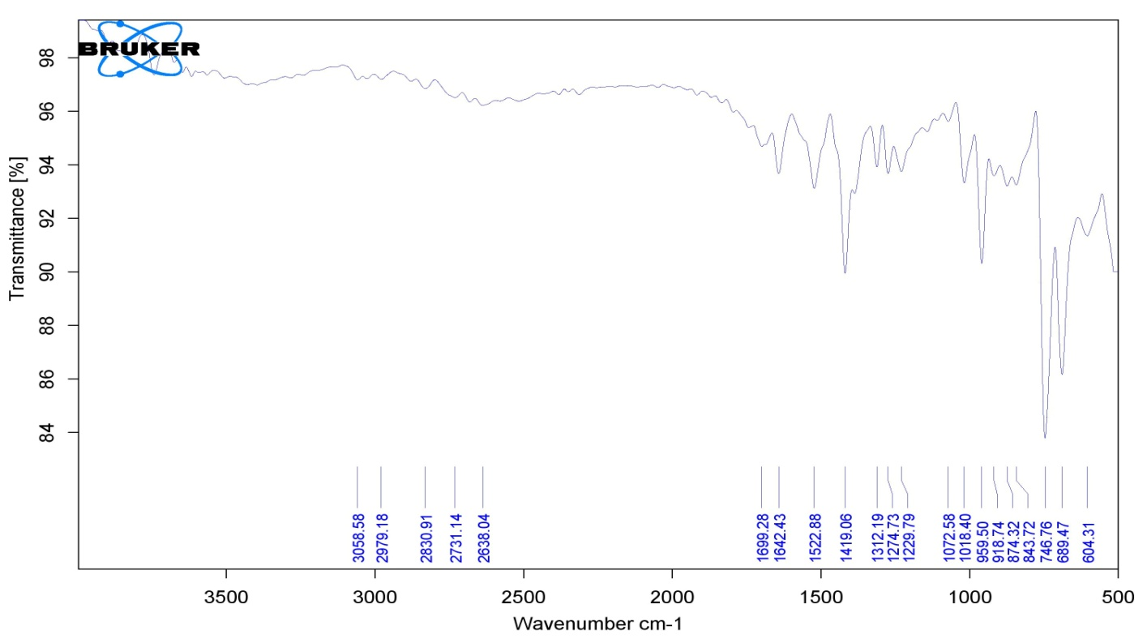
FT-IR Spectra of Compound MS-6

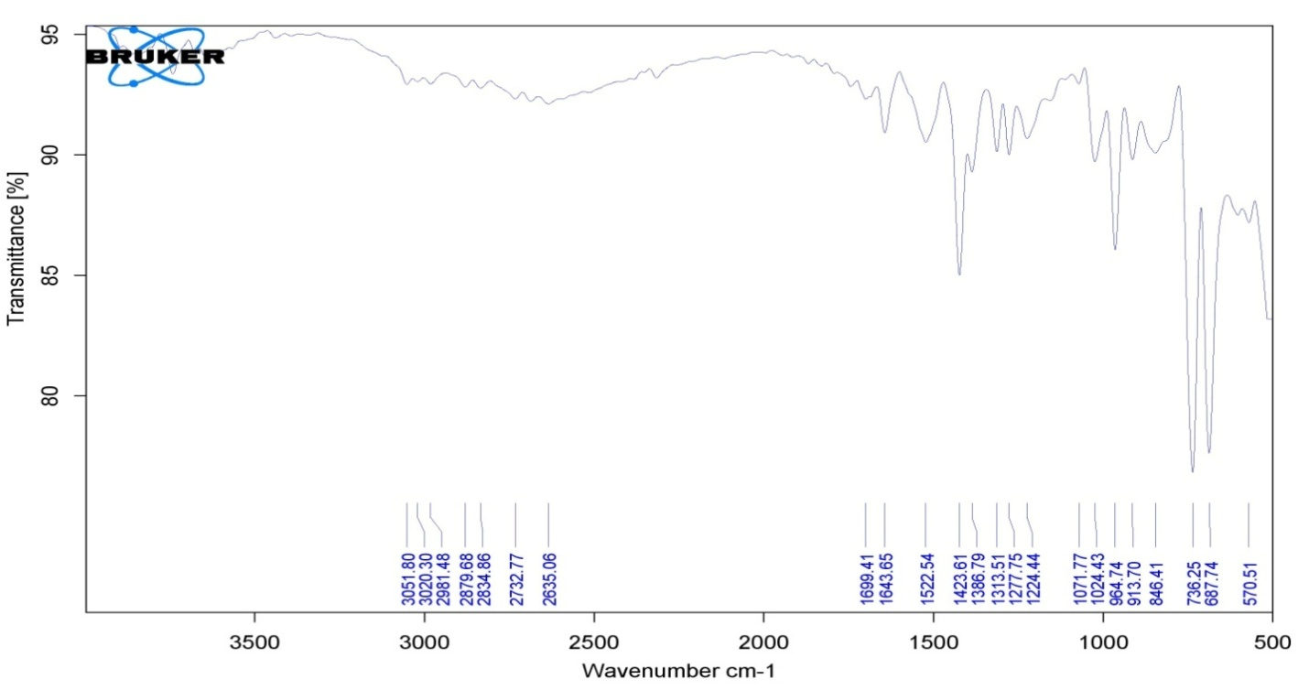
FT-IR Spectra of Compound MS-7

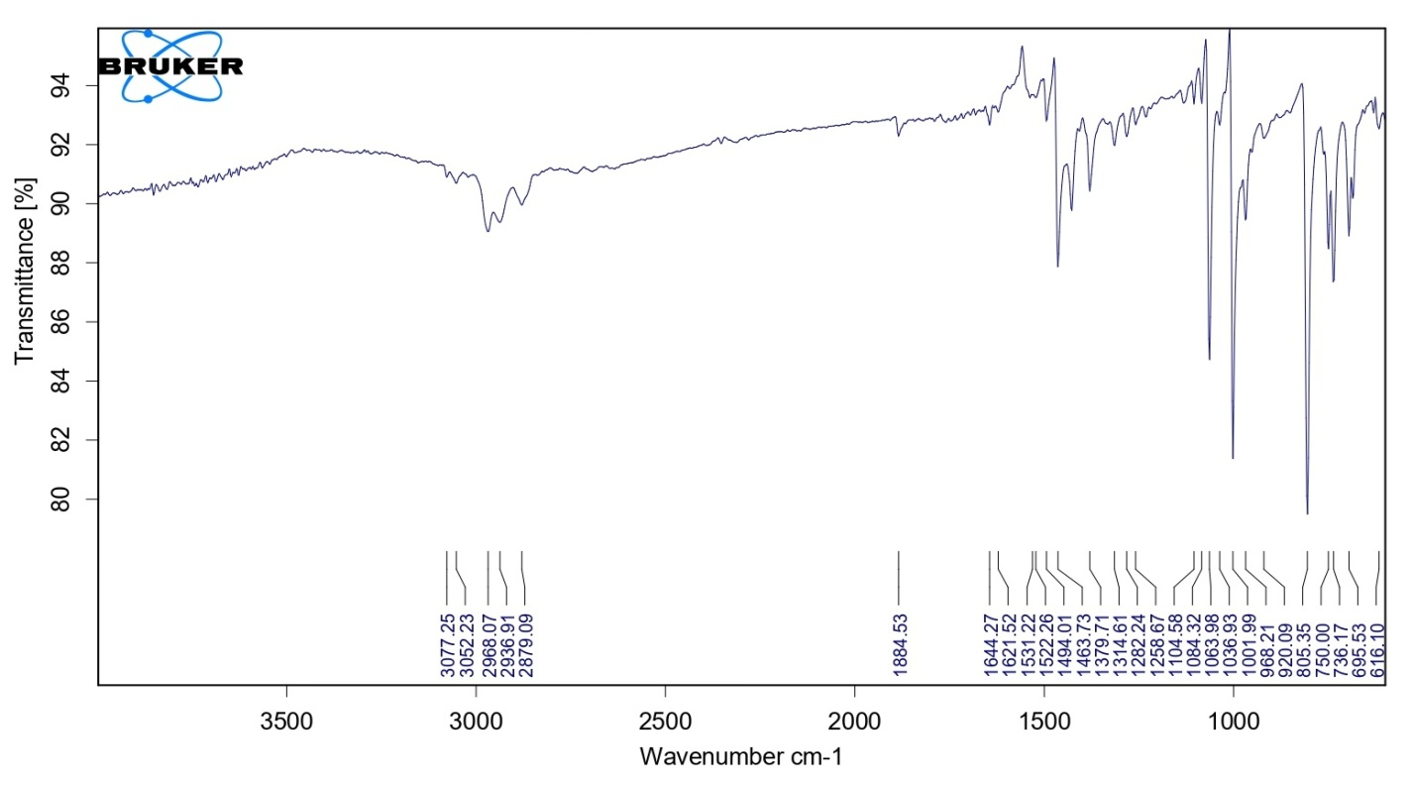
FT-IR Spectra of Compound MS-8

¹H NMR Spectra:
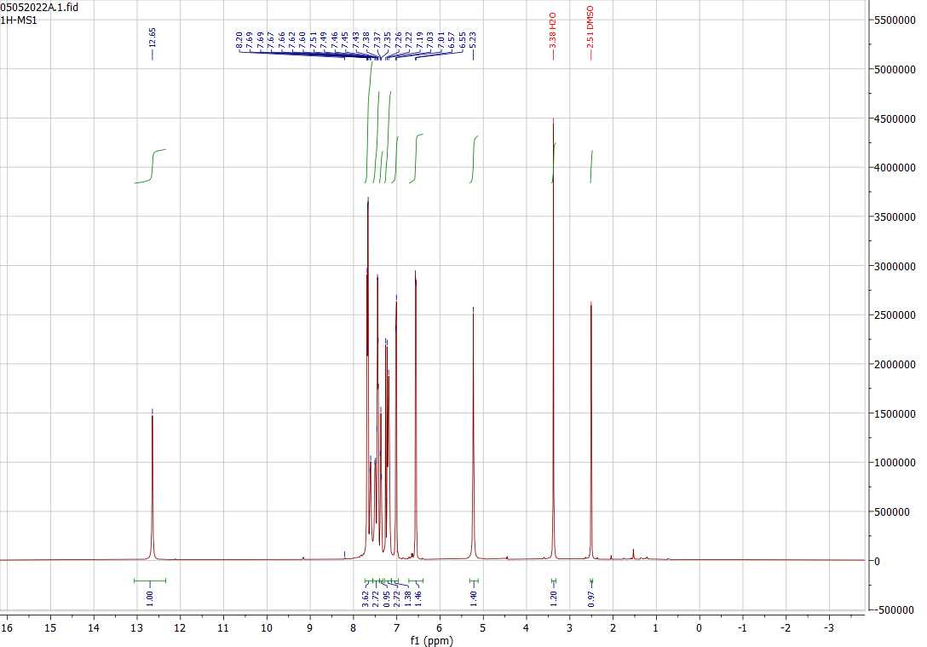
¹H NMR Spectra of Compound MS-1
¹H NMR Spectra of Compound MS-2

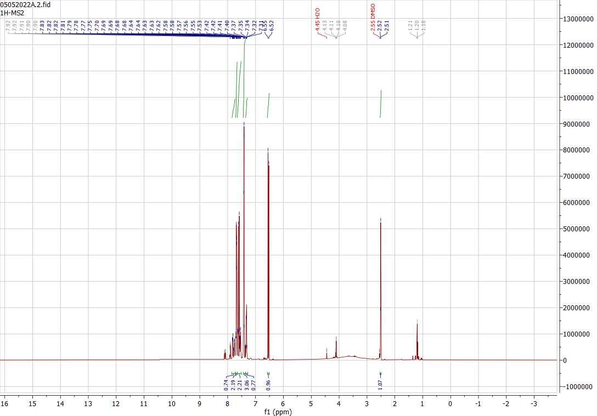
¹H NMR Spectra of Compound MS-2

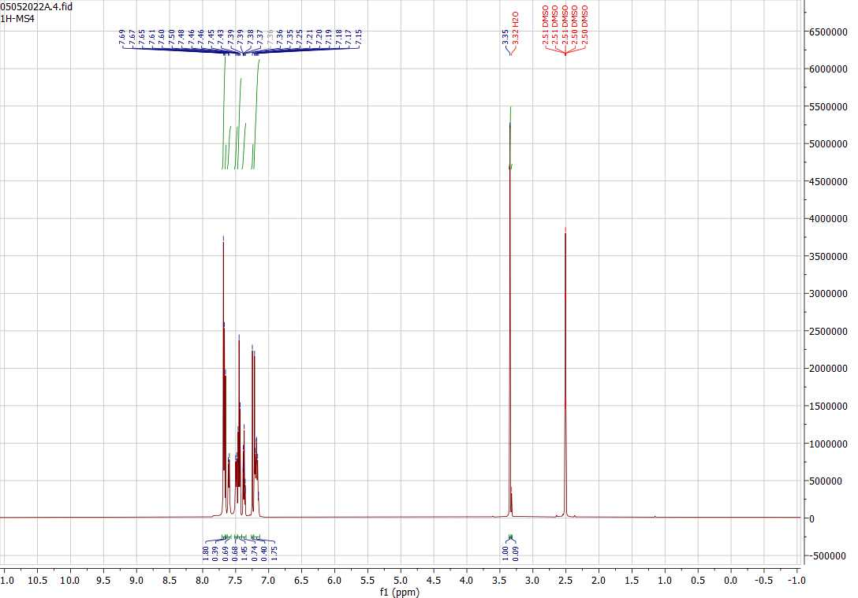
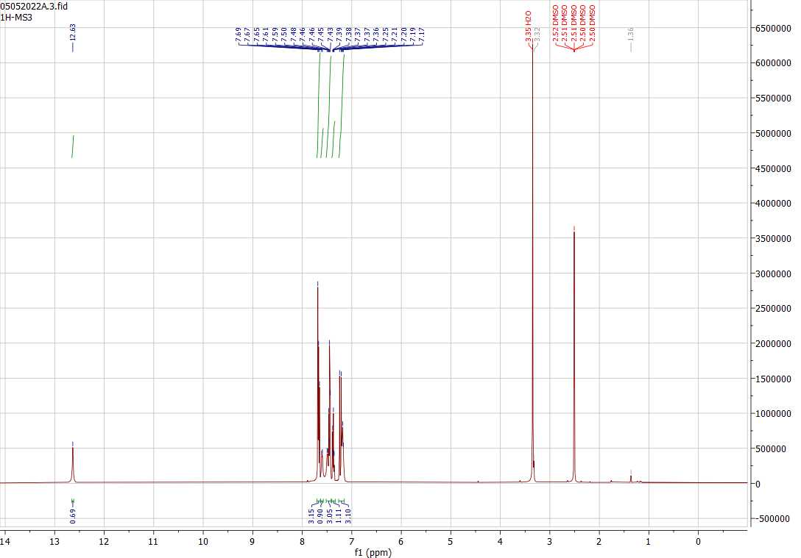
¹H NMR Spectra of Compound MS-4
¹H NMR Spectra of Compound MS-3
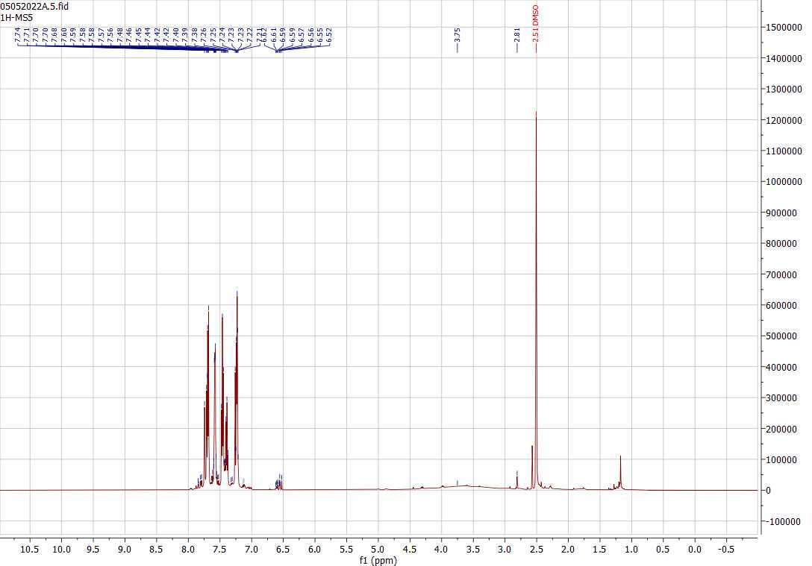
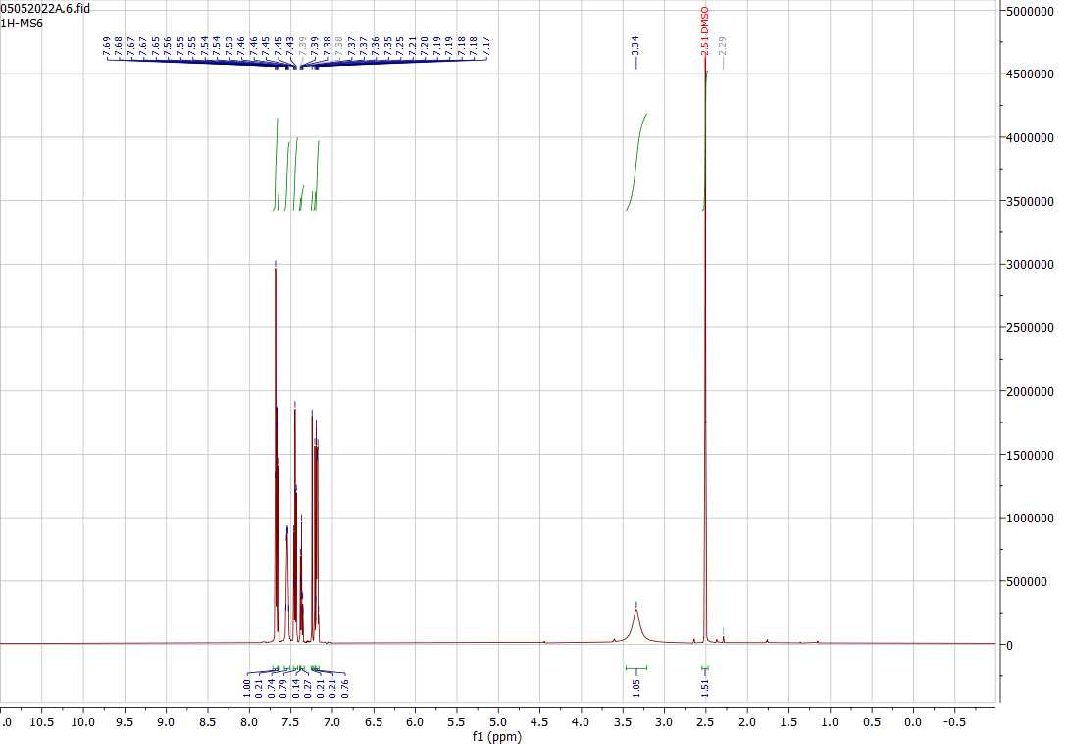
¹H NMR Spectra of Compound MS-5
¹H NMR Spectra of Compound MS-6
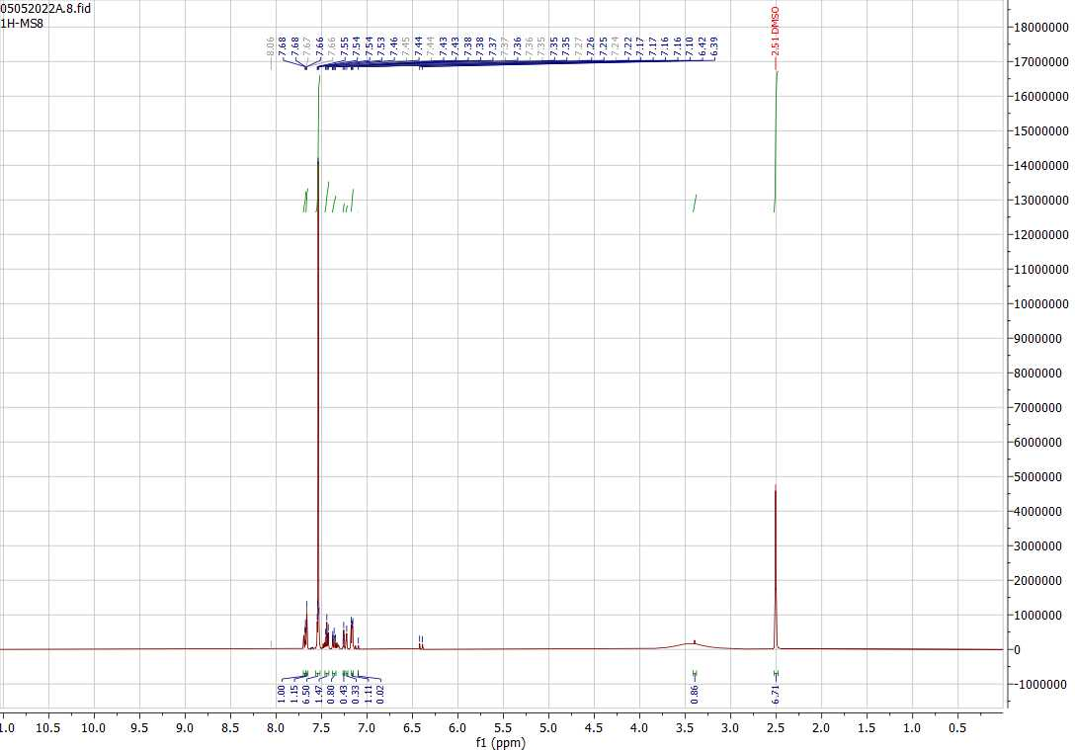
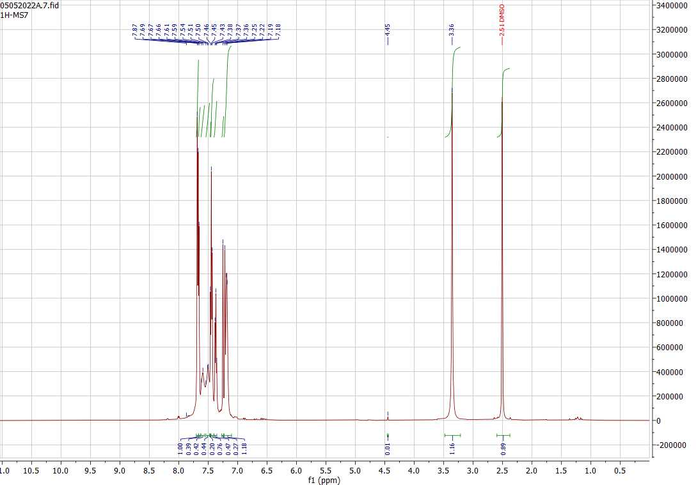
¹H NMR Spectra of Compound MS-7
¹H NMR Spectra of Compound MS-8

¹³C NMR Spectra:
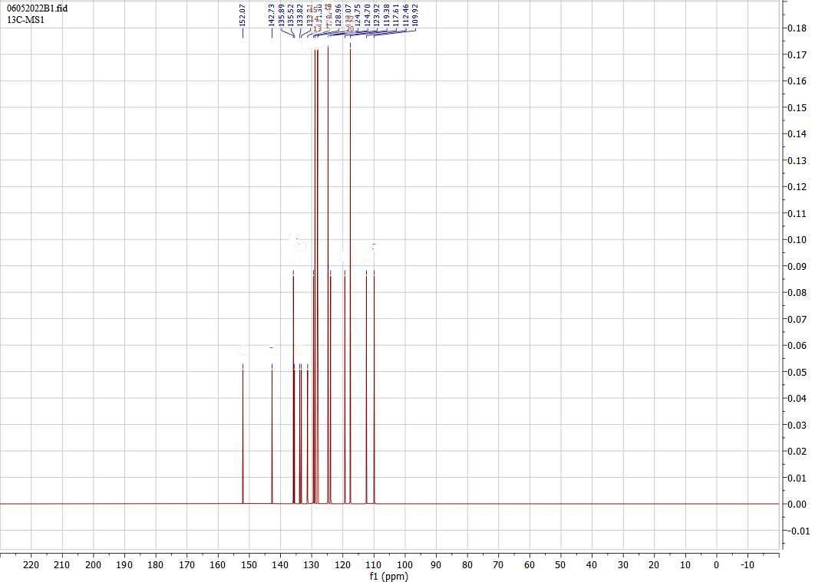
¹³C NMR Spectra of compound MS-1

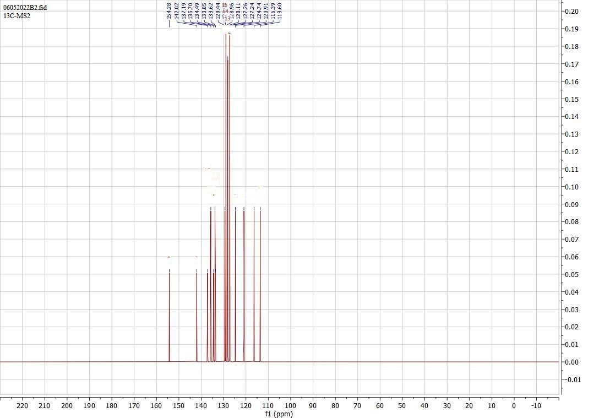
¹³C NMR Spectra of compound MS-2
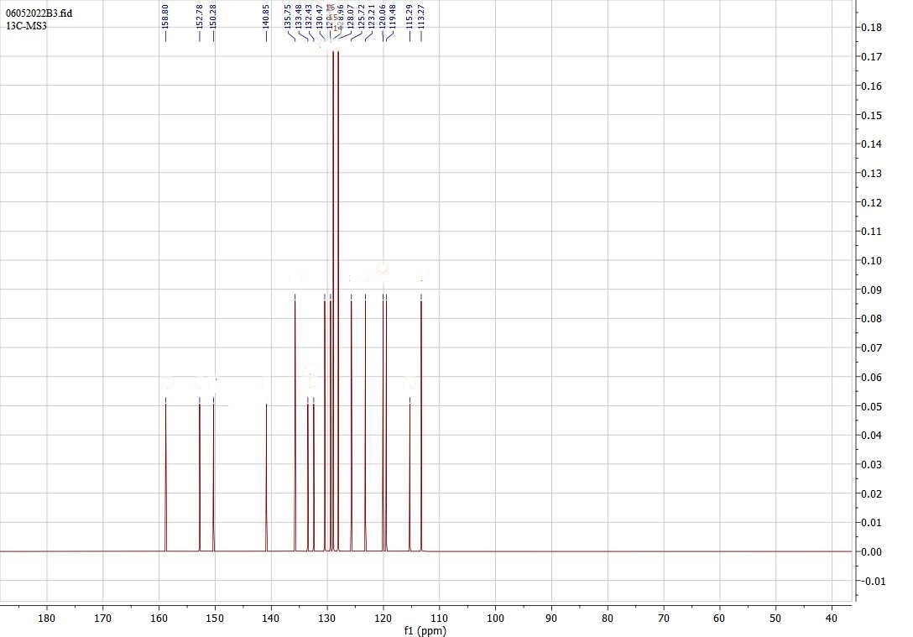
¹³C NMR Spectra of compound MS-3

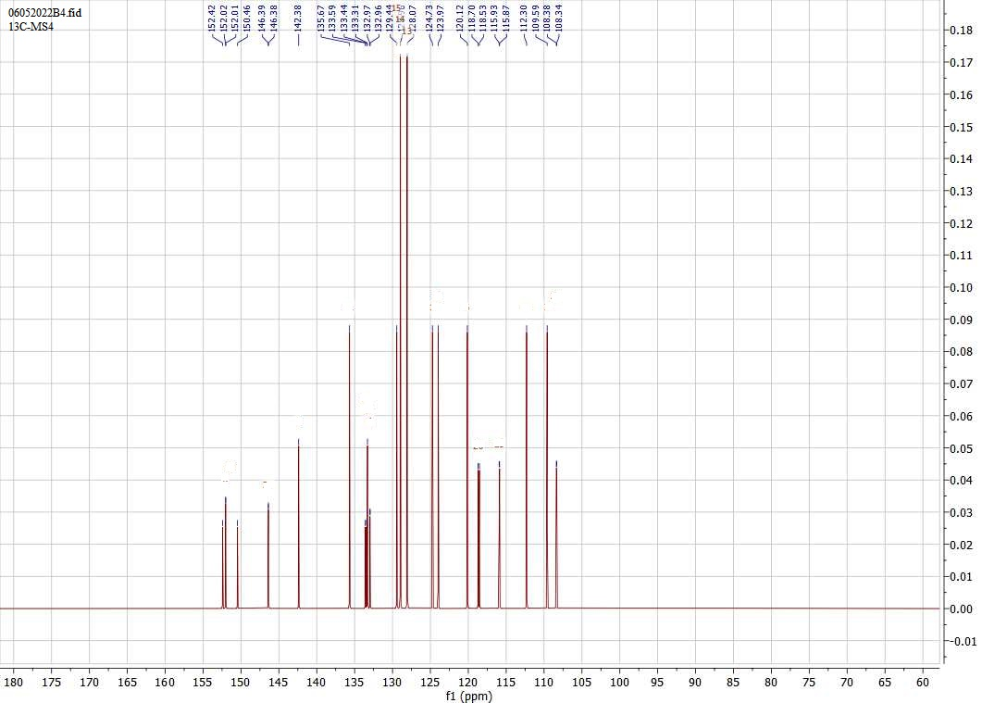
¹³C NMR Spectra of compound MS-4

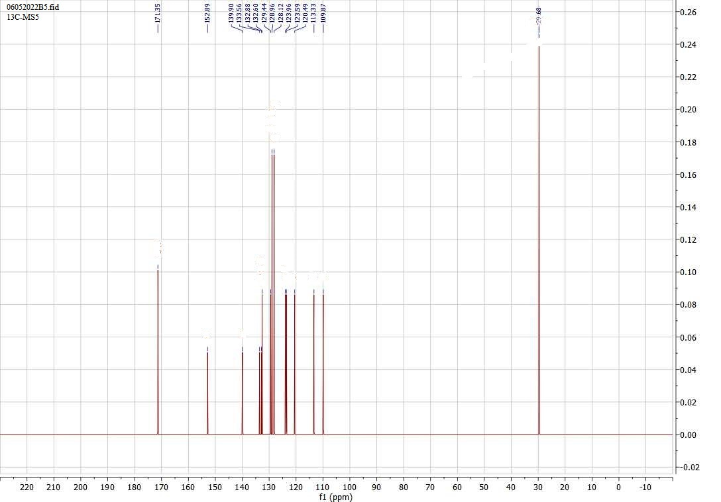
¹³C NMR Spectra of compound MS-6
¹³C NMR Spectra of compound MS-5

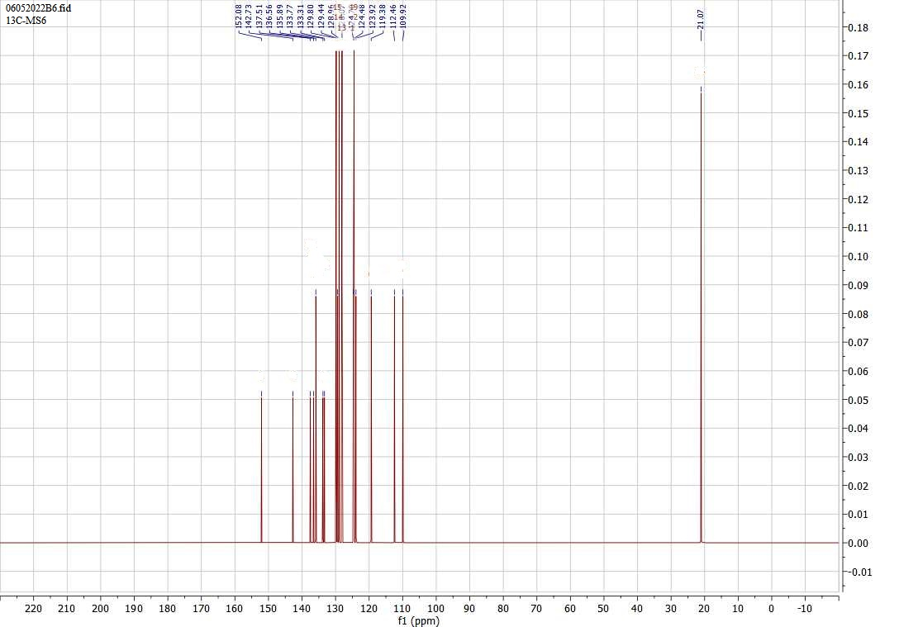

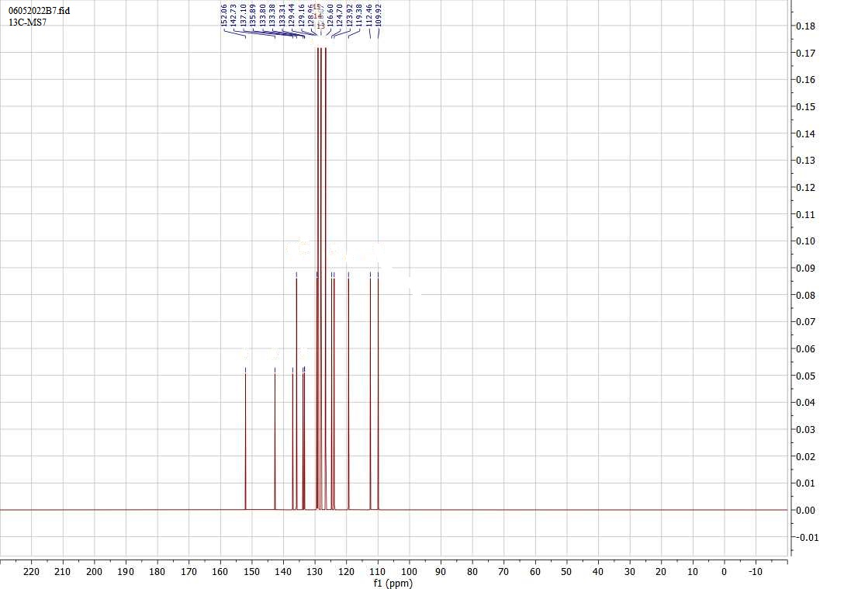
¹³C NMR Spectra of compound MS-7

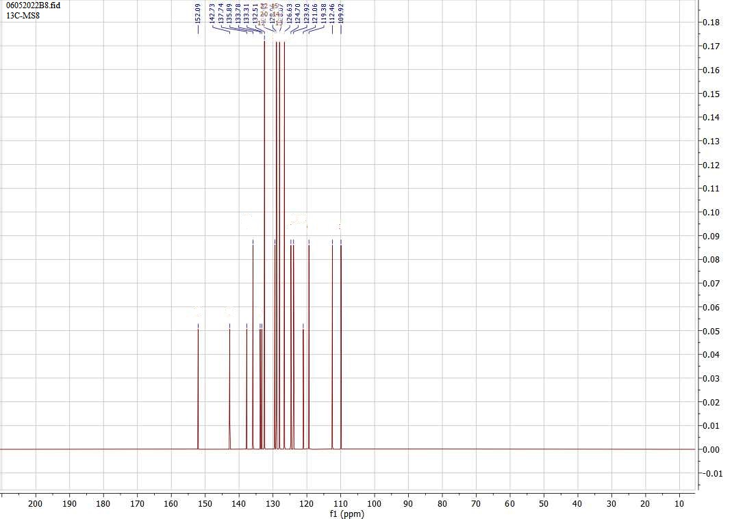
¹³C NMR Spectra of compound MS-8

Mass Spectra:
Mass Spectra of compound MS-1
MS-1

m/z
50
100
150
200
250
300
350
400
450
500
550
600
650
700
750
800
850
900
950
1000
%
0
100

TOF MS ES+
5.58e3
311.24
5581
118.30
2258
104.49
348
120.31
1486
297.24
434
127.32
277
312.24
3620
323.24
596

Mass Spectra of compound MS-2
MS-2

m/z
356
357
358
359
360
361
362
363
364
365
366
367
%
0
100

1: TOF MS ES+
3.77e4
360.2
37727
361.1
6787
361.2
6646
Mass Spectra of compound MS-3
MS-3

m/z
100
150
200
250
300
350
400
450
500
550
600
650
700
750
800
850
900
950
1000
%
0
100

TOF MS ES+
2.16e3
245.31
2163
86.46
1211
214.44
306
163.50
233
98.47
171
138.52
91
194.46
134
247.31
1517
278.52
1152
330.55
442

Mass Spectra of compound MS-4
MS-4

m/z
50
100
150
200
250
300
350
400
450
500
550
600
650
700
750
800
850
900
950
1000
%
0
100

TOF MS ES+
6.46e3
330.31
6462
145.32
1570
237.49
852
134.48
324
86.46
257
225.49
295
147.31
1095
358.49
544
308.46
408
307.47
260
368.45
500
454.38
326
331.32
2610
531.34
350
Mass Spectra of compound MS-5
MS-5

m/z
50
100
150
200
250
300
350
400
450
500
550
600
650
700
750
800
850
900
950
%
0
100

TOF MS ES+
1.12e5
195.44
112100
168.35
4492
94.43
4074
317.43
87384
245.29
73675
196.45
17381
218.45
11602
247.29
48982
380.35
29058
269.45
16670
270.42
10692
381.37
6096
3816

Mass Spectra of compound MS-6
MS-6

m/z
100
150
200
250
300
350
400
450
500
550
600
650
700
750
800
850
900
950
1000
%
0
100

TOF MS ES+
4.70e3

310.47
3604

91.42
684
240.51
247
196.48
205
126.32
816
330.47
3523
331.48
838
369.33
323
397.43
258

104.236787

Mass Spectra of compound MS-7
MS-7

m/z
327
328
329
330
331
332
333
%
0
100

1: TOF MS ES+
3.02e3
330.2
3020
331.2
437

Mass Spectra of compound MS-8
MS-8

m/z
80
100
120
140
160
180
200
220
240
260
280
300
320
340
360
380
400
420
440
460
480
%
0
100

TOF MS ES+
2.49e3
245.31
989
190.41
294
375.33
740
247.30
632
118.59
549
249.32
112
355.33
383
297.38
242
302.61;112
337.33
78
356.32
159
104.3487

6
185.7865

6
6

6
2

6

