Engineered Vildagliptin-loaded Polymeric Nanoparticles via Microfluidic and Spray Drying for enhanced Antidiabetic activity
Eknath Koleª, Krishna Jadhav^{b}, Zia Khanª, Rahul K. Verma^{b}, Jitendra Naik^{a*}
ªDepartment of Pharmaceutical Technology, University Institute of Chemical Technology, KBC North Maharashtra University, Jalgaon M.S. 425001, India.
^{b}Pharmaceutical Nanotechnology Lab, Institute of Nano Science and Technology, Sahibzada Ajit Singh Nagar (Mohali), Punjab 140306, India.

Correspondence author*
Prof. Jitendra B. Naik
Director
University Institute of Chemical Technology,
KBC North Maharashtra University, Jalgaon M.S.425001, India
Email- jbnaik@nmu.ac.in
Phone- +91 9422205671
ORCID: 0000-0001-8906-7903

S1. Setup of Microreactor
The microreactor setup included two inlets for introducing Solutions A and B. Solution A, comprising chitosan and vildagliptin, and Solution B, containing dextran sulfate, were infused into the microreactor using Uni Labs syringe pumps to ensure constant and precise flow rates, typically varied between 0.1 to 1.0 mL/min. The narrow channels within the microreactor facilitated rapid and homogeneous mixing of the solutions.
Flow rates for both solutions were systematically adjusted between 0.2 mL/min to 0.8 mL/min to study their impact on nanoparticle size. The chitosan concentration in Solution A was maintained at 50 mg in a 0.5% acetic acid solution, while the dextran sulfate concentration in Solution B was 0.1% w/v in double-distilled water. Both solutions were stirred at a constant speed of 800 rpm using a LabQuest Motorless Magnetic Stirrer during preparation and collection. Prior to infusion, the solutions were sonicated for 15 minutes to ensure complete dispersion and removal of any agglomerates, and then filtered using a 0.45 µm filter.
The synthesis process was carried out at room temperature, approximately 25°C, to maintain the stability of the solutions and nanoparticles. The resulting nanosuspension was collected from the microreactor outlet under continuous magnetic stirring at 800 rpm to prevent aggregation and ensure uniform particle distribution.
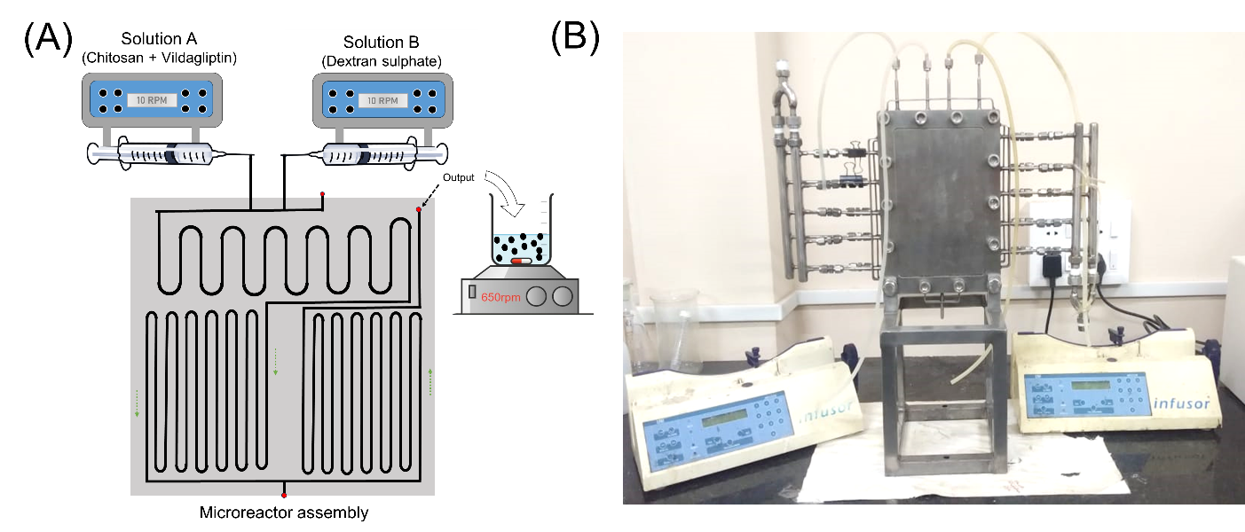
Figure S1. (A) Schematic for microreactor setup for production of VLG nanoparticles. (B) Image for microreactor (AmAR 2 metal) assembly, a microfluidic device supplied by Amar Equipment Pvt. Ltd, India

Table S1. Summary of ANOVA for Y₁, Y_{2,} Y_{3,} and Y₄ the response CDNPs prepared by BBD
Particle size (Y₁) | Source | df | F-value | p-value
Particle size (Y₁) | Model | 9 | 12.72 | 0.0015 | significant
Particle size (Y₁) | X₁-Chitosan | 1 | 5.84 | 0.0463
Particle size (Y₁) | X₂-Dextran Sulphate | 1 | 1.81 | 0.2204
Particle size (Y₁) | X₃-Tween 80 | 1 | 0.3135 | 0.5930
Particle size (Y₁) | X₁X₂ | 1 | 10.81 | 0.0133
Particle size (Y₁) | X₁X₃ | 1 | 0.1701 | 0.6923
Particle size (Y₁) | X₂X₃ | 1 | 6.58 | 0.0373
Particle size (Y₁) | X₁² | 1 | 12.58 | 0.0094
Particle size (Y₁) | X₂² | 1 | 57.62 | 0.0001
Particle size (Y₁) | X₃² | 1 | 20.89 | 0.0026
Particle size (Y₁) | Lack of Fit | 3 | 1.71 | 0.3020 | not significant
PDI (Y₂) | Model | 9 | 4.76 | 0.0258 | significant
PDI (Y₂) | X₁-Chitosan | 1 | 10.73 | 0.0136
PDI (Y₂) | X₂-Dextran Sulphate | 1 | 9.75 | 0.0168
PDI (Y₂) | X₃-Tween 80 | 1 | 1.56 | 0.2524
PDI (Y₂) | X₁X₂ | 1 | 6.44 | 0.0388
PDI (Y₂) | X₁X₃ | 1 | 0.0047 | 0.9475
PDI (Y₂) | X₂X₃ | 1 | 5.55 | 0.0507
PDI (Y₂) | X₁² | 1 | 0.7546 | 0.4138
PDI (Y₂) | X₂² | 1 | 0.1449 | 0.7148
PDI (Y₂) | X₃² | 1 | 8.09 | 0.0249
PDI (Y₂) | Lack of Fit | 3 | 3.05 | 0.1548 | not significant
EE% (Y₄) | Model | 9 | 25.91 | 0.0001 | significant
EE% (Y₄) | X₁-Chitosan | 1 | 5.19 | 0.0569
EE% (Y₄) | X₂-Dextran Sulphate | 1 | 49.57 | 0.0002
EE% (Y₄) | X₃-Tween 80 | 1 | 52.39 | 0.0002
EE% (Y₄) | X₁X₂ | 1 | 55.70 | 0.0001
EE% (Y₄) | X₁X₃ | 1 | 0.2871 | 0.6087
EE% (Y₄) | X₂X₃ | 1 | 1.01 | 0.3479
EE% (Y₄) | X₁² | 1 | 52.10 | 0.0002
EE% (Y₄) | X₂² | 1 | 10.54 | 0.0141
EE% (Y₄) | X₃² | 1 | 6.27 | 0.0408
EE% (Y₄) | Lack of Fit | 3 | 1.50 | 0.3426 | not significant

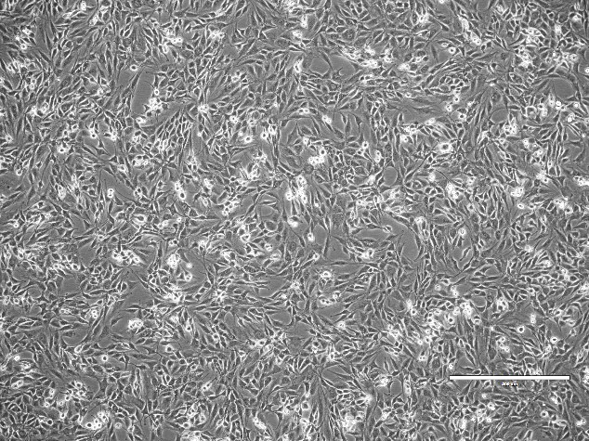
Figure S2. Morphology of L6 cell line (rat skeletal muscle cell line) (10X)

S2. Drug release kinetics
To investigate the drug release mechanism and evaluate the fit of various kinetic models, the release data were analyzed using several approaches, including the Higuchi, first-order, zero-order, Hixson-Crowell, and Korsmeyer-Peppas models (Table S2). At pH 1.2, the Higuchi model (R² = 0.9007) provided the best correlation, indicating that the drug release was primarily diffusion-controlled. The first-order model (R² = 0.7395) suggested that the release rate was somewhat dependent on the drug concentration, while the zero-order model (R² = 0.6809) showed a less consistent fit, pointing to a more varied release rate. The Hixson-Crowell model (R² = 0.7203) highlighted the potential role of particle size reduction or erosion in the release process. The Korsmeyer-Peppas model (R² = 0.3159) showed poor alignment, suggesting that it is not a suitable model for describing the release mechanism at pH 1.2.
At pH 6.8, the Higuchi model (R² = 0.8648) continued to describe the release mechanism well, though diffusion appeared to be slightly less dominant than at pH 1.2. The first-order model (R² = 0.7203) showed that the release rate remained somewhat concentration-dependent, while the zero-order model (R² = 0.5156) indicated greater variability in the release rate. The Hixson-Crowell model (R² = 0.6941) again suggested a role for erosion, while the Korsmeyer-Peppas model (R² = 0.2317) provided a poor fit, reinforcing its unsuitability for this release profile. Overall, diffusion remained the primary release mechanism across both pH levels, with contributions from other processes varying depending on the pH.
Table S2. Drug release kinetics of VLG from nanoformulation
Release kinetic Model | Formulation
Release kinetic Model | pH-1.2 | pH-6.8
 | R² | R²
Zero-order kinetics | 0.6809 | 0.6401
First-order kinetics | 0.7395 | 0.7203
Higuchi model | 0.9007 | 0.8648
Hixson-Crowell model | 0.7203 | 0.6941
Korsmeyer-Peppas model | 0.3159 | 0.2317

