Supplemental Figures

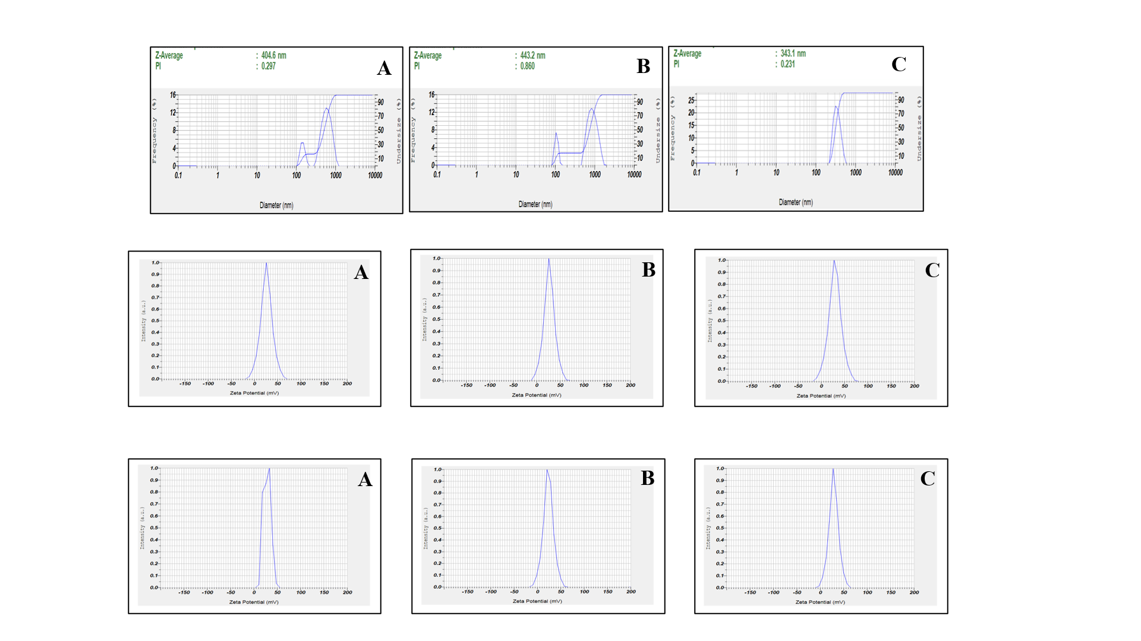
Supplementary Figure. 1: DLS results: Size and PDI of DOX-SLN (A. Blank SLN, B. DOX-SLN, C. RIF-SLN)
Supplementary Figure 2: DLS results: Zeta Potential of DOX-SLN (A. Blank SLN, B. DOX-SLN, C. RIF-SLN).
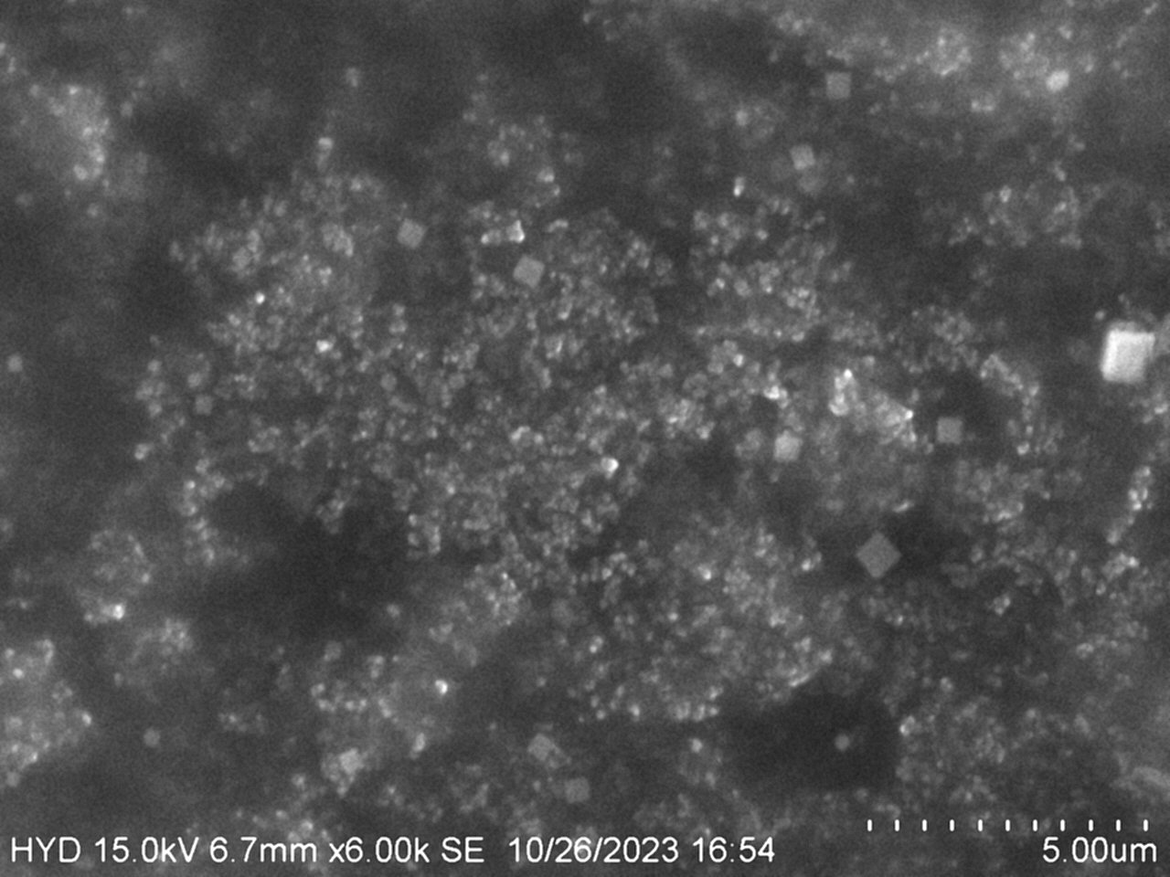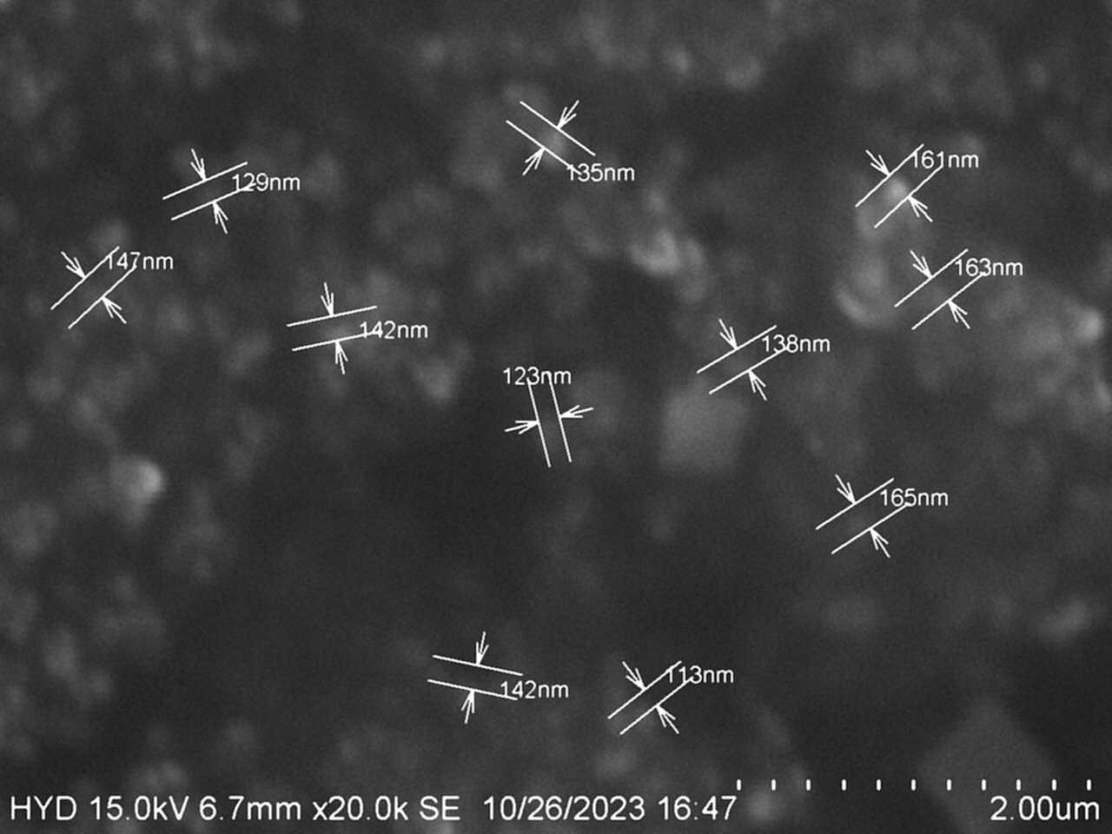

Supplementary Figure 3: Scanning electron microscope images of DOX-SLN.
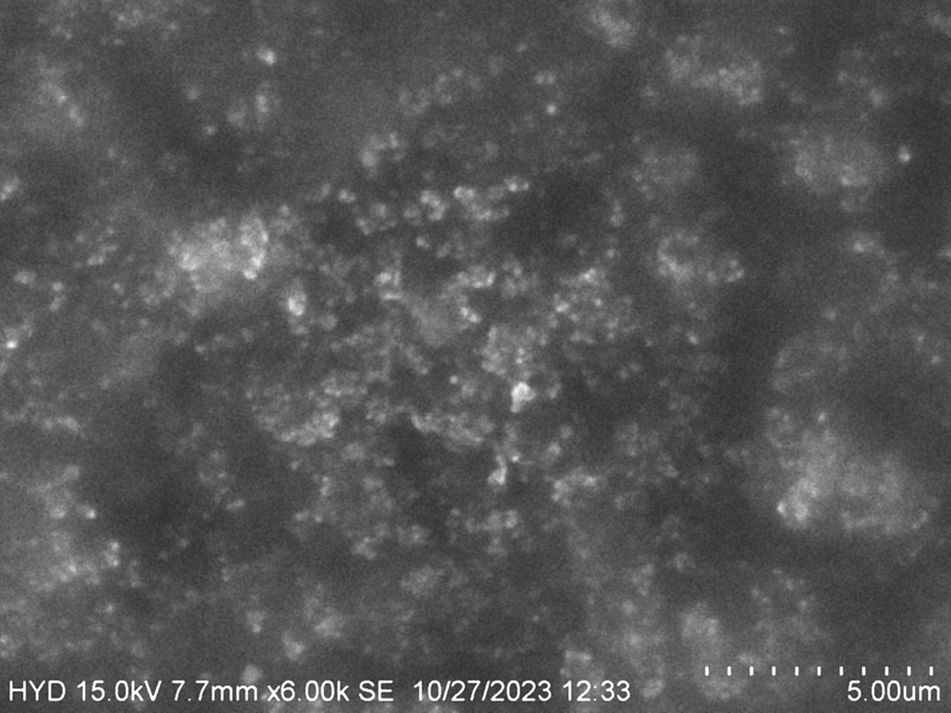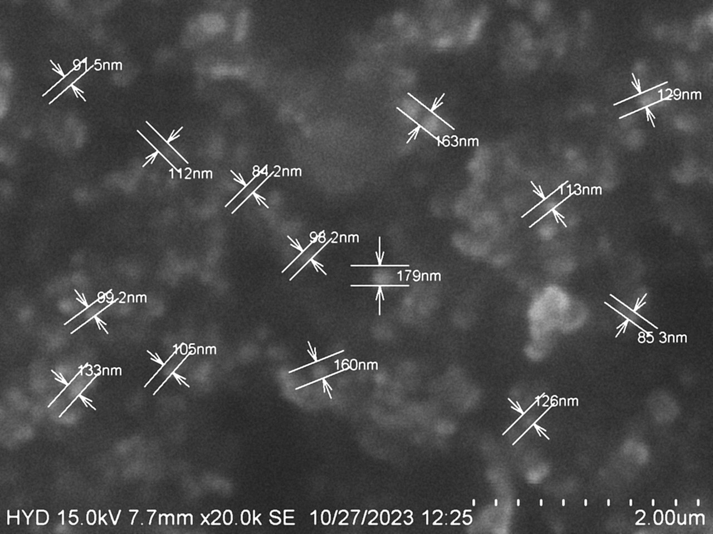

Supplementary Figure 4: Scanning electron microscope images of RIF-SLN.

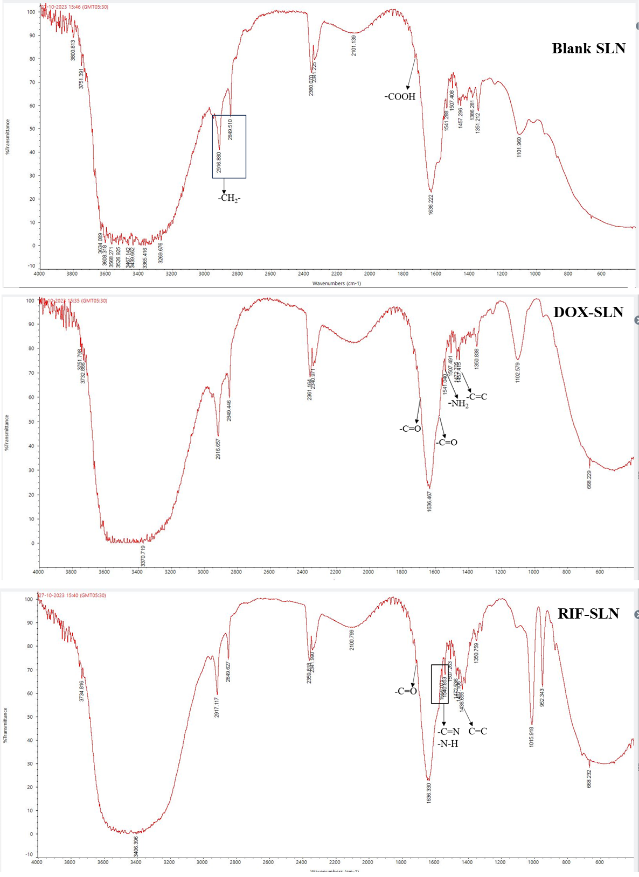
Supplementary Figure 5:FTIR analysis (A. Blank SLN, B. DOX-SLN, C. RIF-SLN).

Supplementary Figure 6.DSC thermogram of free drug, blank and drug-loaded SLN.
Left column
- DSC thermogram of stearic acid
- DSC thermogram of free DOX
- DSC thermogram of DOX-SLN
Right column
- DSC thermogram of stearic acid
- DSC thermogram of free RIF
- DSC thermogram of RIF-SLN

Supplementary Figure7: Dissolution study of (A)RIF-SLN (Zero order - First order - Korsmeyer peppas) and (B) DOX-SLN (Zero order - First order - Korsmeyer peppas).
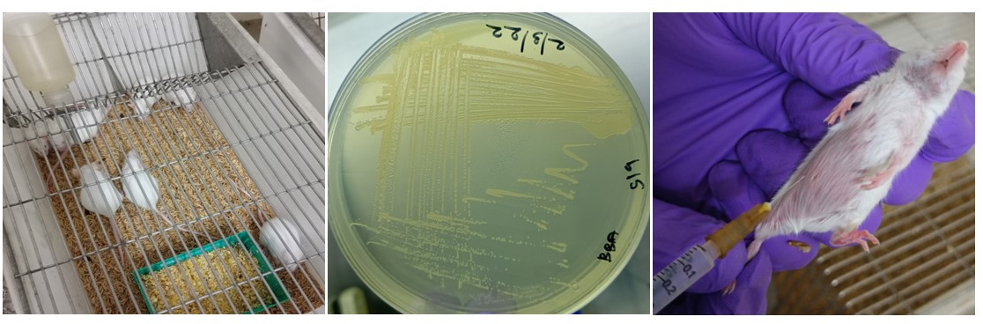
Supplementary Figure 8: In-vivo evaluation of NP in mice model. A) Test animal Swiss albino mice. B) Challenge strain Brucella abortus S19. C) Intraperitonial inoculation of challenge strain

.
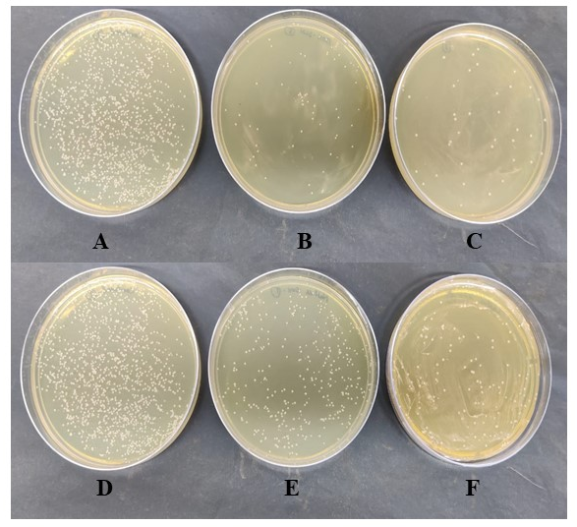
Supplementary Figure 9: Effect on cellular morphology of RAW 264.67 cells after treatment with blank NP, free drug and drug-loaded NP. A) Control, B) Blank SLN, C) DOX-SLN at MIC, D) Free DOX at MIC, E) DOX-SLN at 10X MIC, F) Free DOX at 10X MIC, G)RIF-SLN at MIC, H) Free RIF at MIC, I) RIF-SLN at 10X MIC, J) Free RIF at 10X MIC.

Supplementary Figure 10: Colony forming units of B. abortus S 19 treated with drug loaded nanoparticles and free drug in mice model
- Control (B. abortus S19 - 10⁻³ dilution)
- DOX-SLN (B. abortus S19 - 10⁻² dilution)
- RIF-SLN (B. abortus S19 - 10⁻¹ dilution)
- Control (B. abortus S19 - 10⁻³ dilution)
- Free DOX (B. abortu sS19 - 10⁻³ dilution)
- Free RIF (B. abortus S19 - 10⁻² dilution)

