Sidr Honey Manuscript - SI

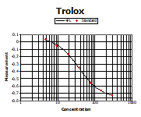

Figure S1. (A) DPPH and (B) ABTS radical scavenging activities. (C) Trolox was used as positive control for ABTS assay.

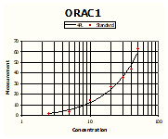

Figure S2. (A) ORAC antioxidative activities. (B) TE/Trolox standard equivalent. (C) Lipoxygenase (5-LOX) inhibition of honey extracts.

