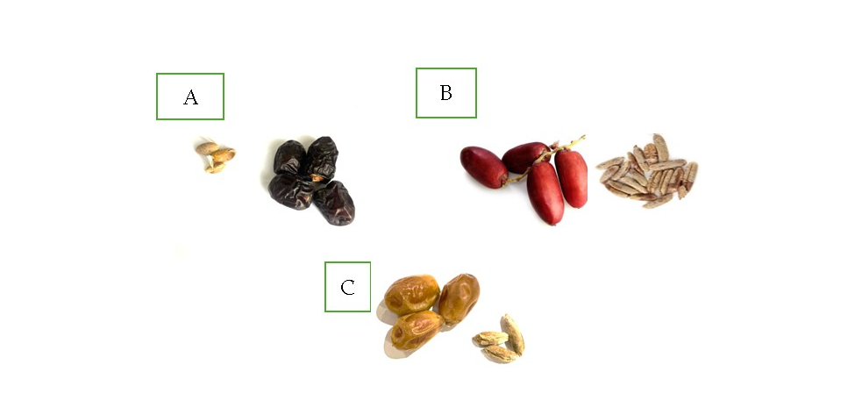
Figure S1. (a) Ajwa dates fruit and seeds. (b) Zaghloul dates fruit and seeds. (c) Sukkari date fruit and seeds.

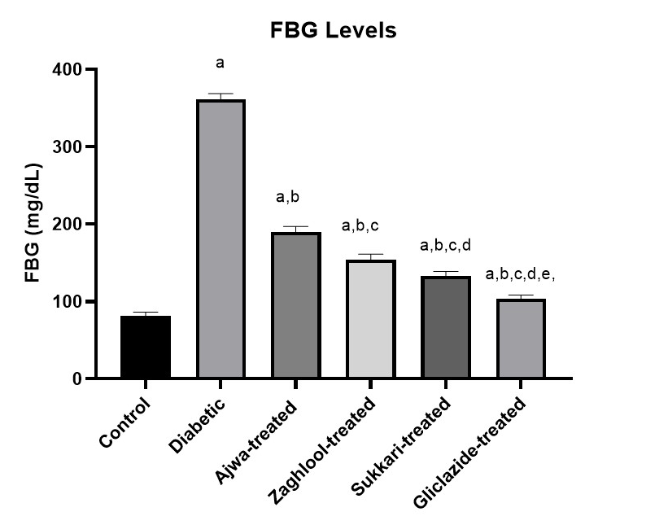
Figure S2. Effect of three varieties of Egyptian date seeds on FBG (mg/dL) levels in STZ-induced diabetic rats. Data are represented as mean ± S.D. (n=6). Statistical analysis was performed using one-way ANOVA followed by Tukey’s post-hoc test. Superscripts indicate significant differences: a (compared to Control), b (compared to Diabetic), c (compared to Ajwa-treated), d (compared to Zaghloul-treated), e (compared to Sukkari-treated) at P < 0.05.
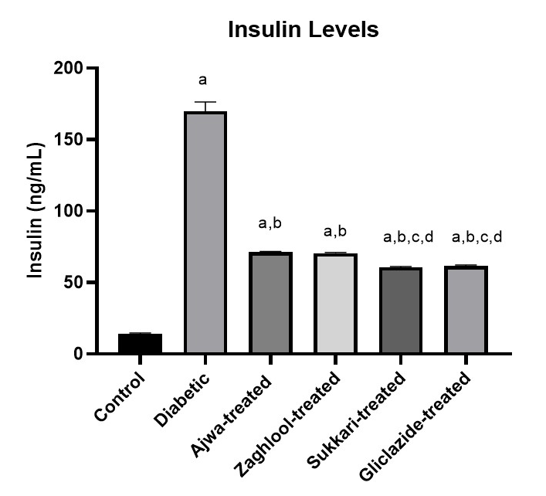

Figure S3. Effect of three varieties of Egyptian date seeds on insulin (ng/mL), levels in STZ-induced diabetic rats. Data are represented as mean ± S.D. (n=6). Statistical analysis was performed using one-way ANOVA followed by Tukey’s post-hoc test. Superscripts indicate significant differences: a (compared to Control), b (compared to Diabetic), c (compared to Ajwa-treated), d (compared to Zaghloul-treated), e (compared to Sukkari-treated) at P < 0.05.

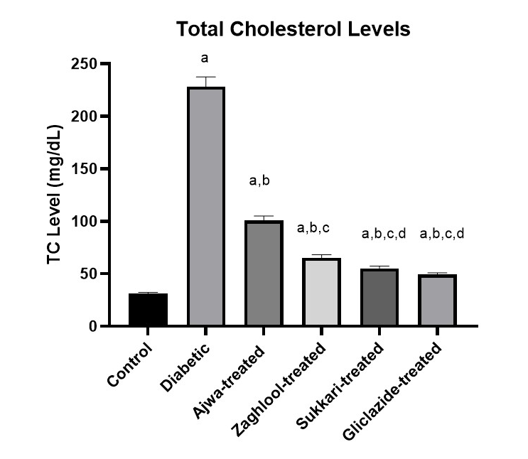

Figure S4. Effect of three varieties of Egyptian date seeds on TC (mg/dL)levels in STZ-induced diabetic rats. Data are represented as mean ± S.D. (n=6). Statistical analysis was performed using one-way ANOVA followed by Tukey’s post-hoc test. Superscripts indicate significant differences: a (compared to Control), b (compared to Diabetic), c (compared to Ajwa-treated), d (compared to Zaghloul-treated), e (compared to Sukkari-treated) at P < 0.05.

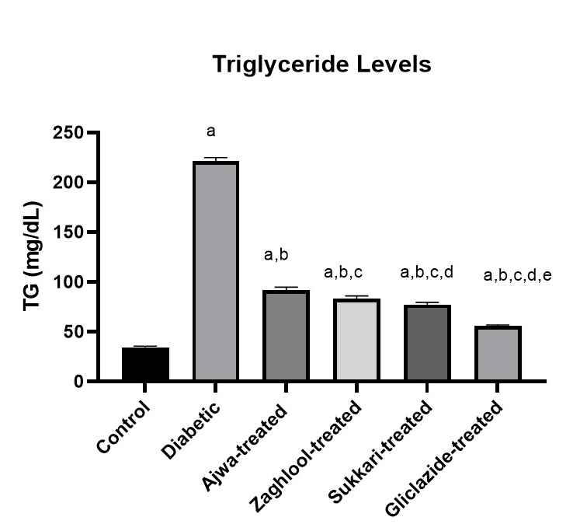
Figure S5. Effect of three varieties of Egyptian date seeds on TG (mg/dL) levels in STZ-induced diabetic rats. Data are represented as mean ± S.D. (n=6). Statistical analysis was performed using one-way ANOVA followed by Tukey’s post-hoc test. Superscripts indicate significant differences: a (compared to Control), b (compared to Diabetic), c (compared to Ajwa-treated), d (compared to Zaghloul-treated), e (compared to Sukkari-treated) at P < 0.05.

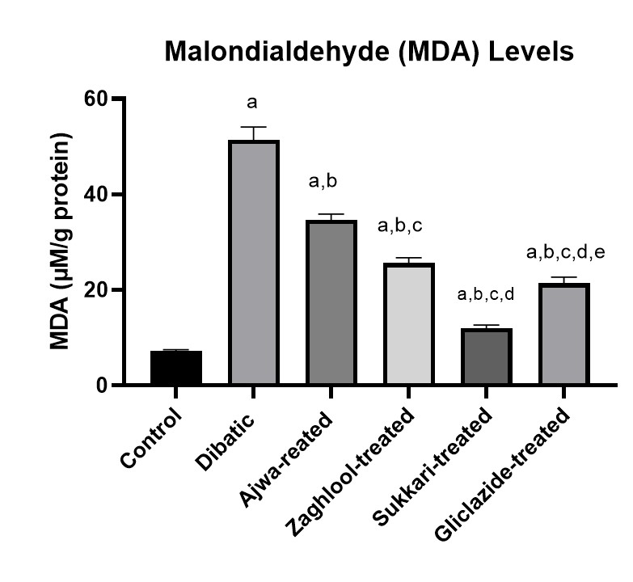
Figure S6. Effect of three varieties of Egyptian date seeds on MDA (µM/g protein), levels in STZ-induced diabetic rats. Data are represented as mean ± S.D. (n=6). Statistical analysis was performed using one-way ANOVA followed by Tukey’s post-hoc test. Superscripts indicate significant differences: a (compared to Control), b (compared to Diabetic), c (compared to Ajwa-treated), d (compared to Zaghloul-treated), e (compared to Sukkari-treated) at P < 0.05.

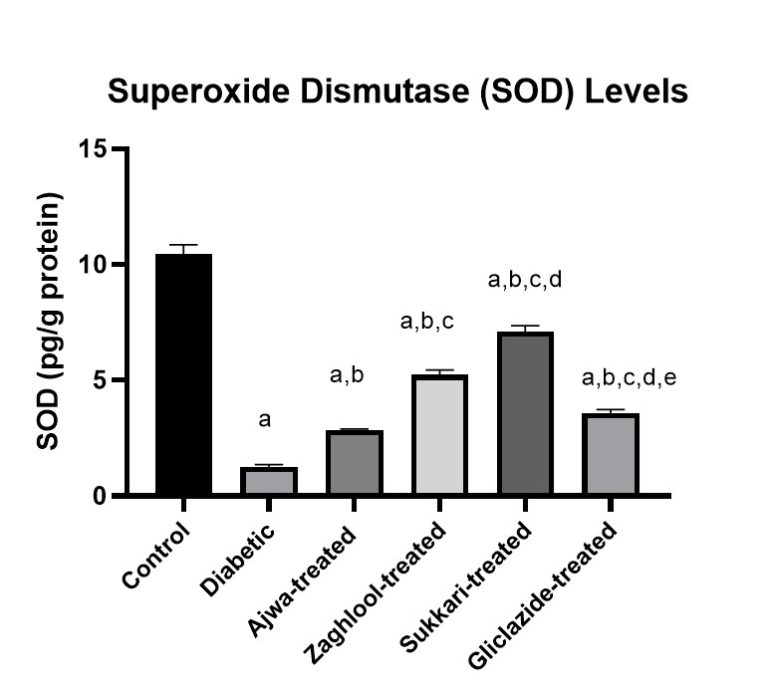

Figure S7. Effect of three varieties of Egyptian date seeds on SOD (pg/g protein) levels in STZ-induced diabetic rats. Data are represented as mean ± S.D. (n=6). Statistical analysis was performed using one-way ANOVA followed by Tukey’s post-hoc test. Superscripts indicate significant differences: a (compared to Control), b (compared to Diabetic), c (compared to Ajwa-treated), d (compared to Zaghloul-treated), e (compared to Sukkari-treated) at P < 0.05.

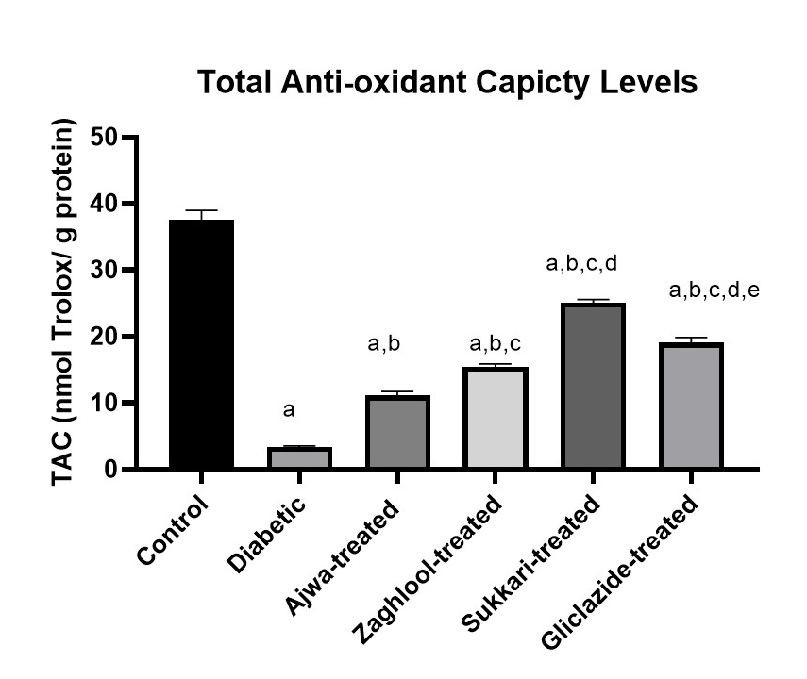
Figure S8. Effect of three varieties of Egyptian date seeds TAC (nmol Trolox/ g protein) levels in STZ-induced diabetic rats. Data are represented as mean ± S.D. (n=6). Statistical analysis was performed using one-way ANOVA followed by Tukey’s post-hoc test. Superscripts indicate significant differences: a (compared to Control), b (compared to Diabetic), c (compared to Ajwa-treated), d (compared to Zaghloul-treated), e (compared to Sukkari-treated) at P < 0.05.

