Molecular Insights into the Potentiation of Antibiotic Activity by Apple Cider Vinegar in Diabetic Wound Pathogens
Supplementary Figures
Figure 1.
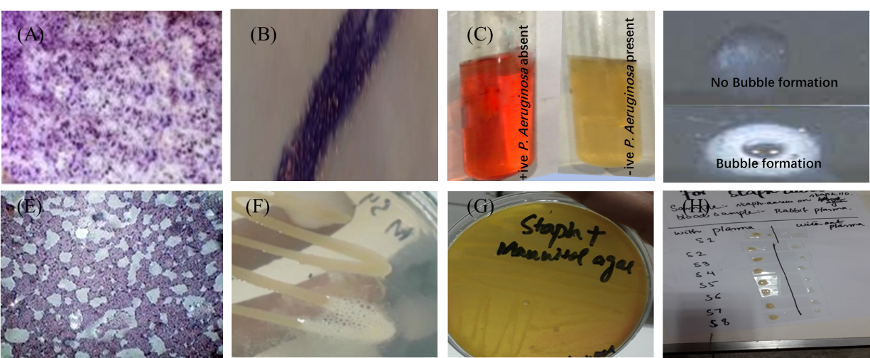
Supp Figure 1. Gram staining and biochemical analysis results (A&E) Gram staining results for PA in pink and SA in purple round respectively. Biochemical tests for PA (B) oxidase test positive (C) Urease test positive (D) catalase test and biochemical test for SA (F) coagulase positive (G) mannitol fermentation positive (H) catalase test
Figure 2.
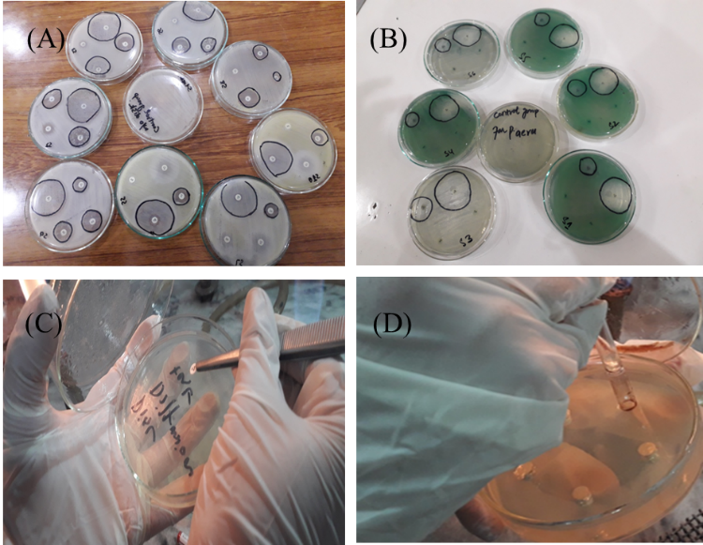

Supp Figure 2. Disk diffusion assay (A) Antibiotic disk placement on MHA media plate for SA (B) Antibiotic disk placed for PA (C) disk placement for assay SA and for PA (D) Hole or well preparation for antibiotic and ACV for evaluating antimicrobial potential

