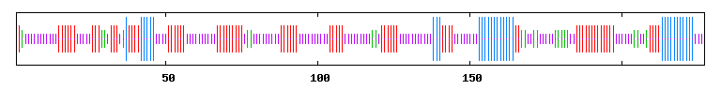
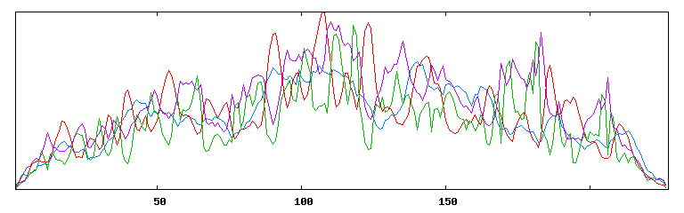
Supplementary Figure-1
(a)

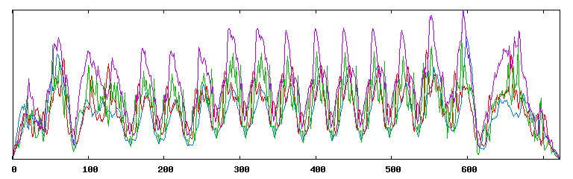
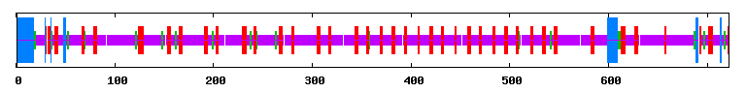
(b)

