Supplementary information
Fig. S1. Cloning strategy

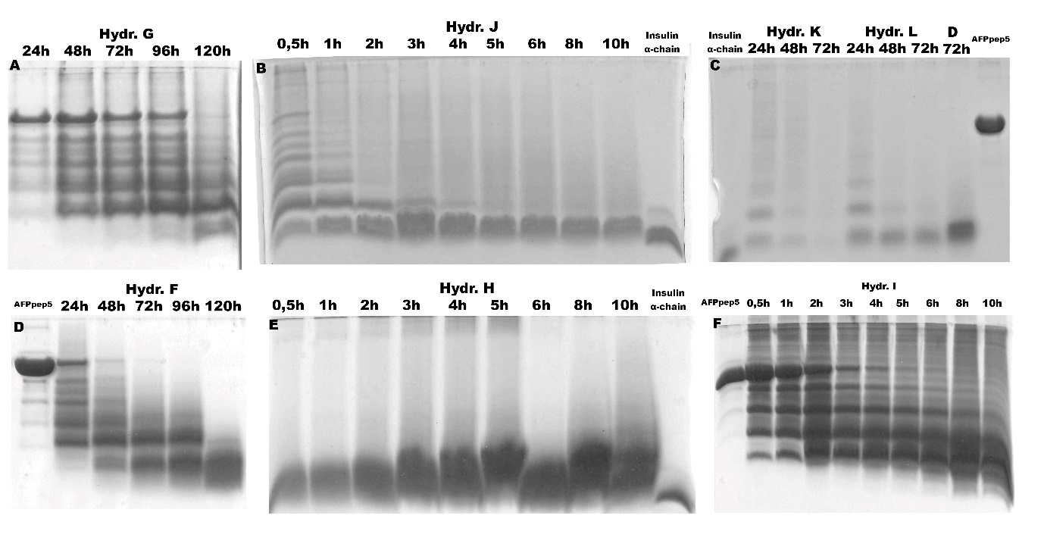
Fig. S2. Tricine-SDS-PAGE analysis of different hydrolysis methods
Fig. S3. Analysis of hydrolysis mixture D – 96h by MALDI-MS (3026.2 – AFPpep1; 3082.2 – formyl-AFPpep1)
Fig. S4. Fragmentation spectrum of formyl-PLEHHHHH.

Table. S1. Formic acid hydrolysis products by HPLC-ESI-MS
 | Rt [min] | m/z measured |  | Mr calculated | z | Δ m/z [ppm] |  | Intensity | Score |  | Sequence |  |  | Modifications
 | 1,11 | 118,0864 |  | 117,079 | 1 | 0,88 |  | 12 190 | 31 |  | L.V.K
 | 15,02 | 937,9925 |  | 1873,976 | 2 | -2,96 |  | 3 898 | 16,4 |  | -.PWGVALQTMKQEFLIN.L
 | 15,06 | 618,6003 |  | 2470,377 | 4 | -1,95 |  | 16 810 | 40,3 |  | -.PWGVALQTMKQEFLINLVKQK.P
 | 15,14 | 605,9355 |  | 3024,647 | 5 | -1,92 |  | 7 732 | 19,3 |  | -.PWGVALQTMKQEFLINLVKQKPQITD.-
 | 15,14 | 757,1676 |  | 3024,647 | 4 | -1,96 |  | 1 907 000 | 57,5 |  | -.PWGVALQTMKQEFLINLVKQKPQITD.-
 | 15,17 | 1009,2208 |  | 3024,647 | 3 | -2,09 |  | 299 500 | 56,8 |  | -.PWGVALQTMKQEFLINLVKQKPQITD.-
 | 15,21 | 728,4109 |  | 2909,6201 | 4 | -1,91 |  | 96 970 | 63,1 |  | -.PWGVALQTMKQEFLINLVKQKPQIT.D
 | 15,21 | 970,8787 |  | 2909,6201 | 3 | -1,97 |  | 18 360 | 48,2 |  | -.PWGVALQTMKQEFLINLVKQKPQIT.D
 | 15,21 | 970,8787 |  | 2909,6201 | 3 | -1,97 |  | 18 360 | 48,2 |  | -.PWGVALQTMKQEFLINLVKQKPQIT.D
 | 15,32 | 764,1659 |  | 3052,642 | 4 | -2,5 |  | 450 300 | 47 |  | -.PWGVALQTMKQEFLINLVKQKPQITD.- |  |  | Formyl: 1
 | 15,36 | 735,4093 |  | 2937,615 | 4 | -2,42 |  | 22 340 | 46,9 |  | -.PWGVALQTMKQEFLINLVKQKPQIT.D |  |  | Formyl: 1
 | 15,36 | 735,4093 |  | 2937,615 | 4 | -2,42 |  | 22 340 | 46,9 |  | -.PWGVALQTMKQEFLINLVKQKPQIT.D |  |  | Formyl: 1
 | 15,65 | 764,166 |  | 3052,642 | 4 | -2,27 |  | 444 300 | 50,3 |  | -.PWGVALQTMKQEFLINLVKQKPQITD.- |  |  | Formyl: 8
 | 15,65 | 1018,5522 |  | 3052,642 | 3 | -2,34 |  | 81 540 | 51,2 |  | -.PWGVALQTMKQEFLINLVKQKPQITD.- |  |  | Formyl: 8
 | 15,69 | 735,409 |  | 2937,615 | 4 | -2,71 |  | 20 220 | 40,2 |  | -.PWGVALQTMKQEFLINLVKQKPQIT.D |  |  | Formyl: 10
 | 15,69 | 980,208 |  | 2937,615 | 3 | -4,41 |  | 4 866 | 18,8 |  | -.PWGVALQTMKQEFLINLVKQKPQIT.D |  |  | Formyl: 8
 | 15,69 | 980,208 |  | 2937,615 | 3 | -4,41 |  | 4 866 | 18,8 |  | -.PWGVALQTMKQEFLINLVKQKPQIT.D |  |  | Formyl: 10
 | 15,69 | 980,208 |  | 2937,615 | 3 | -4,41 |  | 4 866 | 18,8 |  | -.PWGVALQTMKQEFLINLVKQKPQIT.D |  |  | Formyl: 8
 | 15,69 | 980,208 |  | 2937,615 | 3 | -4,41 |  | 4 866 | 18,8 |  | -.PWGVALQTMKQEFLINLVKQKPQIT.D |  |  | Formyl: 10
 | 15,81 | 771,1638 |  | 3080,6369 | 4 | -3,43 |  | 83 200 | 43 |  | -.PWGVALQTMKQEFLINLVKQKPQITD.- |  |  | Formyl: 1, 8
 | 16,2 | 1018,552 |  | 3052,642 | 3 | -2,6 |  | 34 540 | 40,7 |  | -.PWGVALQTMKQEFLINLVKQKPQITD.- |  |  | Formyl: 21
 | 16,2 | 1018,552 |  | 3052,642 | 3 | -2,6 |  | 34 540 | 44,2 |  | -.PWGVALQTMKQEFLINLVKQKPQITD.- |  |  | Formyl: 19
 | 16,27 | 739,0802 |  | 2214,2235 | 3 | -2,12 |  | 9 206 | 50,4 |  | -.PWGVALQTMKQEFLINLVK.Q
 | 16,36 | 1027,8834 |  | 3080,6369 | 3 | -2,71 |  | 8 196 | 15,1 |  | -.PWGVALQTMKQEFLINLVKQKPQITD.- |  |  | Formyl: 1, 21
 | 16,63 | 1027,883 |  | 3080,6369 | 3 | -3,1 |  | 7 936 | 20,6 |  | -.PWGVALQTMKQEFLINLVKQKPQITD.- |  |  | Formyl: 8, 19
 | 16,63 | 1027,883 |  | 3080,6369 | 3 | -3,1 |  | 7 936 | 17,9 |  | -.PWGVALQTMKQEFLINLVKQKPQITD.- |  |  | Formyl: 10, 21
 | 18,04 | 1018,5544 |  | 3052,642 | 3 | -0,15 |  | 167 400 | 47 |  | -.PWGVALQTMKQEFLINLVKQKPQITD.- |  |  | Formyl: 10
 | 18,04 | 1018,5544 |  | 3052,642 | 3 | -0,15 |  | 167 400 | 59,6 |  | -.PWGVALQTMKQEFLINLVKQKPQITD.- |  |  | Formyl: 1
 | 18,07 | 980,2118 |  | 2937,615 | 3 | -0,49 |  | 11 460 | 25 |  | -.PWGVALQTMKQEFLINLVKQKPQIT.D |  |  | Formyl: 1
 | 18,07 | 980,2118 |  | 2937,615 | 3 | -0,49 |  | 11 460 | 25 |  | -.PWGVALQTMKQEFLINLVKQKPQIT.D |  |  | Formyl: 1
 | 18,47 | 1027,8858 |  | 3080,6369 | 3 | -0,42 |  | 39 580 | 38 |  | -.PWGVALQTMKQEFLINLVKQKPQITD.- |  |  | Formyl: 1, 10
 | 18,47 | 1027,8858 |  | 3080,6369 | 3 | -0,42 |  | 39 580 | 54,8 |  | -.PWGVALQTMKQEFLINLVKQKPQITD.- |  |  | Formyl: 1, 8

