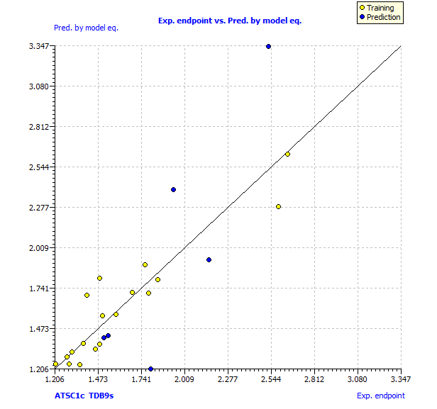
Fig. S1. The plot of experimental endpoint vs predicted pMIC₅₀ by model equation

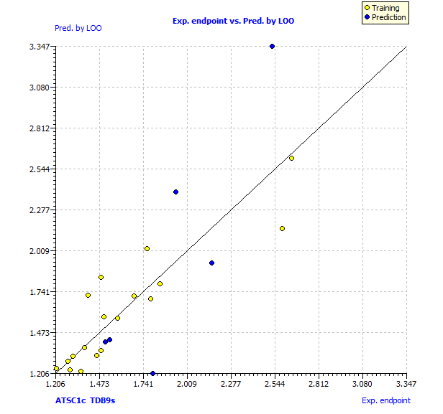
Fig. S2. The plot of experimental endpoint vs predicted pMIC₅₀ LOO

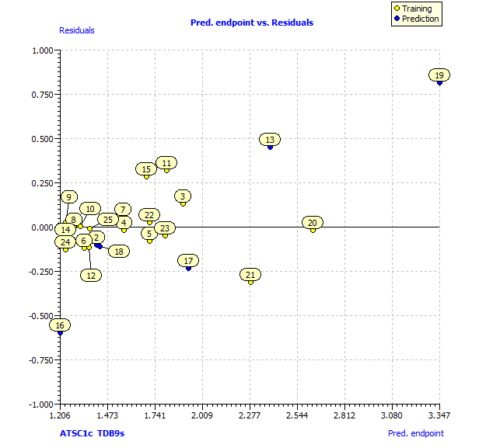
Fig. S3. View residuals calculated using predictions by model equation

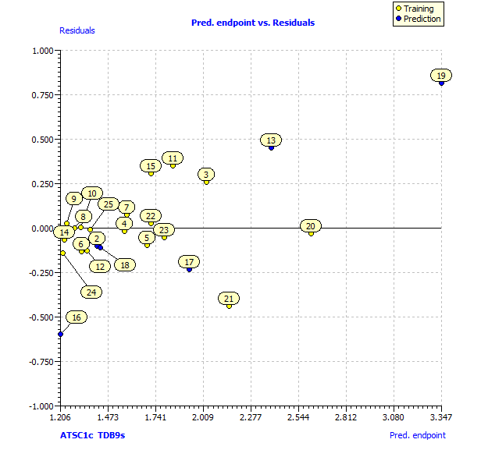
Fig. S4. View Residuals calculated using predictions by LOO

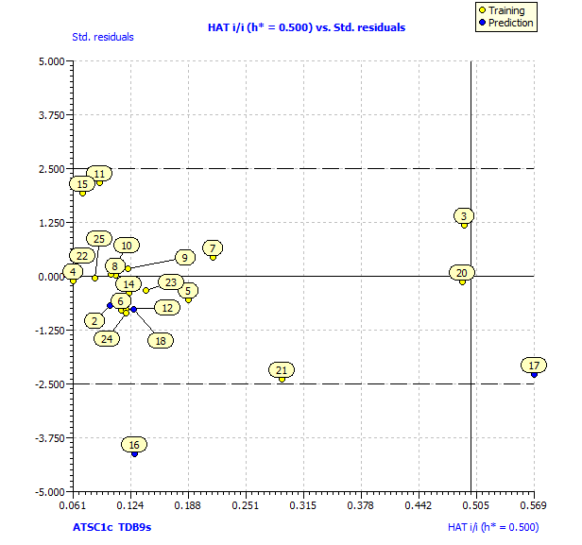
Fig. S5. Using h* = 0.5 as the warning leverage, the plot of standardized residuals versus hat values (William plot).

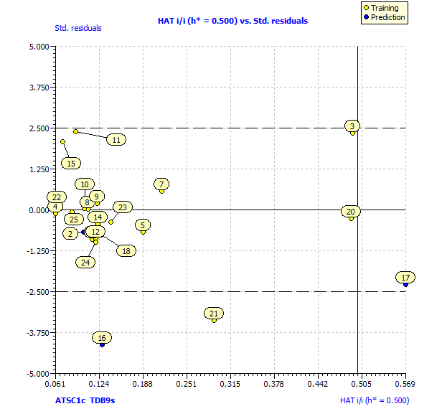
Fig. S6. Using h* = 0.5 as the warning leverage, the plot of standardized residuals versus hat values (William plot – Prediction by LOO).

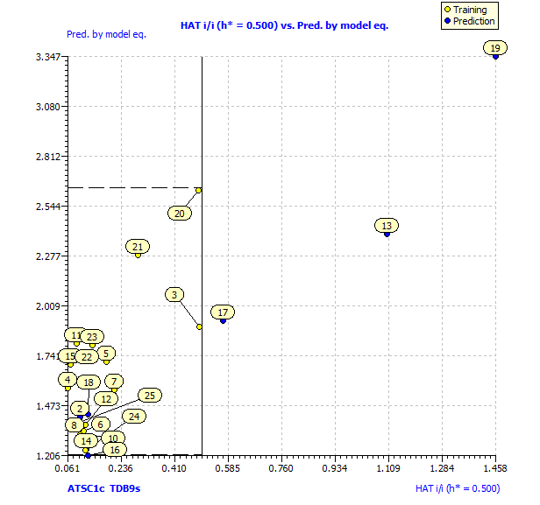
Fig. S7. Insubria Graph for the applicability domain inspection of the developed model

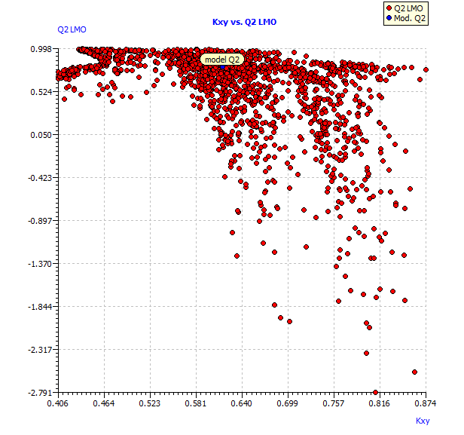
Fig. S8. Leave-two-out cross validation vs Kxy

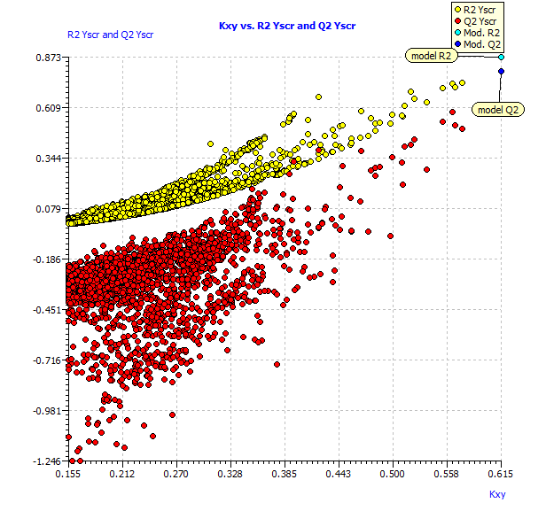
Fig. S9. Plot of Y-scrambled validations models compared with the original model.
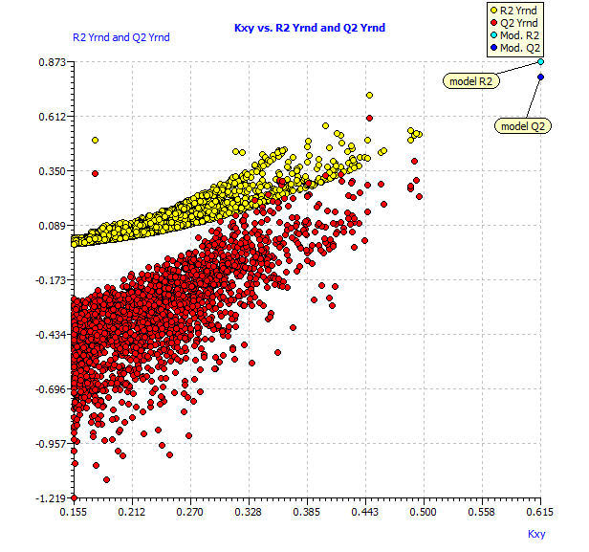
Figure S10. Y-randomization validation procedure to verify chance correlation of a model using QSAR modeling.

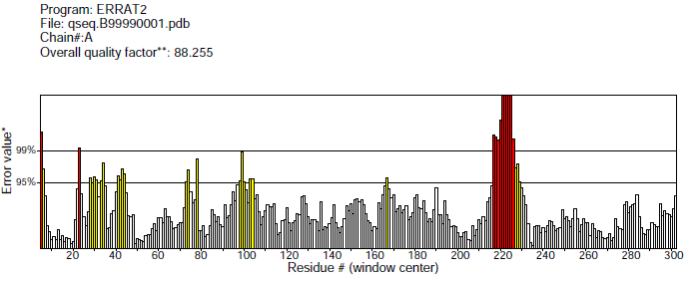A
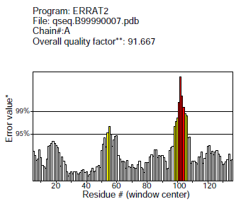B

Fig. S11. Quality verification plot of the energy minimized model of the19-fatty acid desaturase performed using ERRAT.

