Supplementary Material
Biotechnologically potential genes in a polysaccharide-degrading epibiont of the Indonesian brown algae Hydroclathrus sp.

Stalis Norma Ethica^{1*}, Dewi Seswita Zilda^{2*}, Oedjijono Oedjijono³, Muhtadi Muhtadi⁴, Gintung Patantis², Sri Darmawati¹, Sri Sinto Dewi⁵, Agus Sabdono⁶, Agustinus Robert Uria^{7ζ}
¹ Magister Program of Clinical Laboratory Science, Universitas Muhammadiyah Semarang (UMS)
Jalan Kedungmundu Raya, Semarang 50273, Indonesia. Email: norma@unimus.ac.id
² Research and Development Center for Marine and Fisheries Product Processing and Biotechnology
Jalan KS Tubun Petamburan VI, Slipi, Jakarta Pusat 10260, Indonesia.
Email: seswitazilda@gmail.com, gintungpatantis@gmail.com
³ Faculty of Biology, Universitas Jenderal Soedirman, Purwokerto 53122, Indonesia. Email: oedjijono@hotmail.com
⁴ Faculty of Pharmacy, Universitas Muhammadiyah Surakarta, Sukoharjo 57162, Indonesia. Email: muhtadi@ums.ac.id
⁵ Diploma Study Program of Medical Laboratory Technology, Faculty of Nursing and Health Sciences,
Universitas Muhammadiyah Semarang, Semarang 50273, Indonesia. Email: sintomun@yahoo.com
⁶ Department of Marine Science, Faculty of Fisheries and Marine Science, Diponegoro University
Semarang 50272, Indonesia. Email: agus_sabdono@yahoo.com
⁷ Faculty of Pharmaceutical Sciences, Hokkaido University
Kita 12 Nishi 6 Kita-ku, Sapporo 060-0812, Japan. Email: auria@pharm.hokudai.ac.jp.

*Contributed equally
^{ζ} corresponding authors

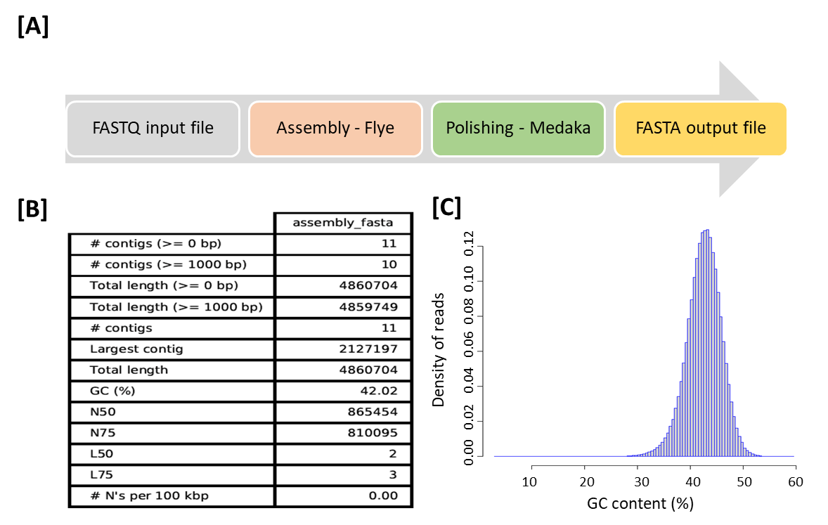
Figure S1. Visualization and quality assessment of whole H103-3b genome assembly. [A] Workflow of HI03-3b genome sequence assembly. [B] Quality parameters of the assembled HI03-3b genome sequence using Quast (Gurevich et al., 2013). [C] GC content of the assembled HI03-3b genome sequence against density of reads using RSeQC (Wang et al., 2012).

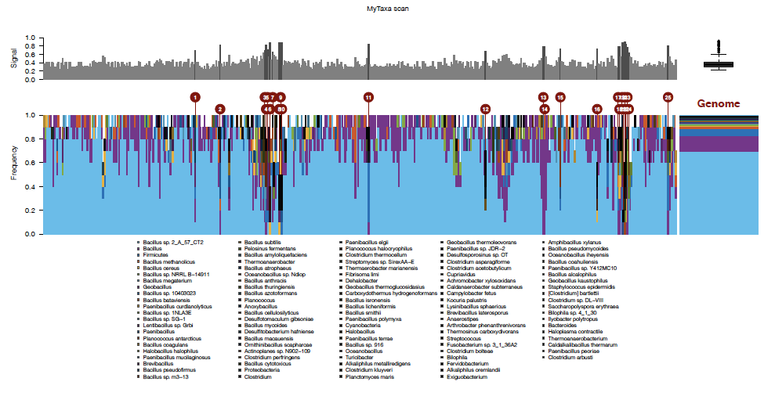

Figure S2. Taxonomic distribution analysis based on MyTaxa Scan result from MiGA (Luo et al., 2014; Rodriguez-R et al., 2018) on the assembled HI03-3b genome sequence, showing that the high quality genome (the major light blue) with minor contamination.

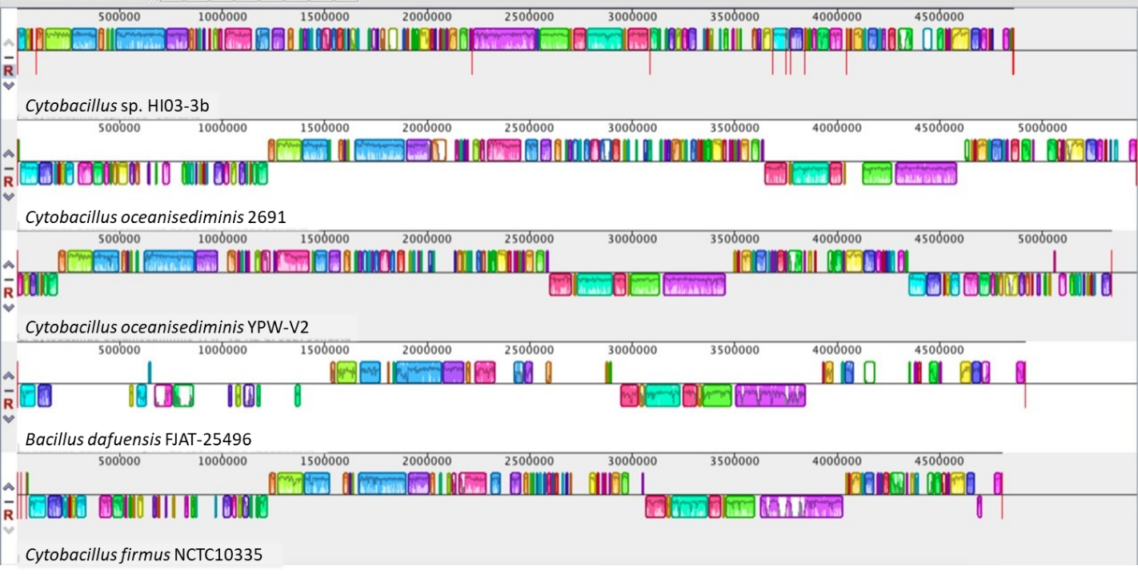
Figure S3. Genome comparison of HI03-3b with three closely related Cytobacillus strains using Mauve (Darling et al., 2004). Each colored block represents a region of the HI03-3b genome sequence, which align with parts of other genomes. Blocks above the central line show forward orientation relative to the first genome sequence, while blocks below the central line indicate regions aligning in the reverse complement orientation. Inside each block, the height of the similarity profile correlates with the average level of conservation region of the genome.
Table S1. The order and direction of HI03-3b contigs were validated by comparing with the genome sequences of C. oceanisedirmins 2691 and C. firmus NCTC10335
HI03-3b | C. firmus NCTC10335 [NZ_UFTC01000001.1] |  |  |  |  | C. oceanisediminis 2691 (GCA_000294775.2)
Contig & size | relative position (bp) |  | I (%) | C (%) | St. | relative position (bp) |  | I (%) | C (%) | St.
7 (959 bp) | 12,840 | 13,424 | 99.81 | 94 | +/+ | 12866 | 13398 | 99.81 | 94 | +/+
3 (20951 bp) | 15,144 | 35,936 | 95.97 | 99 | +/- | 18,940 | 35,374 | 92.33 | 99 | +/-
2 (63377 bp) | 35,560 | 89,674 | 91.07 | 99 | +/- | 35,560 | 113,348 | 91.98 | 99 | +/-
4 (68696 bp) | 104,984 | 162,081 | 95.47 | 99 | +/- | 106,220 | 165,027 | 96.07 | 99 | +/-
1 (92553 bp) | 173,179 | 288,027 | 97.12 | 96 | +/- | 173462 | 284650 | 88.37 | 98 | +/-
5 (207137 bp) | 370,139 | 530,545 | 93.87 | 89 | +/- | 358248 | 341870 | 93.80 | 93 | +/-
8 (2909 bp) | 392309 | 394107 | 98.67 | 98 | +/+ | 172639 | 175547 | 98.76 | 100 | +/+
14 (601380 bp) | 614,475 | 1,179,003 | 93.52 | 76 | +/- | 918615 | 931246 | 89.99 | 85 | +/-
12 (2127197 bp) | 1,365,935 | 2,282,052 | 93.63 | 73 | +/+ | 1361801 | 2906270 | 88.27 | 86 | +/+
13 (865454 bp) | 3,062,058 | 3,691,424 | 96.19 | 96 | +/- | 3,697,504 | 4,624,004 | 89.14 | 97 | +/-
6 (810095 bp) | 3,968,023 | 4,679,433 | 96.90 | 65 | +/+ | 4838455 | 4854294 | 91.13 | 76 | +/+

Table S2 Comparation of genomic features between Cytobacillus HI03-3b (in this work) and C. firmus NCTC10335 (GenBank assembly accession number GCA_900445365.1)
Properties | Cytobacillus HI03-3b  [GenBank GCA_023197125.1]  (In this work) | C. firmus NCTC10335  [GenBank GCA_900445365.1]
Genome size | 4,860,704 bp | 4,803,910
Open reading frames (ORFs) or total genes ª | 5655 | 5307
Coding genes or CDSs (with protein) ^{b} | 4409 | 4575
tRNA genes ^{b, c} | 94 | 107
rRNAs ^{b} | 32 | 36
23S-rRNAs ^{b, d} | 11 | 12
16S-rRNAs ^{b, d} | 11 | 12
5S-rRNAs ^{b, d} | 10 | 12
ncRNAs ^{b} | 6 | 6
ª) determined using GeneMark.hmm PROKARYOTIC (Version 3.26) (Besemer et al., 2001)
^{b}) based on NCBI record
^{c}) predicted with tRNAscan-SE 2.0. (Chan et al., 2021; Lowe and Chan, 2016)
^{d}) estimated based on KofamKOALA (Aramaki et al., 2020)

Table S3 Estimated numbers of tRNAs in HI03-3b genome sequence analyzed using tRNAscan-SE 2.0. (Chan et al., 2021; Lowe and Chan, 2016)
Isotype/ | Contig |  |  |  |  |  |  |  |  |  |  | Total
Anticodon | 1 | 6 | 5 | 4 | 3 | 2 | 14 | 13 | 7 | 8 | 12 | Total
Ala | 1 | 1 |  |  |  |  | 1 | 1 |  |  |  | 4
Arg | 1 | 1 |  |  |  |  | 1 | 2 |  |  | 1 | 6
Asn | 2 |  |  |  |  |  |  | 1 |  |  | 1 | 3
Asp | 1 | 1 | 1 |  |  |  | 1 | 1 |  |  | 1 | 6
Cys |  |  |  |  |  |  | 1 |  |  |  | 1 | 2
Gln | 2 |  |  |  |  |  | 1 | 1 |  |  | 1 | 5
Ile |  |  |  |  |  |  | 1 | 1 |  |  |  | 2
Gly | 2 |  |  |  |  |  | 2 | 2 |  |  | 2 | 8
Glu | 2 | 1 |  |  |  | 1 | 1 | 1 |  |  | 1 | 7
His |  |  |  |  |  |  | 1 |  |  |  | 1 | 2
Leu | 2 |  |  |  |  |  | 1 | 2 |  |  | 2 | 7
Lys | 2 | 1 |  |  |  |  | 1 | 1 |  |  |  | 5
Met |  |  |  |  |  | 1 | 2 | 2 |  |  |  | 5
Phe |  | 1 |  |  |  |  | 1 | 1 |  |  | 1 | 4
Pro | 1 |  |  |  |  |  | 1 | 1 |  |  |  | 3
SeC |  |  |  |  |  |  |  |  |  |  | 1 | 1
Ser | 1 |  |  |  | 1 |  | 1 | 2 |  |  | 1 | 6
Thr | 2 |  |  |  |  |  |  |  |  |  | 1 | 3
Trp |  |  |  |  |  |  | 1 |  |  |  | 1 | 2
Tyr | 1 |  |  |  |  |  | 1 |  |  |  | 1 | 3
Val | 1 |  |  |  |  |  | 1 | 1 |  |  | 2 | 5
fMet |  |  | 1 |  |  |  |  |  |  |  | 1 | 2
Total | 21 | 6 | 2 | 0 | 1 | 2 | 20 | 22 | 0 | 0 | 20 | 94

Table S4 Numbers of 16S-rRNAs in HI03-3b genome sequence based on KofamKOALA (Aramaki et al., 2020)
Top Hit | Accession | Contig |  |  |  |  |  |  |  |  |  |  | Total
(BlastN) | number | 1 | 6 | 5 | 4 | 3 | 2 | 14 | 13 | 7 | 8 | 12 | Total
C. firmus NBRC 15306 | NR_112635.1 | 1 | 2 |  | 1 | 1 | 1 | 1 | 1 |  | 1 | 0 | 9
C. firmus IAM 12464 | NR_025842.1 |  |  | 2 |  |  |  |  |  |  |  |  | 2
B. sanguinis BML-BC004 | NR_175555.1 |  |  |  |  |  |  |  |  | 1 |  |  | 1
 |  |  |  |  |  |  |  |  |  |  |  |  | 12

Table S5 Predicted carbohydrate metabolisms in HI03-3b based on KofamKOALA (Aramaki et al., 2020)
  - Central carbohydrate metabolism
    - M00001 Glycolysis (Embden-Meyerhof pathway), glucose => pyruvate (10) (complete 9/9)
    - M00002 Glycolysis, core module involving three-carbon compounds (6) (complete 5/5)
    - M00003 Gluconeogenesis, oxaloacetate => fructose-6P (8) (complete 7/7)
    - M00009 Citrate cycle (TCA cycle, Krebs cycle) (17) (complete 8/8)
    - M00010 Citrate cycle, first carbon oxidation, oxaloacetate => 2-oxoglutarate (3) (complete 3/3)
    - M00011 Citrate cycle, second carbon oxidation, 2-oxoglutarate => oxaloacetate (14) (complete 5/5)
    - M00004 Pentose phosphate pathway (Pentose phosphate cycle) (9) (complete 7/7)
    - M00006 Pentose phosphate pathway, oxidative phase, glucose 6P => ribulose 5P (3) (complete 2/2)
    - M00007 Pentose phosphate pathway, non-oxidative phase, fructose 6P => ribose 5P (5) (complete 4/4)
    - M00580 Pentose phosphate pathway, archaea, fructose 6P => ribose 5P (3) (complete 2/2)
    - M00005 PRPP biosynthesis, ribose 5P => PRPP (1) (complete 1/1)
    - M00008 Entner-Doudoroff pathway, glucose-6P => glyceraldehyde-3P + pyruvate (3) (1 block missing 3/4)
    - M00308 Semi-phosphorylative Entner-Doudoroff pathway, gluconate => glycerate-3P (4) (1 block missing 3/4)
  - Other carbohydrate metabolism
    - M00854 Glycogen biosynthesis, glucose-1P => glycogen/starch (5) (complete 2/2)
    - M00855 Glycogen degradation, glycogen => glucose-6P (3) (1 block missing 2/3)
    - M00549 Nucleotide sugar biosynthesis, glucose => UDP-glucose (3) (complete 3/3)
    - M00909 UDP-N-acetyl-D-glucosamine biosynthesis, prokaryotes, glucose => UDP-GlcNAc (5) (complete 5/5)
    - M00012 Glyoxylate cycle (5) (complete 5/5)
    - M00741 Propanoyl-CoA metabolism, propanoyl-CoA => succinyl-CoA (3) (1 block missing 2/3)

Table S6 Energy metabolisms in HI03-3b based on KofamKOALA (Aramaki et al., 2020) analysis
2.1. Carbon fixation
    - M00167 Reductive pentose phosphate cycle, glyceraldehyde-3P => ribulose-5P (5) (1 block missing 6/7)
    - M00168 CAM (Crassulacean acid metabolism), dark (1) (1 block missing 1/2)
    - M00169 CAM (Crassulacean acid metabolism), light (1) (1 block missing 1/2)
    - M00579 Phosphate acetyltransferase-acetate kinase pathway, acetyl-CoA => acetate (2) (complete 2/2)
2.2. Methane metabolism
    - M00345 Formaldehyde assimilation, ribulose monophosphate pathway (4) (complete 3/3)
2.3. Sulfur metabolism
    - M00176 Assimilatory sulfate reduction, sulfate => H2S (5) (complete 3/3) ATP synthesis
    - M00151 Cytochrome bc1 complex respiratory unit (3) (complete 1/1)
    - M00416 Cytochrome aa3-600 menaquinol oxidase (4) (complete 1/1)
    - M00157 F-type ATPase, prokaryotes and chloroplasts (8) (complete 1/1)

Table S7 Lipid metabolisms in HI03-3b based on KofamKOALA (Aramaki et al., 2020) analysis
3.1. Fatty acid metabolism
    - M00082 Fatty acid biosynthesis, initiation (6) (complete 2/2)
    - M00083 Fatty acid biosynthesis, elongation (6) (complete 1/1)
    - M00086 beta-Oxidation, acyl-CoA synthesis (1) (complete 1/1)
    - M00087 beta-Oxidation (5) (complete 3/3) Lipid metabolism
    - M00098 Acylglycerol degradation (2) (complete 2/2)
    - M00093 Phosphatidylethanolamine (PE) biosynthesis, PA => PS => PE (3) (complete 3/3)

Table S8 Nucleotide metabolisms in HI03-3b based on KofamKOALA (Aramaki et al., 2020) analysis
4.1. Purine metabolism
    - M00049 Adenine ribonucleotide biosynthesis, IMP => ADP, ATP (4) (complete 4/4)
    - M00050 Guanine ribonucleotide biosynthesis, IMP => GDP, GTP (4) (complete 4/4) Pyrimidine metabolism
    - M00051 Uridine monophosphate biosynthesis, glutamine (+ PRPP) => UMP (7) (1 block missing 2/3)
    - M00052 Pyrimidine ribonucleotide biosynthesis, UMP => UDP/UTP, CDP/CTP (3) (complete 3/3)
    - M00053 Pyrimidine deoxyribonuleotide biosynthesis, CDP => dCTP (3) (complete 2/2)
    - M00938 Pyrimidine deoxyribonuleotide biosynthesis, UDP => dTTP (5) (complete 5/5)

Table S9 Predicted amino acid metabolisms in HI03-3b based on KofamKOALA (Aramaki et al., 2020)
  - Serine and threonine metabolisms
    - M00020 Serine biosynthesis, glycerate-3P => serine (2) (1 block missing 2/3)
    - M00018 Threonine biosynthesis, aspartate => homoserine => threonine (5) (complete 5/5)
  - Cysteine and methionine metabolism
    - M00021 Cysteine biosynthesis, serine => cysteine (2) (complete 2/2)
    - M00609 Cysteine biosynthesis, methionine => cysteine (6) (complete 6/6)
    - M00017 Methionine biosynthesis, aspartate => homoserine => methionine (9) (complete 7/7)
  - Branched-chain amino acid metabolism
    - M00019 Valine/isoleucine biosynthesis, pyruvate => valine / 2-oxobutanoate => isoleucine (5) (complete 4/4)
    - M00535 Isoleucine biosynthesis, pyruvate => 2-oxobutanoate (3) (1 block missing 2/3)
    - M00570 Isoleucine biosynthesis, threonine => 2-oxobutanoate => isoleucine (6) (complete 5/5)
    - M00432 Leucine biosynthesis, 2-oxoisovalerate => 2-oxoisocaproate (4) (complete 3/3)
  - Lysine metabolism
    - M00525 Lysine biosynthesis, acetyl-DAP pathway, aspartate => lysine (9) (complete 9/9)
    - M00526 Lysine biosynthesis, DAP dehydrogenase pathway, aspartate => lysine (5) (1 block missing 5/6)
    - M00527 Lysine biosynthesis, DAP aminotransferase pathway, aspartate => lysine (6) (1 block missing 6/7)
  - Arginine and proline metabolism
    - M00028 Ornithine biosynthesis, glutamate => ornithine (4) (1 block missing 3/4)
    - M00844 Arginine biosynthesis, ornithine => arginine (3) (complete 3/3)
    - M00029 Urea cycle (4) (1 block missing 4/5)
    - M00015 Proline biosynthesis, glutamate => proline (3) (complete 2/2)
  - Polyamine biosynthesis
    - M00133 Polyamine biosynthesis, arginine => agmatine => putrescine => spermidine (4) (complete 4/4)
    - M00134 Polyamine biosynthesis, arginine => ornithine => putrescine (1) (1 block missing 1/2)
  - Histidine metabolism
    - M00026 Histidine biosynthesis, PRPP => histidine (10) (complete 6/6)
    - M00045 Histidine degradation, histidine => N-formiminoglutamate => glutamate (4) (complete 4/4)
  - Aromatic amino acid metabolism
    - M00022 Shikimate pathway, phosphoenolpyruvate + erythrose-4P => chorismate (7) (complete 4/4)
    - M00023 Tryptophan biosynthesis, chorismate => tryptophan (7) (complete 3/3)
    - M00024 Phenylalanine biosynthesis, chorismate => phenylpyruvate => phenylalanine (3) (1 block missing 1/2)
    - M00025 Tyrosine biosynthesis, chorismate => HPP => tyrosine (3) (1 block missing 1/2)
  - Other amino acid metabolism
    - M00027 GABA (gamma-Aminobutyrate) shunt (2) (1 block missing 2/3)

Table S10 Predicted glycan metabolism in HI03-3b based on KofamKOALA (Aramaki et al., 2020)
6.1. Lipopolysaccharide metabolism
    - M00923 UDP-L-FucNAm biosynthesis (3) (1 block missing 3/4)

Table S11 Carbon and vitamins metabolisms in HI03-3b based on KofamKOALA (Aramaki et al., 2020)
7.1. Cofactor and vitamin metabolism
    - M00899 Thiamine salvage pathway, HMP/HET => TMP (3) (complete 2/2)
    - M00125 Riboflavin biosynthesis, plants and bacteria, GTP => riboflavin/FMN/FAD (7) (complete 7/7)
    - M00916 Pyridoxal-P biosynthesis, R5P + glyceraldehyde-3P + glutamine => pyridoxal-P (2) (complete 1/1)
    - M00115 NAD biosynthesis, aspartate => quinolinate => NAD (6) (complete 5/5)
    - M00119 Pantothenate biosynthesis, valine/L-aspartate => pantothenate (5) (complete 5/5)
    - M00913 Pantothenate biosynthesis, 2-oxoisovalerate/spermine => pantothenate (4) (1 block missing 4/5)
    - M00120 Coenzyme A biosynthesis, pantothenate => CoA (4) (1 block missing 2/3)
    - M00123 Biotin biosynthesis, pimeloyl-ACP/CoA => biotin (5) (complete 3/3)
    - M00573 Biotin biosynthesis, BioI pathway, long-chain-acyl-ACP => pimeloyl-ACP => biotin (4) (1 block missing 4/5)
    - M00577 Biotin biosynthesis, BioW pathway, pimelate => pimeloyl-CoA => biotin (5) (1 block missing 4/5)
    - M00881 Lipoic acid biosynthesis, plants and bacteria, octanoyl-ACP => dihydrolipoyl-E2/H (1) (1 block missing 1/2)
    - M00882 Lipoic acid biosynthesis, eukaryotes, octanoyl-ACP => dihydrolipoyl-H (1) (1 block missing 1/2)
    - M00883 Lipoic acid biosynthesis, animals and bacteria, octanoyl-ACP => dihydrolipoyl-H => dihydrolipoyl-E2 (3) (complete 3/3)
    - M00884 Lipoic acid biosynthesis, octanoyl-CoA => dihydrolipoyl-E2 (1) (1 block missing 1/2)
    - M00126 Tetrahydrofolate biosynthesis, GTP => THF (7) (1 block missing 4/5)
    - M00842 Tetrahydrobiopterin biosynthesis, GTP => BH4 (2) (1 block missing 2/3)
    - M00843 L-threo-Tetrahydrobiopterin biosynthesis, GTP => L-threo-BH4 (2) (1 block missing 2/3)
    - M00880 Molybdenum cofactor biosynthesis, GTP => molybdenum cofactor (5) (complete 3/3)
    - M00140 C1-unit interconversion, prokaryotes (3) (complete 3/3)
    - M00141 C1-unit interconversion, eukaryotes (1) (1 block missing 1/2)
    - M00846 Siroheme biosynthesis, glutamyl-tRNA => siroheme (7) (1 block missing 5/6)
    - M00121 Heme biosynthesis, plants and bacteria, glutamate => heme (10) (complete 10/10)
    - M00926 Heme biosynthesis, bacteria, glutamyl-tRNA => coproporphyrin III => heme (9) (complete 9/9)
    - M00924 Cobalamin biosynthesis, anaerobic, uroporphyrinogen III => sirohydrochlorin => cobyrinate a, c-diamide (13) (complete 11/11)
    - M00122 Cobalamin biosynthesis, cobyrinate a, c-diamide => cobalamin (7) (1 block missing 6/7)
    - M00116 Menaquinone biosynthesis, chorismate (+ polyprenyl-PP) => menaquinol (8) (1 block missing 8/9)

Table S12 Predicted terpenoid biosynthesis in HI03-3b based on KofamKOALA (Aramaki et al., 2020)
8.1. Terpenoid backbone biosynthesis
    - M00096 C5 isoprenoid biosynthesis, non-mevalonate pathway (8) (complete 8/8)
    - M00364 C10-C20 isoprenoid biosynthesis, bacteria (2) (complete 2/2)
    - M00365 C10-C20 isoprenoid biosynthesis, archaea (1) (1 block missing 1/2)

Table S13 some genes encoding carbohydrate active enzymes
Gene ID | AA | KEGG Orthology search | BLASTx search |  | Proposed function
Gene ID | AA | KEGG Orthology search | Protein | I/S (%)
HI03-512 | 558 | oligo-1,6-glucosidase/ α-glucosidase [EC:3.2.1.10] | α-glucosidase [WP_222497254.1] | 99/99 | α-glucosidase
HI03-513 | 561 | trehalose-6-phosphate hydrolase [EC:3.2.1.93] | α-phosphotrehalase [WP_222497253.1] | 99/99 | α-phosphotrehalase
HI03-1147 | 561 | oligo-1,6-glucosidase [EC:3.2.1.10] | alpha-glucosidase [WP_197246158.1] | 99/99 | α-glucosidase
HI03-1148 | 539 | oligo-1,6-glucosidase [EC:3.2.1.10] | alpha-glucosidase [WP_262172852.1] | 99/100 | α-glucosidase
HI03-2057 | 496 | β-fructofuranosidase [EC:3.2.1.26] | sucrose-6-phosphate hydrolase [WP_252218572.1] | 97/98 | sucrose-6-phosphate hydrolase
HI03-5125 | 1120 | mannosyl-glycoprotein endo-β-N-acetylglucosaminidase [EC:3.2.1.96] | N-acetylglucosaminidase [WP_139344984.1] | 41/57 | N-acetylglucosaminidase
HI03-2145 | 222 | β-glucosylceramidase [EC:3.2.1.45] | glycoside hydrolase family 30 protein [MBN8203477.1] | 94/95 | glucosylceramidase
HI03-1798 | 443 | xylose isomerase [EC:5.3.1.5] | xylose isomerase [WP_248347596.1] | 100/100 | xylose isomerase
HI03-5147 | 417 | L-rhamnose isomerase [EC:5.3.1.14] | L-rhamnose isomerase [WP_258751270.1] | 98/100 | L-rhamnose isomerase
HI03-4199 | 308 | purine nucleosidase [EC:3.2.2.1] | nucleoside hydrolase [WP_197214150.1] | 100/100 | nucleoside hydrolase
HI03-424 | 213 | soluble lytic murein transglycosylase [EC:4.2.2.-] | lytic transglycosylase domain-containing protein [WP_197214652.1] | 100/100 | lytic transglycosylase
HI03-1355 | 387 | chitinase [EC:3.2.1.14] | glycosyl hydrolase family 18 [WP_227887042.1] | 98/99 | chitinase
HI03-1798 | 443 | xylose isomerase [EC:5.3.1.5] | xylose isomerase [WP_227887452.1] | 99/99 | xylose isomerase
HI03-2670 | 521 | pullulanase [EC:3.2.1.41] | type I pullulanase [WP_222500182.1] | 99/  99 | pullulanase

Table S14 Genes on HI03-3b genome encoding biotechnologically potential enzymes
Gene ID | AA | KEGG Orthology search  (Aramaki et al., 2020) |  | BLASTx search (Altschul et al., 1990) |  |  | Proposed function
Gene ID | AA | KO/  HMM | Protein | Protein | Organism | I/S (%) | Proposed function
HI03-104 | 301 | K01476  369.3 | arginase [EC:3.5.3.1] | arginase  [WP_197201066.1] | Cytobacillus firmus | 99/  100 | arginase
HI03-309 | 214 | K13282  116.9 | cyanophycinase [EC:3.4.15.6] | cyanophycinase  [SUV02533.1] | C. firmus | 89/  95 | cyanophycinase
HI03-512 | 558 | K01187 277.10 | alpha-glucosidase [EC:3.2.1.20] | alpha-glucosidase WP_222497254.1 | C. firmus | 99/  99 | α-glucosidase
HI03-932 | 411 | K07263  287.1 | zinc protease [EC:3.4.24.-] | insulinase family [WP_227887042.1] | C. firmus | 99/  100 | zinc-dependent metallo-proteinase
HI03-1355 | 387 | K01183  132.3 | chitinase [EC:3.2.1.14] | glycosyl hydrolase family 18 [WP_227887042.1] | Cytobacillus sp. | 98/  99 | chitinase
HI03-1694 | 593 | K01400  565.2 | bacillolysin [EC:3.4.24.28] | M4 family metallopeptidase  [WP_222500569.1] | C. firmus | 99/  99 | bacillolysin
HI03-1798 | 443 | K01805  691.1 | xylose isomerase [EC:5.3.1.5] | xylose isomerase  [WP_227887452.1] | C. oceanisediminis | 99/  99 | xylose isomerase
HI03-2166 | 449 | K17734  397.3 | serine protease AprX [EC:3.4.21.-] | S8 family peptidase [WP_226617693.1] | C. firmus | 99/  99 | serine protease
HI03-2463 | 348 | K13953  507.3 | ADH, propanol-preferring [EC:1.1.1.1] | alcohol dehydrogenase AdhP [WP_227888089.1] | C. oceanisediminis | 99/  99 | alcohol dehydrogenase
HI03-2670 | 521 | K01200  594.8 | pullulanase [EC:3.2.1.41] | type I pullulanase [WP_222500182.1] | C. firmus | 99/  99 | pullulanase
HI03-3302 | 306 | K01424  316.1 | L-asparaginase [EC:3.5.1.1] | Asparaginase  [WP_222497870.1] | C. firmus | 100/100 | L-asparaginase
HI03-3438 | 958 | K01200  984.7 | pullulanase [EC:3.2.1.41] | type I pullulanase [WP_222500182.1] | C. firmus | 99/  99 | pullulanase
HI03-3561 | 391 | K20486  401.2 | lantibiotic leader peptide-processing serine protease [EC:3.4.21.-] | S8 family serine peptidase [WP_048011423.1] | C. firmus | 99/  99 | subtilisin
HI03-3984 | 399 | K04771  292.0 | serine protease Do [EC:3.4.21.107] | trypsin-like peptidase domain-containing protein  [WP_222498307.1] | C. firmus | 100/  100 | trypsin-like serine peptidase
HI03-2429 | 200 | K06999 | carboxylesterase [EC 3.1.1.1] | carboxylesterase  [OMF59661.1] | Paenibacillus sp. FSL R5-0490 | 96/  99 | carboxylesterase
HI03-2637 | 267 | K01054 | lysophospholipase [EC:3.1.1.5] | phospholipase [OMF54228.1] | Paenibacillus sp. FSL R5-0490 | 99/  100 | lysophospholipase
HI03-63 | 261 | K17836 | beta-lactamase class A [EC:3.5.2.6] | class A beta-lactamase-related serine hydrolase [WP_226620288.1] | C. firmus | 95/  97 | β-lactamase
HI03-3504 | 425 | K01438 | acetylornithine deacetylase [EC:3.5.1.16] | acetylornithine deacetylase [OMF56067.1] | Paenibacillus sp. FSL R5-0490 | 98/  99 | acetylornithine deacetylase
HI03-4153 | 346 | K13979 | alcohol dehydrogenase (NADP+) [EC:1.1.1.2] | NAD(P)-dep. alcohol dehydrogenase [WP_227888799.1] | C. oceanisediminis | 99/  99 | NADP-dep. ADH [WP_248349163.1]
HI03-4410 | 296 | K01585 | arginine decarboxylase [EC:4.1.1.19] | arginine decarboxylase [PAE22928.1] | Bacillus sp. 7894-2 | 94/  96 | SpeA_aminotransferase class I [WP_248349356.1]
HI03-5147 | 417 | K01813 | L-rhamnose isomerase [EC:5.3.1.14] | L-rhamnose isomerase [WP_258751270.1] |  | 98/  100 | L-rhamnose isomerase
Abbreviations: KO, KEGG Ortholog; I, identity; S, similarity
Notes:
- Arginase has been used for environmentally friendly preparation of L-ornithine as food supplement and nutrition product (Li et al., 2021).
- Microbial proteases have found various applications in the detergent, food, pharmaceutical, leather, and textile industries (Rao et al., 1998).
- Chitinase has been applied in food industry, medicine, cosmetics, and crop protection (Poria et al., 2021). GH18 chitinase was particularly subjected to protein engineering for the development of tailor-made chitinases (Poria et al., 2021).
- Xylose isomerase has widely been used in the production of high fructose corn syrup (HFCS) and is potentially explored to produce some value-added chemicals in the food, cosmetics, and pharmaceutical industries (Miyamoto et al., 2021).
- L-asparaginase has been used as anticancer chemotherapeutic agents for the treatment of leukemia, Hodgkin disease, and sarcoma (Egler et al., 2016; Narta et al., 2007; Verma et al., 2007; Wriston, 1985). It is also used to reduce acrylamide levels in cooked carbohydrate-rich food especially during the heat treatment of starchy foods (Jia et al., 2021).
- Carboxylesterases (CEs) have been applied in xenobiotic & endobiotic degradations, biocatalysis, & drug metabolism (Wheelock et al., 2005)
- Phospholipases have been used in scientific and medical research, such as inhibitors for generating anti-inflammatory agents and as diagnostic markers for microbial infections (Karabina et al., 2010; Sutto-Ortiz et al., 2017).
- Arginine decarboxylase catalyzes conversion of l-arginine into agmatine, a valuable pharmaceutical intermediate with various potential therapeutic functions in neurotransmitter systems, nitric oxide synthesis, and polyamine metabolism (Sun et al., 2017).
- L-rhamnose isomerase catalyzes the isomerization between L-rhamnose and L-rhamnulose. It has great potential application in producing a wide variety of rare sugars (Xu et al., 2016)

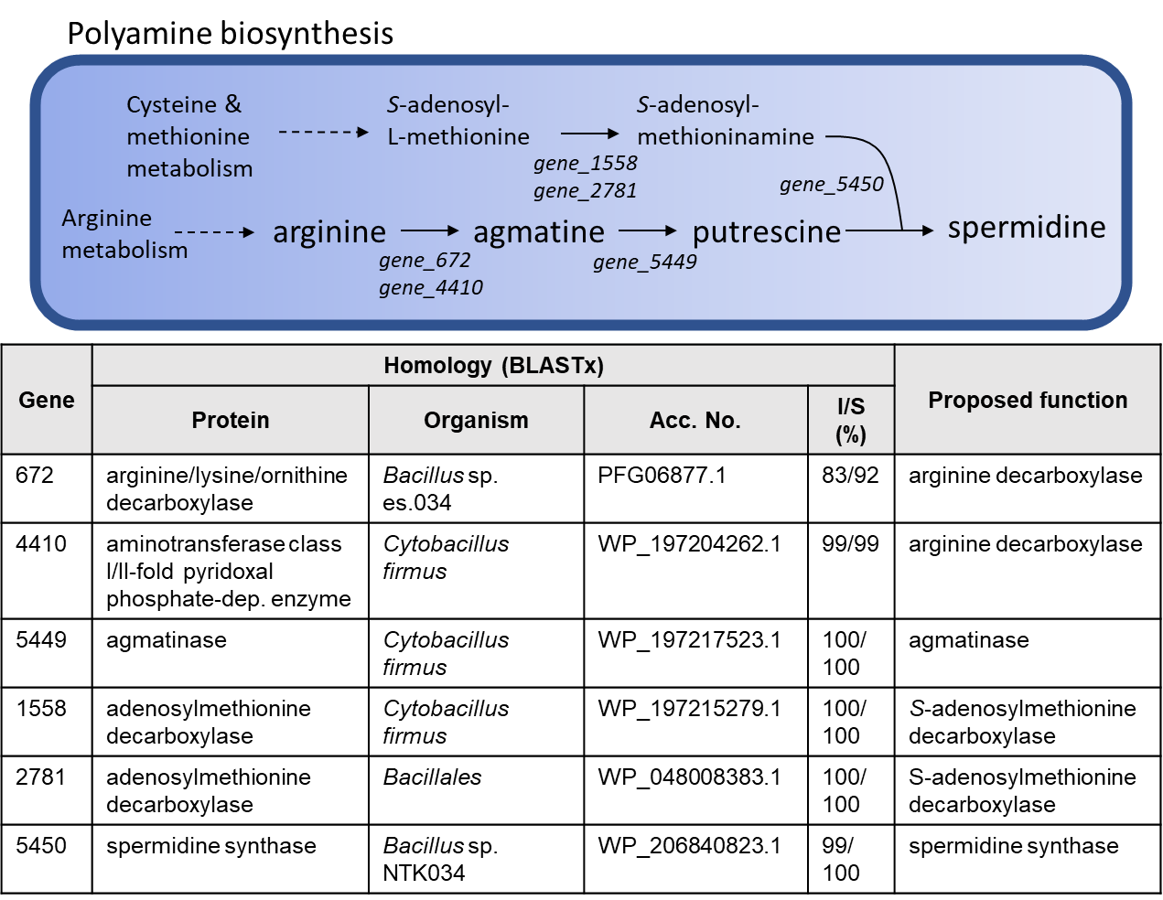

Figure S4. Genes involved in spermidine biosynthesis identified in the HI03-3b genome, which were predicted based on KofamKOALA (Aramaki et al., 2020) and BLASTx (Altschul et al., 1990). Notes: spermidine has been shown to increase epithelial renewal and anti-inflammatory macrophage development in the colon, highlighting its importance in the maintenance of intestinal homoeostasis and immunity (Nakamura et al., 2021). From medical perspective, spermidine has been known to extend life span in model organisms, indicating its potential application in delaying aging and promoting longevity in human (Madeo et al., 2018).

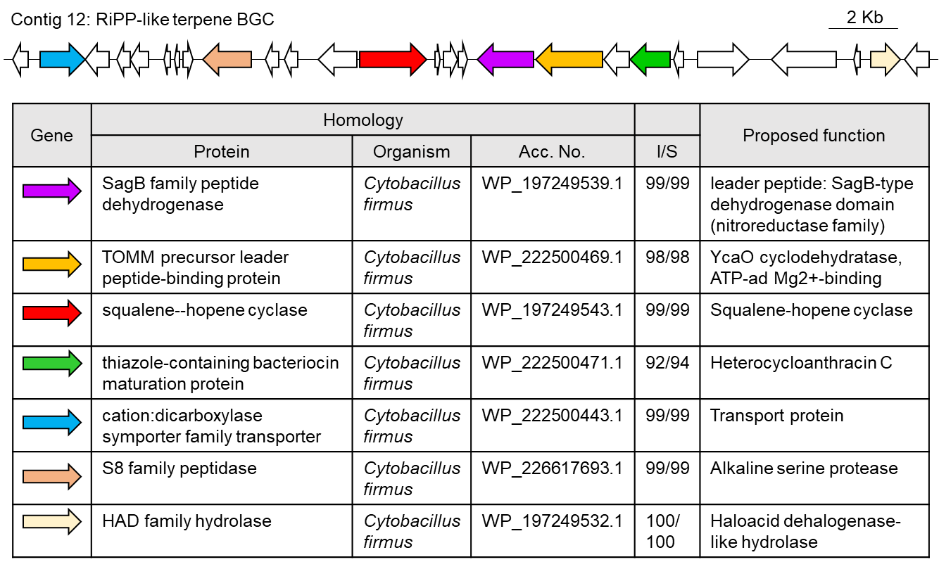

Figure S5 RiPP-like terpene BGC identified in the HI03-3b genome, which were predicted based on antiSMASH (Blin et al., 2021) and BLASTx (Altschul et al., 1990)

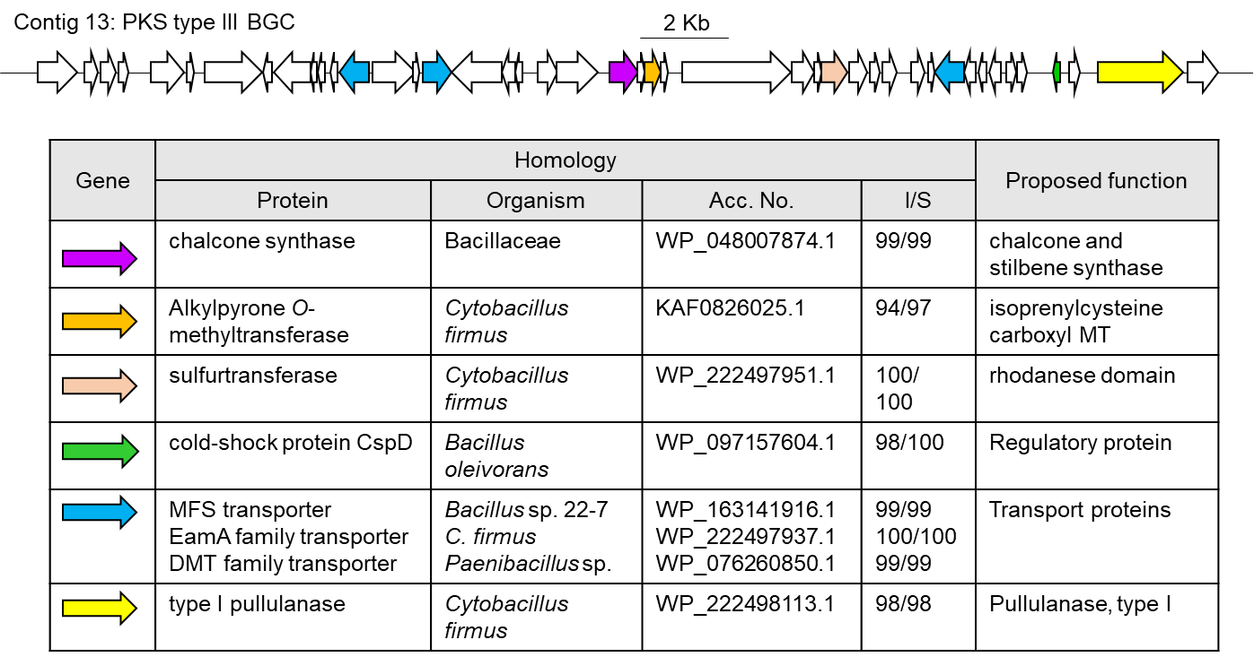

Figure S6 PKS type III BGC identified in the HI03-3b genome, which were predicted based on antiSMASH (Blin et al., 2021) and BLASTx (Altschul et al., 1990).

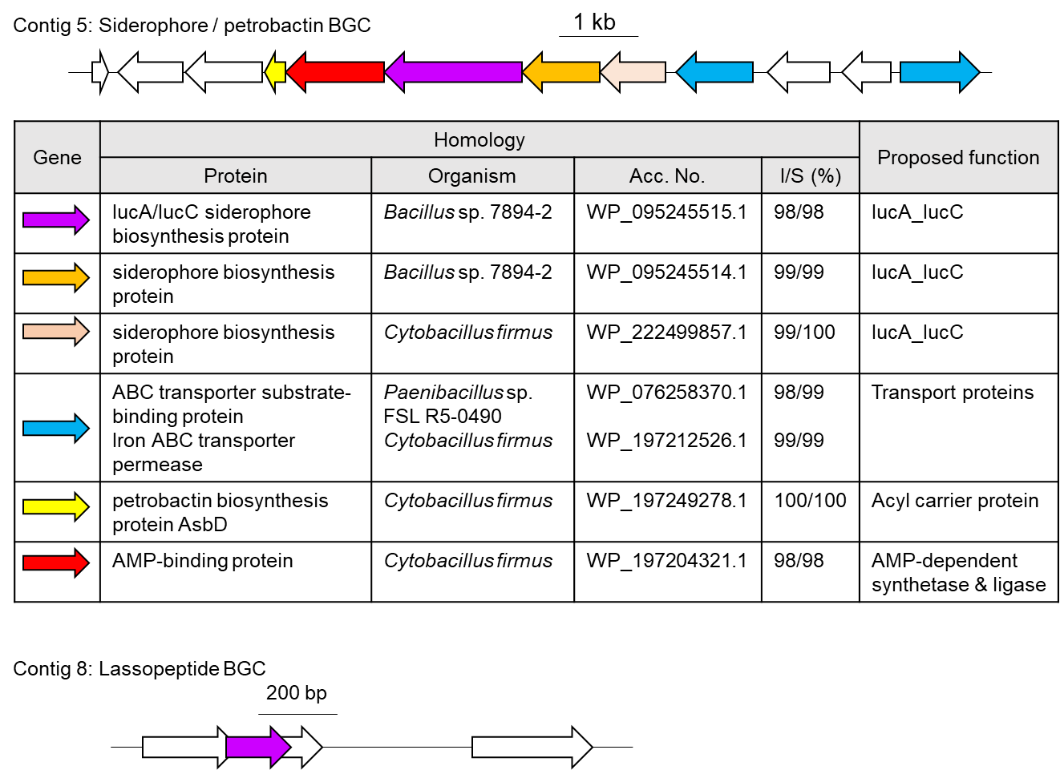

Figure S7 Siderophore/petrobactin BGC and lassopeptide BGC identified in the HI03-3b genome, which were predicted based on antiSMASH (Blin et al., 2021) and BLASTx (Altschul et al., 1990).

Table S15 Comparation of biosynthetically potential genes between Cytobacillus HI03-3b and C. firmus NCTC10335
Genetically encoded protein or small molecule | Gene presence & copy number
Genetically encoded protein or small molecule | Cytobacillus HI03-3b  [GCA_023197125.1]  (In this work) | C. firmus NCTC10335  [GCA_900445365.1]
Carbohydrate active enzymes:
oligo-1,6-glucosidase [EC:3.2.1.10] | 5 | 4
α-glucosidase [EC:3.2.1.20] | 3 | 1
trehalose-6-phosphate hydrolase [EC:3.2.1.93] | 1 | 1
β-fructofuranosidase [EC:3.2.1.26] | 1 | 1
mannosyl-glycoprotein endo-β-N-acetylglucosaminidase [EC:3.2.1.96] | 1 | -
β-glucosylceramidase [EC:3.2.1.45] | 1 | -
xylose isomerase [EC:5.3.1.5] | 1 | -
L-rhamnose isomerase [EC:5.3.1.14] | 1 | -
purine nucleosidase [EC:3.2.2.1] | 3 | 1
soluble lytic murein transglycosylase [EC:4.2.2.-] | 1 | 1
chitinase [EC:3.2.1.14] | 1 | -
pullulanase [EC:3.2.1.41] | 2 | 2
neopullulanase [EC:3.2.1.135] | - | 2
α-amylase [EC:3.2.1.1] | - | 1
Protein-degrading enzymes:
zinc protease [EC:3.4.24.-] | 14 | 11
serine protease [EC:3.4.21.-] | 8 | 9
bacillolysin [EC:3.4.24.28] | 2 | 1
Other enzymes:
L-asparaginase [EC:3.5.1.1] | 1 | 1
carboxylesterase [EC 3.1.1.1] | 2 | 4
lysophospholipase [EC:3.1.1.5] | 1 | 1
arginase [EC:3.5.3.1] | 1 | -
dimethylargininase [EC:3.5.3.18] | 1 | 1
arginine decarboxylase [EC:4.1.1.19] | 2 | 2
beta-lactamase class A [EC:3.5.2.6] | 1 | 3
acetylornithine deacetylase [EC:3.5.1.16] | 1 | 2
alcohol dehydrogenase (NADP+) [EC:1.1.1.2] | 1 | 1
Polyamine biosynthesis:
arginine => agmatine => putrescine => spermidine | + | +
Vitamin biosynthesis:
thiamine (B1) | + | +
riboflavin (B2) | + | +
pantothenate (B5) | + | +
pyridoxine (B6) | + | +
biotin (B7) | + | +
lipoic acid | + | +
cobalamin (B12) | + | +
menaquinone (K2) | + | +
Secondary metabolite biosynthesis:
siderophore | 1 | 1
terpene | 1 | 1
type III polyketide synthase (PKS) | 1 | 1
lassopeptide | 1 | -
lanthipeptide Class II | - | 1
Note: primary metabolisms above predicted based on KofamKOALA (Aramaki et al., 2020), while secondary metabolite biosynthesis based on antiSMASH analysis (Blin et al., 2021).

References

Altschul, S.F., Gish, W., Miller, W., Myers, E.W., Lipman, D.J., 1990. Basic local alignment search tool. Journal of Molecular Biology 215, 403–410. https://doi.org/10.1016/S0022-2836(05)80360-2
Aramaki, T., Blanc-Mathieu, R., Endo, H., Ohkubo, K., Kanehisa, M., Goto, S., Ogata, H., 2020. KofamKOALA: KEGG Ortholog assignment based on profile HMM and adaptive score threshold. Bioinformatics 36, 2251–2252. https://doi.org/10.1093/bioinformatics/btz859
Besemer, J., Lomsadze, A., Borodovsky, M., 2001. GeneMarkS: a self-training method for prediction of gene starts in microbial genomes. Implications for finding sequence motifs in regulatory regions. Nucleic Acids Research 29, 2607–2618. https://doi.org/10.1093/nar/29.12.2607
Blin, K., Shaw, S., Kloosterman, A.M., Charlop-Powers, Z., van Wezel, G.P., Medema, M.H., Weber, T., 2021. antiSMASH 6.0: improving cluster detection and comparison capabilities. Nucleic Acids Res 49, W29–W35. https://doi.org/10.1093/nar/gkab335
Chan, P.P., Lin, B.Y., Mak, A.J., Lowe, T.M., 2021. tRNAscan-SE 2.0: improved detection and functional classification of transfer RNA genes. Nucleic Acids Research 49, 9077–9096. https://doi.org/10.1093/nar/gkab688
Darling, A.C.E., Mau, B., Blattner, F.R., Perna, N.T., 2004. Mauve: Multiple Alignment of Conserved Genomic Sequence With Rearrangements. Genome Res 14, 1394–1403. https://doi.org/10.1101/gr.2289704
Egler, R.A., Ahuja, S.P., Matloub, Y., 2016. L-asparaginase in the treatment of patients with acute lymphoblastic leukemia. J Pharmacol Pharmacother 7, 62–71. https://doi.org/10.4103/0976-500X.184769
Gurevich, A., Saveliev, V., Vyahhi, N., Tesler, G., 2013. QUAST: quality assessment tool for genome assemblies. Bioinformatics 29, 1072–1075. https://doi.org/10.1093/bioinformatics/btt086
Jia, R., Wan, X., Geng, X., Xue, D., Xie, Z., Chen, C., 2021. Microbial L-asparaginase for Application in Acrylamide Mitigation from Food: Current Research Status and Future Perspectives. Microorganisms 9, 1659. https://doi.org/10.3390/microorganisms9081659
Karabina, S.-A., Gora, S., Atout, R., Ninio, E., 2010. Extracellular phospholipases in atherosclerosis. Biochimie, Phospholipases A2 and lipid mediators 92, 594–600. https://doi.org/10.1016/j.biochi.2010.02.002
Li, M., Qin, J., Xiong, K., Jiang, B., Zhang, T., 2021. Review of arginase as a promising biocatalyst: characteristics, preparation, applications and future challenges. Critical Reviews in Biotechnology 0, 1–17. https://doi.org/10.1080/07388551.2021.1947962
Lowe, T.M., Chan, P.P., 2016. tRNAscan-SE On-line: integrating search and context for analysis of transfer RNA genes. Nucleic Acids Res 44, W54–W57. https://doi.org/10.1093/nar/gkw413
Luo, C., Rodriguez-R, L.M., Konstantinidis, K.T., 2014. MyTaxa: an advanced taxonomic classifier for genomic and metagenomic sequences. Nucleic Acids Res 42, e73. https://doi.org/10.1093/nar/gku169
Madeo, F., Carmona-Gutierrez, D., Kepp, O., Kroemer, G., 2018. Spermidine delays aging in humans. Aging (Albany NY) 10, 2209–2211. https://doi.org/10.18632/aging.101517
Miyamoto, R.Y., de Melo, R.R., de Mesquita Sampaio, I.L., de Sousa, A.S., Morais, E.R., Sargo, C.R., Zanphorlin, L.M., 2021. Paradigm shift in xylose isomerase usage: a novel scenario with distinct applications. Crit Rev Biotechnol 1–20. https://doi.org/10.1080/07388551.2021.1962241
Nakamura, A., Kurihara, S., Takahashi, D., Ohashi, W., Nakamura, Y., Kimura, S., Onuki, M., Kume, A., Sasazawa, Y., Furusawa, Y., Obata, Y., Fukuda, S., Saiki, S., Matsumoto, M., Hase, K., 2021. Symbiotic polyamine metabolism regulates epithelial proliferation and macrophage differentiation in the colon. Nat Commun 12, 2105. https://doi.org/10.1038/s41467-021-22212-1
Narta, U.K., Kanwar, S.S., Azmi, W., 2007. Pharmacological and clinical evaluation of L-asparaginase in the treatment of leukemia. Crit Rev Oncol Hematol 61, 208–221. https://doi.org/10.1016/j.critrevonc.2006.07.009
Poria, V., Rana, A., Kumari, A., Grewal, J., Pranaw, K., Singh, S., 2021. Current Perspectives on Chitinolytic Enzymes and Their Agro-Industrial Applications. Biology (Basel) 10, 1319. https://doi.org/10.3390/biology10121319
Rao, M.B., Tanksale, A.M., Ghatge, M.S., Deshpande, V.V., 1998. Molecular and Biotechnological Aspects of Microbial Proteases. Microbiol Mol Biol Rev 62, 597–635.
Rodriguez-R, L.M., Gunturu, S., Harvey, W.T., Rosselló-Mora, R., Tiedje, J.M., Cole, J.R., Konstantinidis, K.T., 2018. The Microbial Genomes Atlas (MiGA) webserver: taxonomic and gene diversity analysis of Archaea and Bacteria at the whole genome level. Nucleic Acids Res 46, W282–W288. https://doi.org/10.1093/nar/gky467
Sun, A., Song, W., Qiao, W., Chen, X., Liu, J., Luo, Q., Liu, L., 2017. Efficient agmatine production using an arginine decarboxylase with substrate-specific activity. Journal of Chemical Technology & Biotechnology 92, 2383–2391. https://doi.org/10.1002/jctb.5245
Sutto-Ortiz, P., Camacho-Ruiz, M. de los A., Kirchmayr, M.R., Camacho-Ruiz, R.M., Mateos-Díaz, J.C., Noiriel, A., Carrière, F., Abousalham, A., Rodríguez, J.A., 2017. Screening of phospholipase A activity and its production by new actinomycete strains cultivated by solid-state fermentation. PeerJ 5, e3524. https://doi.org/10.7717/peerj.3524
Verma, N., Kumar, K., Kaur, G., Anand, S., 2007. L-Asparaginase: A Promising Chemotherapeutic Agent. Critical Reviews in Biotechnology 27, 45–62. https://doi.org/10.1080/07388550601173926
Wang, L., Wang, S., Li, W., 2012. RSeQC: quality control of RNA-seq experiments. Bioinformatics 28, 2184–2185. https://doi.org/10.1093/bioinformatics/bts356
Wheelock, C.E., Shan, G., Ottea, J., 2005. Overview of Carboxylesterases and Their Role in the Metabolism of Insecticides. Journal of Pesticide Science 30, 75–83. https://doi.org/10.1584/jpestics.30.75
Wriston, J.C., 1985. [79] Asparaginase, in: Methods in Enzymology, Glutamate, Glutamine, Glutathione, and Related Compounds. Academic Press, pp. 608–618. https://doi.org/10.1016/S0076-6879(85)13082-X
Xu, W., Zhang, W., Zhang, T., Jiang, B., Mu, W., 2016. l-Rhamnose isomerase and its use for biotechnological production of rare sugars. Appl Microbiol Biotechnol 100, 2985–2992. https://doi.org/10.1007/s00253-016-7369-z

