Supplementary materials
The ITS transcript of each Artocarpus sample used in this study
>Karusung (A. anysophyllus) 727 bp
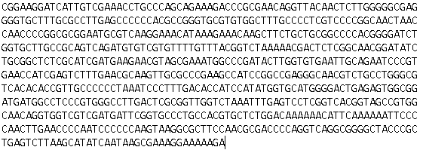
>Tiwadak (A. integer) 643 bp
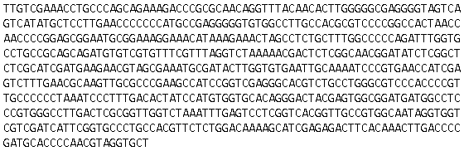
>Kulur (A. camansi) 679 bp
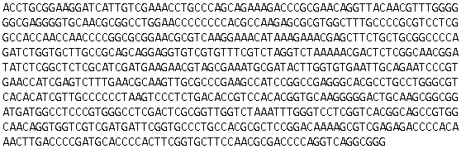

>Tarap (A. sericicarpus) 669 bp
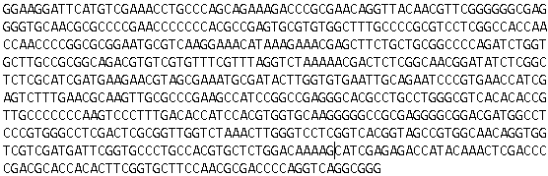
>Anjani* (A. hirsutus) 665 bp
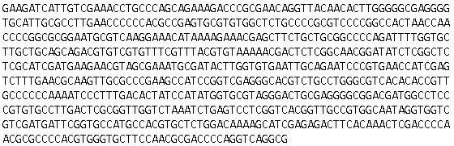
>Nangka (A. heterophyllus) 628 bp
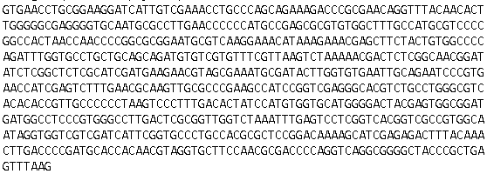
>Mantiwadaka (A. kemando) 663 bp
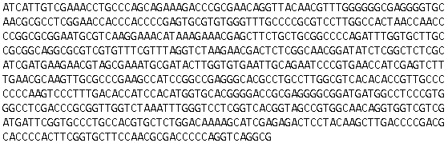

>Kulidang (A. lanceifolius) 661 bp
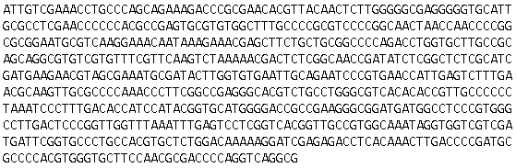
>Tampang Susu (A. limpato) 660 bp
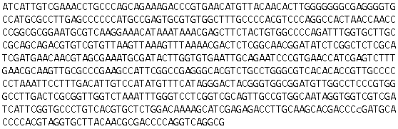
>Binturung_1 (A. odoratissimus) 660 bp
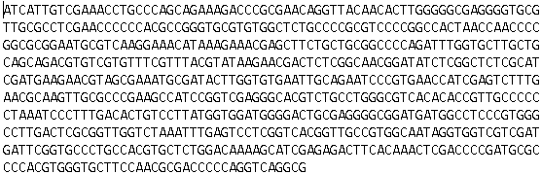
>Binturung_2 (A. odoratissimus) 640 bp
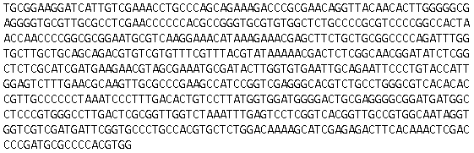

>Tampang (A. primackii) 660 bp
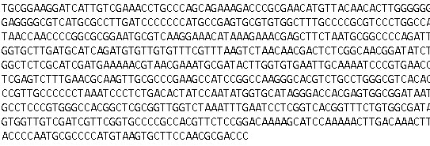
>Puyian (A. rigidus) 671 bp
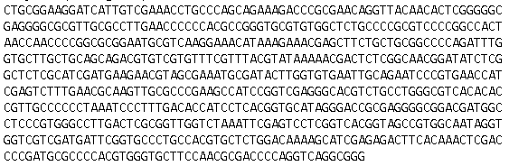
>Tiwadak Banyu (A. teysmannii) 677 bp
