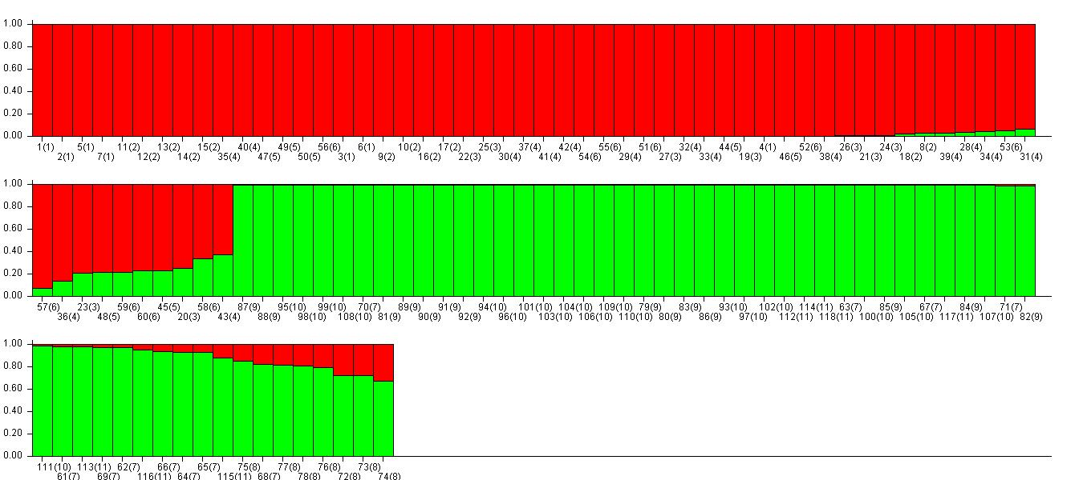
CLUSTER I
CLUSTER II

a.
K | Reps | Mean LnP(K) | Stdev LnP(K) | Ln'(K) | |Ln''(K)| | Delta K
1 | 20 | -37630.005000 | 0.890579 | — | — | —
2 | 20 | -31854.235000 | 8.502772 | 5775.770000 | 4257.505000 | 500.719648
3 | 20 | -30335.970000 | 190.460301 | 1518.265000 | 335.010000 | 1.758949
4 | 20 | -29152.715000 | 431.454733 | 1183.255000 | 32.765000 | 0.075941
5 | 20 | -28002.225000 | 341.516705 | 1150.490000 | 1991.020000 | 5.829934
6 | 20 | -28842.755000 | 3713.098518 | -840.530000 | 3104.140000 | 0.835997
7 | 20 | -26579.145000 | 171.552004 | 2263.610000 | 1830.290000 | 10.669010
8 | 20 | -26145.825000 | 390.125089 | 433.320000 | 3686.705000 | 9.450059
9 | 20 | -29399.210000 | 9014.790263 | -3253.385000 | 4012.245000 | 0.445074
10 | 20 | -28640.350000 | 6474.118122 | 758.860000 | 8448.605000 | 1.304982
11 | 20 | -36330.095000 | 42196.462783 | -7689.745000 | 18981.335000 | 0.449832
12 | 20 | -25038.505000 | 1374.395045 | 11291.590000 | — | —
b.
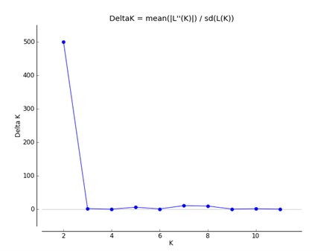
c.
Fig. S3 Bayesian analysis of 118 individuals of G. sylvestre in STRUCTURE software showing, a. Bar plot representing individuals arranged according to its most likely ancestry b. Evanno table highlighting that value of K which describes the genetic groups of species c. Graph showing the peak corresponding to that value of K which tells genetic groups of species estimated by Evanno method

