Supplementary data:
Supplementary Table 1: Chromosomal abnormalities of the MM patients.
Chromosomal  Abnormality | Karyotypes
Hyperdiploidy | 55~108, XY*
Hyperdiploidy | 47, XY,+ Mar
Hyperdiploidy | 33~57,XX,-X,+3,+5,+7,+8,+11,+13,+ 5,+17,+19,+mar[cp26]
Hyperdiploidy | 50~52,XY,inv(1p),dup(3q),+i(7q),+9,+11,+15,+19,+20,+mar,+mar[cp15]
Hyperdiploidy | 51~53,XY,dup(1)(q21q31),+4,+5,+6,+8,+9,+11,+12,+13,+17,+18,+mar,+mar
Hyperdiploidy | 46~53,XY,+5,+6,+8,+15,+19,-20,+19,-21,+22,+mar,+mar,+mar,+mar
Hyperdiploidy | 55,XX,+5,+7,+8,+14,+15,+15,+19,+mar,+mar
Hypodiploidy | 41~45,XY,-6,-13,-14,-19,-20  42~45,XX,-10,-14,-18,-22  32~45,X,-2,-5,-9,-10,-11,-12,-13,-14,-16,-17,-19,-20,-21,-Y  43~45,XY,-9,-12,-15,-16,-22  40~45,X,-16,-19,-X  41~45,X,-12,-19,-21,-Y  40~45,X,-9,-11,-13,-15,-16,-17,-19,-22,-Y  40~45,X,-5,-18,-Y  41~45,XX,-1,-9,-10,-18,-19  41~45,XX,-6,-7,-17,-18,-20  40~45,XX,-3,-6,-9,-13,-15,-16,-17,-20,-21,-22  44~45,X,-9,-16,-20,-22,-Y  42~45,XX,-5,-13  44~46,XY,-12,-21  45~44, XY,-20,-21  42~45,XX,-9  44~45,X,-8,-X  44~45,X,-4,-12,-Y  41~45,XX,-10,-12,-18,-19,-21
Hypodiploidy | 34~45,XX,-4,-8,-12,-21
Structural abnormalities | 46,XX,del(16)(q12q22)
* Counted, due to poor morphology of chromosomes and clumped nature could not construct the karyogram

Supplementary Table 2: Representation of mRNA expression levels of Shelterin complex genes, hTERT and mTL. Data represented in median (range).
 | Controls | Cases
TRF1 | 0.609 (0.013 – 1.519) | 0.868 (0.018 – 1.962)
TRF2 | 0.473 (0.134 – 0.855) | 0.484 (0.003 – 1.846)
POT1 | 0.583 (0.003 – 1.723) | 1.254 (0.001 – 2.815)
RAP1 | 0.593 (0.089 – 1.808) | 0.984 (0.014 – 2.294)
TIN2 | 0.778 (0.009 - 1.980) | 1.008 (0.0004 – 1.946)
TPP1 | 0.491 (0.032 - 1.122) | 0.765 (0.003 – 1.947)
hTERT | 0.574 (-0.81 – 1.767) | 0.779 (0.022 – 1.968)
mTL | 0.480 (0.053 – 0.901) | 0.794 (0.165 – 1.918)

Supplementary Table 3: Representation of AUC (Area under Curve) obtained by Receiver operative curves.
Parameters | Area under Curve (AUC)
TRF1 | 0.6431
TRF2 | 0.5500
POT1 | 0.7778
RAP1 | 0.6861
TIN2 | 0.5874
ACD | 0.6164
hTERT | 0.5806
mTL | 0.7100

Supplementary table 4: Kaplan- Meier analysis of all the genes.
Genes | Months (mean low Vs high) | P value
TRF1 | 13.8 Vs 15.4 | 0.873
TRF2 | 16.5 Vs 12.9 | 0.929
POT1 | 15.5 Vs 14.2 | 0.943
RAP1 | 12.29 Vs 15.8 | 0.020*
TIN2 | 10.2 Vs 15.0 | 0.421
ACD | 14.1 Vs 14.6 | 0.908
hTERT | 13.2 Vs 17.8 | 0.037*
mTL | 17.06 Vs 17.4 | 0.304

Supplementary table 5: Representation of ‘r’ and ‘p’ values by spearman correlation between mRNA levels of Shelterin complex genes, hTERT and mTL.
r | TRF1 | TRF2 | POT1 | RAP1 | TIN2 | ACD | hTERT | mTL
p
TRF1 |  | 0.323 | 0.117 | 0.099 | 0.055 | 0.103 | 0.002 | -0.004
TRF1 |  | 0.005* | 0.327 | 0.406 | 0.641 | 0.390 | 0.982 | 0.974
TRF2 |  |  | 0.146 | -0.072 | 0.055 | 0.130 | 0.063 | -0.086
TRF2 |  |  | 0.218 | 0.542 | 0.641 | 0.277 | 0.595 | 0.550
POT1 |  |  |  | 0.111 | -0.015 | 0.189 | 0.299 | -0.222
POT1 |  |  |  | 0.350 | 0.895 | 0.113 | 0.015 | 0.121
RAP1 |  |  |  |  | 0.044 | 0.135 | 0.162 | 0.007
RAP1 |  |  |  |  | 0.709 | 0.259 | 0.171 | 0.958
TIN2 |  |  |  |  |  | 0.200 | 0.289 | -0.096
TIN2 |  |  |  |  |  | 0.094 | 0.031 | 0.507
ACD |  |  |  |  |  |  | 0.038 | -0.037
ACD |  |  |  |  |  |  | 0.752 | 0.783
hTERT |  |  |  |  |  |  |  | -0.004
hTERT |  |  |  |  |  |  |  | 0.9768

Supplementary table 6: Representation of ‘r’ and ‘p’ values by spearman correlation between mRNA levels of Shelterin complex genes, hTERT, mTL and clinical parameters.

r | TRF1 | TRF2 | POT1 | RAP1 | TIN2 | ACD | hTERT | mTL
p
Total Protein | 0.197  0.095 | 0.118  0.323 | 0.037  0.755 | 0.198  0.095 | -0.036  0.758 | -0.025  0.833 | 0.008  0.945 | 0.125  0.383
Albumin | -0.315  0.0069 | -0.108  0.3659 | 0.189  0.110 | -0.087  0.467 | 0.058  0.623 | -0.030  0.799 | -0.027  0.818 | -0.152  0.292
Globulin | 0.214  0.699 | 0.198  0.1084 | 0.001  0.991 | 0.232  0.049 | -0.055  0.642 | 0.019  0.872 | -0.109  0.361 | 0.112  0.437
Bilirubin total | -0.163  0.169 | -0.049  0.679 | 0.001  0.989 | -0.119  0.316 | -0.107  0.369 | 0.114  0.340 | -0.186  0.116 | -0.093  0.516
Bilirubin direct | -0.245  0.037 | -0.055  0.644 | -0.101  0.398 | -0.158  0.182 | -0.092  0.437 | -0.195  0.105 | -0.167  0.159 | -0.007  0.956
Bilirubin indirect | -0.043  0.714 | 0.126  0.289 | 0.120  0.312 | -0.259  0.028 | -0.109  0.359 | 0.056  0.639 | -0.121  0.311 | -0.075  0.603
SGOT | -0.021  0.859 | -0.005  0.960 | 0.041  0.729 | 0.059  0.620 | -0.087  0.467 | 0.182  0.127 | -0.057  0.633 | 0.133  0.354
SGPT | 0.007  0.946 | -0.010  0.931 | 0.018  0.879 | -0.104  0.383 | 0.067  0.572 | 0.093  0.440 | -0.107  0.368 | 0.085  0.553
Calcium | 0.100  0.402 | 0.105  0.375 | 0.039  0.740 | 0.023  0.845 | -0.049  0.681 | 0.270  0.022 | -0.051  0.665 | -0.015  0.912
ALP | -0.192  0.106 | -0.119  0.318 | -0.238  0.043 | -0.054  0.651 | 0.147  0.215 | -0.108  0.369 | -0.106  0.374 | 0.044  0.760
Sodium | -0.082  0.489 | -0.180  0.129 | 0.042  0.724 | -0.143  0.228 | 0.291  0.012 | -0.078  0.517 | 0.182  0.125 | 0.148  0.302
Potassium | 0.124  0.299 | -0.044  0.711 | 0.093  0.434 | 0.067  0.573 | -0.095  0.423 | 0.199  0.096 | -0.069  0.561 | 0.098  0.496
Blood urea | 0.044  0.709 | -0.010  0.931 | -0.113  0.344 | 0.128  0.283 | -0.194  0.102 | -0.008  0.944 | 0.146  0.220 | 0.037  0.797
Uric acid | 0.118  0.321 | 0.134  0.261 | 0.064  0.592 | -0.007  0.953 | -0.040  0.734 | 0.1005  0.404 | -0.062  0.603 | 0.187  0.192
Creatinine | 0.062  0.600 | -0.133  0.262 | -0.026  0.825 | 0.1531  0.199 | -0.259  0.027 | -0.103  0.391 | -0.018  0.879 | 0.145  0.314
Hb | -0.173  0.146 | -0.116  0.331 | 0.073  0.541 | 0.061  0.607 | 0.252  0.032 | -0.007  0.951 | 0.079  0.508 | -0.088  0.539
ESR | 0.239  0.043 | -0.014  0.901 | -0.062  0.600 | 0.061  0.607 | 0.152  0.200 | -0.033  0.782 | 0.091  0.445 | 0.045  0.754

Supplementary figures:
Supplementary Figure 1: Box Whisker plot showing relative mRNA expression of A)TRF1, B)TIN2, C)ACD, D)hTERT and E) mTL.

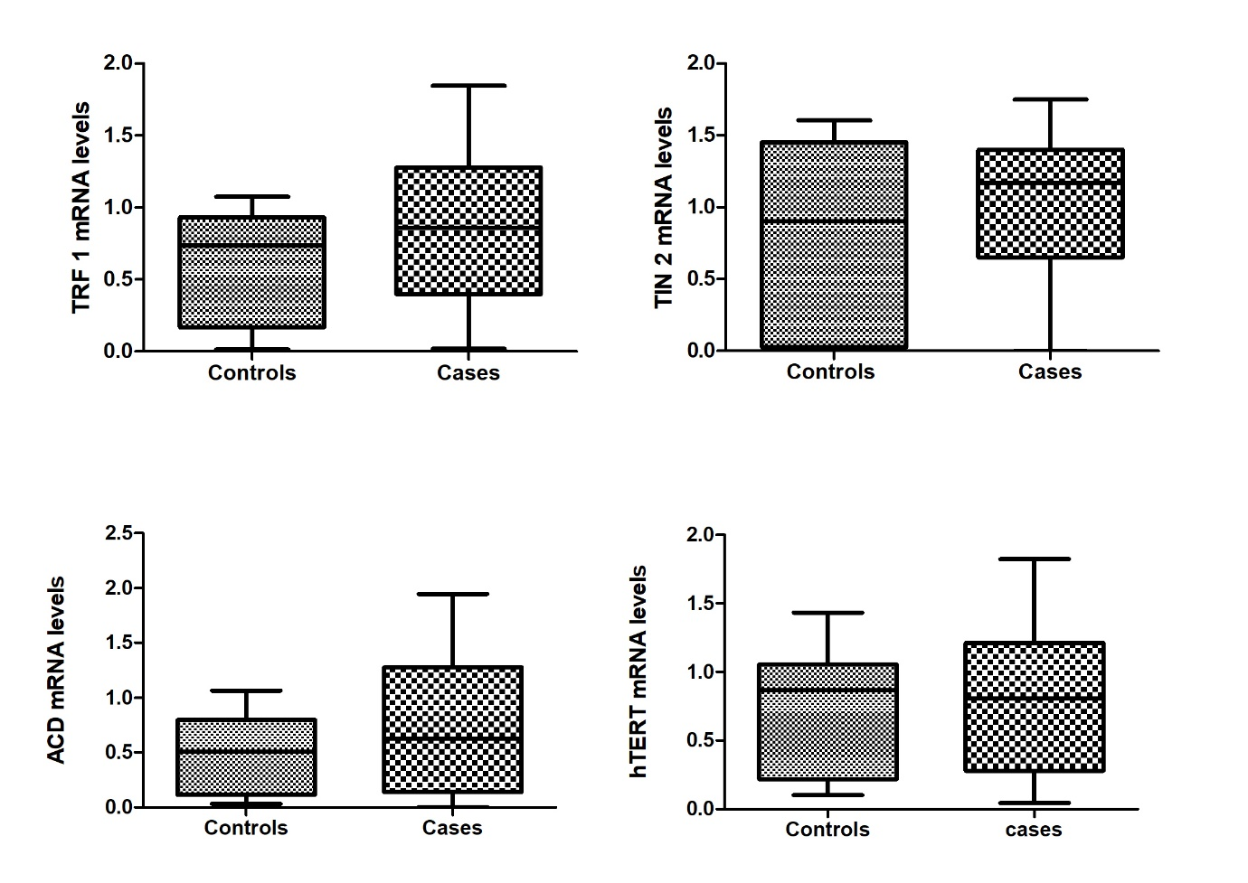

Supplementary Figure 2:: Kaplan Meier curve showing overall survival for MM patients stratified by A) TRF1 (P = 0.873), B) TRF2 (P = 0.929), C) POT1 (P = 0.943), D) TIN2 (P = 0.421), E) ACD (P = 0.908) and F) mTL (P = 0.304).

