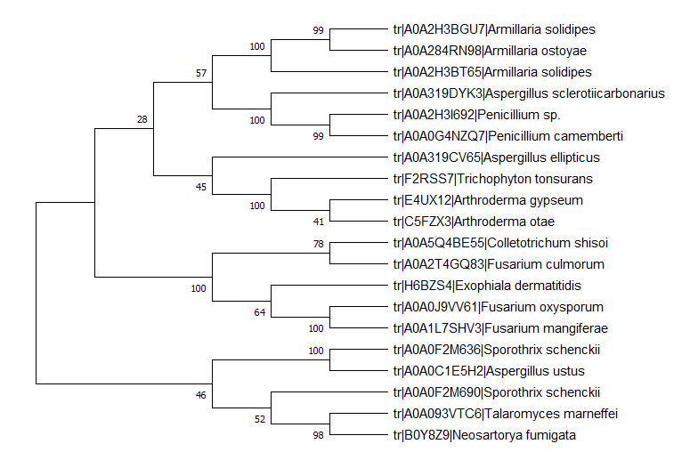
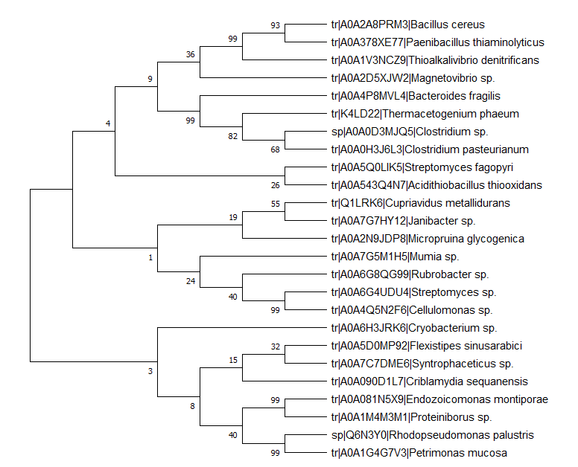
Fig. S3.1: Phylogenetic tree of arsenite methyltransferase of bacteria
Fig. S3.2: Phylogenetic tree of arsenite methyltransferase of fungi

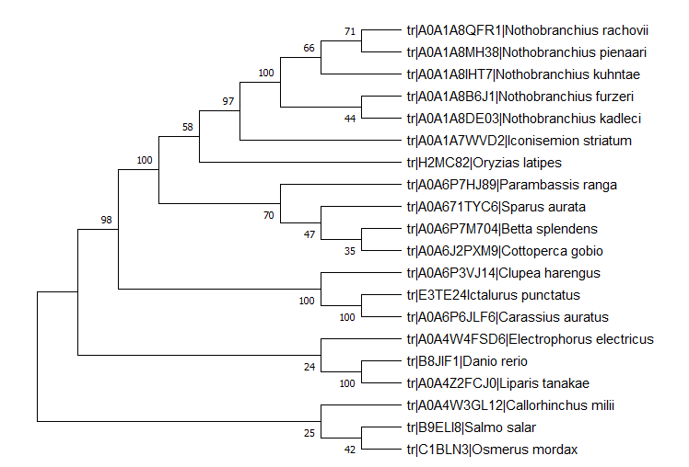

Fig. S3.3: Phylogenetic tree of arsenite methyltransferase of fishes
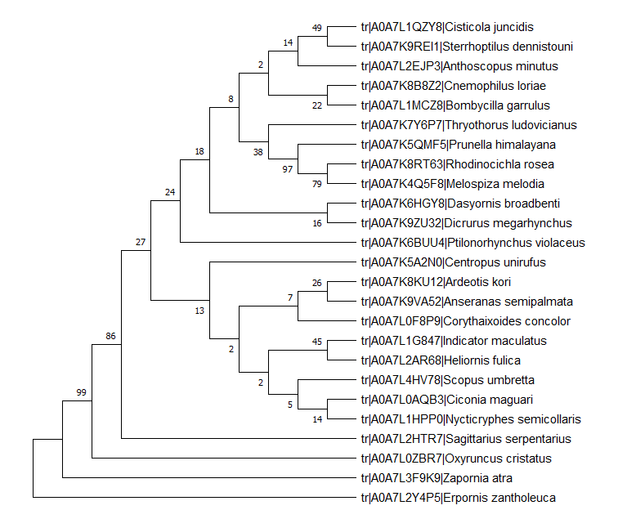

Fig. S3.4: Phylogenetic tree of arsenite methyltransferase of birds
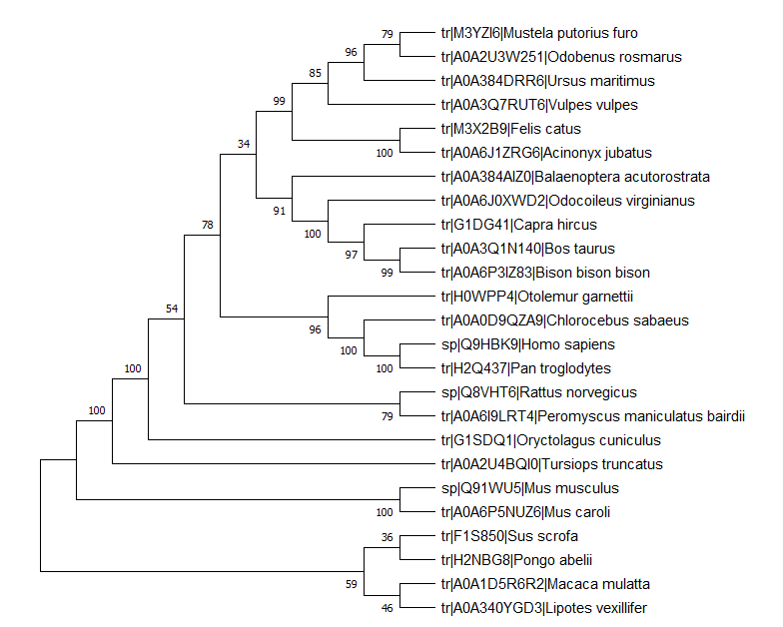
Fig. S3.5: Phylogenetic tree of arsenite methyltransferase of mammals

