RESULTS

Table 1: Demographic distribution information for physiotherapy patients and PWD (n=158)
Gender | N (%)
Female | 73 (46.20)
Male | 85 (53.80)
Age
15 – 25 | 5 (3.16)
26 – 35 | 25 (15.82)
36 – 45 | 45 (28.48)
46 – 55 | 59 (37.34)
56 and above | 24 (15.19)
The average distance from the hospital (km) | 15.50(14.32)
Disability history
Since birth | 10 (6.33)
A few days | 3 (1.90)
Two weeks | 6 (3.80)
A few months | 46 (29.11)
More than one year | 93 (58.86)
Level of education attained by patients
None | 22 (13.92)
Primary | 64 (40.51)
Secondary | 31 (19.62)
Tertiary | 23 (14.56)
University | 18 (11.39)
Occupation
Government employee | 47 (29.75)
Self-employed | 41 (25.95)
Farmer | 35 (22.15)
Domestic work | 32 (20.25)
Others | 3 (1.90)
Monthly income
0 - 9,999 Kshs | 31 (19.62)
10,000 - 39,999 Kshs | 40 (25.32)
40,000 - 69,999 Kshs | 68 (43.04)
70,000 - 79,999 | 13 (8.23)
> 80, 000 Kshs | 6 (3.80)
Religion
Protestant | 75(47.47)
Roman Catholic | 71(44.94)
Muslim | 12(7.59)
Marital status
Married | 128(81.01)
Never married | 15(9.49)
Widowed | 9(5.70)
Divorced | 6(3.70)
Separated | 1(0.6)

Table 2: Common diagnosis for the patients and PWD (n = 158)
Diagnosis | n | %
Stroke (hemiparesis/hemiplegia) | 30 | 18.98
Knee arthritis | 10 | 6.32
Hip arthritis (hip replacement) | 12 | 7.59
Back pain | 14 | 8.86
Trauma | 17 | 10.75
Paraparasis | 6 | 3.79
Paraplegia | 5 | 3.16
Diabetes | 14 | 8.86
Club foot | 3 | 1.89
Peripheral nerve injuries | 5 | 3.16
Ankle sprain | 4 | 2.53
Post injection palsy | 3 | 1.89
Amputee (above the knee, below knee and bilateral) | 10 | 6.32
Sciatica | 10 | 6.32
Post poliomyelitis | 13 | 8.22
Others | 2 | 1.26

Table 3 : The type of transportation means used by physiotherapy patients and PWD (n=158)
What means of transport do you commonly use in everyday life? | n | %
Public transport (bus, taxi, and motorcycle) | 64 | 40.51
Walk | 59 | 37.34
Bicycle | 12 | 7.59
Private vehicle | 18 | 11.39
Pushed on a wheelchair | 5 | 3.16
What means of transport do you commonly use to the hospital?
Public transport (bus, taxi, and motorcycle) | 118 | 74.68
Walk | 26 | 16.46
Private vehicle | 11 | 6.96
Bicycle | 2 | 1.27
Pushed on a wheelchair | 2 | 1.27

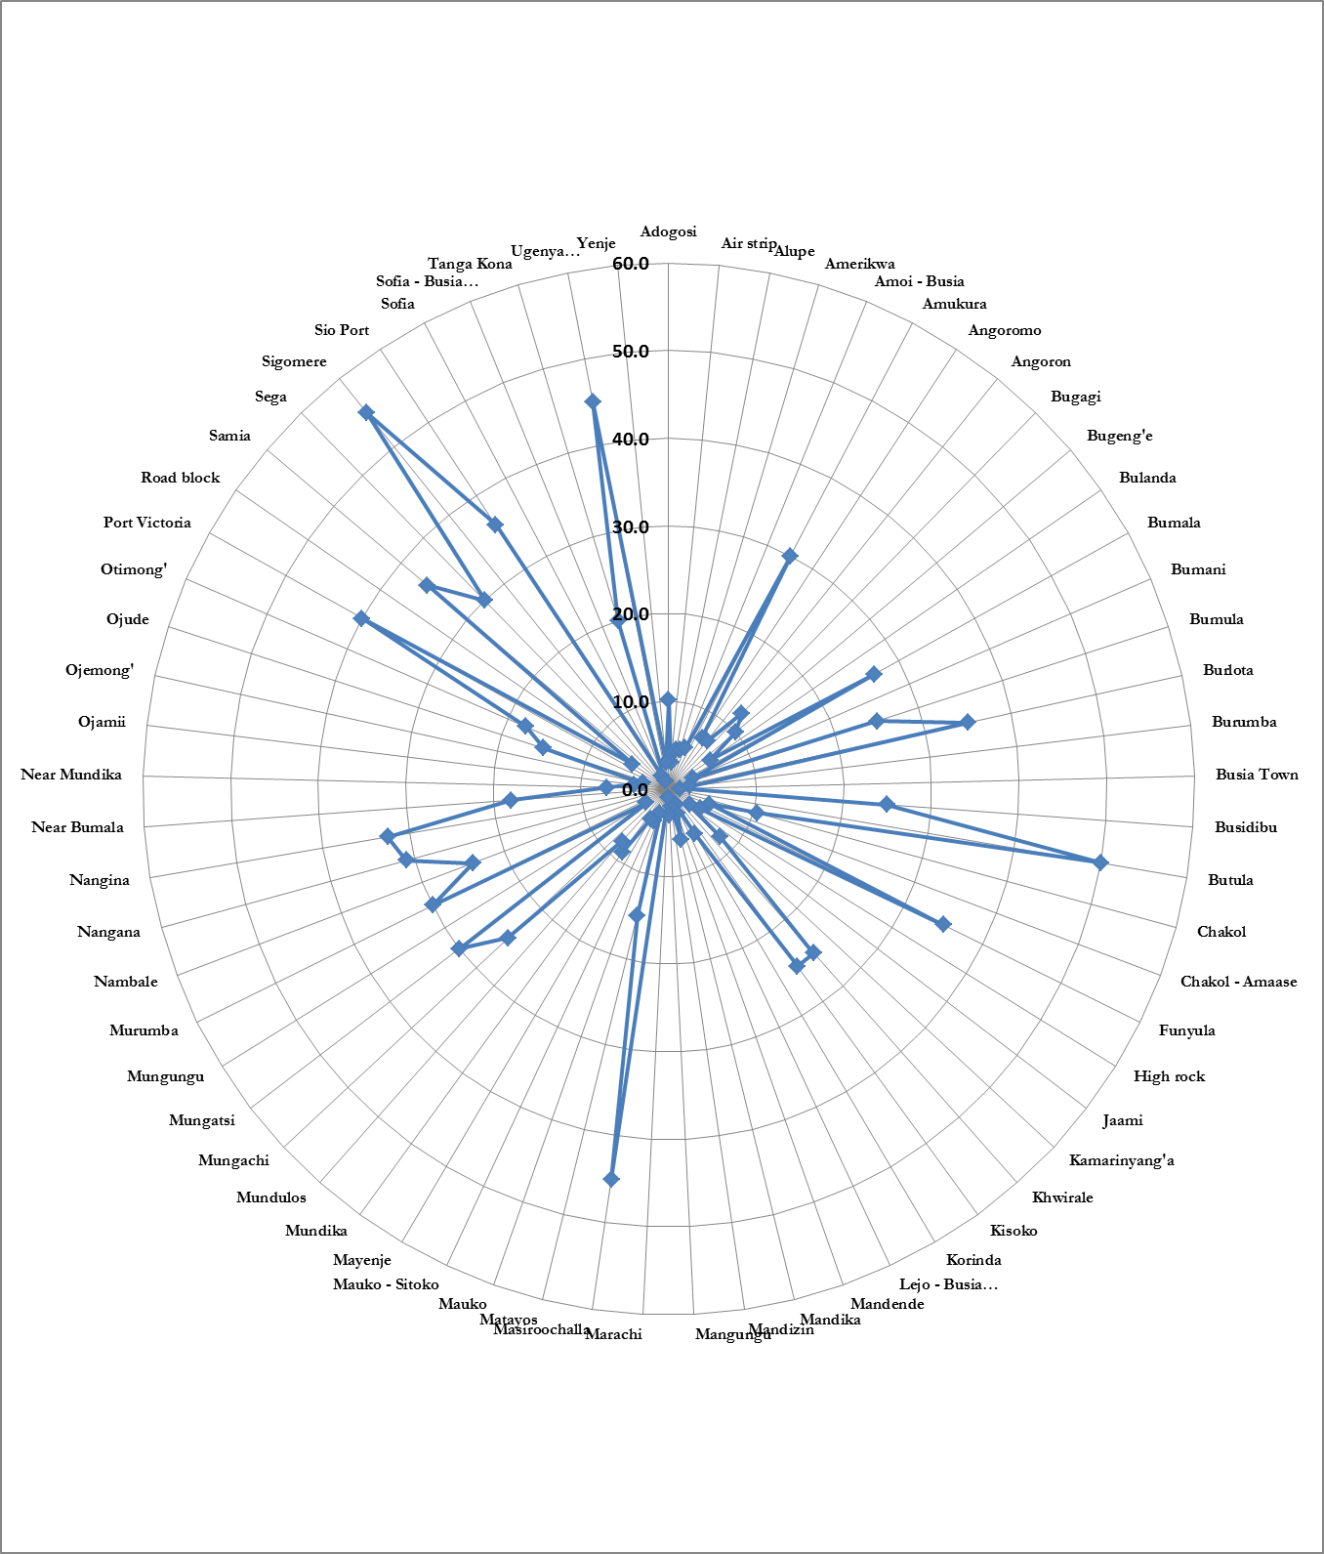
Figure 1: Place of residence and distance from the hospital.

Table 4: Assessment of the level of Knowledge and utilisation of physiotherapy services from patients and PWD (n = 158)

To what extend do you agree with this statement? | Disagree Completely n% | Somewhat Disagree n% | Somewhat Agree n% | Strongly Agree n% | Agree Completely n%
Physiotherapy service is one of the five common services given in all health service institutions in Busia County. | 30 (18.98) | 40(25.31) | 83(52.53) | 2(1,26) | 3(1.89)
There is a lot of information about the use and the importance of physiotherapy services among all the community members. | 82(51.89) | 35 (22.15) | 30(18.98) | 5(3.16) | 6(3.79)
It is easy for one to get information about physiotherapy in the hospital than in the local community. | 6(3 .79) | 13(8.22) | 26(16.45) | 76(48.10) | 38(24.05)

Table 5: The frequency physiotherapy patients and PWD attended physiotherapy services (n = 158)

How frequently do you attend physiotherapy services in a week? | Total | Male | Female
Once | 104 (66.67) | 47(45.19) | 57(54.81)
Two times | 46 (29.49) | 21(45.65) | 25(54.35)
Three times | 6 (3.85) | 4(66.67) | 2(33.33)

Table 6: Assessment of satisfaction of physiotherapy patients and PWD with the treatment they were given (n = 158)
The performance measure of physiotherapy services
How satisfied are you with the treatment you are being offered in the physiotherapy department? | n | %
Extremely dissatisfied | 16 | 10.06
Somewhat dissatisfied | 9 | 5.66
Somewhat satisfied | 61 | 38.61
Very dissatisfied | 13 | 8.18
Extremely satisfied | 60 | 37.97
How well do physiotherapy services meet your needs? | n | %
Extremely well | 9 | 5.66
Very well | 61 | 38.36
Somewhat well | 46 | 28.93
Not so well | 22 | 13.84
Not at well | 20 | 13.21

Table 7: Recommending physiotherapy services to be ideal for mobility and general health problems (n = 158)

To what extent do you agree to recommend physiotherapy services to a friend or colleague as a suitable treatment for mobility and general health problems | n | %
Disagree completely | 8 | 5.03
Somewhat disagree | 12 | 7.55
Somewhat agree | 62 | 38.99
Strongly agree | 46 | 28.93
Agree completely | 31 | 19.50

Table 8: Assessment of satisfaction of the cost of physiotherapy services by patients and PWD (n =158)
 | extremely dissatisfied n% | very dissatisfied  n% | somewhat dissatisfied  n% | somewhat satisfied  n% | extremely satisfied n%
How satisfied are you with what you pay for physiotherapy services? | 7(4.46) | 14(8.92) | 17(10.83) | 80(50.96) | 40 (24.84)
To what extent do you agree … it is the amount of money one has that determines access to physiotherapy service rather than the level of education | 27(17.09) | 29 (18,35) | 45(28.48) | 33(20.89) | 24(15.19)
To what extent do you agree … if physiotherapy services were free of charge most of the mobility and general health problems will be less | 3(1.94) | 32(20.65) | 60(38.71) | 23(14.84) | 37(23.87)

Table 9: Barriers that could lead to failure to attend physiotherapy by patients and PWD (n = 158)
Barriers, n (%) | Disagree completely  n% | Somewhat disagree n% | Somewhat agree n% | Strong agree n% | Agree completely  n%
Cultural factors were a challenge | 137 ( 86.70) | 18 (11.39) | 3(1.89) | 0(0) | 0(0)
Being handle roughly by the physiotherapist | 147(93.03) | 9(5.69) | 2(1.26) | 0(0) | 0(0)
Sometimes you could find nobody to attend to you | 145(91.77) | 9(5.69) | 0(0) | 0(0) | 4(2.53)
Busy with domestic responsibilities | 71(44.93) | 45(28.48) | 34(21.51) | 8(5.06) | 0(0)
Waiting time is too long before being attended to | 125(79.11) | 25(15.82) | 8(5.06) | 0(0) | 0(0)
Informed by traditional medicine person that it was not good | 77(48.73) | 40(25.31) | 28(17.72) | 9(5.69) | 3(1.89)
Far from home | 41(25.94) | 29(18.35) | 24(15.18) | 37(23.41) | 26(16.45)
No money for transport and treatment | 38(24.05) | 20(12.65) | 16(10.12) | 23(14.56) | 61(38.60)
Attending to other family matters | 65(41.13) | 37(23.41) | 37(23.41) | 11(6.96) | 9(5.69)

Table 10 : The evaluation of satisfaction with the amount of money physiotherapy patients and PWD paid for physiotherapy service (n = 158)

How would you rate your monthly income in terms of the amount? | Extremely dissatisfied n (%) | Very dissatisfied n (%) | Somewhat dissatisfied n (%) | Somewhat satisfied n (%) | Extremely satisfied n % |  | Chi-square | P- Value
0-9,999 | 6(19.35) | 9(29.03) | 10(32.26) | 5(16.13) | 1 (3.23) |  | 87.02 | 0.000
10,000-39,999 | 0(0) | 4(10.26) | 4(10.26) | 21(53.85) | 10(25.64)
40,000-69,999 | 1(1.47) | 1(1.47) | 3(4.41) | 47(69.12) | 16(23.53)
70,000-79,999 | 0(0) | 0(0) | 0(0) | 5(38.46) | 8(61.54)
80,000 and above | 0(0) | 0(0) | 0(0) | 2(33.33) | 4(66.67)
Total | 7(4.46) | 14(8.92) | 17(10.83) | 80(50.96) | 39(24.84)

Table 11 : Assessment of the association of the monthly income and access to physiotherapy services by physiotherapy patients and PWD (n=158)

 | To what extent do you agree … it is the amount of money one has that determines access to physiotherapy service rather than the level of education
How would you rate your monthly income in terms of the amount | Disagree n (%) completely | Somewhat disagree n (%) | Somewhat agree n (%) | Agree n (%) | Completely agree n (%) | Chi-square | p-value
0-9,999 | 2(6.45) | 1(3.23) | 4(12.9) | 15(48.39) | 9(29.03) | 88.08 | 0.000
10,000-39,999 | 5(12.5) | 5(12.5) | 14(35) | 10(25) | 6(15)
40,000-69,999 | 6(8.82) | 20(29.41) | 26(38.24) | 8(11.76) | 8(11.76)
70,000-79,999 | 8(61.54) | 3(23.08) | 1(7.69) | 0(0) | 1(7.69)
80,000 and above | 6(100) | 0(0) | 0(0) | 0(0) | 0(0)
Total | 27(17.09) | 29(18.35) | 45(28.48) | 33(20.89) | 24(15.19)

Table 12: Assessment of the association of the monthly income and the presence of mobility and general health challenges encountered by physiotherapy patients and PWD (n = 158)
 | to what extent do you agree … if physiotherapy services were free of charge most of the mobility and general health problems will be less
How would you rate your monthly income in terms of the amount | Disagree completely n (%) | Somewhat disagree n(%) | Somewhat agree n (%) | Agree n (%) | Completely agree n (%) | Chi-square | p-value
0-9,999 | 1(3.33) | 0(0) | 9(30) | 7(23.33) | 13(43.3) | 62.24 | 0.00
10,000-39,999 | 1(2.63) | 0(0) | 23(60.53) | 7(18.42) | 7(18.42)
40,000-69,999 | 1(1.47) | 18(26.47) | 26(38.24) | 8(11.76) | 15(22.06)
70,000-79,999 | 0(0) | 9(69.23) | 1(7.67) | 1(7.69) | 2(15.38)
80,000 and above | 0(0) | 5(83.33) | 1(16.67) | 0(0) | 0(0)
Total | 3(1.94) | 32(20.65) | 60(38.71) | 23(14.84) | 37(23.87)

Logistic regression
A multinominal logistic regression analysis was performed to determine the relationship that best fits the observed data in terms of the access and utilisation of physiotherapy. The data and culculations presented are based on the muitinominal logistic regression model for access and utilisation of physiotherapy at BCRH.
Physiotherapy patients and PWD
- Multinominal logistic regression with monthly income
An income of KS40, 000-69,999 was the baseline comparison group. The model converged after 5 iterations at the log likelihood -181.17138. The model was well fit having likelihood ratio chi-square was 69.524 and p-value 0.000.
Table 13: Multinominal logistic regression with monthly income
monthly income | Coef. |  | St.Err. | t-value |  | p-value | [95% Conf |  | Interval] | Sig
0-9,999 | -1.691 |  | 0.313 | -5.40 |  | 0.000 | -2.304 |  | -1.077 | ***
Constant | 5.083 |  | 1.120 | 4.54 |  | 0.000 | 2.888 |  | 7.278 | ***
10,000-39,999 | -0.316 |  | 0.275 | -1.15 |  | 0.251 | -0.856 |  | 0.224
Constant | 0.719 |  | 1.125 | 0.64 |  | 0.523 | -1.487 |  | 2.925
40,000-69,999 | 0.000 |  | . | . |  | . | . |  | .
o.Constant | 0.000 |  | . | . |  | . | . |  | .
70,000-79,999 | 1.235 |  | 0.543 | 2.27 |  | 0.023 | 0.170 |  | 2.300 | **
Constant | -6.969 |  | 2.470 | -2.82 |  | 0.005 | -11.811 |  | -2.127 | ***
80,000 and above | 1.594 |  | 0.856 | 1.86 |  | 0.063 | -0.084 |  | 3.272 | *
Constant | -9.473 |  | 3.993 | -2.37 |  | 0.018 | -17.299 |  | -1.647 | **
Mean dependent var |  | 2.525 |  |  | SD dependent var |  |  | 1.026
Pseudo r-squared |  | 0.161 |  |  | Number of obs |  |  | 158.000
Chi-square |  | 69.524 |  |  | Prob > chi2 |  |  | 0.000
Akaike crit. (AIC) |  | 378.343 |  |  | Bayesian crit. (BIC) |  |  | 402.844
*** p<0.01, ** p<0.05, * p<0.1
- x_{1i} is how satisfied are you with what you pay for physiotherapy services
The result show that patients and PWD with a monthly income of 70,000 – 79999 and 80,000 and above were 1.235times and 1.594 times on relative log odds scale likely to agree compared to those with income of 40000 – 69999. However those with income of 0- 9999 and 10,000 – 39999 were 1.691 times and 0.316 times on relative log odds scale were unlikely to agree compared to those with an income of 40000 – 69999.

Using x_{1i}
- x_{1i} is to what extent do you agree that it is the amount of money one has that determines compliance to physiotherapy service than level of education
Produces well-fitting model having likelihood ratio chi-square was 59.804and p-value 0.000.

Table 14: Multinominal regression with compliance to physiotherapy service
monthly income | Coef. |  | St.Err. | t-value |  | p-value | [95% Conf |  | Interval] | Sig
0-9,999 | 0.792 |  | 0.215 | 3.69 |  | 0.000 | 0.371 |  | 1.213 | ***
Constant | -3.490 |  | 0.811 | -4.30 |  | 0.000 | -5.079 |  | -1.900 | ***
10,000-39,999 | 0.210 |  | 0.171 | 1.23 |  | 0.217 | -0.124 |  | 0.545
Constant | -1.168 |  | 0.560 | -2.08 |  | 0.037 | -2.266 |  | -0.070 | **
40,000-69,999 | 0.000 |  | . | . |  | . | . |  | .
o.Constant | 0.000 |  | . | . |  | . | . |  | .
70,000-79,999 | -1.128 |  | 0.353 | -3.20 |  | 0.001 | -1.819 |  | -0.437 | ***
Constant | 0.894 |  | 0.711 | 1.26 |  | 0.208 | -0.499 |  | 2.288
80,000 and above | -14.983 |  | 583.449 | -0.03 |  | 0.980 | -1158.522 |  | 1128.555
Constant | 14.492 |  | 583.449 | 0.03 |  | 0.980 | -1129.047 |  | 1158.032
Mean dependent var |  | 2.522 |  |  | SD dependent var |  |  | 1.024
Pseudo r-squared |  | 0.138 |  |  | Number of obs |  |  | 159.000
Chi-square |  | 59.804 |  |  | Prob > chi2 |  |  | 0.000
Akaike crit. (AIC) |  | 390.843 |  |  | Bayesian crit. (BIC) |  |  | 415.394
*** p<0.01, ** p<0.05, * p<0.1
The result show that patients and PWD with an a monthly income of 0 –9999 and 10000- 39999 were 0.792 times and 0.210 times on relative log odds scale likely to agree compared to those with income of KS40000 – 69999. However those with income of 70000 – 799999 and 80000 and above were -1.128 times and -14.983 times on relative log odds scale were unlikely to agree compared to those with an income of 40000 – 69999.

Using x_{1i}

- x_{1i} is to what extent do you agree that if physiotherapy services were free of charge most of mobility and general health problems will be less
Table 15: Multinominal regression with monthly income and access to physiotherapy services
Monthly income |  | Coef. |  | St.Err. | t-value |  | p-value | [95% Conf |  | Interval] | Sig
0-9,999 | 0.679 |  |  | 0.218 | 3.12 |  | 0.002 | 0.252 |  | 1.107 | ***
Constant | -3.299 |  |  | 0.859 | -3.84 |  | 0.000 | -4.983 |  | -1.614 | ***
10,000-39,999 | 0.208 |  |  | 0.191 | 1.09 |  | 0.276 | -0.166 |  | 0.582
Constant | -1.285 |  |  | 0.683 | -1.88 |  | 0.060 | -2.624 |  | 0.053 | *
40,000-69,999 | 0.000 |  |  | . | . |  | . | . |  | .
o.Constant | 0.000 |  |  | . | . |  | . | . |  | .
70,000-79,999 | -0.670 |  |  | 0.338 | -1.98 |  | 0.047 | -1.332 |  | -0.008 | **
Constant | 0.384 |  |  | 0.970 | 0.40 |  | 0.692 | -1.517 |  | 2.286
80,000 and above | -1.439 |  |  | 0.619 | -2.33 |  | 0.020 | -2.651 |  | -0.227 | **
Constant | 1.376 |  |  | 1.464 | 0.94 |  | 0.347 | -1.494 |  | 4.246
Mean dependent var |  |  | 2.538 |  |  | SD dependent var |  |  | 1.025
Pseudo r-squared |  |  | 0.065 |  |  | Number of obs |  |  | 156.000
Chi-square |  |  | 27.880 |  |  | Prob > chi2 |  |  | 0.000
Akaike crit. (AIC) |  |  | 413.899 |  |  | Bayesian crit. (BIC) |  |  | 438.297
*** p<0.01, ** p<0.05, * p<0.1
The result show that patients and PWD with a monthly income of 0- 9999 and 10,000 – 39999 were 0.679 times and 0.208 times on relative log odds scale likely to agree compared to those with income of 40000 – 69999. However those with income of 70,000 – 79999 and 80,000 and above were -0.670 times and 1.439 times on relative log odds scale unlikely to agree compared to those with an income of 40000 – 69999.

