Search Strategy comments:
On January 9th 2024 the terms “Physical Therapy Education” AND “Artificial Intelligence” were entered in the following databases, PubMed, MedLine, EBSCOHost, CINAHL. Only a small number of results were returned and none were specific to the use of AI in Physical Therapy Education.

PubMed search strategy:
Search: ("Physical Therapy Education") AND (Artificial Intelligence)
"Physical Therapy Education"[All Fields] AND ("artificial intelligence"[MeSH Terms] OR ("artificial"[All Fields] AND "intelligence"[All Fields]) OR "artificial intelligence"[All Fields])
Translations
Artificial Intelligence: "artificial intelligence"[MeSH Terms] OR ("artificial"[All Fields] AND "intelligence"[All Fields]) OR "artificial intelligence"[All Fields]

PubMed Search Results:


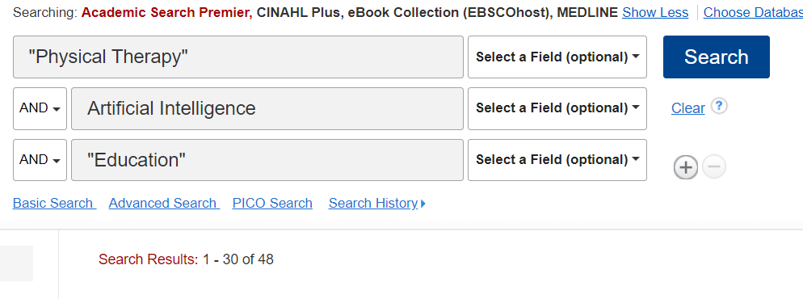
CINAHL, EBSCO and MEDLINE search strategy:

