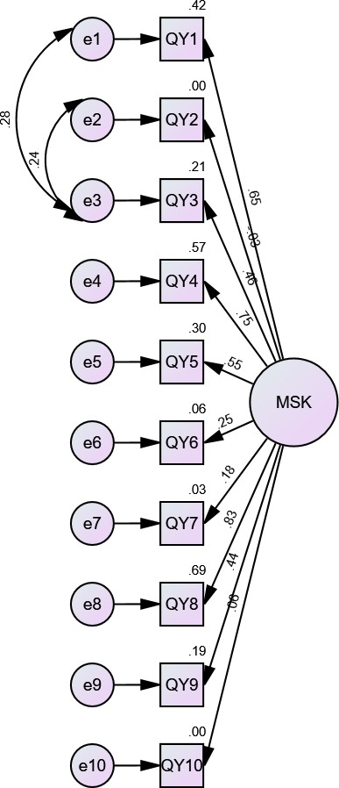
Figure 1S: Confirmatory Factor Analysis

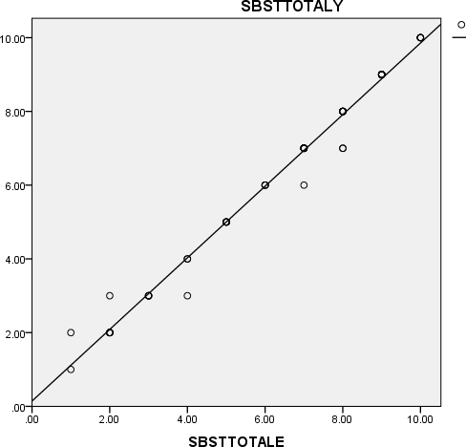
STarT MSK TOTAL-Y

r=0.993 (0.001)

STarT MSK TOTAL-E

Figure S2: a scattered plot diagram which depicts the correlation between the Yoruba and English version of the STarT MSK tool.

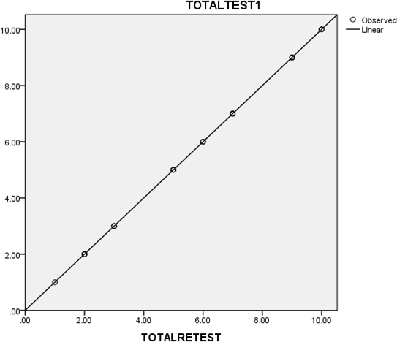
STarT MSK-Y RETEST TOTAL
r=1.000(0.001)
STarT MSK-Y TOTAL

Figure S3: Scattered plot diagram which depicts the correlation between the test-retest of the Yoruba version of the STarT MSK tool

