Supplementary Figure 1. Bootstrap-Corrected Calibration Curve of the Multivariable Prediction Model
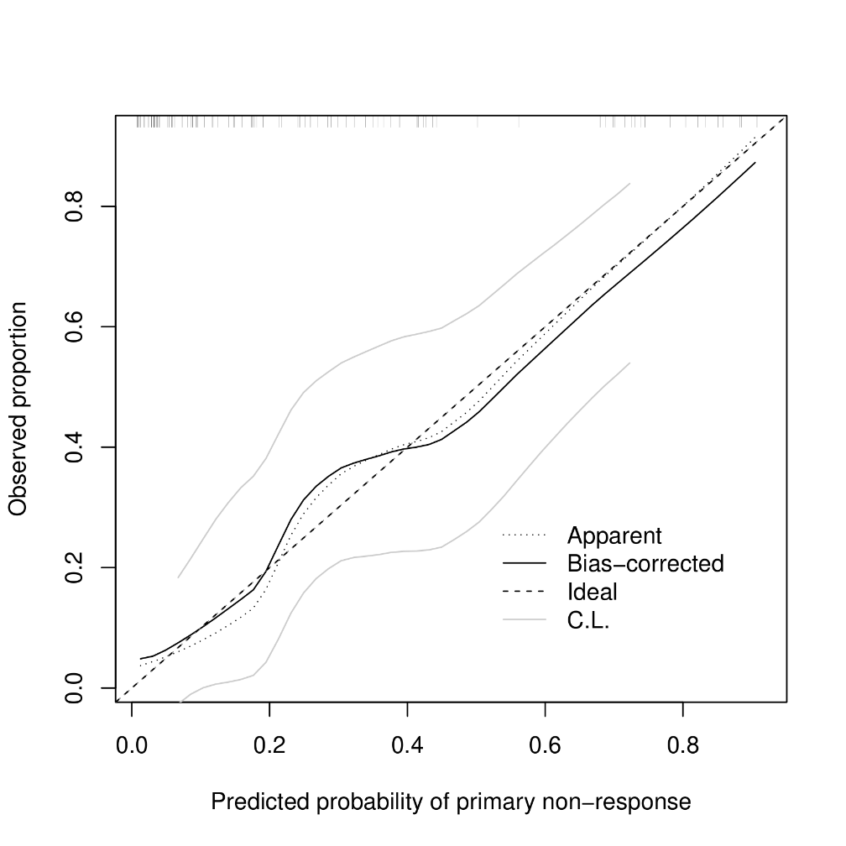

Bootstrap-corrected calibration curve for the multivariable model (2000 resamples). Mean absolute error between predicted and observed probabilities 0.026.

Supplementary Figure 2. Decision Curve Analysis Comparing the Multivariable Model with NAR and Default Treatment Strategies

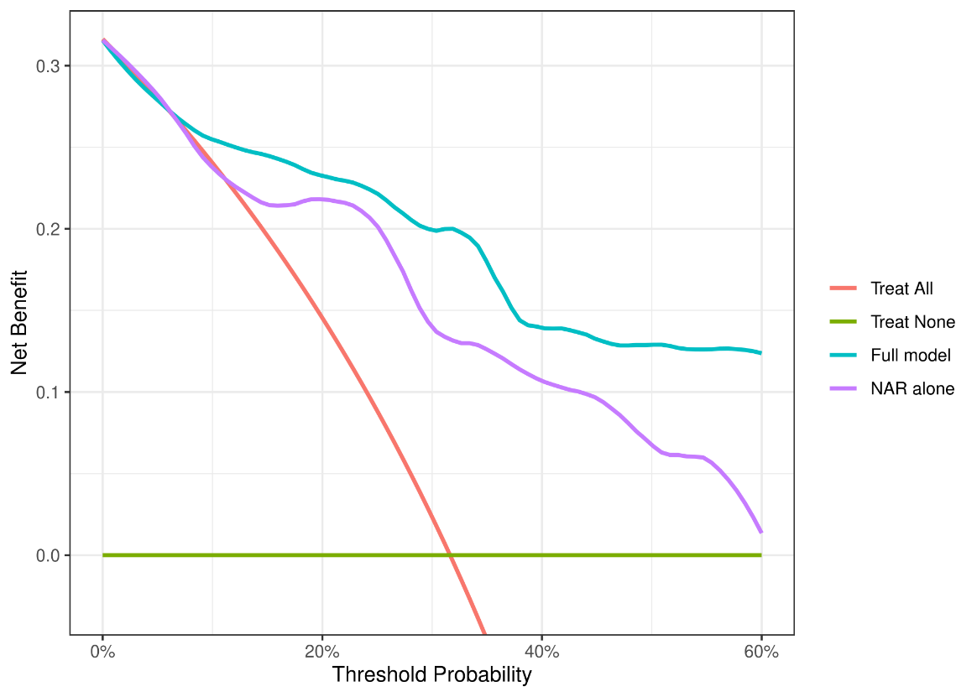

Legend. Decision-curve analysis comparing the multivariable model, NAR alone, and treat-all and treat-none strategies across threshold probabilities from 0 to 0.6.

