Appendix 1.
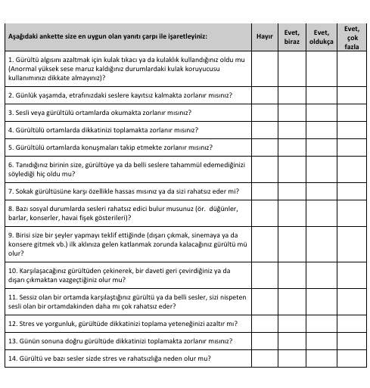
Turkish Adaptation of Khalfa Hyperacusis Questionnaire

