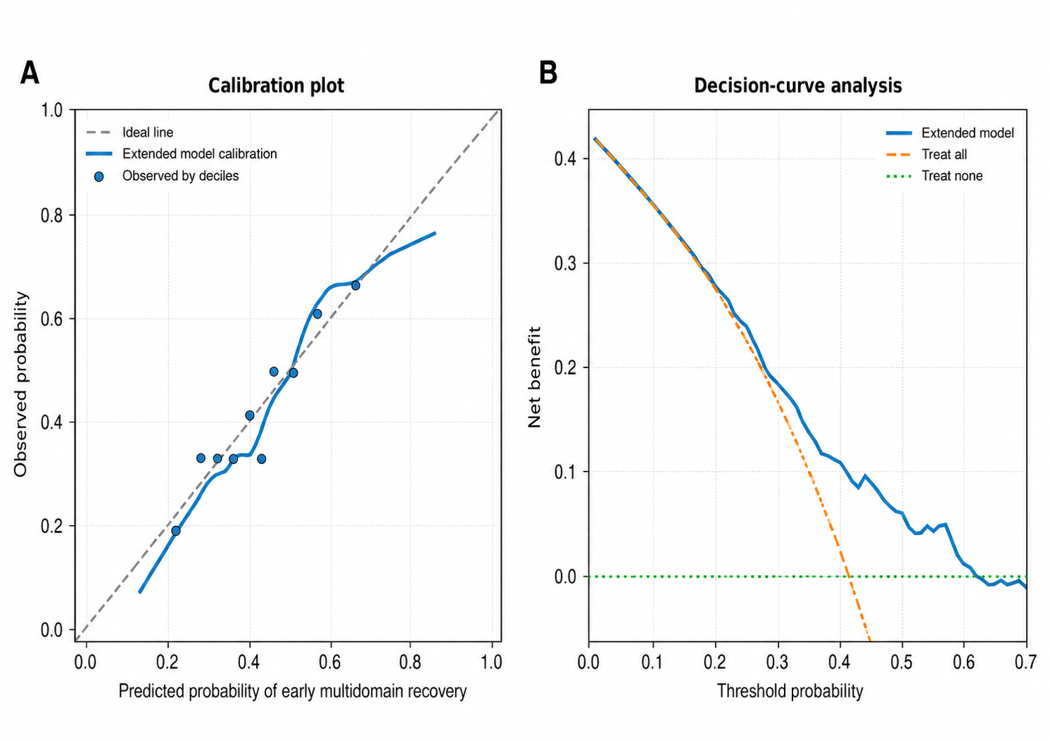

Supplementary Figure S1. Calibration and decision-curve analyses of the extended prediction model.
(A) Calibration plot comparing the predicted and observed probabilities of early multidomain symptomatic recovery. The diagonal line represents perfect calibration.
(B) Decision-curve analysis showing the net benefit of the extended prediction model across a range of threshold probabilities, compared with the strategies of treating all patients or treating no patients. These analyses were exploratory and based on internal validation only.

