Supplementary figures

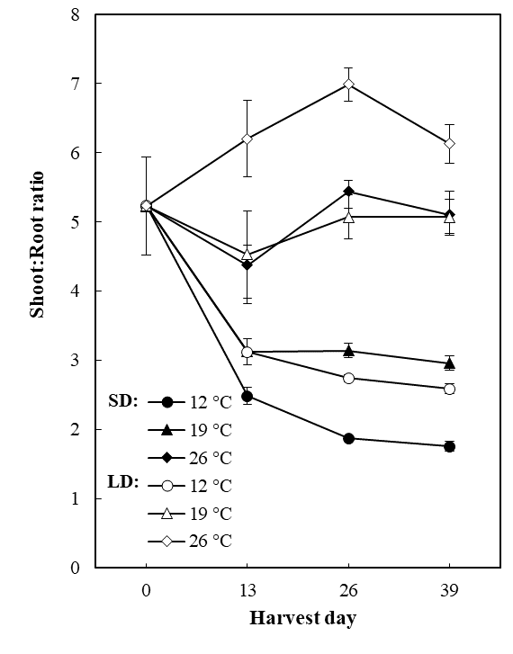

Fig. S1 Time course changes in shoot/root ratio (DW basis) and leaf area in ‘Delizzimo’ strawberry plants during 39 days of cultivation. Values are the means ± SE of three biological replicates with 5 to 10 plants each.
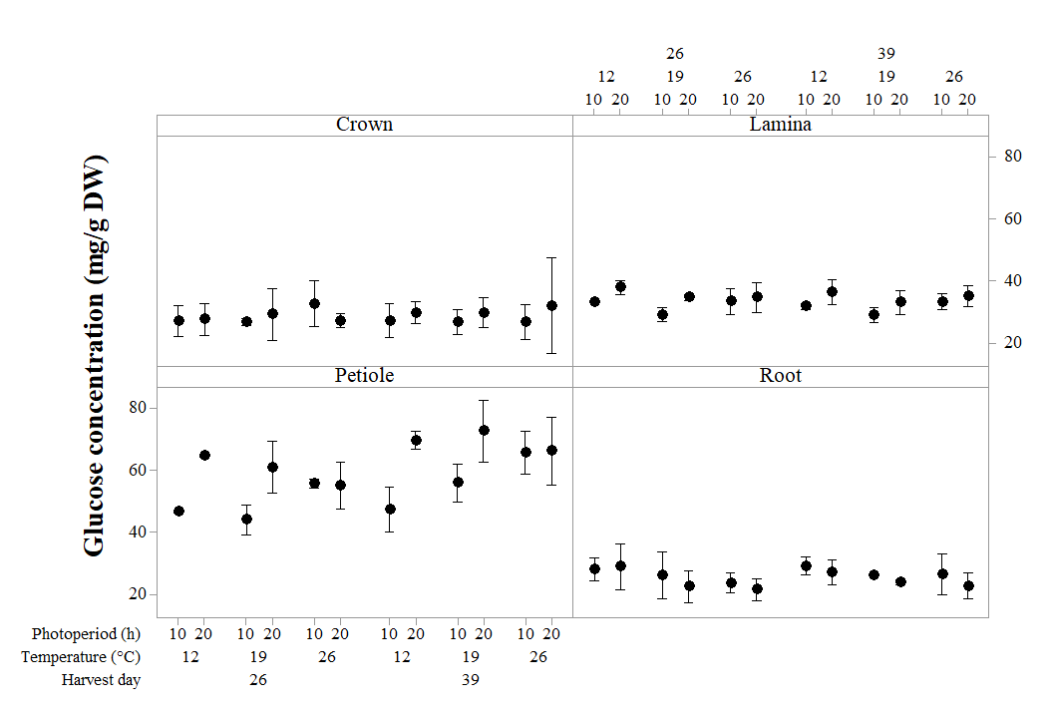
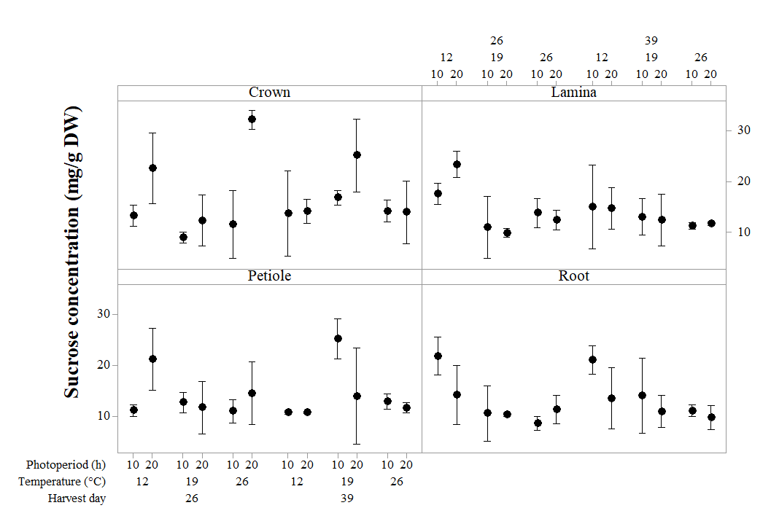
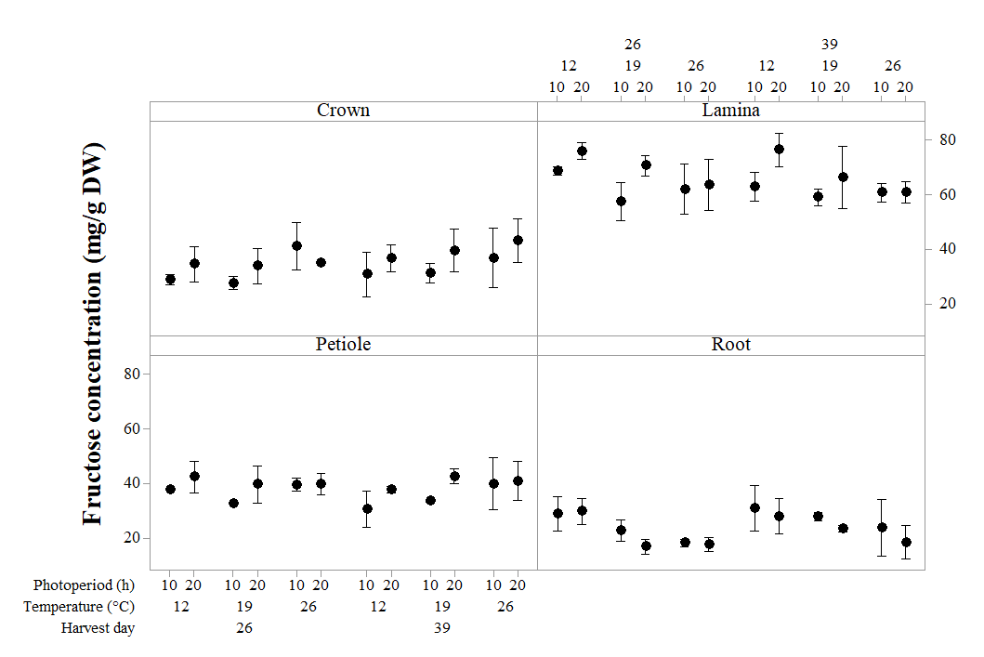
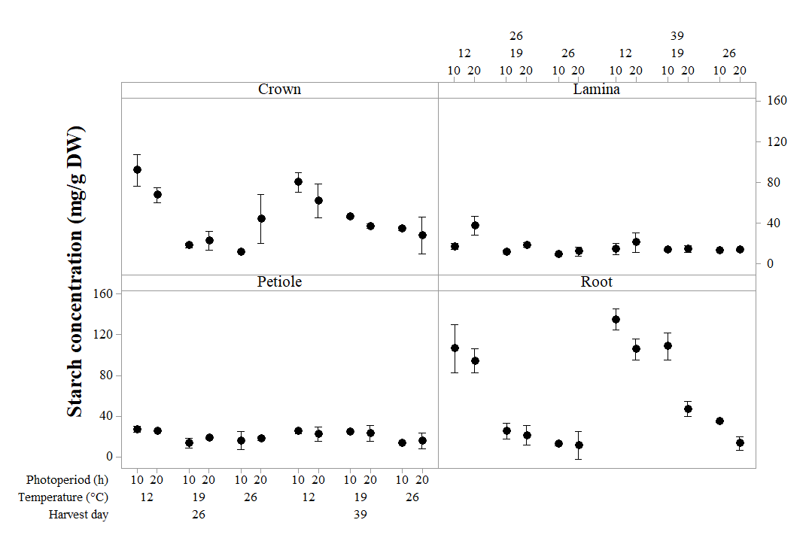

Fig. S2. Photoperiod x Temperature x Growth period interaction plots for the sucrose, glucose, fructose and starch content of the different plant fractions. Data are means of 10, 8, 6 and 5 plants depending on the harvest period. Vertical bars represent the 95% confidence interval for the means.

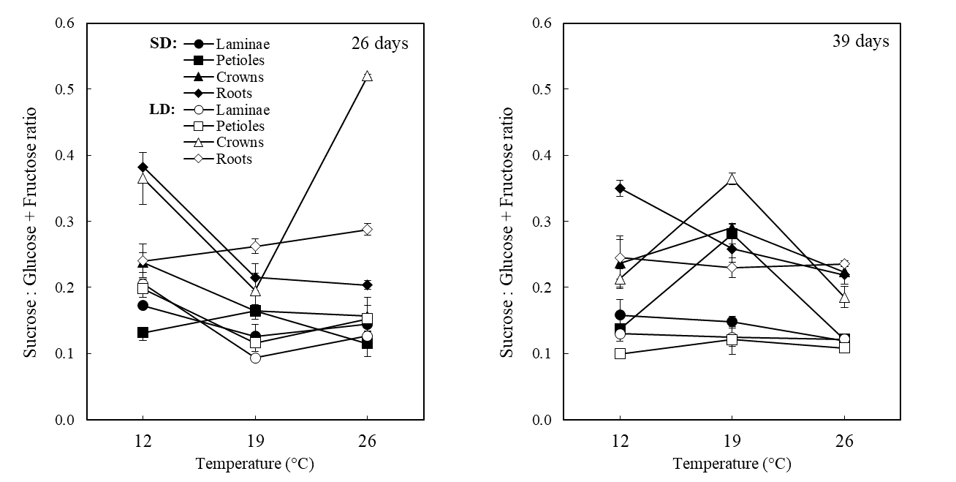
Fig. S3 Ratio of tissue concentrations of sucrose vs. glucose + fructose in ‘Delizzimo’ strawberry plants as affected by temperature and photoperiod treatments after 26 and 39 days of growth as indicated. Values are the means ± SE of three biological replicates with 5-6 plants each.
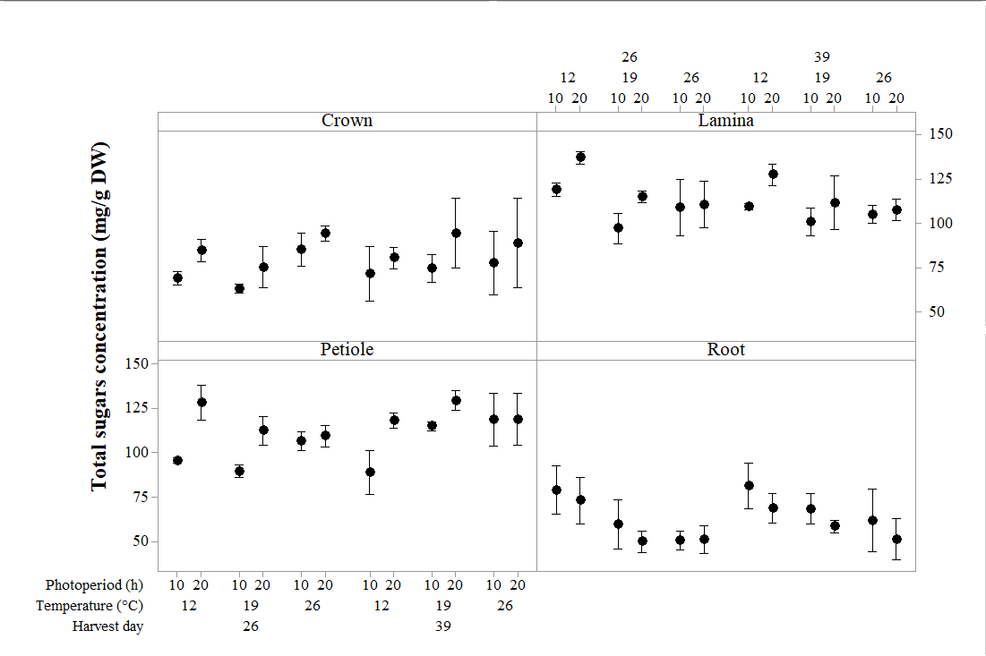
Fig. S4 Photoperiod x Temperature x Growth period interaction plots for the total soluble sugars content of the different plant fractions. Data are means of 10, 8, 6 and 5 plants depending on the harvest period. Vertical bars represent the 95% confidence interval for the means.
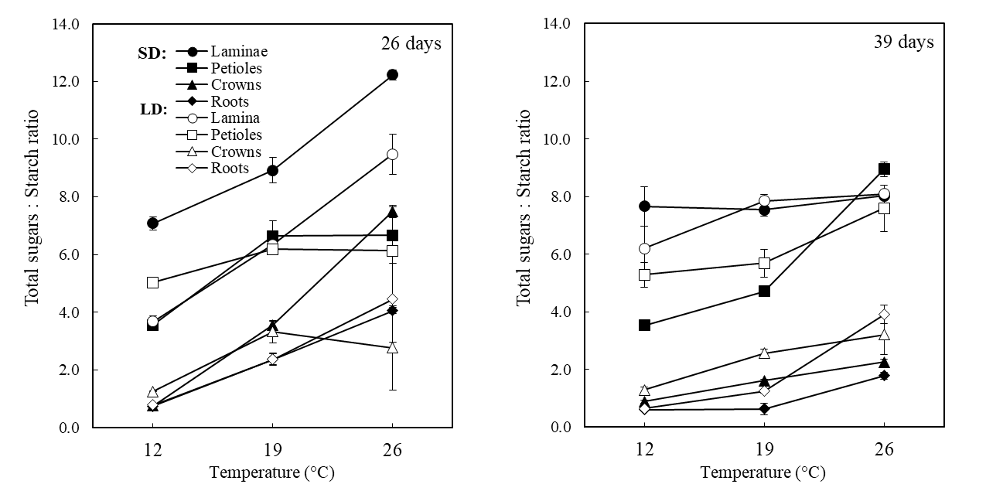

Fig. S5 Ratio of tissue concentrations of total sugars (sucrose, glucose and fructose) vs. starch in ‘Delizzimo’ strawberry plants as affected by temperature and photoperiod treatments after 26 and 39 days of growth as indicated. Values are the means ± SE of three biological replicates with 5-6 plants each.

