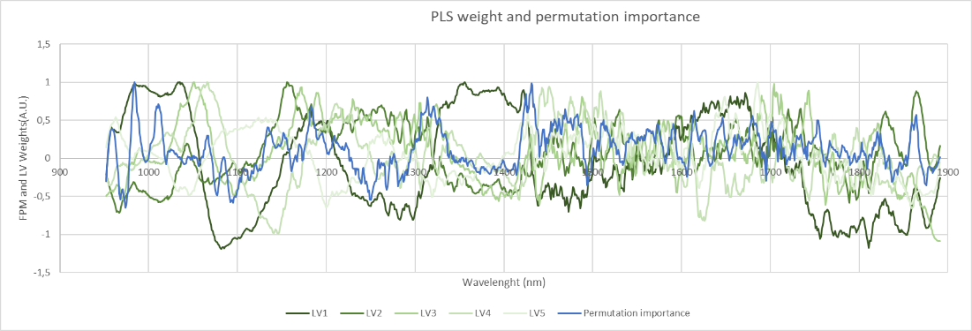
Figure S1. Scaled feature importance and weights of the first five PLS components; both models trained on both species SNV dataset.

Sample # | Varieties | Species | Source | Protein (% d.m.)
1 | Marco Aurelio | Durum Wheat | University of Bari | 8.10
2 | Iride | Durum Wheat | University of Bari | 9.16
3 | Maciste | Durum Wheat | University of Bari | 10.19
4 | Marco Aurelio | Durum Wheat | University of Bari | 11.84
5 | Saragolla | Durum Wheat | University of Bari | 12.14
6 | Maciste | Durum Wheat | University of Bari | 13.06
7 | Maciste | Durum Wheat | University of Bari | 14.20
8 | HT514 | Tritordeum (Durum Wheat x Barley) | University of Bari | 15.52
9 | HT490 | Tritordeum (Durum Wheat x Barley) | University of Bari | 16.16
10 | HT503 | Tritordeum (Durum Wheat x Barley) | University of Bari | 17.58
11 | HT515 | Tritordeum (Durum Wheat x Barley) | University of Bari | 18.22
12 | HT511 | Tritordeum (Durum Wheat x Barley) | University of Bari | 19.88
Table S1. List of the cereal samples.

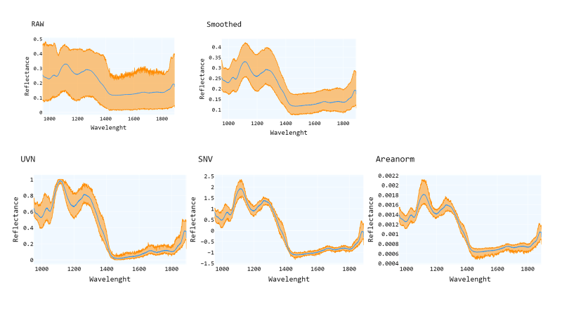
Figure S2. Min max and mean of the wheat datasets.

Section 1 CNN structure
The Convolutional Neural Network used for this approach (Table 2) is composed of two main parts, the convolution section separates and identify features from the NIR spectra and give a numerical output from which the dense, fully interconnected, layers predict the protein content of the sample.
In detail, the input layer adapts the further layer to the shape of the data and the batch normalization layer accelerate the training and prevent overfitting by re-centering and re-scaling to every new batch of training and so reducing the internal covariate shift. The data is then fed to the first one-dimensional convolution layer “Conv_1” with kernel size 7 and a 64-point windows. A dropout layer then randomly removes half of the node in each training epoch, this layer reduces unnecessary feature redundancy and helps preventing overfitting. The data is then fed to two subsequent convolution layers “Conv_2” and “Conv_3” with kernel sizes 3 and 2 and filter windows of 32 and 16.
The flatten layer is necessary to merge the convolutional block and the dense block of the network as it reshapes the data to be a one-dimension array.
The 3 dense fully interconnected layers use a ReLU, rectified linear activation function and have 128,128, and 64 nodes, respectively.
Finally, the output dense layer gives as output the predicted protein content.
The model was trained with Mean Square Error as loss function for 5000 max epochs with a 0.2 validation split using the RMSprop optimizer with 0.001 learning rate and an early stopping callback with 300 epoch patience that restored the best weights and monitored the validation set Mean Absolute Error.
The callback ensures the best fit before the model starts to overfit during training, the 5000 max epoch hyperparameter was selected to be sure the model have enough training epoch but in this case the callback stopped the training after around 1300 epochs.
The CNN was built using Python v3.9.12 and TensorFlow v2.10.0[tensorflow] and trained on an AMD Ryzen 7 2700U system.
The CNN performance was evaluated in terms of: Root Mean Square Error, Mean Absolute Error, Ratio of Performance to the InterQuartile that is the interquartile range of the observed values divided by the Root Mean Square Error of the prediction [Bellon] and R2.
The regression was performed 5 times with different train test split selected using the random shuffle split from sklearn library.

Layer | Layer (type) | Hyperparameter | Output Shape | Parameters
Input
Reshape | Reshape | Time steps=1 | 941.1 | 0
Batch_Normalization | Batch Normalziation |  | 941.1 | 4
Conv_1 | Conv1D | Filters=64  Kernel Size= 7  Activation=ReLU | 935.64 | 512
Dropout | Dropout | Rate=0.5 | 935.64 | 0
Conv_2 | Conv1D | Filters=32  Kernel Size= 3  Activation=ReLU | 933.32 | 6176
Conv_3 | Conv1D | Filters=16  Kernel Size= 2  Activation=ReLU | 932.16 | 1040
Flatten | Flatten | None | 14912 | 0
Dense_1 | Dense | Nodes=128  Activation=ReLU | 128 | 1908864
Dense_2 | Dense | Nodes=128  Activation=ReLU | 128 | 16512
Dense_3 | Dense | Nodes=64  Activation=ReLU | 64 | 8256
Output | Dense | Nodes=1  Activation=Linear | 1 | 65
Table S2. The CNN architecture.

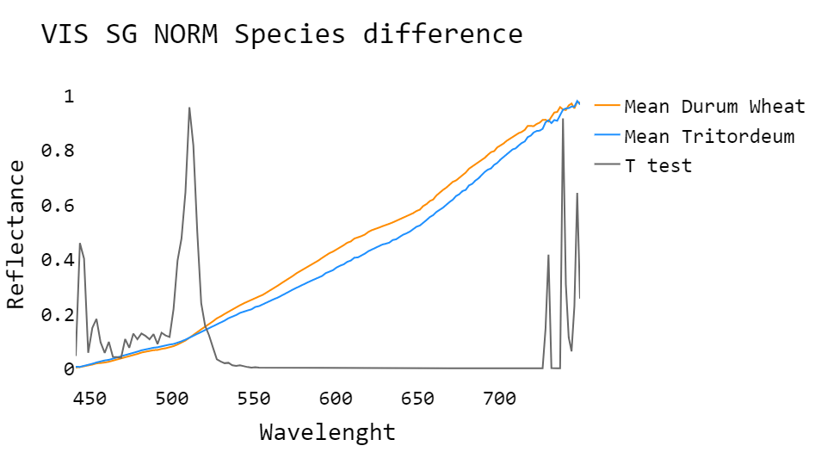
Figure S3. Mean of VIS smoothed and normalized spectra of Durum Wheat and Tritordeum, and T test taken at every point of the spectra between the samples of the two species.
The VIS spectra of the two species show a significative difference between them.

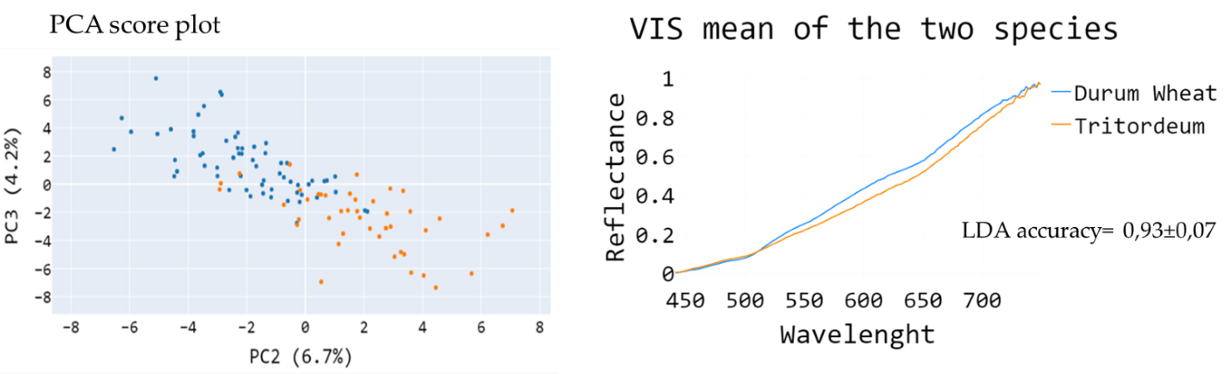
Figure S4. PCA score plot of PC2 and PC3 from VIS dataset with sample colored by their species to show the separation in the dataset; the mean spectra of all Tritordeum and Durum Wheat samples that show the difference in the region between 525nm and 700nm, and the accuracy of a discriminant LDA model on this dataset.

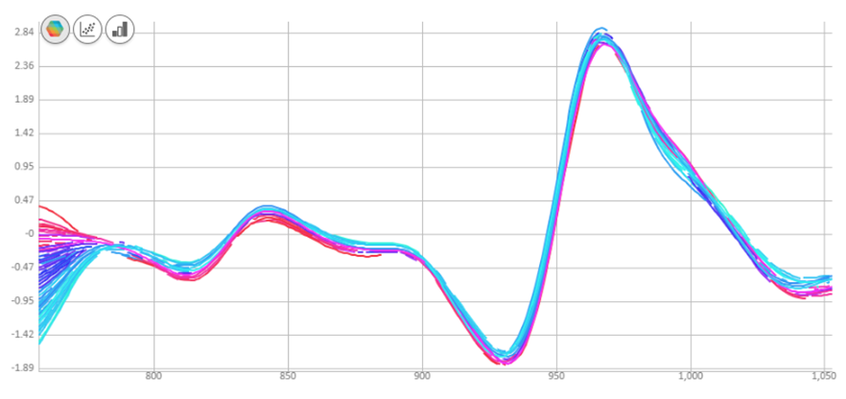
Figure S5. NIR spectra after pre-treatment of 2020 TSS data with logarithm, second derivative and SNV preprocessing steps.

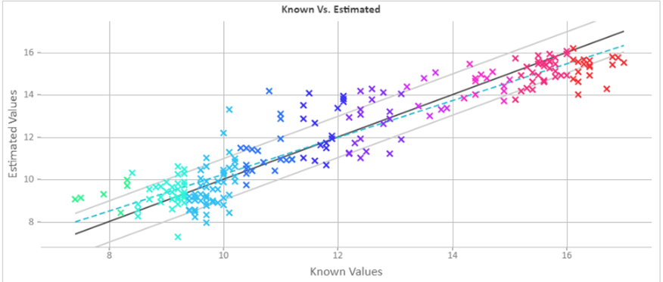
Figure S6. Measured values and predicted values according to the best model seen in Table 5 for 2020 The different colors indicate the various sampling times.
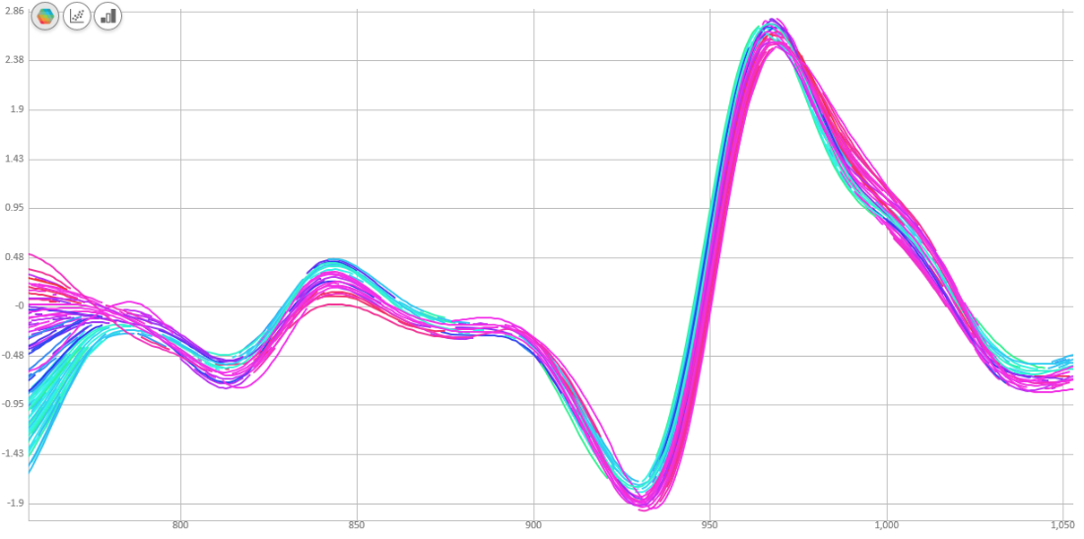
Figure S7. NIR spectrum after pre-treatment of 2021 NIR spectral data with second derivative and SNV.

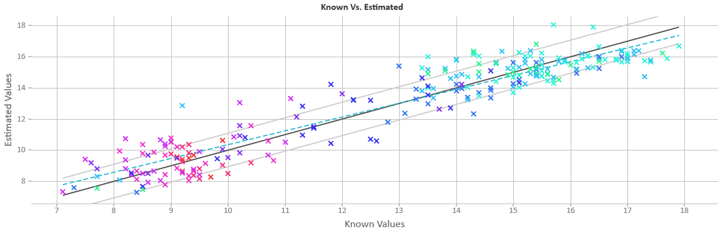
Figure S8. Measured values and predicted values according to the second-best model for TSS seen in Table 10. The different colors indicate the different sampling times.

Peak nm | Identification
982 | moisture
995 | OH primary alcool
1008 | OH tertiary
1014 | protein NH aromatic amines
1020 | CH methyl
1063 | carbonyl
1143 | CH aromatic
1162 | Carbonyl
1193 | CH methyl
1215 | CH nmethylene
1228 | CH secondary and tertiary
1360 | CH methyl
1373 | CH aromatic
1392 | CH methylene
1404 | OH with hydrogen bonding
1418 | CH aromatic
1432 | protein NH aromatic amines
1442 | NH/OH
1453 | NH/OH
1459 | NH amide or NH2
1463 | NH/OH
1488 | NH
1505 | NH primary aromatic
1512 | NH amide or NH₂
1534 | NH
1553 | NH/OH
1574 | NH amide
1590 | C=O
1622 | CH
1636 | CH vinyl
1660 | CH methyl
1669 | CH aromatic
1692 | CONH
1696 | CH
1702 | CH
1736 | CH methyl
1762 | CH methylene
1779 | CH methylene
1793 | OH water
1823 | OH CH combination
1891 | OH
Table S3. Peaks of importance for the CNN model assigned according to Workman and Weier (2012).

PLS RESULTS
 | C-MAE | C-RMSE | C-R² | C-RPIQ | V-MAE | V-RMSE | V-R² | V-RPIQ | LV
RAW | 1.15±0.08 | 1.48±0.07 | 0.83±0.01 | 3.3±0.5 | 2.8±0.2 | 3.5±0.2 | -0.01±0.2 | 1.7±0.3 | 7
SG | 0.81±0.08 | 1.2±0.2 | 0.88±0.03 | 4.7±0.8 | 1.5±0.5 | 2.2±0.7 | 0.6±0.2 | 2.7±0.9 | 15
SNV | 0.65±0.07 | 1.1±0.1 | 0.91±0.02 | 5.8±0.7 | 1.3±0.3 | 2.0±0.4 | 0.67±0.01 | 2.6±0.7 | 13
Areanorm | 0.7±0.1 | 1.1±0.2 | 0.91±0.04 | 5±2 | 1.3±0.2 | 1.1±0.6 | 0.9±0.2 | 3±1 | 15
UVN | 0.71±0.02 | 1.18±0.06 | 0.89±0.01 | 4.6±0.4 | 1.3±0.1 | 1.9±0.2 | 0.71±0.06 | 3,1±0.4 | 15
RAW DW | 0.23±0.04 | 0.31±0.05 | 0.975±0.007 | 12±2 | 1.4±0.1 | 1.7±0,2 | 0.1±0.2 | 1.5±0.3 | 8
RAW TD | 0.35±0.06 | 0.44±0.07 | 0.92±0.02 | 4.8±0.9 | 1.1±0.2 | 1.4±0,4 | -0.1±0.5 | 1.2±0.6 | 6
SG DW | 0.1±0.01 | 0.13±0.02 | 0.995±0.001 | 27±6 | 0.5±0.1 | 0.7±0,3 | 0.9±0.1 | 5±2 | 15
SG TD | 0.09±0.02 | 0.15±0.03 | 0.990±0.004 | 15±3 | 0.34±0.06 | 0.42±0,08 | 0.91±0.03 | 6±2 | 15
SNV DW | 0.074±0.007 | 0.11±0.01 | 0.9971±0.0008 | 37±6 | 0.40±0.05 | 0.48±0.05 | 0.94±0.02 | 7±1 | 14
SNV TD | 0.08±0.01 | 0.16±0.03 | 0.989±0.003 | 14±3 | 0.32±0.04 | 0.39±0.07 | 0.90±0.04 | 4±1 | 14
Areanorm DW | 0.11±0.01 | 0.15±0.01 | 0.9946±0.0007 | 22±3 | 0.46±0.06 | 0.52±0.08 | 0.92±0.03 | 7±3 | 15
Areanorm TD | 0.098±0.009 | 0.15±0.02 | 0.988±0.004 | 14±2 | 0.5±0.1 | 0.7±0.3 | 0.8±0.1 | 4±1 | 15
UVN DW | 0.09±0.01 | 0.12±0.01 | 0.996±0.001 | 28±5 | 0.5±0.1 | 0.6±0.1 | 0.89±0.06 | 6±2 | 14
UVN TD | 0.101±0.007 | 0.15±0.01 | 0.991±0.002 | 15±1 | 0.38±0.06 | 0.48±0.09 | 0.8±0.1 | 3±1 | 13
CNN RESULTS
 | C-MAE | C-RMSE | C-R² | C-RPIQ | V-MAE | V-RMSE | V-R² | V-RPIQ
RAW | 1.4±0.7 | 1.9±0.7 | 0.6±0.3 | 2.9±0.9 | 3.0±0.4 | 3.7±0.5 | -0.1±0.2 | 1.6±0.1
SG | 0.8±0.3 | 1.3±0.4 | 0.86±0.08 | 5±2 | 1.1±0.4 | 1.6±0.6 | 0.8±0.1 | 4±3
SNV | 0.4±0.2 | 0.8±0.3 | 0.94±0.04 | 9±4 | 0.9±0.3 | 1.6±0.8 | 0.7±0.2 | 4±3
Areanorm | 0.4±0.1 | 0.8±0.1 | 0.94±0.01 | 9±3 | 0.9 ±0.3 | 1.6±0.9 | 0.7±0.2 | 4 ±3
UVN | 0.41±0.08 | 0.6±0.1 | 0.97±0.01 | 10±2 | 0.8±0.2 | 1.5±0.5 | 0.8±0.1 | 4±1
RAW DW | 0.8±0.2 | 1.0±0.2 | 0.73±0.09 | 4±1 | 1.6±0.3 | 2.0±0.4 | -0.02±0.2 | 1.5±0.5
RAW TD | 1.3±0.4 | 1.6±0.5 | -0.3±0.7 | 1.4±0.4 | 1.7±0.2 | 2.1±0.4 | -1.2±0.8 | 1.1±0.5
SG DW | 0.44±0.09 | 0.53±0.09 | 0.92±0.03 | 7±1 | 0.6±0.1 | 0.7±0.2 | 0.86±0.05 | 4±1
SG TD | 0.9±0.4 | 1.1±0.5 | 0.4±0.6 | 2±1 | 1.0±0.3 | 1.2±0.4 | 0.0±0.6 | 1.4±0.5
SNV DW | 0.3±0.1 | 0.410717±0.132635 | 0.952847±0.031494 | 8.798147±2.612358 | 0.49071±0.092877 | 0.58614±0.079283 | 0.912096±0.021955 | 4.130962±1.055182
SNV TD | 0.4±0.1 | 0.5±0.1 | 0.88±0.04 | 4±1 | 0.6±0.1 | 0.7±0.1 | 0.7±0.1 | 4±2
Arean DW | 0.23±0.02 | 0.30±0.02 | 0.977±0.004 | 12±1 | 0.5±0.2 | 0.7±0.4 | 0.8±0.1 | 8±4
Arean TD | 0.5±0.1 | 0.6±0.1 | 0.82±0.05 | 3±1 | 0.6±0.1 | 0.77±0.09 | 0.7±0.1 | 3±1
UVN DW | 0.35±0.06 | 0.43±0.05 | 0.95±0.01 | 9±2 | 0.5±0.2 | 0.6±0.2 | 0.89±0.04 | 5±2
UVN TD | 0.6±0.4 | 0.8±0.5 | 0.6±0.4 | 3±2 | 1.0±0.6 | 1.3±0.8 | -0.04±0.9 | 2.2±0.7
Table S4. Metrics of the CNN and PLS regression on the single specie datasets as mean ± standard deviation of the 5 measures. DW= Durum Wheat; TD= Tritordeum; V-MAE= Validation Mean Absolute Error. V-RMSE= Validation Root Mean Square Error. V-R² = Validation R².V-RPIQ= Validation Ratio of Performance over InterQuartile . C-MAE= Calibration Mean Absolute Error. C-RMSE= Calibration Root Mean Square Error. C-R² = Calibration R². C-RPIQ= Calibration ratio of Performance over InterQuartile; SG = Savitzky Golay smoothing; NORM= normalized; N comp.= number of PLS components. V-RPD= Validation-Ratio of Performance to Deviation. C-RPD= Calibration-Ratio of Performance to Deviation.

Workman. Jr.J. & Weyer. L. (2012). Practical Guide and Spectral Atlas for Interpretive Near-Infrared Spectroscopy. Journal of Chemical Information and Modeling (2nd ed..). Boca Raton. FL. USA. CRC Press (Taylor & Francis group). https://doi.org/10.1017/CBO9781107415324.004.

