The EZH2 Selective Inhibitor ZLD1039 Attenuates UUO-Induced Renal Fibrosis by Suppressing YAP Activation
Qingling Xia ^{1, §}, Fujiang Xu ^{2, §}, Lidan Zhang ³, Wenfei Ding ¹, Jiang Liu ¹, Jing Liu ⁴, Minhao Chen ⁵, Santao Ou ^{1, *}, Yong Xu ^{6, *}, Li Wen ^{1, *}
¹ Department of Nephrology, The Affiliated Hospital of Southwest Medical University; Sichuan Clinical Research Center for Nephropathy and Metabolic Vascular Diseases Key Laboratory of Sichuan Province, Luzhou, China.
² Department of Oncology, The Affiliated Hospital of Southwest Medical University, Luzhou, China.
³ Laboratory of Anesthesia & Critical Care Medicine, Translational Neuroscience Center, West China Hospital of Sichuan University, Chengdu, China.
⁴ Department of Urology, The Affiliated Hospital of Southwest Medical University, Luzhou, China.
⁵ Clinical Medical College, Southwest Medical University, Luzhou, China.
⁶ Department of Endocrinology and Metabolism, The Affiliated Hospital of Southwest
Medical University, Luzhou, China.
§ These authors contributed equally to this work.
* Correspondence: Santao Ou, Yong Xu and Li Wen, The Affiliated Hospital of Southwest Medical University, No.25 Taiping Street, Jiangyang district, Luzhou, 646000, China. Tel.: +86-0830-3165341. E-mail: ousantao@163.com(ST Ou), xywyll@swmu.edu.cn (Y Xu), and wenlixnydfy@163.com (L Wen).

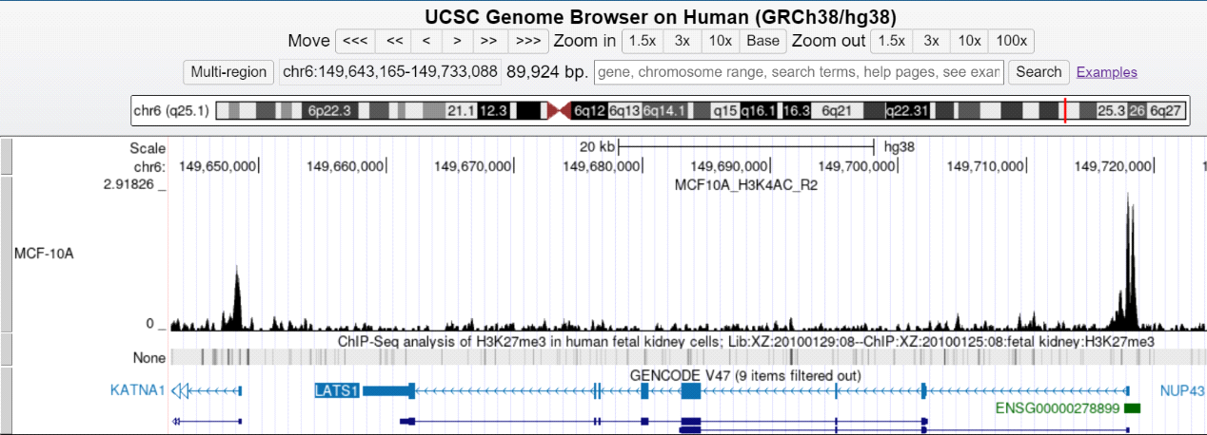
Fig.S1 The ChIP-seq results from the Cistrome Data Browser show a distinct enrichment peak of H3K27me3 in the promoter region of LATS1.

