Supplementary material
Development of a trispecific fusion protein based on angiotensin-converting enzyme 2, glycoprotein 130, and tumor necrosis factor receptor 2 as a promising therapeutic for COVID-19

Yongfeng Qiao^{a,b,#}, Yanjun Han^{a,b,#}, Lu Zhao^{a,b,#}, Wenjing Gao^{a,b}, Hong Hu^{b,e}, Chao Su^{c}, Anqi Zheng^{d}, Junqing Sun^{a,d}, Mingxiong Tian^{c}, Yarong Wu^{b}, Lianmei Bai^{b}, Yuping Lei^{f}, Jiahao Wu^{a,b}, Weibing Zhang^{a,b}, Pu Han^{d}, Xiaoyu Li^{b}, Chunbo Dong^{a,b,*}, Haidong Wang^{a,*}, Zhida Liu^{a,b,g,*}, Pengcheng Han^{c,*}

ªCollege of Veterinary Medicine, Shanxi Agricultural University, Jinzhong, China
^{b}Shanxi Academy of Advanced Research and Innovation, Taiyuan, China
^{c}Jiangsu Provincial Key Laboratory of Critical Care Medicine, School of Medicine, Zhongda Hospital, Advanced Institute for Life and Health, Southeast University, Nanjing, 210009 China
^{d}CAS Key Laboratory of Pathogen Microbiology and Immunology, Institute of Microbiology, Chinese Academy of Sciences, Beijing, China
^{e}Ankerui (Shanxi) Biological Cell Co., Ltd., Taiyuan, China
^{f}Shanxi Animal Disease Prevention and Control Center, Taiyuan, China
^{g}MOE Key Laboratory of Coal Environmental Pathogenicity and Prevention, Shanxi Medical University, Taiyuan, China

*Correspondence:
Pengcheng Han (101013216@seu.edu.cn)
Zhida Liu (zhida_liu@saari.org.cn)
Haidong Wang (wanghaidong@sxau.edu.cn)
Chunbo Dong (Chunbo_dong@saari.org.cn)

#These authors contributed equally to this work
Table S1 qRT-PCR primers list
Primer name | Sequence (5’-3’)
GAPDH-F | CCACCCAGAAGACTGTGGAT
GAPDH-R | GTTGAAGTCAGAGGAGACCACC
CCL4-F | AGGAAGCTTCCTCGCAACTT
CCL4-R | TCAGTTCAGTTCCAGGTCATACA
CXCL2-F | CTCAAGAATGGGCAGAAAGC
CXCL2-R | AAACACATTAGGCGCAATCC
IRF-1-F | CCACCCAGAAGACTGTGGAT
IRF-1-R | GTTGAAGTCAGAGGAGACCACC

Table S2 List of Abbreviation
Abbreviation | Definition
SARS-CoV-2 | Severe Acute Respiratory Syndrome Coronavirus 2
COVID-19 | Coronavirus Disease 2019
RSV | Respiratory Syncytial Virus
SIRS | Systemic Inflammatory Response Syndrome
ARDS | Acute Respiratory Distress Syndrome
GP130 | Glycoprotein 130
TNFR2 | Tumor Necrosis Factor Receptor 2
TNF | Tumor Necrosis Factor
IL-6 | Interleukin-6
IL-6R | Interleukin-6 Recptor
hyper-IL-6 | IL-6R-GGGGSGGGGS-IL-6
RBD | Receptor binding domain
BA.2 | SARS-CoV-2 Omicron sub-lineage BA.2
BA.4/5 | SARS-CoV-2 Omicron sub-lineages BA.4 and BA.5
CH1.1 | SARS-CoV-2 Omicron sub-variant CH.1.1
BQ.1 | SARS-CoV-2 Omicron sub-variant BQ.1
XBB | SARS-CoV-2 Omicron sub-variant XBB
ACE2 | Angiotensin-converting enzyme 2
WT | Wild-type
PT | Prototype
MT | Monotherapy Group
CT | Combination Therapy Group
BLI | Biolayer interferometry
SPR | Surface Plasmon Resonance
VSV | Vesicular Stomatitis Virus
ELISA | Enzyme-Linked Immunosorbent Assay
GFP | Green Fluorescent Protein
LPS | Lipopolysaccharide
R848 | Resiquimod
EC₅₀ | Half-maximal Effective Concentration
IC₅₀ | Half-maximal Inhibitory Concentration
ALT | alanine aminotransferase
CREA | creatinine

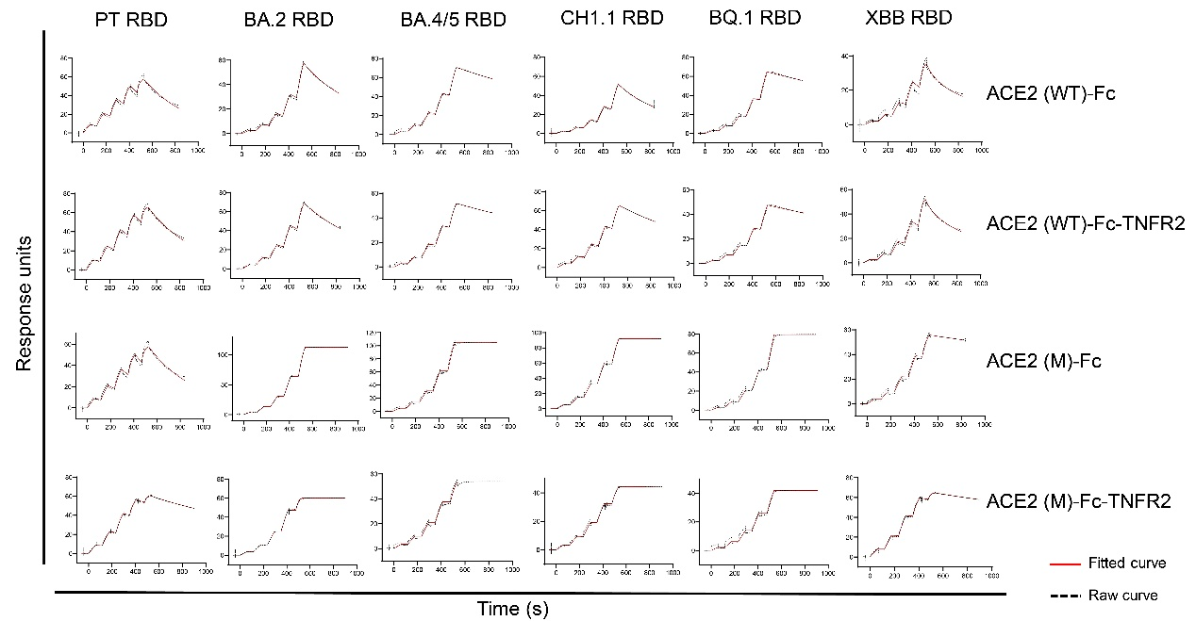 Fig. S1 SPR analysis of the binding affinity between the fusion proteins and SARS-CoV-2 RBDs. The fusion proteins were immobilized on protein A chip and the K_{D} values with different concentrations of RBDs from SARS-CoV-2 PT or variants (BA.2, BA.4/5, CH1.1, BQ.1, XBB) were calculated by single-cycle kinetics.

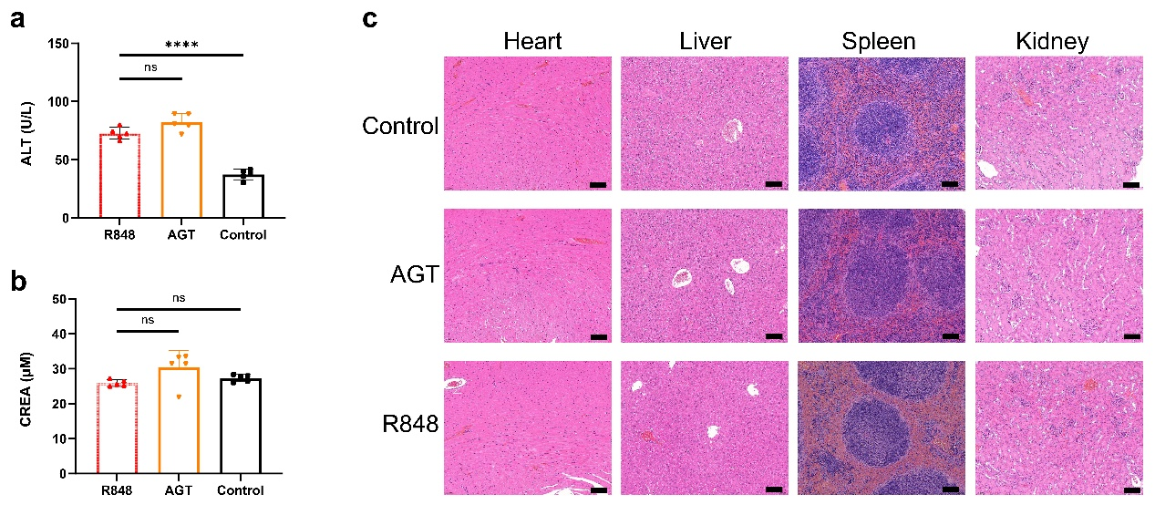Fig. S2 Safety assessment of the trispecific fusion protein ACE2(M)-Fc-mGP130-TNFR2 (AGT) in vivo. The serum samples from control, R848 and AGT groups were analyzed for hepatic function biomarkers (ALT(a)) and renal function biomarker (CREA(b)). c H&E staining for the main organs, including heart, liver, spleen and kidney. Statistical significance is denoted as follows: ****P < 0.0001 and ns P ≥ 0.05. Scale bars, 100 μm

