Artificial intelligence-based diagnostic model for identifying PTPRZ1-MET fusion in a clinically defined secondary glioblastoma cohort
Jin-Hao Zhang^{1,†}, Ji Shi^{2,3,†}, Han-Xiao Zhou¹, Wen-Lu Tan¹, Ying Zhang^{1,*}, Tao Jiang^{1,2,4,5,*}, Zheng Zhao^{1,4,5,*}
¹Department of AI and Biomedical Information, Beijing Neurosurgical Institute, Capital Medical University, Beijing 100070, China
²Department of Neurosurgery, Beijing Tiantan Hospital, Capital Medical University, Beijing 100070, China
³ Department of Neurosurgery, Liaoning Cancer Hospital & Institute, Cancer Hospital of Dalian University of Technology, Cancer Hospital of China Medical University, Shenyang 110042, China
⁴Chinese/Asian Glioma Genome Atlas (CGGA/AGGA) Network, Beijing 100070, China
⁵Chinese Neuro-Oncology Genome Atlas (CGGA-CNS) Network, Beijing 100070, China
*Corresponding author: zhaozheng0503@ccmu.edu.cn (Zheng Zhao), taojiang1964@163.com (Tao Jiang) and zhangy_bni@163.com (Ying Zhang)
†These authors contributed equally to this work

SUPPLEMENTARY FIGURE
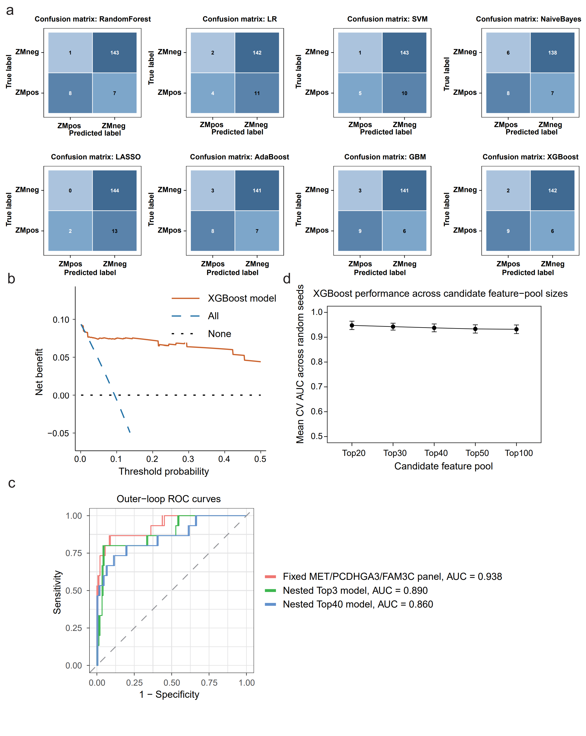
Fig. S1 Additional performance and robustness analyses of machine-learning models for ZM fusion classification. (a) Confusion matrices of eight model-specific three-gene classifiers, including random forest, logistic regression, support vector machine, naive Bayes, LASSO, AdaBoost, gradient boosting machine, and XGBoost. Predicted and true labels are shown for ZM-positive and ZM-negative tumors. (b) Decision curve analysis of the XGBoost model based on cross-validated out-of-fold predicted probabilities, compared with the “all” and “none” strategies. (c) Outer-loop ROC curves from fully nested cross-validation, showing the performance of the training-fold Top40 model, training-fold-selected Top3 model, and fixed MET/PCDHGA3/FAM3C panel. (d) XGBoost performance across different candidate feature-pool sizes, including Top20, Top30, Top40, Top50, and Top100 genes. Points indicate mean cross-validated AUC values across repeated random seeds, and error bars indicate standard deviations.

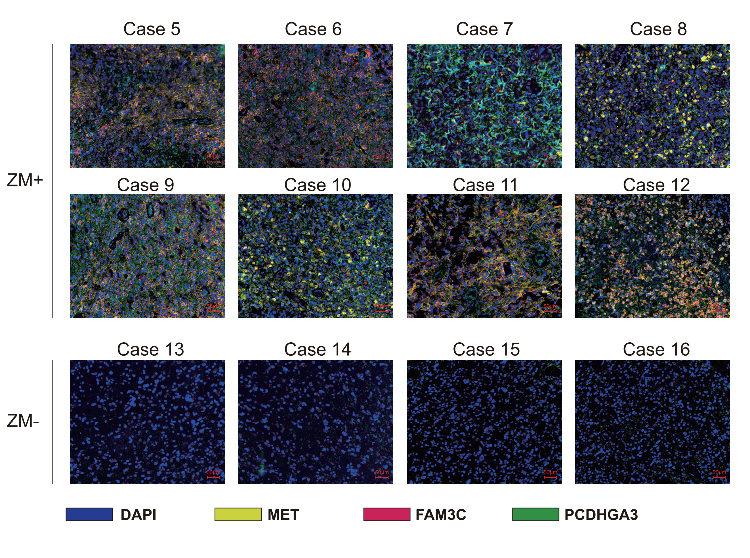
Fig. S2 Additional multiplex immunofluorescence validation of MET, FAM3C, and PCDHGA3 expression in independent FFPE tumor samples. Representative merged multiplex immunofluorescence images are shown for additional ZM-positive cases (cases 5–12) and ZM-negative cases (cases 13–16). DAPI marks nuclei, whereas MET, FAM3C, and PCDHGA3 are shown in yellow, red, and green, respectively. ZM-positive tumors showed stronger combined staining signals for the three biomarkers than ZM-negative tumors. Scale bars = 50 μm.

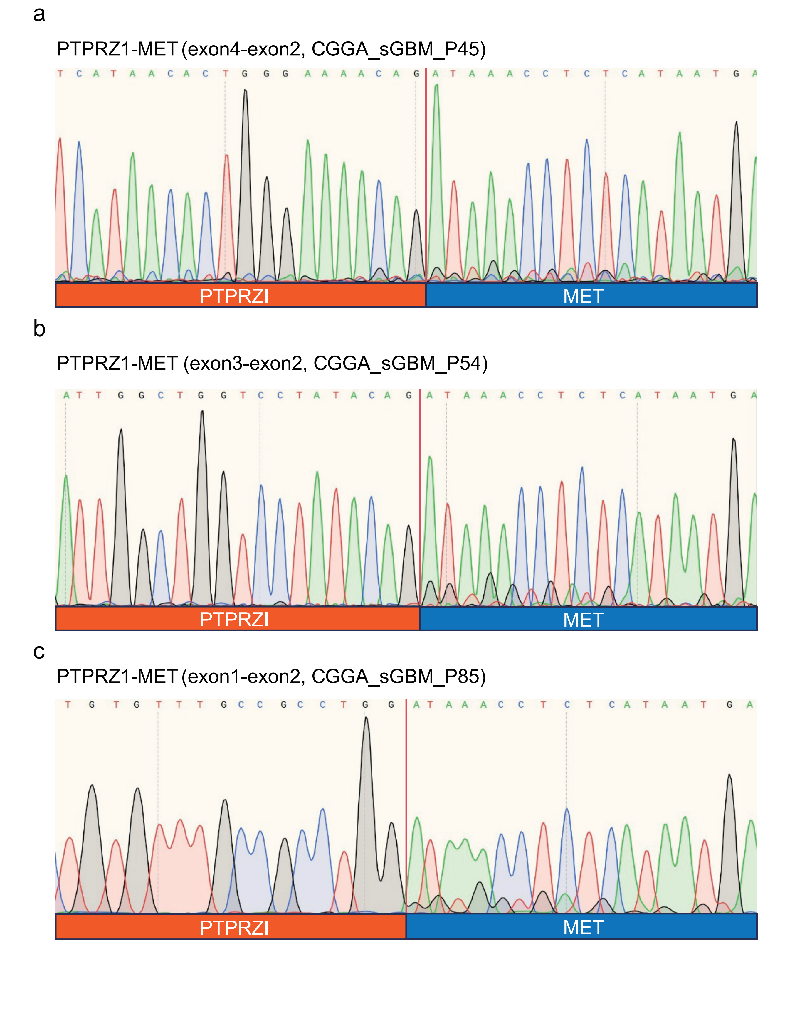
Fig. S3 Representative Sanger sequencing chromatograms validating selected PTPRZ1-MET fusion junctions. Sanger sequencing traces showing PTPRZ1-MET fusion breakpoints in three representative fusion-positive cases: PTPRZ1 exon 4–MET exon 2 in CGGA_sGBM_P45 (a), PTPRZ1 exon 3–MET exon 2 in CGGA_sGBM_P54 (b), and PTPRZ1 exon 1–MET exon 2 in CGGA_sGBM_P85 (c). The red vertical line indicates the fusion junction. Orange and blue bars indicate PTPRZ1-derived and MET-derived sequences, respectively.
SUPPLEMENTARY TABLES
Supplementary Tables S1–S9 are provided in the accompanying Excel file.
Table S1. Age- and sex-adjusted limma analysis of the original ZM-upregulated transcriptional program.
Table S2. Cross-validated performance metrics of eight machine-learning classifiers based on model-specific three-gene panels derived from the Top40 candidate gene set.
Table S3. Age- and sex-adjusted differential expression analysis of MET, PCDHGA3, and FAM3C between ZM-positive and ZM-negative tumors.
Table S4. Performance metrics of fully nested cross-validation analyses.
Table S5. XGBoost feature-pool sensitivity analysis across Top20, Top30, Top40, Top50, and Top100 candidate gene sets.
Table S6. Performance comparison of unweighted and class-weighted XGBoost models using the fixed MET/PCDHGA3/FAM3C panel.
Table S7. Case-level clinicopathological characteristics and prior lower-grade glioma history of the 159 secondary glioblastoma cases.
Table S8. Hyperparameter grids of the eight machine-learning classifiers evaluated in this study.
Table S9. Clinicopathological characteristics and validation assays of the independent FFPE cohort used for protein-level validation.

