Precision Base-Editing of the Cryptic 3’ Acceptor Site to Correct the RNA Splicing Defect of β⁶⁵⁴-thalassemia
Dan Lu,^{1,2,3*} Xiuli Gong,^{1,3} Xinbing Guo,^{1,3} Qin Cai,^{1,3} Wenxiu Li,^{1,3} Yanwen Chen,^{1,3} Dali Li^{1,3,4*}, and Fanyi Zeng^{1,2,3,5*}
1 Shanghai Institute of Medical Genetics, Shanghai Children's Hospital, Shanghai Jiao Tong University School of Medicine, Shanghai, 200040, China
2 Department of Histo-Embryology, Genetics and Developmental Biology, Shanghai Jiao Tong University School of Medicine, Shanghai, 200025, China
3 NHC Key Laboratory of Medical Embryogenesis and Developmental Molecular Biology & Shanghai Key Laboratory of Embryo and Reproduction Engineering, Shanghai, 200040, China
4 Shanghai Frontiers Science Center of Genome Editing and Cell Therapy, Shanghai Key Laboratory of Regulatory Biology, Institute of Biomedical Sciences and School of Life Sciences, East China Normal University, Shanghai, 200241, China
5 School of Pharmacy, Macau University of Science and Technology, Macau, China
*Correspondence:
Fanyi Zeng, M.D., Ph.D.
E-mail: fzeng@vip.163.com
Dali Li, Ph.D.
E-mail: dlli@bio.ecnu.edu.cn
Dan Lu, Ph.D.
E-mail: danlu125@163.com
Running heads: Base editor therapy for β⁶⁵⁴-thalassemia

Online Supplementary Data
Table S1. Primer sequences.
Primer name | Primer sequence | Utility
sgRNA-1 | TCCCTAATCTCTTTCTTTCA | Guide sequences
sgRNA-2 | TTCCCTAATCTCTTTCTTTC | Guide sequences
sgRNA-3 | TGCCCTGAAAGAAAGAGATT | Guide sequences
sgRNA-4 | GCCCTGAAAGAAAGAGATTA | Guide sequences
T7-sgRNA-3 | TAATACGACTCACTATAGGTGCCCTGAAAGAAAGAGATT | Preparation of sgRNAs
T7-sgRNA-1 | TAATACGACTCACTATAGGTCCCTAATCTCTTTCTTTCA | Preparation of sgRNAs
G-R | AAAAAAGCACCGACTCGGTG | Preparation of sgRNAs
Mhbb-QF1 | TGGGCAGGCTGCTGGTTGTC | qPCR for copy number of mouse β-major globin gene
Mhbb-QR1 | CAAGTGATTCAGGCCATCGTT | qPCR for copy number of mouse β-major globin gene
Mus TF-F | TGACTGCACCGGCAATTTC | qPCR for copy number of mouse transferrin gene
Mus TF-R | GGTACCCTCTGGAAGTTTAACGAA | qPCR for copy number of mouse transferrin gene
β-L | GACCAAATCACGGTAATTTTGC | PCR detection of the human β-globin gene (616 bp)
β-R | GGCAGAATCCAGATGCTCAA | PCR detection of the human β-globin gene (616 bp)
β-L-READ1 | TCGTCGGCAGCGTCAGATGTGTATAAGAGACAGGACCAAATCAGGGTAATTTTGC | Primers to amplify the Endogenous target site for amplicon deep sequencing
R2-READ2 | GTCTCGTGGGCTCGGAGATGTGTATAAGAGACAGGAATGGTGCAAAGAGGCATGA
OT1-F | TCGTCGGCAGCGTCAGATGTGTATAAGAGACAGATGAATTCATGCCAAA | Primers to amplify the predicted off-target sites for amplicon deep sequencing
OT1-R | GTCTCGTGGGCTCGGAGATGTGTATAAGAGACAGATTGCTCTGGAATTAGAAGTT
OT2-F | TCGTCGGCAGCGTCAGATGTGTATAAGAGACAGAGATTAAGATGCCCATAAGA
OT2-R | GTCTCGTGGGCTCGGAGATGTGTATAAGAGACAGTAGCCAAGAAGGAGGGATATT
OT3-F | TCGTCGGCAGCGTCAGATGTGTATAAGAGACAGGGGGAAGAGAATTTGACTGA
OT3-R | GTCTCGTGGGCTCGGAGATGTGTATAAGAGACAGGGTGTCAAAATGTATCAAACAGTA
OT4-F | TCGTCGGCAGCGTCAGATGTGTATAAGAGACAGTTTGGGTTAAATCTGCTTAGT
OT4-R | GTCTCGTGGGCTCGGAGATGTGTATAAGAGACAGCAATTGGCGTACTGAT
OT5-F | TCGTCGGCAGCGTCAGATGTGTATAAGAGACAGTTTTGTTTATCTGGAACTGTC
OT5-R | GTCTCGTGGGCTCGGAGATGTGTATAAGAGACAGAGCAGGAGAGAAGTAACTC
OT6-F | TCGTCGGCAGCGTCAGATGTGTATAAGAGACAGAGTCCAGGAGGTTGAGG
OT6-R | GTCTCGTGGGCTCGGAGATGTGTATAAGAGACAGATGAGATGAGCCAGTGATAGA
OT7-F | TCGTCGGCAGCGTCAGATGTGTATAAGAGACAGATGAAGGCATTGATGGATATA
OT7-R | GTCTCGTGGGCTCGGAGATGTGTATAAGAGACAGGGGGACTAGCAAGTCAG
OT8-F | TCGTCGGCAGCGTCAGATGTGTATAAGAGACAGGGCAGTGGTCAGGCCTTAAT
OT8-R | GTCTCGTGGGCTCGGAGATGTGTATAAGAGACAGCCACAGACATGGCGTAACCTT
OT9-F | TCGTCGGCAGCGTCAGATGTGTATAAGAGACAGACACTCCACACCTTTGTTCCA
OT9-R | GTCTCGTGGGCTCGGAGATGTGTATAAGAGACAGAGTCTAGGCAGGTAGTCAGCTG
OT10-F | TCGTCGGCAGCGTCAGATGTGTATAAGAGACAGATACGAGGATGACCATATGTA
OT10-R | GTCTCGTGGGCTCGGAGATGTGTATAAGAGACAGAAAACTTAAGAACACGCTA
HGB-L | GAGGAGAAGTCTGCCGTTAC | RT-PCR for human β-globin (399 bp or 472 bp)
HGB-R | AGCCACACCAGCCACCACTT | RT-PCR for human β-globin (399 bp or 472 bp)
GAPDH-L | AGGCCGGTGCTGAGTATGTC | RT-PCR for mouse Gapdh(530 bp)
GAPDH-R | TGCCTGCTTCACCACCTTCT | RT-PCR for mouse Gapdh(530 bp)
Q-Gapdh-F | AGGTCGGTGTGAACGGATTTG | qPCR for mRNA expression of mouse Gapdh gene
Q-Gapdh-R | GGGGTCGTTGATGGCAACA | qPCR for mRNA expression of mouse Gapdh gene

Table S2. Summary of predicted off-target sites identified by CRISPOR
Site number | Location | Gene name | Sequences
On Target | chr11_5225995-5225975:- | HBB | TGCCCTGAAAGAAAGAGATT
OT1 | chr3:174204131-174204153:- | RN7SKP234-NLGN1 | TGCTCCAAAAGAAAAAGATT
OT2 | chr12:93077796-93077818:+ | Y_RNA-RP11-202G11.2 | GGACCAGAAAGAAAGAAATT
OT3 | chr1:245015063-245015085:- | EFCAB2 | CACCCAGAAAGAAAGAGATT
OT4 | chr14:52992879-52992901:- | FERMT2-DDHD1/RP11-368P15.3 | AGCCTCAAAAGAAAGAGATT
OT5 | chr11:113667535-113667557:- | DRD2-TMPRSS5 | AATCCTGAAAGAAAAAGATT
OT6 | chr5:149321993-149322015:+ | AFAP1L1 | TGCACTCAAAAAAAGAAATT
OT7 | chr11:105272413-105272435:+ | RP11-94P11.4-Metazoa_SRP | TTCCCCAAAAGAAAGAAATT
OT8 | chr12:62532287-62532309:+ | MON2 | TTCCCTAAATGAAAGAAATT
OT9 | chr4:170395548-170395570:+ | RP11-789C1.2-RP11-322J23.1 | TCTCCTGAAAGAAAGAGATT
OT10 | chr13:42045543-42045565:- | RP11-187A9.3-DGKH | TTACCTGAATGAAAAAGATT
The red letters indicate mismatched bases relative to the on-target sequence.

Table S3 Base-editing sites and status of splicing pathway
Base-editing Site | Sequences after base-editing（IVS2-578 to IVS2-581） | Status of splicing pathway
β⁶⁵⁴ | AGGG | aberrant
IVS2-579 G>A | AAGG | correct
IVS2-579 G>T | ATGG | correct
IVS2-579 G>C | ACGG | correct
IVS2-580 G>A | AGAG | aberrant
IVS2-581 G>A | AGGA | aberrant
IVS2-579_580 GG>AA | AAAG | correct
IVS2-579_580 GG>TA | ATAG | aberrant
IVS2-580_581 GG>TA | AGTA | aberrant

Table S4. Hematologic analyses of F0 and F1 β^{654-BE} mice.
Group | N | RBC (10¹²/L) | HGB (g/L) | HCT (%) | MCV (fL) | MCH (pg) | RET (%)
WT | 8 | 9.5±0.3 * | 144.1±8.3 * | 47.2±2.7 * | 49.6±2.8 * | 15.1±0.9 * | 3.1±0.5*
β^{654-BE} | 6 | 9.8±0.5 * | 151.3±9.5 * | 50.3±3.3 * | 51.2±1.4 * | 15.4±0.7 * | 4.7±2.2*
F1-β^{654-BE} | 12 | 9.9±1.1 * | 152.9±16.6 * | 51.6±4.8 * | 52.4±1.8 * | 15.5±0.4 * | 4.0±0.8 *
β⁶⁵⁴ | 11 | 6.5±1.0 | 84.6±7.7 | 29.4±4.3 | 45.1±3.9 | 13.1±1.7 | 26.2±8.1
A One-Way ANOVA test was used for intergroup comparisons. Values represent mean ± standard deviation. Statistically significant differences are indicated for WT, β^{654-BE} or F1-β^{654-BE} compared with β⁶⁵⁴. * P<0.01. N: number of mice tested; RBC: red blood cell count; HGB: hemoglobin; HCT: hematocrit; MCV: mean corpuscular volume; MCH: mean corpuscular hemoglobin; RET: reticulocyte count.

Table S5. Initial and filtered unique variant counts from whole-genome sequencing.
Group | Sample No. | Counts of Indel | Unique Indel | Counts of SNV | Unique SNV
β⁶⁵⁴ | 1 | 429875 | - | 1272965 | -
β⁶⁵⁴ | 2 | 401426 | - | 1225484 | -
β⁶⁵⁴ | 3 | 324740 | - | 838206 | -
β⁶⁵⁴ | 4 | 364963 | - | 1127096 | -
β^{654-BE} | 1 | 452140 | 50493 | 1109138 | 118513
β^{654-BE} | 2 | 386530 | 28609 | 785120 | 27077
β^{654-BE} | 3 | 459806 | 55595 | 1178977 | 154279
β^{654-BE} | 4 | 430721 | 27789 | 1102099 | 12731
β^{654-BE} | 5 | 378361 | 24681 | 806857 | 11411
β^{654-BE} | 6 | 414075 | 31016 | 1009492 | 52508

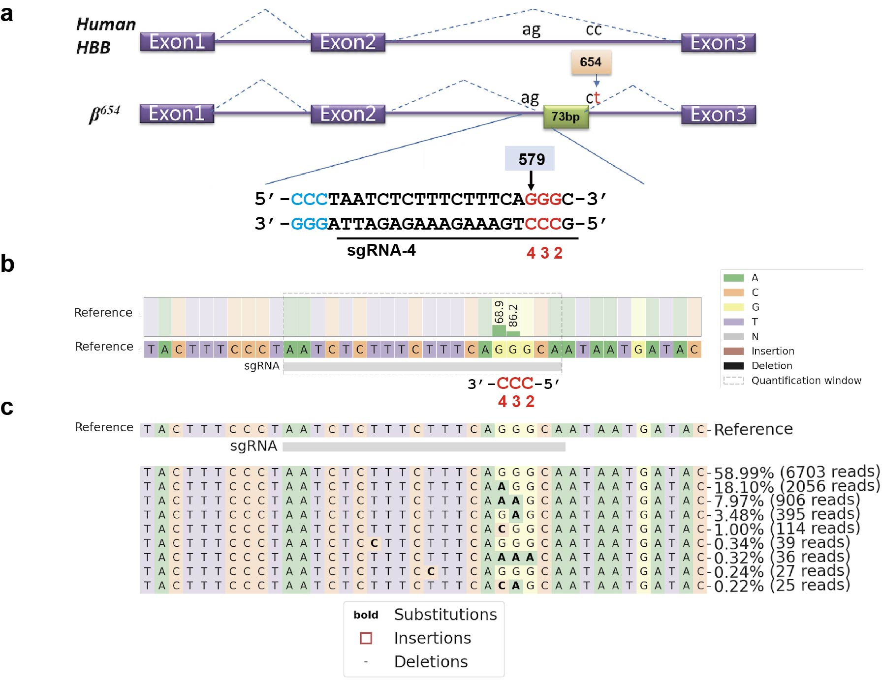
Figure S1. Schematic of sgRNA-4 target site and editing activity detected in HEK293T cells
(a) Schematic of sgRNA-4 target site. The sgRNA-4 binding sequence is underlined, while nucleotides within the predicted editing window spanning IVS2-579_581 GGG are labeled; protospacer adjacent motif (PAM) sequences are highlighted..
(b) Nucleotide distribution surrounding the sgRNA-4 target site following Td-CBEmax editing.
(c) Distribution of edited alleles at the target locus as determined by deep sequencing. Nucleotides are color-coded (A, green; C, red; G, yellow; T, purple). Substituted bases are shown in bold.

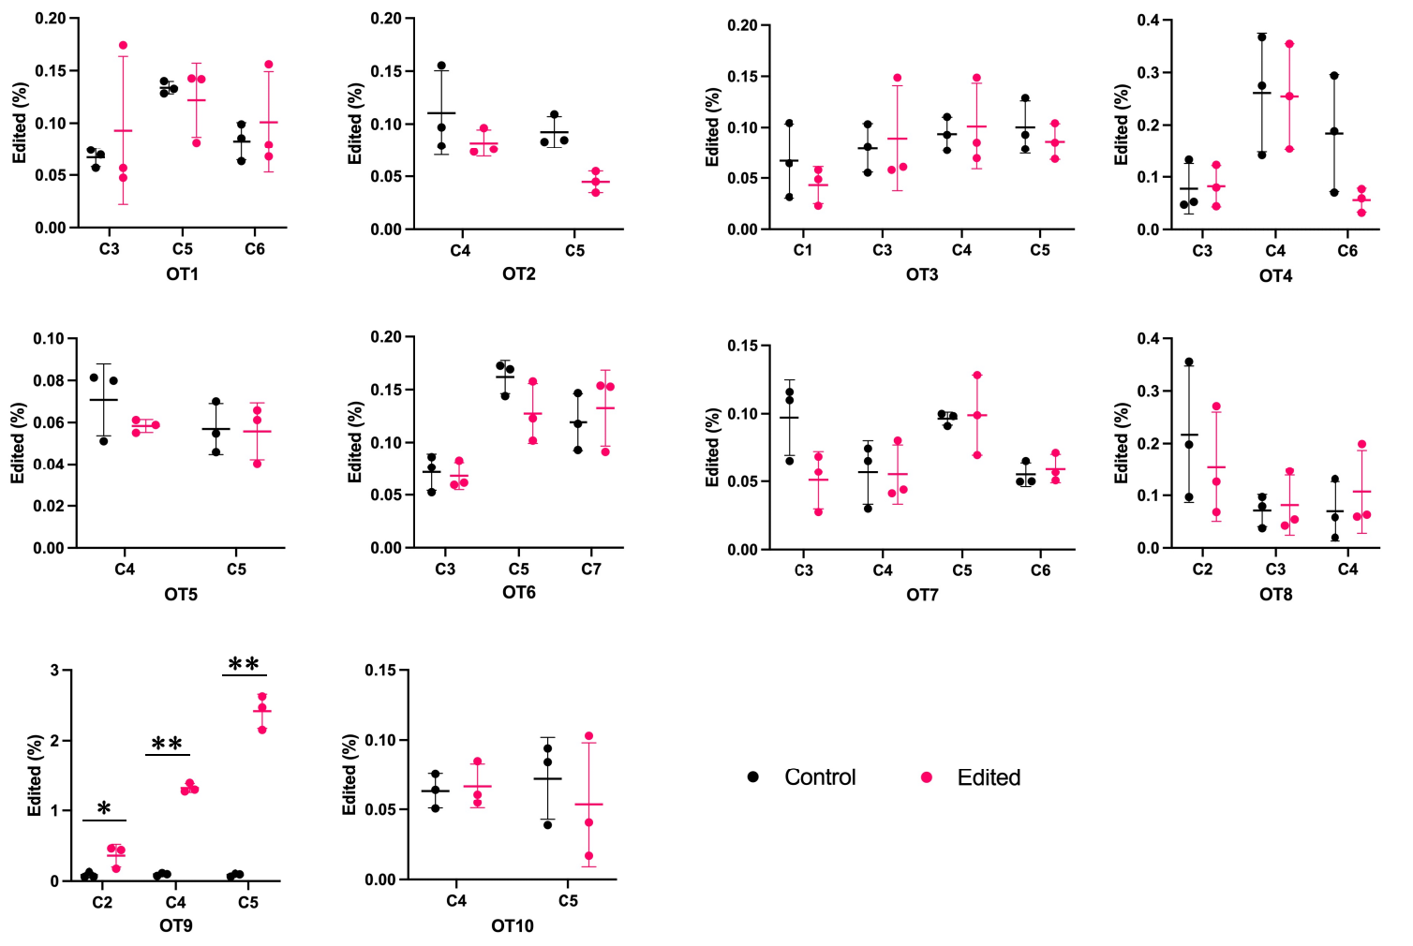
Figure S2. Targeted deep sequencing of amplicons of the top ten predicted off-target sites.
Using the CRISPOR tool, 10 potential genomic off-target sites with 4 or fewer mismatches to the on-target sequence were identified. Each site was evaluated by amplicon deep sequencing. Dot graphs show the percentage of sequencing reads containing C•G-to-T•A conversions within protospacer positions 1–11 at off-target sites in genomic DNA samples from HEK293T cells treated with Td-CBEmax plasmid, or untreated controls (n = 3). * indicates off-target sites with significant difference in edit frequency between mock and edited samples (*P<0.05; ** P<0.01). Each input sample is from an independent experiment.

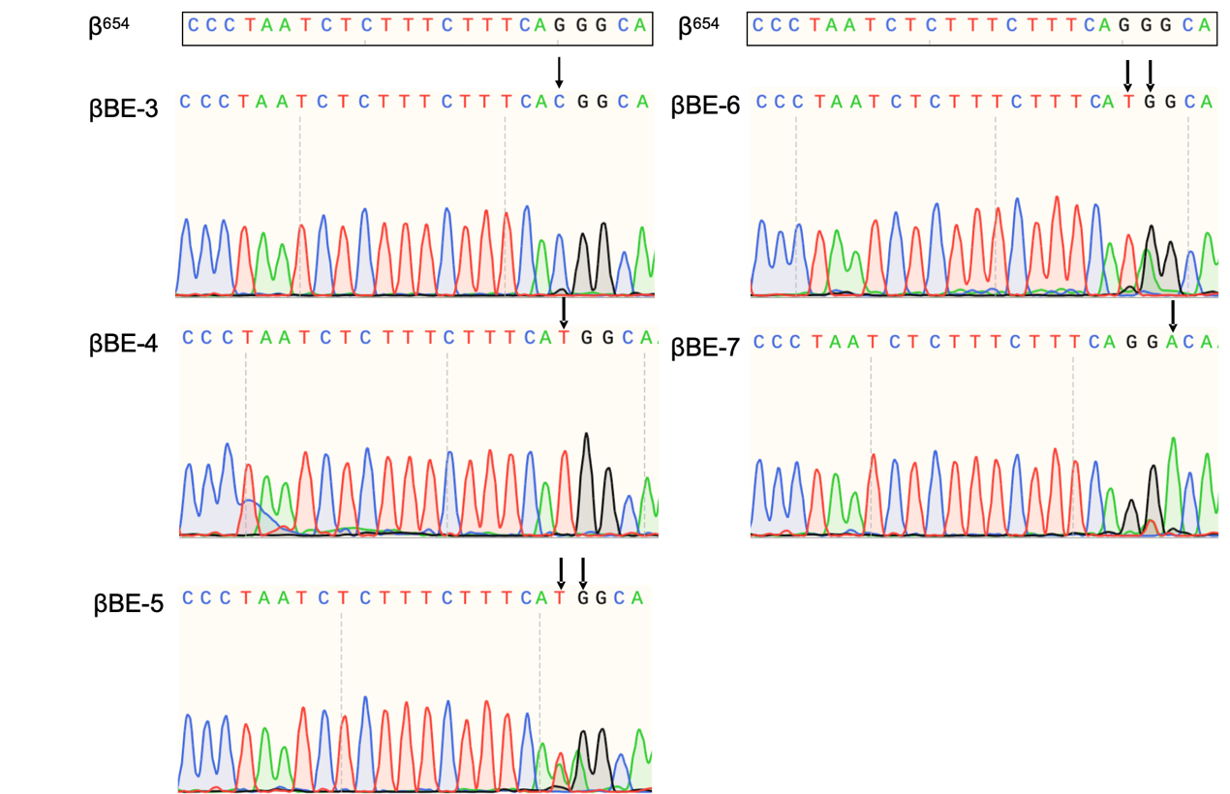
Figure S3. Genotyping of β^{654-BE} founder mice using Sanger sequencing
Representative Sanger sequencing chromatograms of β⁶⁵⁴ mice and β^{654-BE} founder mice (βBE3–7) injected with Td-CBEmax mRNA and sgRNA-3.

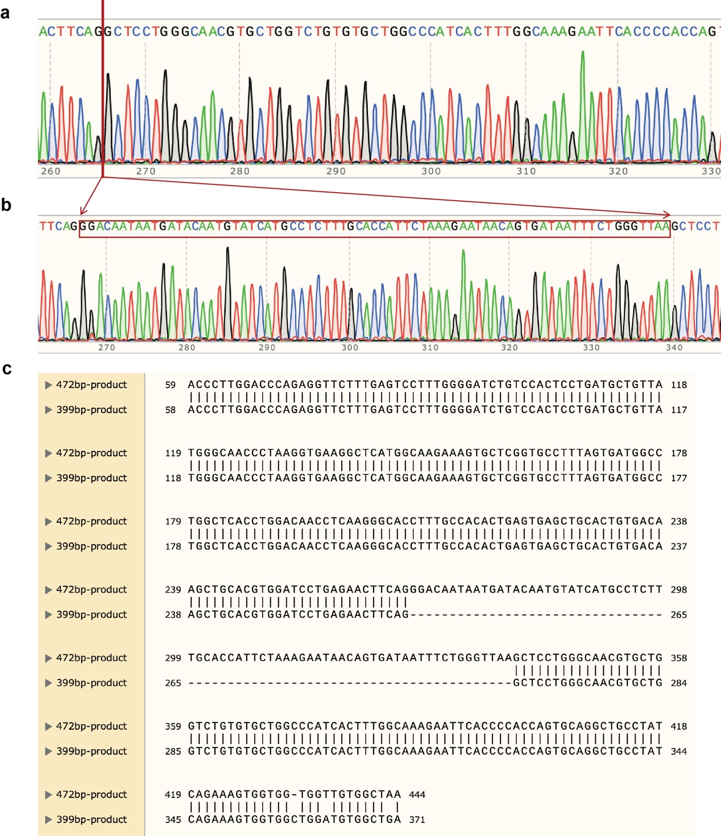
Figure S4. RT-PCR to Identify normal and aberrant β-globin splicing products using Sanger sequencing validation.
(a) Representative Sanger sequencing chromatograms of the 399-bp product, corresponding to normally spliced β-globin transcripts, amplified from founder mouse βBE4.
(b) Representative Sanger sequencing chromatograms of the 472-bp product, corresponding to aberrantly spliced β-globin transcripts, amplified from founder mouse βBE7.
(c) Sequence alignment of the 472-bp and 399-bp RT-PCR products, confirming the presence of the abnormally inserted exon sequence in the longer fragment.

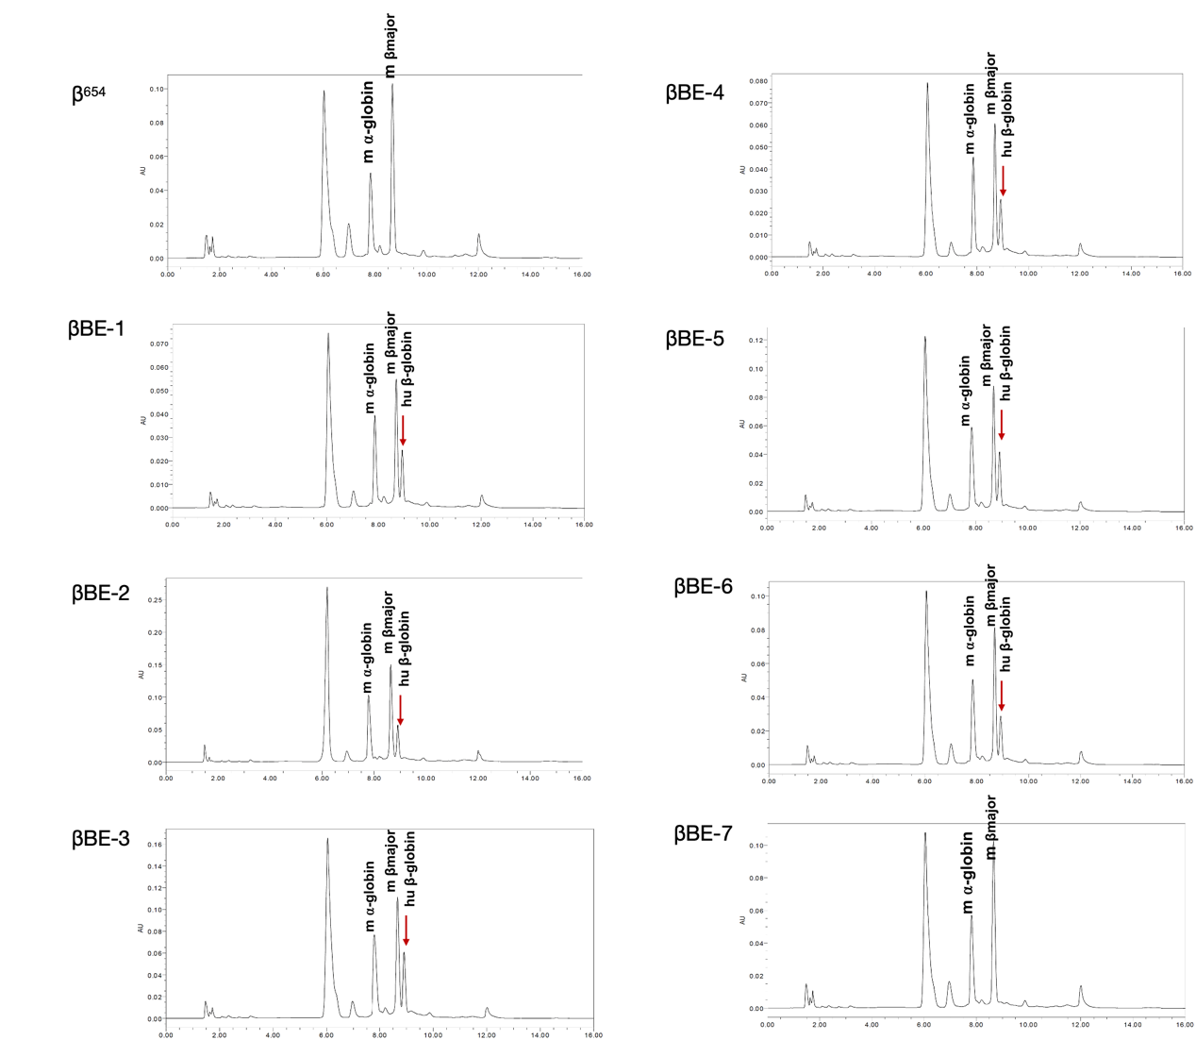
Figure S5. Expression analysis of β-globin gene in β^{654-BE} mice.
Representative high-performance liquid chromatography chromatograms. In β⁶⁵⁴ mice, peaks corresponding to mouse α-globin and mouse β-major globin are shown. In β^{654-BE} mice, peaks corresponding to human β-globin, mouse α-globin, and mouse β-major globin are indicated. Red arrows denote human β-globin peaks.

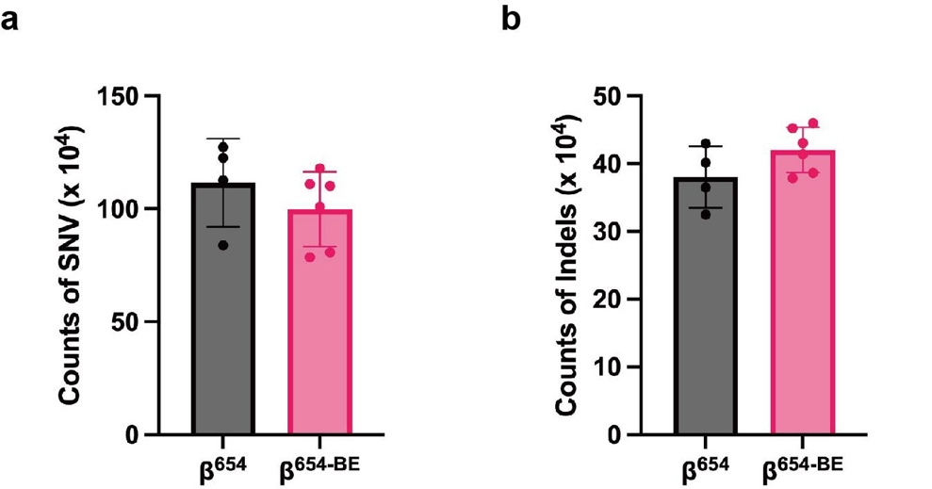

Figure S6. Genome-wide SNV and small indel loads in Td-CBEmax-edited β^{654-BE} mice versus untreated β⁶⁵⁴ controls.
(a) Bar plots overlaid with individual scatter points showing the average number of genome-wide SNVs for β^{654-BE} (n = 6) and control β⁶⁵⁴ mice (n = 4).
(b) Bar plots with overlaid dot graphs depicting the mean counts of small insertions and deletions (Indels) in the two mouse groups. No statistically significant differences in SNV or indel abundance were detected between the edited and control cohorts. Raw quantitative data are provided in Table S4.

