Supplementary Information

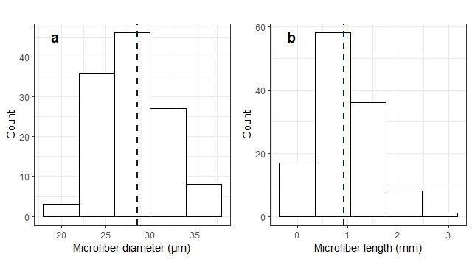
Figure S1. Diameter and length distribution of the microplastic fibers (n=120) used in this study. Data are based on measurements on pictures of fibers taken with a binocular microscope using image analysis with ImageJ.

