Supplementary information

Titel: Microplastics have shape- and polymer-dependent effects on soil processes

Authors: Anika Lehmann^{1,2,*} , Eva F. Leifheit^{1,2}, Maurice Gerdawischke¹, Matthias C. Rillig^{1,2}
¹ Freie Universität Berlin, Institut für Biologie, 14195 Berlin, Germany;
² Berlin-Brandenburg Institute of Advanced Biodiversity Research, 14195 Berlin, Germany
* Correspondence: lehmann.anika@googlemail.com; Tel.: +49-30-838-53145

Keywords: microplastic; soil aggregation; organic matter; shape

Search term development

We wanted to build a search term which is sensitive but also precise enough to detect relevant, experimental studies on microplastic contaminated soil systems. For this, we used the broad search string TS= (micro-plastic* OR microplastic*) to run a topic search on the 7th of September 2020 in the Web of Science (Thomson Reuters) Core collection database via subscription of the Freie Universität Berlin, Germany. We included any languages, publication years (available timespan: 1945 to 2020) and indexes.
We exported the all retrieved 4339 records for word analysis (text mining) in biblioshiny – the web interface of the R package “bibliometrix” ¹. We checked the top 200 words or word groups, respectively, in titles, abstracts, author keywords and keywords plus for words of interest.
Since not all experimental studies on soil systems clearly state that they performed an experiment with soil as substrate we could not include terms as “soil” or “experimental” in the search string without losing potential matching articles. Instead we specified systems and studies which we want to exclude via NOT Boolean operator. We excluded terms representing aquatic systems or aquatic organisms. Other frequent terms identified via word analysis were associated with environmental microplastic monitoring or extraction studies but also research on metals, alloys and nanoparticles.
The final search string looked as followed:
TS=(micro-plastic* OR microplastic*) NOT (marine OR sea$ OR river* OR coast$ OR coastal OR "freshwater" OR "fresh-water" OR beaches OR beach OR ocean* OR bay OR atlantic OR lake$ OR pacific OR estuar* OR gulf OR seawater OR sediment$ OR coral$ OR *fish* OR daphnia OR mussel$ OR zooplankton OR "mytilus edulis" OR *bird OR *birds OR "arenicola marina" OR "caenorhabditis elegans" OR "microalgae" OR aquacultur* OR bivalv* OR deformation OR microplasticity OR nanoplastic* OR nanoparticle$ OR fatigue OR alloy$ OR steel$ OR metals$ OR crystal$ OR "modeling" OR "modelling" OR spectroscopy OR extraction OR monitoring OR "risk assessment" OR infrared )

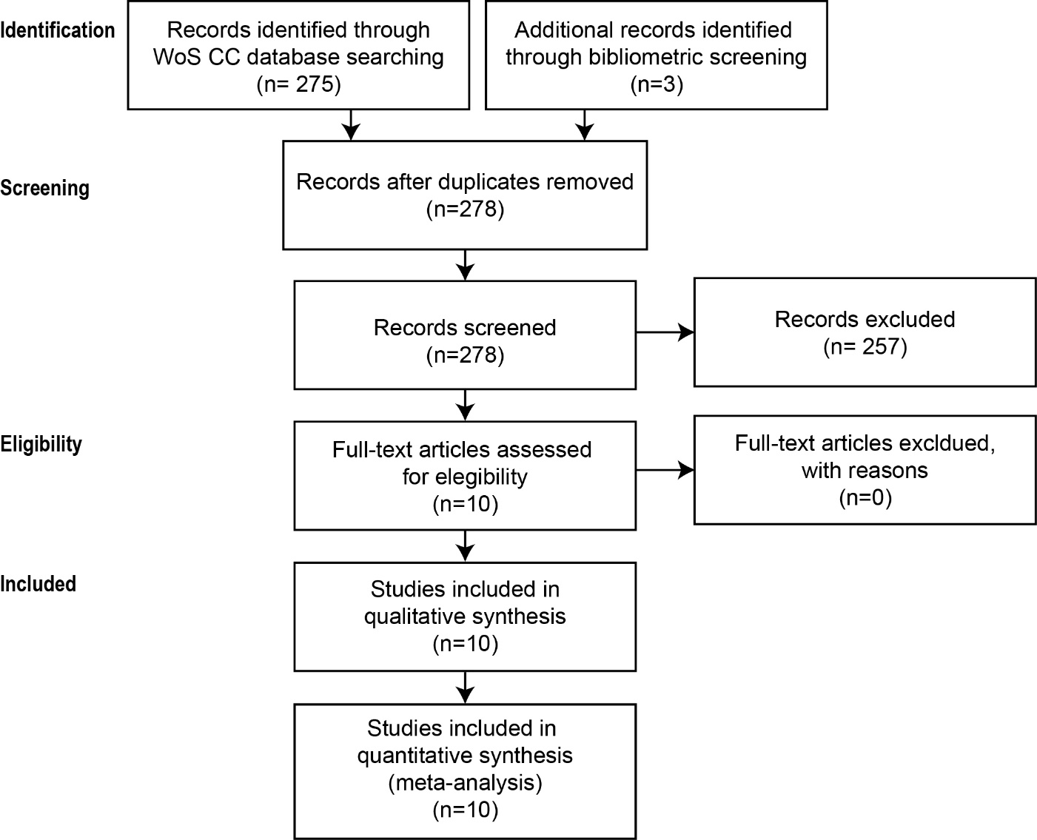

Figure S1. Flow diagram following PRSIMA which illustrates the process of data collection and quality control.

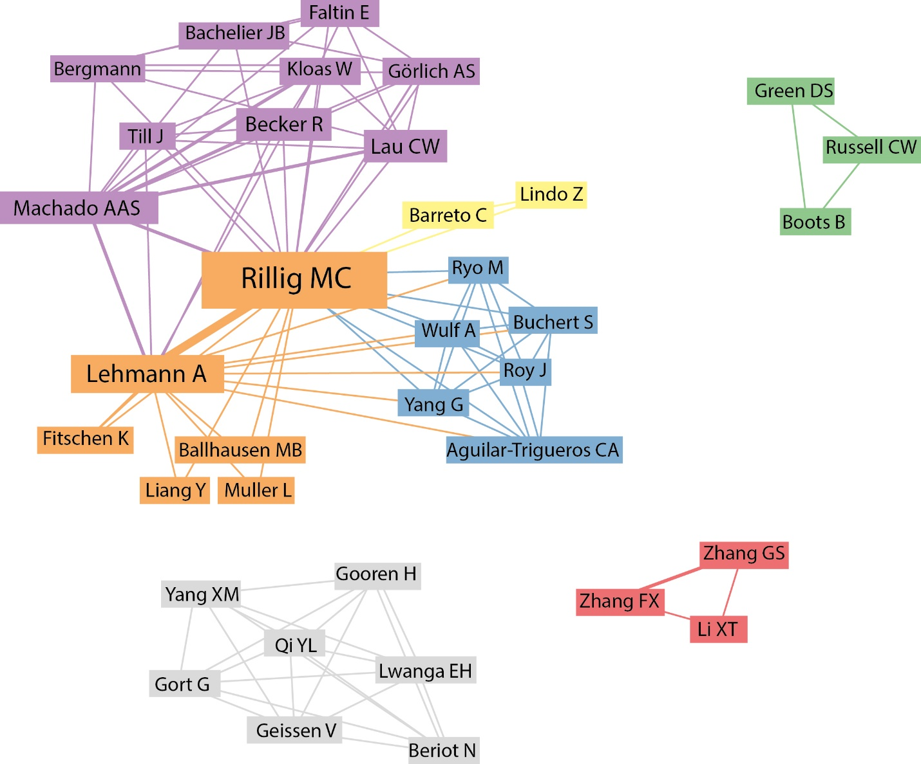
Figure S2. Author collaboration networks for the 10 publications included in our meta-analysis. The boxes with author names represent the nodes and the connecting lines the links. All co-authors of each publication are depicted and distinct clusters are represented by similar colors. The article collection comprised 2 multi-paper clusters and just 2 unrelated author collaboration clusters.
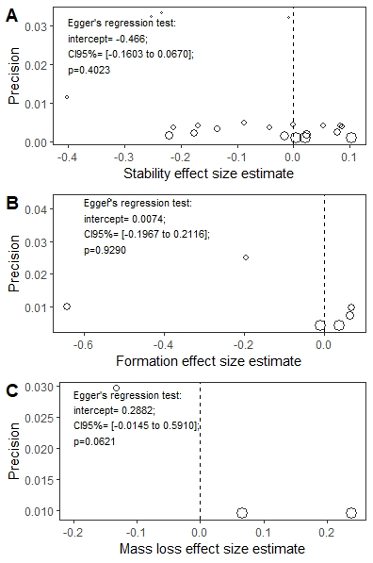
Figure S3. Egger’s regression test to evaluate publication bias. Circles represent effect size values from the corresponding aggregate formation, stabilization and organic matter loss datasets plotted against the standard errors (study precision). If the intercept of the resulting regression line deviates from zero, the analyzed relationship is asymmetrically and hence a publication bias is plausible. The p-value for this analysis was set to p=0.1. No publication bias was evident for the aggregate formation and stability datasets. For the soil organic matter loss dataset, the number of effects size estimates is too low to run a trustworthy publication test.

Table S1. Evaluation of data precision depending on the data source for the stability dataset
Data source | Estimate estimate | Lower border 95%CI | Upper norder 95%bCI | p-value
raw data | -0.0337 | -0.4243 | 0.3569 | 0.8609
tables | -0.1134 | -0.3655 | 0.1388 | 0.365
figures | -0.1371 | -0.5952 | 0.321 | 0.5448

Data for dataset construction builds on three sources from which data for effect size and variance calculation were drawn from: raw data extracted from supplementary data tables, data tables presenting means and variance data and figures presenting means and variance data or even raw data distributions. We ran a mixed-effects model for the largest dataset (the stability-dataset which has the highest statistical power for bias detection) and tested the categorical subgroup variable “data source” with the three levels “raw data”, “table” and “figure”. We found no significant difference between and comparable width of confidence intervals among the three levels (df=1,28, p = 0.7700; Table S1). Hence we do not expect any accuracy bias depending on the source of data.

Table S2. Multilevel model outcomes for the soil aggregate stability effect sizes for test systems including a plant. All effects are neutral because lower and upper borders of the 95% CIs include zero. Thus, no negative or positive microplastic-mediated effects are evident in this subset.
Subgroup | Subgroup level | Effects size estimate | lower border95% CI | upper border95% CI
Overall | Overall | -0.23156 | -0.57629 | 0.11316
Shape | Fibers | -0.09017 | -0.48019 | 0.29985
 | Particles | -0.28094 | -0.66180 | 0.09991
Polymer | Biodegradable | -0.27907 | -2.46900 | 1.91085
 | Mix | -0.19153 | -2.50872 | 2.12565
 | Polyamid | -0.27689 | -2.36067 | 1.80689
 | Polyester | -0.04076 | -2.10570 | 2.02418
 | Polyethylene | -0.27470 | -2.26521 | 1.71581
 | Polyethyleneterephthalate | -0.28621 | -2.34957 | 1.77714
 | Polypropylene | -0.36149 | -2.52118 | 1.79821
 | Polysterene | -0.14433 | -2.20699 | 1.91834

Table S3. Plastic products used to produce secondary microplastics.
Polymer | Specific name | Full name | Type | Provider | Source
PP |  | polypropylene | fiber | Hornbach (Art. 8442182, Seil 6cm x 2m) | https://www.hornbach.de/
PA |  | polyamide synonymous to nylon | fiber | Hornbach (Art. 6702575, 0.35mm) | https://www.hornbach.de/
PES |  | polyester | fiber | Hornbach (Art. Art. 8442173, Seil 8cm x 10m) | https://www.hornbach.de/
PE | LDPE | polyethylene | foil | anti-algae folie (FolienBernhardt.de) | https://www.folien-  bernhardt.de/produkte/folien
PET |  | polyethylene terephthalate | foil | oven bag, Toppits, EAN(s): 4008871209672 | from supermarket
PP | C/PP | cast polypropylene | foil | transparent folder; Stylex (Art. 40928) | from stationery shop
PET |  | polyethylene terephthalate | fragment | water bottle | from supermarket
PP |  | polypropylene | fragment | planting pots | from lab storage
PC |  | polycarbonate | fragment | CD, DVD | from supermarket
PU |  | polyurethan | foam | Hornbach (Art. 6411731) | https://www.hornbach.de/
PE | LDPE | low density polyethylene | foam | package foam, HP laptop | from lab storage
PS | EPS | expanded polysterene | foam | transport box | from lab storage

Table S4. Outcomes for newly formed aggregates (NFA in %, n=70), water-stability of aggregates (WSA in %, n=70) and organic matter loss (OML in %, n=61) and microplastic shapes. A p-value < 0.05 was considered significant and marked in bold.
 | NFA |  | WSA |  | OML
Treatment-control≥0 | z-value | p-value | z-value | p-value | z-value | p-value
Fiber | -5.021 | <0.001 | -1.948 | 0.0795 | -2.034 | 0.0671
Film | -2.427 | 0.0248 | 1.833 | 0.9987 | -3.276 | 0.002
Foam | -1.446 | 0.1913 | -1.89 | 0.0899 | -0.52 | 0.5978
Fragment | -2.509 | 0.0201 | 0.826 | 0.965 | -1.48 | 0.1933

Table S5. Outcomes for newly formed aggregates (NFA in %, n=70), water-stability of aggregates (WSA in %, n=70) and organic matter loss (OML in %, n=61) and microplastic polymer per shape. A p-value < 0.05 was considered significant and marked in bold.
 |  | NFA |  | WSA |  | OML
Treatment - control >= 0 |  | z-value | p-value | z-value | p-value | z-value | p-value
Fiber | PA | -6.577 | <0.0001 | -1.04 | 0.709 | -1.27 | 0.56571
 | PES | -3.081 | 0.01123 | -1.939 | 0.225 | -1.605 | 0.37739
 | PP | -2.118 | 0.14265 | -0.989 | 0.735 | -1.306 | 0.5448
Film | CPP | -1.161 | 0.58602 | 1.603 | 1 | -1.939 | 0.21859
 | PES | -2.339 | 0.0878 | 2.824 | 1 | -3.548 | 0.00226
 | PET | -1.939 | 0.20226 | -0.29 | 0.957 | -1.541 | 0.41187
Foam | EPP | -0.22 | 0.93908 | 0.061 | 0.989 | -1.09 | 0.66493
 | PE | -1.91 | 0.21316 | -2.119 | 0.158 | 0.886 | 0.99974
 | PU | -1.251 | 0.53727 | -1.237 | 0.602 | -0.975 | 0.72407
Fragment | PC | -2.176 | 0.12631 | 0.272 | 0.996 | -0.004 | 0.98054
 | PET | -3.481 | 0.00287 | 1.012 | 1 | -0.41 | 0.92538
 | PP | -0.728 | 0.79465 | -0.019 | 0.984 | -2.272 | 0.10966

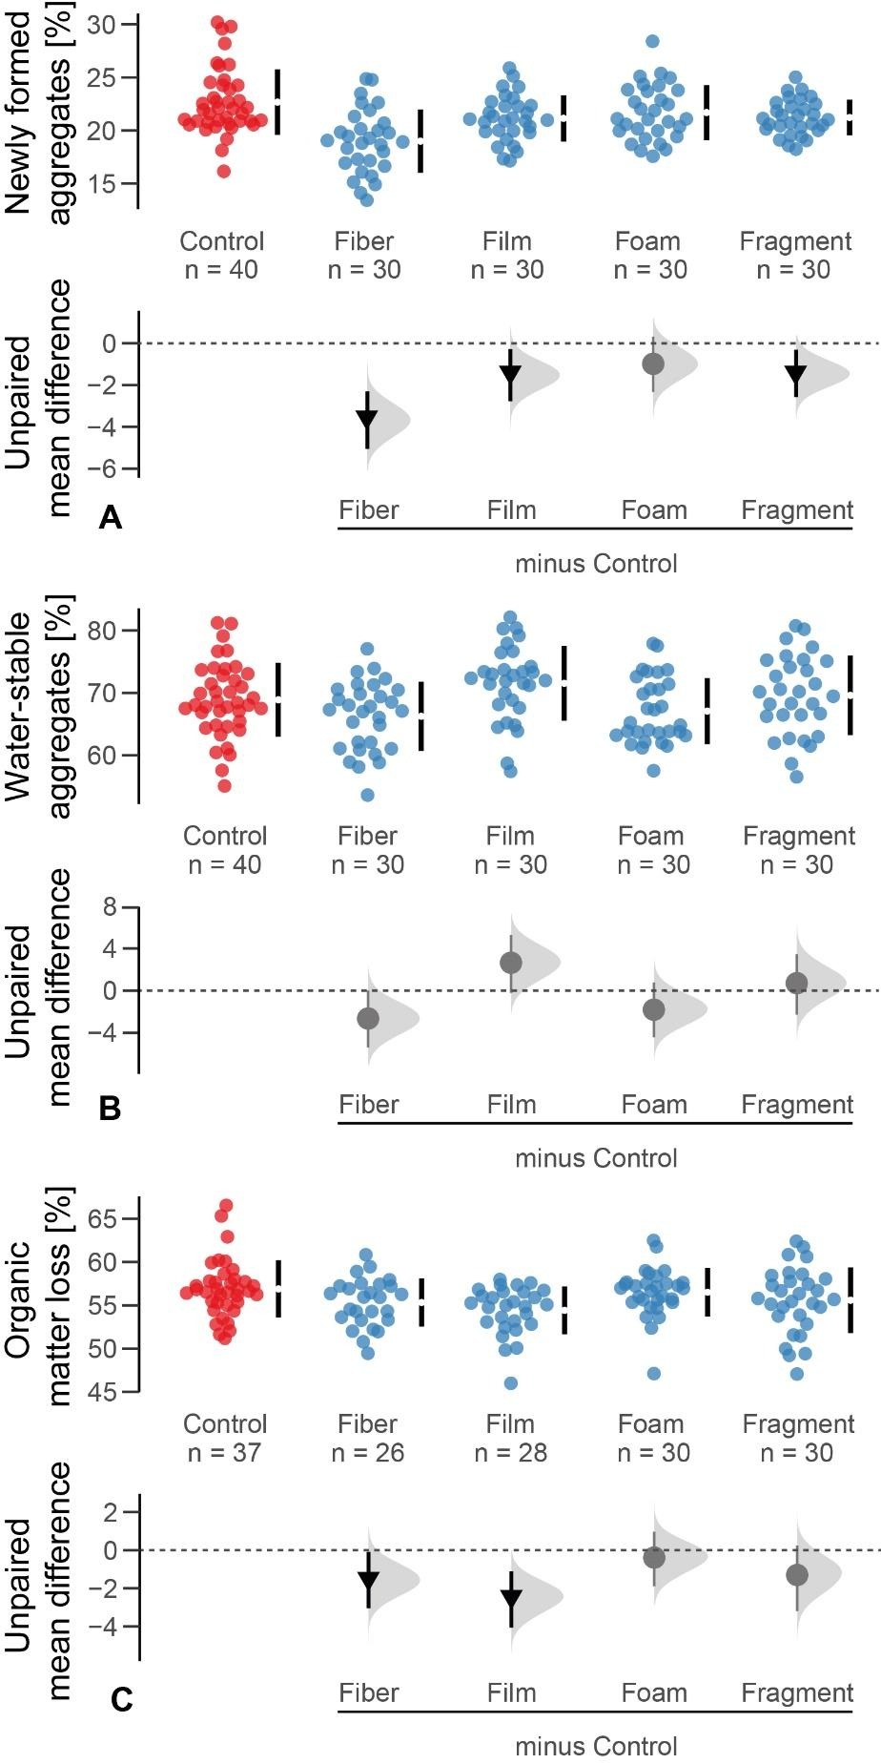
Figure S4. Microplastic shape effects on (A) newly formed aggregates > 2mm (in %), (B) stability of aggregates (in %) and (C) organic matter loss (in %). Raw data are presented as swarm plots in the first row of each panel and number of replicates (n) are depicted. In the second row of each panel, multi-group estimation plots present the unpaired mean differences of the microplastic treatments and controls. The unpaired means (effect magnitude) are symbolized by circles and triangles and the corresponding confidence intervals (CIs; effect precision) by the vertical, black lines. The sampling error distribution is presented as a grey curve. Negative (arrow head down) effects are colored in black whereas neutral effects (circle) are colored in grey. Outcomes of statistical analysis are presented in Table S2 and S3.

1. Aria, M.; Cuccurullo, C., bibliometrix: An R-tool for comprehensive science mapping analysis. Journal of Informetrics 2017, 11, (4), 959-975.

